SIMATS ENGINEERING
SAVEETHA INSTITUTE OF MEDICAL AND TECHNICAL SCIENCES
NAME: J.VIVEK
DATE:03/10/2026
Roll. No: 14
Reg Mo: 192325149
Course Code/ Name: DSA0601 /Data Handling and Visualization
Slot C | CLASS ACTIVITY (R Only)

Chart 1: Fuel efficiency (km per litre)
Violin | Skew (answer) | Mean vs Median (answer)
Brand Z | Right skew | Mean > Median
Brand X | Left skew | Mean < Median
Brand V | Left skew | Mean < Median
Interpretation: Brand Z: Right skew, so Mean > Median.; Brand X: Symmetric, so Mean ≈ Median.; Brand V: Left skew, so Mean < Median.
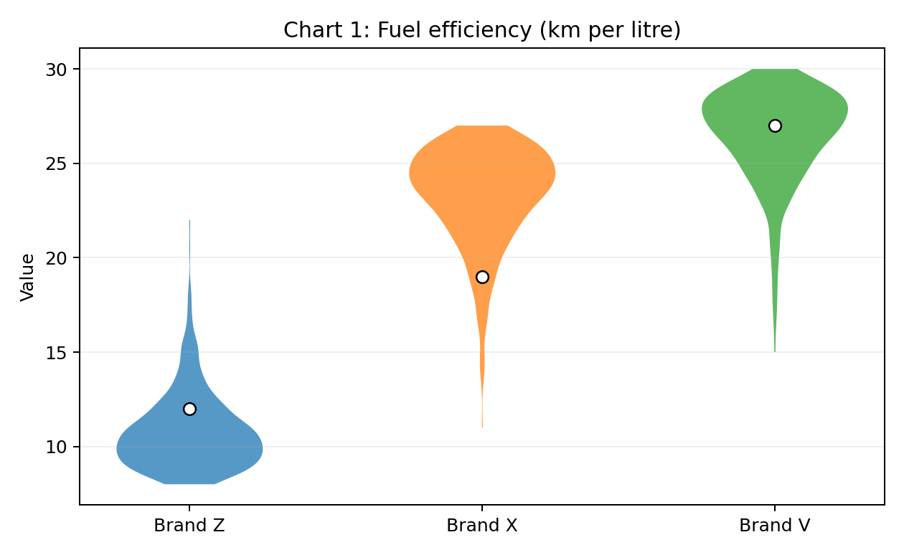

Chart 2: Order value (Rs hundred)
Violin | Skew (answer) | Mean vs Median (answer)
Store 1 | Symmetric | Mean ≈ Median
Store 4 | Left skew | Mean < Median
Store 2 | Right skew | Mean > Median
Interpretation: Store 1: Symmetric, so Mean ≈ Median.; Store 4: Left skew, so Mean < Median.; Store 2: Right skew, so Mean > Median.
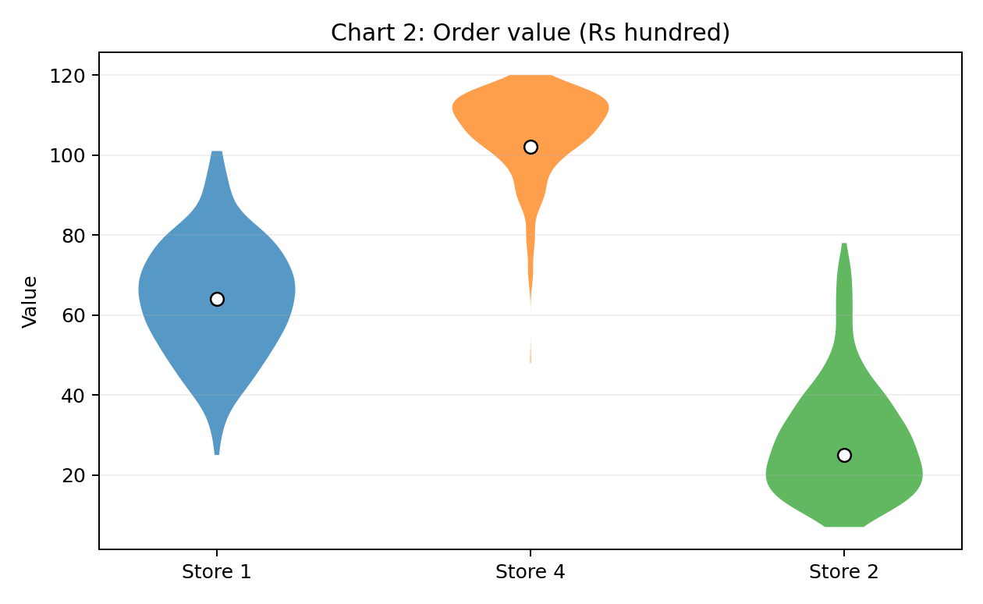

Chart 3: Monthly income (Rs thousand)
Violin | Skew (answer) | Mean vs Median (answer)
City | Left skew | Mean < Median
Metro | Symmetric | Mean ≈ Median
Town | Right skew | Mean > Median
Interpretation: City: Left skew, so Mean < Median.; Metro: Symmetric, so Mean ≈ Median.; Town: Right skew, so Mean > Median.
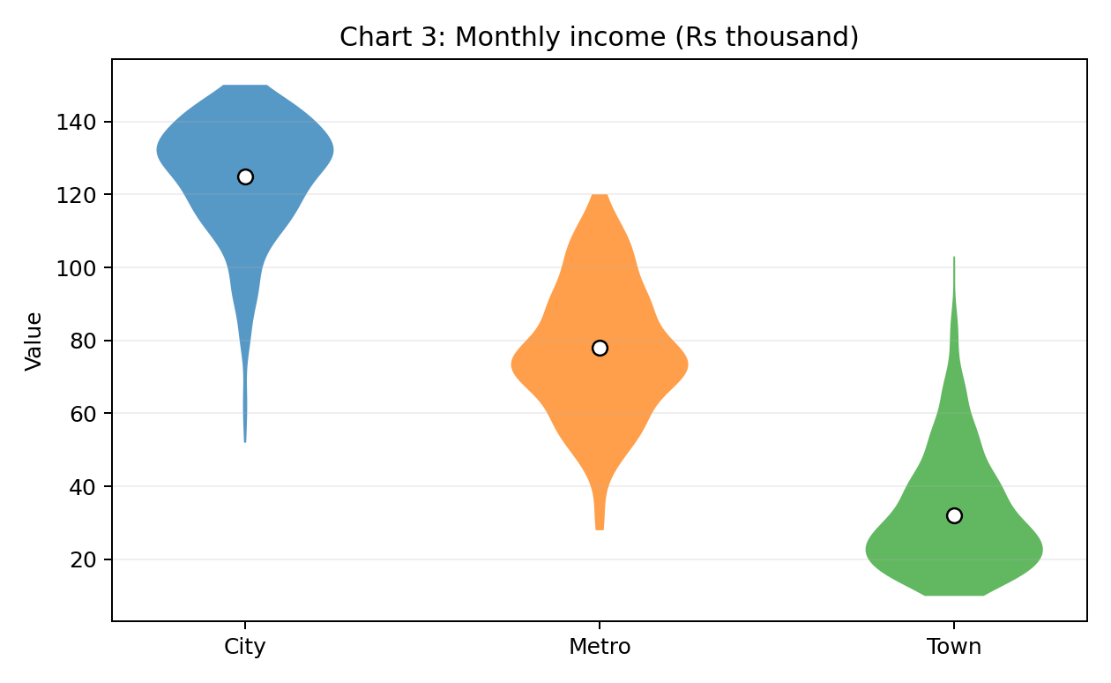

Chart 4: Waiting time (minutes)
Violin | Skew (answer) | Mean vs Median (answer)
Ward A | Left skew | Mean < Median
Ward E | Right skew | Mean > Median
Ward B | Symmetric | Mean ≈ Median
Interpretation: Ward A: Left skew, so Mean < Median.; Ward E: Right skew, so Mean > Median.; Ward B: Symmetric, so Mean ≈ Median.
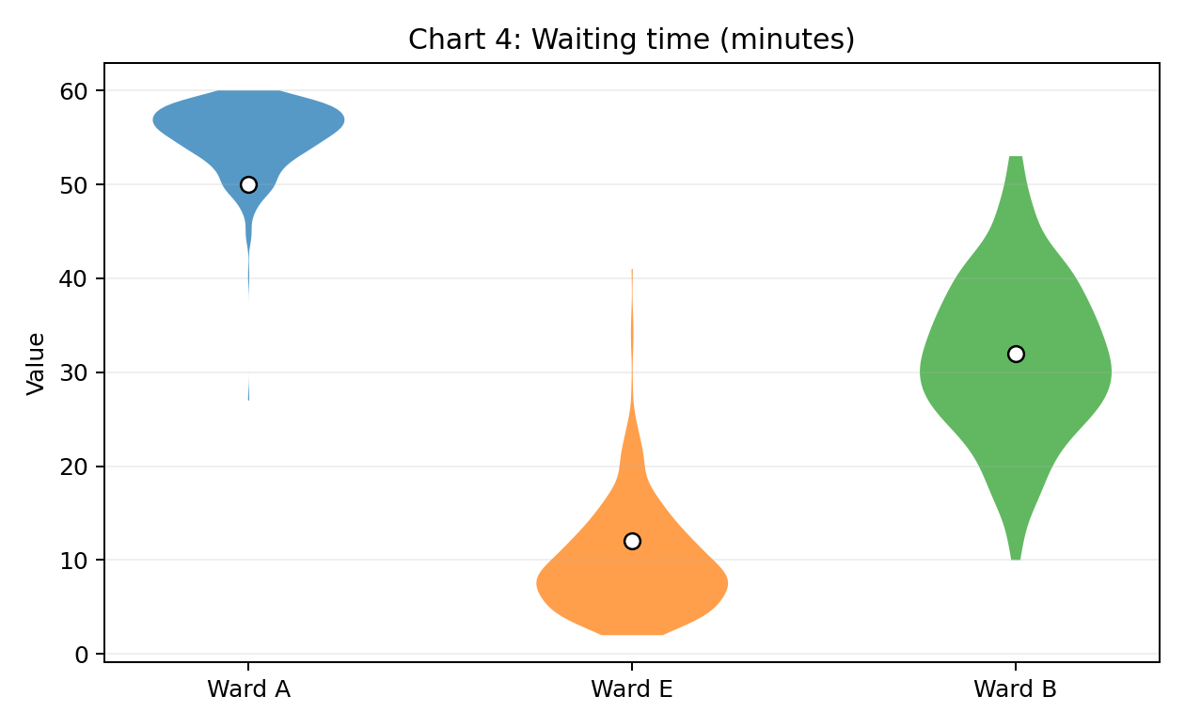

Part B (2 marks)
B1. In Chart 4, violin “Ward A” is not symmetric. Towards which side is its tail, and which is the better measure of a typical waiting time here: mean or median? Give one reason. [1]
Answer: Ward A has a tail toward the lower-value side (left-skewed). The median is the better measure of a typical waiting time because the long lower tail can pull the mean downward, making the mean less representative of the central waiting time.
B2. Write one ggplot2 line that draws violins of value for each group from a data frame df (columns group, value), with the median shown. [1]
Answer:
ggplot(df, aes(x = group, y = value)) + geom_violin() + stat_summary(fun = median, geom = "point", color = "white", size = 2.5)
This maps group to the x-axis and value to the y-axis, draws one violin per group, and overlays the median as a point.

Final Answer Summary
Group | Skew | Mean vs Median
Brand Z | Right skew | Mean > Median
Brand X | Left skew | Mean < Median
Brand V | Left skew | Mean < Median
Store 1 | Symmetric | Mean ≈ Median
Store 4 | Left skew | Mean < Median
Store 2 | Right skew | Mean > Median
City | Left skew | Mean < Median
Metro | Symmetric | Mean ≈ Median
Town | Right skew | Mean > Median
Ward A | Left skew | Mean < Median
Ward E | Right skew | Mean > Median
Ward B | Symmetric | Mean ≈ Median

