SIMATS ENGINEERING
SAVEETHA INSTITUTE OF MEDICAL AND TECHNICAL SCIENCES
NAME: J.Vivek
DATE:13/10/2026
LAB EXP: 19
Reg Mo: 192325149
Course Code/ Name: DSA0602 / Data Handling and Visualization
Set 19: Survey Responses Analysis
Dataset: Survey Responses
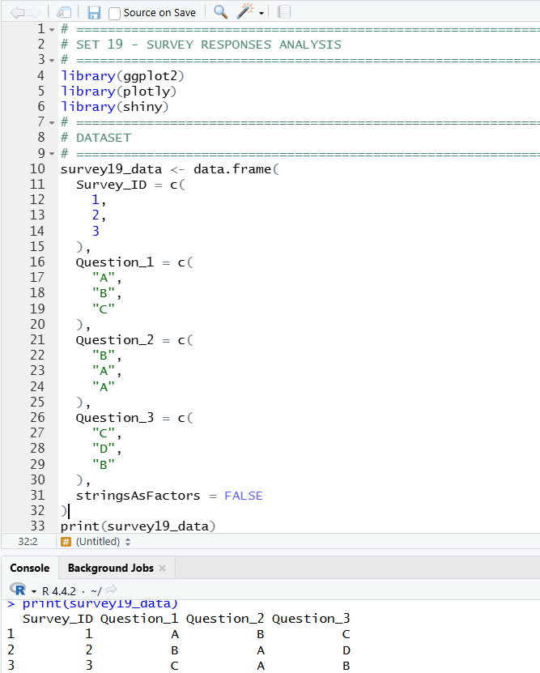
1. Create a grouped bar chart to visualize the distribution of answers for Question 1. Label the chart elements.
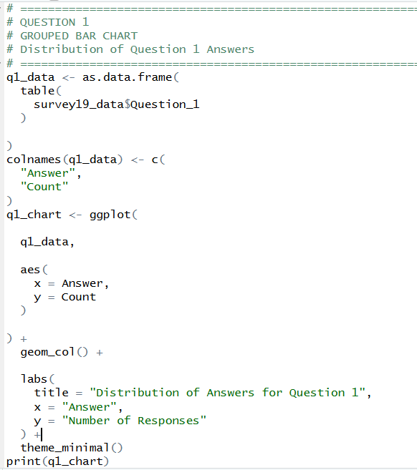
OUTPUT:
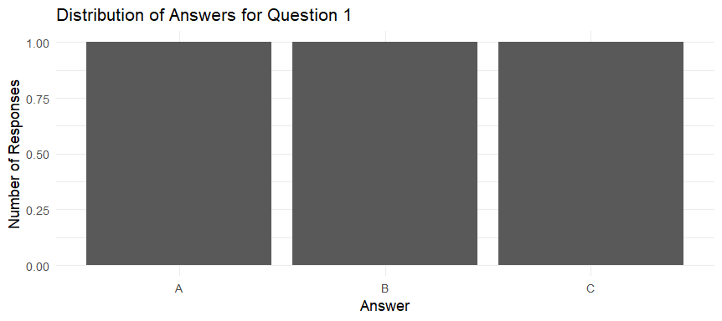

2. Generate a stacked bar chart to represent the overall distribution of responses for all three questions.
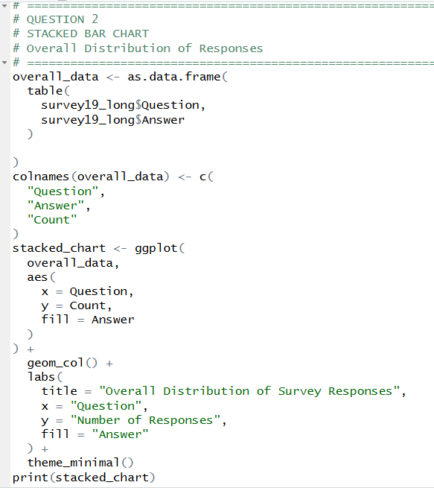
OUTPUT:
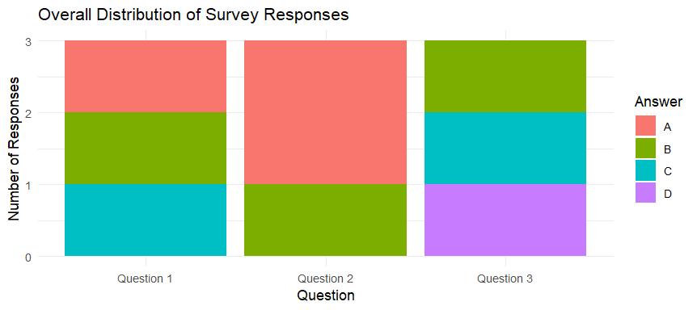

3. Build a table to show the survey response data for each survey. Label the table elements.
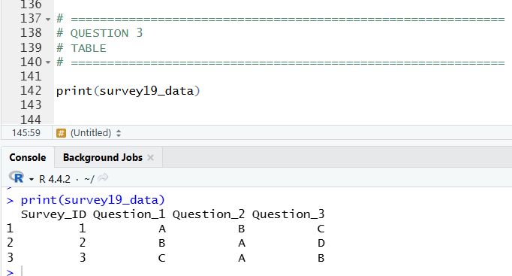

4. Develop a Tableau dashboard combining the grouped bar chart, stacked bar chart, and the table for interactive exploration of survey responses.
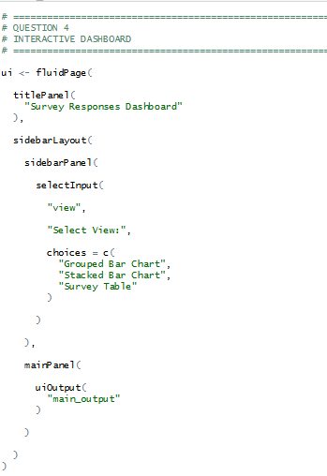
OUTPUT:
