SIMATS ENGINEERING
SAVEETHA INSTITUTE OF MEDICAL AND TECHNICAL SCIENCES
NAME: J.Vivek
DATE:13/10/2026
LAB EXP: 20
Reg Mo: 192325149
Course Code/ Name: DSA0602 / Data Handling and Visualization
Set 20: Stock Analysis
Dataset: Stock Prices
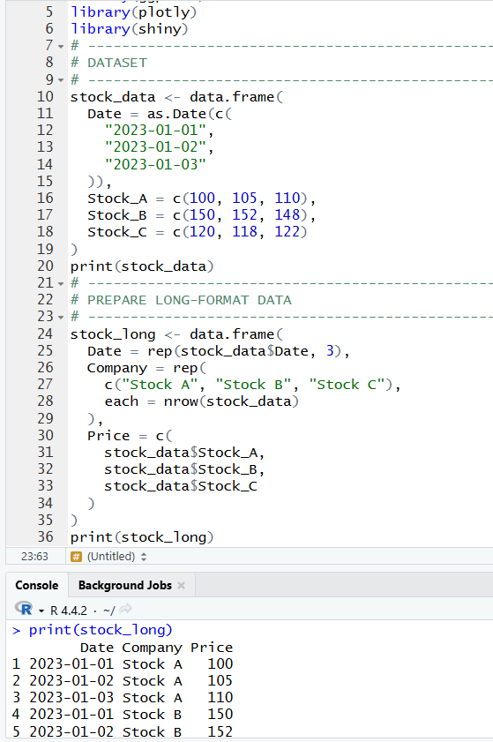
1. Create a line chart to visualize the stock prices of three companies (Stock A, Stock B, and Stock C) over a specific time period. Label the axes and title the chart.
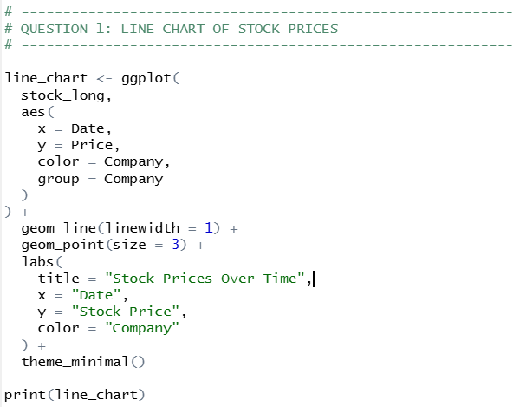
OUTPUT:
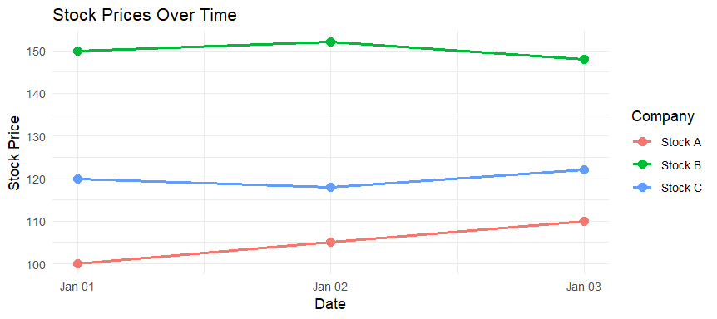

2. Generate a bar chart showing the daily percentage change in stock prices for Stock A. Label the chart elements.
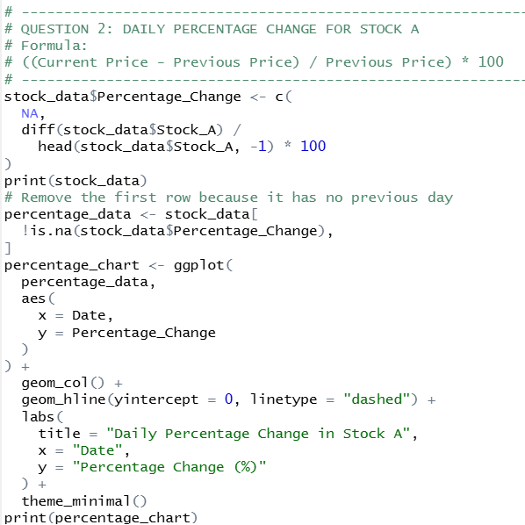
OUTPUT:
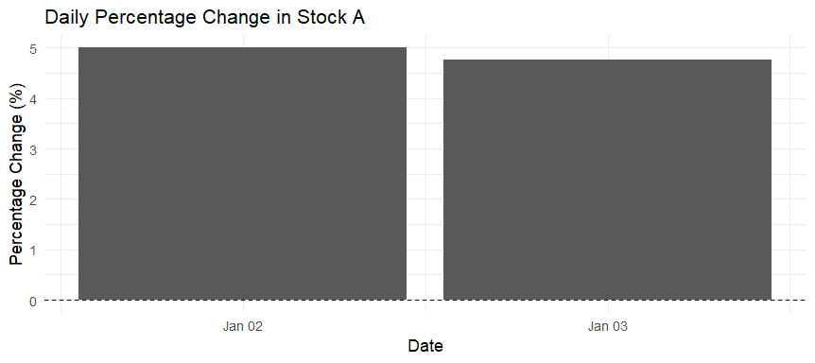

3. Build a table to display the stock price data for each company over the given period. Label the table elements.
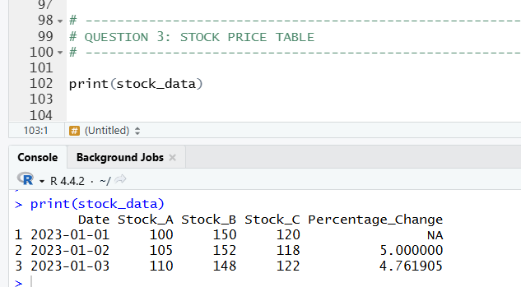

4. Develop a Tableau dashboard combining the line chart, bar chart, and the table for interactive exploration of stock prices.
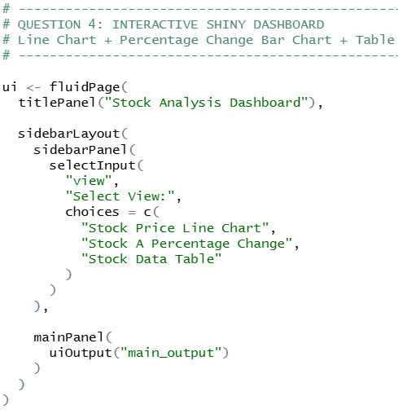
OUTPUT:
