SIMATS ENGINEERING
SAVEETHA INSTITUTE OF MEDICAL AND TECHNICAL SCIENCES
NAME: J.Vivek
DATE:15/10/2026
LAB EXP: 22
Reg Mo: 192325149
Course Code/ Name: DSA0602 / Data Handling and Visualization
Set 22: Time Series Analysis
Dataset: Monthly Sales Data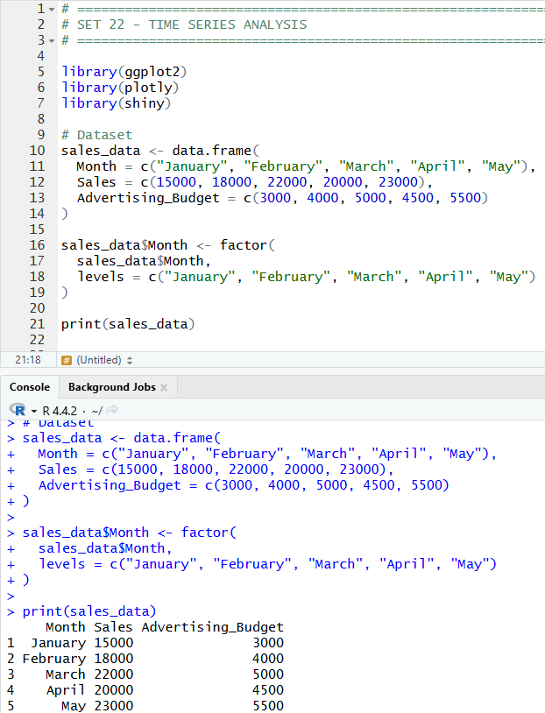
1. In R, create a time series line chart to visualize the trend in monthly sales. Label the axes and title the chart.
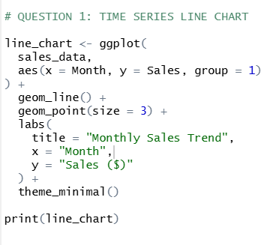
OUTPUT:
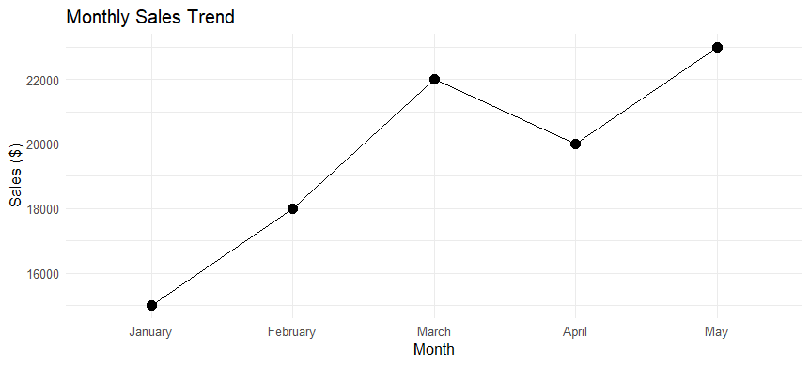

2. In R, generate a scatter plot to analyze the relationship between advertising budget and monthly sales. Explain any insights.
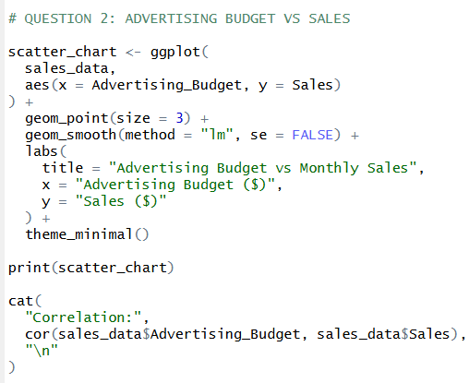
OUTPUT:
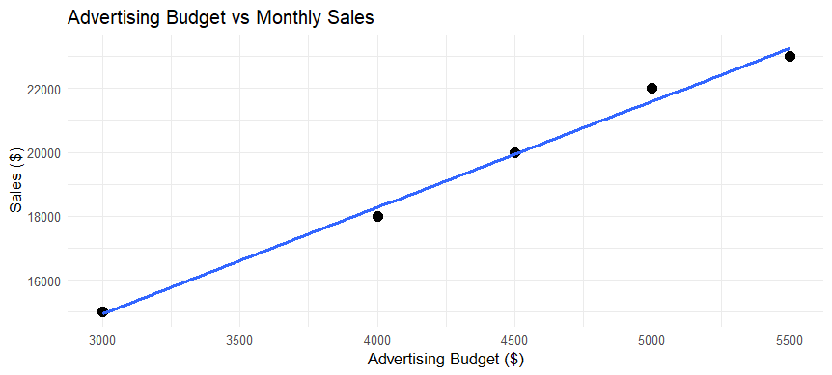

3. In Tableau, build a dashboard combining a line chart showing sales trend and a pie chart displaying the distribution of sales across products.
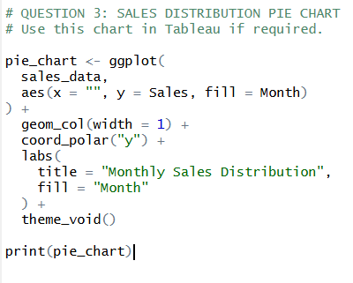
OUTPUT:
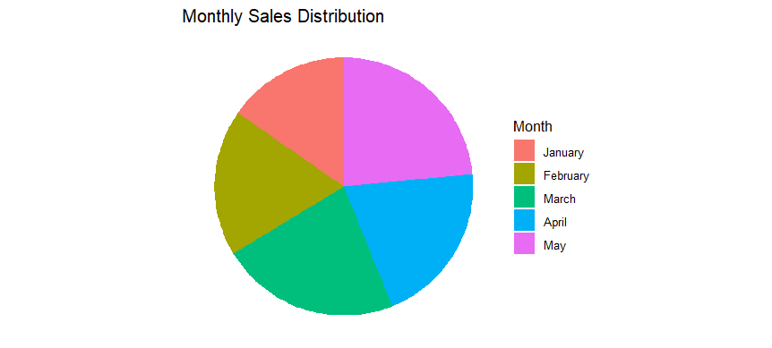

4. In R, create an autocorrelation plot to identify seasonality in the time series data.
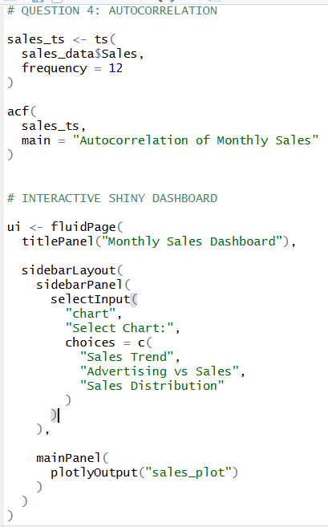
OUTPUT:
