SIMATS ENGINEERING
SAVEETHA INSTITUTE OF MEDICAL AND TECHNICAL SCIENCES
NAME: J.Vivek
DATE:15/10/2026
LAB EXP: 23
Reg Mo: 192325149
Course Code/ Name: DSA0602 / Data Handling and Visualization
Set 23: Employee Performance Analysis
Dataset: Employee Performance
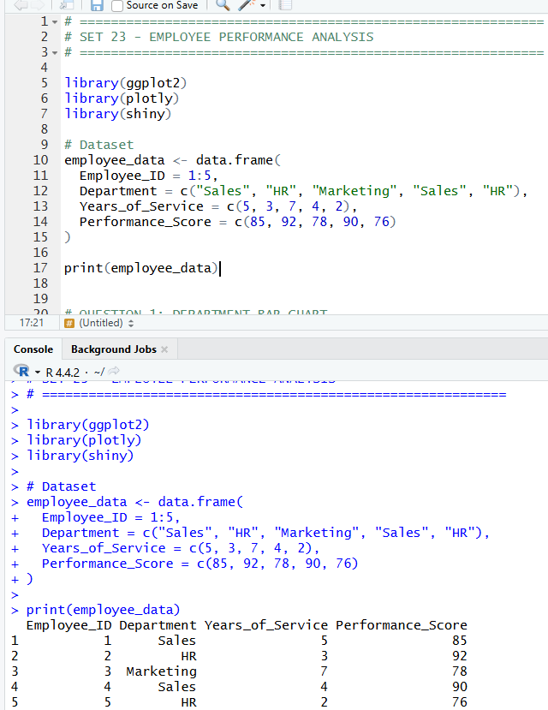
1. In R, create a bar chart to visualize the distribution of employees across different departments. Label the chart elements.
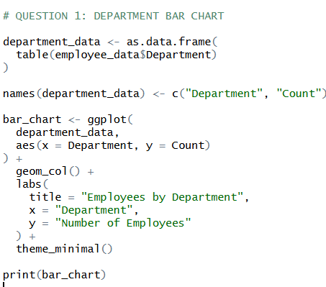
OUTPUT:
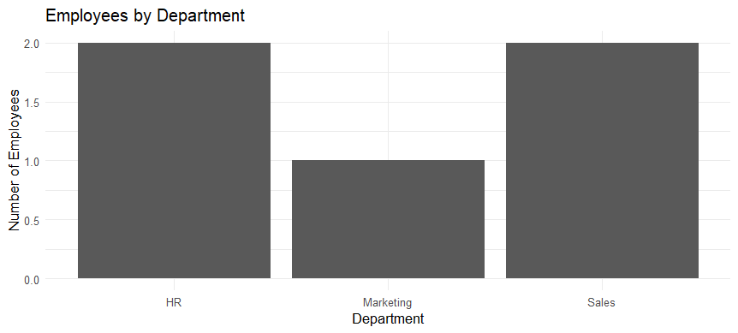

2. In R, generate a line chart to visualize the performance trend of employees over time. Label the axes and title the chart.
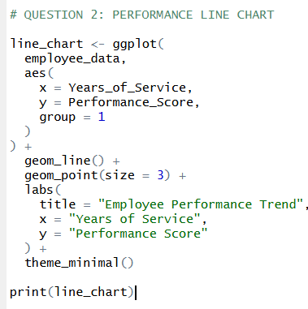
OUTPUT:
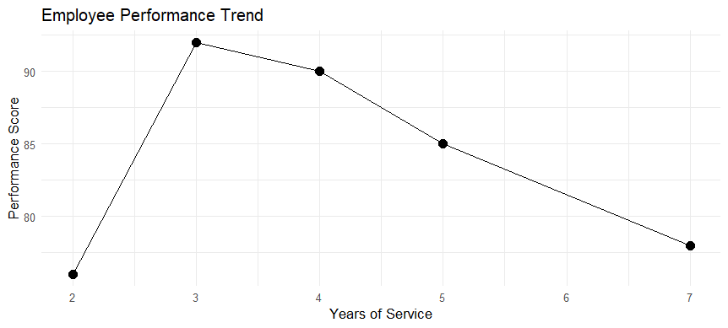

3. In Tableau, build a dashboard combining a bar chart showing department distribution and a scatter plot displaying the relationship between years of service and performance scores.
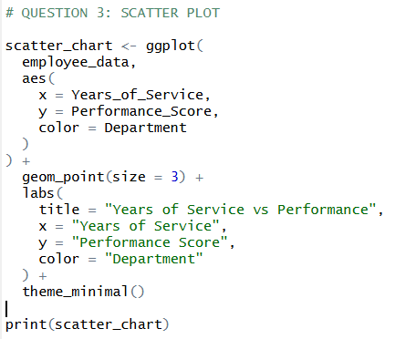
OUTPUT:
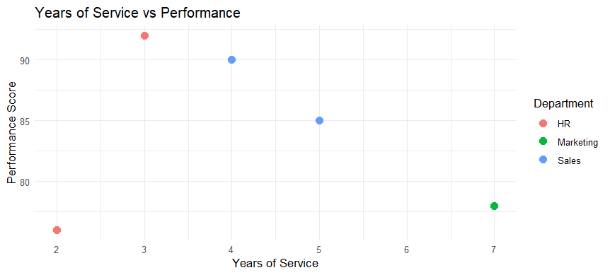

4. In R, develop a table showing the performance data for each employee. Label the table elements.
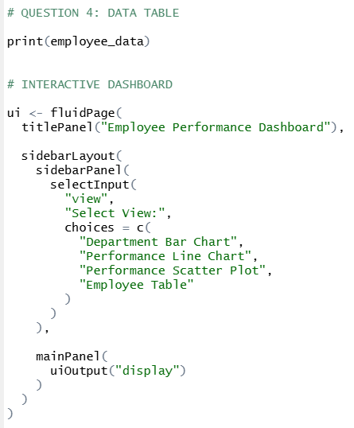
OUTPUT:
