Roll No- 14 Name- J.VIVEK
Reg No- 192325149 Activity-02

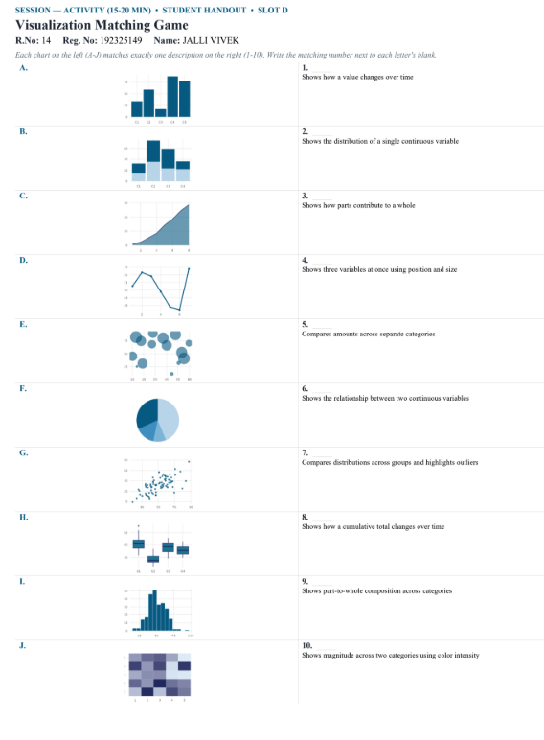

ANSWERS

Visualization Matching Game
Chart Matching number Description
A 5 Compares amounts across separate categories
B 9 Shows part-to-whole composition across categories
C 8 Shows how a cumulative total changes over time
D 1 Shows how a value changes over time
E 4 Shows three variables at once using position and size
F 3 Shows how parts contribute to a whole
G 6 Shows the relationship between two continuous variables
H 7 Compares distributions across groups and highlights outliers
I 2 Shows the distribution of a single continuous variable
J 10 Shows magnitude across two categories using color intensity

