UNITED STATES PATENT AND TRADEMARK OFFICE
PROVISIONAL PATENT APPLICATION — 35 U.S.C. § 111(b)
MACE — MULTI-DOMAIN ADAPTIVE CORRELATION ENGINE
Method and System for Probabilistic Asset Identity Reconciliation, Adaptive Cross-Domain Cybersecurity Correlation, and Automated Multi-Jurisdictional Regulatory Evidence Generation
DRAFT v3 (figures attached) — FOR REVIEW BY REGISTERED PATENT COUNSEL — June 2026
Field | Details
Inventor | Vivek Sindhu, United States of America
Applicant | UnifiedSec Technologies Inc., a Delaware Corporation
Application type | Provisional under 35 U.S.C. § 111(b)
Priority date | [DATE OF FILING — inserted by counsel]
Planned foreign filing | PCT within 12 months; EPO and GCC Patent Office national/regional phases via PCT
IPC (tentative) | G06F 21/55; G06F 21/57; H04L 9/40; H04L 41/00; G06N 20/00; G06F 21/60; H04L 63/14
CPC (tentative) | H04L 63/1416; H04L 63/20; G06F 21/552; G06N 20/00; G06F 21/577; H04L 63/1425
Reduction to practice | Working software implementation; full automated test suite passing as of June 2026
Classification | CONFIDENTIAL — Attorney-Client Privileged — Do Not Distribute

NOTES FOR COUNSEL — CHANGES FROM v1 (remove before filing)
1. Claims renumbered into a single consistent set of 30 with explicit dependencies; the v1 'addendum' claims are integrated. Hybrid and multiple dependencies removed (former Claims 6 and 22).
2. Former Claim 5 antecedent-basis defect fixed ('further comprising').
3. Marketing language ('first of its kind', 'no prior art', competitor capability counts) removed throughout; statements about the absence of prior art deleted per 37 C.F.R. § 1.56 considerations.
4. Framework count harmonized at fourteen (14) implemented frameworks; the framework library is described as extensible. (v1 used both 14 and 22.)
5. Saudi Arabia NCA ECC-1:2018 re-classified under GCC/Saudi Arabia — it is not a UAE framework (v1 error).
6. UREA state-machine trigger renamed breach_confirmed (v1: framework_identified → BREACH was semantically wrong).
7. Independent claims now lead with the technical effect (latency reduction, tamper-evident records, attested telemetry) to strengthen § 101 posture; please review claim 1 framing under Alice step two.
8. Filing posture harmonized: US provisional is the priority document. The v1/v2.1 investor-document statement that claims were already 'filed in PCT national-phase entries' (including India IN/2026/UNISEC/MACE-001) is inconsistent and procedurally impossible pre-PCT; please confirm true status of any India filing and any assignment needed.
9. Figures 1-12 are now ATTACHED as line drawings in Section 5 (v2 described them only).
10. 30 claims exceed the 20-claim base for the later non-provisional; select 3-4 independent claims deliberately and budget excess-claim fees.
11. New in v3: Definitions subsection (6.0) supporting claim construction; worked numerical example (6.2.1) supporting enablement; system claim 9 is now fully self-contained (no method-claim dependency).

ABSTRACT
A computer-implemented system unifies cybersecurity threat correlation and regulatory evidence generation. Asset observation records from heterogeneous sources are reconciled into a probabilistic, time-decaying asset graph using weighted identity matching with a hardware-identifier boost. Security events are scored by an explainable seven-domain weighted formula incorporating exploitation-probability data, kill-chain stage and blast-radius multipliers, and a per-asset confidence score, with weight coefficients adapted online from analyst feedback. Threshold crossings drive a deterministic finite automaton that generates tamper-evident regulatory evidence records, comprising an SHA-256 hash chain and pre-populated notification drafts, for a database of regulatory frameworks spanning multiple jurisdictions. Extensions include a single-pass cross-platform endpoint agent whose reports are signed by a hardware root of trust, federated adaptive learning with differential privacy, attack-path simulation over the asset graph, and a tool-using conversational interface with a safety allowlist.

1. FIELD OF THE INVENTION
The invention relates to cybersecurity intelligence platforms, and more specifically to: (a) probabilistic graph-based asset identity reconciliation across heterogeneous data sources; (b) real-time multi-domain adaptive threat correlation scoring; (c) kill-chain-aware threat prioritization using exploitation-probability data; (d) automated multi-jurisdictional regulatory compliance evidence generation; (e) unified endpoint scanning with hardware-rooted report attestation; and (f) privacy-preserving federated learning of correlation parameters.

2. BACKGROUND
Enterprise security operations typically span multiple disjoint platforms — asset inventory, endpoint detection, vulnerability management, log analytics, and compliance tooling — each emitting an independent alert stream with no shared asset identity model and no unified pre-alert scoring. Analysts manually reconcile these streams before an incident determination can be made, adding hours of latency during which attacker dwell time accumulates. Separately, breach-notification regimes in multiple jurisdictions impose deadlines as short as one hour; evidence assembly and notification drafting remain manual, error-prone, and unverifiable after the fact.
A preliminary search identified, among others: US 9,591,027 and US 10,021,140 (asset aggregation); US 10,523,713 (endpoint telemetry analysis); US 10,986,135 (vulnerability scan correlation); US 11,539,736 (cloud security posture); US 11,070,592 and US 2017/0230391 A1 (behavioral anomaly detection); and US 7,810,156 (SIEM correlation rules). The applicant's preliminary review did not locate a disclosure of the combination claimed herein; characterization of the art and any further search are deferred to counsel. No statement herein is intended as an admission regarding the scope or content of the prior art.

3. SUMMARY OF THE INVENTION
The invention provides a method and system comprising seven cooperating components. Components 1-3 form the core correlation-and-evidence pipeline; Components 4-7 extend the system to endpoint posture, attestation, federated learning, and conversational operation.

3.1 Component 1 — Universal Temporal Asset Graph (UTAG)
A probabilistic, time-decaying graph-based asset identity resolution engine that: (a) computes a weighted similarity score across hardware and network identity dimensions (MAC address, cloud instance identifier, TLS certificate fingerprint, hostname, serial number, IP address), applying a hardware-identifier boost factor (default 1.15) when a hardware-level identifier matches; (b) merges records meeting a configurable confidence threshold τ (default 0.38) into a canonical vertex with source-set union; (c) maintains a time-decaying Asset Confidence Score (ACS) per vertex via exponential decay over a configurable staleness window (default half-life 7 days), with ACS below a threshold (default 0.30) triggering shadow-IT classification; (d) detects physically impossible geo-velocity using Haversine geodesic distance against a configurable speed threshold (default 500 km/h); and (e) computes per-vertex graph entropy as a behavioral anomaly signal. The graph spans 11 asset classes with class-specific decay profiles and supports CVE lineage inheritance between cloned assets.

3.2 Component 2 — Cross-Domain Correlation Score (CDCS)
An explainable weighted scoring formula producing a unified threat priority score in [0, 10]:
CDCS = min(10.0, [α·V + β·E + γ·I + δ·N + ε·C + ζ·T + η·H] × 10 × Smult × Blast × KCmult × ACS)
where V, E, I, N, C, T, H are vulnerability, endpoint-event, identity, network, compliance-posture, threat-intelligence, and endpoint-posture sub-scores respectively; α…η are jurisdiction-specific weight coefficients normalized to sum to 1.0 with a per-weight floor; Smult is a sector multiplier (1.0-1.5); Blast = 1.0 + 0.1 × lateral hop count (capped at 1.5); KCmult is a MITRE ATT&CK kill-chain stage multiplier (1.0 reconnaissance to 1.5 exfiltration/impact); and ACS is the asset confidence score of Component 1. The vulnerability sub-score integrates CVSS v3, EPSS exploitation probability, exploit status, exposure, KEV listing, and SLA breach. Weights adapt online from analyst true-positive/false-positive feedback, bounded within ±20% of a jurisdiction baseline profile. The technical effect is a reduction of cross-tool triage latency from hours of manual reconciliation to sub-second scoring at event arrival, with a deterministic, auditable rationale for each score.

3.3 Component 3 — Universal Regulatory Evidence Automaton (UREA)
A deterministic finite automaton with states NOMINAL → MONITORING → INVESTIGATION → BREACH → REPORTED → CLOSED, driven by CDCS threshold crossings and incident lifecycle events (the BREACH transition trigger is breach_confirmed). On entering evidentiary states, the automaton: determines applicable frameworks from jurisdiction, sector, event type and data classification; generates framework-specific notification drafts with required fields pre-populated; assigns jurisdiction-specific reference numbers; and appends to a tamper-evident hash chain hashₙ = SHA256(incident_id ‖ cdcs ‖ timestamp ‖ hashₙ₋₁). Fourteen (14) frameworks are implemented at filing (table below); the framework library is a data-driven, extensible database, and the claims are not limited to the enumerated frameworks.
Jurisdiction | Framework | Deadline | Automated output
USA | FedRAMP SIR | 1 hour | Structured incident report
USA | HIPAA Breach Notification | 60 days | PHI breach notification
USA | PCI-DSS v4.0 | 24 hours | Cardholder data breach notice
USA | SEC Cyber Disclosure (8-K) | 4 business days | Material incident disclosure draft
USA | SOC 2 Type II | Per engagement | Auditor evidence package
USA | CMMC Level 2/3 | 72 hours | CUI incident report
USA | CISA KEV remediation | Per directive | Remediation status report
EU | GDPR Articles 33/34 | 72 hours | DPA notification + data-subject draft
EU | NIS2 Directive | 24h early warning / 72h | Entity incident notification
EU | DORA | 4h from classification | ICT incident report
UAE | NESA IAS | Immediate | Critical-infrastructure notification
UAE | aeCERT | Immediate | National CERT notification + reference
UAE | DIFC DPL 2020 | 72 hours | DIFC data-breach notification
KSA/GCC | NCA ECC-1:2018 | Immediate | Essential Cybersecurity Controls breach report (GCC expansion)

3.4 Component 4 — Unified MACE Endpoint Agent (UMEA)
A cross-platform agent (Windows, macOS, Linux, Android, iOS) that performs in a single scan pass: hardware asset inventory; software asset inventory; STIG/CIS compliance probes; local CVE matching against a daily-refreshed cache of NVD, CISA KEV, and FIRST.org EPSS data; malware indicators; hackable-configuration heuristics; intrusion detection (on-device and on-LAN); EDR-class behavioral rules (LSASS access, encoded PowerShell, Office-to-shell trees, beacon patterns, WMI persistence) via ETW / Endpoint Security framework / eBPF; DLP pattern detection; CycloneDX 1.5 SBOM generation with typo-squat and malicious-package cross-reference; honeytoken deception; and read-only nightly privilege-escalation probes. All outputs are emitted as one canonical signed report bundle consumed by Components 1 and 2.

3.5 Component 5 — Hardware-Rooted Report Attestation
Each agent report is signed by a key bound to the device hardware root of trust (Apple Secure Enclave; TPM 2.0 via Platform Crypto Provider or tpm2-tools; Android Strongbox), with a key_source field distinguishing hardware-backed from software-fallback signing, so that a compromised agent cannot misrepresent its own state, and providing the cryptographic foundation of the Component 3 chain of custody.

3.6 Component 6 — Federated Adaptive-Correlation Learning
Each customer engine computes a local CDCS weight gradient from feedback batches, adds Gaussian differential-privacy noise of configurable sigma, and transmits only the noisy gradient to an aggregator, which broadcasts a customer-size-weighted mean blended locally by a configurable trust factor. Raw events, asset identifiers, IP addresses and hostnames never leave the customer environment.

3.7 Component 7 — Tool-Using Conversational Interface
A conversational agent exposing the system through structured tools (scan_device, get_report, lookup_cve, run_playbook, search_logs, explain_finding, provision_cloud), with back-end selection between remote LLM providers and a deterministic rule-based fallback for air-gapped operation, and a safety layer gating destructive actions by allowlist and priority-score threshold.

3.8 Auxiliary methods
(i) Attack-path simulation over the asset graph with EPSS-weighted edges, producing MITRE ATT&CK-annotated step-by-step paths to designated crown-jewel assets with per-step preventive controls. (ii) Post-quantum readiness inventory of cryptographic primitives with FIPS 203/204/205 successor recommendations on CNSA 2.0 timelines. (iii) Streaming voice-authenticity scoring from spectral and prosodic features computed in one-second windows without retaining or transmitting audio. (iv) Cross-asset incident replay via an append-only event ledger with periodic snapshots enabling state reconstruction at arbitrary timestamps. (v) Auto-remediation in which commands execute only when matching a safe-verb allowlist AND meeting a priority threshold AND (analyst approval OR autonomous mode for the class), with full audit logging.

4. CLAIMS
What is claimed is:

Family A — Correlation and regulatory evidence (Claims 1-12)
Claim 1. A computer-implemented method for unified cybersecurity threat correlation and regulatory evidence generation, the method reducing cross-tool incident triage latency and producing tamper-evident compliance records, comprising:
(a) receiving, by a computing system, asset observation records from two or more heterogeneous cybersecurity data sources, each record comprising one or more identity attributes selected from: hardware MAC address, cloud instance identifier, TLS certificate fingerprint, hostname, serial number, and IP address;
(b) computing, for pairs of asset observation records, a weighted similarity score as a linear combination of identity-attribute match indicators, wherein a match on a hardware-level identifier applies a boost factor of at least 1.10;
(c) merging records whose similarity score meets a configurable threshold into a canonical asset vertex of a temporal asset graph, and maintaining for each vertex a time-decaying Asset Confidence Score;
(d) computing, for a security event associated with an asset vertex, a Cross-Domain Correlation Score comprising a normalized linear combination of at least six domain sub-scores — vulnerability, endpoint, identity, network, compliance, and threat intelligence — multiplied by a sector multiplier, a blast-radius multiplier, a kill-chain stage multiplier, and the Asset Confidence Score, bounded to a fixed range; and
(e) responsive to the Cross-Domain Correlation Score crossing a configurable threshold, transitioning a deterministic finite automaton toward a breach state and generating a regulatory evidence record comprising a tamper-evident SHA-256 chain-of-custody hash computed over the incident identifier, the score, a timestamp, and the preceding hash; a pre-populated regulatory notification draft; and a jurisdiction-specific incident reference number.
Claim 2. The method of claim 1, wherein the kill-chain stage multiplier corresponds to a MITRE ATT&CK phase and ranges from 1.0 for reconnaissance to 1.5 for exfiltration or impact.
Claim 3. The method of claim 1, further comprising updating weight coefficients of the linear combination by online learning from analyst true-positive or false-positive feedback, bounded within a maximum deviation from a jurisdiction-specific baseline profile.
Claim 4. The method of claim 1, wherein maintaining the Asset Confidence Score comprises applying exponential temporal decay over a configurable staleness window, and classifying vertices whose score falls below a threshold as unauthorized (shadow IT) assets.
Claim 5. The method of claim 1, further comprising detecting a geo-velocity anomaly by computing the Haversine geodesic distance between successive observations of an asset and flagging observations implying travel speed exceeding a configurable threshold.
Claim 6. The method of claim 1, wherein the blast-radius multiplier equals 1.0 plus a configurable coefficient times a lateral hop count of observed network propagation from an initially compromised asset, bounded at a maximum value.
Claim 7. The method of claim 1, wherein the linear combination further comprises a seventh, endpoint-posture sub-score computed from a signed report bundle of an endpoint agent, the sub-score being a weighted combination of hardware-exposure, software-staleness, configuration-compliance, malware-indicator, hackable-configuration, and intrusion-pressure signals.
Claim 8. The method of claim 3, further comprising transmitting a locally computed weight gradient to a central aggregator only after addition of Gaussian differential-privacy noise, and blending a customer-size-weighted aggregate gradient received from the aggregator into local weights according to a configurable trust factor, wherein raw events and asset identifiers are not transmitted.
Claim 9. A system for unified cybersecurity threat correlation and regulatory evidence generation, comprising: at least one processor; a regulatory framework database comprising at least fourteen regulatory frameworks across at least three jurisdictions, each framework record comprising a notification deadline, required notification fields, and a draft template; and a non-transitory computer-readable medium storing instructions that, when executed by the at least one processor, cause the system to: receive asset observation records from two or more heterogeneous cybersecurity data sources; compute, for pairs of the records, a weighted similarity score over identity attributes wherein a hardware-level identifier match applies a boost factor of at least 1.10; merge records whose similarity score meets a configurable threshold into a canonical vertex of a temporal asset graph and maintain a time-decaying asset confidence score per vertex; compute, for a security event associated with a vertex, a cross-domain correlation score comprising a normalized linear combination of at least six domain sub-scores multiplied by a sector multiplier, a blast-radius multiplier, a kill-chain stage multiplier, and the asset confidence score; and, responsive to the correlation score crossing a configurable threshold, transition a deterministic finite automaton toward a breach state and generate, using a framework record selected from the regulatory framework database, a regulatory evidence record comprising a tamper-evident SHA-256 chain-of-custody hash, a pre-populated notification draft, and a jurisdiction-specific incident reference number.
Claim 10. The system of claim 9, wherein the regulatory framework database comprises United States frameworks selected from: FedRAMP incident reporting, HIPAA breach notification, PCI-DSS, SEC cybersecurity disclosure, CMMC incident reporting, SOC 2 evidence packaging, and CISA Known Exploited Vulnerabilities remediation reporting.
Claim 11. The system of claim 9, wherein the regulatory framework database comprises European Union frameworks selected from: GDPR Articles 33 and 34, the NIS2 Directive, and DORA.
Claim 12. The system of claim 9, wherein the regulatory framework database comprises Middle East frameworks selected from: UAE NESA Information Assurance Standards, UAE aeCERT notification, DIFC Data Protection Law 2020, and Saudi Arabia NCA Essential Cybersecurity Controls.

Family B — Unified endpoint agent (Claims 13-22)
Claim 13. A computer-implemented method for unified endpoint security scanning, comprising: collecting, in a single scan pass on a host computer by a software agent, (a) a hardware asset inventory comprising at least one of CPU specification, memory size, storage devices, network interfaces, firmware revision, secure-boot state, and disk-encryption state; (b) a software asset inventory comprising at least operating-system version, patch level, installed applications, listening ports, and kernel modules; (c) configuration-compliance findings produced by a curated cross-platform probe set; and (d) vulnerability findings produced by correlating the software asset inventory against a vulnerability database; and emitting the result sets as a single canonical bundle to an ingest endpoint.
Claim 14. The method of claim 13, further comprising signing the canonical bundle with a key bound to a hardware root of trust selected from: a Secure Enclave processor, a TPM 2.0 device, an Android Strongbox-backed keystore, and a platform cryptographic provider, the bundle further comprising a field distinguishing hardware-backed from software-fallback signing.
Claim 15. The method of claim 13, further comprising monitoring operating-system event streams and triggering an incremental rescan when an event of type process-execution, file change, login, installation attempt, or policy change is observed within a configurable debounce window.
Claim 16. The method of claim 13, wherein correlating against the vulnerability database comprises consulting a local cache refreshed from a national vulnerability database and annotated with exploitation-probability scores and known-exploited flags from at least two external feeds.
Claim 17. The method of claim 13, further comprising producing a prioritized remediation plan in which each finding is assigned a priority score computed as a weighted combination of severity score, exploitation probability, exploit status, and patch availability, and in which findings sharing a single remediation command are bundled into one action.
Claim 18. The method of claim 17, further comprising executing a remediation command if and only if (a) the command matches a configurable allowlist of safe-verb patterns, (b) the priority score meets a configurable threshold, and (c) explicit analyst approval has been given or the system operates in an autonomous mode for the finding class; and appending the executed command, exit code, and outputs to a tamper-evident audit log.
Claim 19. The method of claim 13, further comprising evaluating behavioral detection rules over the host process tree, the rules comprising detection of at least one of: access to a security-authority subsystem process from a non-system parent, an encoded shell command exceeding a length threshold, an office-application process spawning a shell-class child, and a command line matching a known command-and-control beacon pattern.
Claim 20. The method of claim 13, further comprising placing honeytoken files containing inert decoy credentials at attacker-targeted paths on the host and alerting when any honeytoken's access time, content hash, or existence deviates from a baseline recorded at placement.
Claim 21. The method of claim 13, further comprising generating a software bill of materials from the software inventory and detecting supply-chain indicators comprising at least one of: a package name within an edit-distance threshold of a popular package, a package appearing on a malicious-package list, and an exact match to a known compromised package-version pair.
Claim 22. A system comprising agents performing the method of claim 13 deployed on two or more of: a Microsoft Windows computer, an Apple macOS computer, a Linux computer, an Android device, and an iOS device, wherein each agent emits the canonical bundle to a common ingest endpoint for consumption by a temporal asset graph and a cross-domain correlation engine.

Family C — Auxiliary methods and systems (Claims 23-30)
Claim 23. A method for cybersecurity attack-path simulation, comprising: receiving vertices and edges of a temporal asset graph of an enterprise environment; designating at least one vertex as a protected asset; receiving a hypothetical initial compromise comprising an asset identifier and a vulnerability identifier; computing a graph search over exploitability-weighted edges, the weights derived from exploitation-probability scores; and producing a step-by-step path annotated with adversarial-technique identifiers, estimated per-step dwell time, and preventive controls.
Claim 24. A method for post-quantum readiness assessment, comprising: inventorying cryptographic primitives in use on a host, including at least TLS handshakes, SSH keys, and code-signing certificates; identifying primitives using quantum-vulnerable algorithms; and producing per-primitive successor recommendations and migration deadlines derived from published government migration timelines.
Claim 25. A method for streaming voice-authenticity scoring, comprising: computing, in fixed-length windows over a live audio stream, features comprising variance of the second derivative of a log-mel energy envelope, a pitch micro-variation measure, and inter-phoneme gap entropy; producing a per-window authenticity score; and discarding audio samples after feature computation such that audio is neither persisted nor transmitted.
Claim 26. A method for cross-asset incident replay, comprising: recording an append-only ledger of process, network, identity, and file events for each asset associated with an incident; writing periodic full-state snapshots; and reconstructing the state of every such asset at an arbitrary timestamp by loading the nearest preceding snapshot and replaying subsequent ledger events.
Claim 27. A system for identity threat detection comprising at least one identity-provider connector and a detector producing a finding upon at least one of: a threshold number of multi-factor authentication challenges to one account within a time window, successive logins implying geo-velocity above a threshold, grant of offline access to a third-party application, and privileged-role assignment outside configured hours.
Claim 28. A system for endpoint software-defined segmentation comprising a local DNS resolver that answers queries for blocklisted domains with a non-routable address and forwards other queries upstream, the blocklist refreshed from at least one threat-intelligence feed.
Claim 29. A system operating a tool-using conversational interface for security operations, comprising structured tools including at least device scanning, report retrieval, vulnerability lookup, and playbook execution; back-end selection logic preferring a remote language-model provider when credentials are present and otherwise falling back to a deterministic rule-based responder; and a safety layer requiring any destructive action to satisfy an allowlist and a priority-score threshold before invocation.
Claim 30. The method of claim 1, further comprising presenting, for each Cross-Domain Correlation Score, a decomposition of the score into its domain sub-scores and multipliers, whereby each alert is accompanied by a deterministic, human-auditable rationale.

5. DRAWINGS
The following twelve figures form part of this disclosure. Reference numerals in the drawings identify the corresponding elements described in Sections 3 and 6.
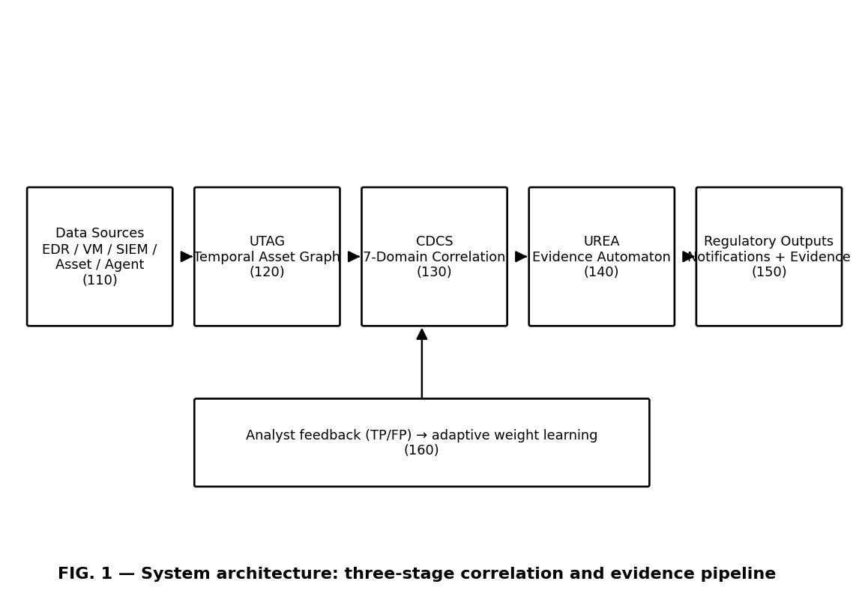
FIG. 1 — System architecture: three-stage correlation and evidence pipeline
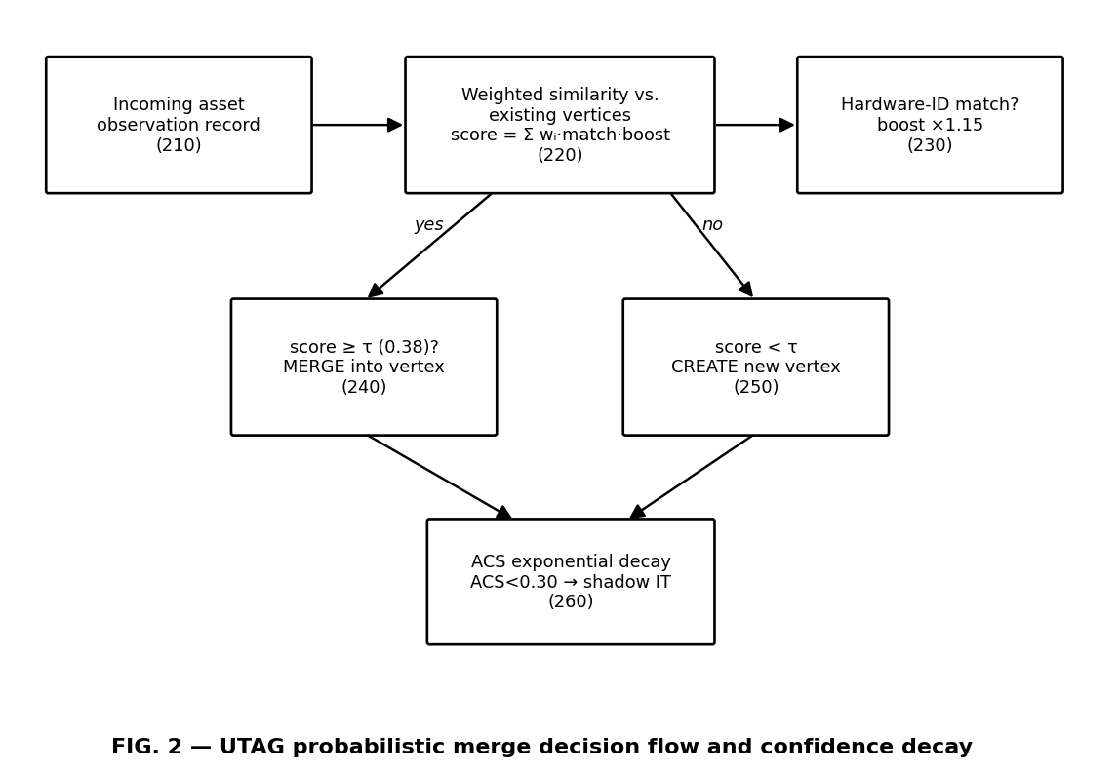
FIG. 2 — UTAG probabilistic merge decision flow and confidence decay
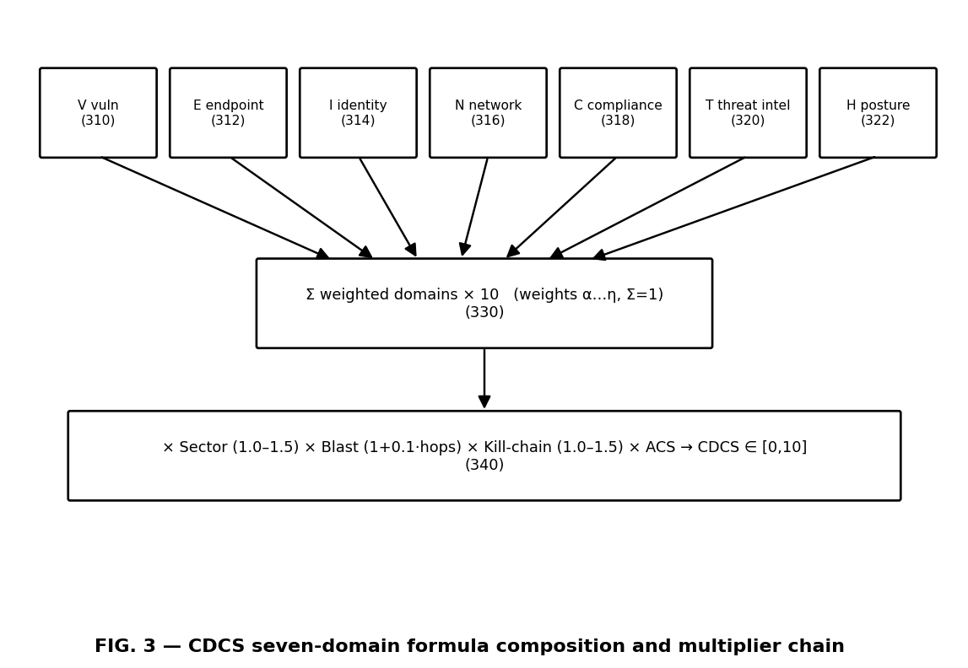
FIG. 3 — CDCS seven-domain formula composition and multiplier chain
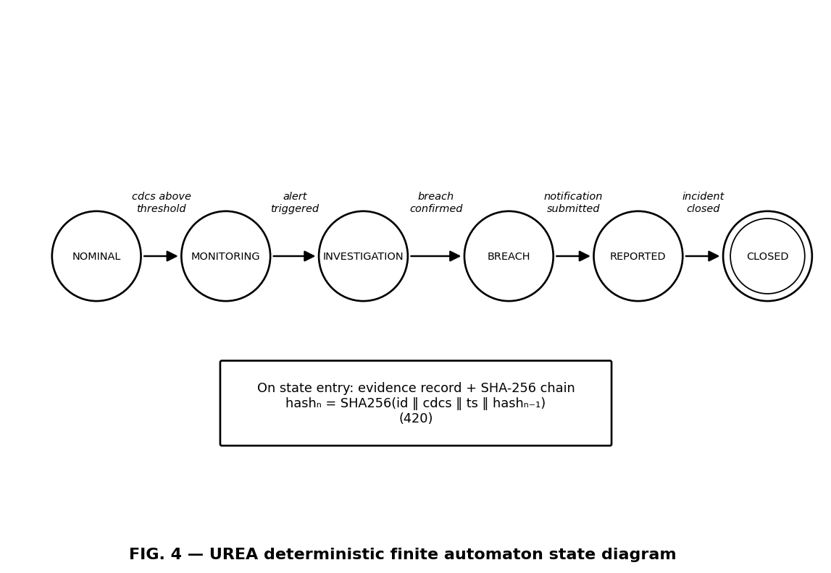
FIG. 4 — UREA deterministic finite automaton state diagram
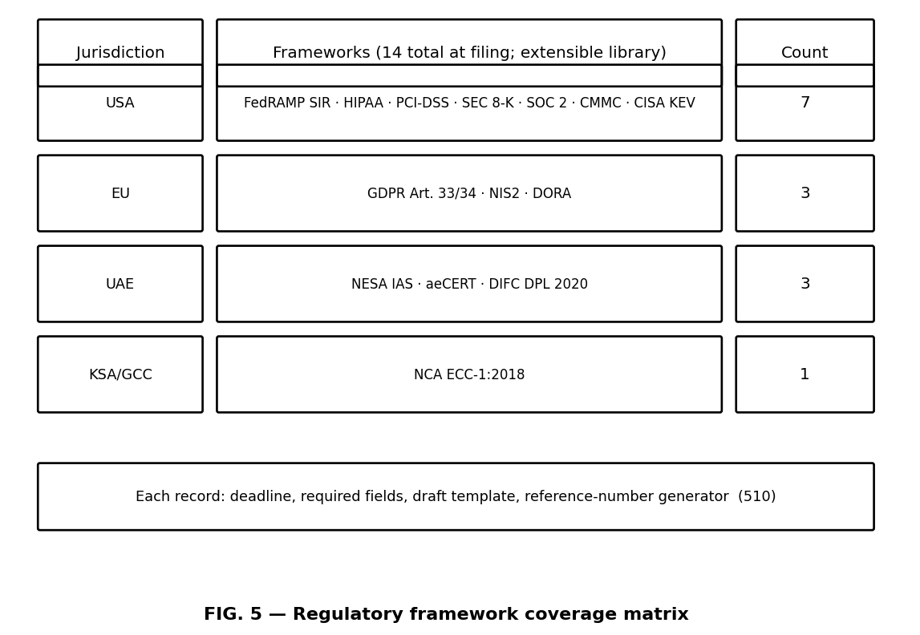
FIG. 5 — Regulatory framework coverage matrix
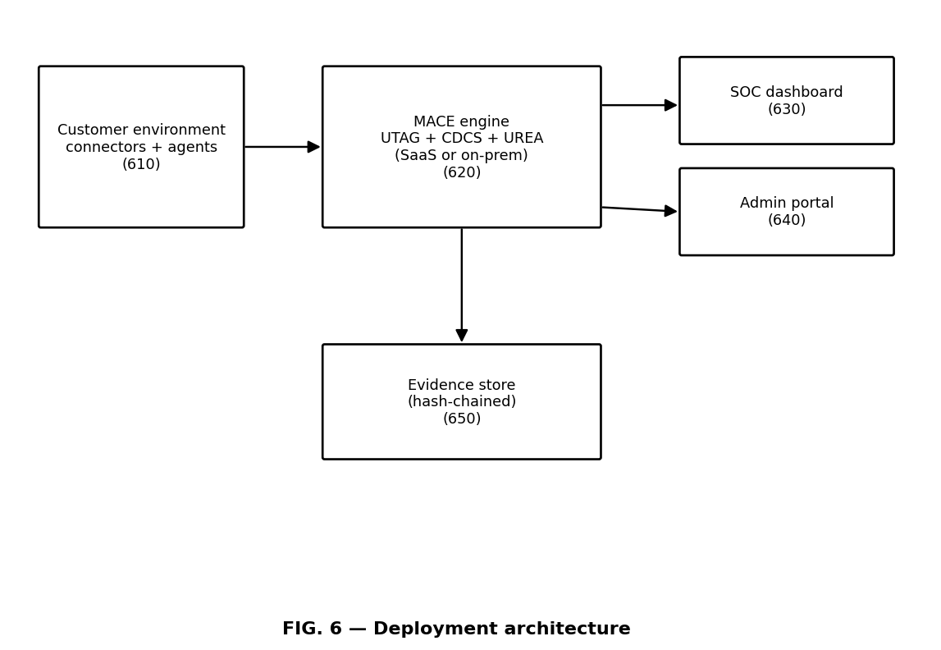
FIG. 6 — Deployment architecture
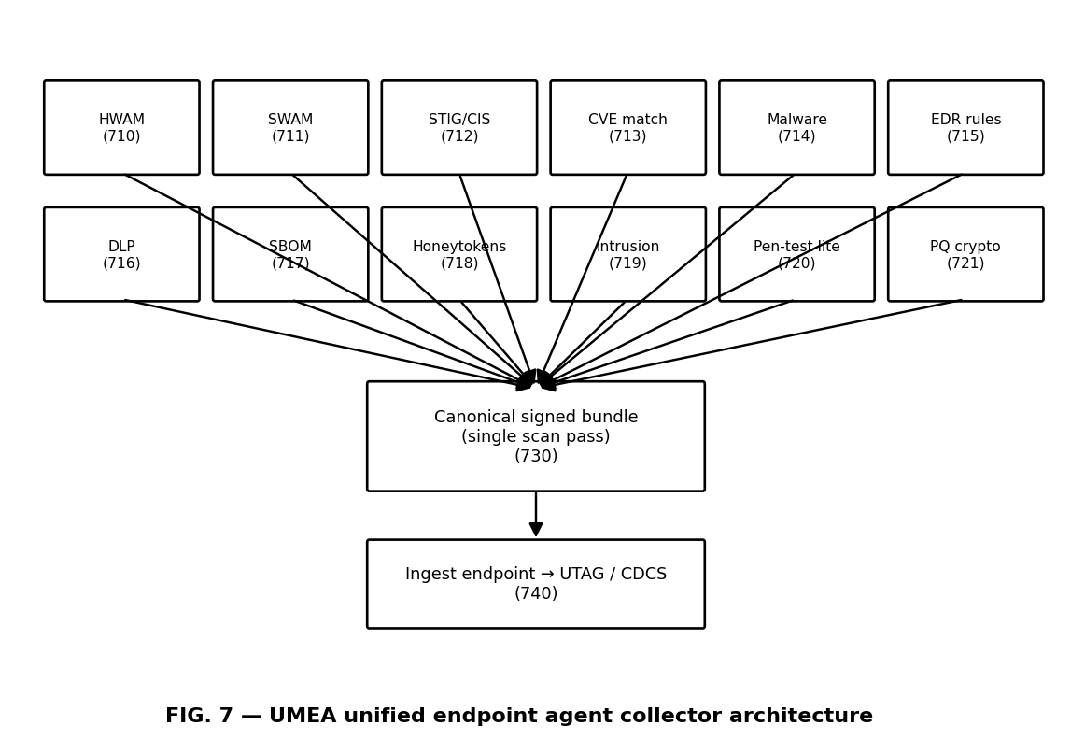
FIG. 7 — UMEA unified endpoint agent collector architecture
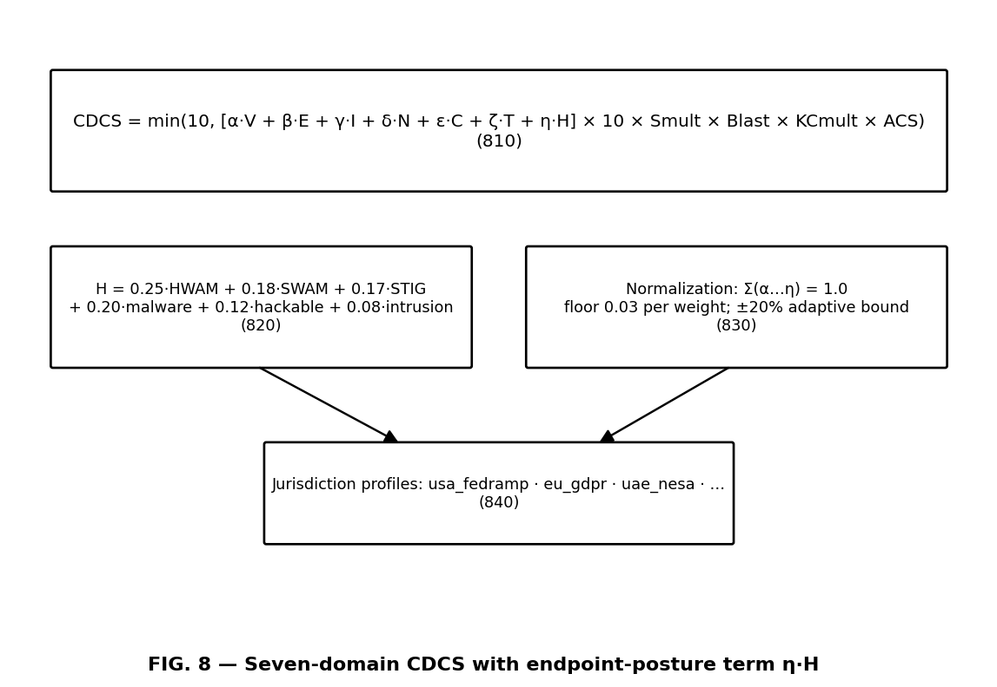
FIG. 8 — Seven-domain CDCS with endpoint-posture term η·H
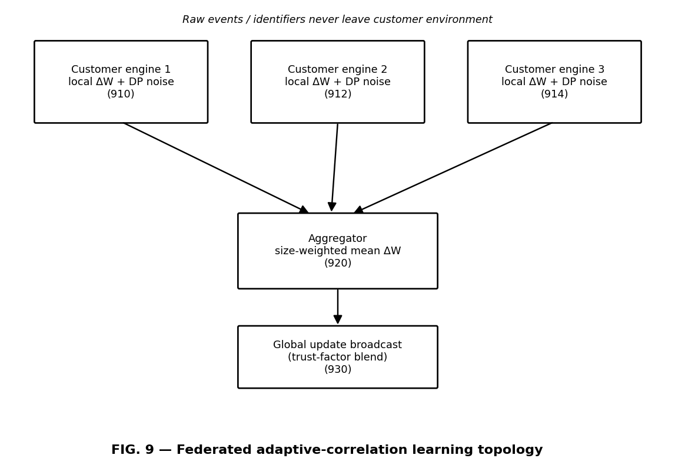
FIG. 9 — Federated adaptive-correlation learning topology
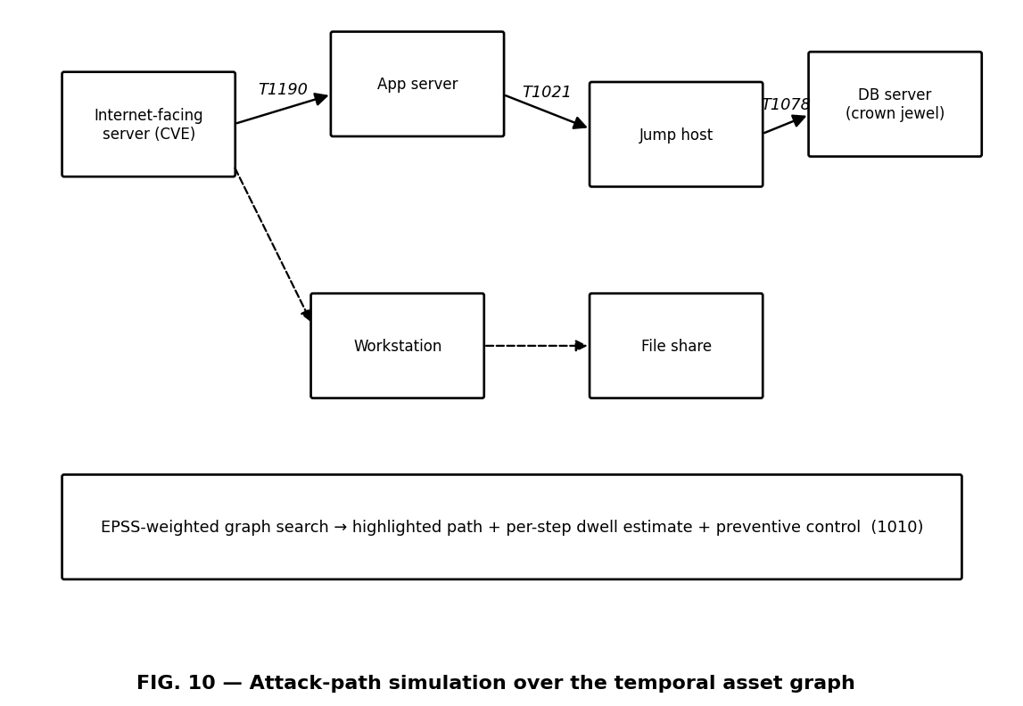
FIG. 10 — Attack-path simulation over the temporal asset graph
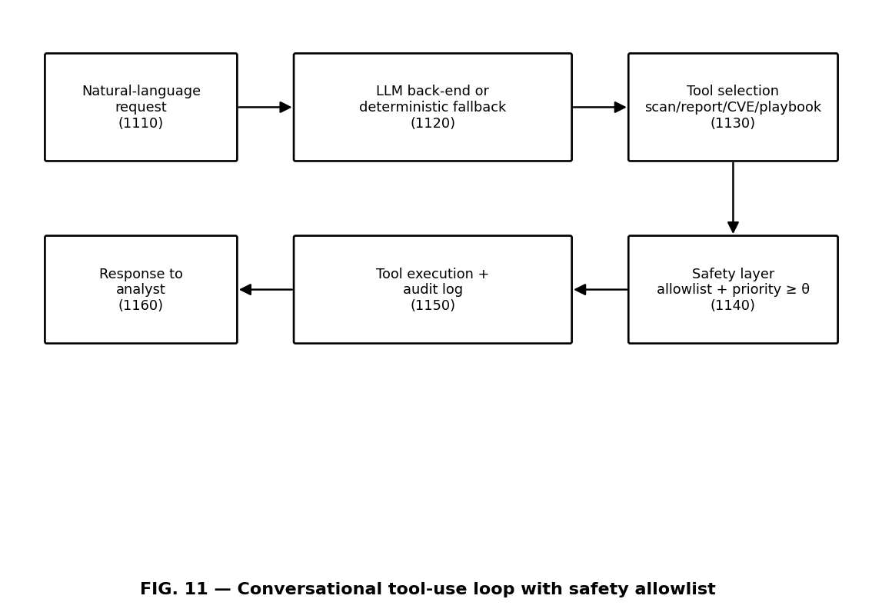
FIG. 11 — Conversational tool-use loop with safety allowlist
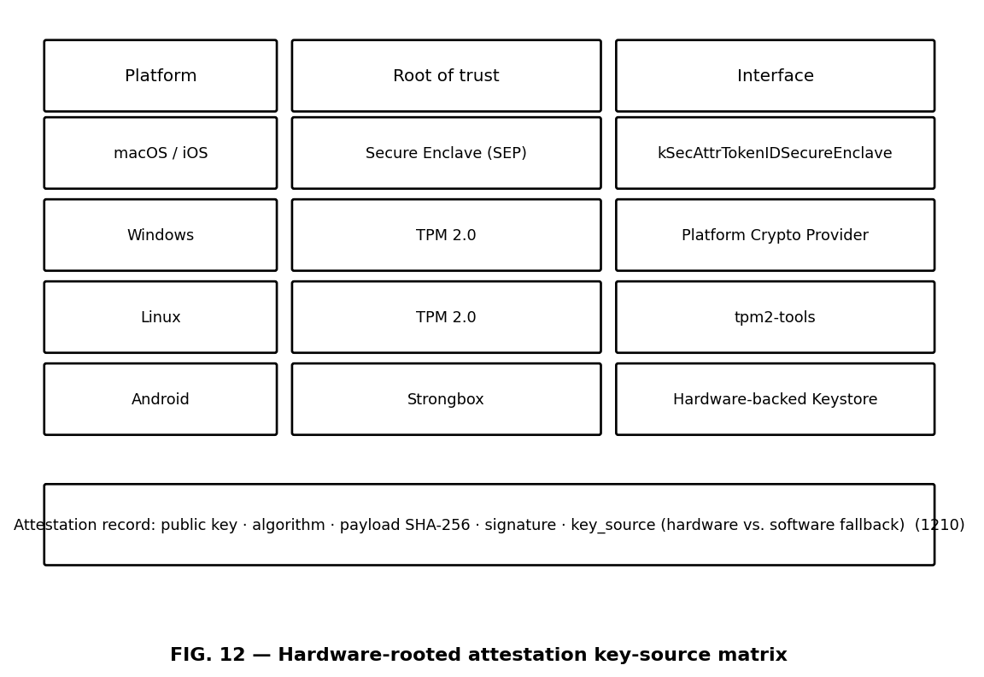
FIG. 12 — Hardware-rooted attestation key-source matrix

6. DETAILED DESCRIPTION

6.0 Definitions
As used herein: 'asset observation record' means any structured report of a computing asset received from a cybersecurity data source, regardless of schema. 'Hardware-level identifier' means an identity attribute bound to physical hardware or a cryptographic device identity, including a MAC address, device serial number, or TLS certificate fingerprint, as distinguished from network-assigned attributes such as IP address or hostname. 'Asset Confidence Score' (ACS) means a value in [0, 1] expressing the system's current confidence that an asset vertex is live, authorized, and accurately observed. 'Domain sub-score' means a normalized value in [0, 1] summarizing security signals of one signal domain. 'Kill-chain stage multiplier' means a scalar selected according to the adversarial tactic stage attributed to an event. 'Blast-radius multiplier' means a scalar increasing with the observed count of lateral propagation hops. 'Tamper-evident' means that any post-hoc modification of a recorded field is detectable by recomputation of a hash chain. 'Regulatory framework record' means a data structure comprising at least a notification deadline, a set of required fields, and a draft template for a specific legal or regulatory reporting regime. Terms of degree such as 'approximately' encompass ±10% unless stated otherwise. All numeric constants given in this description are configurable defaults of one embodiment and do not limit the claims.

6.1 UTAG implementation
The graph G = (V, E) holds canonical assets as vertices identified by immutable UUIDs; edges represent clone lineage, network connection, or lateral movement. For incoming record r and vertex v: score(r, v) = Σᵢ wᵢ · match(rᵢ, vᵢ) · boost(i), with default dimension weights MAC 0.50, cloud instance ID 0.45, TLS certificate fingerprint 0.40, hostname 0.35, serial 0.30, IP 0.20, and hardware boost 1.15 on MAC/serial/certificate matches. Merge occurs at score ≥ τ (default 0.38). ACS(t) = ACS_base · e^(−λ·Δt/T_half), T_half default 7 days; ACS < 0.30 → shadow IT; unobserved 2×T_half → stale. All constants are configurable defaults, not claim limitations.

6.2 CDCS implementation
Vulnerability sub-score: CVSS band mapping (CRITICAL→0.90, HIGH→0.70, MEDIUM→0.45, LOW→0.20); EPSS boosts +0.20 above 0.50 and +0.10 above 0.75; exploit-status multipliers 1.40 (public) / 1.20 (PoC); exposure multipliers 1.30 (internet-facing) / 1.00 / 0.60 (air-gapped); KEV floor 0.85; SLA breach +0.15. Identity sub-score: weighted normalized sum of impossible travel 0.25, privilege escalation 0.20, golden-ticket indicator 0.20, MFA failure rate 0.15, credential stuffing 0.10, pass-the-hash 0.10. Endpoint-posture sub-score H = 0.25·HWAM_exposure + 0.18·SWAM_staleness + 0.17·STIG_noncompliance + 0.20·malware_indicator + 0.12·hackable_config + 0.08·intrusion_pressure. Sector multipliers: banking 1.50, defence/government 1.45, healthcare 1.40, critical infrastructure 1.35, energy/telecom 1.30, default 1.00. Weights α…η normalize to 1.0 with floor 0.03 per weight; adaptive updates are bounded ±20% of the jurisdiction baseline. Seven-domain weight profiles are maintained per jurisdiction (e.g., usa_fedramp, eu_gdpr, uae_nesa).

6.2.1 Worked example (one embodiment)
An internet-facing server in a government environment (usa_fedramp profile: α=0.27, β=0.20, γ=0.16, δ=0.11, ε=0.07, ζ=0.09, η=0.10) presents: CVE with CVSS 9.8 (V_base 0.90), EPSS 0.94 (boosts +0.20 and +0.10), public exploit (×1.40), internet-facing (×1.30) — V clamps to 1.00. Other sub-scores: E=0.60, I=0.40, N=0.50, C=0.30, T=0.70, H=0.55. Weighted sum = 0.27(1.00) + 0.20(0.60) + 0.16(0.40) + 0.11(0.50) + 0.07(0.30) + 0.09(0.70) + 0.10(0.55) = 0.648; ×10 = 6.48. Multipliers: sector defence/government 1.45; blast radius 2 hops → 1.20; kill-chain exfiltration → 1.50; ACS 0.92. Product = 6.48 × 1.45 × 1.20 × 1.50 × 0.92 ≈ 15.56, clamped to CDCS = 10.0 → CRITICAL; the UREA automaton transitions and, on breach confirmation, emits a FedRAMP structured incident report draft within the 1-hour mandate, carrying chain hash hashₙ. By contrast, a quiet asset with no domain signals yields a weighted sum of 0 and CDCS = 0; no automaton transition occurs. The decomposition of every score into its terms is preserved and presented with each alert (claim 30), providing the deterministic, auditable rationale that black-box anomaly detectors cannot.

6.3 UREA implementation
Automaton (Σ, S, s₀, δ, F): Σ = {cdcs_above_threshold, alert_triggered, breach_confirmed, notification_submitted, incident_closed}; S = {NOMINAL, MONITORING, INVESTIGATION, BREACH, REPORTED, CLOSED}; s₀ = NOMINAL; δ: (NOMINAL, cdcs_above_threshold)→MONITORING, (MONITORING, alert_triggered)→INVESTIGATION, (INVESTIGATION, breach_confirmed)→BREACH, (BREACH, notification_submitted)→REPORTED, (REPORTED, incident_closed)→CLOSED; F = {CLOSED}. Hash chain: hash₀ = SHA256(incident_id₀ ‖ cdcs₀ ‖ ts₀ ‖ seed); hashₙ = SHA256(incident_idₙ ‖ cdcsₙ ‖ tsₙ ‖ hashₙ₋₁). The chain value is embedded in every evidence record and notification draft.

6.4 UMEA, attestation, and auxiliary methods
UMEA collectors invoke platform-native APIs (system_profiler, WMI, lshw, Android Build/PackageManager, libimobiledevice) and event streams (FSEvents, Endpoint Security framework, ETW, inotify, logcat) with a debounce window for incremental rescans. Vulnerability cache: NVD 2.0 API daily refresh, EPSS daily feed, KEV catalog. Attestation: Secure Enclave (kSecAttrTokenIDSecureEnclave), Platform Crypto Provider (TPM 2.0), tpm2-tools, Strongbox; record carries public key, algorithm, payload SHA-256, signature, key_source. Federated learning: Gaussian noise of configurable sigma targeting ε ≈ 3 yearly; gradients only, customer-size-weighted aggregation, trust-factor blending. Auto-remediation allowlist verbs include package-manager upgrades, service unload, OS update invocation; execution requires priority ≥ 9.0 plus allowlist match, otherwise analyst approval; full audit logging of command, exit code, stdout/stderr, snapshot.

7. FILING NOTES FOR PATENT COUNSEL
(a) This provisional is the priority document; UnifiedSec Technologies Inc. (Delaware) is the applicant; inventor assignment to be executed at filing. (b) PCT within 12 months; EPO and GCC regional phases via PCT; evaluate UAE national route. (c) Confirm the status of any India provisional referenced in earlier drafts (IN/2026/UNISEC/MACE-001) and any assignment or priority-claim coordination needed; earlier marketing materials describing already-completed national-phase entries are incorrect and have been retracted. (d) Non-provisional due within 12 months under 35 U.S.C. § 119(e). (e) Select final independent claims (recommended: 1, 13, 23 or 29) and budget excess-claim fees. (f) Attach Figures 1-12.

