# **PIZZA SALES SQL QUERIES**

KPI’s

1. Total Revenue





1. Average Order Value





1. Total Pizzas Sold





1. Total Orders





1. Average Pizzas Per Order

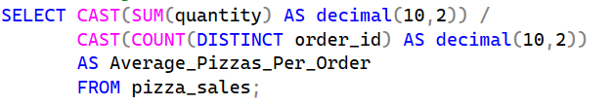



Questions:

1. Daily Trend for Total Orders

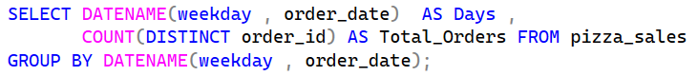

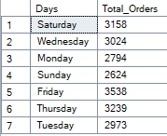

1. Hourly Trend for Total Orders

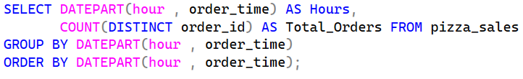

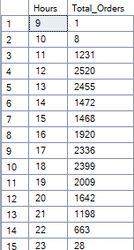

1. Percentage of Sales by Pizza Category

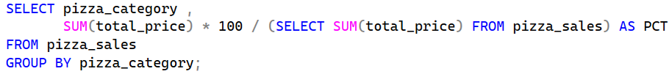

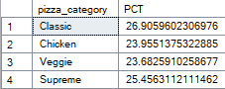

1. Percentage of Sales by Pizza Size

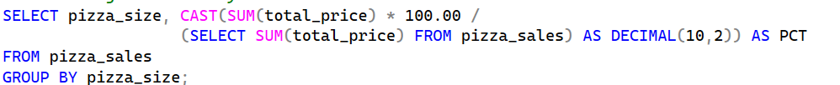

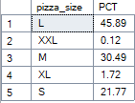

1. Total Pizzas Sold by Pizza Category

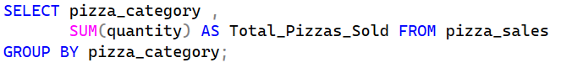

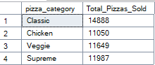

1. Top 5 Best Sellers by Total Pizzas Sold

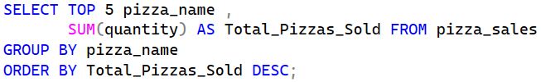

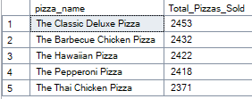

1. Bottom 5 Worst Sellers by Total Pizzas Sold

