**Task 3**

**Project: Online Store Order Management System (PostgreSQL)**

**Objective:**

**Create a system to manage orders, customers, and products for an online store.**

**The project will include the following tasks:**

**Database Creation:**

**Create a database named OnlineStore.**

Create tables:

Customers (CUSTOMER_ID, NAME, EMAIL, PHONE, ADDRESS)

Products (PRODUCT_ID, PRODUCT_NAME, CATEGORY, PRICE, STOCK)

Orders (ORDER_ID, CUSTOMER_ID, PRODUCT_ID, QUANTITY, ORDER_DATE)

Set up foreign keys linking Orders to Customers and Products.

Data Creation:

Insert sample data for customers, products, and orders.

**Order Management:**

a) Retrieve all orders placed by a specific customer.

b) Find products that are out of stock.

c) Calculate the total revenue generated per product.

d) Retrieve the top 5 customers by total purchase amount.

e) Find customers who placed orders in at least two different product categories.

**Analytics:**

a) Find the month with the highest total sales.

b) Identify products with no orders in the last 6 months.

c) Retrieve customers who have never placed an order.

d) Calculate the average order value across all the orders.

Table create

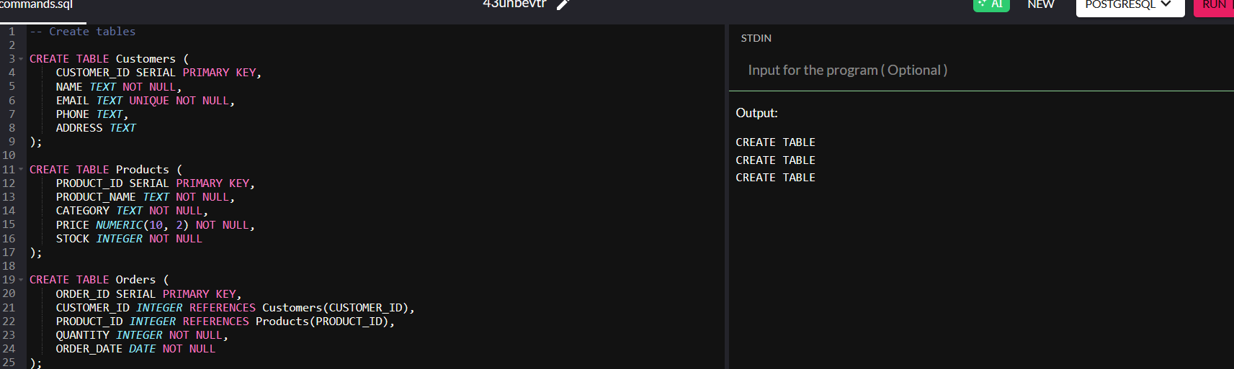

Insert data

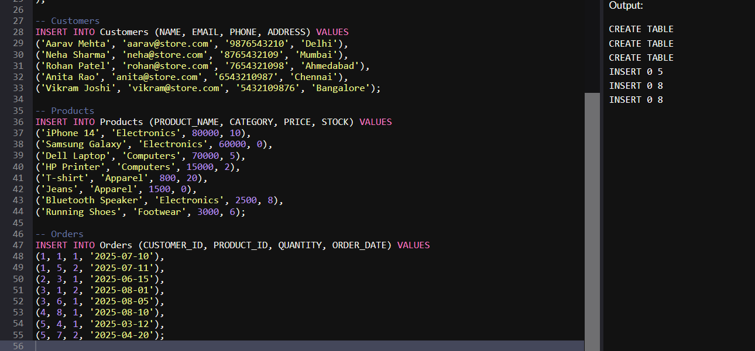

**Order Management:**

a) Retrieve all orders placed by a specific customer.

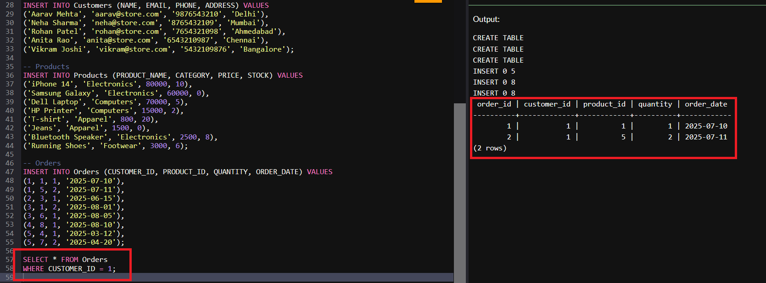

b) Find products that are out of stock.

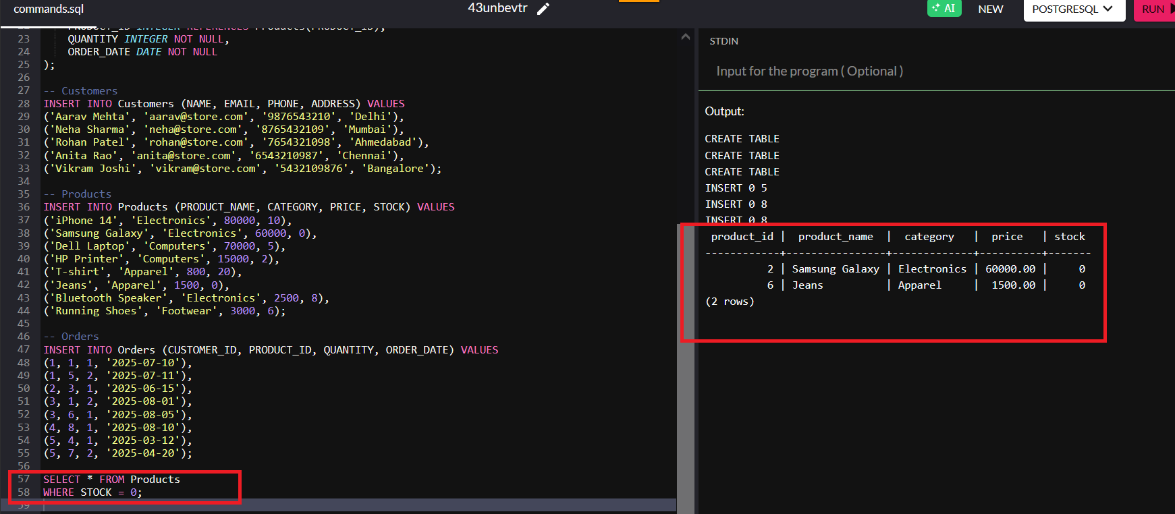

c) Calculate the total revenue generated per product.

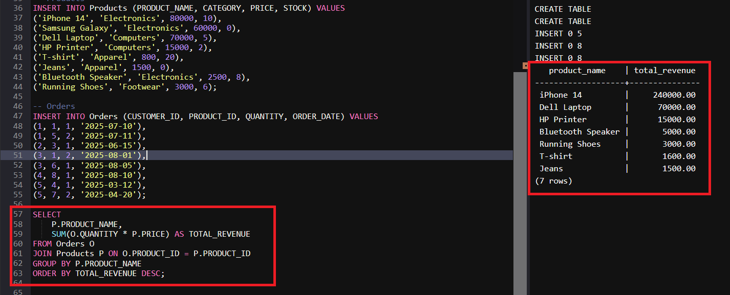

d) Retrieve the top 5 customers by total purchase amount.

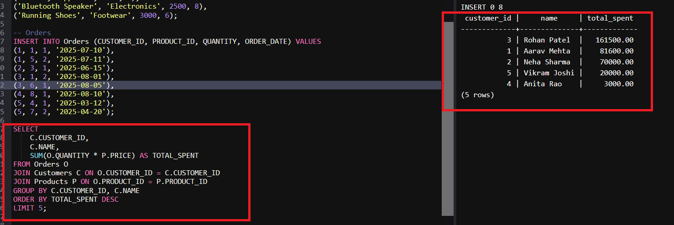

e) Find customers who placed orders in at least two different product categories.

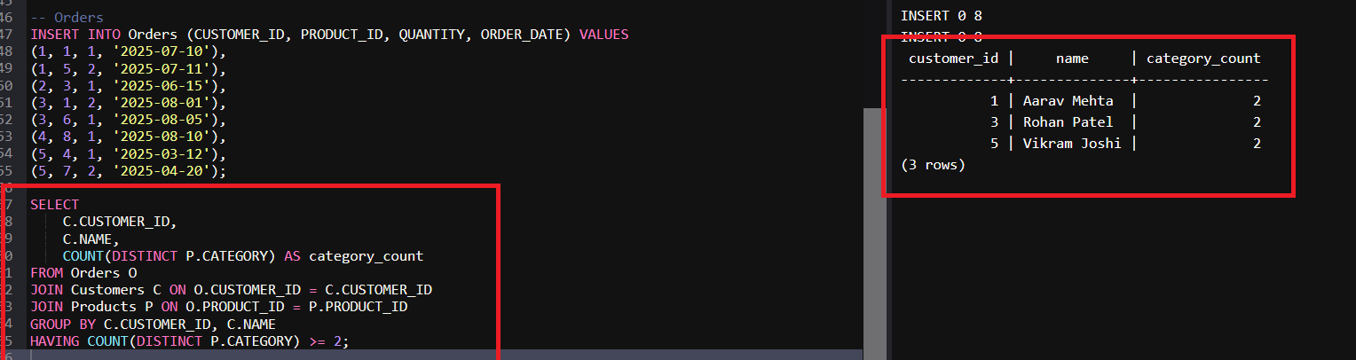

**Analytics:**

a) Find the month with the highest total sales.

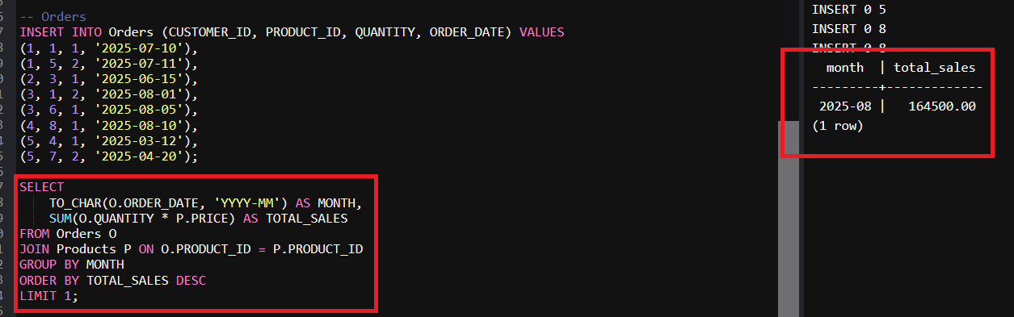

b) Identify products with no orders in the last 6 months.

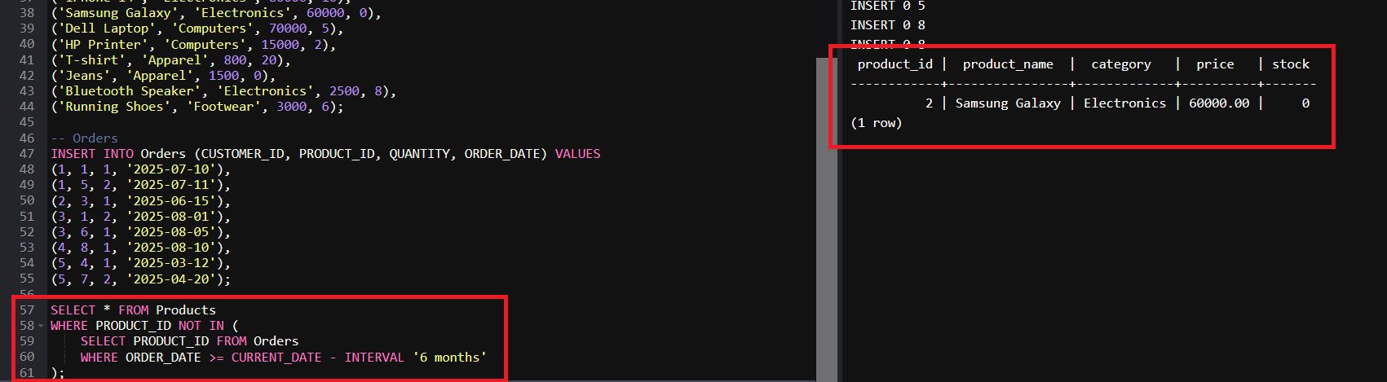

c) Retrieve customers who have never placed an order.

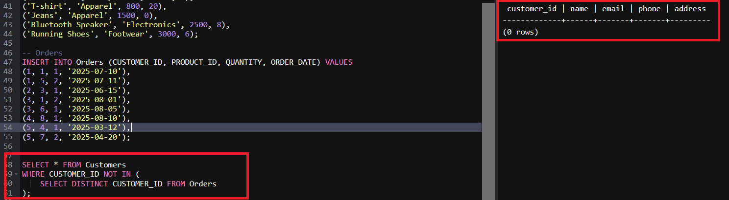

d) Calculate the average order value across all the orders.

