

Department of Computer Science,

Rollwala Computer Center

6th Semester Project Report



|  |  |
| --- | --- |
| Submitted By | Vivek B. Barbhaya |
| Internal Guide | Dr. Hardik Joshi |
| External Guide | Jay Trivedi |

[ GVX Certificate ]

**Abstract**

Data as a Service and API as a Service is an ecommerce platform for our US Client. We are selling two products in two different way. One way is through API and second way is providing data in .pdf, .xls, .txt, .xml, etc.

We sell two product one is Watch List Screening. Second is Customs Data. Watch List Screening is used to validate the genuineness of a customer, some businesses need to identify and verify the criminal background of the customer, this is where WLS came to rescue for such businesses. Customs Data is a data / information related to import export businesses such as what is excise duty for the particular country in a particular country etc.

**Acknowledgement**

The accomplishment of any project is never an individual effort. During the period of the internship I have learned many things like how an IT company functions work with different people and complete what is needed to be achieved. I would earnestly like to thank my project guides, **Dr. Hardik Joshi** and **Mr. Jay Trivedi** for their constant support and for navigating in the correct direction always. They have also helped in inculcating many working principles. I am fortunate to be a part of **Data-as-a-Service** Project team as I witnessed the whole Software Development Life Cycle during the internship at GlobalVox Inc. I also acknowledge all the faculties and members of the department for their suggestions and advices along the year.

**Vivek Barbhaya**

**Table of Contents**

**1… Introduction**

**1.1 Personal Profile**

|  |  |
| --- | --- |
| Name | Vivek B. Barbhaya |
| Roll Number | 32 |
| Seat Number |  |
| Course | MCA Sem-6 |

**1.2 Project Profile**

|  |  |
| --- | --- |
| Title | Data-as-a-Service |
| Company | GlobalVox Inc. |
| Type | Web Application |
| External Guide | Mr. Jay Trivedi |
| Internal Guide | Dr. Hardik Joshi |

**1.3 Introduction GlobalVox Inc.**

Since our founding in 2002, Global Vox is committed to offering innovative managed services portfolio and ultimate customer experience that drives innovation and accelerates growth. We leverage IT consulting services and technology solutions that deliver tangible business value and meets the changing needs of the business. Our role is to enhance the efficiency and productivity of your staff so that they can focus on other key business initiatives.

We have a proven track record of monitoring, offering world-class managed IT services and solutions as well as helping customers manage heterogeneous infrastructure. Being one of the leading managed service providers we deliver unified communications, managed IT and network connectivity to over 80,000 customers across the country. From over two decades we are helping our clients become more agile, secure and flexible by modernizing their IT infrastructure, innovating their business and monitoring as well as securing their mission-critical data.

We believe in putting people first. Thus, through our customer centric engagement model, we ensure we are always there for our customers by offering them comprehensive solutions for guaranteed performance. In partnership with industry leading technology providers we focus on solutions to help business cut costs, increase flexibility, maximize reliability to eliminate risks and improve service.

**Website:** [**https://www.globalvoxinc.com**](https://www.globalvoxinc.com)

**2… Introduction to the System**

**2.1 Project Definition**

Data as a Service and API as a Service is an ecommerce platform for our US Client. We are selling two products in two different way. One way is through API and second way is providing data in .pdf, .xls, .txt, .xml, etc.

We sell two product one is Watch List Screening. Second is Customs Data. Watch List Screening is used to validate the genuineness of a customer, some businesses need to identify and verify the criminal background of the customer, this is where WLS came to rescue for such businesses. Customs Data is a data / information related to import export businesses such as what is excise duty for the particular country in a particular country etc.

**2.2 Project Scope**

* [www.globaltradesdata.com](http://www.globaltradesdata.com) is a B2C and B2B marketplace.
* [www.globaltradesdata.com](http://www.globaltradesdata.com) has 2 major actors.
  + Customer-user
  + Admin-user
* This site serves as an ecommerce platform for Customer-user.
* Introduction to Customer-User
  + GTD is developed to create an interface / platform where customer can find the product of their interest ranging from WLS to Customs Data.
  + Without appropriate management of customer-user module, the website will be ineffective.
  + Customer-user is an equally important pillar of the site as Admin-user.
  + GTD will let customers to join & surf the website for searching the WLS and Customs Data product of their choice & many more things.

**2.3 Feature of Customer-user**

* **Search product**
  + Core feature of GTD is to search WLS and Customs Data on site by applying basic filters like: Category
* **Filter search for products**
  + To make search more efficient and user-friendly for customers, GTD has multiple filters to narrow down the search result & get the accurate result for them.
* **Detailed view of the Product**
  + More info on the site will give the detailed view of the product including the price of the product and description of the product.
  + For Web services the detailed view includes the slab rates of the API calls.
* **Send Inquiry**
  + Send inquiry feature will send a lead directly to Admin dashboard with contact no., email & a message from customer-user.
* **Login and Registration**
  + Customer-user has a facility to register themselves on website and login to make the purchase.
* **Purchase of the product**
  + Customer-user will add the products into his/her cart and checkout them by paying online using his/her credit/debit card.
* **View Invoice**
  + Customer-user will be able to see the invoice of his purchase detail in rich and attractive html view.
* **Download Invoice**
  + Customer-use will be able to download invoice in pdf format anytime by login into the website.
* **Order History**
  + Customer-user will be able to view his/her previous orders.
* **Subscription Detail**
  + Customer-user will be able to view his subscription details.
  + i.e. status of his products, validity of it, download etc.
* **View Profile**
  + Customer-user will be able to view/edit his profile details.
* **Change Password**
  + Customer-user will be able to change his/her password.

**2.4 Feature of Admin-user**

* **Dashboard**
  + Admin-user will be able to see the dashboard which includes total orders in current month, earnings in current month, registered users, no. of visitors, earnings per month, top 5 highest earning data products and top 5 highest earning API products.
* **Categories**
  + Admin-user will be able to add / update / delete the categories.
  + Admin-user will be able to turn the status on or off.
* **Customs Data**
  + Admin-user will be able to add / update / delete the customs data files.
  + Admin-user can upload .zip file separately.
  + Admin-user can view
  + Admin-user will be able to turn the status on or off.
* **Web Services**
  + Admin-user will be able to add / update / delete web services.
  + Admin-user will be able to turn the status on or off.
* **Combo Pack**
  + Admin-user will be able to add / update / delete combo offers.
  + Admin-user will be able to turn the status on or off.
* **Purchase Details (Data)**
  + Admin-user will be able to see the selling history of the Data.
* **Purchase Details (API)**
  + Admin-user will be able to see the selling history of the apis.

**2.5 Problem Statement**

* **Hard to identify the genuineness of a customer**
  + In some businesses there is a solid need to identify the genuineness of the customer,
* **Very difficult to track record of International Trade Data**
  + Every country has different norms to do trade with every country, so there are huge combinations can be built. One individual can not keep the track of them by themselves.
* **No system was available to smooth the International Trade**
  + Our project is pioneering one, there is no such system available that solve the both of the above problem together.

**2.6 Proposed Solution**

* **Our special team monitors the black listings of all countries around the globe**
  + We are having monopolised network to get the information of such confidential things; we make a list of it and use it for the product creation process.
* **Provides the data and API to authenticate the customer / person / organization**
  + We are providing an API to authenticate the customer; vendors just have to call our API with the name of the person and as a response our API will send them the information about that person in Json.
* **Covers the International trade data ranging from customs to list of ports to product classification**
  + We are providing the all class and category of the WLS and Customs Data products, such as financial frauds, terrorist list etc.

**3… Tools and Environments**

**3.1 Hardware and Software requirements**

GTD is a web-based application so the requirements to use are very minimal. It needs internet connection and a device which has a web browser be it a computer system or a mobile device.

**Hardware Requirements**

Computer System (Minimum Requirement)

Processor: Intel Core 2 Duo 2.4 GHz

RAM: 2GB

HDD: 128GB

Operating System (S/W): Any operating system

**Software Requirements**

**Web Browser**

Any one of the following browsers:

* Google
* Mozilla Firefox
* Safari

**Browser Configuration**

Your browser must be configured as follows:

* JavaScript must be enabled
* Cookies must be enabled
* Pop-up windows must be enabled

**3.2 Technology used to Develop**

**Frontend**

* HTML, CSS, JavaScript
* Thymeleaf (Template Engine)
* Ajax, jQuery

**Backend**

* MySQL (Workbench)
* Java SpringBoot (IntellijIDEA)
* Hibernate

**Other Tools**

* Microsoft Teams
* ZOHO
* Jenkins

**Documentation Tools**

* Office 365
* Draw.io

**3.3 About MVC**

MVC stands for Model–View–Controller. It is a software architectural pattern. It divides a given software application into three interconnected parts, so as to separate internal representations of information from the ways that information is presented to or accepted from the user.

**Components of MVC**

* **Model**: It specifies the logical structure of data in a software application and the high-level class associated with it.
* **View:** View component is used for all the UI logic of the application and these are the components that display the application’s user interface (UI).
* **Controller:** Controllers act as an interface between Model and View components. It processes all the business logic and incoming requests, manipulate data using the Model component, and interact with the Views to render the final output. It receives input and initiates a response by making calls on model objects.

**3.4 About Thym**elea**f**

Thymeleaf is a Java XML/XHTML/HTML5 template engine that can work both in web and non-web environments. It is better suited for serving XHTML/HTML5 at the view layer of MVC-based web applications, but it can process any XML file even in offline environments. It provides full Spring Framework integration.

Thymeleaf is a modern server-side Java template engine for both web and standalone environments.

Thymeleaf's main goal is to bring elegant *natural templates* to your development workflow — HTML that can be correctly displayed in browsers and also work as static prototypes, allowing for stronger collaboration in development teams.

With modules for Spring Framework, a host of integrations with your favourite tools, and the ability to plug in your own functionality, Thymeleaf is ideal for modern-day HTML5 JVM web development — although there is much more it can do.

**3.5 About SpringBoot**

Spring Boot is an open source Java-based framework used to create a micro Service. It is developed by Pivotal Team and is used to build stand-alone and production ready spring applications

Spring Boot provides a good platform for Java developers to develop a stand-alone and production-grade spring application that you can just run. You can get started with minimum configurations without the need for an entire Spring configuration setup.

**Advantages**

Spring Boot offers the following advantages to its developers

* Easy to understand and develop spring applications.
* Increases productivity.
* Reduces the development time.

## **Why Spring Boot?**

* It provides a flexible way to configure Java Beans, XML configurations, and Database Transactions.
* It provides a powerful batch processing and manages REST endpoints.
* In Spring Boot, everything is auto configured; no manual configurations are needed.
* It offers annotation-based spring application.
* Eases dependency management.
* It includes Embedded Servlet Container

**3.6 About Hibernate**

Hibernate is a Java framework that simplifies the development of Java application to interact with the database. It is an open source, lightweight, ORM (Object Relational Mapping) tool. Hibernate implements the specifications of JPA (Java Persistence API) for data persistence.

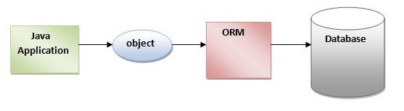

**Advantages**

* Hibernate framework is open source under the LGPL license and lightweight.
* The performance of hibernate framework is fast because cache is internally used in hibernate framework. There are two types of cache in hibernate framework first level cache and second level cache. First level cache is enabled by default.
* HQL (Hibernate Query Language) is the object-oriented version of SQL. It generates the database independent queries. So, you don't need to write database specific queries. Before Hibernate, if database is changed for the project, we need to change the SQL query as well that leads to the maintenance problem.
* Hibernate framework provides the facility to create the tables of the database automatically. So, there is no need to create tables in the database manually.
* Hibernate supports Query cache and provide statistics about query and database status.

**3.7 About Microsoft Teams**

Microsoft Teams, also referred to as simply Teams, is a unified communication and collaboration platform that combines persistent workplace chat, video meetings, file storage (including collaboration on files), and application integration. The service integrates with the Office 365 subscription office productivity suite and features extensions that can integrate with non-Microsoft products. Microsoft Teams is a competitor to services such as Slack and is the evolution and upgrade path from Microsoft Skype for Business.

**3.8 About Jenkins**

Jenkins is a free and open source automation server. It helps automate the parts of software development related to building, testing, and deploying, facilitating continuous integration and continuous delivery. It is a server-based system that runs in servlet containers such as Apache Tomcat. It supports version control tools, including AccuRev, CVS, Subversion, Git, Mercurial, Perforce, ClearCase and RTC, and can execute Apache Ant, Apache Maven and sbt based projects as well as arbitrary shell scripts and Windows batch commands. The creator of Jenkins is Kohsuke Kawaguchi. Released under the MIT License, Jenkins is free software.

Builds can be triggered by various means, for example by commit in a version control system, by scheduling via a cron-like mechanism and by requesting a specific build URL. It can also be triggered after the other builds in the queue have completed. Jenkins functionality can be extended with plugins.

**4… System Design**

**4.1 System Process Flow**

The System is divided into 5 main modules.

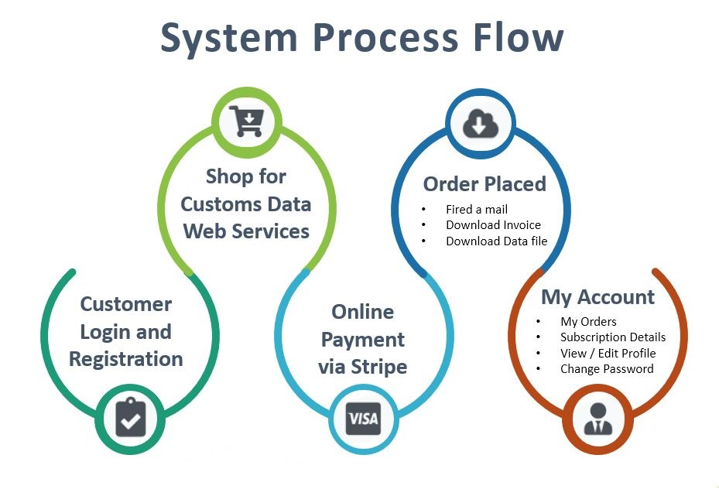

* **Customer Login / Registration**
  + In this module customer will register them self and login for using the site.
* **Shop for Customs Data / Web Services**
  + Customer will do the shopping for Customs data and APIs
* **Online Payment via Stripe**
  + After taking product of choice into cart, customer will do checkout and do the payment online using stripe gateway.
* **Order Placed**
  + After user made payment successfully, order is placed and use will get an order confirmation mail, user will also get the invoice in mail as well as they can download it in pdf format, user can also download the data file by login to the site.
* **My Account**
  + My account is a module, where user can view their past orders, they can view their subscription details regarding the product both data and api.
  + User can also view/edit their profile details and they can change their password.

**4.2 Use Case Diagram**

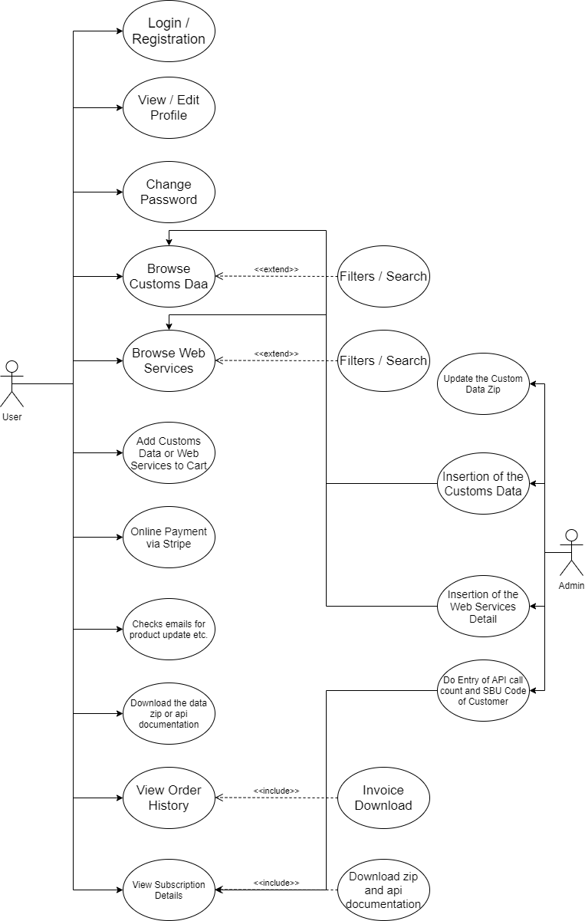

**4.3 Entity Relationship Diagram**

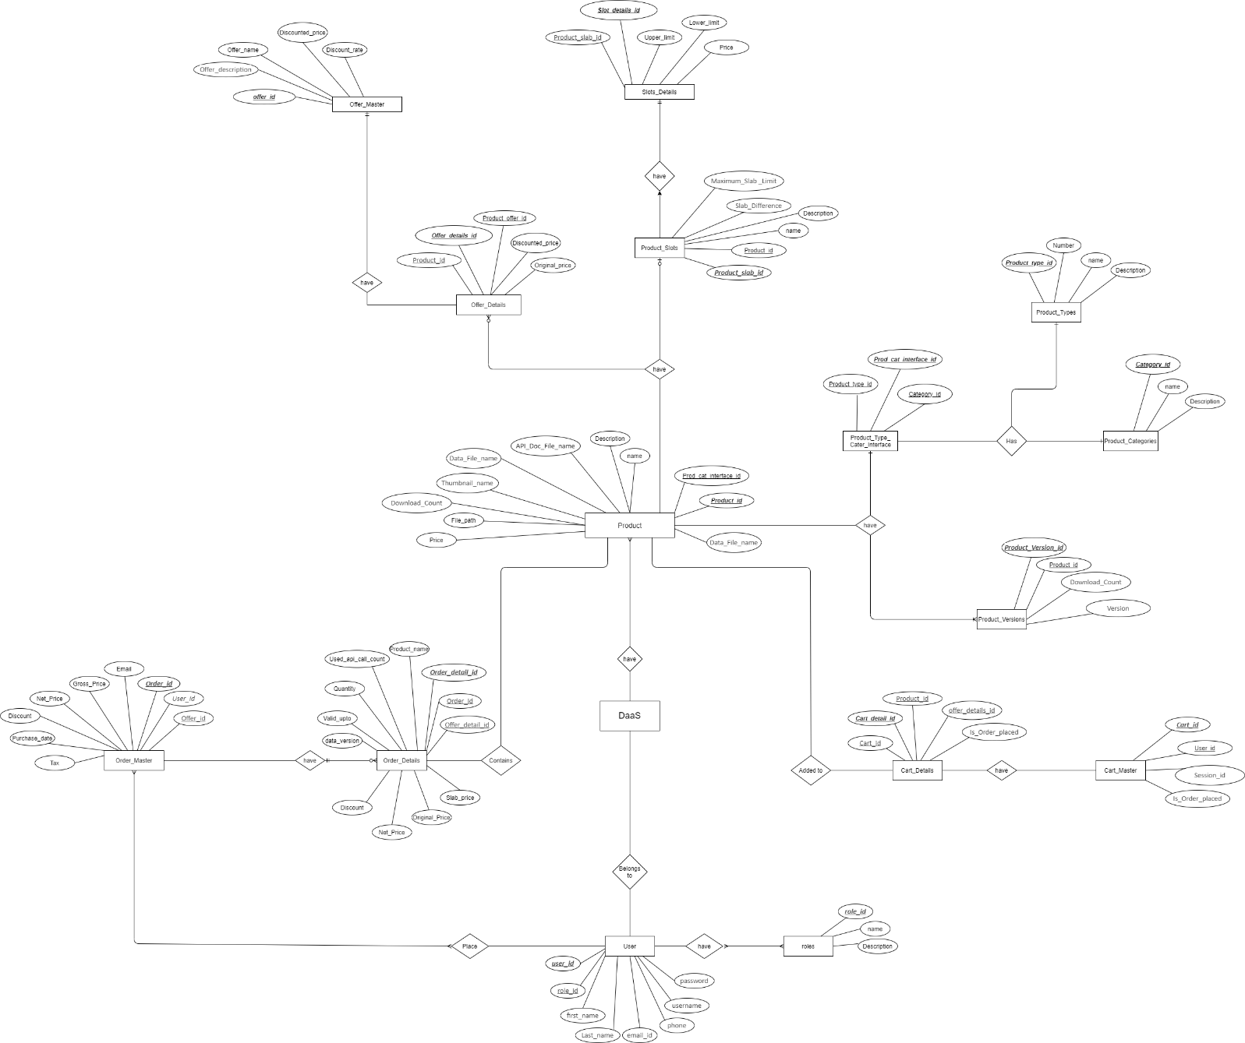

**4.4 Activity Diagram**

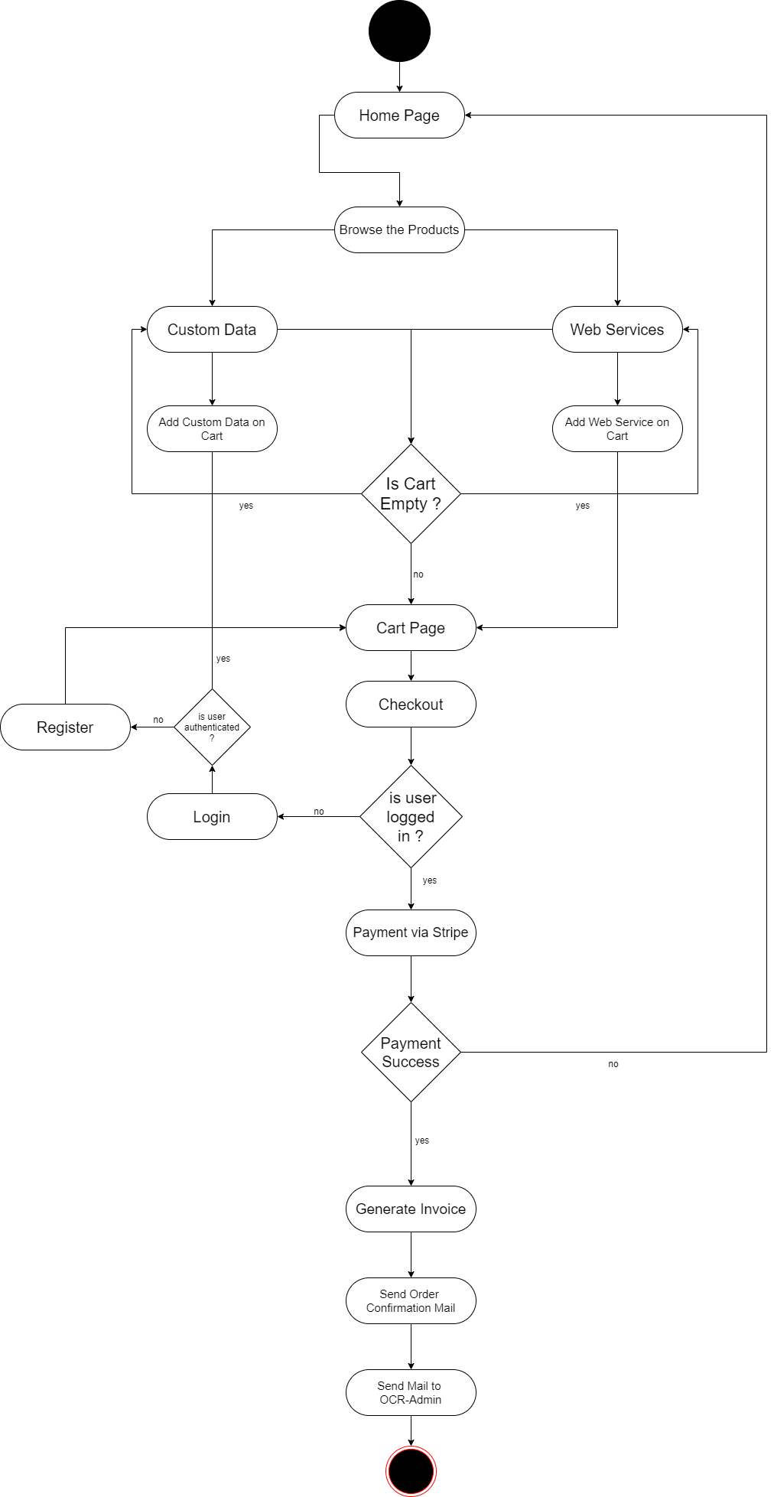

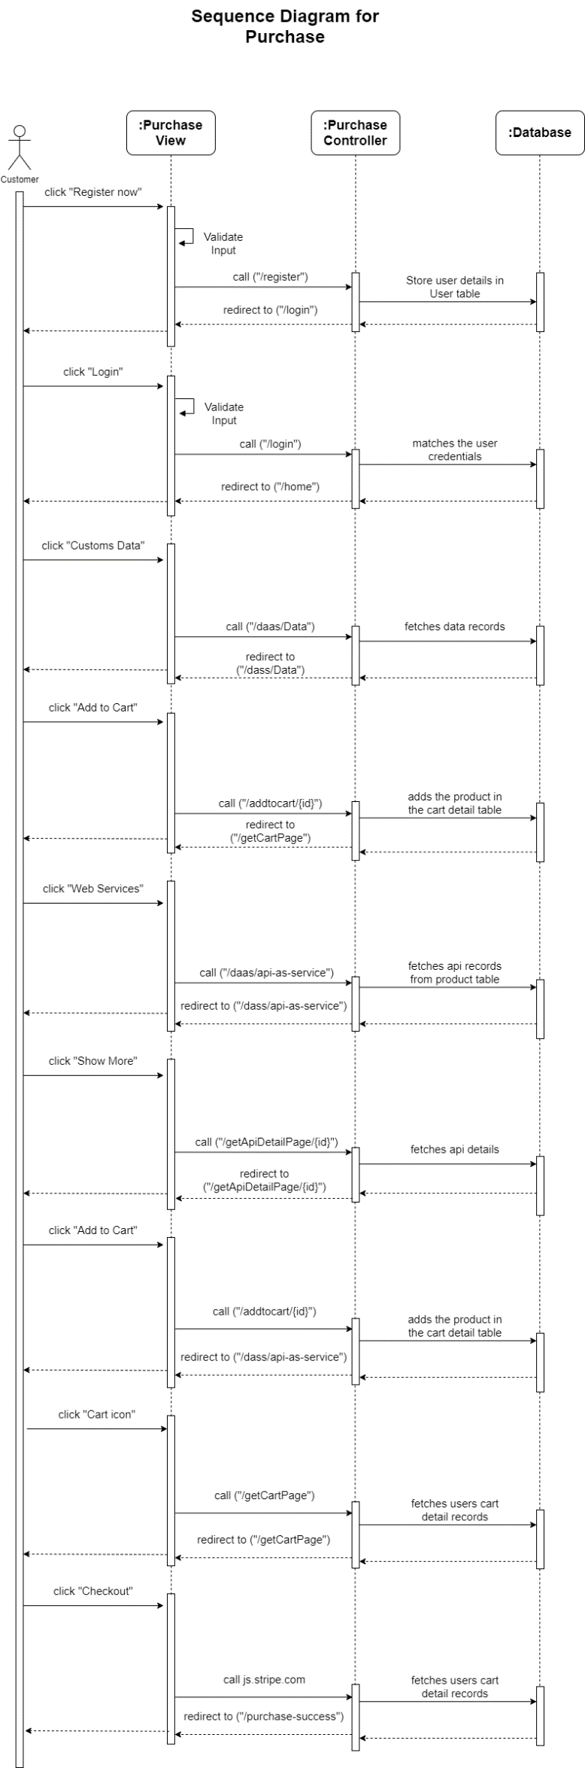**4.5 Sequence Diagram**

**4.6 Data Dictionary**

**5… Screen Shots**

**6… Testing**

**7… Future Enhancement**

**8… Bibliography**