Play framework used: <http://downloads.typesafe.com/typesafe-activator/1.2.2/typesafe-activator-1.2.2.zip?_ga=1.46818791.1309318605.1403657397>

The **code** of nano-paypal is divided in following components:

1. **nanoPaypal**: the play framework application. This is the only component that depends on the UI. All other are java components that can be plugged into any other UI

Comes with the following features:

* 1. Validators: (controllers.com.nanoPaypal.validator) can validate most of the request coming into the system
  2. Global.java: Controls proper routing, authorization and authentication of requests
  3. test: junit tests to ensure the system is running fine.
  4. Error reporting using filelogger (point 4 below)

1. **nanoPaypal_API**: the helper classes for the UI
2. **nanoPaypal_configurationManager**: The configuration manager for the entire system. Important fields in the config.properties file are:

dbConnection=jdbc\:sqlite\:d\:\\\\paypal.db

dbClass=org.sqlite.JDBC

1. **nanoPaypal_logging:** Managers logs for the system. Responsible for logging error, system and transaction logs.
2. **nanoPaypal_persistence:** The data access layer. It maintains a connection pool to the database, and has features like atomicity and consistency specially taken care of, and more so in case of handling transaction. For that case and more, it provides a batch option mode, which is atomic.
3. **nanoPaypal_transaction:** The transaction manager. System can be easily changed to operate transactions on database, or on network, or on any other layer.
4. **nanoPaypal_user:** The user manager. Important features:
   1. Can support multiple roles of a user
   2. Can support multiple contacts of a user
   3. Can load user from DB, Network etc.
5. Misc:
   1. Error/reporting logs go in logs folder

**Database:**

Tables in the system:

**account**: manages balance of a user

**roles**: maintains roles a user can have

**users**: the main user table.

**recipient**: maintains a list of users which whom an individual can interact

**transactionRecord**: transaction records

Deployment Steps:

1. Download play (now activator) framework from <http://downloads.typesafe.com/typesafe-activator/1.2.2/typesafe-activator-1.2.2.zip?_ga=1.46818791.1309318605.1403657397>
2. Change config.properties to point to paypal.db
3. Start the activator UI (see type safe activator document here: <http://www.playframework.com/documentation/2.3.x/Home>)

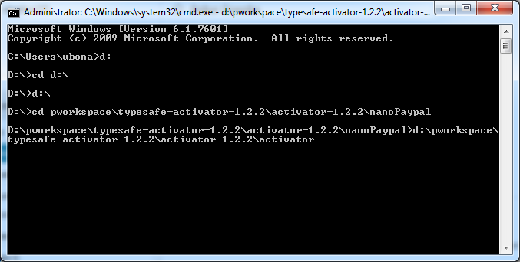

1. Run the application

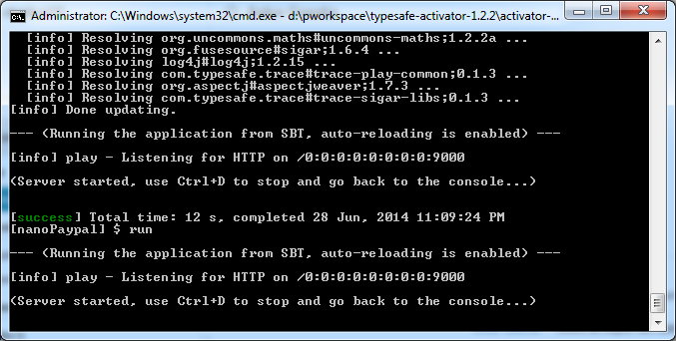

1. Working application:

