**Welcome Screen:** Main screen shows login option:

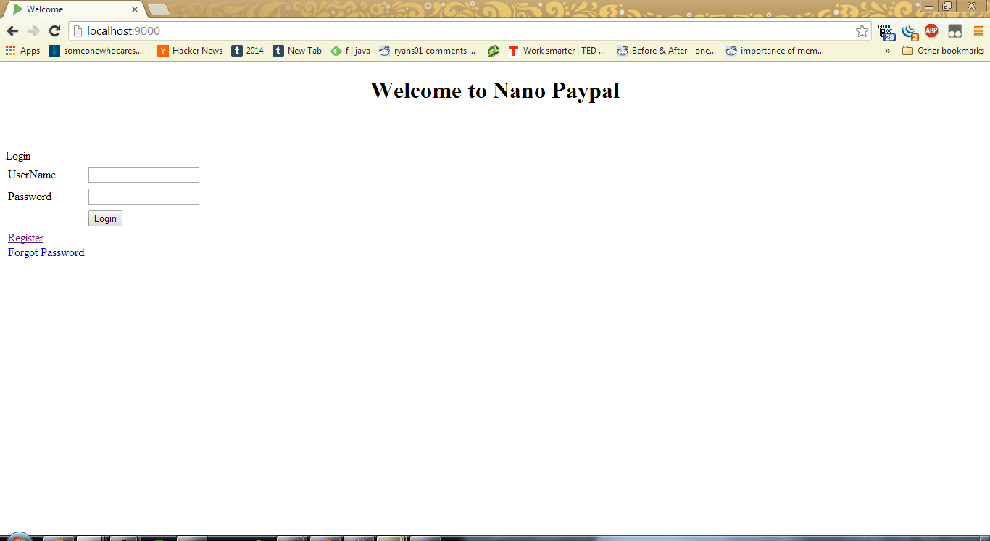

**Registration Screen:** When we go to the registration page, it gives us the following page, with client side validation in place:

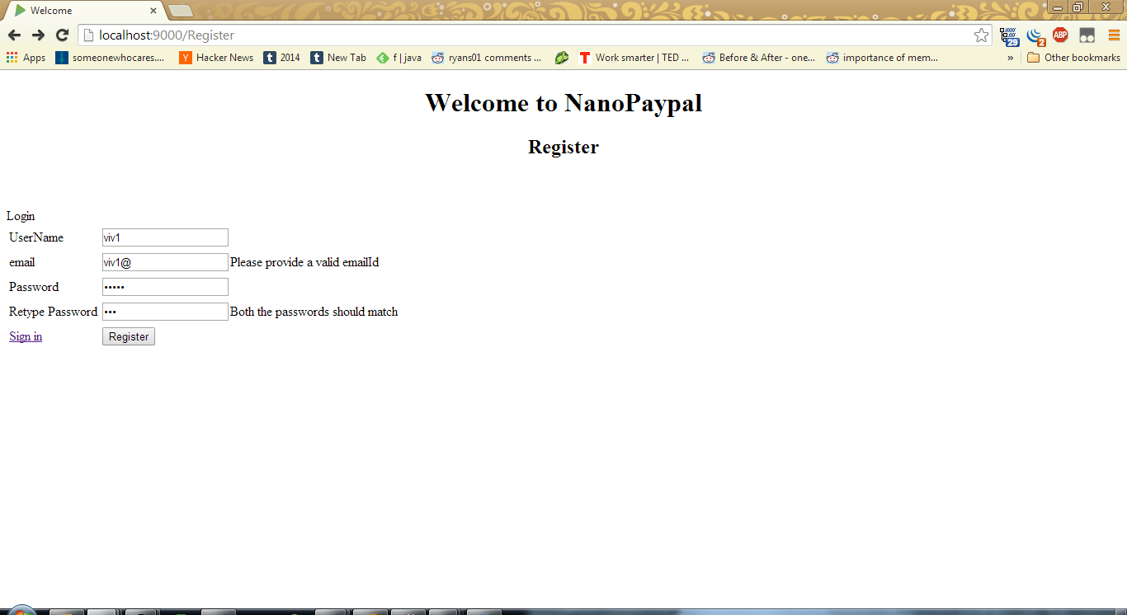

**Registration Screen (b):** On successful user creation:

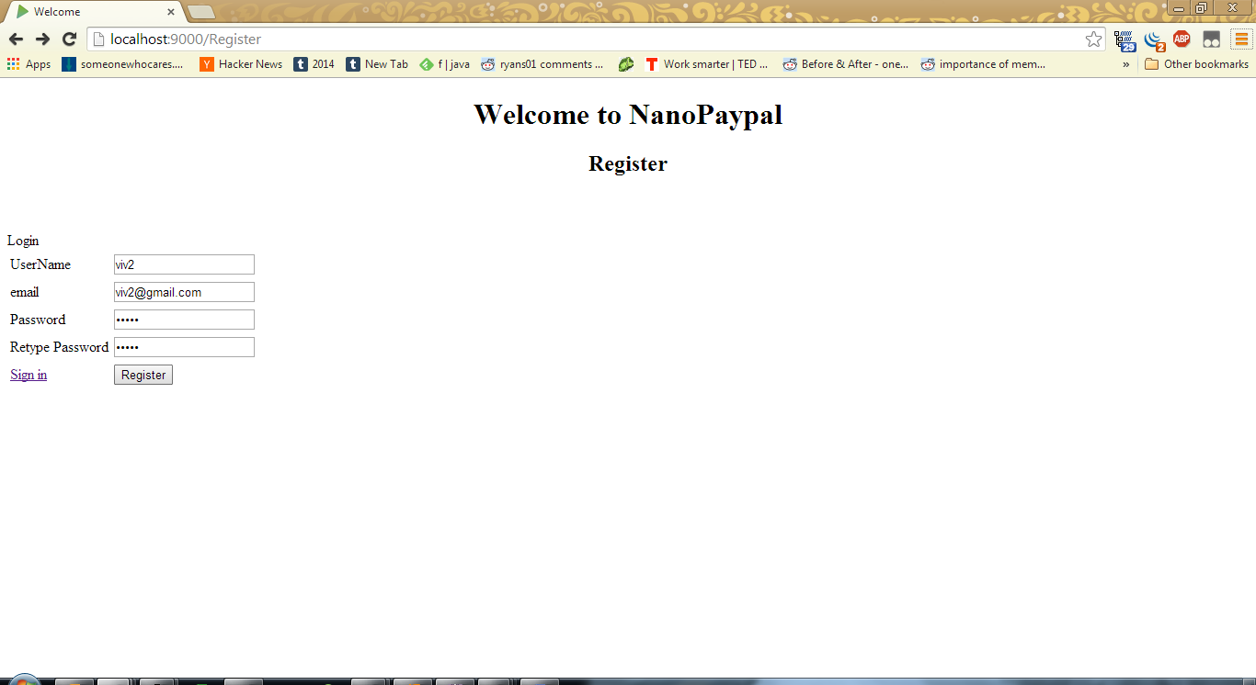

**User Screen**: I get automatically signed in, and there are couple of options on the screen for me:

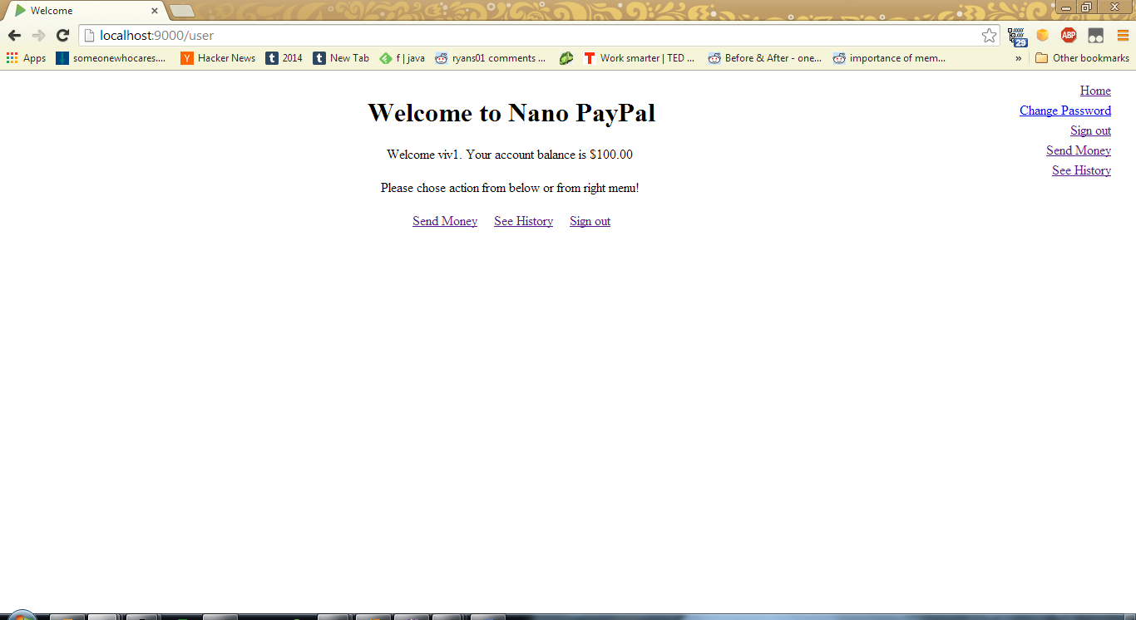

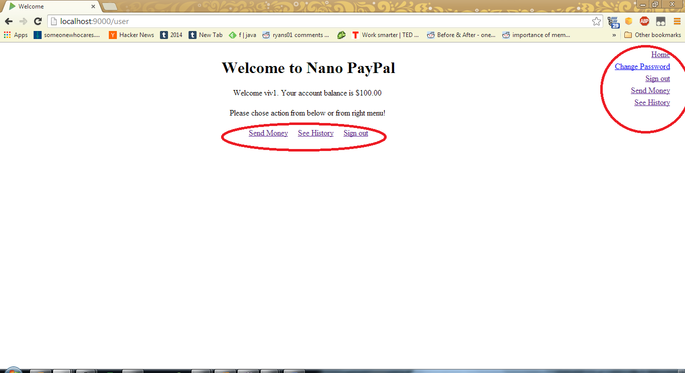

Home is the main screen visible above.

**Password Change Screen:** Change password screen:

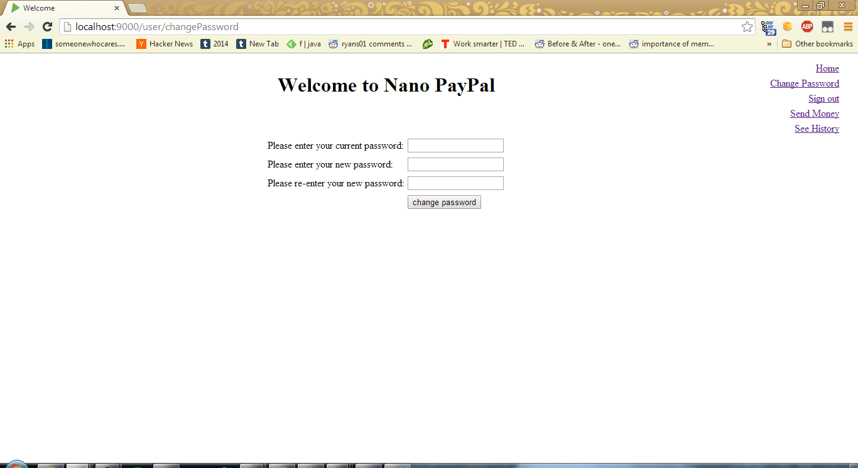

**Transaction Main Screen:** Send money screen takes us to another set of options:

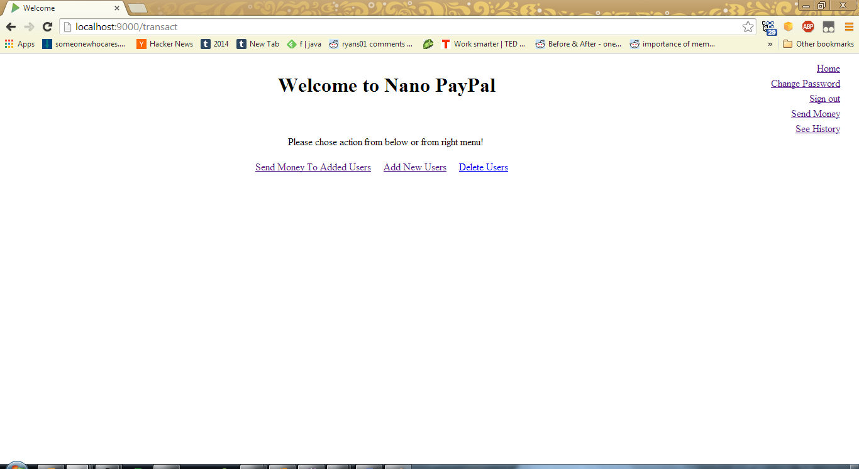

I have an option to add user using his email, send money to already added user, or delete a user.

**Add user screen**: I can add a user if I know his email Id and he is registered into the system:

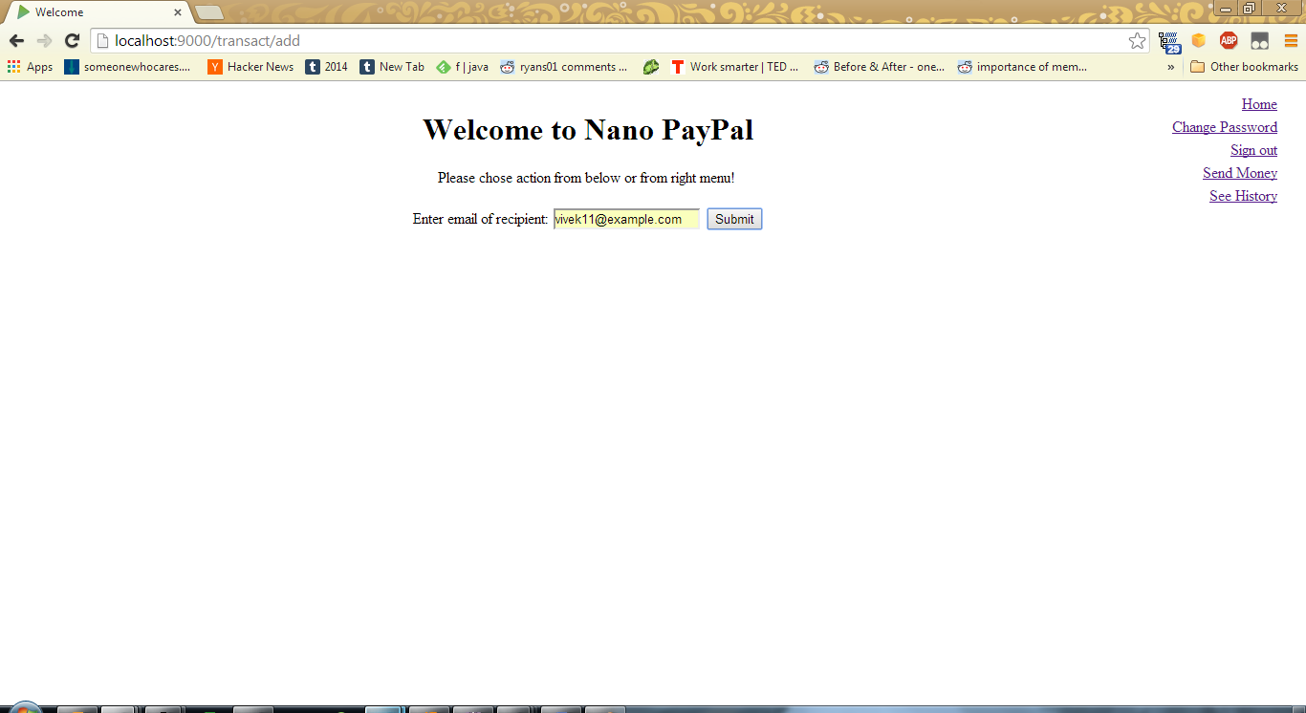

User added successfully:

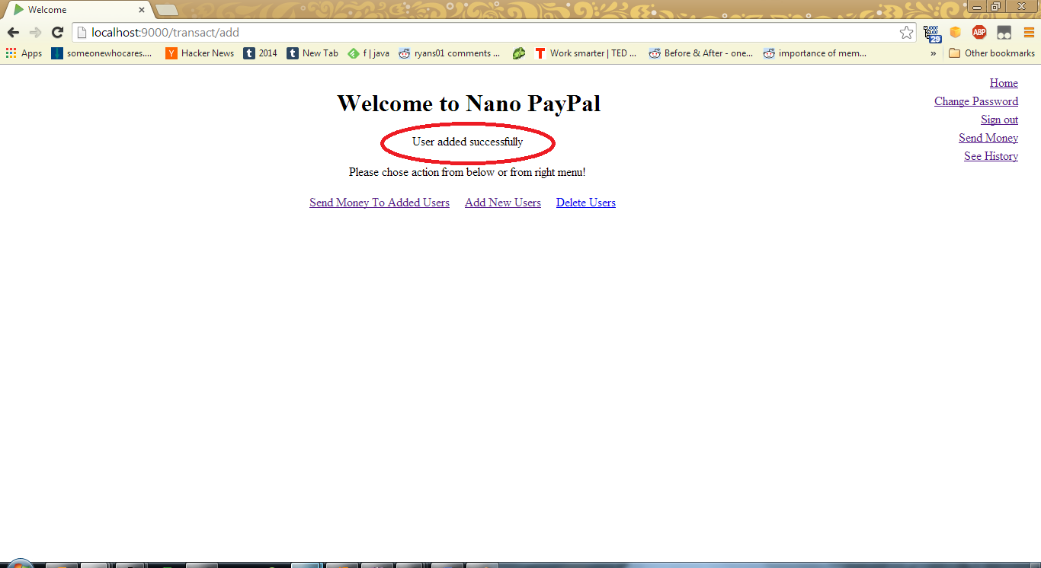

**Transaction Screen:** Now if I go to send money screen and fill in some amount to transfer:

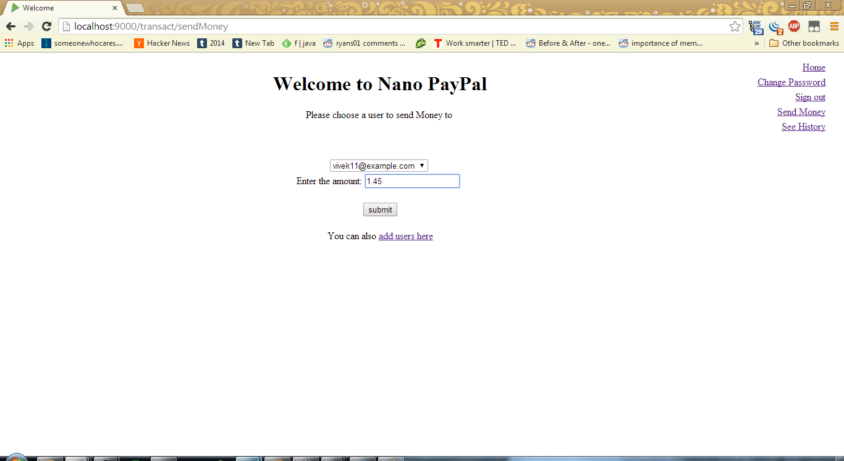

**Confirmation Screen:** It asks for confirmation:

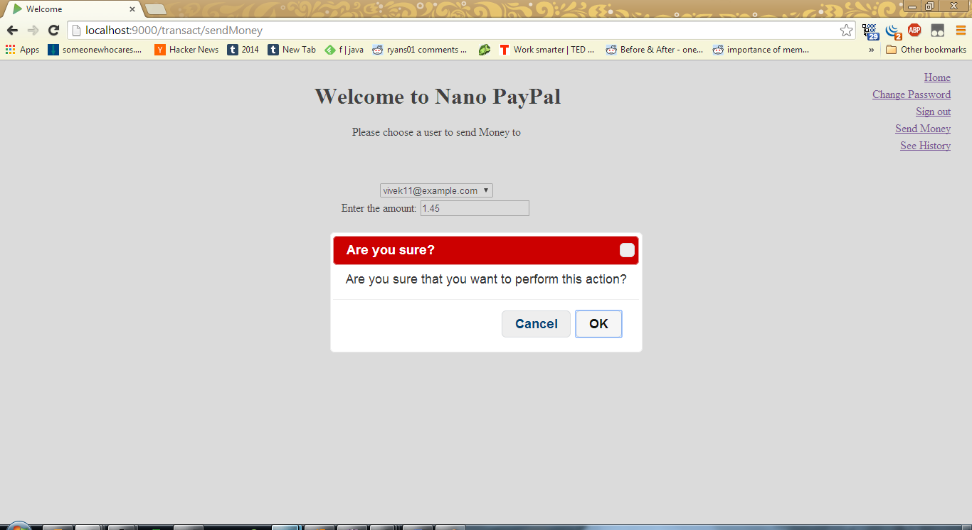

On pressing ok, I get:

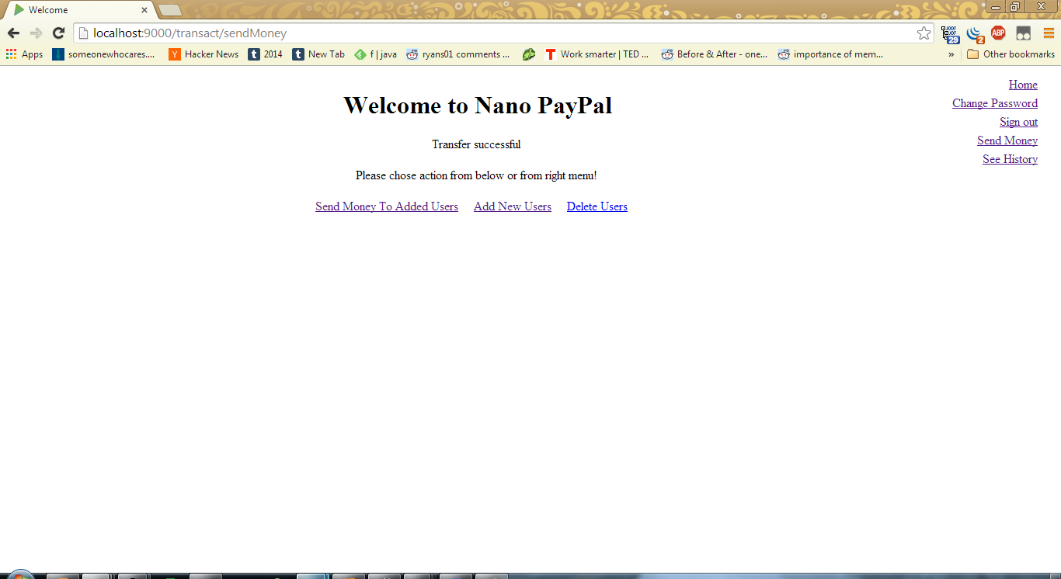

**History Screen:** Now, if I go to history, I can see my transaction:

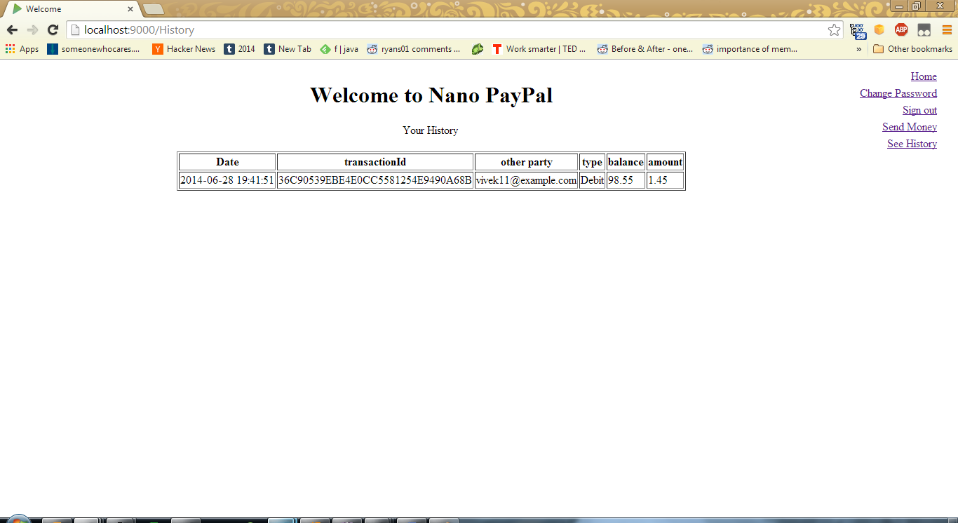

**User Screen (b)**: Balance gets updated on the main page:

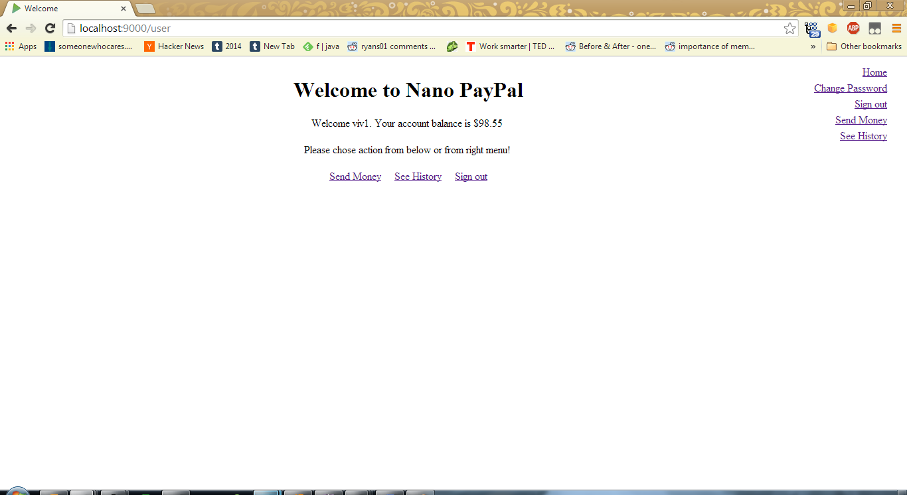

**Delete User Screen**: If I want to delete a user:

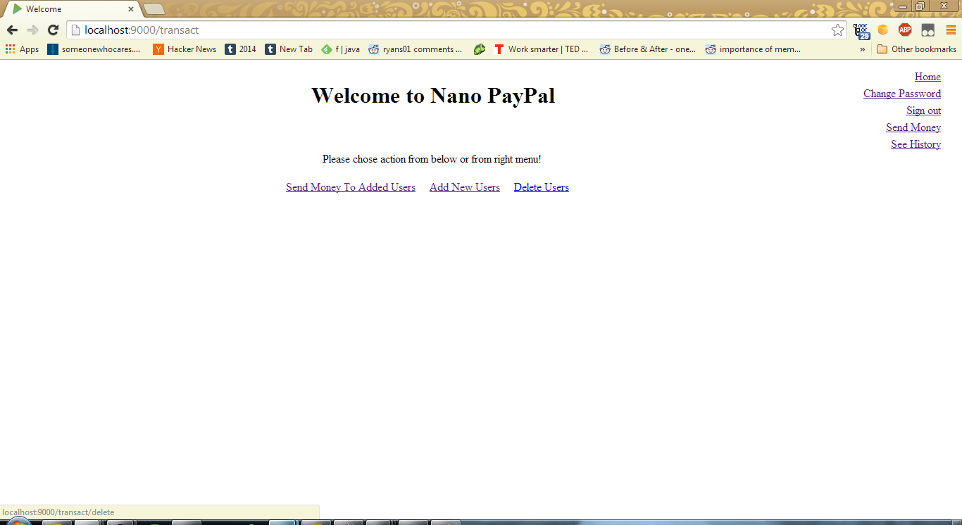

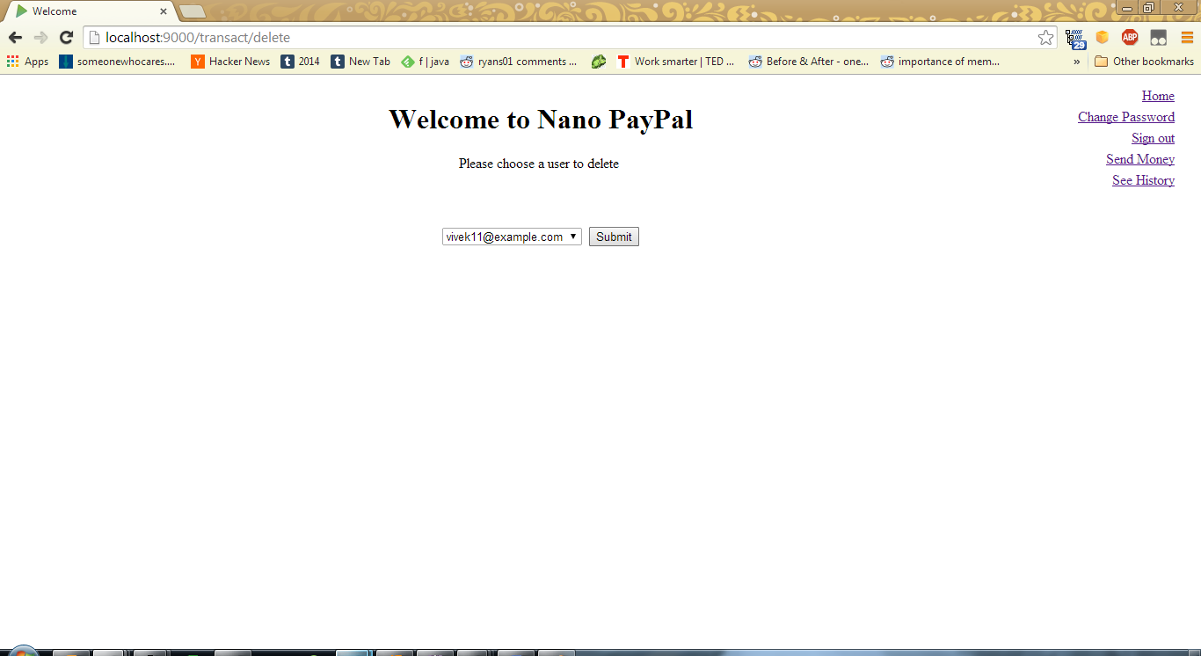

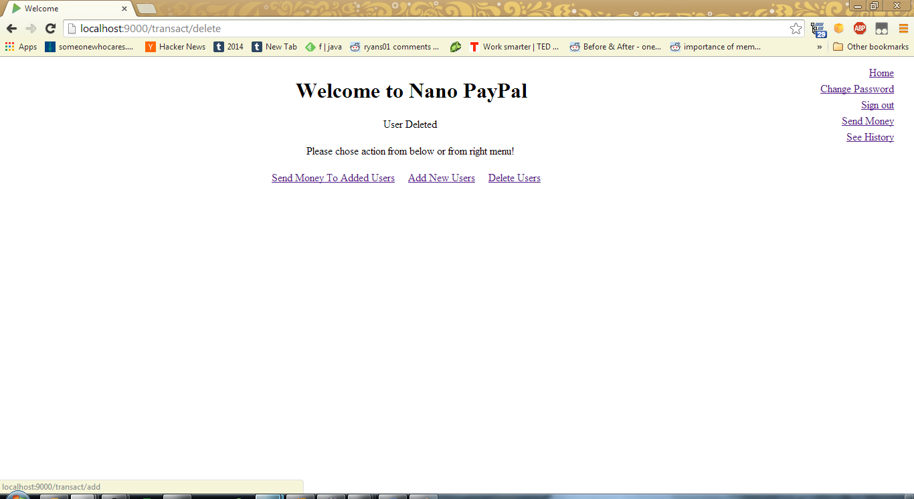

**Login Screen**: Login as admin (password: admin)

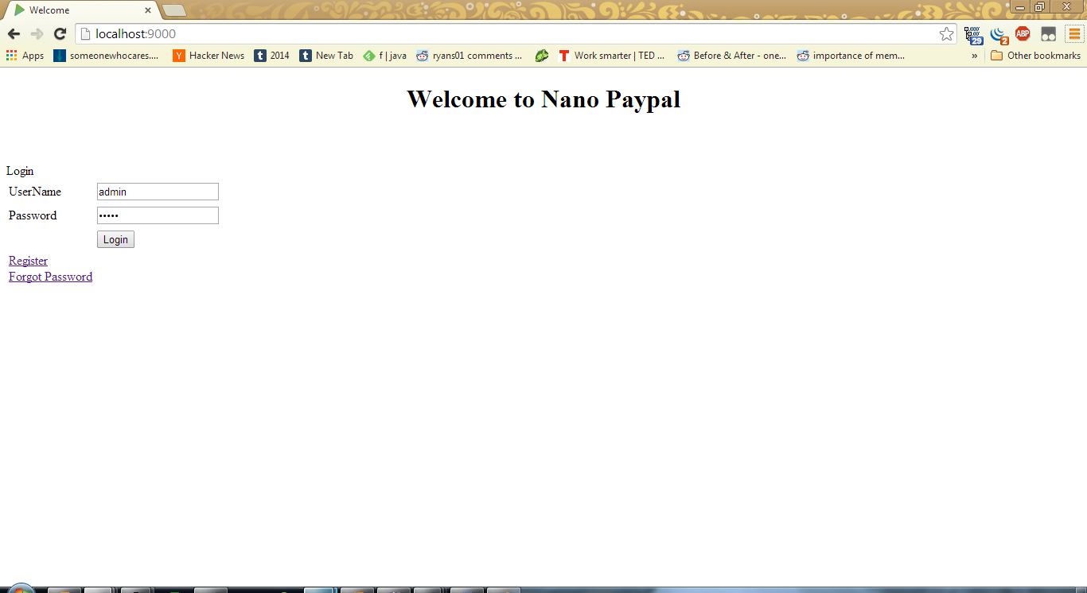

I get an extra option on the right:

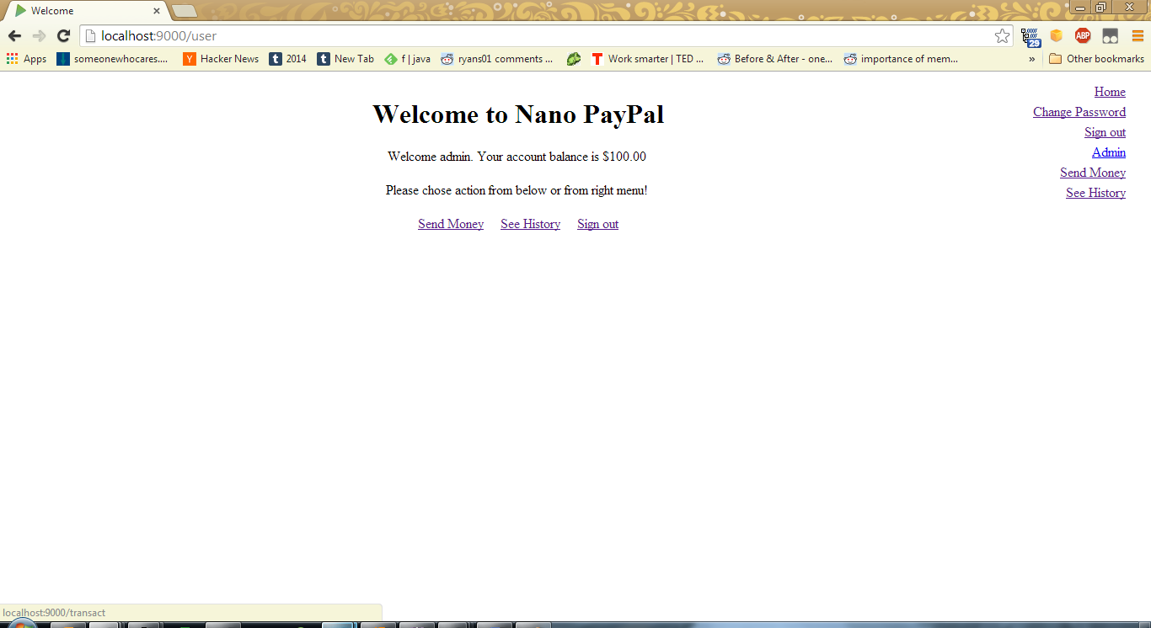

**Admin Screen**: In admin section, I can see the following:

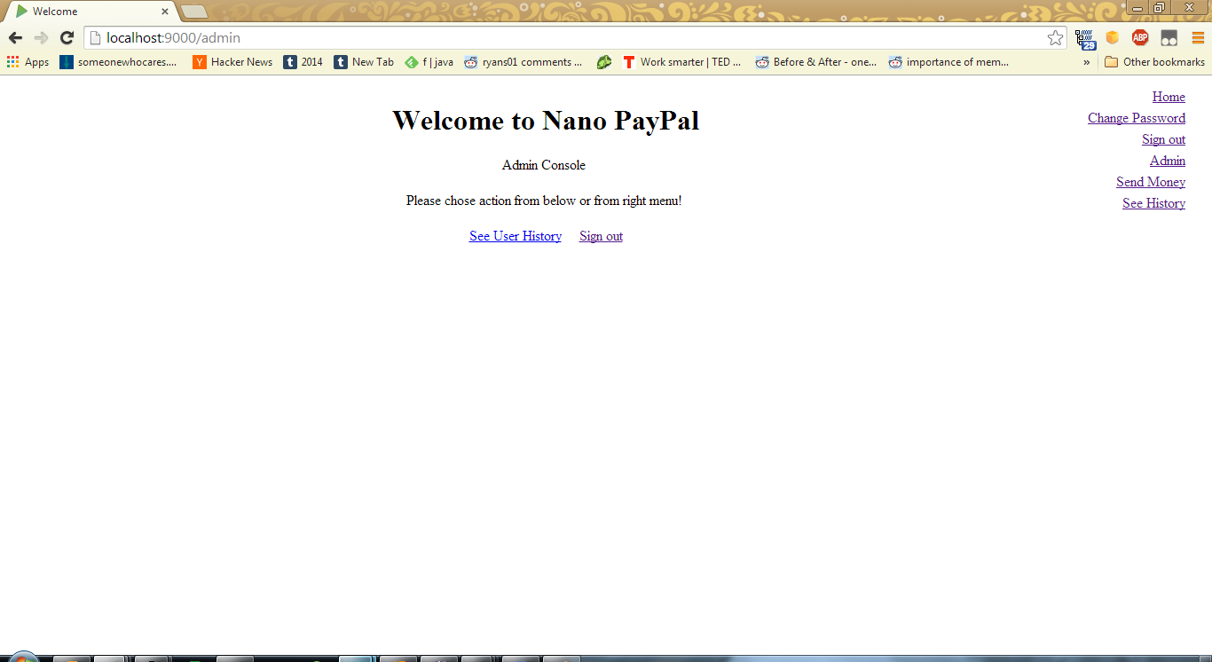

**Admin History Screen**: When I click on “See User History”, I can either filter based on user, or see every one’s transaction:

