OA'S
- SUBSTRING GENERATION : all substring are a, b, c, ab, bc, abc. worst O(n^2) lagega hi.
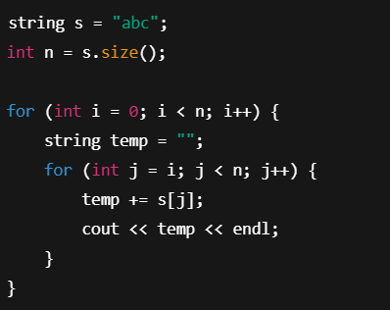

2) SUBSEQUENCES GENERATION : worst O(2^n) lagega hi
a) RECURSION :
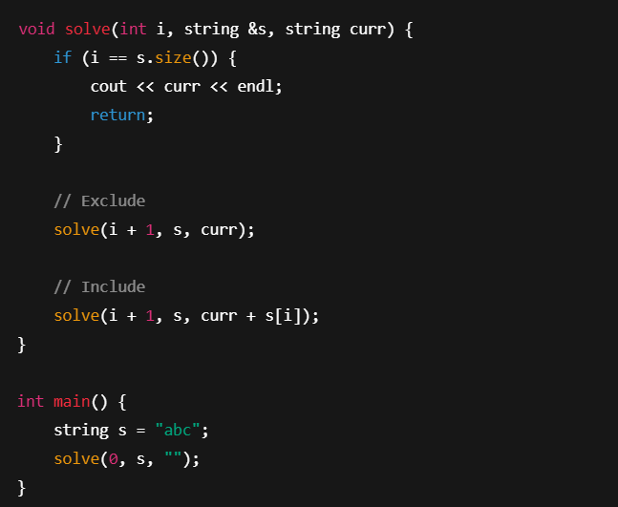

b) BITMASKING:
