- Recursion mein function stack mien tab tak intezar karte rehta hai jab tak usko kuch return mein nahi mil jata aur ye return kon karta hai, base case hi kuch bhi return karta hai jiske wajah se har wo function jo stack mein wait kar raha tha kisi bhi function ke complete hone ka, uska wait over hota hai, if base case nahi dia hua hai toh infinite functions ko wait karna padega jiske wajah se stack will run out of memory and segmentaion fault occurs.
- Below is for fibonacci numbers :-
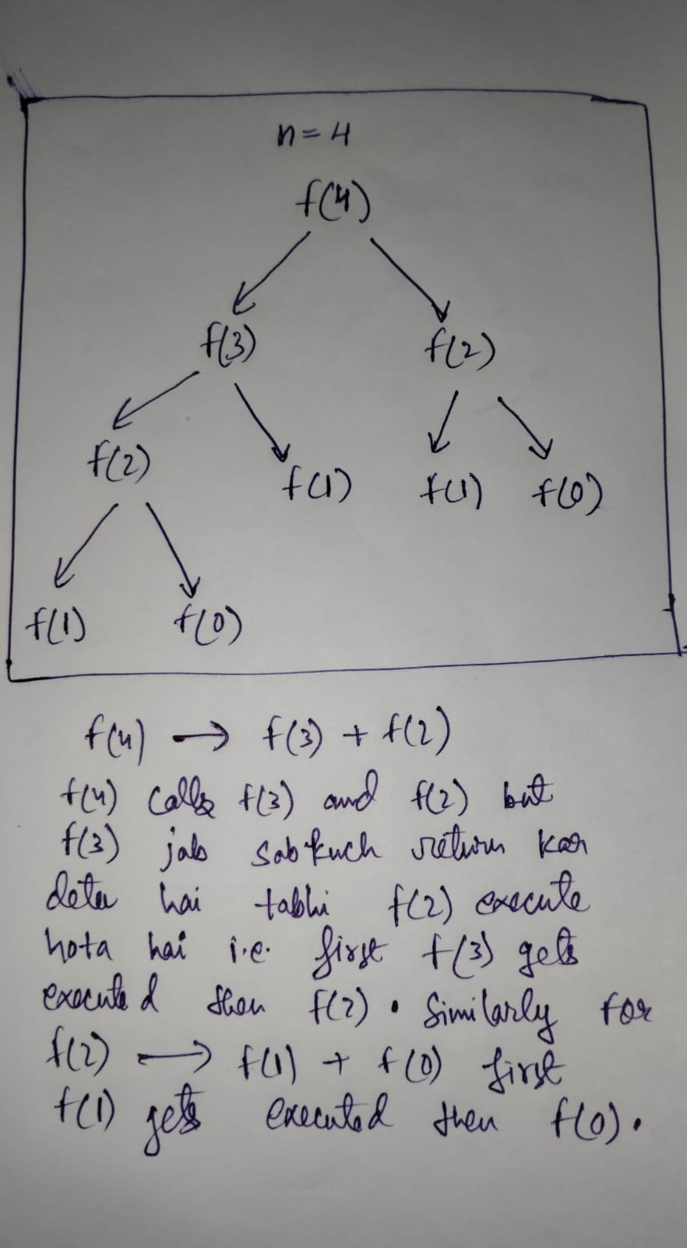
- Recursion tree aur code similar hi hota hai, if you can make recursion tree you can also write the code.
- Recursion ka jo stack space hota hai wo bhi space comeplexity ka part hai but usko mostly nahi compute karte hai but agar program mein koi aur space use ho raha hai toh usko spce complexity mien include karte hai.
- Recursion is trying out all possibilities, recursion tree mein bhi aisa hi hota hai, like abhi jo state mein hai usse konse konse state mein jaa sakte hai.
- Recursion tree mein hamesha phele left wala part pura execute hota hai tabhi right wala hota hai, like left wala part execute hua for each function then backtrack karte hue right wala part ko bhi execute karte chalega.
- Recursion tree banate hai based on question like kuch mein pick and not pick se ban jata hai, kisi mein pointer ko array pe move karne se banta hai and other ways also depends on question.
- Recursion playlist – 6,7,20,21 dekh lena in which 6,7 –most imp.
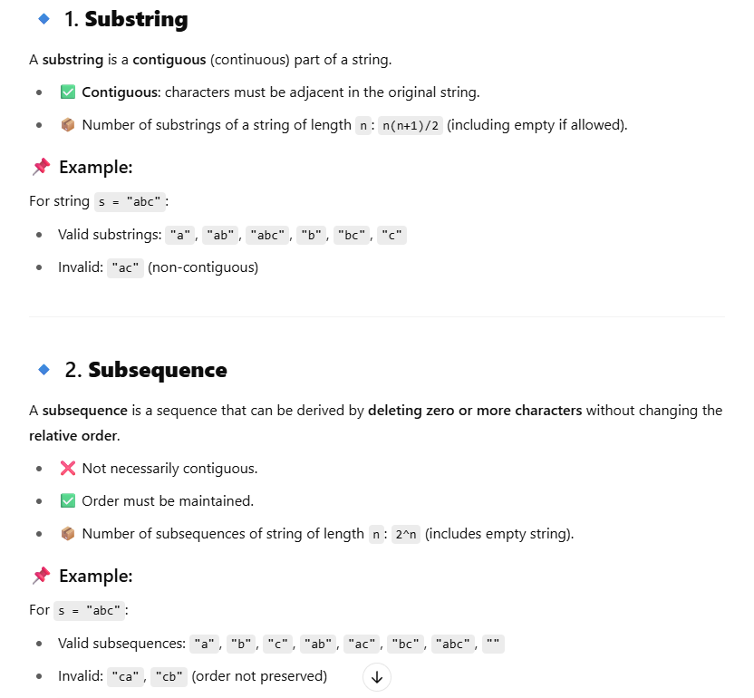

PERMUTATION
Given a set or array of n distinct elements, a permutation is any of the possible ways to order these n elements.
- The total number of permutations of n distinct elements is:
n!=n×(n−1)×…×1
✅ Example:
If you have the set {1, 2, 3}, then its permutations are:
[1, 2, 3]
[1, 3, 2]
[2, 1, 3]
[2, 3, 1]
[3, 1, 2]
[3, 2, 1]
These are a total of six, and 3! = 6.
