
Lab Manual- SysOps with Azure CLI

Prepared for:
Date: 18th Nov 2024
Prepared by: Bipin Sinhaa
Document Name: Lab Manual
Document Number SysOpsLab311
Contributor:
Shruti Sinhaa

Table of Contents
1 OBJECTIVE 3
2 PRE-REQUISISTE 3
3 Setup Up Azure CLI in Cloud Shell 3
3.1 Azure Resource Group 5
3.2 Azure VM Comamnd 6
3.3 Azure Storage Comamnd 8

OBJECTIVE
Azure CLI is a cross-platform command line tool, that is used to manage and administrate Microsoft Azure. It doesn’t replace PowerShell but provides an alternative to using managing Azure from the command line. You can still continue using PowerShell, the APIs and the Azure Portal just like before. Azure CLI provides some tangible benefits over these, especially over PowerShell in that it’s very nimble and can be quickly installed on almost any platform.This Lab will cover the basics of configuring Azure cli.

Actually an Azure CLI command has the following structure:

- a command group which represents an Azure service and which can be the composition of subgroups
- a command which is the action you want to do on the group / Azure service
- arguments optionally which are a list of parameter names and values

PRE-REQUISISTE
- Accounts in Azure
- A local Computer with 4 CPU, 16 GB RAM, 200 GB disk space

Setup Up Azure CLI in Cloud Shell

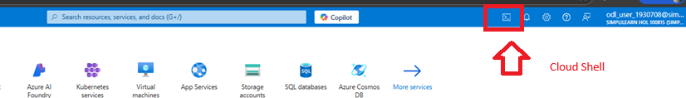

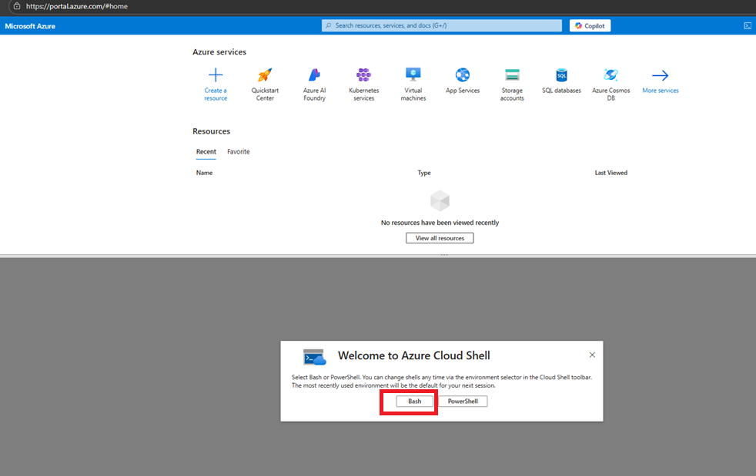

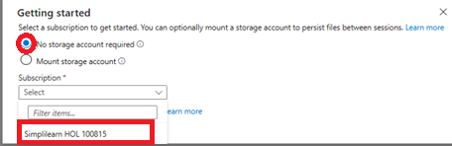

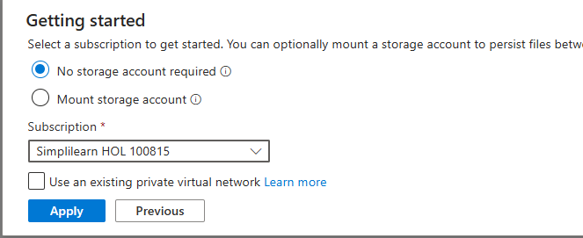

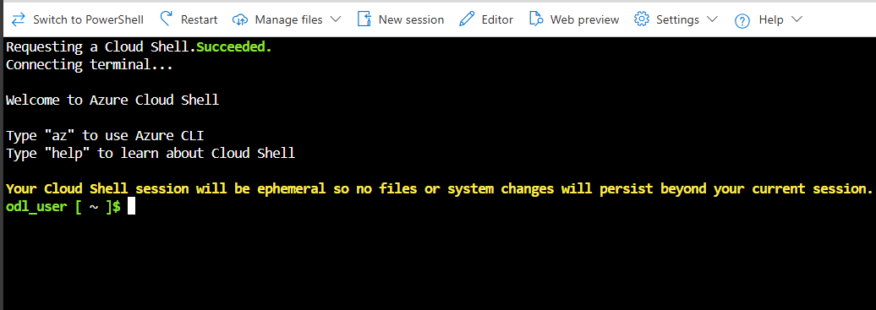

Azure Resource Group
To list all Resource Groups, use:
az group list --output table
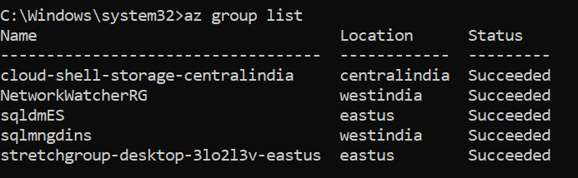
To create a new Resource Group Name Azclidemo at eastuse region , type:
az group create --name bipeenRG --location westus2
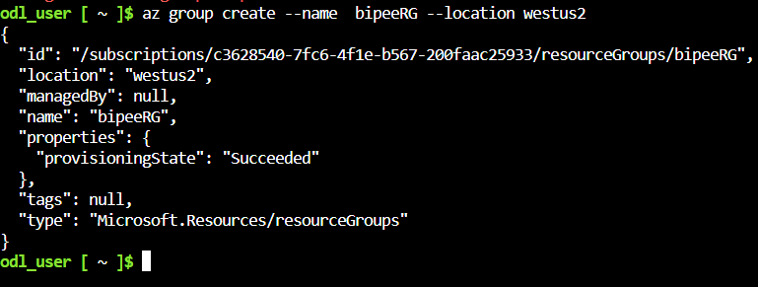
Now list the resources group again to see your created Resources group Azclidemo
az group list --output table
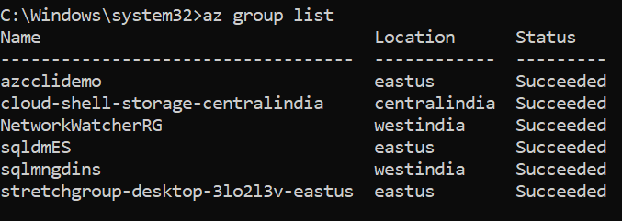
Now to delete Resources group Azclidemo type below command and type list command to verify
az group delete --resource-group azcclidemo --yes --no-wait
az group list --output table
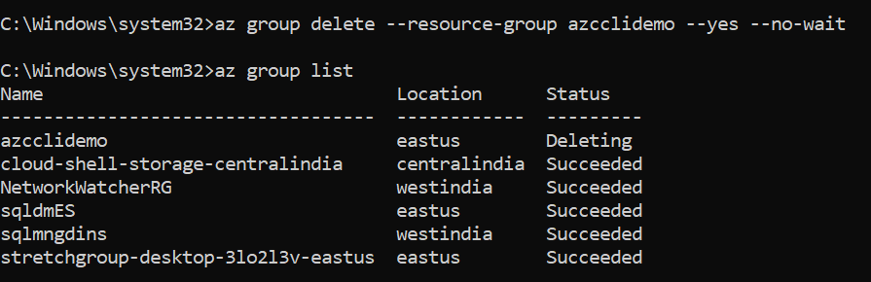

Azure VM Comamnd
Type below command to create a vm name BipeenVM in resource group BipeenRG resource group with default user VMadmin
az vm create --resource-group "bipeenRG" --name "bipVM" --image "Win2016Datacenter" --admin-username "Vmadmin" --admin-password "Password@123" --location westus2 --storage-sku "Standard_LRS"
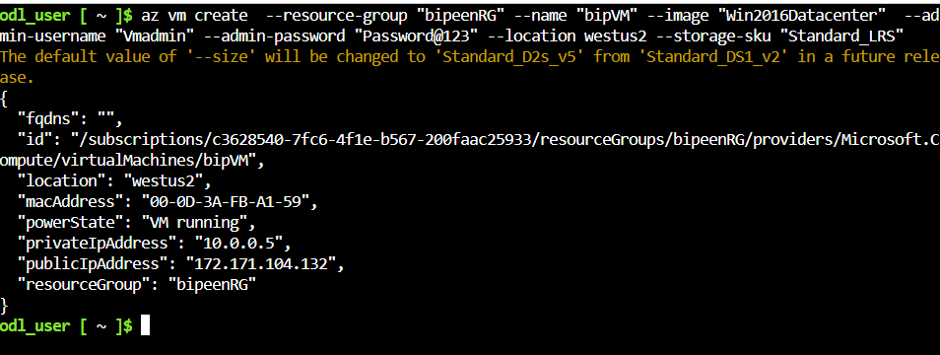
To list all vm type below command
az vm list --output table
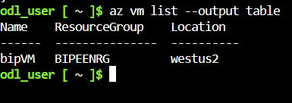
To stop vm type below command
az vm stop --resource-group BipeenRG --name BipeenVM
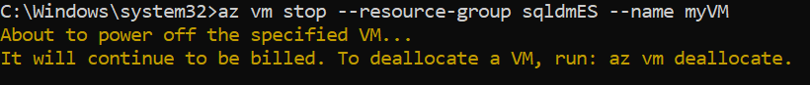
az vm start --resource-group BipeenRG --name BipeenVM
az vm delete --resource-group BipeenRG --name BipeenVM
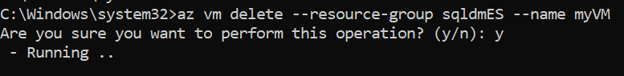

Azure Storage Comamnd

az storage account create --name bipeenst675676 --resource-group BipeenRG --location westus2 --sku Standard_LRS --kind StorageV2 --access-tier Hot

az storage container create --name data --account-name bipeenst675676 --auth-mode login

az storage container create --name marketing --account-name bipeenst675676 --auth-mode login

az storage container delete --name data --account-name bipeenst675676 --auth-mode login

az storage account update --name bipeenst675676 --resource-group BipeenRG --set tags.Depart=Sales

az storage container list --account-name bipeenst675676 --auth-mode login --output table

az storage account show --name bipeenst675676 --resource-group BipeenRG --query "tags" --output table

