Data :

(First 5 rows)

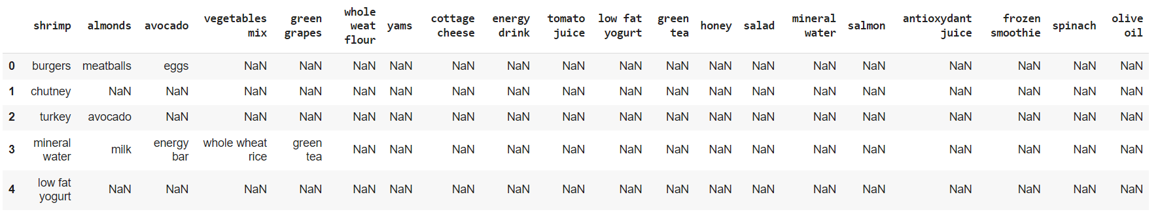

Data visualization:

