23BD1A661G P. Viswambhar CSM-A
Elastic File Storage
Amazon Elastic File System (EFS) is a scalable and fully managed file storage service provided by Amazon Web Services (AWS). It allows you to create and configure file systems that can be accessed concurrently from multiple EC2 instances, providing a highly available and scalable storage solution for your applications and workloads.
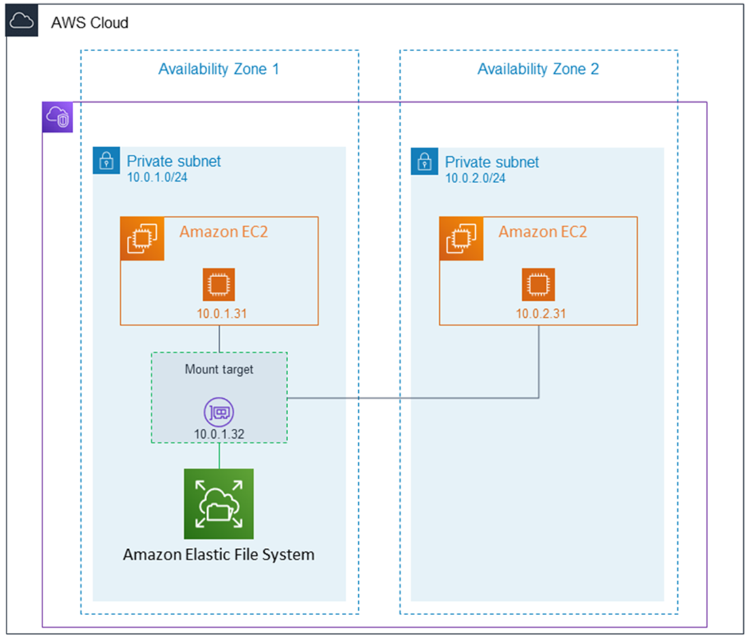
Amazon EFS supports for only Amazon Linux instance:
Step 1: Launching EC2 Instances
1. Sign in to AWS Management Console.
2. Go to the EC2 dashboard.
3. Click on "Launch Instance".
4. Configure instance details:
- Instance Name: EFS-1
5. Choose an Amazon Machine Image (AMI) for Linux.
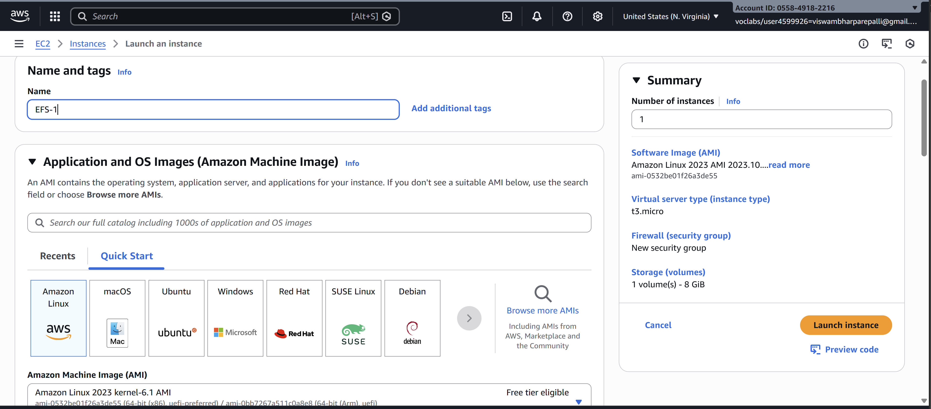
6. Select instance type: t2.micro.
- Key Pair: EFS
- Network: Choose Subnet-1a
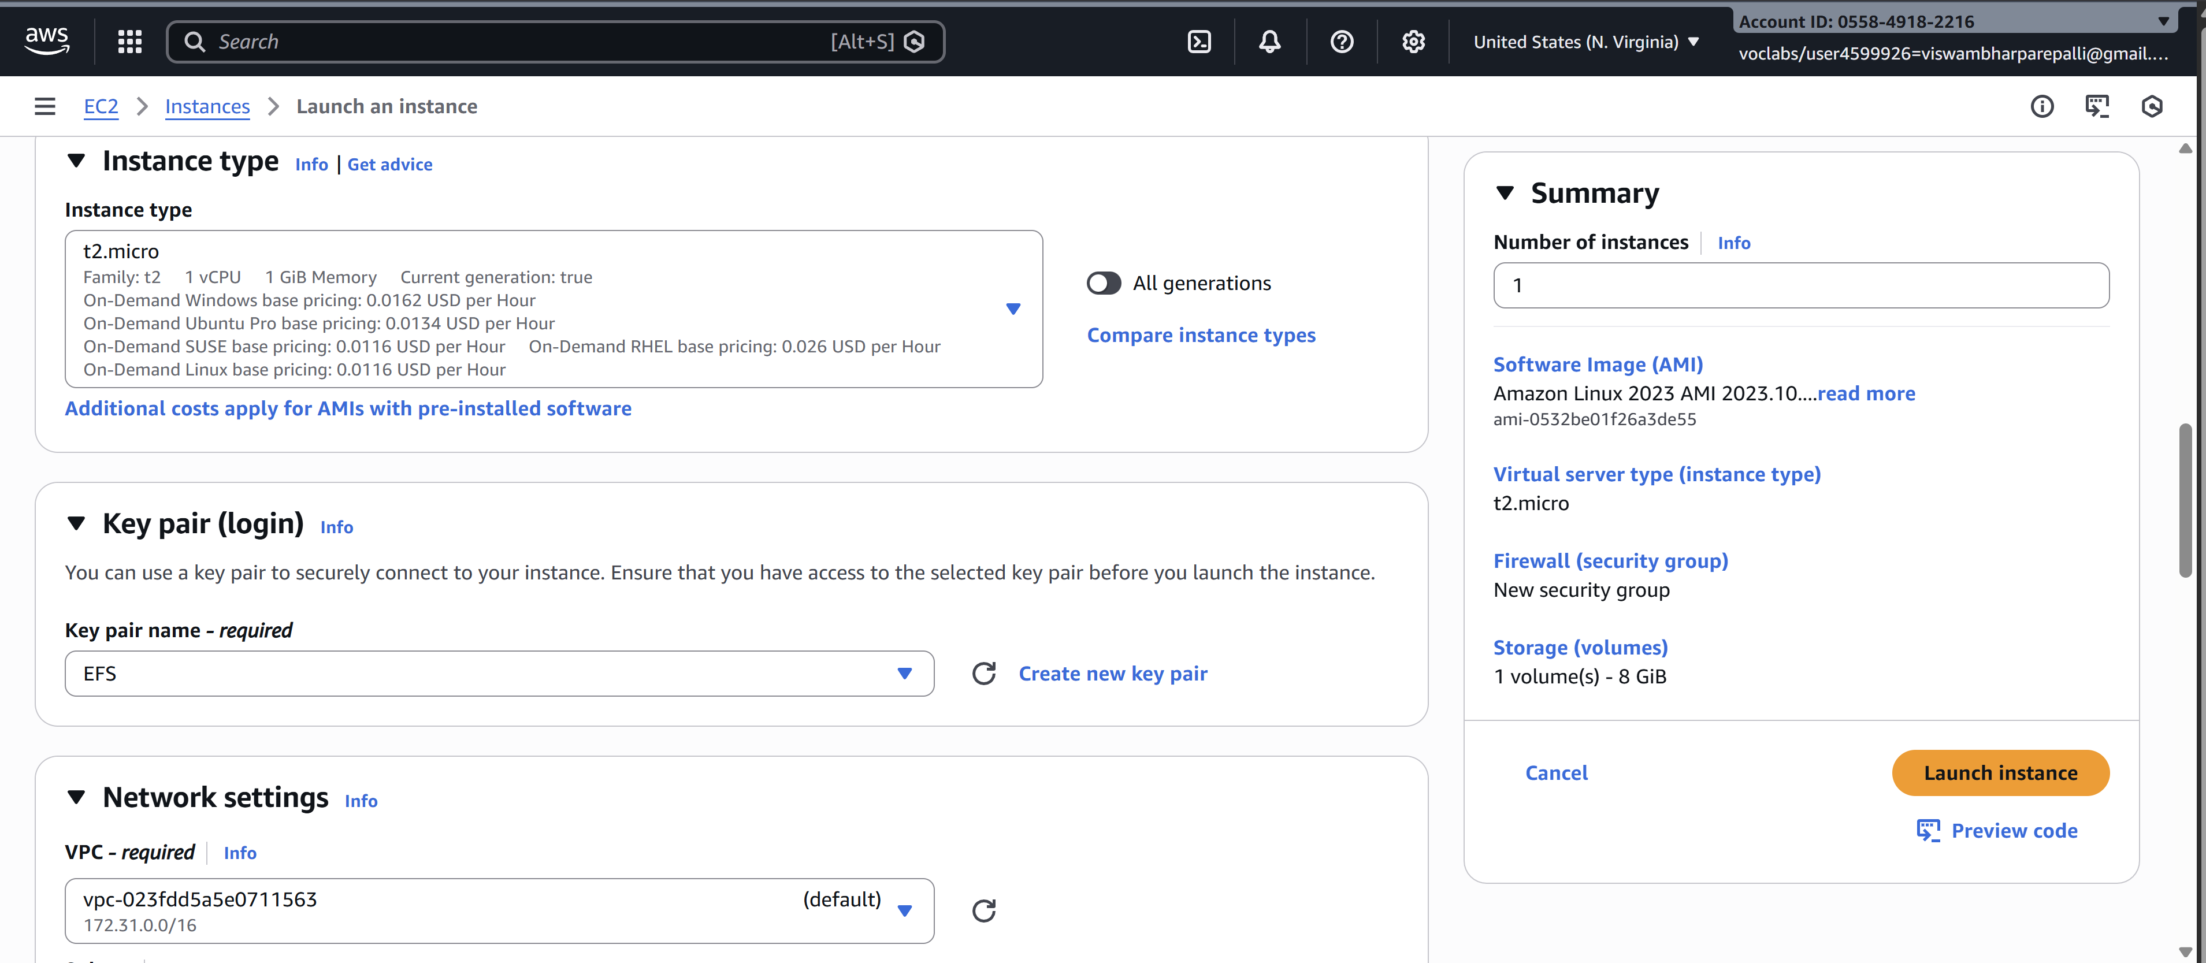
- Security Group: Create a new security group (SG) and add NFS and allow from anywhere.
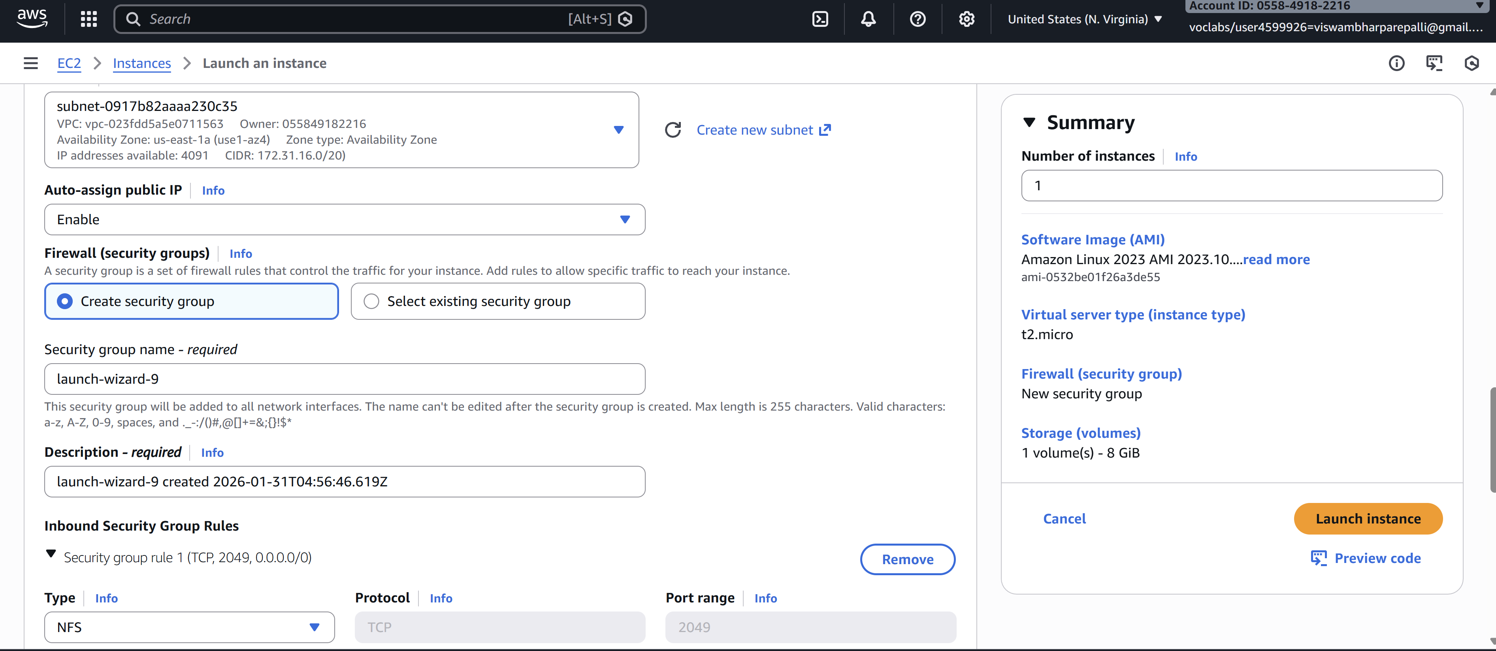
7. Launch the instance.
8. Repeat the above steps to launch another instance named EFS-2 in Subnet-1b with the same configuration.
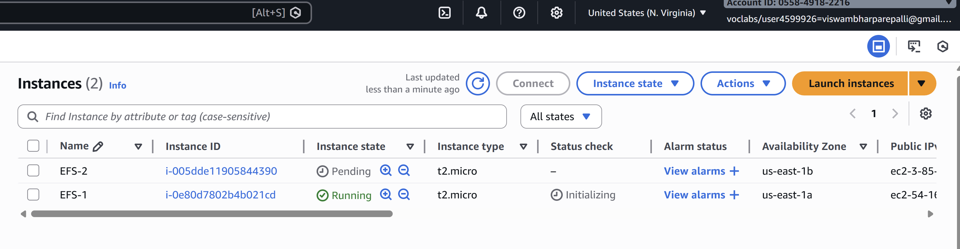
Step 2: Creating an EFS File System
1. Go to the EFS service in the AWS Management Console.
2. Click on "Create file system".
3. Specify details:
- Name: Optional
- VPC: Default
- Enable region button.
Click on "Next".
4. In the Network settings:
- Delete all security groups.
- Select the newly created security group (NFS).---which is created while creating instance
Click on "Next" and review the configuration.
Click on "Create file system".
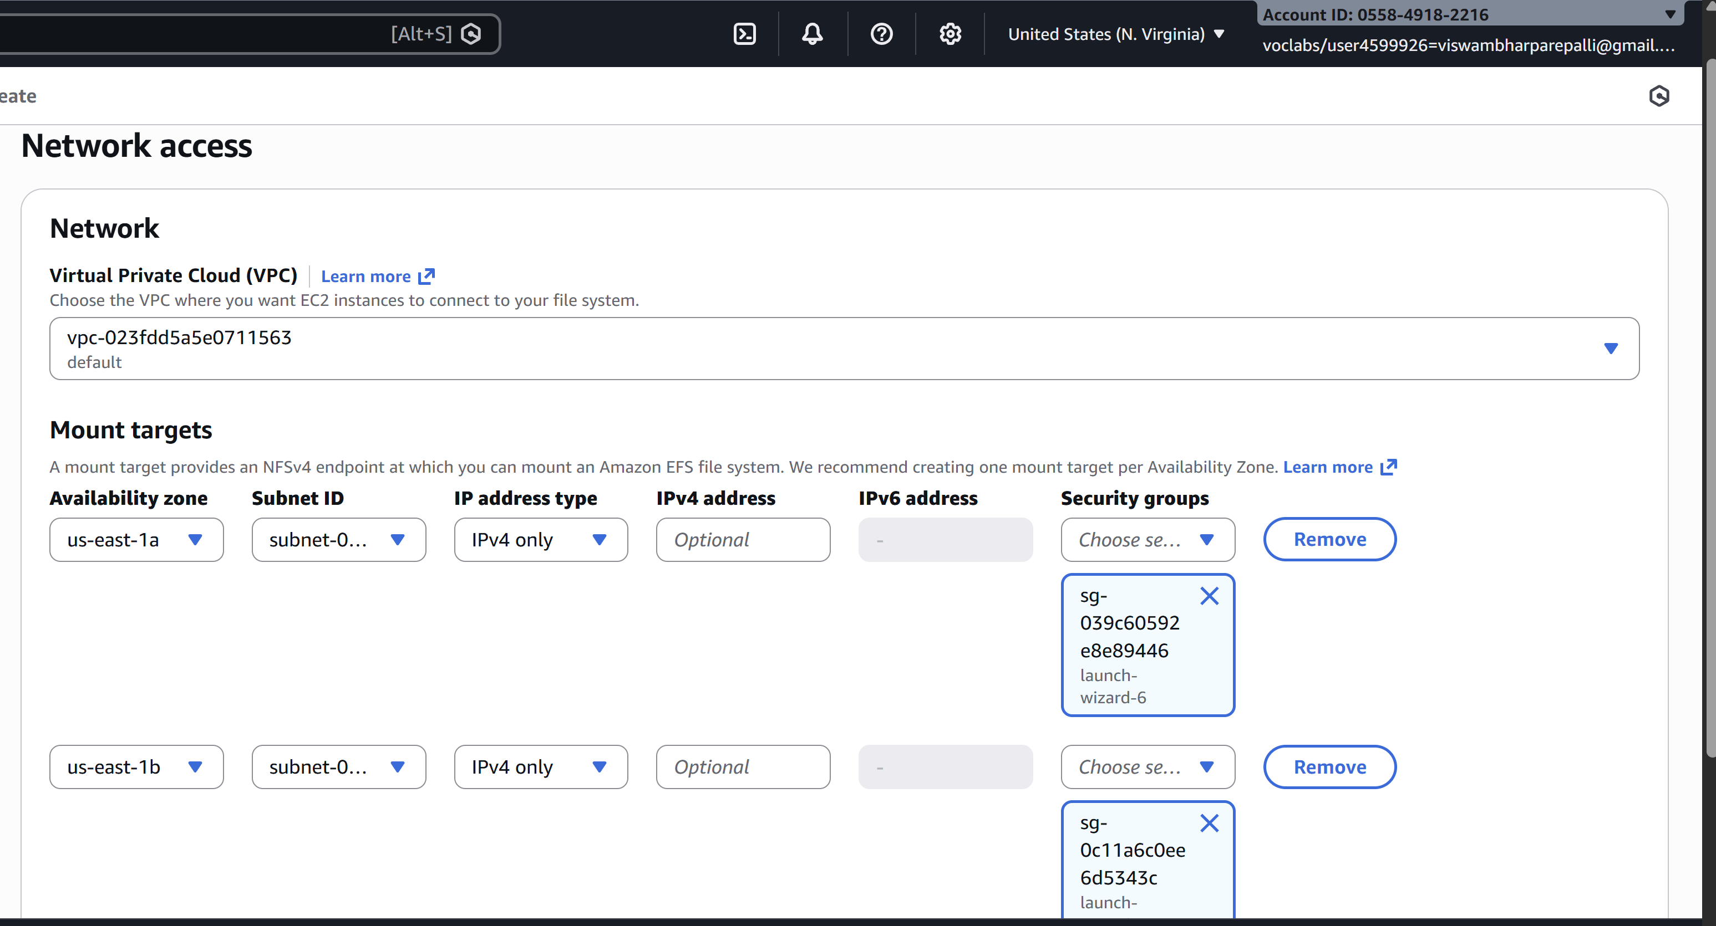
Step 3: Accessing the two EC2 instances named EFS-1 & EFS -2 in two different PowerShell sessions and performing the specified tasks:
Accessing EFS-1 Instances in Two Different PowerShell Sessions:
1. Open Two PowerShell Sessions:
- Open two separate PowerShell windows or tabs on your local machine.
For each Instance:
2. SSH into the Instance:
- Use the SSH command to connect to the EFS-1 instance
ssh -i [path-to-your-keypair.pem] ec2-user@[instance-public-ip]
3. Switch to Root User:
- Gain root access by executing the following command:
sudo su
4. Create a Directory:
- Make a directory named "efs" using the following command:
mkdir efs
5. Install Amazon EFS Utilities:
- Use yum package manager to install the Amazon EFS utilities:
yum install -y amazon-efs-utils
6. List Files:
- Execute the following command to list files in the current directory:
ls
7. Verify Installation (Optional):
- Optionally, you can verify the installation of the Amazon EFS utilities by checking the version:
efs-utils --version
Repeat Steps 2-7 for ------------------------- EFS-2 Instance.
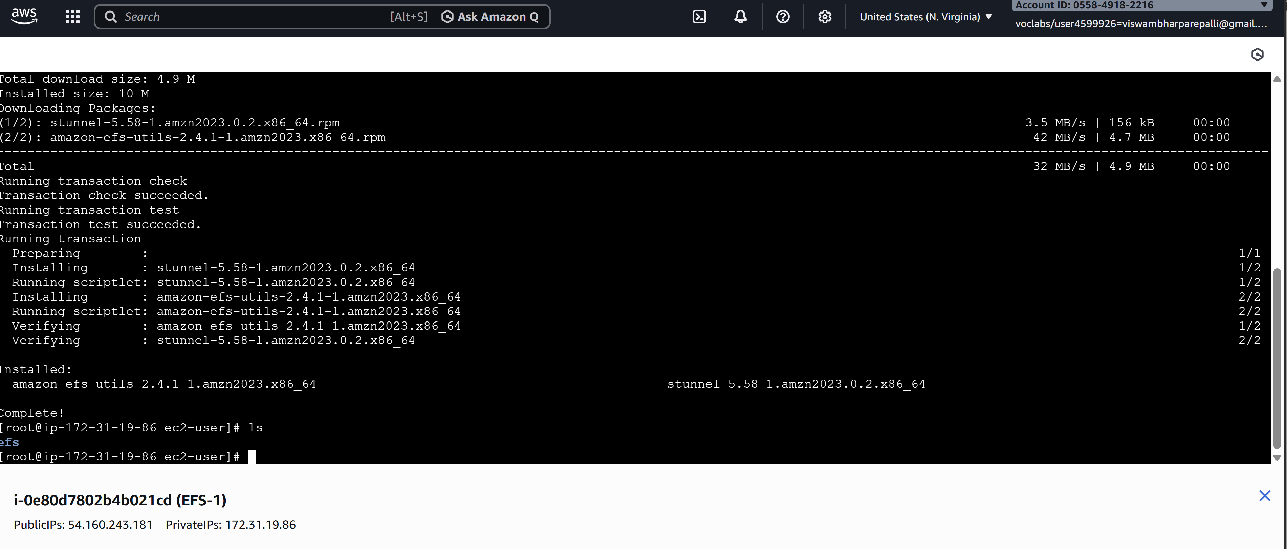
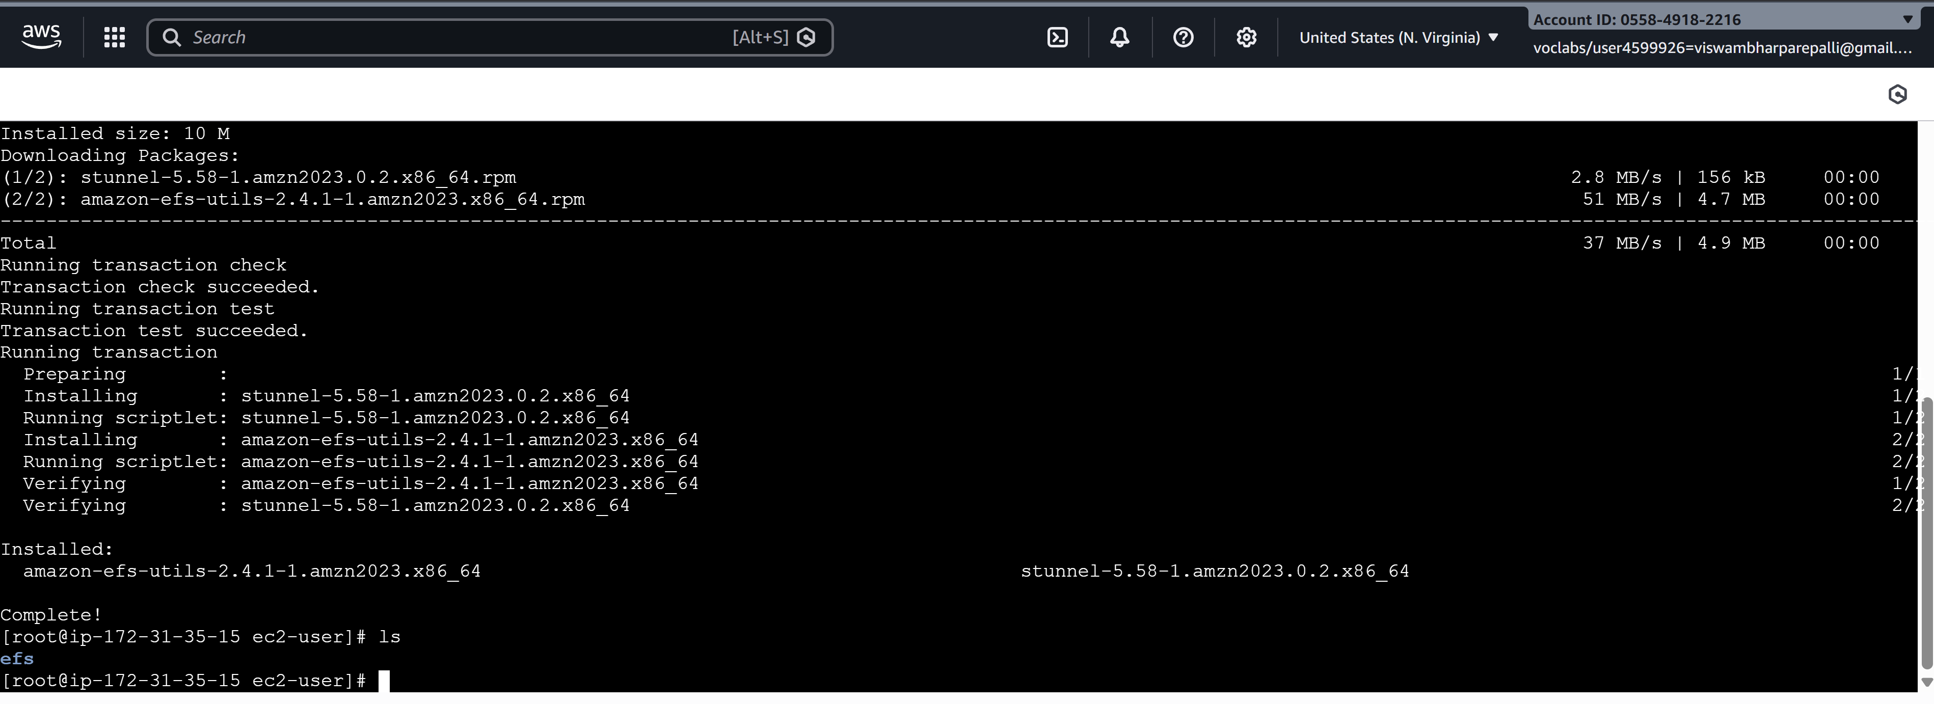
By following these steps, you'll have accessed each EFS-1 instance in separate PowerShell sessions, switched to the root user, created a directory named "efs," installed the Amazon EFS utilities, and listed files in the directory. This setup allows you to configure and manage each instance individually as needed.
Step 4: Attaching EFS to EC2 Instances
1. Go to the EFS service in the AWS Management Console.
2. Click on the target EFS file system.
3. Click on the "Attach" button.
4. Choose "Mount via DNS" option.
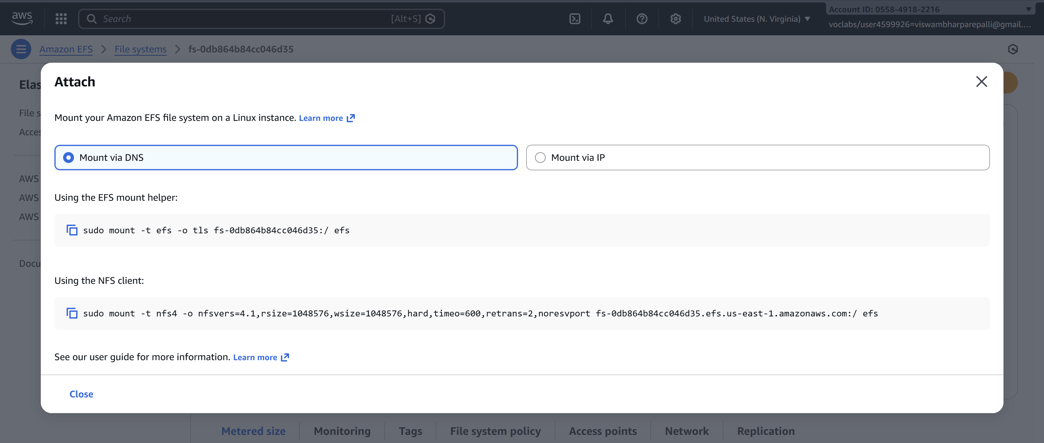
5. Copy the displayed command. ,on both ec2 instances(powershell)
6. Paste and execute the copied command in the terminal to mount the EFS file system onto the instance.
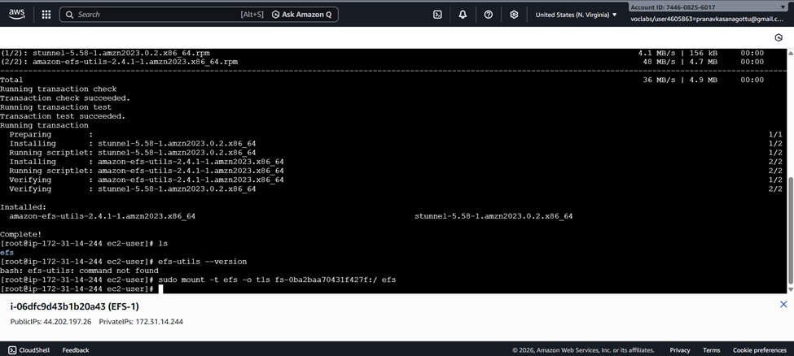
Step 5: Verify and Test EFS
1. Change the directory to EFS on both instances.
2. Create a file on one instance.
3. Verify that the file automatically synchronizes and appears on the other instance.
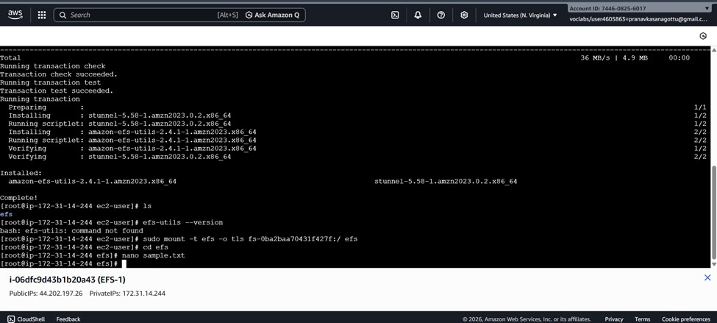

By above steps, we can successfully create EC2 instances, configured them, created an EFS file system, and attached it to the instances in the same availability zone in the Mumbai region. Now, the instances can seamlessly access and share files stored in the EFS file system.

VIVA QUESTIONS
1. Multiple EC2 across AZs must read/write same files. Which service and why?
EFS. It’s a shared network file system that supports simultaneous access from many EC2s across Availability Zones, unlike block storage.

2. EC2 in three AZs needs shared storage with low ops overhead. How does EFS help?
EFS is fully managed, auto-scales, and provides one filesystem mounted by all EC2s—no clustering or replication setup needed.

3. Can two EC2s modify the same file at once? What happens?
Yes. Both can write, but last write wins unless your application handles file locking.

4. EFS mount times out. What do you check first?
Security Groups (port 2049), mount targets, subnet routing, and NACLs.

5. EC2 in private subnet can’t mount EFS. What’s missing?
Usually a mount target in that AZ/subnet or proper security group rules allowing NFS traffic.

6. No mount targets in all AZs — impact?
EC2 in those AZs cannot mount EFS locally and may fail or incur cross-AZ latency.

7. Why mount targets per AZ? What if one AZ fails?
They provide local access and high availability. If one AZ goes down, EC2 in other AZs keep working normally.

8. Two apps in different subnets need EFS. How configure networking?
Ensure mount targets in both subnets’ AZs and allow NFS (2049) between EC2 and EFS security groups.

9. Only specific EC2s should access EFS — how?
Attach a security group to EFS that allows inbound 2049 only from selected EC2 security groups.

10. Why mount with -t nfs4? What’s the advantage?
EFS uses NFS for standard POSIX file access, enabling multiple servers to share files safely and easily.

11. Why move from EBS to EFS for shared access?
Because EBS can’t be concurrently mounted by multiple EC2 instances (except limited Multi-Attach cases).

12. App sees high latency accessing EFS — what to check?
AZ mismatch, cross-AZ traffic, subnet routing, and whether EC2 is mounting a remote AZ target.

13. Can EFS be accessed from another VPC? How?
Yes — using VPC peering, Transit Gateway, or VPN, plus routing and security group rules.

