VPC USING BASTION SERVER
- Inorder to connect to private subnets, we have an option called bastion server. So lets create an ec2 instance with the same name with .ppk keypair.
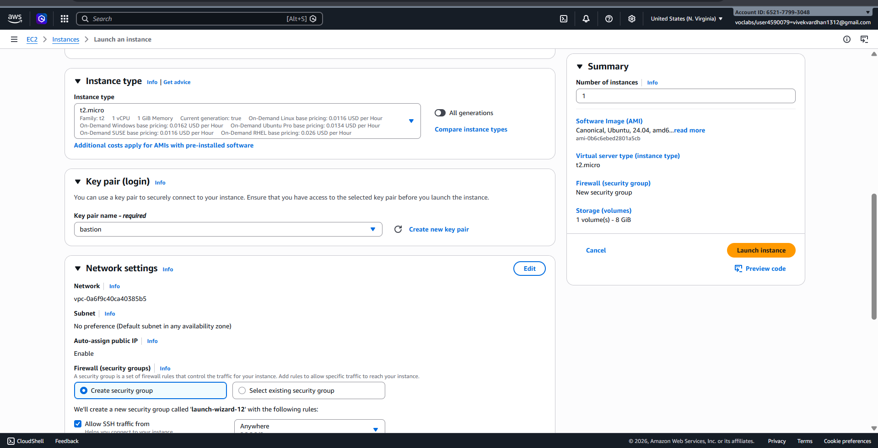

- Create the instance in public subnet, allow ssh and internet traffic along with this, add MYSQl/AURORA also.
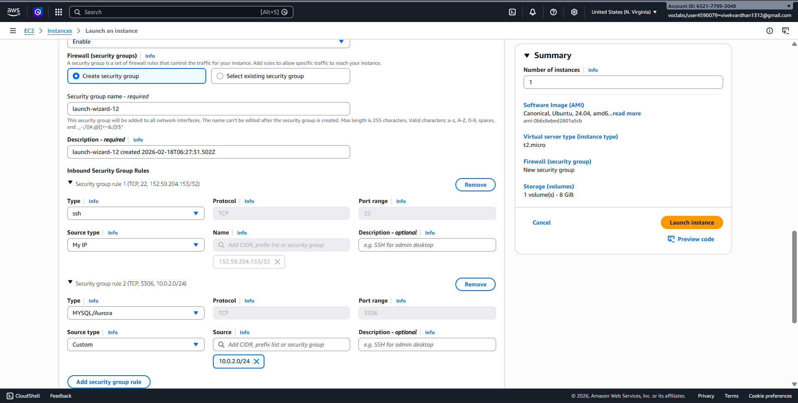
- Download Winscp software for windows from google and install in the computer

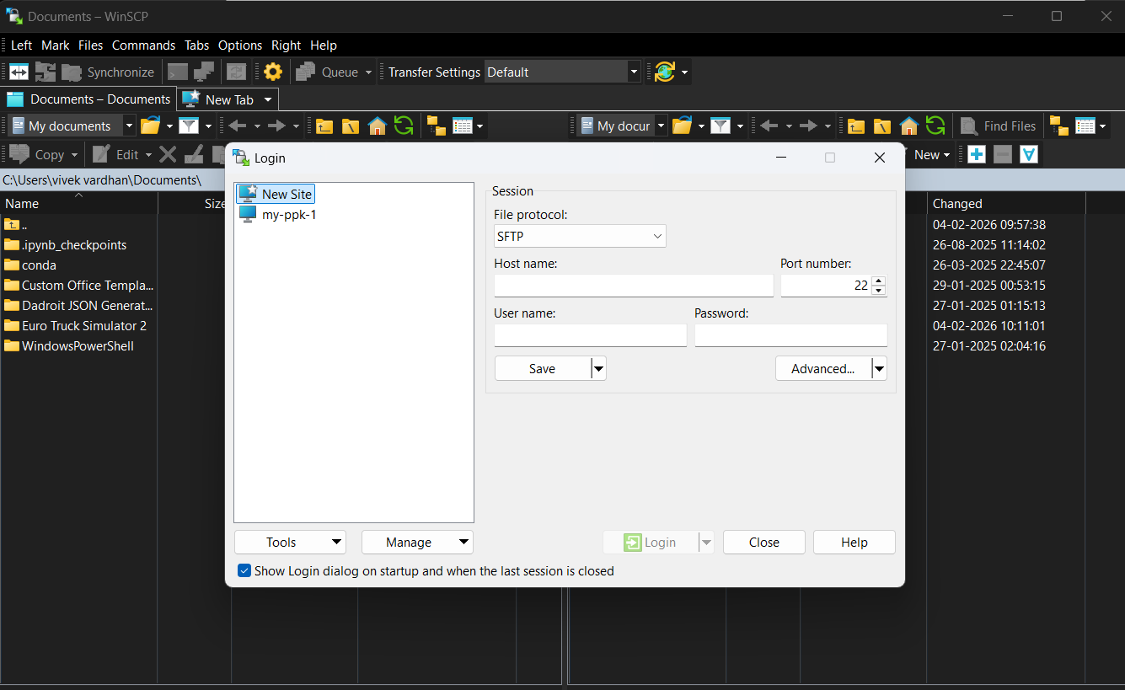
- Copy the public IP address of bastion server and open the winscp in our system.
- Paste the public IP address in Host name and click on advanced.
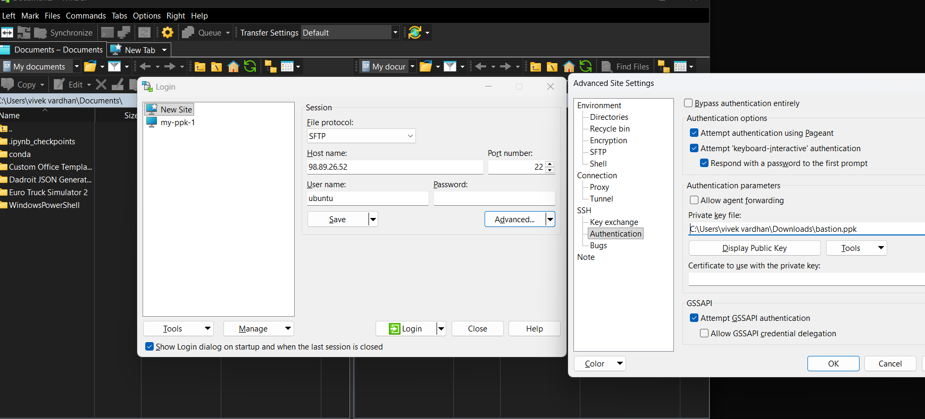

- In advanced, selct authentication, click on browse and navigate to the folder where your .ppk is present and load that file, click on OK. And click on login. Accept the certificate. Give username as Ubuntu.

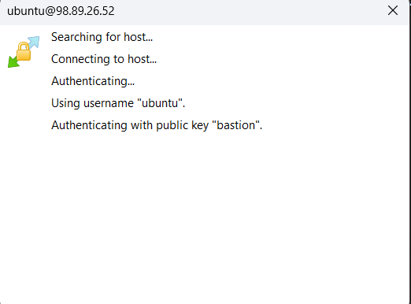

- Copy the .pem file from our desktop to the right side terminal. Just drag and drop.

- Now our private subnet is being accessed. Lets connect the bastion server using putty.

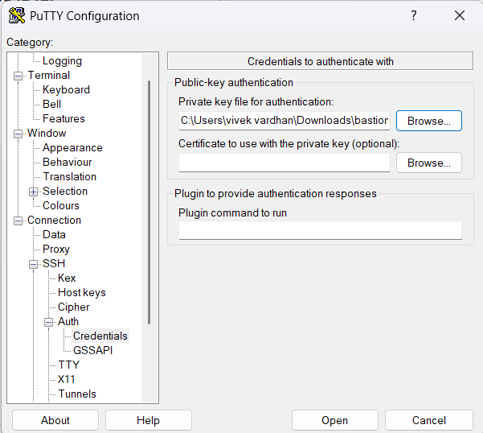

- After connecting through putty, give the commands Sudo su, give ls, check .pem file, give the ssh key of private instance as shown below.

- On successful connection, our private subnet 10.0.2.159 will be connected using successfully. And our ipv6 address will be shown in the command prompt.

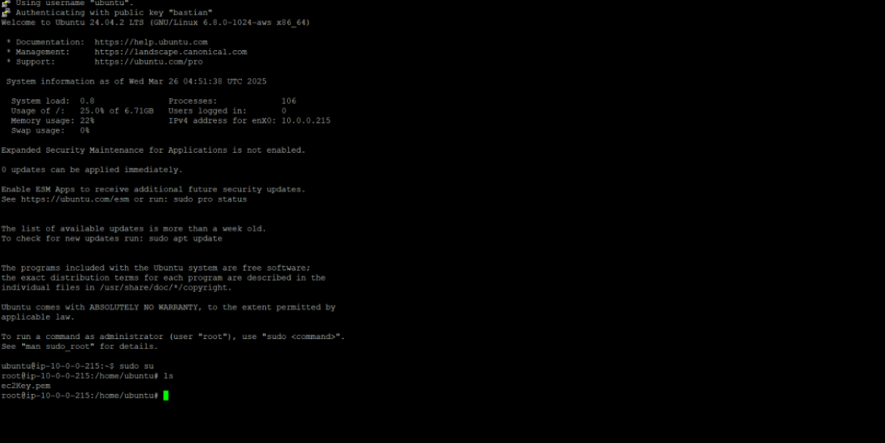

VPC USING NAT GATEWAY

- In the above steps we only connected to private subnet with the help of bastion server. If we want to install or update anything in the instances present in private subnet we cannot do and get the warnings like failed to fetch because internet gateway is not attached to the private subnet as shown below.

- We can overcome this problem with the help of concept called, Network Address Translator (NAT Gateway). Goto NAT Gateway in the left side menu bar and click on create NAT gateway.

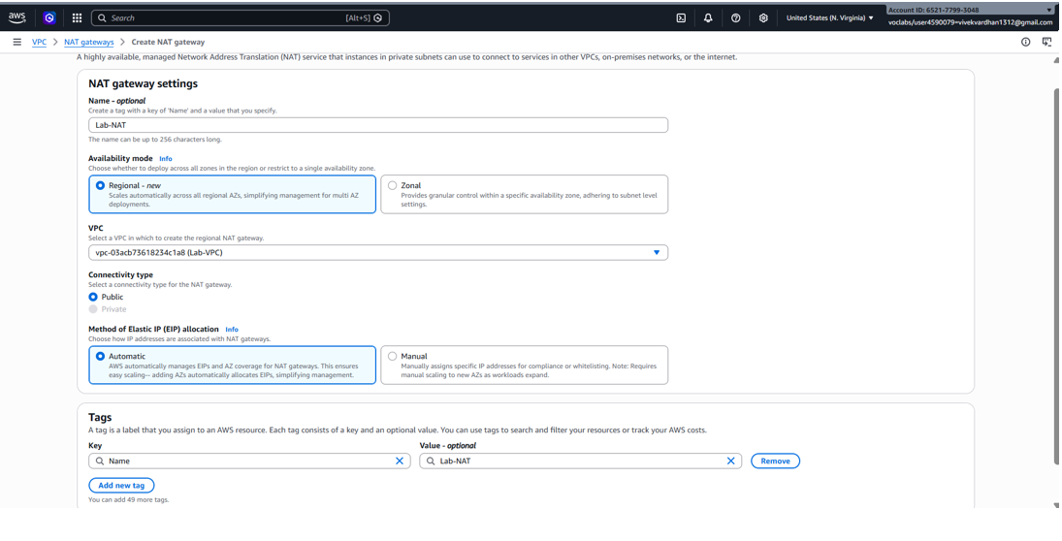

- Give the Nat gateway name, select your VPC, scroll down and clock create NAT gateway

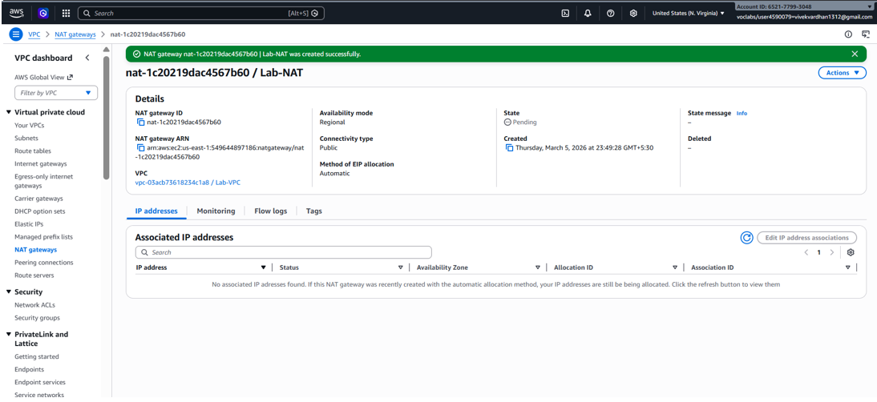

- So Now lets create a rout for accessing NATGateway. Goto Route table click on create route table and give the route table name, along with it our customized vpc and click on create route.
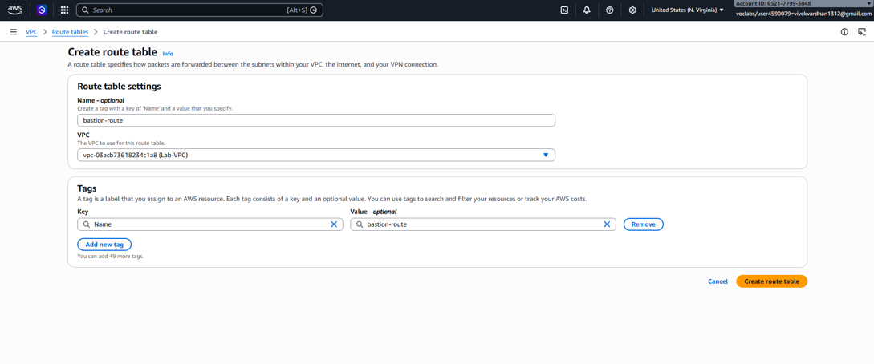

- Click on actions, goto edit subnet associations and add private subnet to this bastion route.
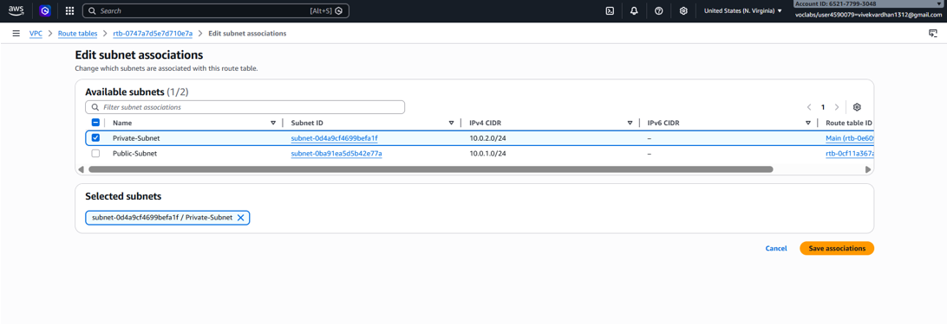

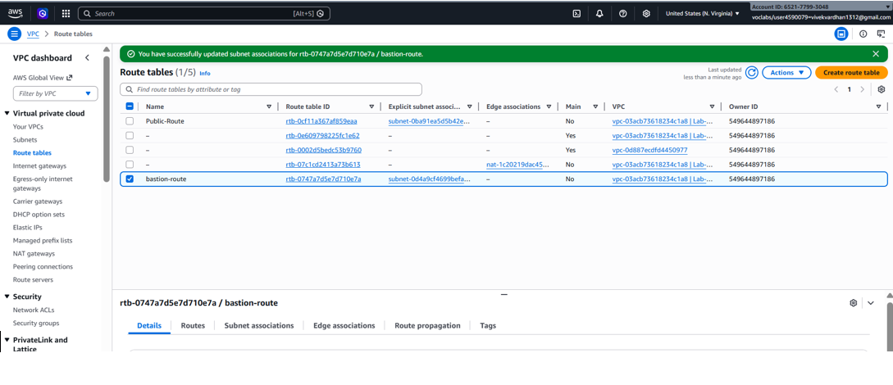

- Again goto actions and click on edit routes, attach NAT Gateway and click on save changes.
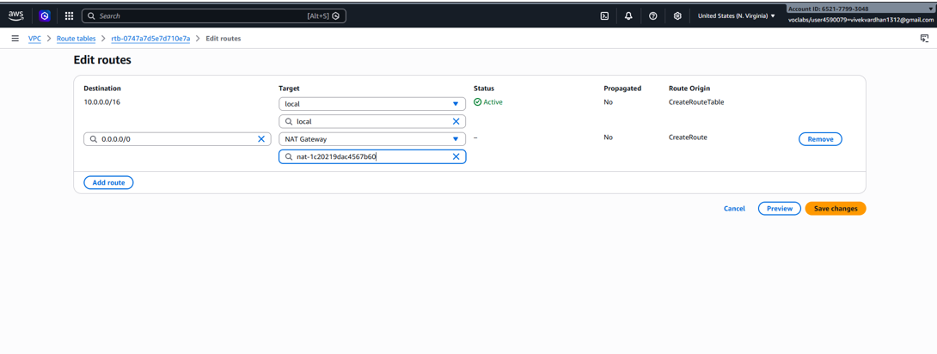
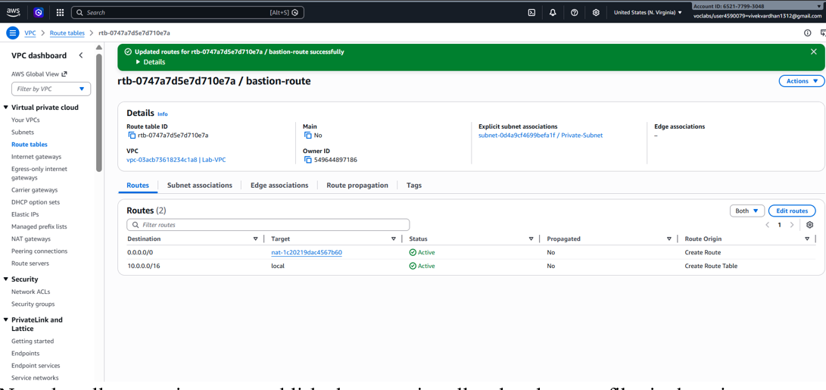
- Now that all connections are established, we can install and update any files in the private subnet as given below.
This completes out VPC with NAT Gateway using Bastion Server inorder to connect and do operations in private subnet.
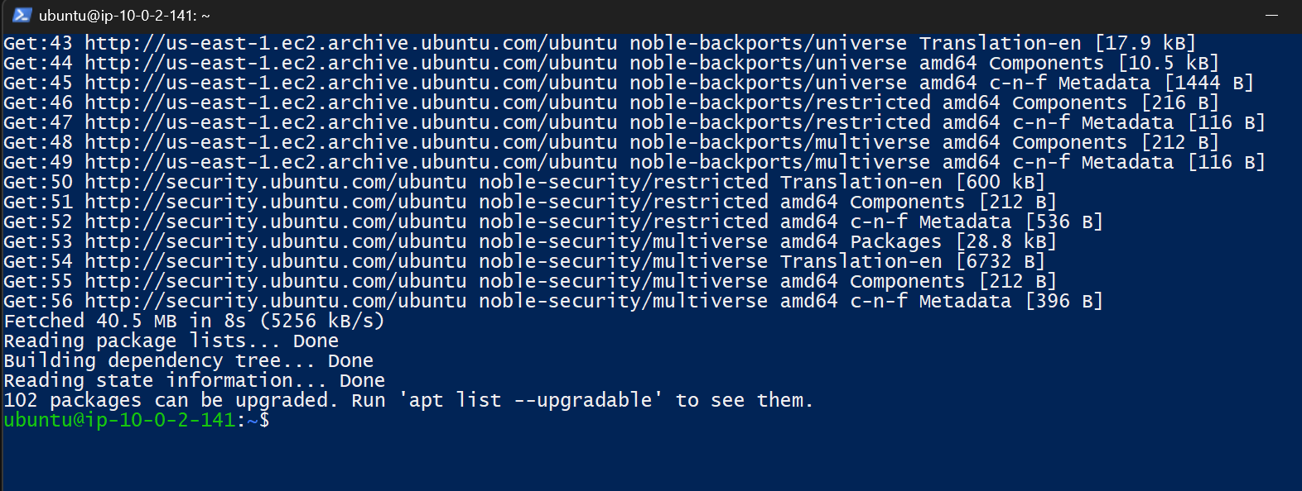
SCENARIO BASED QUESTIONS:-
1. Multiple private subnets in different AZs. One NAT Gateway or multiple?
It is recommended to use multiple NAT Gateways (one per Availability Zone).
This improves high availability and reduces cross-AZ traffic cost, ensuring that if one AZ fails, instances in other AZs can still access the internet.

2. Private subnet instances reach the internet, but NAT Gateway shows no traffic.
Possible reasons:
- Traffic may be routed through another NAT Gateway or Internet Gateway.
- Route table may not be correctly associated with the NAT Gateway.
- Instances may be using VPC endpoints instead of NAT.
- Monitoring delay in NAT Gateway metrics.

3. NAT Gateway created in a private subnet instead of public subnet.
Problem:
The NAT Gateway will not have internet access, so private instances cannot reach the internet.
Fix:
Delete the NAT Gateway and recreate it in a public subnet with an Elastic IP attached.

4. Private subnet needs access only to trusted external services.
You can restrict traffic by:
- Using Security Groups and Network ACLs
- Creating firewall rules
- Allowing outbound traffic only to specific IP addresses or domains.
This ensures the NAT Gateway allows limited outbound access only.

5. Multiple teams share one NAT Gateway and traffic affects others.
Redesign by:
- Creating separate NAT Gateways per team or per subnet
- Using different route tables
- Isolating workloads using separate subnets or VPCs.
This prevents traffic congestion and improves performance.

6. SSH to private EC2 works via Bastion, but apt update fails.
Possible reasons:
- NAT Gateway not configured properly
- Route table missing 0.0.0.0/0 → NAT Gateway
- NAT Gateway placed in wrong subnet
- Internet Gateway not attached to VPC.

7. Private EC2 has internet access but SSH via Bastion fails.
Possible reasons:
- Security Group does not allow SSH (port 22) from Bastion subnet
- Incorrect private IP address
- Network ACL blocking SSH traffic.

8. Bastion server and NAT Gateway created in private subnet.
Impact:
- Bastion server cannot be accessed from the internet
- NAT Gateway cannot access the internet
- Private instances will not get internet connectivity.
Correct setup requires both in public subnet.

9. SSH to Bastion works but SSH to private EC2 fails.
Possible reasons:
- Security group of private EC2 does not allow SSH from Bastion
- Incorrect private IP
- Key file or permissions incorrect
- Network ACL blocking traffic.

10. Why Bastion server cannot replace NAT Gateway?
A Bastion server only provides secure SSH access to private instances.
It does not perform network address translation or allow instances to access external internet services.
NAT Gateway is required for outbound internet connectivity from private subnets.

