WEEK-10--Elastic Beanstalk
Elastic Beanstalk is a Platform as a Service (PaaS) provided by Amazon Web Services that lets you deploy and manage applications without worrying about infrastructure.
Instead of manually setting up servers, load balancers, and scaling:
- You upload your code (Java, Python, Node.js, PHP, etc.)
- Beanstalk automatically:
  - Launches Amazon EC2 instances
  - Configures Elastic Load Balancing
  - Handles scaling (auto scaling)
  - Sets up monitoring with Amazon CloudWatch

When to Use?
Use Elastic Beanstalk when:
- You want quick deployment
- You don’t want to manage infrastructure
- You are building web apps or APIs
Feature | EC2 | Elastic Beanstalk
Type | IaaS (Infrastructure) | PaaS (Platform)
Control | Full control (OS, software) | Limited control
Setup | Manual | Automatic
Scaling | Manual / Auto Scaling setup | Built-in auto scaling
Server Management | You manage everything | AWS manages it
Deployment | Manual (SSH, scripts) | Upload code directly
Learning Curve | High | Low
Use Case | Custom setups | Quick app deployment

Prerequisites
- A web application ready (e.g., .war, .zip, or code) or simple php file

Steps to Create Elastic Beanstalk Application
Step 1: Open Elastic Beanstalk
- Login to AWS Console
- Under Compute section ->Search for Elastic Beanstalk
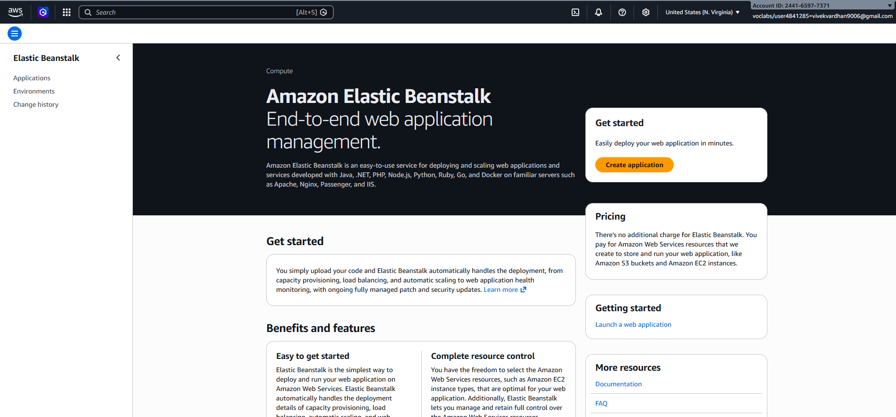
- Click Create Application

Step 2: Create Application
- Enter Application Name (e.g., MyApp)
- Add description (optional)
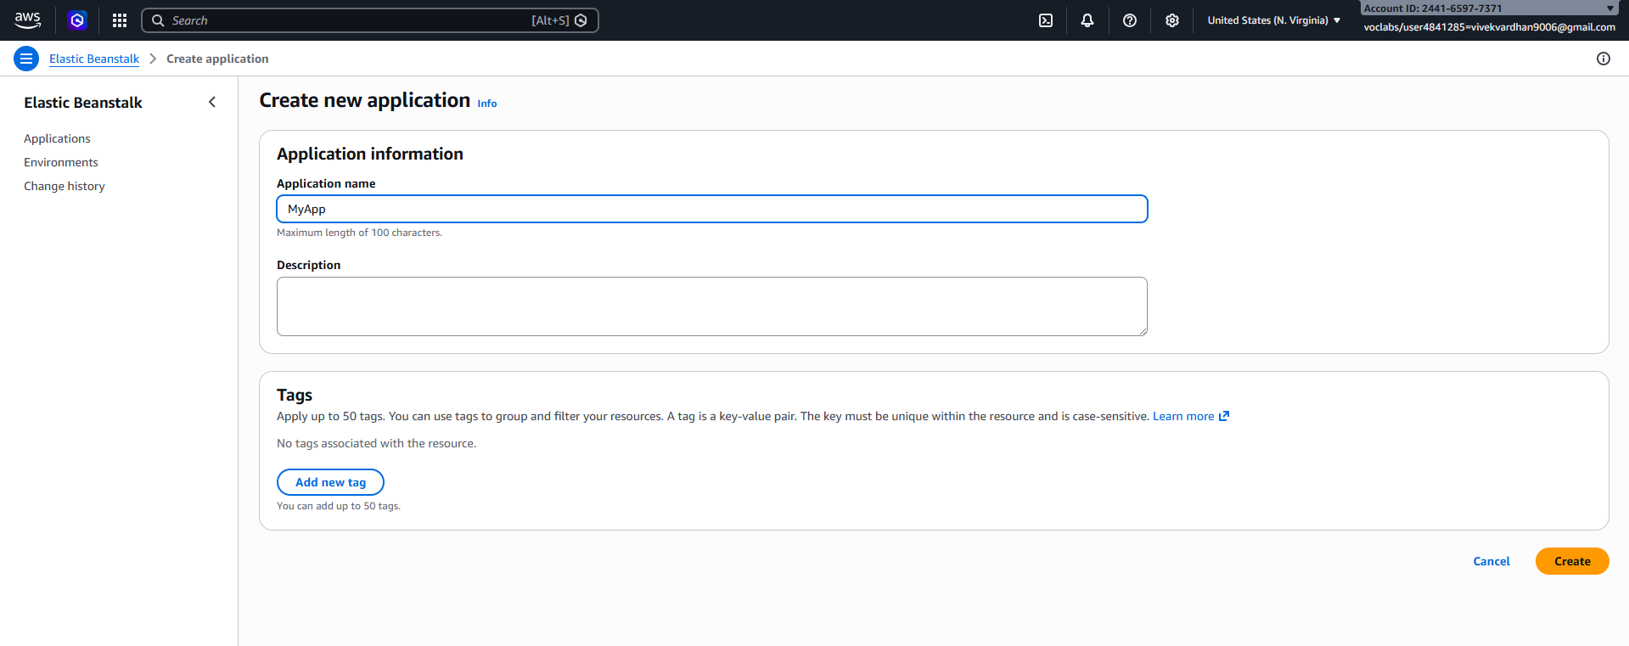
- Click Create
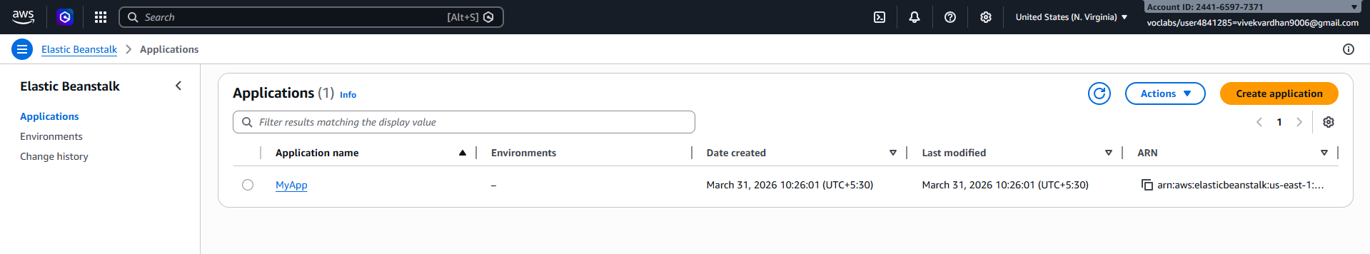

Step 3: Create Environment
- Click Create Environment
- Choose:
  - Web Server Environment (for web apps)
- Click Select

Step 4: Configure Environment
- Enter Environment Name
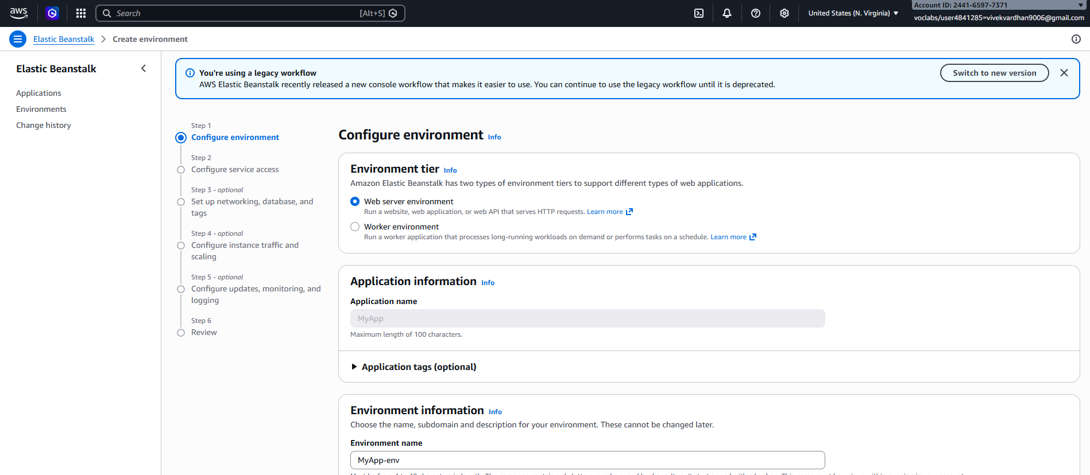
- Choose Platform:
  - Java (for .war)
  - Node.js / Python / PHP / etc.
- Under Application Code:
  - Select Upload your code
  - Upload your .war or .zip file
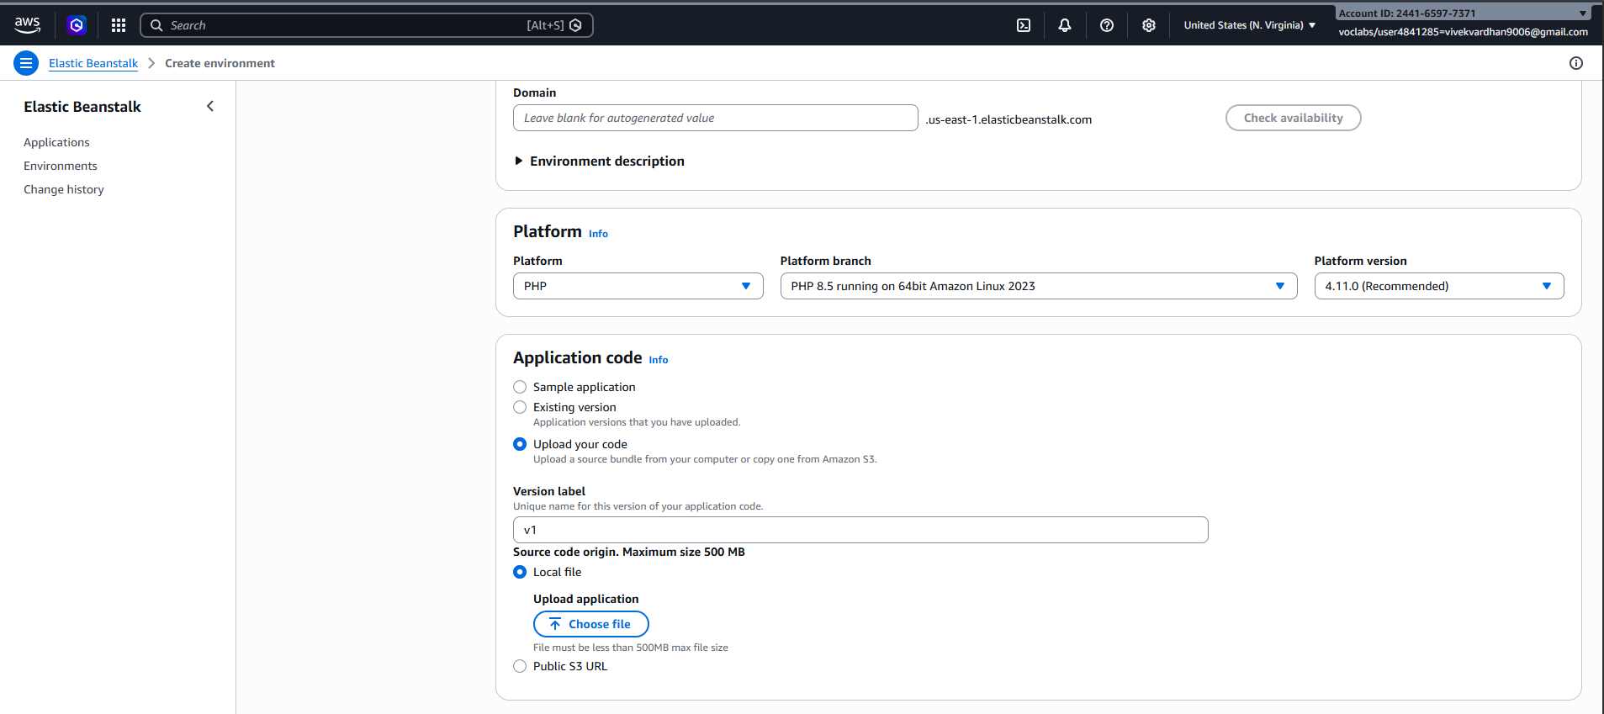

Step 5: Configure Service Access
- Service Role → Select existing -LabRole
- EC2 Key Pair → Optional (for SSH)
- EC2 Instance Profile → select (e.g., LabInstanceProfile)
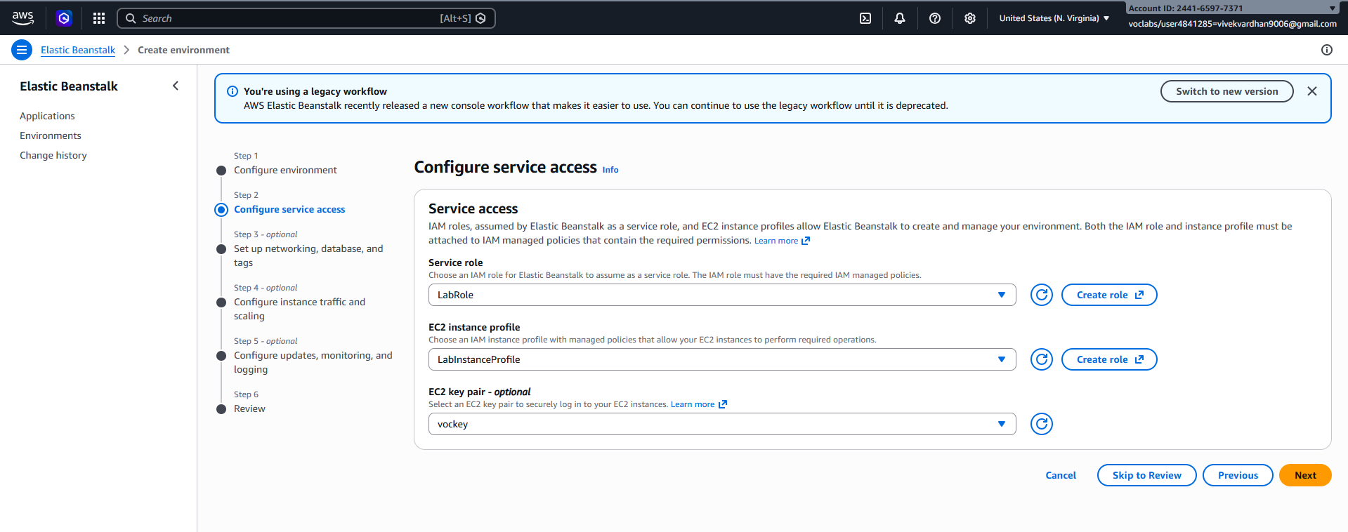

Step 6: Configure Network
- Select VPC (default is fine)
- Select Subnets
- Enable Public IP

Step 7: Instance & Scaling Setup
- Choose Instance type (e.g., t2.micro – free tier)
- Set:
  - Min instances: 1
  - Max instances: 2 (or more)
- Load Balancer → Enabled (optional but recommended)

Step 8: Review & Create
- Click Review
- Click Create

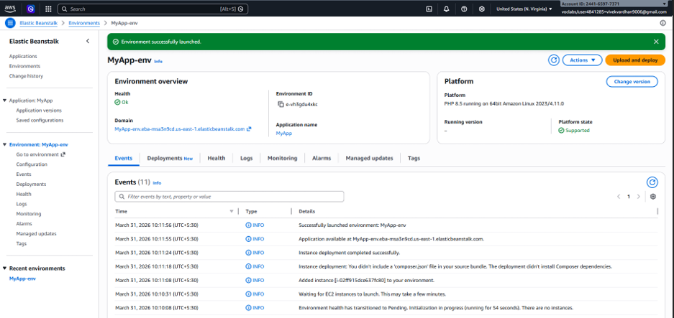

Deployment Process
- AWS automatically creates:
  - EC2 instances

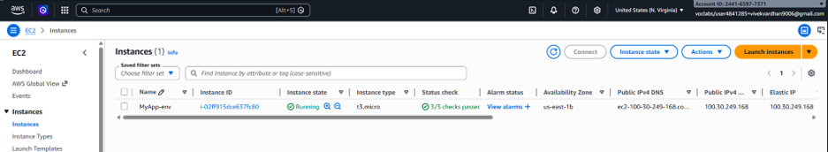
  - Load Balancer
  - Auto Scaling Group
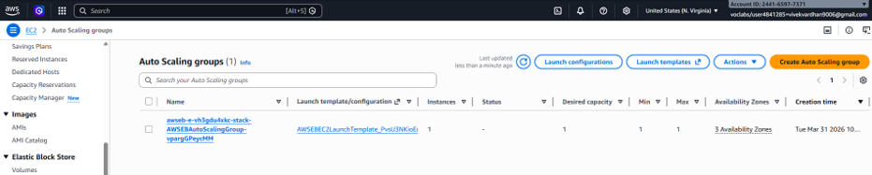

  - Security Groups
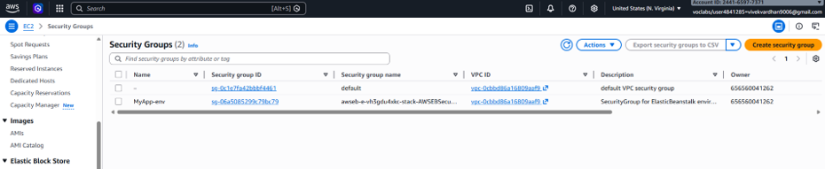

Access Your Application
- After deployment:
  - You will get a URL (domain link)
  - Open it in browser → Your app will run

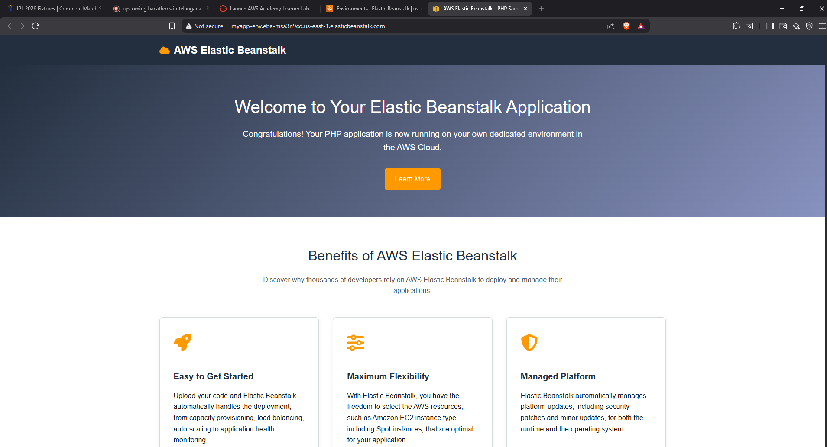

Updating Application
- Go to your environment
- Click Upload and Deploy
- Upload new version
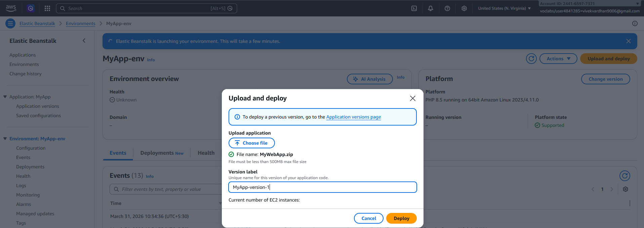
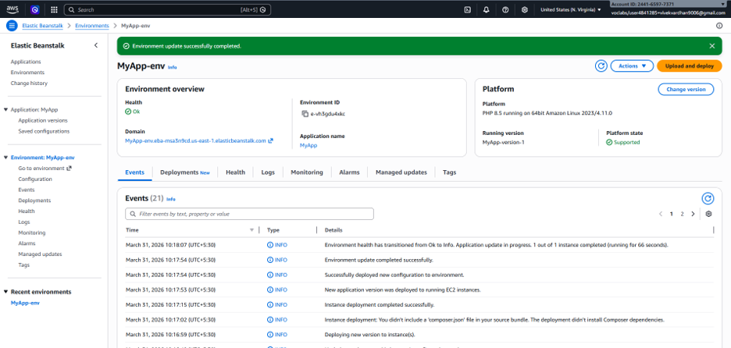

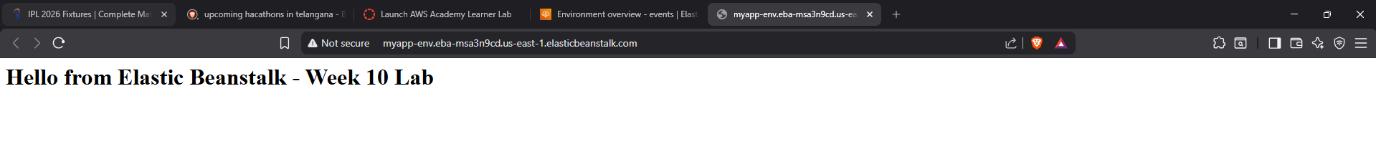

Scenario-Based Questions
Scenario 1: Application Not Loading
You deployed an application using Elastic Beanstalk, but the application does not load and shows an error page.
- What could be the possible reasons for this issue?
- Could deployment or configuration be incorrect?
- How would you troubleshoot this problem?
Answer: The application may not load due to wrong platform selection, deployment failure, incorrect configuration, missing files, or health check issues, and it can be troubleshooted by checking Events, Logs, Environment Health, and EC2 status.

Scenario 2: Incorrect Application Structure
Your application is deployed, but the expected output is not displayed.
- How does application structure affect deployment in Elastic Beanstalk?
- What could happen if files are placed inside an extra folder?
- How would you fix the structure issue?
Answer: Application structure affects deployment because if files are placed inside an extra folder Elastic Beanstalk may not find the entry file, causing incorrect output, and this can be fixed by re-zipping the files in the correct root structure.

Scenario 3: Wrong Platform Selection
While creating the environment, an incorrect platform was selected.
- Why is platform selection important in Elastic Beanstalk?
- What kind of errors or behavior might occur?
- How can you correct the platform without affecting the application?
Answer: Platform selection is important because Elastic Beanstalk installs runtime based on it, and choosing the wrong one can cause application errors or failure to run, which can be corrected by creating a new environment with the correct platform.

Scenario 4: Environment Health Warning
The environment status shows Warning (Yellow) instead of healthy.
- What are possible reasons for this warning?
- Which sections (Events, Logs, Metrics) would you check first?
- How can you resolve health issues?
Answer: A yellow warning may occur due to failed health checks, app errors, high response time, or instance issues, and it should be resolved by checking Events, Logs, Metrics, and application configuration.

Scenario 5: Application Errors in Logs
Logs show a high number of application errors.
- What do such errors indicate?
- Could this be due to misconfiguration or missing resources?
- How would you analyze logs to identify the root cause?
Answer: High application errors in logs indicate runtime issues, misconfiguration, missing dependencies, or resource access problems, and the root cause can be identified by analyzing application logs, web server logs, and event messages.

Scenario 6: Deployment Failure
The application deployment fails during upload.
- What could be wrong with the deployment package?
- Which logs would you check to diagnose the issue?
- How can packaging errors affect deployment?
Answer: Deployment may fail if the package has wrong structure, missing files, unsupported format, or corrupted content, and this can be diagnosed by checking Elastic Beanstalk events, deployment logs, and instance logs.

Scenario 7: Works Locally but Not on Cloud
The application works correctly on a local machine but fails after deployment.
- What environment differences could cause this issue?
- Could configuration or dependency issues be responsible?
- How would you debug using cloud logs?
Answer: An application may work locally but fail on cloud due to environment differences, missing dependencies, wrong configurations, or unsupported runtime, and it can be debugged using Elastic Beanstalk logs and environment settings.

Scenario 8: Blank Output
The application loads but shows no output.
- What could cause an application to display no output?
- Could runtime errors or misconfigurations be responsible?
- How would logs help in identifying the issue?
Answer: Blank output can be caused by runtime errors, incorrect file structure, missing entry file, or application misconfiguration, and logs help identify the exact issue by showing startup or execution errors.

Scenario 9: Application URL Not Accessible
The application URL is not accessible after deployment.
- Could the environment still be launching?
- What status indicators should be checked?
- How can Events help identify the issue?
Answer: The application URL may not be accessible if the environment is still launching, deployment failed, or health is not ready, and this can be identified by checking Status, Health, Events, and EC2 instance state.

Scenario 10: Resource Management Issue
After completing the lab, resources were not terminated.
- What are the cost implications of leaving resources running?
- Which AWS services continue running in the background?
- How can all resources be properly terminated?
Answer: Leaving resources running can increase AWS costs because services like EC2, Load Balancer, Auto Scaling, Security Groups, and CloudWatch continue in the background, so all resources should be terminated by deleting the environment and application.

