WEEK-11—Amazon LEX

Step 1: Open Amazon Lex
- Login to AWS Console
- Search Amazon Lex
- Click Create bot

Step 2: Create Bot
- Choose:
  - Create a blank bot
- Enter:
  - Bot name: HotelBookingBot
- IAM role → Create new role
- Remaining defaultnext
- Language: English
- Voice (optional)
- Click Done
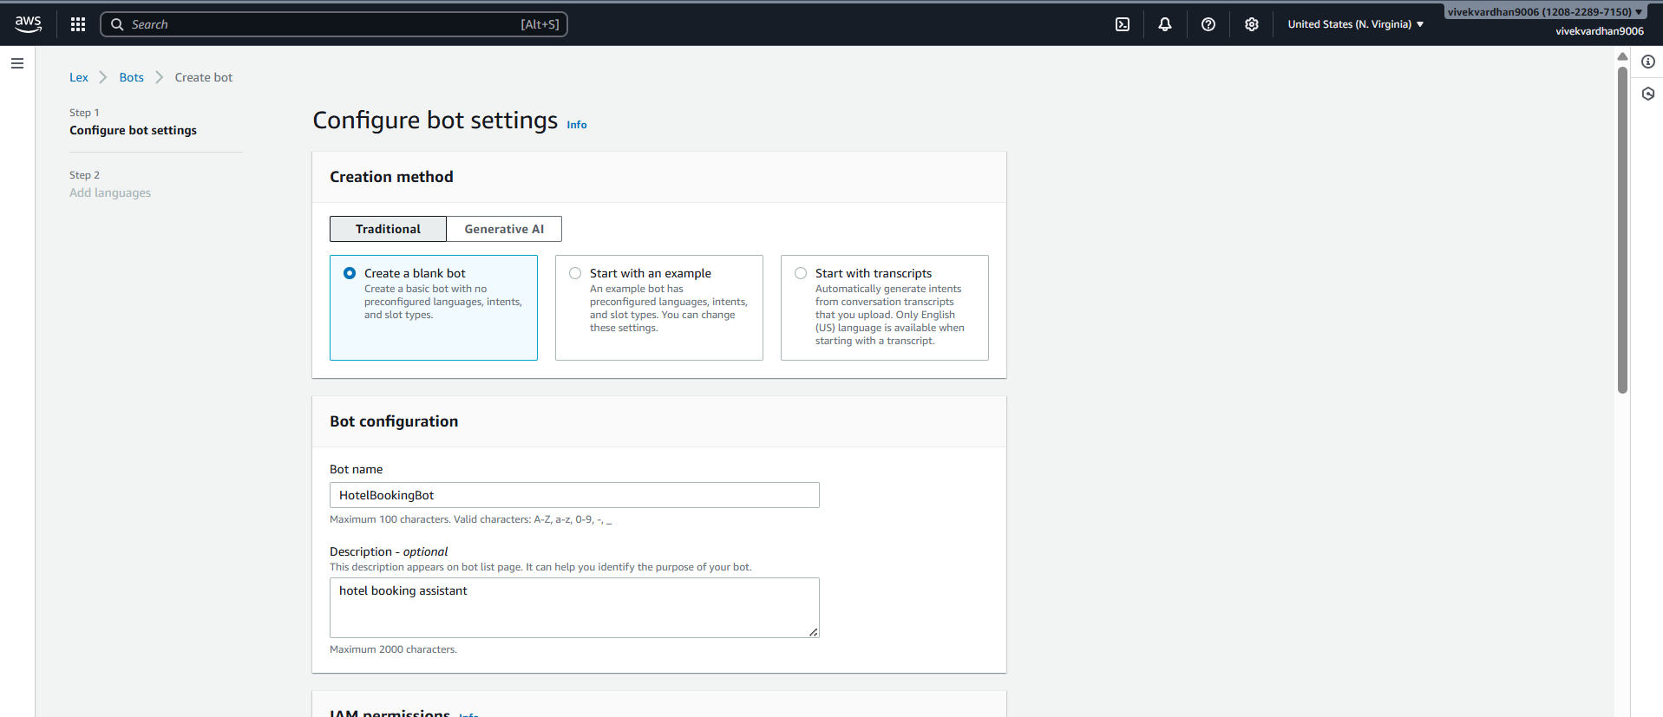
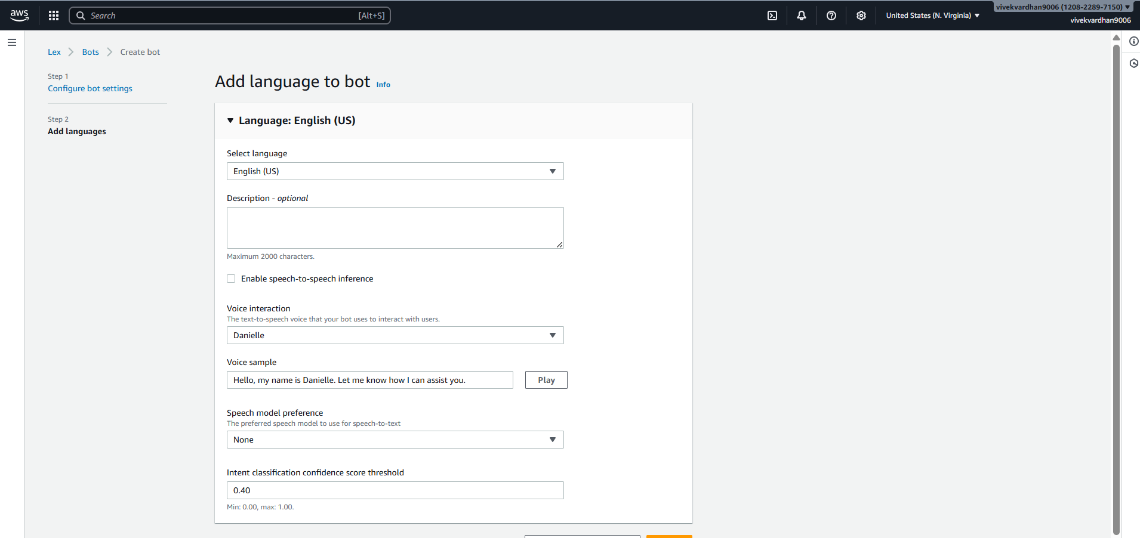
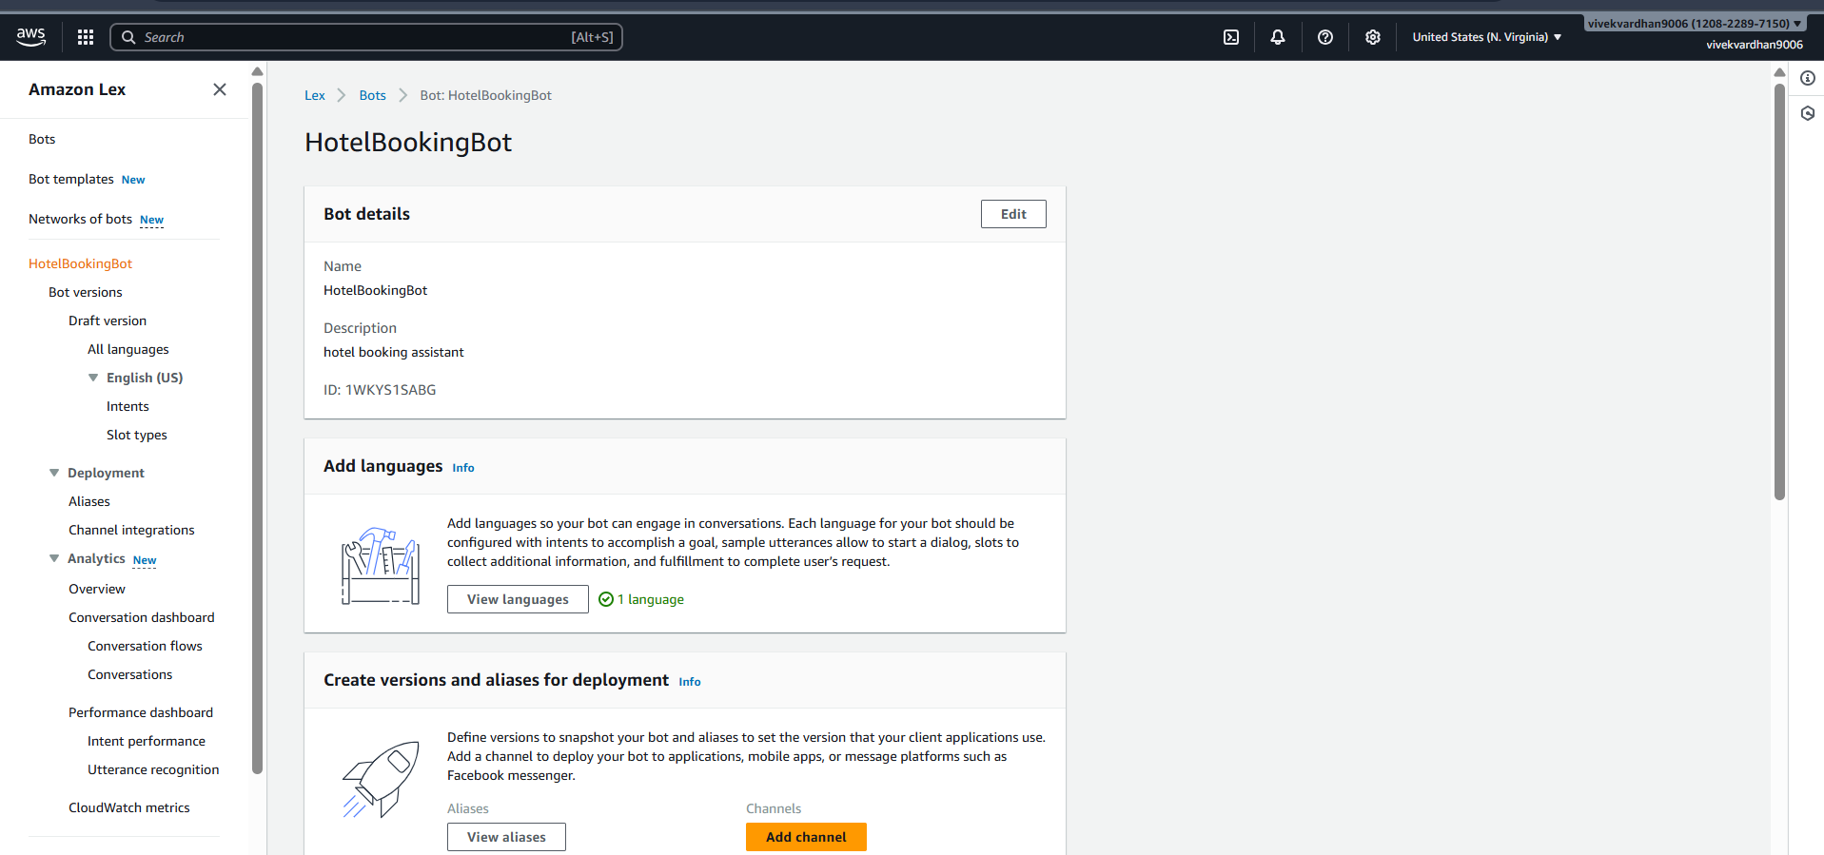

Step 3: Create Intent
- Go to Intents
- Name: BookHotel
- Click Create
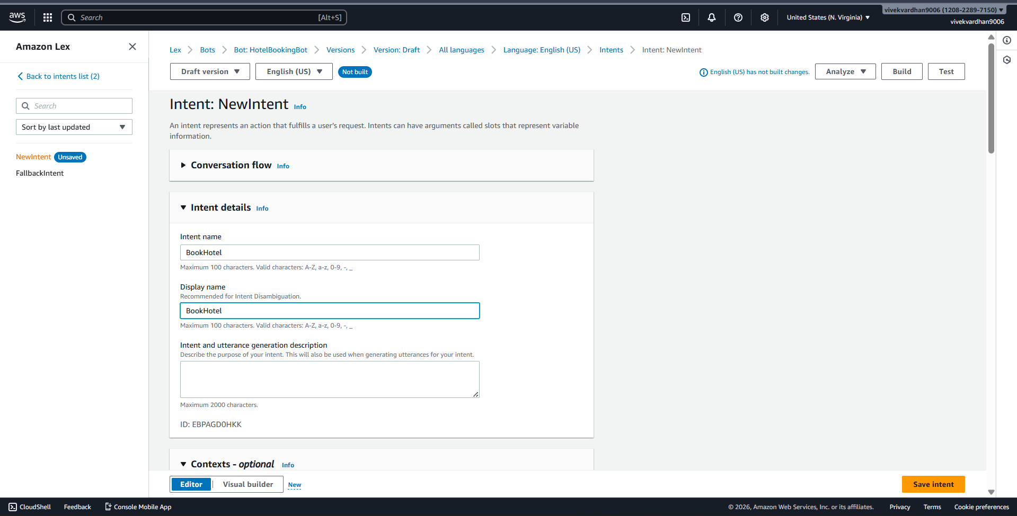

Step 4: Add Sample Utterances
Add user sentences (how user talks):
I want to book a hotel
Book a room
Reserve hotel
I need a room
These are Utterances
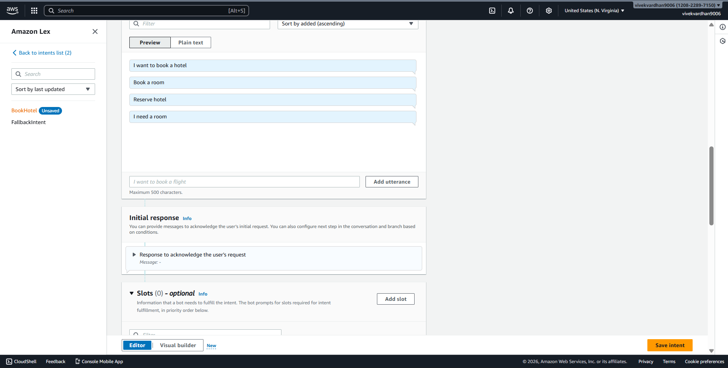

Step 5: Create Slots (User Inputs)
Slots collect user information.
Add Slot
- Click Add slot
- Fill:
  - Slot name: age
  - Slot type: AMAZON.Number
  - Prompt: Which city do you want?
Mark as Required
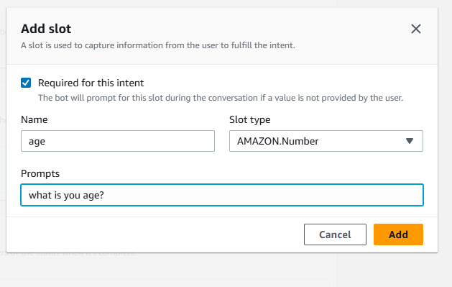
Add IF Conditions (Conditional Logic)
Used to control flow based on slot values
Example Condition:
If {age} < 18
Steps:
- Go to Intent → Slots -> under Advance options
- Scroll to Slot capture: success response ->Conditional branching
- Click Add condition
Example:
Condition:
If {age} < 18
Response:
Your not eligible for hoot booking?
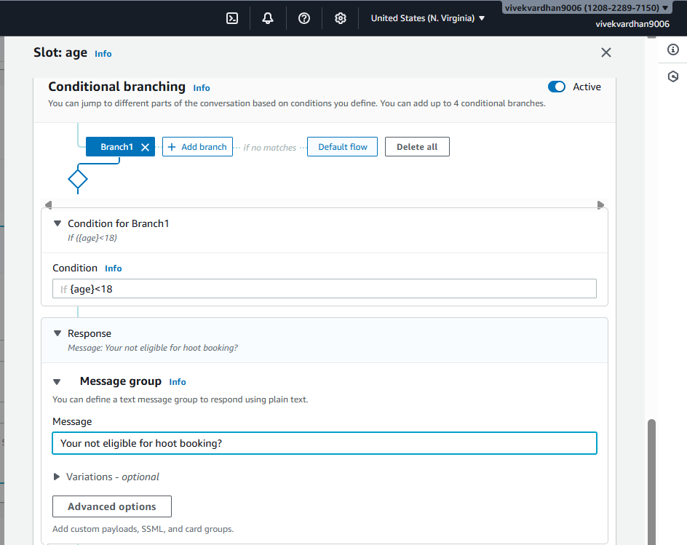

Step 6: Create Slots (User Inputs)
Slots collect user information.
Add Slot
- Click Add slot
- Fill:
  - Slot name: location
  - Slot type: AMAZON.City
  - Prompt: Which city do you want?
- Mark as Required
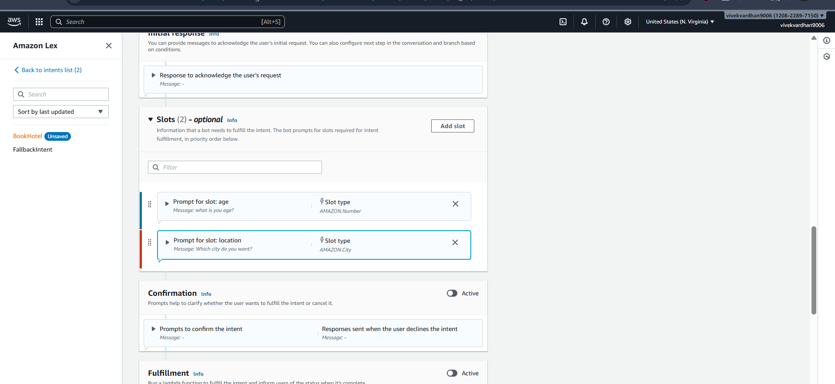

Repeat for other slots.
- Click Add slot
- Fill details:
  - Slot name: checkin
  - Slot type: AMAZON.Date
  - Prompt:
"What is your check-in date?"
- Mark as Required
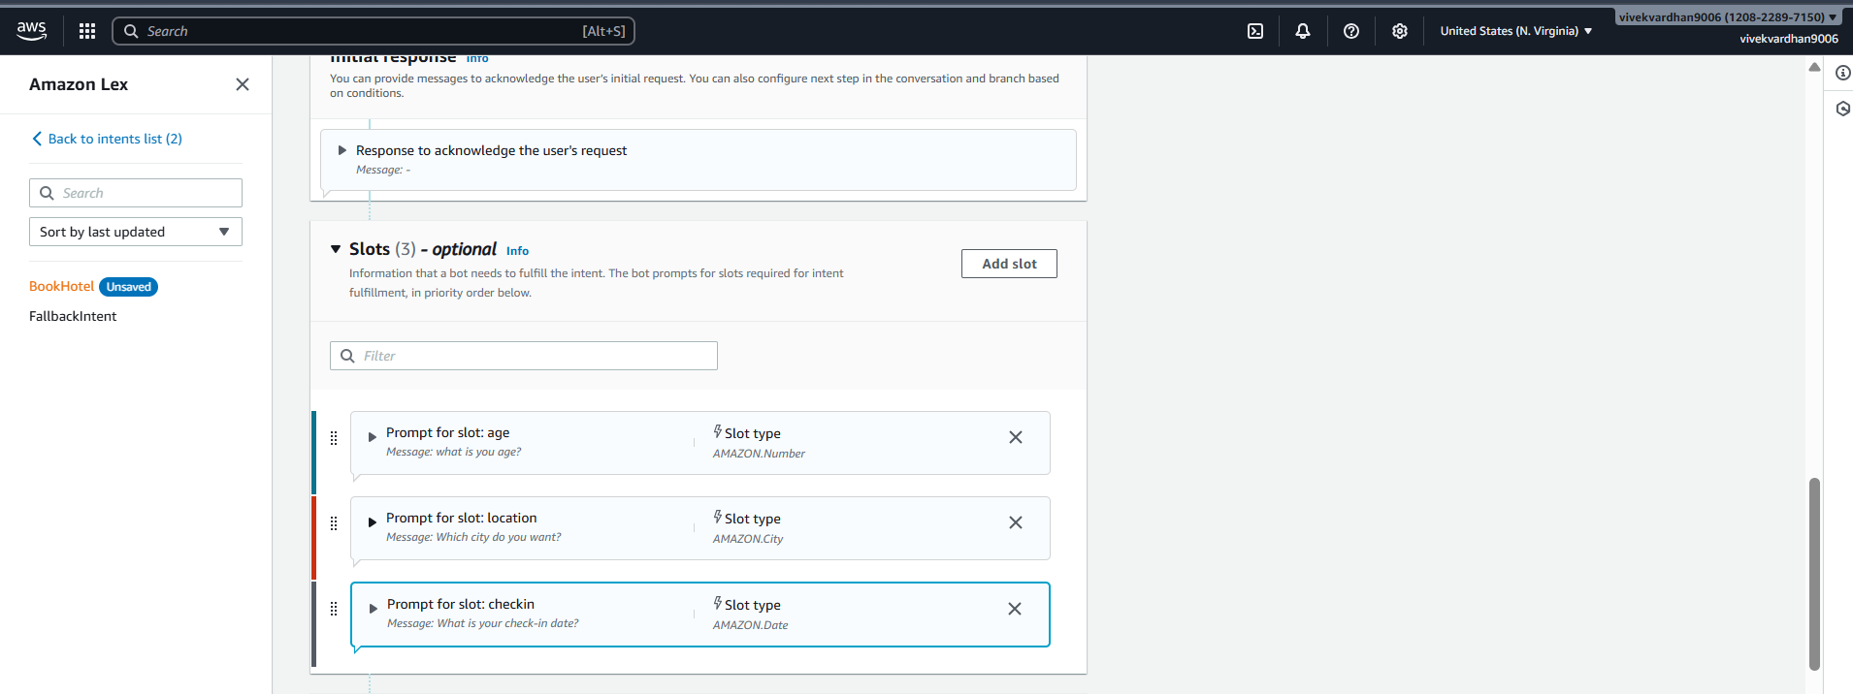
(Optional but recommended)
  - Add Retry prompt:
"Please provide a valid date (e.g., 2026-03-25)"
- Click Save
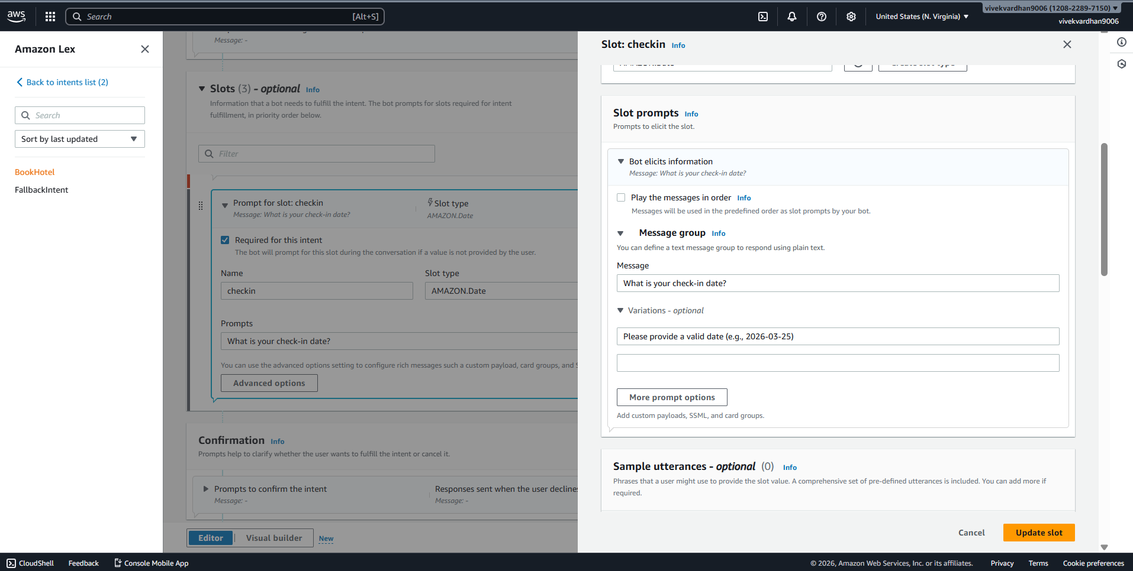

Slot 7: Number of Nights (nights)
Steps:
- Click Add slot again
- Fill details:
  - Slot name: nights
  - Slot type: AMAZON.Number
  - Prompt:
"How many nights will you stay?"
- Mark as Required
- Click Save
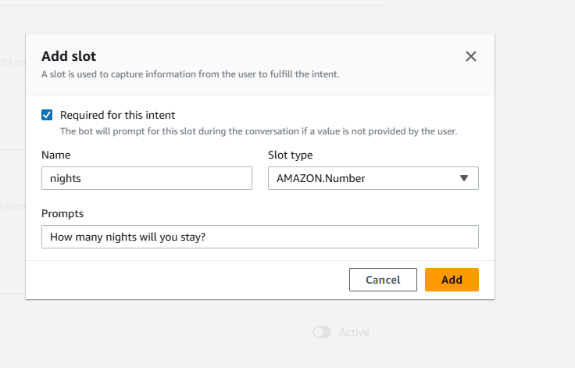

Step 7: Create Custom Slot Type

Save intent

Click on Back to intents
If you want custom values:
- Go to Slot Types
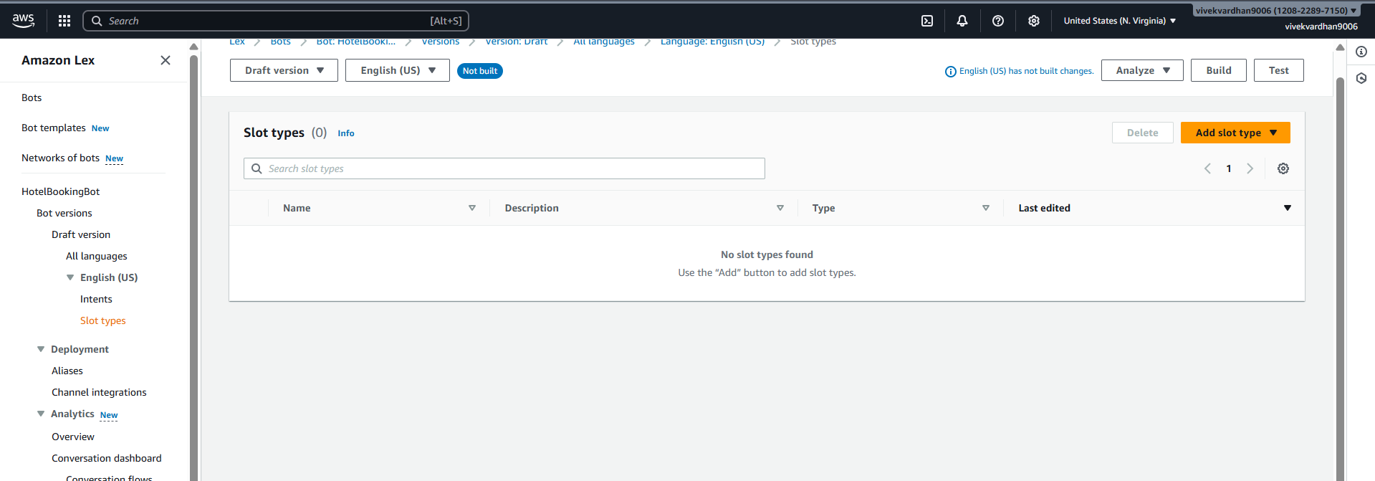
- Click Add slot type ->add blank slot type
- Name: RoomType
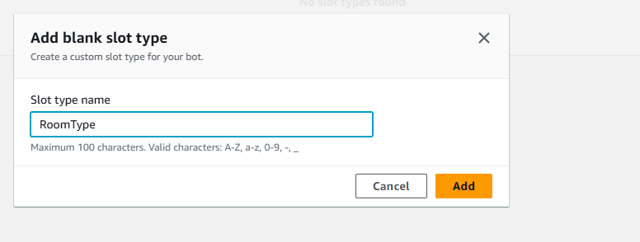
Add values:
Single
Double
Suite
Save slot type
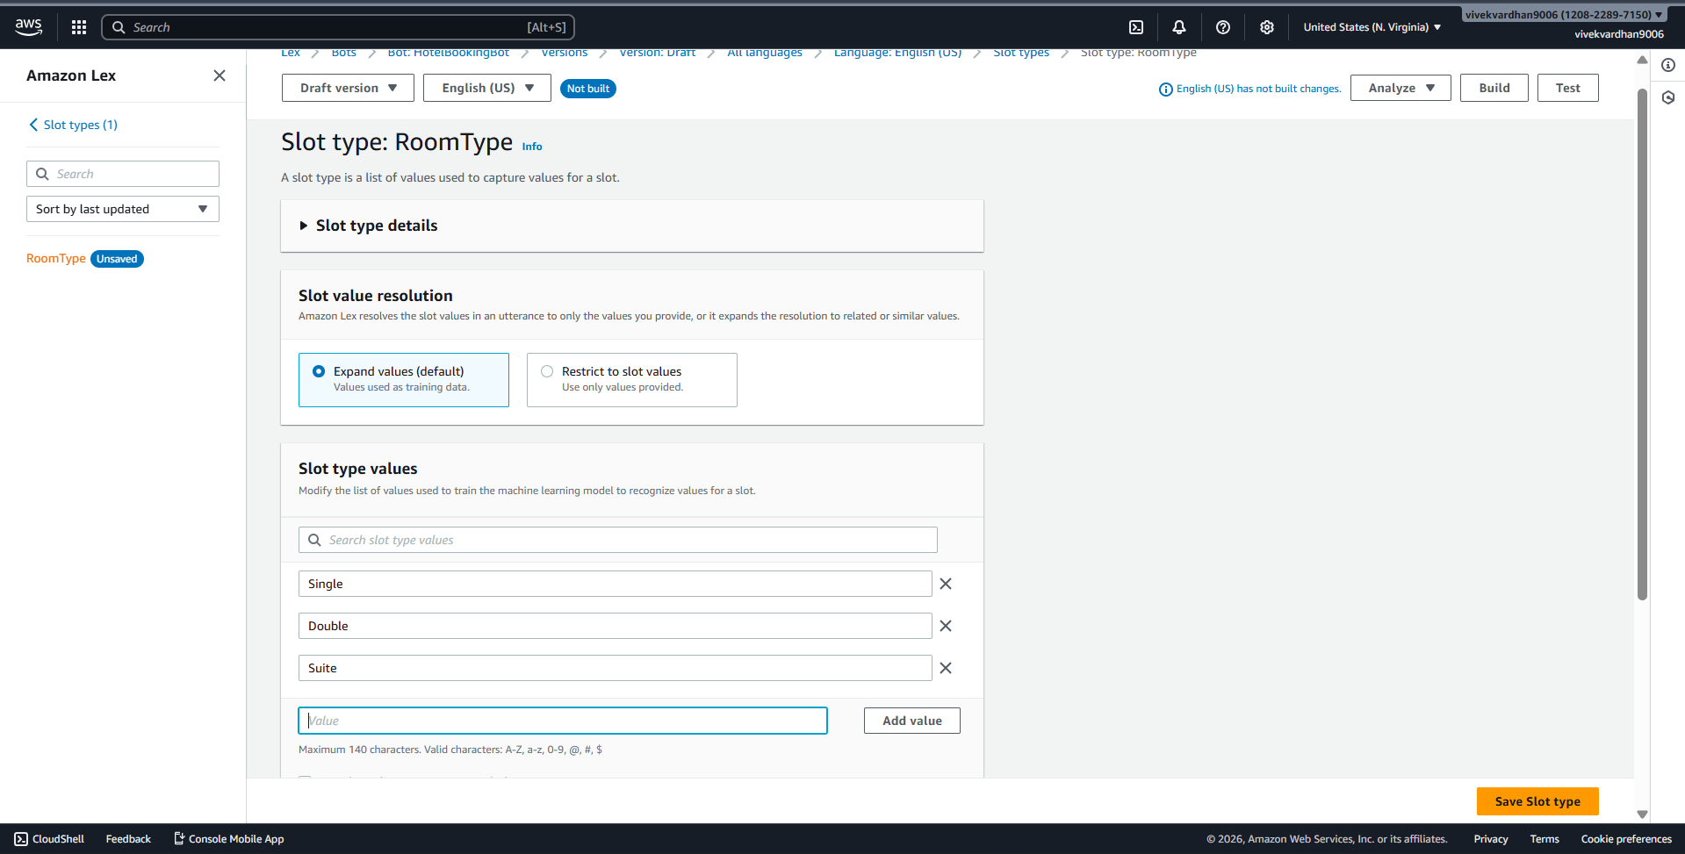
Now use this in slot: go back to intent
- Slot name: RoomType
- Slot type: RoomType
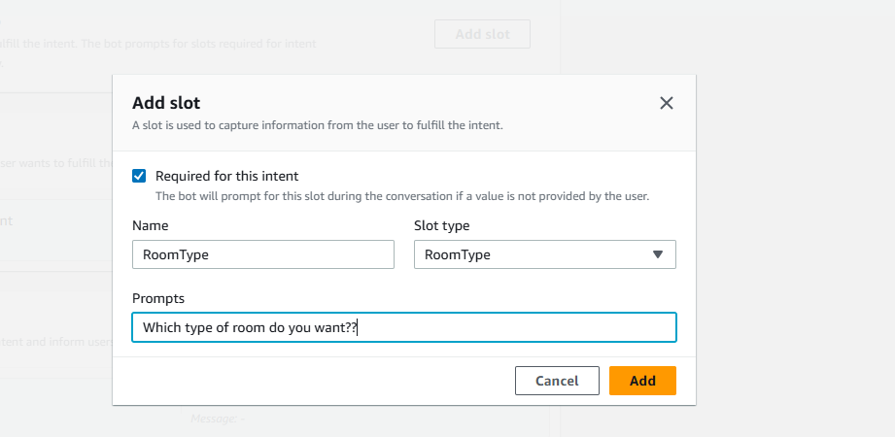

Step 9: Add Response Cards (Card Groups)
Used for buttons (quick replies)
Steps:
- Go to slot prompts -> more prompt options
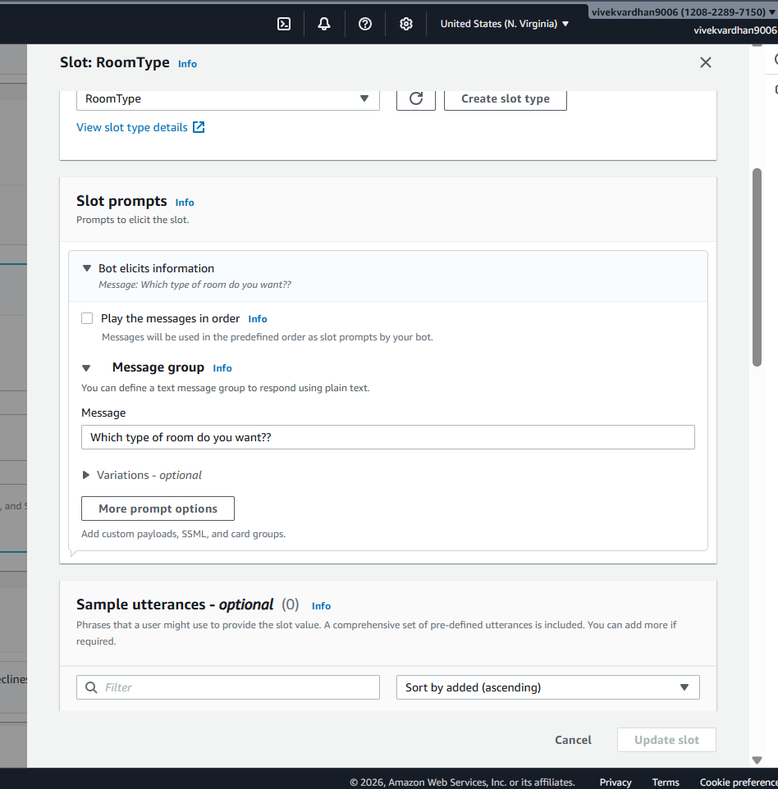
- Click Add -> add card groups
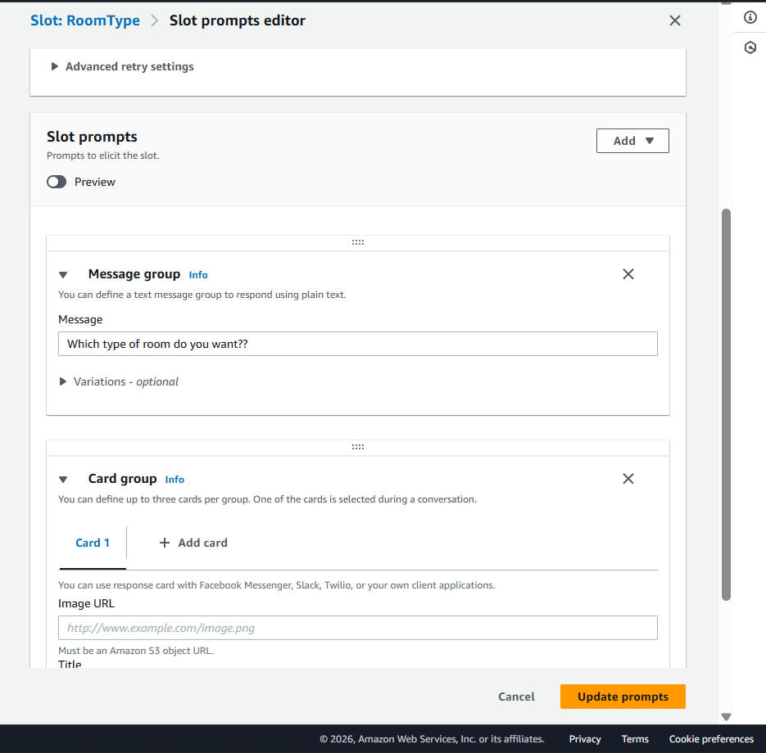

Example:
Card Title: Select Room Type
click on add Buttons:
- Single → "Single"
- Double → "Double"
- Suite → "Suite"
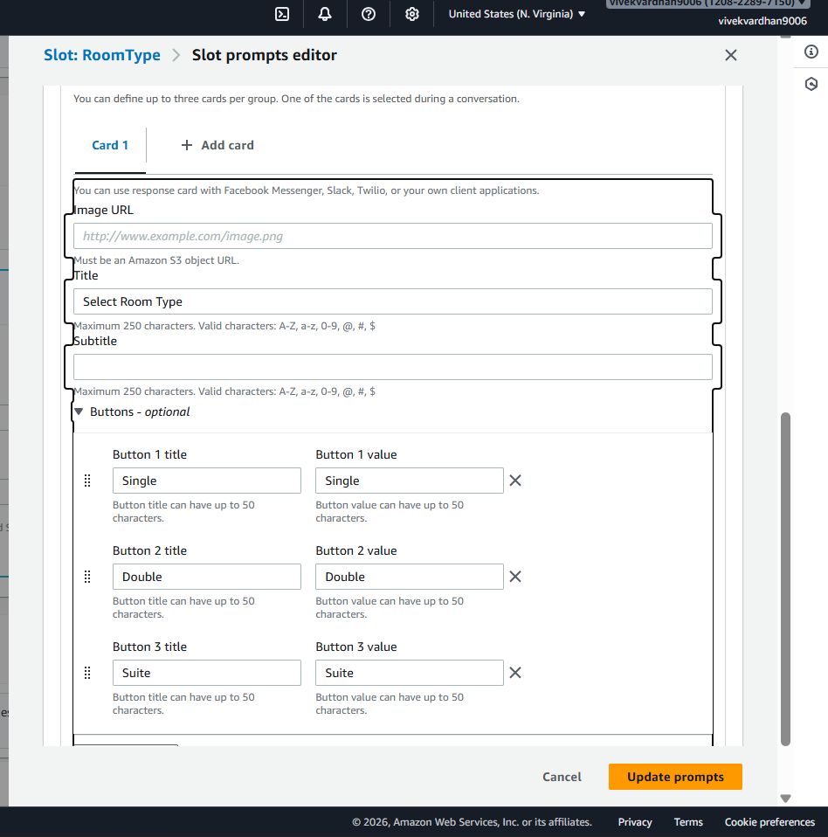

Step 10: Configure Responses
Initial Response:
Welcome to Hotel Booking! What is your name?
Confirmation:
Do you want to confirm booking in {location} for {nights} nights?
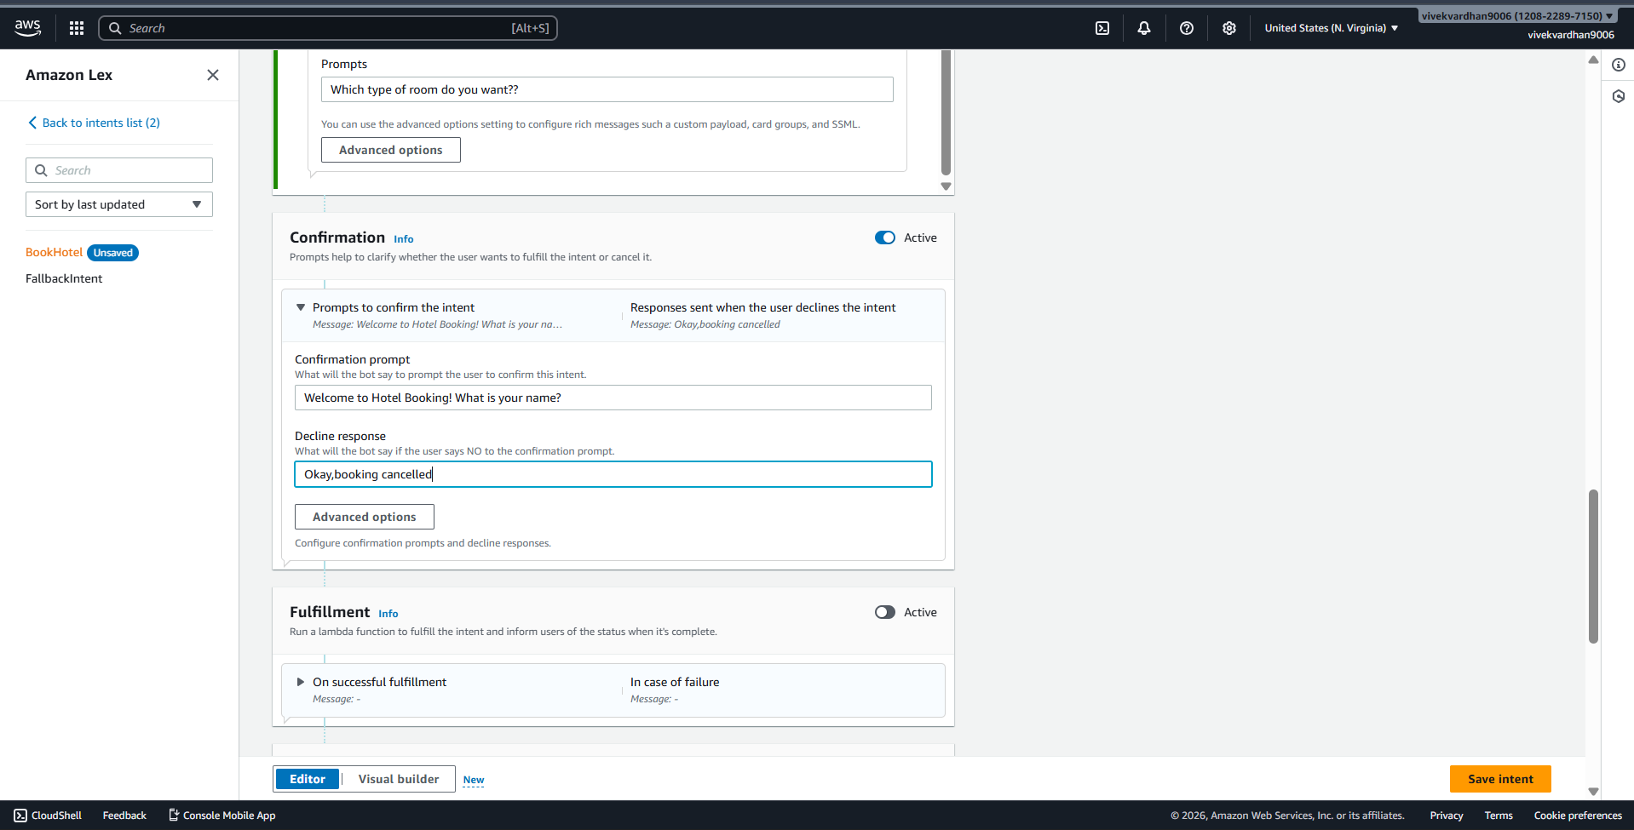

Step 11: Build & Test
- Click Build
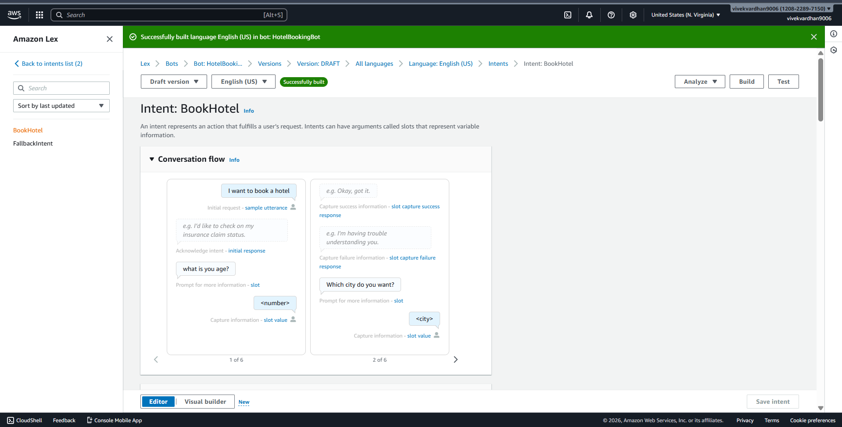
- Use Test chatbot panel
- Try:
Book a hotel

Sample output
User: Book a hotel
Bot: What is your age?
User: 25
Bot: Which city do you want?
User: Hyderabad
Bot: Check-in date?
User: Tomorrow
Bot: Number of nights?
User: 2
Bot: Select room type
User: Double
Bot: Do you want to confirm booking in Hyderabad for 2 nights?
User: Yes
Bot: Booking confirmed.
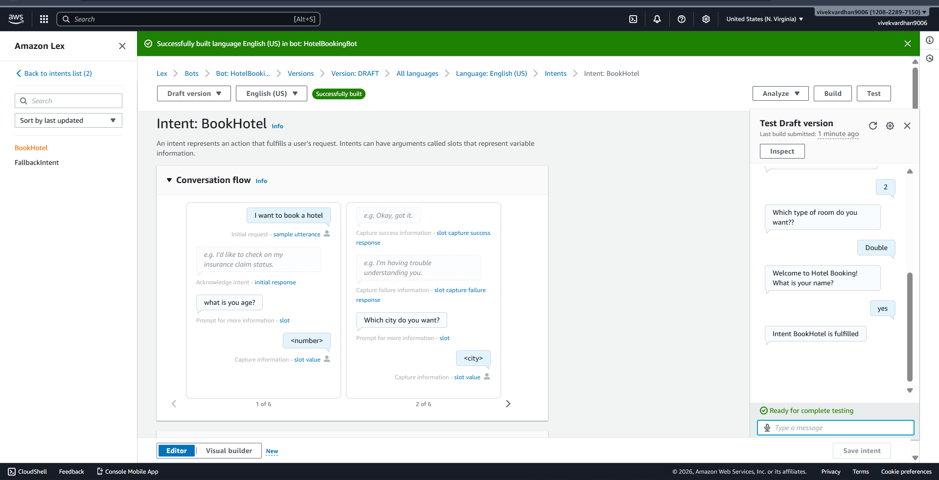

SCENARIO BASED QUESTIONS
Scenario 1: Bot Not Responding
You created a chatbot, but when you test it, the bot does not respond to user input.
- What could be the possible reason for no response?
ANSWER) The bot may not respond due to several reasons such as the bot not being built after making changes, missing or incorrect sample utterances, or improperly configured slots. If the intent does not contain enough training phrases, Amazon Lex may fail to understand the user input. Another reason could be incorrect AWS region selection or permission issues.
- Did you build and publish the bot correctly?
Yes, the bot must be built and published correctly before testing. Without building the bot, changes will not take effect.
- How would you troubleshoot this issue?
- To troubleshoot this issue:
Click the Build button after creating intents and slots.
a)Verify that sample utterances are added properly.
b)Check slot configuration and prompts.
c)Ensure correct AWS region is selected.
d)Review logs using Amazon CloudWatch.

Scenario 2: Incorrect Intent Matching
A user types a valid query, but the chatbot responds with the wrong intent.
- What could cause incorrect intent recognition?
A) Incorrect intent matching occurs when Amazon Lex misinterprets user input and maps it to the wrong intent. This usually happens due to insufficient or unclear sample utterances, overlapping intent phrases, or ambiguous user queries.
- How do utterances affect intent matching?
A) Utterances play an important role because they train the Natural Language Processing (NLP) model. If limited utterances are provided, Lex cannot accurately identify the user’s intention.
- How can you improve accuracy?
A) Accuracy can be improved by:
- Adding more diverse and realistic utterances.
- Avoiding similar intent phrases.
- Using clear and meaningful sentences.
- Testing the chatbot with different user inputs.

Scenario 3: Missing Slot Values
The chatbot asks for user input, but fails to capture required slot values.
- What is a slot in Amazon Lex?
- A slot in Amazon Lex is a variable used to capture specific information from the user, such as location, date, or number of nights.

- Why might slot values not be captured properly?
A)Slot values may not be captured properly if:
The slot is not marked as required.
Incorrect slot type is selected.
The prompt message is unclear.
The user provides input in an invalid format.

- How would you fix slot configuration issues?
A)To fix slot configuration issues:
Mark slots as required.
Choose appropriate slot types such as AMAZON.Date or AMAZON.Number.
Provide clear prompts.
Add retry prompts to guide users.

Test conversation flow thoroughly.

Scenario 4: Fulfillment Not Working
The bot collects all user inputs but does not perform the expected action.
- What is fulfillment in Amazon Lex?
A)
Fulfillment in Amazon Lex refers to the process where the chatbot performs an action after collecting all required information from the user, such as storing booking details or triggering backend operations.
- Could Lambda integration be misconfigured?
A)If Lambda integration is misconfigured, fulfillment may fail. Possible issues include incorrect IAM permissions or incorrect Lambda function configuration.
- How would you verify the backend processing?
A) To verify backend processing:
Check if Lambda function is properly connected.
Verify IAM role permissions.
Test Lambda function independently.
Check logs in Amazon CloudWatch.

Scenario 5: Bot Not Accessible
You created the bot successfully, but users are unable to access it.
- Did you deploy or publish the bot?
A) Even if the bot is created successfully, users may not access it if the bot is not deployed or published correctly.
- Could permissions or channel integration be missing?
A) Permissions or channel integration may be missing, preventing user interaction.
- How would you make the bot accessible to users?
A) To make the bot accessible:
Publish the bot version.
Create and configure an alias.
Ensure IAM permissions are granted.
Integrate the bot with applications using AWS SDK or API Gateway.

Scenario 6: Wrong Language Understanding
The chatbot fails to understand user queries written in slightly different formats.
- How does Amazon Lex process natural language?
A)Amazon Lex uses Natural Language Processing (NLP) and machine learning to understand user queries. It analyzes user sentences and maps them to appropriate intents.
- Why is training with multiple utterances important?
A) Training with multiple utterances is important because users may express the same intention in different ways. More utterances improve recognition accuracy.
- How can you improve NLP performance?
A) To improve NLP performance:
Provide multiple variations of utterances.
Use simple and clear sentences.
Avoid ambiguous words.
Continuously test and refine the chatbot.

Scenario 7: Versioning Issue
You updated the bot, but users still experience the old behavior.
- Did you create a new version of the bot?
A) Users may experience old behavior if a new version of the bot is not created or published after updates.
- Why is alias configuration important?
A) Alias configuration is important because it connects users to a specific bot version.
- How do you ensure users access the latest version?
A) To ensure users access the latest version:
Create a new bot version.
Update alias configuration.
Publish the updated version.
Test using the latest alias.

Scenario 8: Lambda Permission Error
The chatbot is connected to a Lambda function, but it fails during execution.
- What type of permission error might occur?
A) A Lambda permission error occurs when Amazon Lex does not have authorization to invoke the Lambda function.
- How are IAM roles used in this integration?
A) IAM roles are used to grant permissions for Lex to communicate with Lambda services.
- How would you fix the permission issue?
A) To fix permission issues:
Assign correct IAM role to Lambda.
Add permission allowing lex.amazonaws.com.
Verify resource-based policy settings.
Test Lambda execution separately.

Scenario 9: Bot Gives Default Response
The chatbot always gives a fallback/default response instead of proper answers.
- What is a fallback intent?
A) A fallback intent is triggered when Amazon Lex cannot match user input to any defined intent.
- Why does the bot fail to match user input?
A) The bot may fail to match input due to insufficient utterances, incorrect training data, or unclear user queries.
- How can you improve intent recognition?
A) To improve intent recognition:
Add more sample utterances.
Train the bot with different sentence patterns.
Ensure intents are clearly defined.
Test the chatbot frequently.

Scenario 10: Multi-turn Conversation Issue
The chatbot fails to continue conversation properly after asking follow-up questions.
- What is dialog management in Amazon Lex?
A)Dialog management in Amazon Lex controls how the conversation flows between the chatbot and the user.
- How are slots used in multi-turn conversations?
A) Slots play an important role in multi-turn conversations by collecting information step-by-step.
- How can conversation flow be improved?
A) Conversation flow can be improved by:
Organizing slots logically.
Providing clear prompts.
Adding confirmation messages.
Using conditional branching where required.

Scenario 11: Integration with Web Application
A company wants to integrate the chatbot into their website.
- How can Amazon Lex be integrated with web applications?
Amazon Lex can be integrated with web applications using AWS SDK, API Gateway, or JavaScript libraries.
- What services or APIs are required?
A)Required services include:
Amazon Lex API
AWS Lambda
API Gateway
IAM roles for permissions

- What challenges might occur during integration?
A) Challenges during integration may include authentication setup, API configuration, latency issues, and frontend design compatibility.

Scenario 12: Performance Issue
The chatbot responds slowly when many users interact simultaneously.
- What could cause performance delays?
A) Performance delays may occur due to high user traffic, slow Lambda execution, network latency, or improper configuration.
- How can scalability be handled in Amazon Lex?
A) Scalability in Amazon Lex is handled automatically using AWS cloud infrastructure, which adjusts resources based on demand.
- What AWS services can support high traffic handling?
A) AWS services that support high traffic handling include:
AWS Lambda for serverless execution
API Gateway for managing API requests
Amazon DynamoDB for fast data storage
Amazon CloudWatch for monitoring performance

