WEEK-12
IAM
- Administrative Setup (Root User)

Step 1: Log in to the AWS Management Console as the Root User.
Step 2: Search for IAM under the "Security, Identity, & Compliance" category.
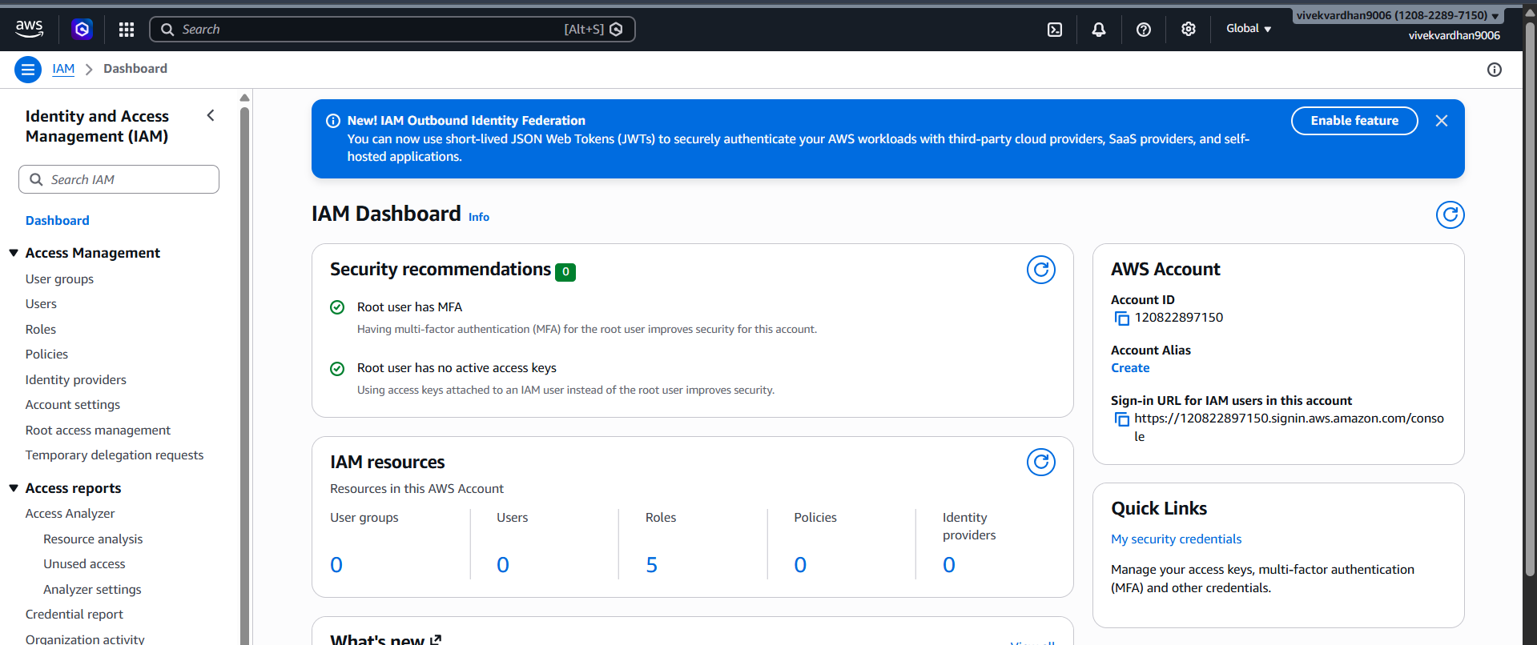
Step 3: Navigate to Users and click Create user
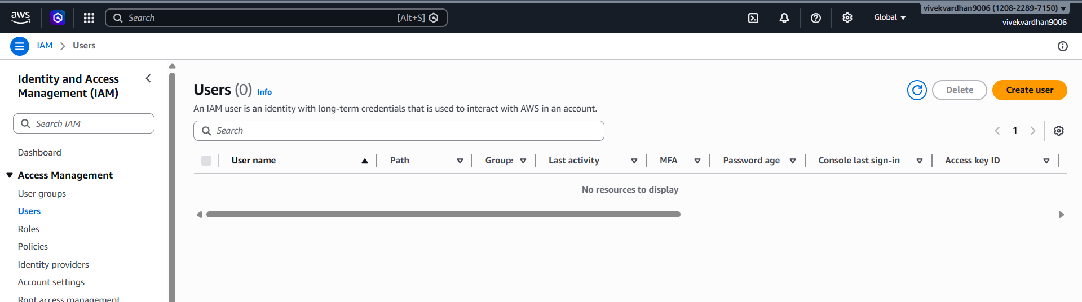

Step 4: User Details: Enter a name (e.g., S3_Specialist). Check the box for "Provide user access to the AWS Management
Console." – custom password.
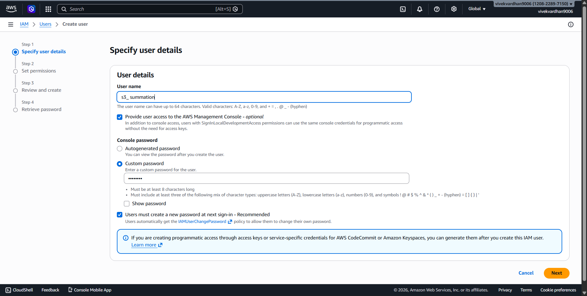

Step 5: Set Permissions: Select "Attach policies directly." Search for and select AmazonS3FullAccess.

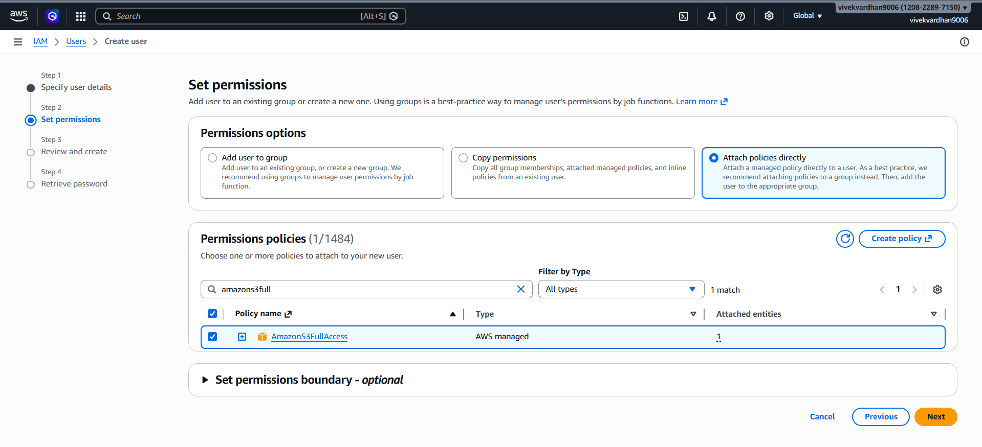
Step 6: Review & Create: Complete the wizard. On the final page, click Download .csv file.

Now you see CC-LAB user created

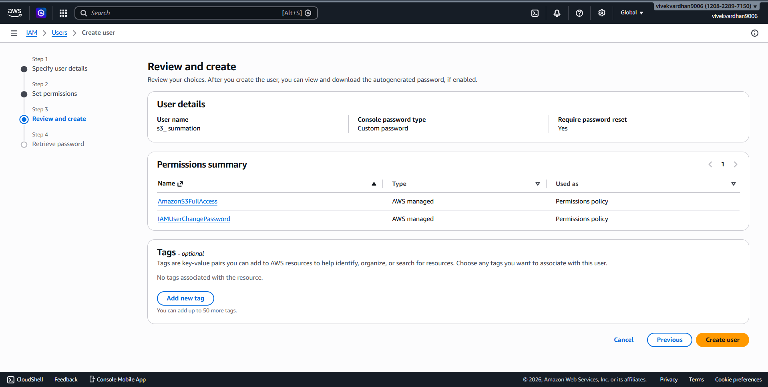

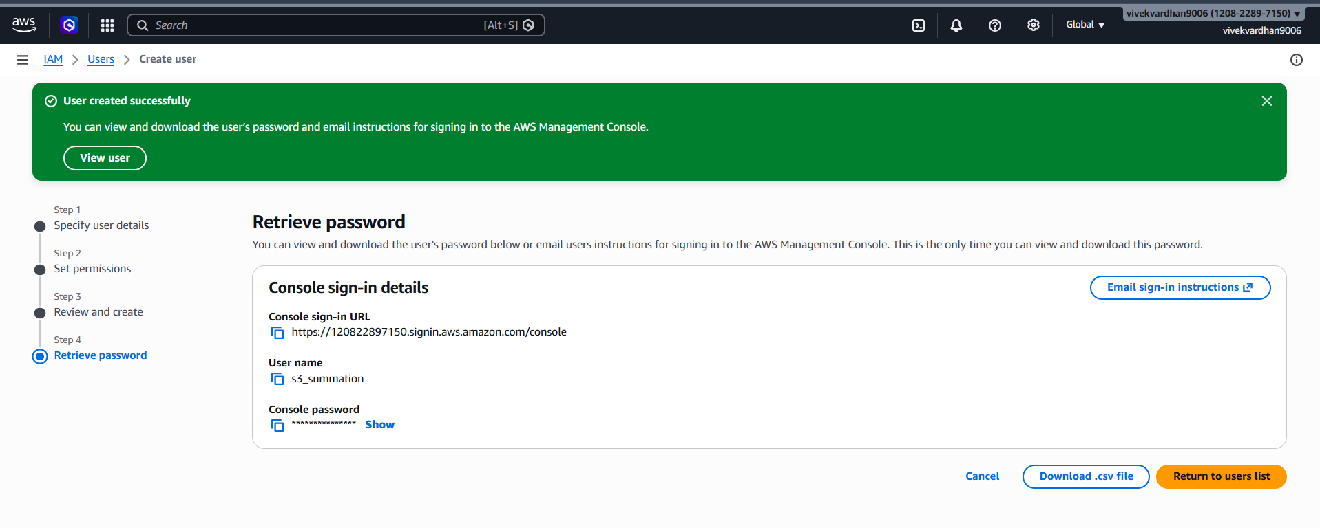

Step 7: Copy your 12-digit Account ID (found in the top-right dropdown or the .csv) and Sign Out
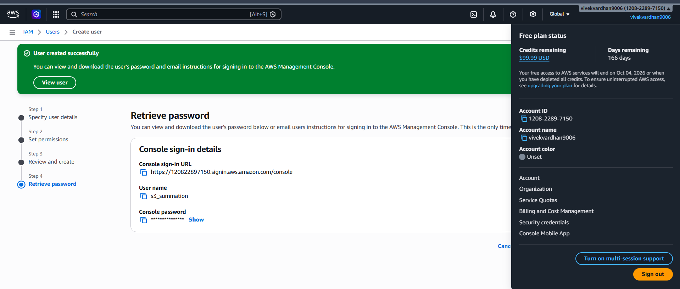

Step 8: Use the Sign-in URL from the .csv (or go to the AWS sign-in page and select IAM User).
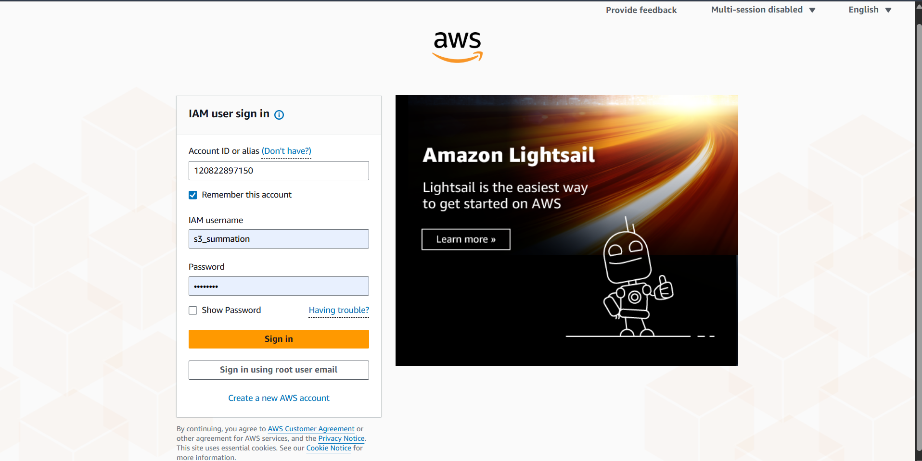

Step 9: Enter the Account ID, then the IAM Username and Password from the .csv.

Test 1 (Failure): Navigate to EC2. Try to view instances. You will see "API Error" or "Access Denied." This proves the user is restricted.
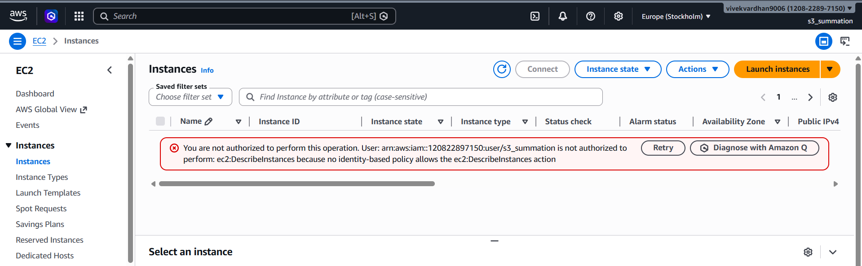

Test 2 (Success): Navigate to S3. Create a new bucket. It will work perfectly because of the attached policy.
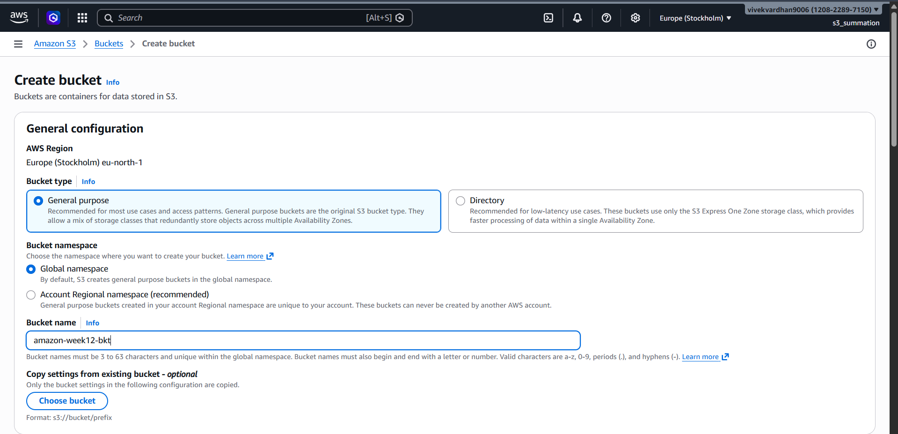
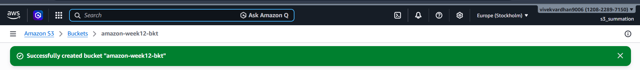

Part B: CLI Access (Programmatic Access)

Objective: Access AWS resources from a standalone system (CMD/Terminal) using security keys.

- Credential Generation
Step 1: While logged in as an Admin/Root, go to IAM > Users and click on your user.
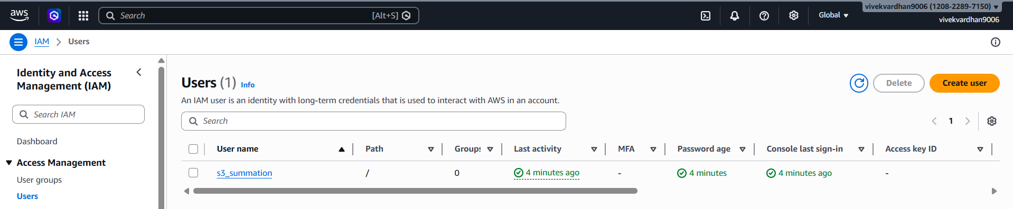
Step 2: Go to the Security credentials tab. Scroll to Access keys and click Create access key.
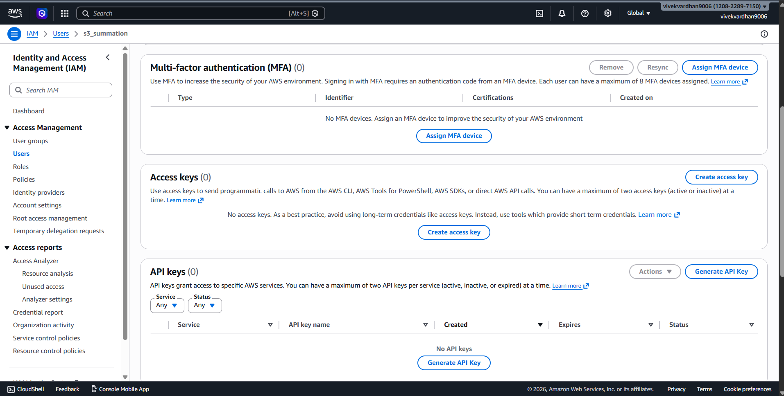
Step 3: Select Command Line Interface (CLI). Acknowledge the warning and click Next.
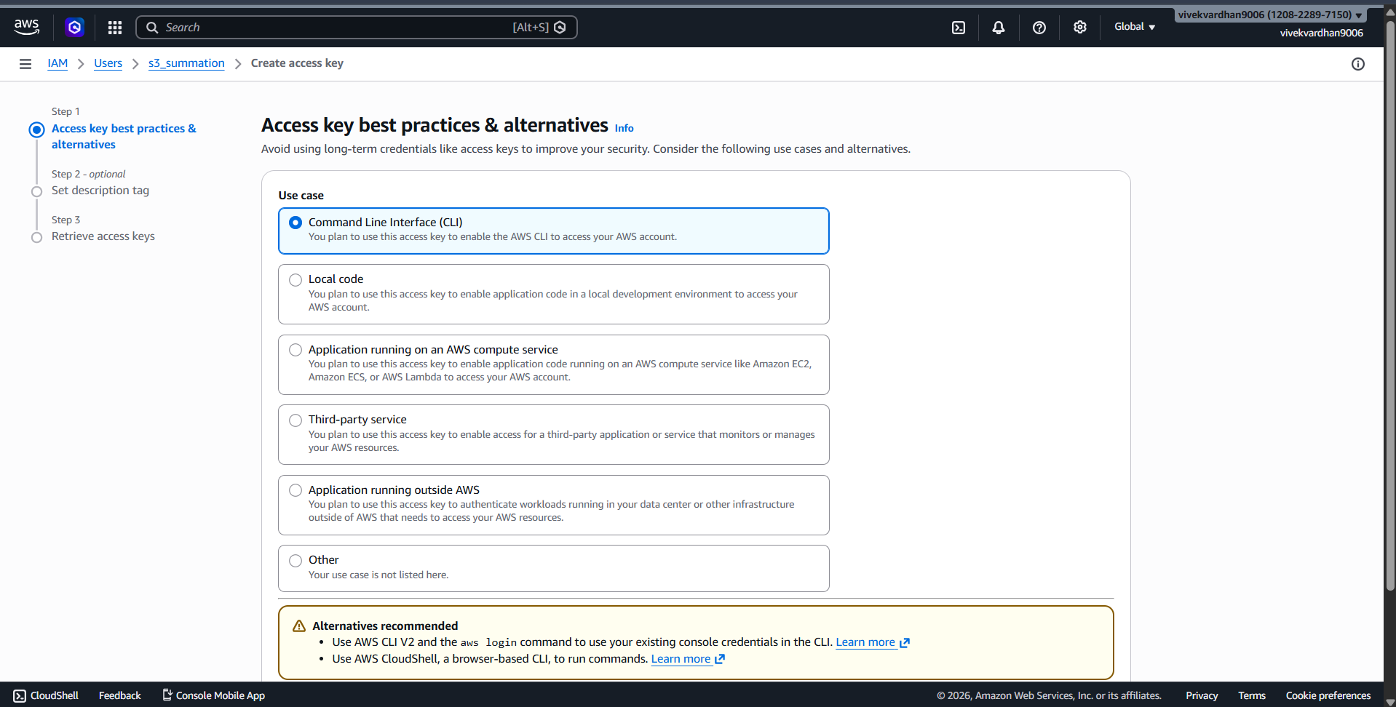
Step 4: Download the .csv file. > Critical: This contains the Access Key ID and Secret Access Key. If lost, you must delete and recreate them.
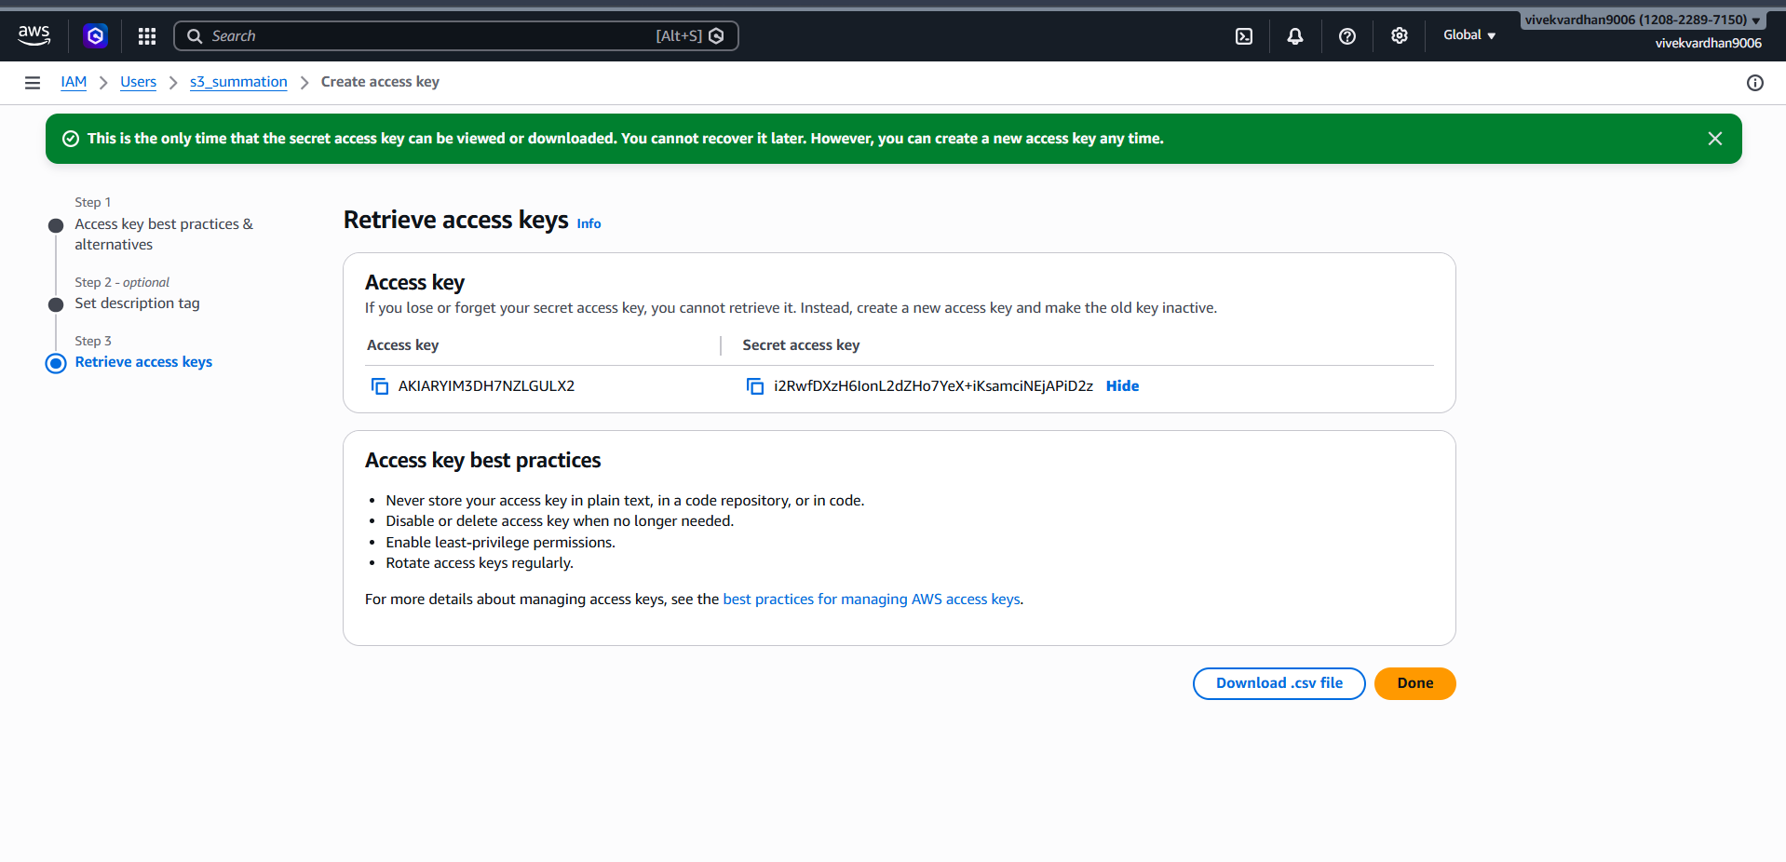
- Standalone System Configuration
Step 5: Install the AWS CLI Tool from google on your computer
Download https://awscli.amazonaws.com/AWSCLIV2.msi
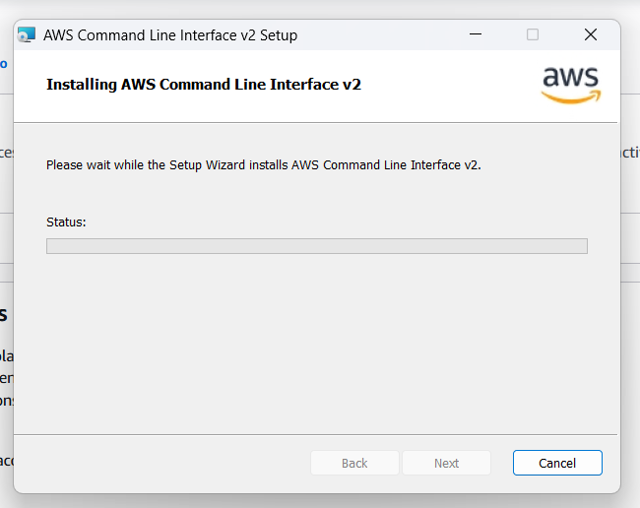

Step 6: Open your Command Prompt (CMD) or Terminal. Step 7: Type aws configure and press Enter.

Step 8: Provide the following from your .csv: Access Key ID
Secret Access Key
Default region: (e.g., ap-south-1)
Default output: json

Run aws ec2 describe-nstances.
Result: You will get an (AccessDenied) error.
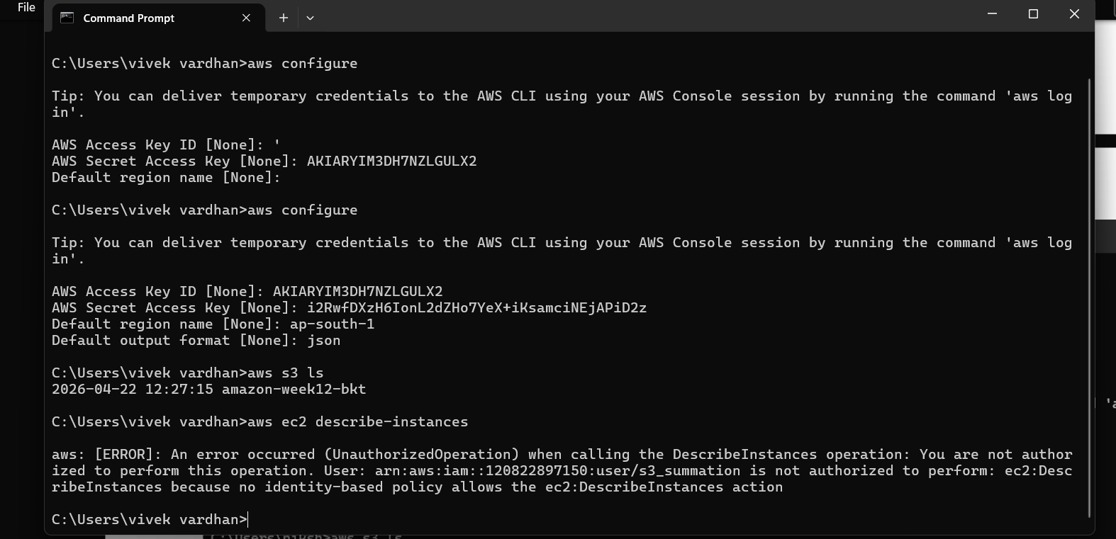

This confirms that the CLI is respecting the same IAM policy as the GUI.

- Verification via Commands
Step 9: Run aws s3 ls. This should list your buckets
Step 10: Run aws s3 mb s3://your-unique-bucket-name. (Success)
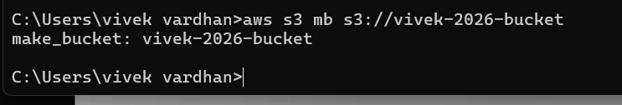

Check in console you see the bucket created from CLI
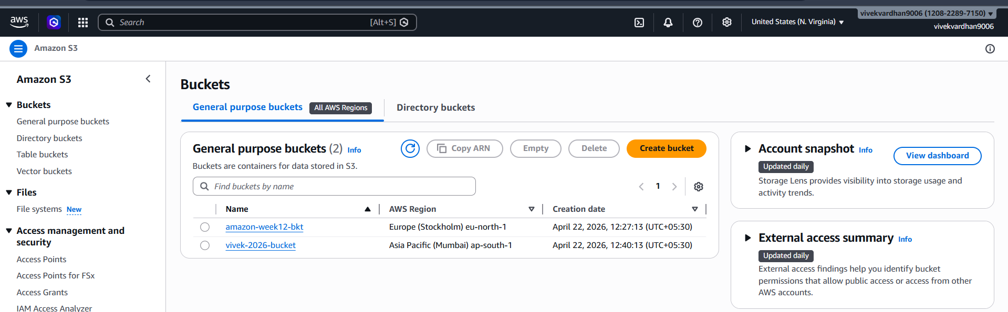

SBQ’S

✅Scenario 1: Security Risk
Q: You logged into AWS using the root user for daily work. What’s wrong here?
A) Root user has full control over entire AWS account, including billing and deleting resources. Using root daily increases security risk. If root credentials are compromised, attacker gets complete control. Best practice is to create IAM users with limited permissions and use root only for critical account-level tasks.

✅ Scenario 2: Account Compromise
Q: Your AWS bill suddenly increases and you suspect root user compromise. What steps will you take?
- Immediately secure the account:
1)Change root password
2)Enable MFA (Multi-Factor Authentication)
3)Delete unknown resources (EC2, S3 etc.)
4)Check CloudTrail logs for suspicious activity
5)Rotate access keys
6)Contact AWS support if required

✅ Scenario 3: Root Credentials Lost
Q: What if you forgot root user password?
A)Use Forgot Password option on AWS login page. Reset password using the registered root email address. AWS sends password reset link to email.
✅ Scenario 4: Root Access Keys
Q: Why should you avoid creating access keys for root user?
Root access keys provide complete control over AWS account. If leaked, attacker can create or delete any resource. Best practice is to never create access keys for root. Instead use IAM users or roles.

✅ Scenario 5: New Developer Joining
Q: A new developer joins your team. How do you give access?
Create a new IAM user for developer. Attach required policies such as EC2 or S3 access. This ensures secure and controlled access instead of sharing root credentials.

✅ Scenario 6: Least Privilege
Q: A user needs only S3 read access. What will you do?
Attach policy:
AmazonS3ReadOnlyAccess
This allows user to view S3 buckets but not modify or delete objects. This follows least privilege principle.

✅ Scenario 7: Temporary Access
Q: A contractor needs access for 2 weeks.
Provide temporary access using IAM role or create IAM user and disable/delete after 2 weeks. Roles with session expiry are more secure.

✅ Scenario 8: Access Denied Error
Q: User gets “Access Denied” while accessing EC2. Why?
User does not have required EC2 permission policy attached. IAM blocks access when permission is not granted.

✅ Scenario 9: Multiple Users Same Permissions
Q: 50 users need same access. What is best practice?
Create IAM group, attach required policy once, then add all 50 users to the group. Easier to manage permissions.

✅ Scenario 10: Configure CLI
Q: You installed AWS CLI. How do you configure it?
Run command:
aws configure
Enter:
- Access Key ID
- Secret Access Key
- Region
- Output format

This connects local system to AWS account.

✅ Scenario 11: Create IAM User via CLI
Q: How to create IAM user using CLI?
aws iam create-user --user-name newuser
Creates IAM user from command line.

✅ Scenario 12: Attach Policy via CLI
Q: Give S3 read access to user using CLI
aws iam attach-user-policy \
--user-name newuser \
--policy-arn arn:aws:iam::aws:policy/AmazonS3ReadOnlyAccess

✅ Scenario 13: Create Access Keys via CLI
Q: How to generate access keys for IAM user?
aws iam create-access-key --user-name newuser
Generates Access Key ID and Secret Access Key.

✅ Scenario 14: List IAM Users
Q: How to check all users using CLI?
aws iam list-users
Shows list of IAM users.

✅ Scenario 15: Delete IAM User via CLI
Q: How to safely delete a user?
aws iam delete-user --user-name newuser
Removes IAM user permanently.
1Q: CLI command fails with AccessDenied. What to check?
Check whether correct IAM policy is attached to user or role. If permission not granted, AWS denies access.
Example:
EC2 command fails if user has only S3 policy.

