WEEK-13

Roles:

Procedure: Attaching a Role to an EC2 Instance

- Log in to the AWS Management Console as the Root User.

Search for IAM under the "Security, Identity, & Compliance" category.

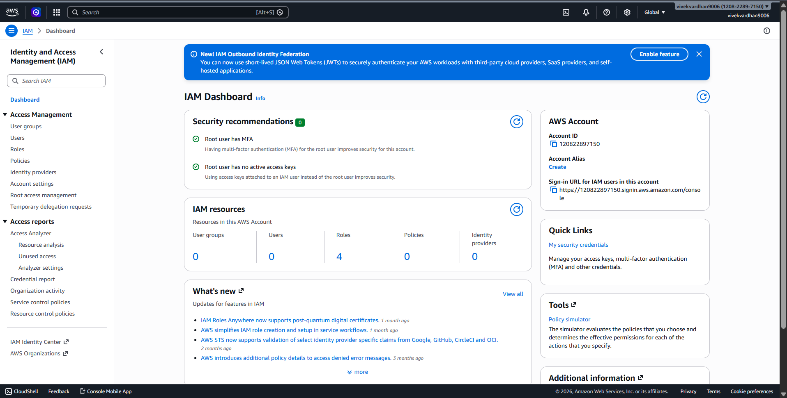
- Create the Role: Go to IAM > Roles > Create role
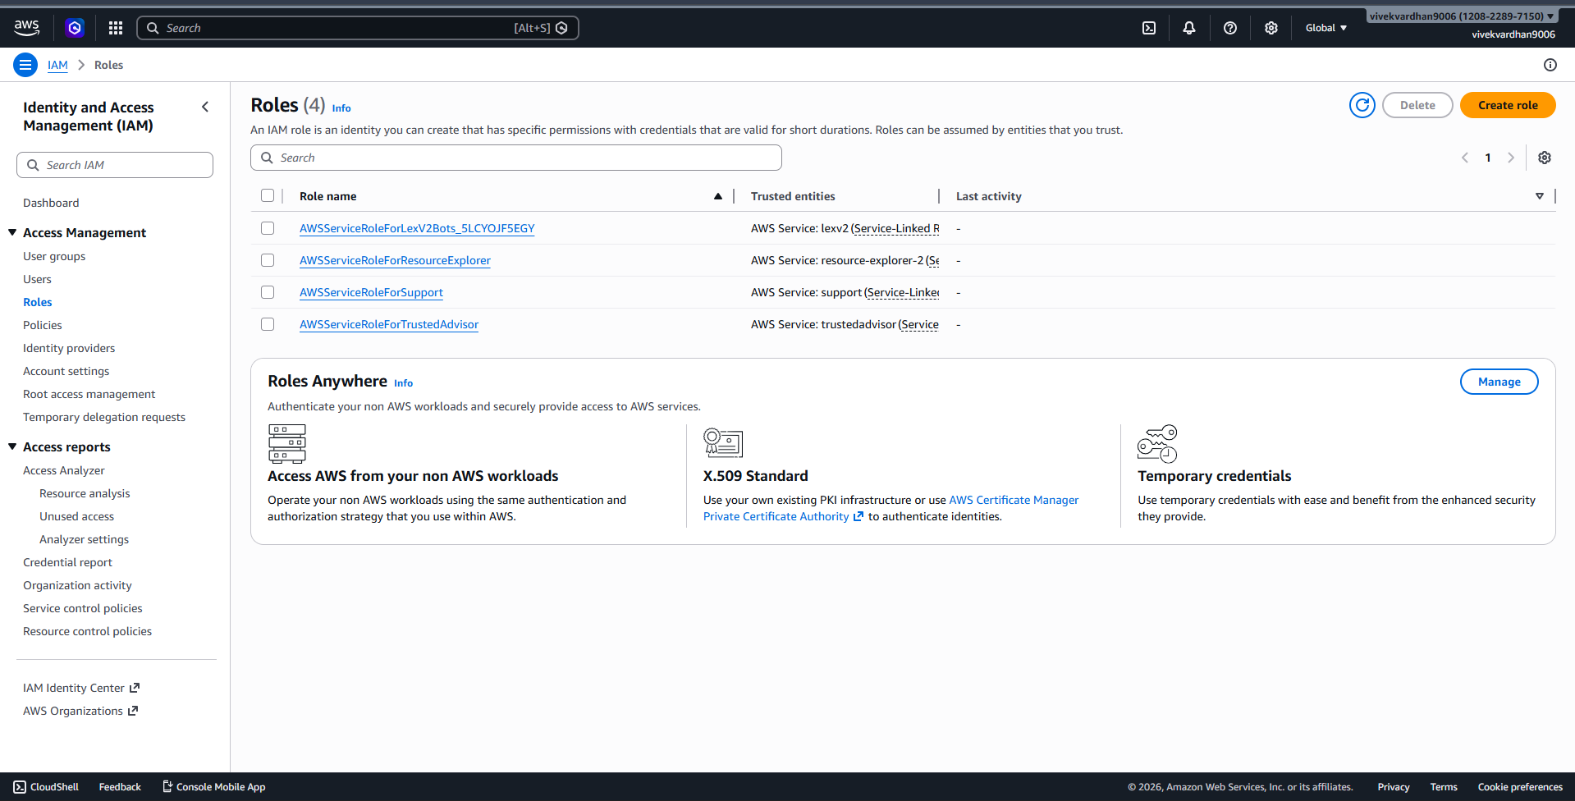
- Select Trusted Entity: Choose AWS Service.
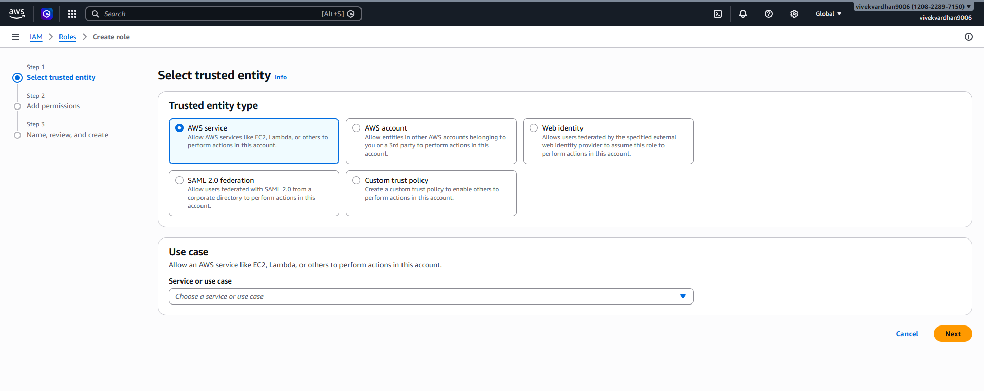
- Under the "Service or use case" dropdown, select EC2. (This tells AWS: "I trust the EC2 service to use this role").
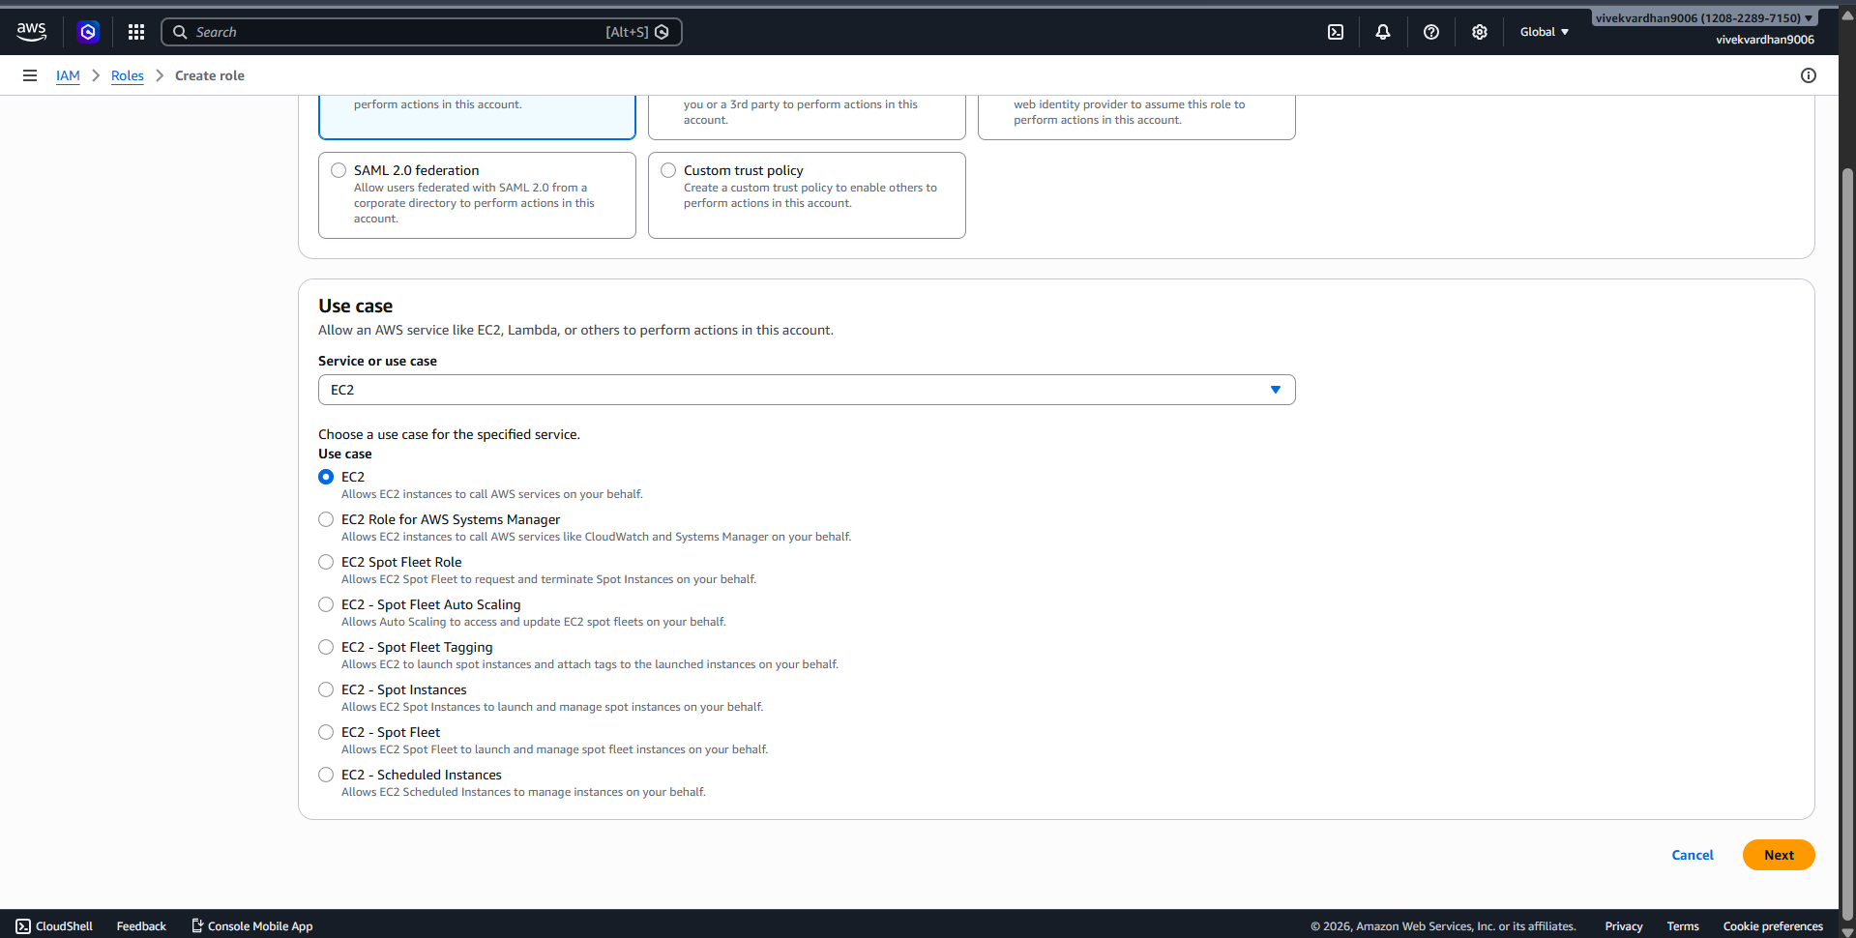
- Add Permissions: Search for and check AmazonS3FullAccess.
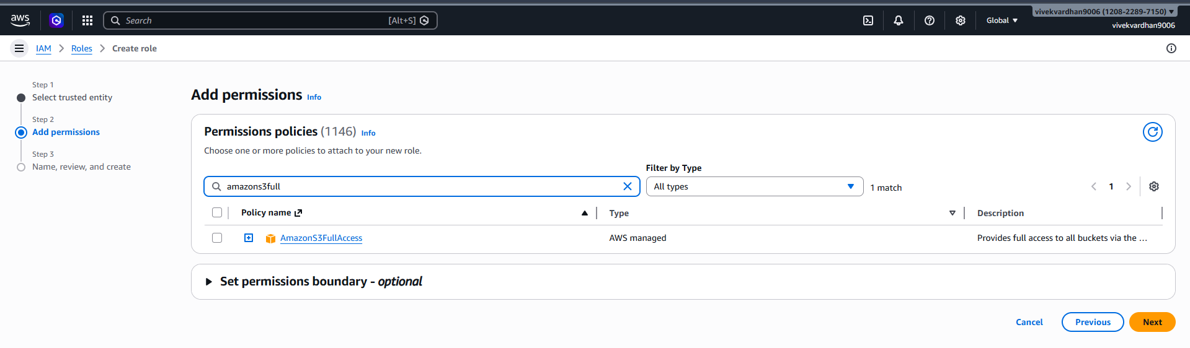
- Name & Review: Name it (e.g., EC2-S3-ReadOnly-Role) and click Create role.
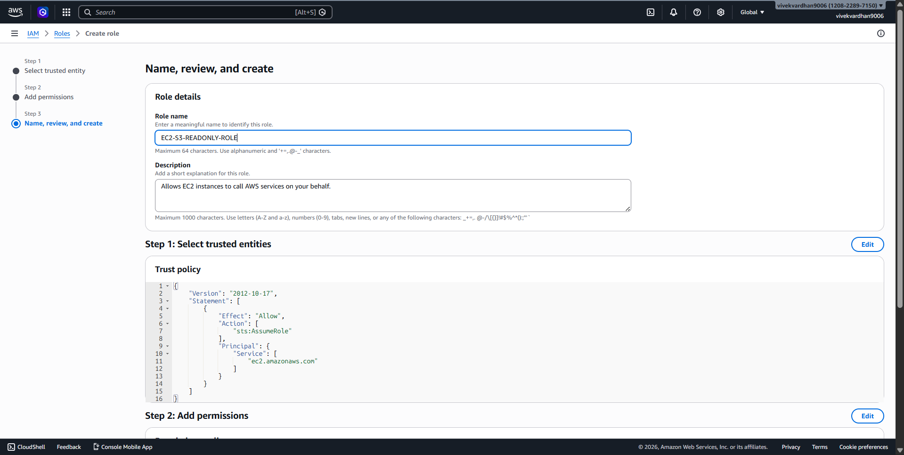
- Role has been created
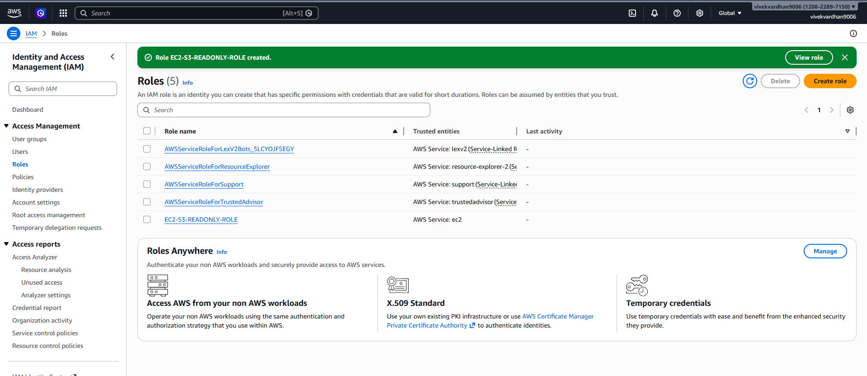
- Create the ec2 instance and and connect to it and check for aws ec2 describe-instances
Attach to Instance:
- Go to the EC2 Dashboard. Select your running instance.
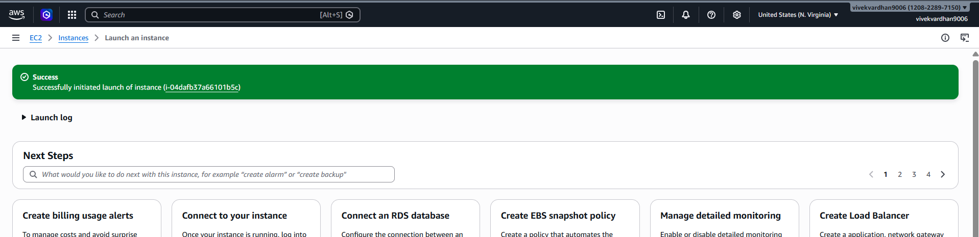

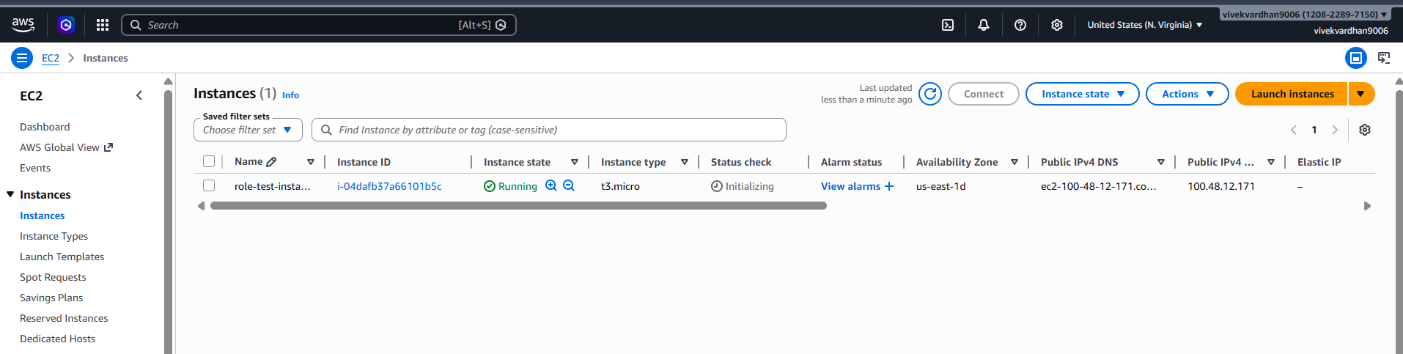
- Click Actions > Security > Modify IAM role.
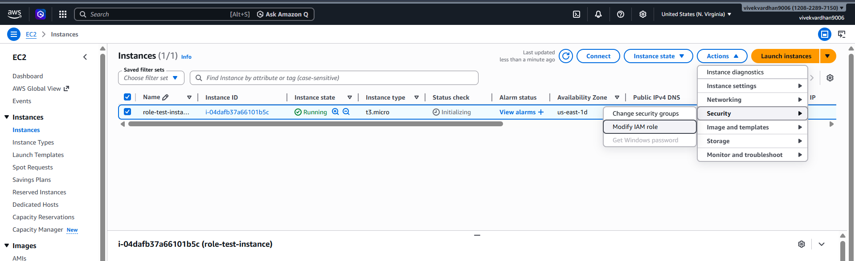
- Select the role you just created and click Update IAM role
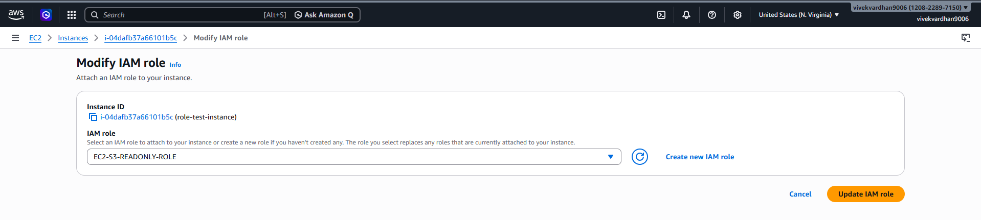
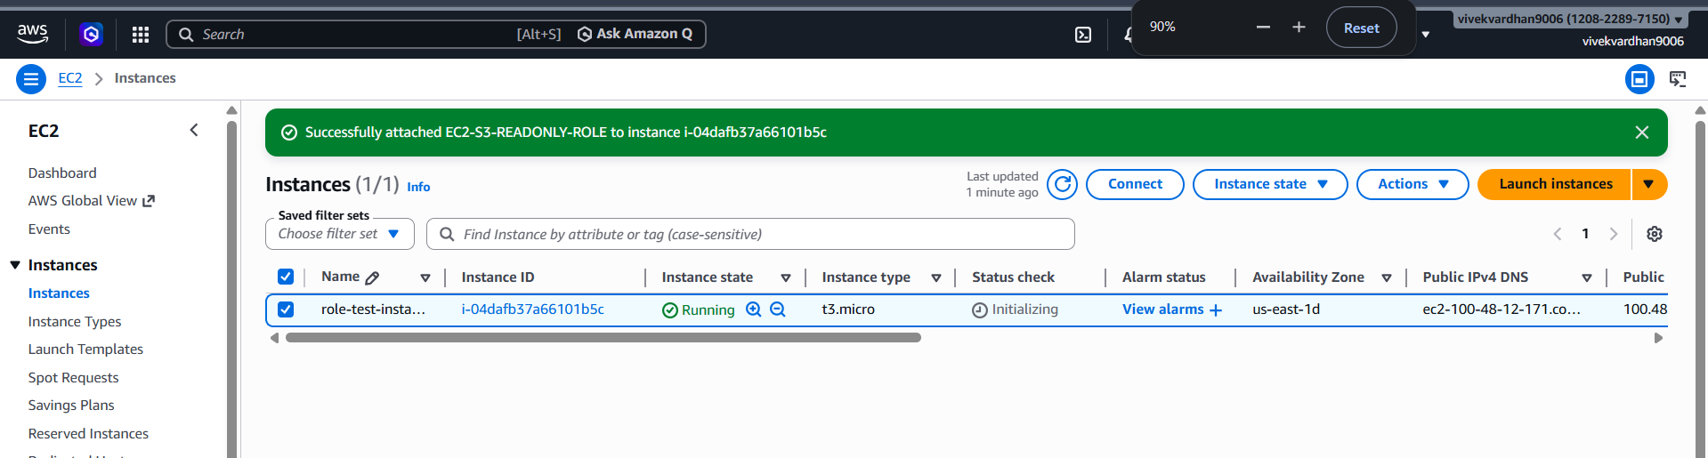
Verify via CLI:
- SSH/Connect into your EC2 instance. Type aws s3 ls.
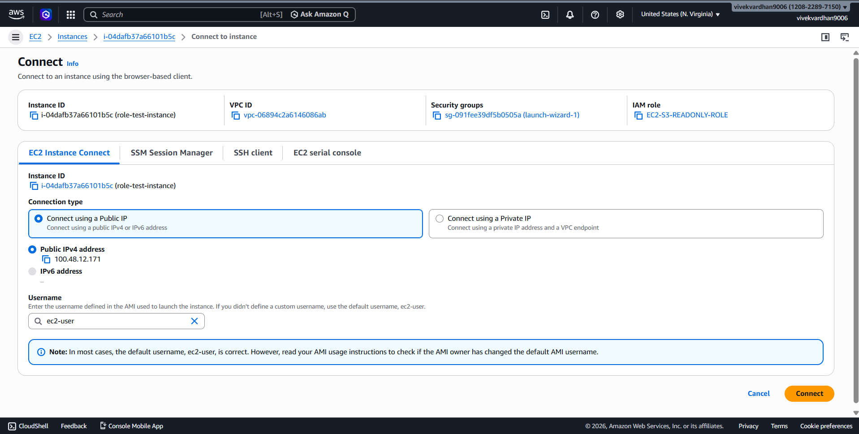aws
- The Result: The command works immediately.
- We can here role has only s3 full access only here-- aws ec2 describe-instances –unauthorized
- You did not have to provide an Access Key or Secret Key. AWS automatically provided
- Temporary Security Credentials to the instance.
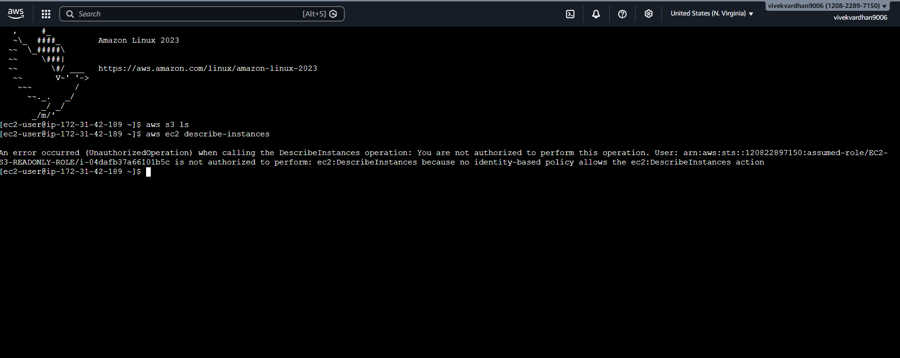

Scenario based questions:

1. Scenario: New Developer Access
You hired a new developer who needs access to EC2 and S3.
Ans) Create an IAM User for the developer. Attach required permissions using policies (for example AmazonEC2FullAccess and AmazonS3ReadOnlyAccess). This ensures the developer gets only required access instead of using root account.
Question: How will you provide access?

2. Scenario: Temporary Access Needed
A user needs access only for 2 days. How to do this?
Ans) Provide temporary access using IAM Role or AWS STS (Security Token Service). Configure the role session duration for 2 days. After expiry, access automatically stops.

3. Scenario: Access Key Leak
A developer accidentally exposed access keys on GitHub.How to resolve this?
Ans) Immediately deactivate or delete the exposed access key from IAM console. Generate a new access key if required. Also review CloudTrail logs to check if the key was misused and update permissions if necessary.

4. Scenario: CLI Access Required
User needs programmatic access. How to do this?
Ans) Create an IAM User and enable programmatic access (Access key + Secret key). Configure credentials using:
aws configure
User can then access AWS services using CLI.

5. Scenario: 50 Employees Same Permissions
50 employees need same S3 access. How to do this?
Ans) Create an IAM Group and attach the required S3 policy to the group. Add all 50 employees (users) to that group. This makes permission management easier.

6. Scenario: Change Permissions for Multiple Users
You need to revoke access from 20 users. How to do this?
Ans) Modify the IAM Group policy or Role policy instead of changing each user individually. All users in the group automatically receive updated permissions.

7. Scenario: Different Departments
HR, Dev, Admin need different access. How to do this?
Ans) Create separate IAM Groups such as HR, Developer, and Admin. Attach different policies based on department needs. Add users to their respective groups.

8. Scenario: EC2 Access to S3
An EC2 instance needs access to S3 without credentials.How to do this?
Ans) Create an IAM Role with S3 access policy. Attach the role to the EC2 instance. EC2 will automatically receive temporary credentials without storing access keys.

9. Scenario: Cross-Account Access
Account A wants to access resources in Account B. How to do this?
Ans) Create an IAM Role in Account B and define a trust policy allowing Account A to assume that role. Users from Account A can then access resources securely.

10. Scenario: Lambda Access to DynamoDB
Lambda needs to read/write DynamoDB. How to give this?
Ans) Create an IAM Role with DynamoDB read/write permissions. Attach this role to the Lambda function so it can access DynamoDB securely.

11. Scenario: Temporary Elevated Access
Admin access needed temporarily. How to do this?
Ans) Create an IAM Role with admin permissions and allow users to assume that role only when needed. Remove or disable role access after task completion.

12. Scenario: Restrict S3 Access to Specific Bucket
User should only access one bucket. How to do this?
Ans) Create a custom IAM policy specifying the ARN of the required S3 bucket. Attach policy to user/role so they can access only that bucket.
Example:
"Resource": "arn:aws:s3:::my-bucket/*"

13. Scenario: Deny Delete Actions
Users should not delete resources. Why this happens?
Ans) Create a policy with explicit Deny for delete actions such as:
"s3:DeleteObject"
Explicit deny always overrides allow permissions.

14. Scenario: Time-Based Access
User should access only during office hours. How to do this?
Ans) Use IAM policy conditions with date or time restrictions. Example: allow access only between 9AM–6PM using condition keys.

15. Scenario: IP-Based Access
Allow access only from office network. How to do?
Ans) Add condition in IAM policy specifying allowed IP address range:
"Condition": {"IpAddress": {"aws:SourceIp": "192.168.1.0/24"}}
Only users from that network can access.

16. Scenario: Secure Best Practice
How do you manage permissions efficiently?
Ans) Follow least privilege principle, use IAM roles instead of access keys, enable MFA, rotate credentials regularly, and use groups for easier management.

17. Scenario: Root User Usage
When should root user be used?
Ans) Root user should be used only for critical account-level tasks such as billing settings, account closure, or initial setup. Daily operations should use IAM users.

18. Scenario: Multiple Services Access
User needs EC2 + S3 + DynamoDB. How to do this?
Ans) Create a single IAM policy including permissions for EC2, S3, and DynamoDB. Attach policy to user, group, or role.

19. Scenario: Audit Permissions
How to track user activity?
Ans) Use AWS CloudTrail to monitor API calls and user activity. CloudWatch can also be used to create alerts for suspicious activity.

20. Scenario: Over-Permission Issue
User has too much permission. How to solve this?
Ans) Review IAM policies using IAM Access Analyzer. Remove unnecessary permissions and apply least privilege principle to restrict access.

