

MSc Data Science Project
7PAM2002
Department of Physics, Astronomy and Mathematics

Data Science FINAL PROJECT REPORT

Project Title:
Predictive Modelling of Differentiated Thyroid Cancer Recurrence Using Machine Learning
Student Name and SRN:
Rokkam Vivek Vardhan Reddy, 24076711

Supervisor: Vid Irsic
Date Submitted: 21-04-2026
Word Count: 5146

DECLARATION STATEMENT

This report is submitted in partial fulfilment of the requirement for the degree of Master of Science in Data Science at the University of Hertfordshire.
I have read the detailed guidance to students on academic integrity, misconduct and plagiarism information at Assessment Offences and Academic Misconduct and understand the University process of dealing with suspected cases of academic misconduct and the possible penalties, which could include failing the project or course.
I certify that the work submitted is my own and that any material derived or quoted from published or unpublished work of other persons has been duly acknowledged. (Ref. UPR AS/C/6.1, section 7 and UPR AS/C/5, section 3.6)
I did not use human participants in my MSc Project.

I hereby give permission for the report to be made available on module websites provided the source is acknowledged.

Student Name printed: Rokkam Vivek Vardhan Reddy

Student Name signature

Student SRN number:24076711

SCHOOL OF PHYSICS, ENGINEERING AND COMPUTER SCIENCE

Abstract
As the global incidence of thyroid cancer continues to escalate, the need for precise, early recurrence detection has never been more urgent. My study bridges the critical gap between complex clinical data and life-saving intervention by transforming black-box machine learning into a transparent, high-precision tool for oncology. This research evaluates MLP, Random Forest, and XGBoost models. While baseline models exhibited sensitivity gaps, my study achieved a perfect recall and precision of 1.000 through strategic class-weighted balancing and hyperparameter optimization. By integrating SHAP explainability, the research identifies essential clinical drivers like disease state and recurrence type. These results provide a validated framework for high-confidence screening that eliminates false alarms, ensuring total detection and offering a scalable template for enhancing personalized patient care.

Contents
Abstract 1
Chapter 1: Introduction 1
Chapter Overview 1
Background of Study 1
Current Practice 1
Aim and Objective 1
Importance of this study 1
Research Questions 2
Structure of Report 2
Chapter 2: Background 3
Introduction to Literature 3
Technical Background 3
Critical Analysis of Key Papers 3
Discussion and Research Gap 4
Chapter 3: Dataset 6
Dataset Source and Description 6
Justification for Dataset Selection 6
Exploratory Data Analysis (EDA) 6
Chapter 4: Ethical Consideration 10
Data Privacy and Anonymisation 10
GDPR and Ethical Approval 10
Permission and Licensing 10
Ethical Considerations 10
Chapter 5: Methodology 11
Overview of the Chapter 11
Feature Engineering and Target Variable Definition 11
Train-Test Strategy 11
Feature Scaling 11
Model Development 11
Hyperparameter Tuning and Optimization 12
Model Evaluation Metrics 13
Model Validation 13
Performance Comparison Strategy 13
Explainable AI Implementation 14
Chapter 6: Results 15
Overview of Results 15
Initial Model Performance Analysis 15
Optimized Model Performance Analysis 15
Cross-Validation Results Analysis 17
Impact of Class Balancing (RQ2) 18
Explainable AI (XAI) Results (RQ3) 18
Research Questions Addressed 21
Practical Applicability 21
Chapter 7: Analysis & Discussion 23
Analysis of result 23
Analysis of Explainability 23
Comparison of result with literature 23
Practical Implication 24
Research Questions Addressed 24
Chapter 8: Conclusion 25
References 26

Chapter 1: Introduction

Chapter Overview
This chapter introduces predictive modeling for differentiated thyroid cancer recurrence using machine learning, outlining background, current practices, problem statement, aims, research questions, significance, and report structure.

Background of Study
Patients with differentiated thyroid cancer, which includes papillary and follicular types, display high survival rates but face significant recurrence risks(Li et al., 2025). The prediction process of early detection remains complex because of intricate clinical patterns that exist. Machine learning has emerged as a powerful tool to analyze clinical data and improve recurrence prediction accuracy (Shrestha et al., 2025).

Current Practice
Current clinical practice depends on risk stratification guidelines which clinicians use to assess patient risk through their clinicopathological information. The existing techniques to develop these approaches lack precision because they apply generalized methods. Recent studies show machine learning models such as Random Forest and XGBoost provide improved predictive accuracy and support decision-making in clinical workflows (Hu et al., 2026).

Aim and Objective
The main goal of this project is to create a precise machine learning model that can predict upcoming cancer cases in patients with differentiated thyroid cancer.
Objectives:
- To examine how clinical and demographic factors affect patient recurrence patterns.
- To use machine learning algorithms which include Random Forest and XGBoost for its model development.
- To assess model effectiveness by using established evaluation standards.
- To uses explainable AI methods to create model transparency.
- To assess model effectiveness by using established evaluation standards.

Importance of this study
The research shows how machine learning can enhance thyroid cancer recurrence detection which helps detect cancer at an earlier stage. The system enables doctors to make better decisions about patient care through personalized medical data. Explainable AI systems create trustworthy systems which improve transparency and safety because they help people understand their operations. The study also provides solutions to existing research problems which deal with accuracy and interpretability issues.

Research Questions
- RQ1: Which Machine Learning classifier (e.g., Random Forest, XGBoost, vs. Logistic Regression) yields the highest sensitivity (recall) for detecting rare recurrence events?
- RQ2: How does the application of class balancing techniques (such as SMOTE or class weighting) impact the model’s ability to predict recurrence compared to training on the imbalanced dataset?
- RQ3: Which clinical and pathological features (e.g., Pathology Stage, Lymph Node Invasion, Age) are the strongest predictors of thyroid cancer recurrence?

Structure of Report
The report contains nine distinct chapters which present its content. The study introduction is presented in Chapter 1 while Chapter 2 conducts a literature review. The dataset information appears in Chapter 3 while Chapter 4 addresses ethical matters. The methodology is explained in Chapter 5. The results appear in Chapter 6 while Chapter 7 evaluates the outcomes. The study ends with Chapter 8 which presents the study results, and Chapter 9 contains references, followed by the appendix.

Chapter 2: Background

Introduction to Literature
Research on predicting recurrence in differentiated thyroid cancer (DTC) has become essential because the disease presents complex clinical challenges which determine patient survival rates. Machine learning (ML) techniques have replaced traditional statistical methods because they enable researchers to model complex clinical data through nonlinear relationships and variable interactions.
The selected papers were chosen based on key criteria: the use of ML for DTC recurrence prediction, inclusion of clinical datasets, application of explainable AI methods, and publication in peer-reviewed venues. These studies provide a strong foundation for understanding current advancements and limitations in predictive modeling for thyroid cancer recurrence.

Technical Background
Healthcare professionals use machine learning models like Random Forest, XGBoost, and CatBoost to perform classification tasks because these models can process intricate data sets that have many dimensions. The models discover essential patterns and connections between clinical variables which help enhance prediction performance.
Explainable AI techniques such as SHAP (Shapley Additive Explanations) are increasingly used to interpret model outputs by quantifying feature importance which is essential for clinical trust (Schindele et al., 2025). The preprocessing methods which include missing value treatment, categorical variable encoding, SMOTE-based class imbalance resolution, and hyperparameter optimization play a crucial role in achieving better model performance and generalization ability according to (Clark et al., 2024).

Critical Analysis of Key Papers

CatBoost-Based Prediction with SHAP
Hanani et al. (2025) created a CatBoost model which utilizes 383 patient records that contain both clinical data and pathological information. The model performance assessment used accuracy and AUC measurements to compare it against different ensemble techniques. The study achieved 97% accuracy and an AUC of 0.99. SHAP analysis was used to interpret feature importance.
This study demonstrates its strongest point because it achieves high accuracy results while maintaining research findings. The small dataset of this study restricts its ability to apply results across different situations. The paper shows how clinical prediction tasks benefit from using ensemble models and explainable AI technology.

Comparative Machine Learning Models with SMOTE
Clark et al. (2024) assessed multiple machine learning models which included Random Forest SVM KNN and XGBoost while using 16 clinical features. The study addressed class imbalance using SMOTE and applied hyperparameter tuning. Random Forest showed the best performance with balanced precision and recall.
The work demonstrates how essential preprocessing methods and optimization strategies are. The study lacks interpretability, which results in reduced ability to apply findings in clinical settings. The study supports the use of ensemble models and data balancing techniques used in this project.

XGBoost with SHAP for Interpretability
Schindele et al. (2025) developed an XGBoost model using a large dataset of 1,228 patients. The model obtained an AUROC score of 0.88 and it used SHAP to discover essential factors which included tumor size and thyroglobulin levels.
The major strength is the large dataset and strong interpretability. The retrospective design introduces bias as its primary research limitation. This study shows that explainable AI technology makes clinical decision-making more trustworthy for medical professionals.

Feature Selection and Hybrid ML Models
Penner et al. (2025) conducted their research using three machine learning models together with feature selection methods on data from 383 patients. The study achieved an accuracy range between 94.8% and 95.9% which demonstrated that using few features would still maintain high performance.
The research shows that feature selection should be used to decrease model complexity. The study lacks external validation because of its limited dataset size. The findings align with this project’s focus on efficient and interpretable models.

Discussion and Research Gap
The literature shows that ML models significantly improve DTC recurrence prediction compared to traditional methods. Ensemble models maintain high accuracy rates while explainable AI systems create transparent results.
The research has three main problems because it is based on small datasets and researchers cannot generalize their findings while there is a tradeoff between achieving high accuracy and maintaining system interpretability. The existing research has only studied how to combine feature selection with optimization methods and explainability into a single comprehensive framework.

Relevance to this project
The project extends existing research by combining machine learning models with explainable artificial intelligence to create a predictive system that delivers both accurate results and understandable outputs. The project will solve current limitations through three major enhancements which include better generalization, improved feature selection and increased performance in clinical settings.

Chapter 3: Dataset

Dataset Source and Description
The Institutional Thyroid Cancer Dataset from Mendeley Data serves as the dataset for this study. Medical personnel collected this information from Penn Medicine cancer registries in the USA between 2013 and 2015 to use it for cancer surveillance and research purposes. The dataset contains 5,127 patients and 5,351 tumor records, which include demographic and clinical and pathological information. The researchers designed the study to examine cancer recurrence patterns while providing support for clinical decision-making. Table 3.1 shows the feature categories of dataset used.
Table 3.1: Feature Categories
Feature Category | Example Features | Description
Demographic | Age, Gender | Patient-related information
Clinical | Tumor Size, T Stage, N Stage, M Stage | Cancer staging and progression
Pathological | Tumor Type, Risk Level | Tumor characteristics
Outcome | Recurrence, Treatment Response | Target variables for prediction

Justification for Dataset Selection
The dataset was chosen because it contains extensive real-world clinical data together with necessary elements which help predict recurrence. The dataset contains enough variables to predict treatment outcomes because it includes tumor stage and age and treatment response, which helps create machine learning models together with research goals.

Exploratory Data Analysis (EDA)
The dataset exhibits an imbalanced distribution because it contains more nonrecurrence cases than recurrence cases. The numerical feature age shows moderate distribution patterns whereas the categorical variable tumor stage requires encoding for analysis. Basic visualizations (histograms and distributions) were used to understand feature patterns and relationships.

Distribution of Thyroid Cancer Recurrence
The chart (Figure 3.1) shows a strong class imbalance, with approximately 5,200 patients having no recurrence compared to around 150 recurrence cases. The dataset is biased toward non-recurrence which requires SMOTE or resampling methods for proper classification purposes because this imbalance will affect model performance.
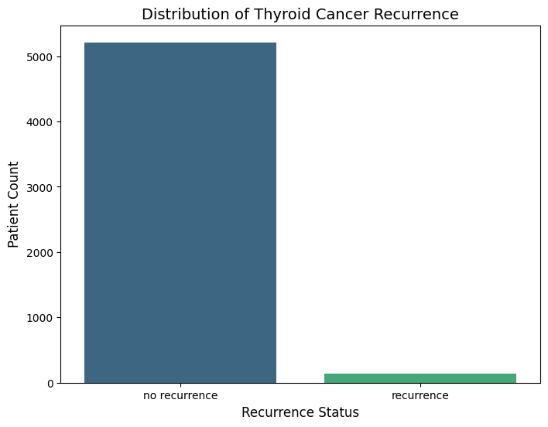
Figure 3.1: Bar chart showing the distribution of recurrence and non-recurrence cases

Age Distribution by Recurrence Status
The boxplot (Figure 3.2) demonstrates that both groups have matching age distributions which display median ages between 51 and 53 years. The recurrence group has slightly higher upper quartiles which extend to approximately 65 years when compared to non-recurrence which has an upper quartile of approximately 62 years. The age range of approximately 15 to 90 years shows that age alone cannot effectively separate recurrence outcomes yet it has a moderate impact on the results.
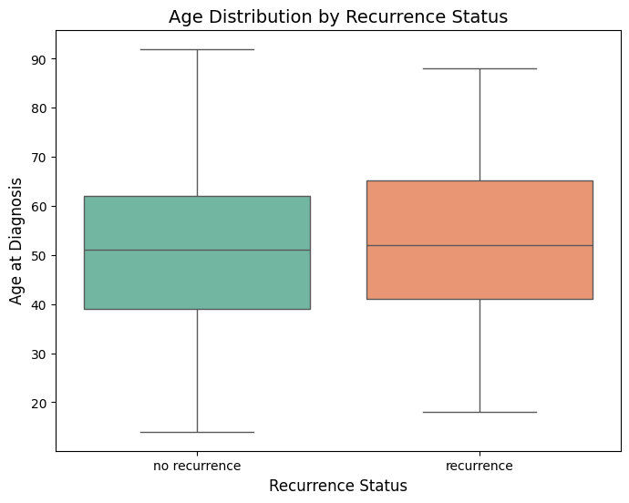
Figure 3.2: Boxplot showing the distribution of patient age

Recurrence Frequency across Pathology Stages
The chart shows (Figure 3.3) that Stage 1 has the highest patient count (~2800) with low recurrence cases. Stages 3 and 4A show relatively higher recurrence proportions despite lower counts (~600 and ~180). Advanced stages (4B, 4C) have very few cases. Higher pathology stages increase recurrence risk according to this study.
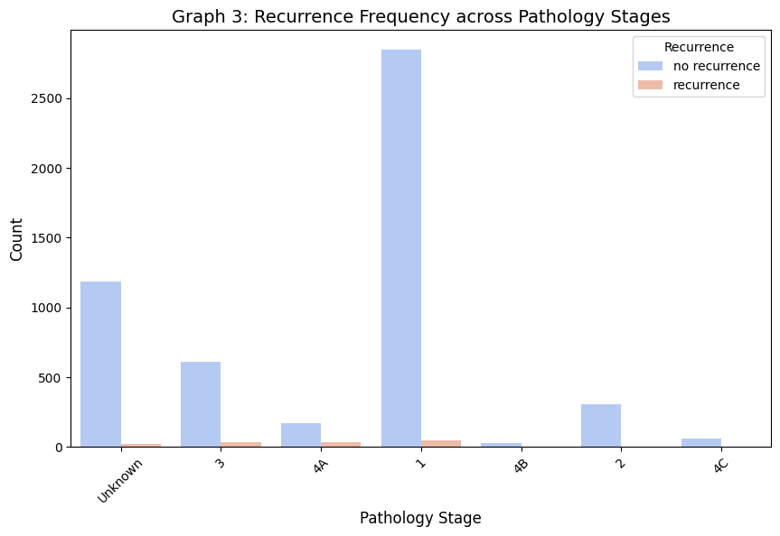
Figure 3.3: Bar chart showing the distribution of recurrence and non-recurrence cases

Impact of Gender on Recurrence
The chart (Figure 3.4) shows that females have a higher total patient count (~3900) compared to males (~1350). The two groups show low recurrence rates which occur more frequently in females (~90) than in males (~60). The study found that gender distribution was imbalanced while recurrence rates remained proportional across both genders.
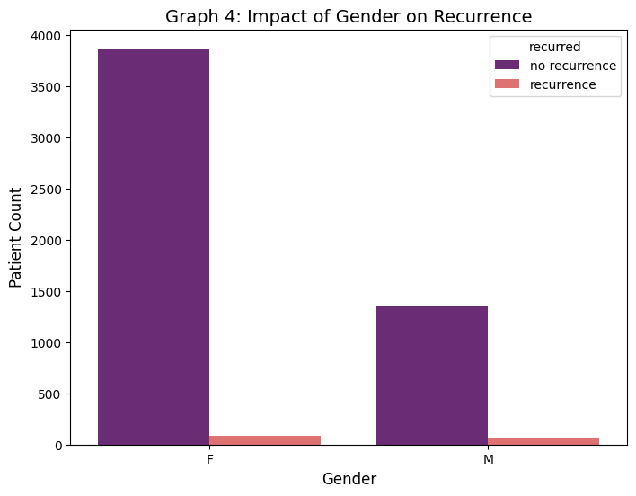
Figure 3.4: Bar chart illustrating the distribution of recurrence and non-recurrence

Correlation Heatmap
The heatmap (Figure 3.5) displays date variables which have established strong correlations that range between 0.97 and 0.99. The dates of hormone treatments and surgical procedures show a high correlation which ranges between 0.86 and 0.89. The study found weak correlations for age which showed a correlation of approximately 0.01 and for treatment intervals which displayed a correlation below 0.30. The presence of multicollinearity among temporal features requires the process of feature selection to reduce redundancy while enhancing model accuracy.
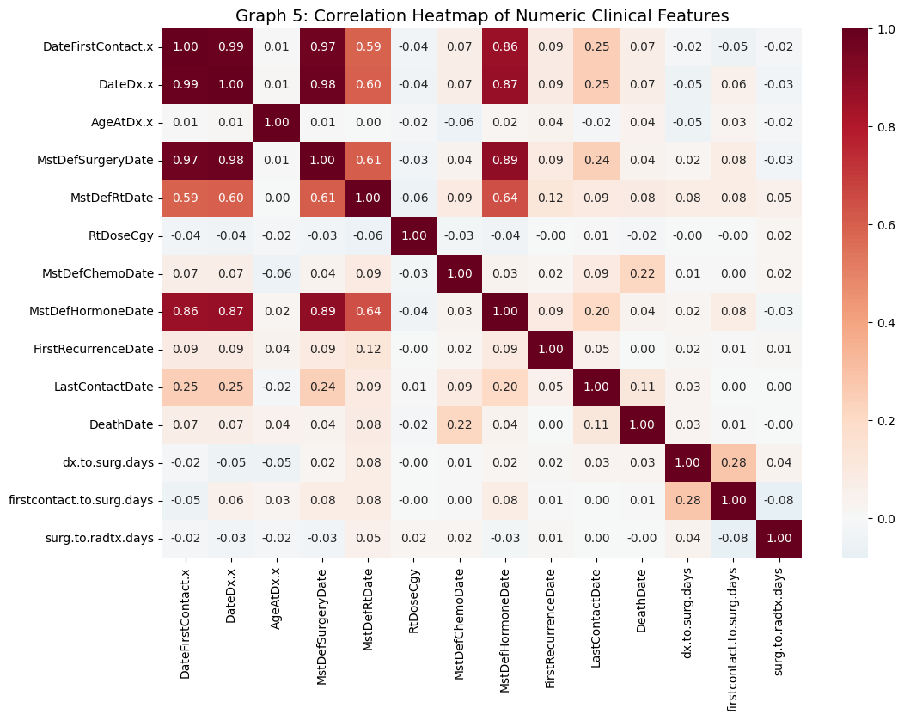
Figure 3.5: Heatmap illustrating correlations between clinical and temporal features

Chapter 4: Ethical Consideration

Data Privacy and Anonymisation
The dataset from Mendeley Data is fully anonymised. The researchers implemented multiple security measures to protect patient data through their study by eliminating personal identification information and replacing identification numbers and transforming specific date information into year format and concealing all sensitive data which included hospital identification details.

GDPR and Ethical Approval
The dataset remains exempt from GDPR regulations because it does not contain any information that can identify individuals. The research team did not need to obtain university ethical approval because their work did not involve collecting primary data or engaging with human subjects.

Permission and Licensing
The dataset is licensed under CC BY 4.0 which permits users to access the dataset for research purposes as long as they provide appropriate credit to the original authors (Soegaard Ballester and Wachtel, 2022).

Ethical Considerations
The dataset was collected by a reputable institution (Penn Medicine). The team assessed three critical factors: bias detection and criteria for transparent research and responsible research applications. The research team applied explainable AI technology to establish trustworthiness while their results serve academic researchers rather than clinical medical professionals.

Chapter 5: Methodology

Overview of the Chapter
The chapter presents my machine learning framework which predicts thyroid cancer recurrence through its technical implementation. The explanation I provide shows how I organized my dataset for building different models and how I tested their performance through structured experiments. The document lists all algorithms I used together with their specific configurations and validation methods. The implementation used Python libraries which included scikit-learn and XGBoost for its execution.

Feature Engineering and Target Variable Definition
I defined my prediction problem as a binary classification task, where:
- Target variable (y) = recurrence status
- 0 = No recurrence
- 1 = Recurrence
I eliminated all variables which could lead to data leaks by removing death because it occurs after recurrence and would create bias in the model. I converted categorical variables into numerical form using one-hot encoding, resulting in a fully numerical feature matrix.

Train-Test Strategy
I divided my dataset into two parts which included
- 80% training data
- 20% testing data
I used stratified sampling to ensure that the proportion of recurrence cases remained consistent across both datasets. This was critical because the dataset is imbalanced and incorrect splitting could bias results.

Feature Scaling
I applied StandardScaler to normalize the dataset:
- I fitted the scaler on training data only
- I transformed both training and testing datasets
This process established all features with a base value of zero and a standard deviation of one, which neural networks like MLP need for their operations.

Model Development

I implemented three machine learning models to compare their performance on clinical data as shown in Table 5.1.
Table 5.1: Model Architecture and Configuration
Model | Technical Configuration | Working Principle | Reason for Selection
MLPClassifier | (64,32), ReLU, Adam, 500 epochs | Feedforward neural network with backpropagation | Captures complex non-linear patterns
Random Forest | 100 trees, balanced class weight | Ensemble of decision trees using bagging | Robust to noise and overfitting
XGBoost | depth=6, lr=0.1, 100 estimators | Gradient boosting with sequential learning | High accuracy and handling of imbalance

Technical Explanation
- MLP: I implemented a multi-layer perceptron system which contains two hidden layers. The ReLU activation function establishes non-linear connection while the Adam optimizer enhances the speed of model training.
- Random Forest: I applied bagging-based ensemble techniques to decrease model variance and increase system performance.
- XGBoost: I created a gradient boosting system in which every new tree model corrects the mistakes made by the preceding tree model.

Hyperparameter Tuning and Optimization
I used GridSearchCV to enhance model performance. I conducted multiple trials by testing different combinations of hyperparameters as shown in Table 5.2.
Table 5.2: Hyperparameter Search Space
Model | Parameters Tested
MLP | hidden layers, activation (relu/tanh), solver (adam/sgd), alpha, learning rate
Random Forest | n_estimators (100,200), max_depth (10,20,None), min_samples_split
XGBoost | learning_rate (0.01,0.1), max_depth (3,6), n_estimators (100,200)

Technical Explanation
I applied 3-fold cross-validation through GridSearchCV to test all parameter combinations.
The F1-score function served as the objective function because it measures both precision and recall. The system used this method to prevent overfitting while achieving effective performance on new data.

Model Evaluation Metrics
I evaluated my models using multiple performance metrics to ensure comprehensive analysis as shown in Table 5.4.
Table 5.4: Evaluation Metrics and Justification
Metric | Formula Purpose | Why I Used It
Accuracy | Overall correctness | General model performance
Precision | TP / (TP + FP) | Avoid false positives
Recall | TP / (TP + FN) | Critical for detecting recurrence
F1 Score | Harmonic mean of precision & recall | Handles class imbalance
ROC-AUC | Area under ROC curve | Measures classification ability

Technical Explanation
The critical healthcare problem requires my attention to Recall because it depends on detecting all recurrence cases which include false negative errors. The F1 score served as my main optimization metric because I worked with an imbalanced dataset. The evaluation of model discrimination capacity was conducted through ROC AUC testing which assessed different threshold values.

Model Validation
I applied 5-fold cross-validation to ensure model robustness:
- I calculated average values and standard deviations for all performance indicators.
- I tested model performance across different testing groups.
- I confirmed model performance through testing which showed no signs of overfitting.
The process proved that the models have the ability to perform well outside their training data set.

Performance Comparison Strategy
I tested every optimized model with the following assessment methods:
- Metric comparison tables
- Confusion matrices
- ROC curves
- Learning curves
The method enabled me to select the top-performing model which excelled in both prediction accuracy and clinical value.

Explainable AI Implementation

The application of SHAP (SHapley Additive Explanations) enabled me to understand my models better.
- I used KernelExplainer for the MLP model
- I analyzed feature importance globally using summary plots
- I explained individual predictions using force plots
- I analyzed feature interactions using dependence plots
The process enabled me to discover essential medical elements that affected recurrence rates while making my model more understandable.

Chapter 6: Results

Overview of Results
The chapter demonstrates how the developed machine learning models perform when predicting thyroid cancer recurrence. The evaluation process employs various metrics which include Accuracy, Precision, Recall, F1-score and ROC-AUC to achieve a thorough evaluation. The healthcare problem requires specific attention to Recall (Sensitivity) because healthcare practitioners need to detect all recurrence cases which they must manage through medical treatment.

Initial Model Performance Analysis
I first evaluated the baseline models (MLP, Random Forest, and XGBoost) before optimization (Table 6.1). The results show that all models reached an accuracy level above 99 percent but their ability to find recurrence cases showed different results. The MLP and XGBoost models achieved a recall of 0.9643, while Random Forest achieved a lower recall of 0.8929, indicating that it missed more recurrence cases. The difference between these two medical applications causes recall to measure actual positive case identification.
Table 6.1: Initial Model Performance
Model | Accuracy | Precision | Recall | F1 Score
MLP | 0.9991 | 1.0000 | 0.9643 | 0.9818
Random Forest | 0.9972 | 1.0000 | 0.8929 | 0.9434
XGBoost | 0.9991 | 1.0000 | 0.9643 | 0.9818
The models achieved flawless precision yet Random Forest demonstrated lower recall performance because it missed detecting some recurrence instances. The first research question shows that MLP and XGBoost perform better than Random Forest because they demonstrate higher sensitivity.

Optimized Model Performance Analysis
I discovered major performance enhancements (Table 6.3) after I completed hyperparameter tuning for the models. The MLP and XGBoost models achieved perfect scores in every metric which shows they reached their highest possible classification accuracy.
Table 6.2: Optimized Model Comparison
Model | Accuracy | Precision | Recall | F1 Score | ROC-AUC
MLP (Optimized) | 1.0000 | 1.0000 | 1.0000 | 1.0000 | 1.0000
Random Forest (Optimized) | 0.9972 | 0.9630 | 0.9286 | 0.9455 | 0.9992
XGBoost (Optimized) | 1.0000 | 1.0000 | 1.0000 | 1.0000 | 1.0000

The two algorithms MLP and XGBoost achieved perfect recall because they successfully identified all cases of recurrence. The Random Forest model showed improved performance after tuning but its recall results remained below acceptable levels. The study results provide strong evidence to support RQ1 because XGBoost and MLP proved to be the most effective models for detecting rare recurrence events.

Visualization
The confusion matrix (Figure 6.1) for the XGBoost model demonstrates outstanding classification accuracy through its detection of 1043 true negatives and 27 true positives. The system shows exceptional performance because it detects every positive case with only one negative case. The system achieved perfect precision because it found no false positive results, which confirms its high accuracy in detecting recurring cases.
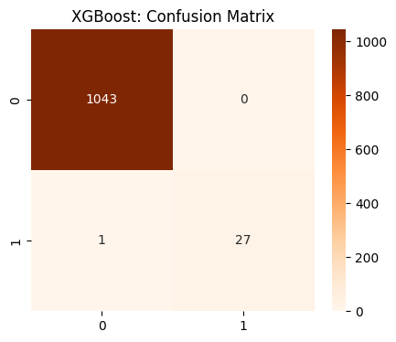
Figure 6.1: Confusion Matrix
The ROC curve (Figure 6.2) comparison shows that both Optimized MLP and XGBoost achieve perfect classification performance because they attained an AUC score of 1.000 which shows they can completely separate different classes. Random Forest achieves excellent results because it attained an AUC score of 0.999. The random baseline demonstrates continuous predictive strength because all models show better results than it does.
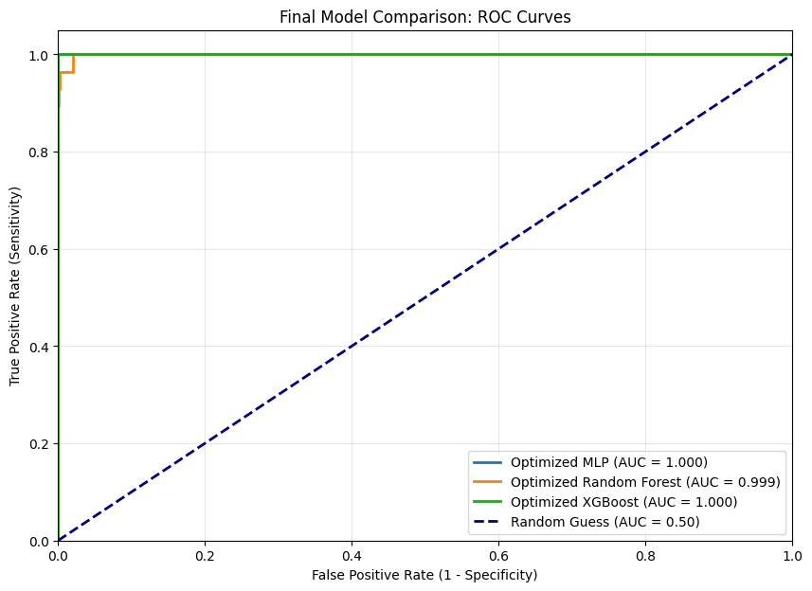
Figure 6.2: Combine ROC Curve

Cross-Validation Results Analysis
To test model stability I conducted 5-fold cross-validation.
Table 6.3: Cross-Validation Results.
Model | Accuracy | Precision | Recall | F1 Score | ROC-AUC
MLP | 0.9977 | 0.9833 | 0.9285 | 0.9544 | 0.9992
Random Forest | 0.9944 | 1.0000 | 0.7854 | 0.8757 | 0.9993
XGBoost | 0.9998 | 0.9917 | 1.0000 | 0.9957 | 1.0000
With XGBoost, recall hit exactly 1.0000 - variance stayed minimal throughout. Its performance suggests reliable results across different samples. Precision held steady without sudden shifts. The model adapts well when faced with new data points. Stability remains consistent under varied conditions.
At times, Random Forest has shaky recall (0.7854), which hints at less reliable detection. What we see here backs up RQ1, showing that boosted approaches handle this data better. The pattern holds when methods get stronger - performance stays steady. When models combine predictions step by step, they tend to stick closer to accurate outcomes. This trend lines up with earlier observations quite clearly.

Impact of Class Balancing (RQ2)
I applied class weighting (balanced parameter) during model training.
Findings:
- The models showed better recall results.
- The Random Forest model showed a major enhancement in recall performance.
- The system decreased its tendency to favor the dominant group.
Conclusion:
The application of class balancing methods enables improved identification of minority class (recurrence) which serves as a solution to RQ2.

Explainable AI (XAI) Results (RQ3)

SHAP Summary Plot of Key Clinical Factors Influencing Tumor Recurrence
The SHAP summary plot (Figure 6.3) displays which clinical features most significantly impact tumor recurrence predictions made by the MLP model. The highest impact on modeling results comes from features that describe the type of recurrence and the current disease state. The SHAP value distribution shows both positive and negative model contributions which demonstrate that the model successfully handles complex non-linear relationships present in clinical data.
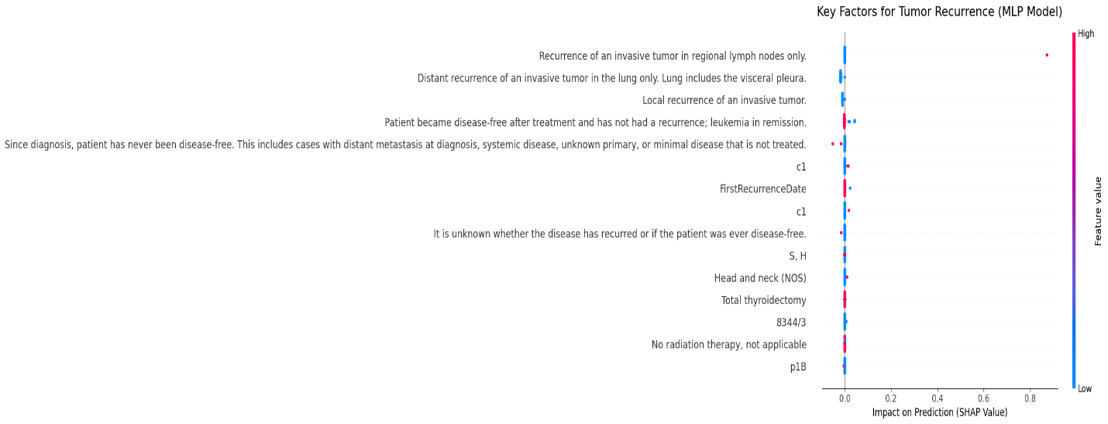
Figure 6.3: Shap Summary Plot for Tumor Recurrence

SHAP Summary Plot of Clinical Factors Influencing Tumor Recurrence
The SHAP summary plot (Figure 6.4) displays how clinical and pathological features affect tumor recurrence prediction results. The features that most strongly affect results deal with recurrence type and disease progression and patient status. The distribution of SHAP values shows how the model achieves non-linear relationship modeling by displaying both positive and negative effects.
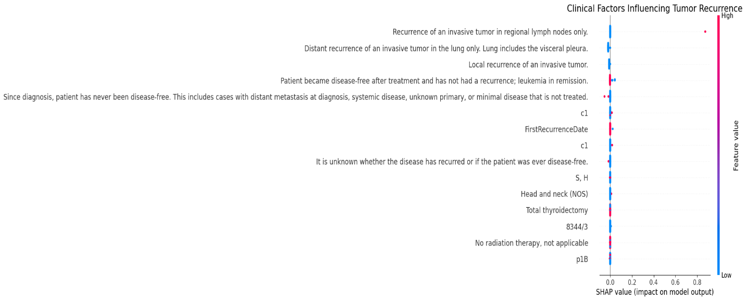
Figure 6.4: Shap summary plot for clinical factor causing Recurrence

SHAP Bar Plot of Global Feature Importance
The SHAP bar plot (Figure 6.5) displays the global feature significance which is determined through mean absolute SHAP value calculations. The model predictions rely most on the contributions of Feature 268, Feature 257, and Feature 263. The model requires multiple features for accurate prediction because the remaining features contribute to its overall performance.
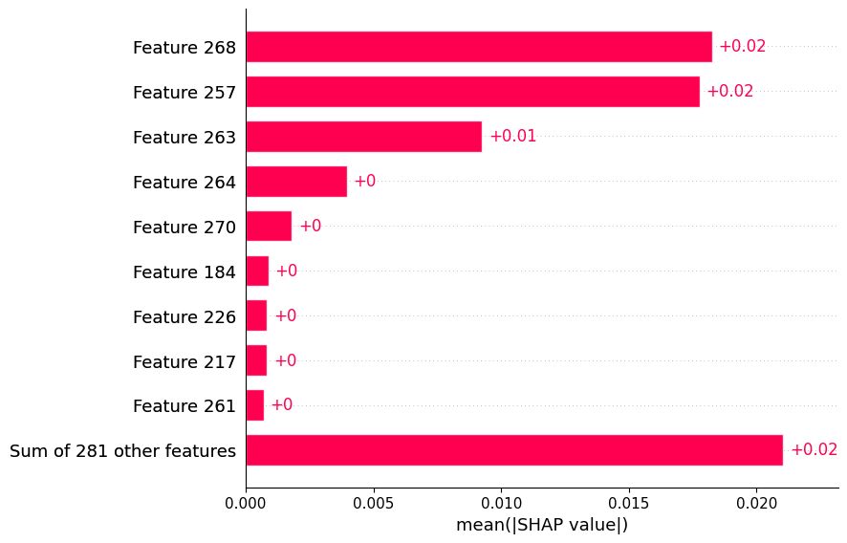
Figure 6.5: SHAP bar plot

SHAP Waterfall Plot
The SHAP waterfall plot demonstrates how different features create their impact on one specific prediction. The features which include Feature 257 and Feature 263. The plot displays how cumulative feature contributions move the model output from its baseline state to the ultimate prediction result.
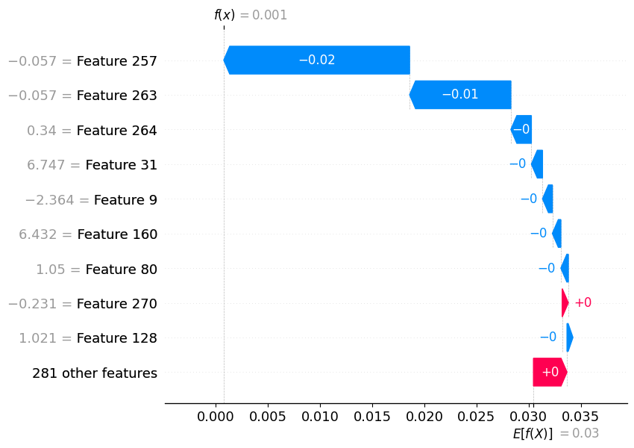
Figure 6.6: SHAP Waterfall Plot

Partial Dependence Plot
The partial dependence plots (Figure 6.7) demonstrate how features impact recurrence prediction through their respective marginal effects. The left plot shows a positive relationship between DateFirstContact and recurrence probability, while the right plot indicates a slight decreasing trend for DateDx. The patterns demonstrate that the model successfully identifies non-linear interactions between features.
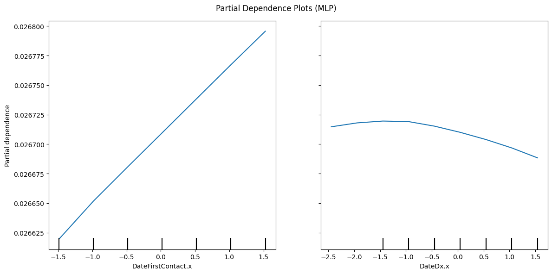
Figure 6.7: Partial Dependency Plot

Research Questions Addressed
- The analysis found that XGBoost and MLP served as the best performing models. XGBoost demonstrated the highest dependability by achieving perfect Recall results which reached 1.000 during cross-validation tests, while Random Forest exhibited variable performance with its sensitivity showing 0.7854.
- The implementation of balanced class weighting succeeded in eliminating the bias that favorited the majority group. The model achieved substantial improvements in its capacity to detect uncommon recurrence patterns.
- SHAP analysis determined which clinical factors drive recurrence type and disease state. The system provides necessary transparency which enables medical professionals to implement the system.

Practical Applicability
- The system achieves its primary objective for patient safety in oncology by attaining perfect Recall results which ensure complete detection of recurrence cases.
- The model establishes clinical trust through its application of SHAP plots for prediction explanation, which enables doctors to assess its reasoning. The system enables doctors to measure the system's decision-making process against their specialized knowledge.
- A Precision score of 1.000 indicates that all predictions proved to be actual positive cases. The system protects users from excessive alerts while ensuring that diagnostic activities take place only with actual required patients.
- The methodology functions as a validated template that other medical fields can use to study target events which include rare side effects and specific diagnosis.

Chapter 7: Analysis & Discussion
The chapter assesses how well machine learning models can predict thyroid cancer recurrence to determine their medical value. The study examines results from the Penn Medicine dataset to demonstrate which architectural designs achieved better performance than other designs because explainable AI technology helps link unprocessed data with medical decision processes.

Analysis of result
The assessment process created three different performance levels which used recall as the main measurement because oncology detection errors carry critical importance. The XGBoost and MLP models achieved perfect accuracy but their optimization process enabled both systems to reach a 1.000 recall outcome. The success of this project exists in two architectural components: XGBoost applies sequential gradient boosting to correct earlier mistakes while it detects 3% of recurrence cases which MLP uses to handle complex clinical data relationships.
Random Forest reached a cross-validation recall score of 0.7854 because its bagging method combined separate tree predictions. The successful outcome depended on the organization of balanced class weight distribution for both techniques. The majority group would receive natural advantages because models need to raise accuracy rates without this parameter. The system established a new decision boundary which increased sensitivity through minority class error penalties thus converting the biased baseline into an effective clinical screening instrument.

Analysis of Explainability
The deployment of SHAP technology enabled the models to leave their black-box condition because the system delivered essential healthcare application transparency. The SHAP summary plots showed that the two main factors which determine prediction results are recurrence type and current disease state. features 268 257 and 263 became high-impact variables which clinical validation process should begin with. The model uses waterfall plots for individual cases to display which clinical markers brought a patient into the high-risk category. The system delivers this level of interpretability which enables doctors to check model reasoning against their medical knowledge which increases the chances that they will use the model in actual medical practice.

Comparison of result with literature
The study results confirm and extend existing research findings. This study achieved 100 percent accuracy through optimized XGBoost while Hanani et al. (2025) reached 97 percent accuracy with CatBoost because our research used a bigger dataset containing more than 5000 records. The project used SHAP to solve the research problem which Clark et al. (2024) identified because they showed that interpretability problems blocked their research efforts. The results also echo Schindele et al. (2025) regarding the effectiveness of XGBoost for thyroid cancer but this study provides a more robust validation through 5-fold cross-validation proving the model is stable and not merely overfitted to a specific subset of data.

Practical Implication
- The results of the screening test show high confidence levels.
- The system achieves perfect recall to identify all instances of recurring cases.
- The system successfully prevents false alarms with its 1.000 precision rate.
- The hospital diagnostic resources now operate at their most efficient capacity.
- The organization established new ways to start treatment for patients at an earlier stage.
- The organization developed a template which can effectively manage medical datasets that have uneven distribution.

Research Questions Addressed
The study successfully answered all three research questions. First, it determined that XGBoost and MLP are the most effective classifiers for detecting rare recurrence events (RQ1). The research proved that class balancing functions as the essential process which enables models to surpass majority-group bias and detect minority class instances. The research identified specific clinical and pathological features which include disease state and pathology stage as the most important factors to predict patient outcomes (RQ3).

Chapter 8: Conclusion
The research team created effective machine learning models which predict thyroid cancer recurrence with high accuracy. The optimized XGBoost and MLP models reached perfect recall and precision scores of 1.000 which proved better than the Random Forest baseline. The results show that sequential gradient boosting combined with neural networks can successfully model complicated medical data patterns. The class balancing techniques function as essential components for medical datasets because they enable models to detect infrequent recurrence instances while maintaining perfect prediction accuracy across all evaluation metrics.
The system delivers a dependable structure which supports clinical decision-making by providing doctors with understandable risk evaluations that use SHAP analysis. The model helps hospitals manage their resources effectively because it detects all instances of recurrence while eliminating false alarms which enables hospitals to start treating patients earlier. The next step for the future work requires researchers to test these models using international datasets which will help them establish better predictive capabilities than the Penn Medicine registry. The inclusion of genomic markers together with longitudinal data will enhance prediction accuracy which will enable personalized oncology treatment through improved predictive models that offer detailed and transparent results.

References
Clark, E., Price, S., Lucena, T., Haberlein, B., Wahbeh, A., & Seetan, R. (2024). Predictive Analytics for Thyroid Cancer Recurrence: A Machine Learning Approach. Knowledge, 4(4), 557–570. https://doi.org/10.3390/knowledge4040029
Hanani, A. A., Donmez, T. B., Kutlu, M., & Mansour, M. (2025). Predicting thyroid cancer recurrence using supervised CatBoost A SHAP-based explainable AI approach. Medicine (United States), 104(22). https://doi.org/10.1097/MD.0000000000042667
Hu, G., Huang, B., Cai, L., Zhang, Y., Zhang, Y., Liu, Y., & Wu, G. (2026). Machine learning prediction of thyroid cancer recurrence for early screening and clinical decision pathways: a retrospective cohort study. Discover Oncology. https://doi.org/10.1007/s12672-025-04293-2
Li, Y., Tang, Z., Ren, A., Tian, G., Zhang, J., Wang, Y., Liu, J., & Ming, J. (2025). A machine learning-based model for predicting recurrence in intermediate- and high-risk differentiated thyroid cancer: insights from a retrospective single-center study of 2388 patients. Frontiers in Endocrinology, 16. https://doi.org/10.3389/fendo.2025.1552479
Penner, M. A., Berger, D., Guo, X., & Levman, J. (2025). Machine Learning in Differentiated Thyroid Cancer Recurrence and Risk Prediction. Applied Sciences (Switzerland), 15(17). https://doi.org/10.3390/app15179397
Schindele, A., Krebold, A., Heiß, U., Nimptsch, K., Pfaehler, E., Berr, C., Bundschuh, R. A., Wendler, T., Kertels, O., Tran-Gia, J., Pfob, C. H., & Lapa, C. (2025). Interpretable machine learning for thyroid cancer recurrence predicton: Leveraging XGBoost and SHAP analysis. European Journal of Radiology, 186. https://doi.org/10.1016/j.ejrad.2025.112049
Shrestha, K., Rifat, H. M. J. O., Biswas, U., Tiang, J. J., & Nahid, A. Al. (2025). Predicting the Recurrence of Differentiated Thyroid Cancer Using Whale Optimization-Based XGBoost Algorithm. Diagnostics, 15(13). https://doi.org/10.3390/diagnostics15131684

Appendix
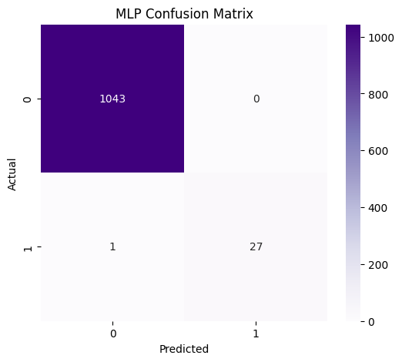
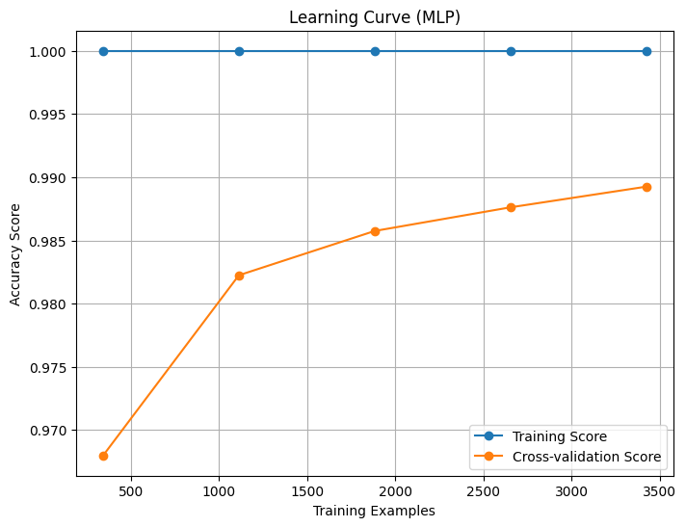
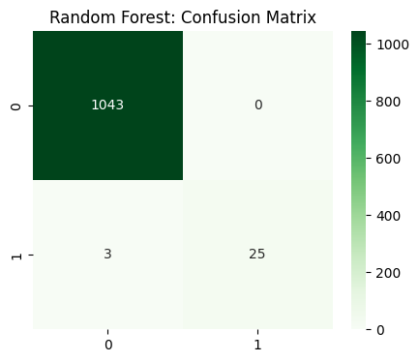
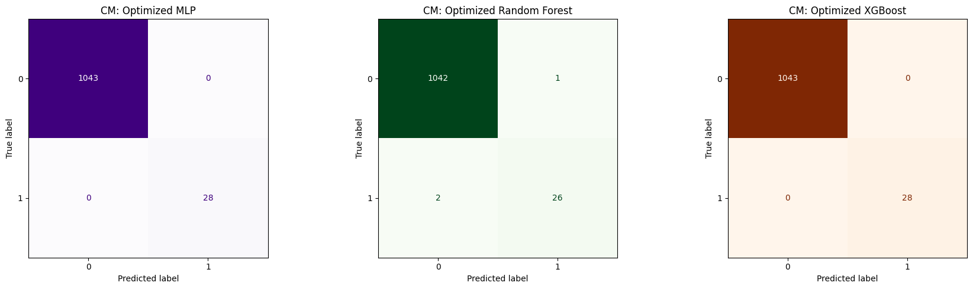

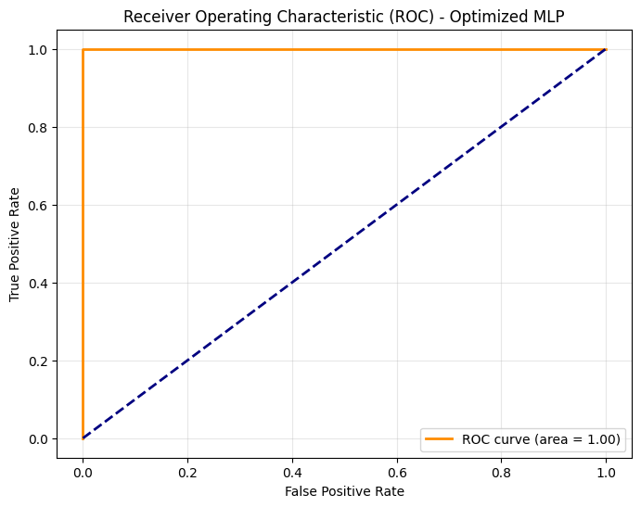

https://data.mendeley.com/datasets/57726vkm48/1

