Lab 2 Individual Report: Agile Planning in Jira
Problem Statement #14: Corporate Mental Wellness & Counseling Platform (Team 14, Helping Hands Software)
Name: Vivek Varma SRN: PES1UG24AM070 Section: 5B Unique Epic: KAN-13 Session Booking & Scheduling

1. My Epic
Epic KAN-13 "Session Booking & Scheduling" covers how an employee books a confidential counselling session. Therapists publish availability (UC-05). Employees see free slots in their own timezone (NFR-001) and book one without any chance of double booking (FR-003, UC-03, UC-10). Both parties get a confirmation (UC-11), and sessions can be rescheduled or cancelled (UC-12). It also supplies the 24-hour priority slot that crisis escalation needs (FR-005). No other team member owns these requirements.
Definition of Done: acceptance criteria pass, the concurrent-booking test shows exactly one winner per slot, the slot list p95 is under 2 seconds at 500 users, and both parties see the same absolute time on a daylight saving changeover date.

2. Jira Backlog with Epic and User Stories
The Epic holds seven user stories (KAN-14 to KAN-20), each written as "As a <role>, I want <goal>, so that <benefit>" with testable acceptance criteria. Four stories (21 SP) are planned into Sprint 1 and three (11 SP) stay in the product backlog.
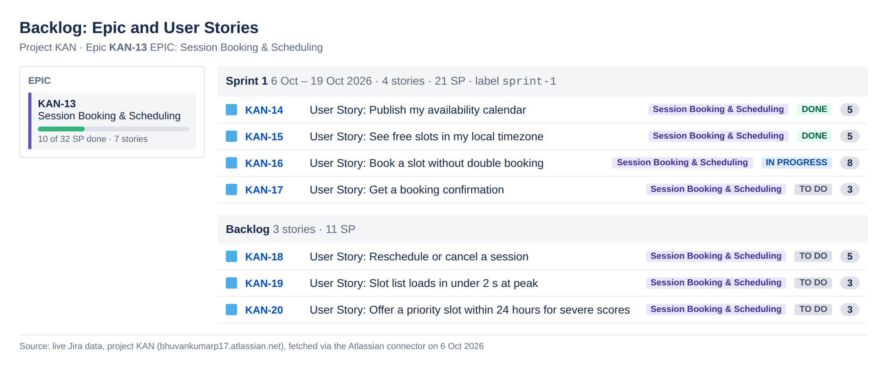
Figure 1: Backlog showing Epic KAN-13, the Sprint 1 stories and the remaining backlog

3. Story Point Assignments
Stories were estimated in story points on the Fibonacci scale (1, 2, 3, 5, 8, 13), relative to a small reference story, KAN-17 booking confirmation (3 SP). Points capture complexity, effort and uncertainty together, not hours.
Key | User story | SP | Priority | Traces to | Sprint | Status
KAN-14 | Publish my availability calendar | 5 | High | FR-003 | Sprint 1 | Done
KAN-15 | See free slots in my local timezone | 5 | High | NFR-001 | Sprint 1 | Done
KAN-16 | Book a slot without double booking | 8 | Highest | FR-003 | Sprint 1 | In Progress
KAN-17 | Get a booking confirmation | 3 | Medium | FR-003 | Sprint 1 | To Do
KAN-18 | Reschedule or cancel a session | 5 | Medium | FR-003 | Backlog | To Do
KAN-19 | Slot list loads in under 2 s at peak | 3 | Medium | NFR-001 | Backlog | To Do
KAN-20 | Offer a priority slot within 24 hours for severe scores | 3 | High | FR-005 | Backlog | To Do
 | Sprint 1 commitment | 21
 | Total epic estimate | 32

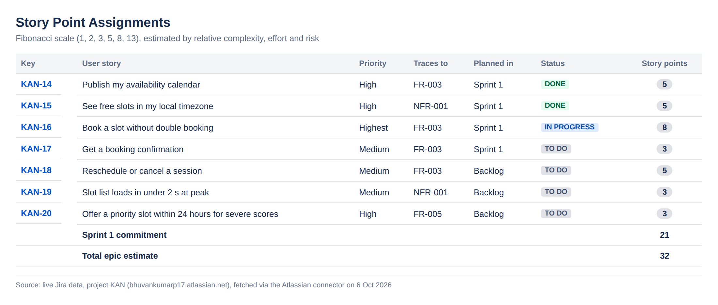
Figure 2: Story point assignments for Epic KAN-13

4. Sprint Board (Active Sprint View)
Sprint 1 runs from Tuesday 6 October to Monday 19 October 2026 (10 working days). Sprint goal: "Employees can book a confirmed session in their own timezone with no double booking." At the time of capture, two stories are Done (10 SP), one is In Progress (8 SP) and one is To Do (3 SP).
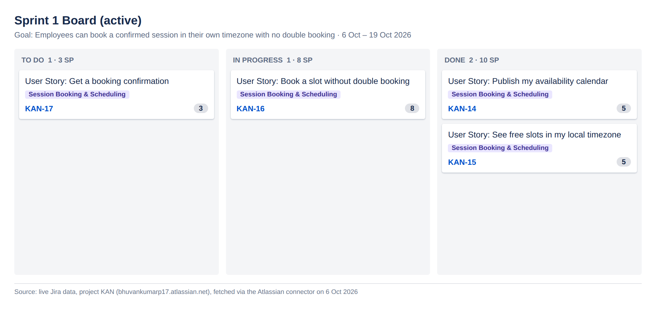
Figure 3: Sprint 1 board with To Do, In Progress and Done columns

5. Burndown Chart
The guideline burns 21 SP to zero over ten working days, about 2.3 SP per day. On day 1, KAN-14 (5 SP) and KAN-15 (5 SP) were completed, leaving 11 SP, well below the guideline. The remaining work is concentrated: KAN-16 (8 SP), the concurrency-safe booking, is most of what is left, and KAN-17 cannot finish until it does. The chart will stay flat until KAN-16 is done, so it is the item to watch at daily stand-ups.
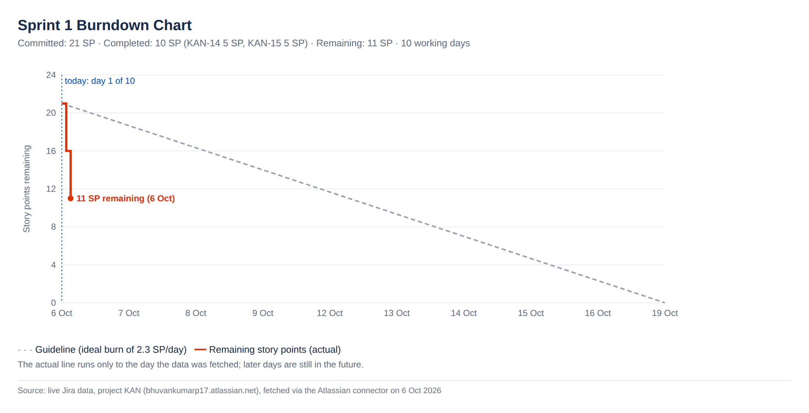
Figure 4: Sprint 1 burndown chart (remaining story points against the ideal guideline)

6. Reflection
Q1. How did you break your Epic into user stories?
I followed the booking journey from the Lab 1 use cases: the therapist publishes slots (UC-05), the employee views them (NFR-001), books one (UC-03 with UC-10), gets confirmed (UC-11) and may later change it (UC-12). Each step became one story that a user can see working on its own. I kept performance (p95 under 2 s) and the crisis priority slot (FR-005) as separate stories, because they have their own acceptance tests and can be scheduled independently.
Q2. How did you assign story points, and what was difficult?
I used relative estimation on the Fibonacci scale, anchored on booking confirmation (3 SP) as a well-understood story. The atomic booking story got 8 SP because it involves concurrency, transactions and a race-condition test, so the risk is high. The hard part was timezone handling. It looks simple, but daylight saving edge cases add real uncertainty, so I gave it 5 SP rather than 3.
Q3. How did you decide what went into Sprint 1?
I chose the smallest set of stories that makes booking work end to end: publish, view, book, confirm. That gives a demonstrable increment at sprint review. Reschedule/cancel, the load-test story and the priority slot depend on core booking existing, so they stay in the backlog. A 21 SP commitment leaves room for the uncertainty in the 8-point booking story.
Q4. What does your burndown chart tell you?
The sprint is ahead of the guideline after day 1, because the two independent 5-point stories were finished first. But the remaining 11 SP sit in one large story and one that depends on it, so the line will likely stay flat for several days and then drop sharply. A burndown only counts fully Done stories, so it hides partial progress. Splitting KAN-16 (for example "lock slot" and "reject out-of-availability bookings") would give a smoother, more honest signal.
Q5. How did Jira help you manage the work?
Jira linked every story to its Epic and to the Lab 1 requirement it implements, so traceability from FR-003 and NFR-001 down to tasks is visible in one place. The board makes the bottleneck (KAN-16) obvious, and the burndown turns daily status into a forecast for the sprint goal. One limitation: our project was created from the Kanban template, so sprints and story points had to be enabled in settings before Scrum reports were available.
Q6. What would you do differently next time?
I would split any story of 8 SP or more before sprint planning and agree the reference story with the team, so estimates are consistent across members' Epics. I would also write the timezone and daylight saving test cases before coding, since those carry the most hidden risk in this Epic.

