Lab 1: Requirements Engineering & UML Use-Case Modelling
Problem Statement #14 - Healthcare & Telemedicine - Corporate Mental Wellness & Counseling Platform
Prepared by
Name : Vivek Varma
SRN : PES1UG24AM070
Sec : 5B
1. Scenario and approach
Scenario: An anonymous counselling portal for a company. Employees can check their stress levels, book confidential sessions with a licensed therapist and follow their own wellness indicators, and at no point does the employer learn who used it.
This report covers Lab 1 for Problem Statement #14. It works from the given scenario through to a set of requirements, a use-case model and four use-case flows.
The problem statement fixes the goal and names two stakeholders, but it leaves the mechanism open. It does not say what the questionnaire contains, how the pseudo-ID is produced, or where the link between an employee and their pseudo-ID is kept. Section 2 settles those points before anything depends on them, so every acceptance criterion has something concrete to test against.
The counts follow the handout: five functional requirements and two non-functional ones, each with a measurable pass and fail condition, at least three actors, and at least one include and one extend relationship in the diagram.
2. Stated assumptions
Assessment instrument. The questionnaire is ten items, each answered on a five-point frequency scale (Never 0, Rarely 1, Sometimes 2, Often 3, Very Often 4), giving a total out of 40. Bands are low (0-10), moderate (11-20), high (21-30) and severe (31-40). This is a wellness self-assessment for triage and self-awareness. It is not a diagnostic instrument and the platform does not present it as one.
Two separate identities. The employee has a corporate identity (employee ID and corporate email) used once, to prove they are entitled to the benefit. Everything on the counselling side is keyed on a pseudo-ID such as WEL-7F42A91C, generated at random rather than derived from the corporate identity, so it cannot be reversed.
Where the link is kept. The pseudo-ID to employee mapping lives in an identity store separate from counselling records. Booking, assessment and notes data hold the pseudo-ID and nothing else, so a leak of the counselling database does not identify anybody.
Out of scope for Lab 1. Session delivery (the video or chat call itself), therapist licensing checks and payment or billing are outside this iteration.

3. Requirements
Req ID | Type | Description | Priority | Acceptance Criteria | Rationale
FR-001 | Functional | The system shall verify an employee against the corporate directory once at registration, then issue a randomly generated pseudo-ID, and shall use only that pseudo-ID in every record and screen available to a therapist, so that no corporate email address, employee ID or name is disclosed. | High | Pass: after an employee books a session, the therapist dashboard and the stored booking record show only the pseudo-ID in the format WEL-XXXXXXXX, and the identity mapping is unreadable from the counselling database. Fail: any booking metadata field contains the employee's email, employee ID or full name, or the pseudo-ID can be derived from the corporate identity. | The whole service depends on this. An employee who thinks HR can see their name simply will not book.
FR-002 | Functional | The system shall let an employee complete a ten-item stress self-assessment, each item answered on a five-point frequency scale, and shall return the total score out of 40 with its band (low, moderate, high or severe) once the final item is answered. | High | Pass: submitting a fully answered questionnaire returns a score between 0 and 40 and the band matching the published ranges, within 2 seconds, labelled as a wellness check rather than a diagnosis. Fail: no result is returned, the band contradicts the score, or a partly answered form is scored. | Gives the employee and the therapist the same starting point. The score is also what FR-005 checks against.
FR-003 | Functional | The system shall allow an employee to book a counselling session only in a slot the therapist has published as free, and shall mark that slot unavailable in the same transaction. | High | Pass: when two employees confirm the same slot at the same moment, one booking is confirmed and the other receives a 'slot no longer available' message. Fail: both bookings are confirmed, or a slot outside the therapist's published availability is accepted. | Stops double booking. A therapist who finds two people waiting for the same slot has to turn one of them away.
FR-004 | Functional | The system shall show an employee a trend of their own wellness indicators (stress score, sleep hours and sessions attended) across their six most recent assessments. | Medium | Pass: an account with six or more assessments plots all six in date order; an account with fewer plots only the assessments that exist. Fail: the chart shows another account's data, or fills dates that have no assessment with estimated values. | A trend is easier to read than a list of old scores, and it gives the employee a reason to keep taking the assessment.
FR-005 | Functional | The system shall, whenever an assessment falls in the severe band, display regional crisis helpline details on the results screen and offer the earliest available priority appointment slot. | High | Pass: a submission scoring in the severe band shows the helpline panel and lists at least one priority slot starting within the next 24 hours. Fail: a severe score is presented as an ordinary result, with no helpline and no priority slot. | A severe score needs attention the same day, not after a two-day wait in the normal booking queue.
NFR-001 | Nonfunctional (Performance & Security) | The appointment scheduler shall convert every slot to the viewer's local timezone correctly, including across daylight saving transitions, and shall return a slot list in under 2 seconds at peak load. | High | Pass: a benchmark of 500 concurrent users across IST, GMT and PST keeps 95th percentile slot-list latency below 2 seconds, and a booking made on a daylight saving changeover date shows the same absolute time to both parties. Fail: the two views disagree on the time, or 95th percentile latency exceeds 2 seconds. | Employees and therapists sit in different countries and book across timezones daily. An hour's error means somebody misses the session.
NFR-002 | Nonfunctional (Security & Privacy) | The system shall hold the pseudo-ID to employee mapping in a store separate from all counselling data, shall encrypt that mapping, session notes and assessment answers with AES-256 at rest and TLS 1.3 in transit, and shall release an aggregate wellness report to a Wellness Program Administrator only where the reported group contains at least ten employees. | High | Pass: a dump of the counselling database yields no readable notes and no corporate identifier, and a report requested for a department of nine employees is refused with a 'group too small' message. Fail: plaintext notes appear in storage or logs, the mapping is readable from counselling data, or a report is released for a group smaller than ten. | Session notes are clinical records, and the mapping is the one table that would undo every pseudo-ID at once. Reports on very small teams would also let HR work out who has been using the service.

4. Actors
Actor | Kind | Role in the system
Corporate Employee | Primary | Takes assessments, books and attends sessions, tracks their own indicators. Known to the counselling side of the system only by a pseudo-ID.
Licensed Therapist | Primary | Publishes availability, conducts sessions and records notes. Sees the pseudo-ID, never the employee's corporate identity.
Wellness Program Administrator | Primary | HR-side owner of the programme. Reads aggregate uptake and wellness reports only, subject to the group size floor in NFR-002.
Corporate Identity Provider | Supporting | The employer's existing directory or SSO. Confirms once that the person is a current employee, and is never told what they do afterwards.
Crisis Support Service | Supporting | External helpline the platform hands off to when an assessment scores in the severe band.
Notification Service | Supporting | External email and push provider that delivers booking confirmations and reminders.
5. Use cases and traceability
Use case | Title | Actor / relationship | Traces to
UC-01 | Create Anonymous Wellness Account | Corporate Employee | FR-001
UC-02 | Take Stress Self-Assessment | Corporate Employee | FR-002
UC-03 | Book Counseling Session | Corporate Employee, Licensed Therapist | FR-003
UC-04 | View Wellness Trend Dashboard | Corporate Employee | FR-004
UC-05 | Manage Availability Calendar | Licensed Therapist | FR-003
UC-06 | Record Encrypted Session Notes | Licensed Therapist | NFR-002
UC-07 | View Aggregate Wellness Report | Wellness Program Administrator | NFR-002
UC-08 | Generate Pseudo-ID | included by UC-01 and UC-03 | FR-001
UC-09 | Escalate to Crisis Support | extends UC-02 | FR-005
UC-10 | Verify Slot Availability | included by UC-03 | FR-003
UC-11 | Send Confirmation Notification | included by UC-03 | FR-003, NFR-001
UC-12 | Reschedule or Cancel Session | extends UC-03 | FR-003
UC-13 | Verify Employment Status | included by UC-01 | FR-001
6. Include and extend relationships
Relationship | Why it is modelled this way
UC-01 «include» UC-13 | Registration always checks the person against the corporate directory first. An account that skipped the check would make the pseudo-ID meaningless.
UC-01 «include» UC-08 | Account creation always generates a pseudo-ID; there is no account without one.
UC-03 «include» UC-08 | Every booking is written against a pseudo-ID, so the identifier is resolved on each booking as well.
UC-03 «include» UC-10 | A booking always checks the slot is still free before it is committed.
UC-03 «include» UC-11 | A confirmed booking always sends a confirmation to both parties.
UC-09 «extend» UC-02 | Crisis escalation runs only when the assessment scores in the severe band.
UC-12 «extend» UC-03 | Rescheduling or cancelling happens only if the employee or therapist later changes the booking.

7. Use-case diagram
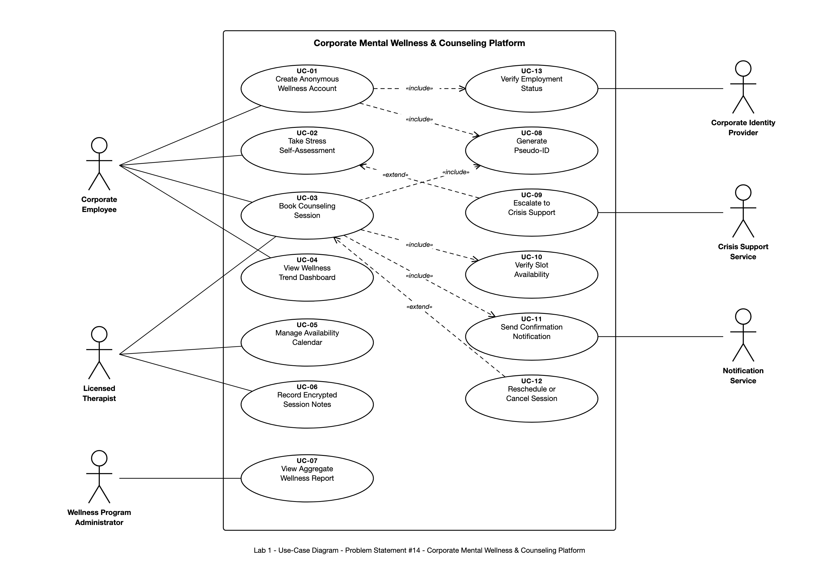

8. Use-case flows
UC-01 Create Anonymous Wellness Account
Primary actor: Corporate Employee
Secondary actors: Corporate Identity Provider
Goal: Get the employee an account that proves they are entitled to the benefit, while leaving the counselling side of the system with nothing but a pseudo-ID.
Trigger: The employee opens the portal for the first time and chooses 'Create account'.
Preconditions
1. The employer has enrolled in the programme and its directory feed is reachable.
2. The employee holds valid corporate credentials.
3. No wellness account exists yet for this employee.
Postconditions (success)
1. A pseudo-ID in the format WEL-XXXXXXXX has been generated at random and issued.
2. The mapping between the employee and the pseudo-ID is stored encrypted, in the identity store rather than with counselling data (NFR-002).
3. The employee can take an assessment and book sessions.
4. No counselling-side record created by this use case carries a corporate identifier (FR-001).
Postcondition (failure): No account, no pseudo-ID and no mapping row exist, and the employee is told the verification did not succeed.
Main success scenario
1. The employee chooses 'Create account'.
2. The system hands the employee to the Corporate Identity Provider to sign in.
3. The employee authenticates with their corporate credentials.
4. The identity provider returns a signed assertion confirming current employment («include» UC-13).
5. The system checks that no wellness account already exists for that assertion.
6. The system generates a random pseudo-ID («include» UC-08) and confirms it is not already in use.
7. The system writes the mapping to the identity store, encrypted.
8. The system drops the corporate identifiers from the session and keeps only the pseudo-ID.
9. The system shows the employee their pseudo-ID and explains that this is the only thing a therapist will ever see.
10. The use case ends successfully.
Alternate flows
4a. The person is not a current employee
4a1. The identity provider returns no assertion, or one marking the account as inactive.
4a2. The system refuses registration and shows the employer's benefits contact.
4a3. Nothing is written to either store and the use case ends.
5a. An account already exists
5a1. The system finds a mapping for that assertion.
5a2. The system signs the employee into the existing account instead of issuing a second pseudo-ID.
5a3. The use case ends successfully, with the pseudo-ID unchanged.
7a. The mapping cannot be written
7a1. The identity store rejects the write or times out.
7a2. The system discards the generated pseudo-ID so no orphan identifier is left behind, and asks the employee to try again.
Notes
• Steps 3 and 4 are the only point in the whole system where a corporate identity is handled. Everything after step 8 works on the pseudo-ID.
• The pseudo-ID is random rather than a hash of the employee ID, so nobody can recompute it from a directory export.

