**List of Contents**

|  |  |
| --- | --- |
| Preamble   * Defining the Problem of Asset Management * State-of-the-art * Prerequisites | 2 |
| Key Features   * Individual Profile * Investment Universe | 3-4 |
| Credit Risk Model | 6 |
| Methodology Employed in the Tool Development   * Equations, constraints and objective function | 6 |
| Results | 8 |
| Case Study 1: Idiosyncratic Factor | 9 |
| Case Study 2: Optimal Duration Bracket | 11 |
| Case Study 3: Rebalancing Stages | 12 |

**Preamble:**

**1) Defining Problem of Asset Management:-**

A dynamic optimization problem of asset management is defined as a problem of optimal decisions solved along a given time horizon with rebalancing of portfolio at particular time steps (stages). Solving this problem for a fixed income securities portfolio would require investment Universe that includes sovereign and corporate debt securities. The information about securities and issuer allow us to model financial variables which are used for the evolution of market price scenarios and estimation of the risk factors which are then used for optimal decision making.

**2) State-of-the-art:-**

Static optimization techniques have failed to answer the risk management challenges faced during the crisis of 2008 when prices were changing to a great extent in a month time. Therefore, a technique needs to be devised where a portfolio is allowed to be rebalanced at a given time stage. We here come up with dynamic optimization technique that maps all the risk factors in a much more efficient way and hence, generating better returns than classical statistical one period optimization approach.

In a nutshell, the steps related to the representation and solution of the dynamic optimization problem (DOP) is as follows:

1. Defining an analytical objective function that maps the set of financial variables and the assumed constraints.
2. Translating the problem into standard algebraic form; formulating all the variables generated into analytical representation standards (MPS: Mathematical Programming Standard) recognisable by the concerned optimization tool.
3. The generation of the vector of returns and the uncertainty variables; this stage is called Scenario Generation. This stage can be divided in two steps; first, evolution of the random/uncertainty financial and economic variables; the so called risk factors, second, using the set of appropriate formulas for the calculation of prices required by the decision problem.
4. The generation of the associated stochastic problem. An extension of the model generation to weight each every possible outcome by a certain probability.
5. The solution of the problem and the description of the optimal strategy, subjected to the financial and economic environment created.

Estimation tool

MC simulator

Investment Universe

DB manager

Event tree generator

Risk factor Statistical Model

*Financial DataFEED*

Dynamic Portfolio model

DSP generator

Optimization tool

Solution Output

**3) Prerequisites:-**

Profiling and Adequacy: Considering the business management of the asset management firms, we introduce different risk aversion profiles for various types of clients, conservative (1), moderate (2), balanced (3), dynamic (4) and aggressive (5). Based on the information collected risk profile if associated with maximum tolerable loss defined with five VaR measures.

**Risk Factors:** in compliance of the requirement of the above information the tool will then be able to process further information collected from the investment universe and generating estimates of the exposure of these risk factors. The optimization process can be seen in two steps, first, measuring risk exposure for the given portfolio and for the choice of risk profile, second, the estimates of the adequacy for exposure to market and credit risk. Both the estimation of exposure to the risk will be defined with respect to the actual probability of evolution market variables excluding assumption of risk neutrality in the definition of statistical model.

**Managing Portfolio:** Various values of the portfolio are interfaced with Datastream, the extent of the investment universe suggests a boundary of the space of the possible choices of the portfolio, this decision space can change over time; the tool allows the updating of the investment universe at all times.

**Key Features:-**

1. **Individual Profile:-** The analysis of the profile is integrated in MS Office environment, where all the information are collected which are necessary for the characterization of the individual application, in particular mapping the financial knowledge, individual goals and financial situation in order to achieve the risk profile and identify the risk exposure to market risk and credit risk, which is defined in five categories, conservative, moderate, balanced, dynamic and aggressive. Other key information is also defined in individual application such as time horizon, current composition and the available choices from the investment universe.

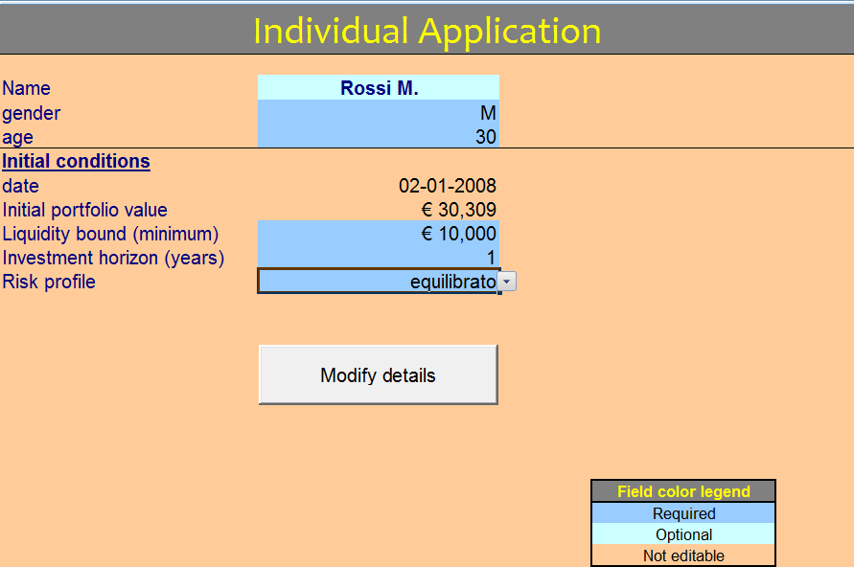

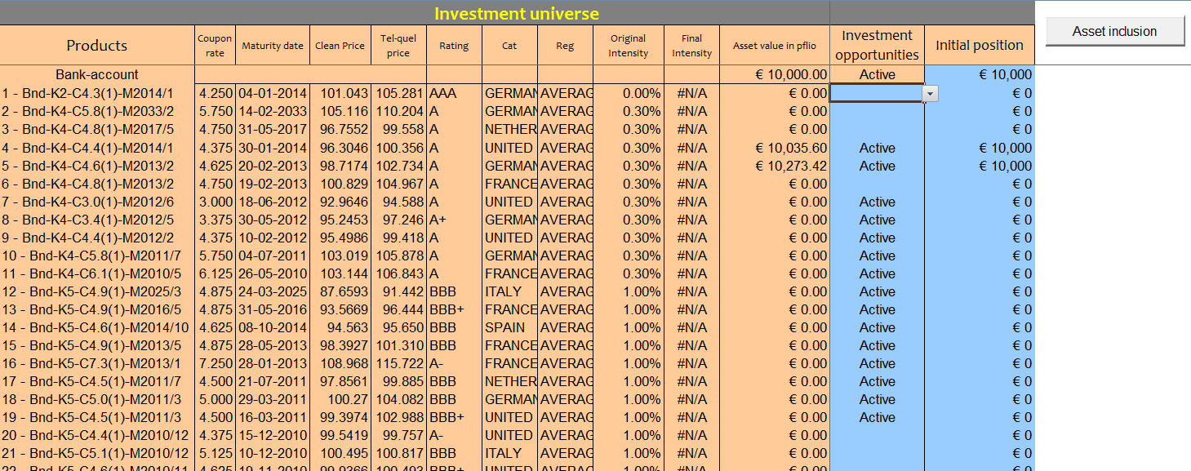

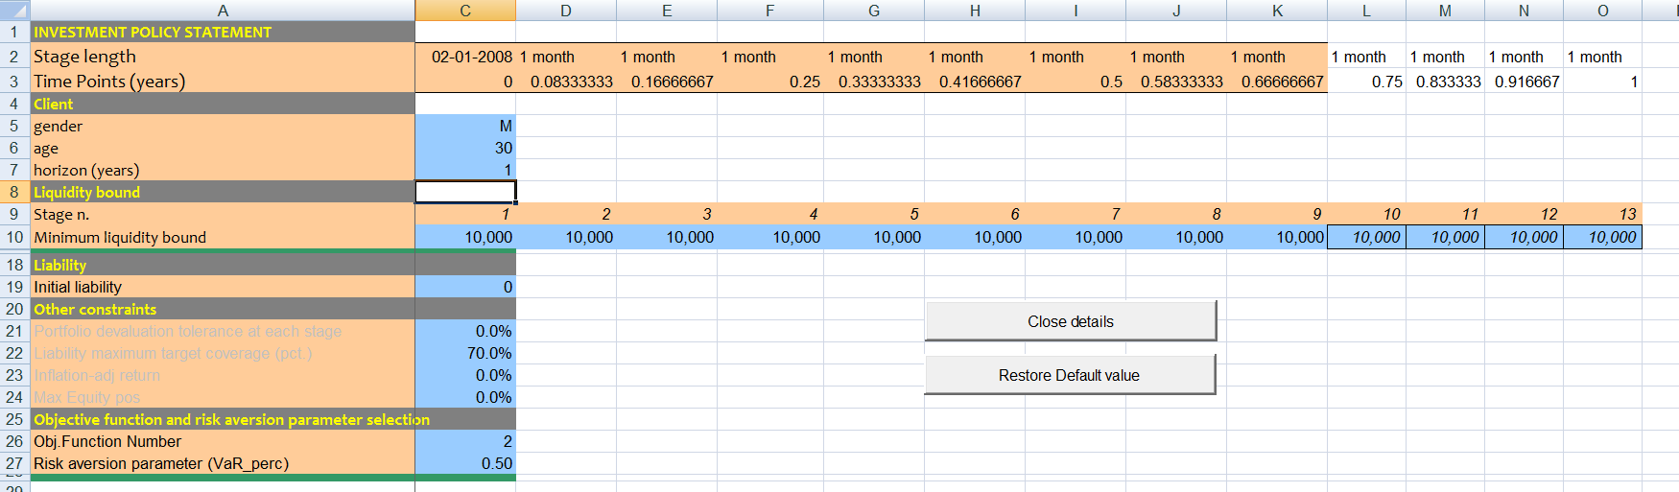

2) **Investment Universe:-** The optimal strategy is defined with respect to the investment universe, we show age structure to support the specification of the securities to define risk factors and specific models. Main features are;

1. The issuer
2. Nominal amount of the issue available
3. The nominal amount of the issue available
4. The rating class
5. Nature of coupon payments, fixed or variable
6. The maturity and frequency of coupon payments
7. The current price
8. The economic sector
9. The geographical region
10. Possible side effects which induce change in the risk class rating

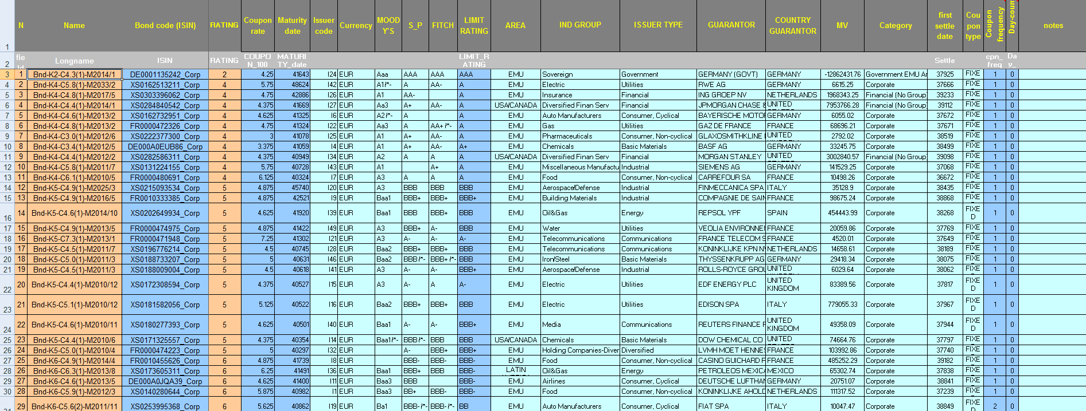

The choices made from the Investment Universe will then be expressed in nominal values to generate revenues and disbursements on the basis of current market value. Each security in the investment portfolio will therefore be characterized by the following parameter:



Collateral

Geographic area

Issuer ID

Economic sector

Coupon frequency

Coupon rate

maturity

Rating class

***X(ik, k, T, c, f, E, G, j)*** where i is issuer ID, k is the asset class, T is the maturity, c is coupon rate, f is the frequency of coupon payment, E represents the economic sector, G represents the geographic region and j is the collateral.

The statistical model coming up with these indicators therefore considers the dependence of the yield of individual securities by the current yield curve, the class rating of the issuer at the time of investment, coupon and the frequency of the coupon payments and the maturity of each security. The last two indicators are particularly relevant information in order to determine the exposure of the portfolio to potential credit risk.

3) Input/Output- Modular:- The input are defined by the historical data including price and credit spread for the various classes, topology; where the branching structure of the scenario tree is defined and the individual application where individual goals and all the key information from the investment universe are gathered for the statistical model.

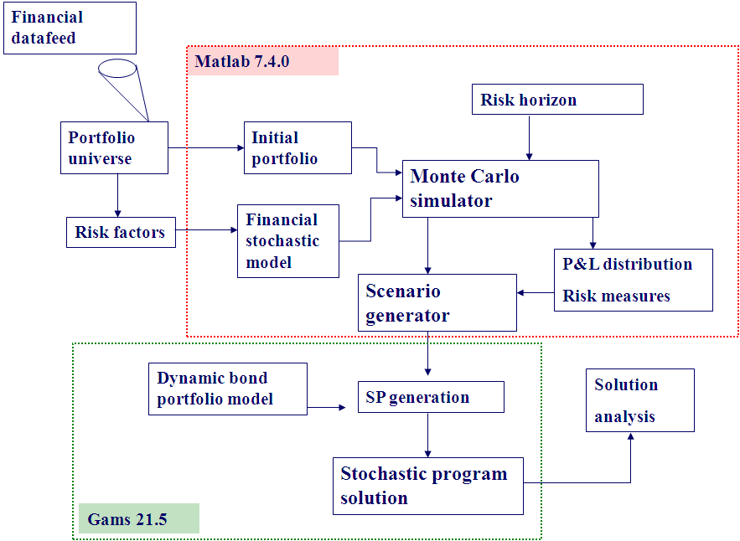

The ouputs are defined by the following:-

1. The analysis of the economic and the financial scenarios produced the statistical model
2. Historical trends and prospective risk factors
3. Strategy allocated at time 0 (Here & Now solution)
4. Analysis of the investment strategies (best, average and worst scenarios)
5. Analysis of the distribution of wealth before and after the optimization process

**Credit Risk Model and Methodology at a glance:-**

Statistical model: - Here we aim to clarify the nature of the statistical model that we intend to integrate with a set of relevant hypothesis:

1. The allocation process is intended to take the advantage of the time horizon given the dynamics of the risk premium offered by the market as a function of the risk aversion nature of the investor. The price dynamics must therefore reflect this trend and be defined with respect to the real world probability measures.
2. The price of a security incorporates three elements of performance, first, the yield curve, second, the rating class of that security (same for all securities in that asset class), third, idiosyncratic factor defined within every asset class and is security specific.
3. The value of the portfolio is expected to increase when spreads show narrowing behaviour. The model incorporates the rate of return on various securities using scenario generator for spreads and price. With higher risk classes the spreads would tend to diverse and there are events possible in which the issuer is failed to make its obligations (events of default). The dynamics of the pricing of these securities must therefore consider partial and complete events of default.
4. The risk of default on the position held may vary over time not only due to a general change in the intensity of default considered in the model but also on the basis of transitions from one rating category to another: in this logic the system is integrated in order to consider the transition probabilities .

We denote *W(n)* as the process of investor's wealth factored by market value of portfolio *X(n)* and the cash balance *C(n); n* represents the node of the scenario tree*.* The wealth held at time 0 is *W(0)* is the initial wealth and represents the initial portfolio and it is assumed that no security has defaulted at time 0. With scenarios generated we evaluate the probability that a default would occur at specified stage and at subsequent stages the probability is weighted by the transition in the rating class.

$$W_{n}=\sum_{k∊K}{\sum_{i∊I_{k}}{x_{in}v_{in}}}+ C_{n}$$

Where $v_{in}$ represents the price of security *i* at node *n* and $x_{in}$ is the holding of bond *i* at node *n* after rebalancing. As time evolves the portfolio manager will not only monitor sudden price movement because of default news, but also credit losses generated by actual payment defaults. The latter are reflected in the cash balance *Cn* defined as:

$$C_{n}= C_{n-}e^{r_{n-}∆t}+ \sum_{i∈I}{x_{in-}C_{in}[1+(β_{k_{i}n}-1)ψ_{in}}$$

The cash balance *Cn* will depend on the interest rate evolution *rn* and the expected cash inflows *xin -cin.* Which in case of default ( $ψ_{in}=1)$ are reduced on the basis of a given rating class specific recovery rate ($β_{k_{i}n})$.

**Methodology Employed in the Tool Development**

* **Gathering Data:-** Collecting data from various data sources (Datastream in our case) to create a significantly large database (Investment Universe)
* **Econometric Modelling:-** Estimation of statistical parameters; mean and standard deviation of rate of interest, credit spread for various asset classes. Cholesky decomposition of the correlation matrix for simulation
* **Monte-Carlo Simulation:-** estimated coefficients are then passed to MC simulator, interest rate and credit spread dynamics-
$$∆r_{n}= μ∆t+σ\sqrt{r_{n}}\sqrt{∆t}e_{0n}$$

$$∆π_{kn}= μ_{k}∆t+σ_{k}\sqrt{π_{kn}}\sqrt{∆t}\sum_{l=0}^{7}{q_{kl}e_{ln}}$$

$$∆η_{in}= μ_{i}∆t+σ_{i}\sqrt{∆t}e_{in}-ln⁡(β_{k_{i}n})ψ_{in}$$

* **Scenario Tree Generation:-**
* $r_{n}$ the one interest rate for cash deposit available at node *n*
* $π_{kn}$ the credit spread of rating class *k* at node *n*
* $η_{in}$ the bond specific incremental spread of bond *i* at node *n*
* $v_{in}$ the price of bond *i* at node *n*
* $f_{in}$ the cash inflow of security *i* at node *n* which takes into account possible cash defaults over the planning horizon

**given $v_{i0}$** , $y_{i0 }= r_{0}+π_{k0}$, $y_{i0}=y_{k0}+η_{i0}$ ∀ *i,k*

**for** t = 1,.....,T-1

**for $n ∈ N_{t}$**

**generate $r_{n} ,π_{kn}$** corrleated

**begin**

**for** *i= 1,.....,I*

**sample $ψ_{in}$**

**if $ψ_{in}=0, ∆η_{in}=0,y_{in }=y_{kn }$**

**derive $Δy_{in },v_{in}, f_{in}, δ_{in},γ_{in}$**

**elseif $ψ_{in}=1$**

**sample $β_{k_{i}}\sim B(α_{1k_{i}},α_{2k_{i}})$**

**generate $∆η_{in}=β_{k_{i}n} ,$ $Δy_{in }=Δy_{in }+ η_{in}$**

**derive $v_{in}, f_{in}, δ_{in},γ_{in}$**

**end if**

**end for** *i*

**end for** *n*

**end for** *t*

$v_{in}= v_{in-}[1-δ_{in-} Δy_{in- }+Δy_{in-}Δt+0.5γ_{in-}{\left(Δy_{in-}\right)}^{2}$

* $Δy_{in-}$ = $y_{in }-Δy_{in- }=[(r_{n}-r_{n-}$) + ${(π}_{kn}-π_{kn-})+$ ($η_{in}-η_{in-})]$
$δ_{in} is bond duration of ith security at node n$

$γ_{in} is bond convexity of ith security at node n$

$β_{k_{i}} is the recovery rate ith security, in case of default spread goes up by this quantity$

* **Objective function:-**
$$max \left(1-α\right)E\left[W^{T}\right]-αR_{e}\left(W^{T}\right)$$

$$A_{0}X_{0}=D_{0}$$

$$A_{n}X_{n-}+B_{n}X_{n}=D_{n}$$

$$R_{e}\left(W^{T}\right)=ε_{e}+\frac{1}{1-e}\sum_{n}{p_{n}}\left(L_{n}-ε_{e}\right)$$

* **Inventory Asset Balance:-**
$$x_{i0}=x_{i}+x_{i0}^{+}-x_{i0}^{-}$$

$$x_{in}=x_{in}+x_{in}^{+}-x_{in}^{-}$$

* **Cash Balance:-**
$$\sum_{i∈I}{v_{i0}x_{i0}^{+}(1+ϰ^{+}})+z_{0}-g_{0}=C_{0}-\overline{g}+\sum_{i∈I}{v_{i0}}x_{i0}^{-}(1-ϰ^{-})$$

$$\sum_{i∈I}{v_{in}x_{in}^{+}(1+ϰ^{+}})+z_{n}-g_{n}=C_{n}-\overline{g}+z_{n-}e^{r_{n-}}-g_{n-}e^{b_{n-}}+\sum_{i∈I}{v_{in}}x_{in}^{-}(1-ϰ^{-})$$

* **Policy Constraints:-**

$$\sum_{i∈I_{k}}{v_{in}x_{in}≤v_{k}.}\sum_{i∈I}{v_{in}x_{in}}$$

$$\sum_{k=0}^{4}{\sum_{i∈I_{k}}{v_{in}x_{in}≤φ_{k}.}}\sum_{i∈I}{v_{in}x_{in}}$$

$$\sum_{k=5}^{7}{\sum_{i∈I_{k}}{v_{in}x_{in}≤ϑ_{k}.}}\sum_{i∈I}{v_{in}x_{in}}$$

**Results:-**

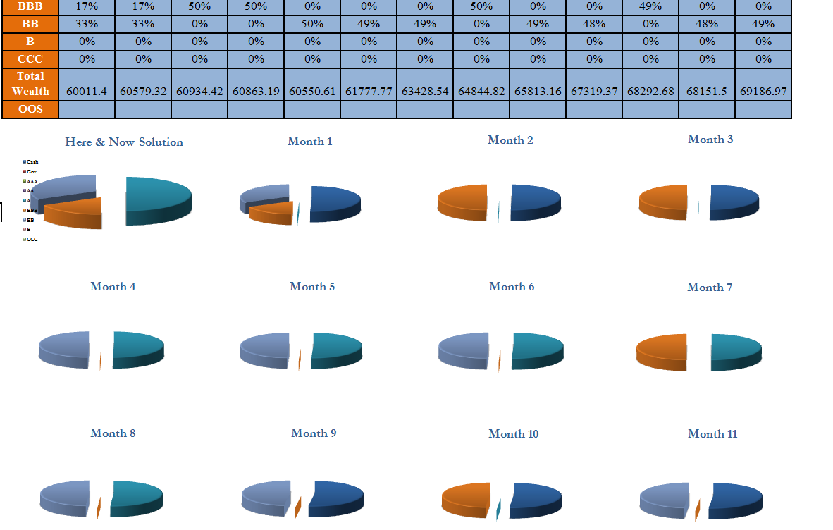

**Case Study 1: Tool with and without idiosyncratic factor**

Constant Lambda, 0.5

**Conclusion:-**

1. Introduction of idiosyncratic factor makes the risk-reward profile more consistent.
2. Without the introduction of the eta factor the CVaR shows much inconsistency.
3. CVaR showed pretty much a constant value in all scenarios.
4. Though the eta factor always shows lesser CVaR in absolute terms than the usual yield process, corresponding to less negative loss or positive return.
5. An average of 10% poor performance is observed on the CVaR scale which is observed negative in most of the cases.

**Case Study 2: Optimal Duration**

Duration Brackets: mean+/- 1

**Research Objective:-** There must exist an interval of ‘duration’ in which optimal wealth can be achieved. The idea is not to allow the tool to consider those securities which do not fall in a particular bracket of securities identified on duration scale.

There may be securities with very high duration or very low duration in the investment universe, while making a stable portfolio one must also consider duration risk coming from such securities. Let us consider a portfolio of securities with average duration say 4, now, introduction of a security with duration say 10 would definitely going to invite duration risk. This can be eliminated by statistical filtering of securities while making them available for investment consideration.

**Results:-**

1. The duration bracket µ+/- 1is observed to be completely an outlier in the above cases.
2. Consistent risk-reward parameters and profile is observed in bracket µ+/- 3.5.
3. Still trying to come up with a suitable model that can effectively incorporate this idea.

However, a key question still remains, by limiting the numbers of securities available for investment consideration aren’t we contradicting with the idea of diversification?

**Case Study 3: Payoff profile with number of rebalancing stages**

**Result:-**

1. In Sample was data from 2004-Dec, 2007 and out sample is data from Jan 2008-Dec 2009.
2. Only monthly rebalancing strategy is able to generate profit.
3. Sharp decline is seen in final wealth from quarterly, half-yearly and in keeping the Here & Now solution portfolio till the horizon.