SKILL 1
2520090101
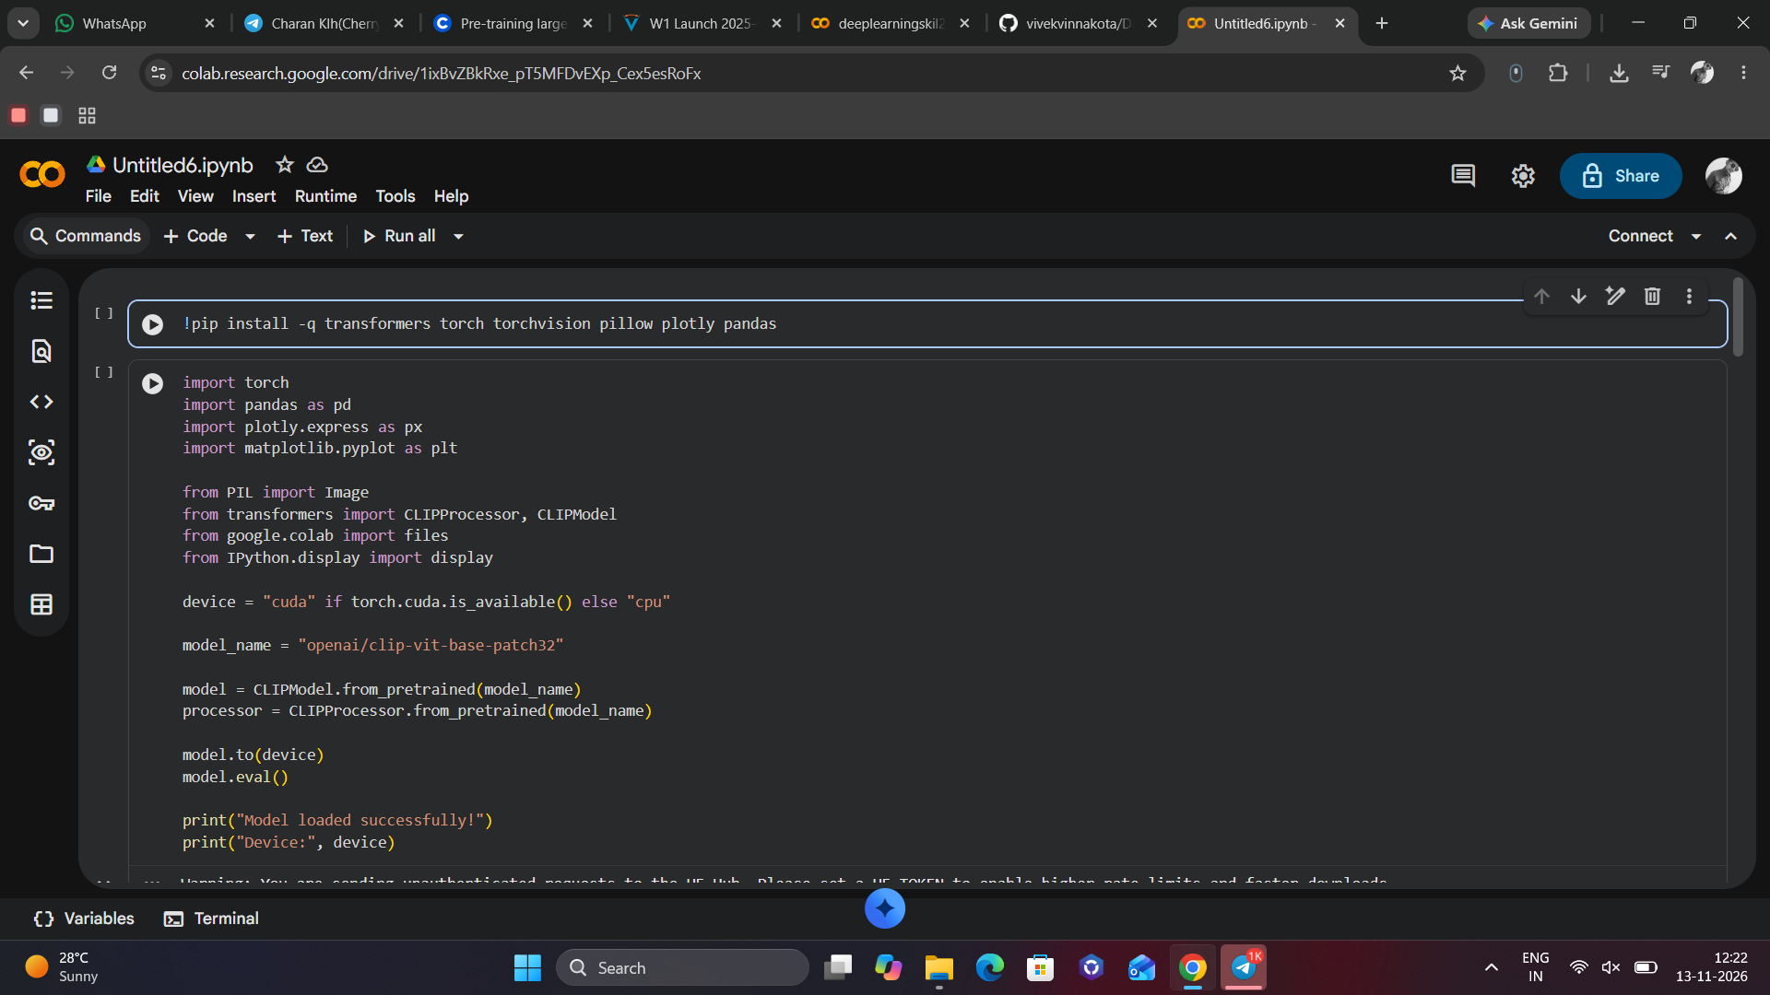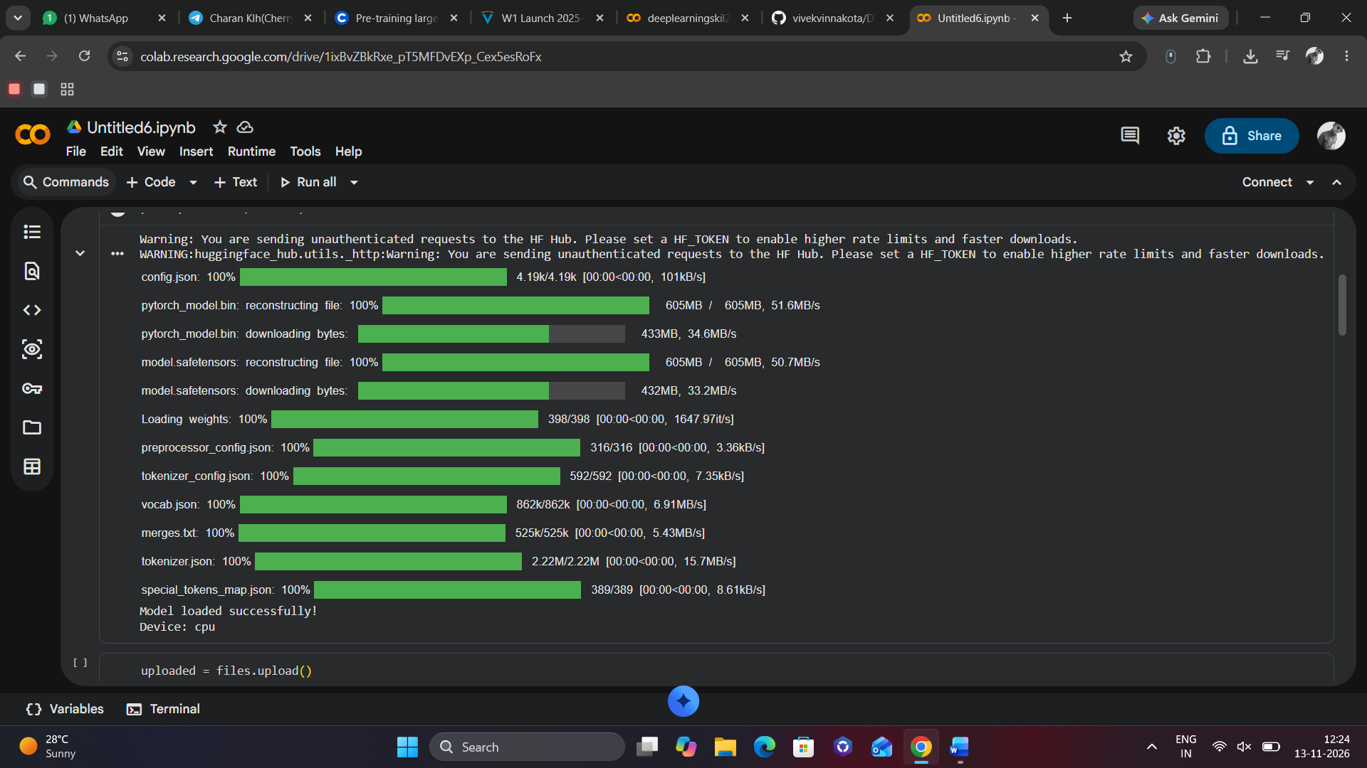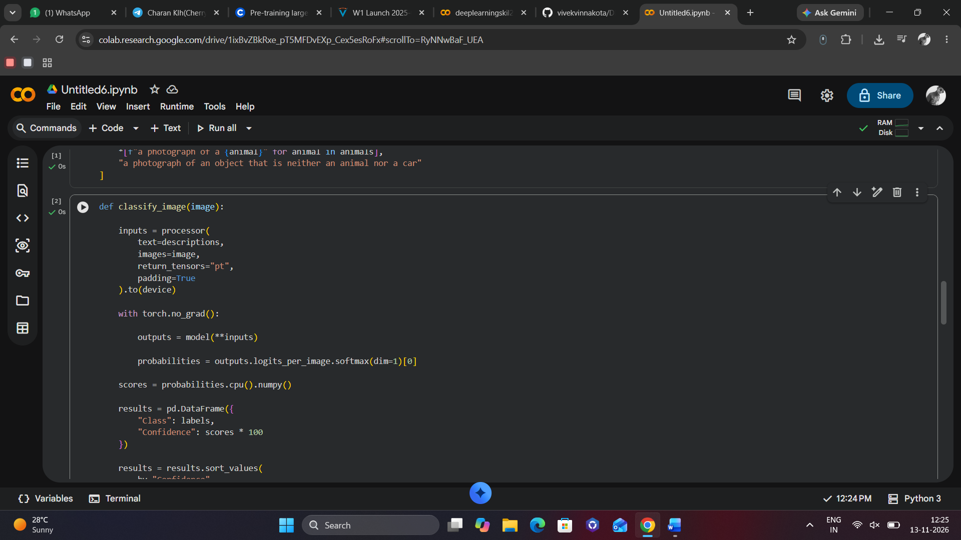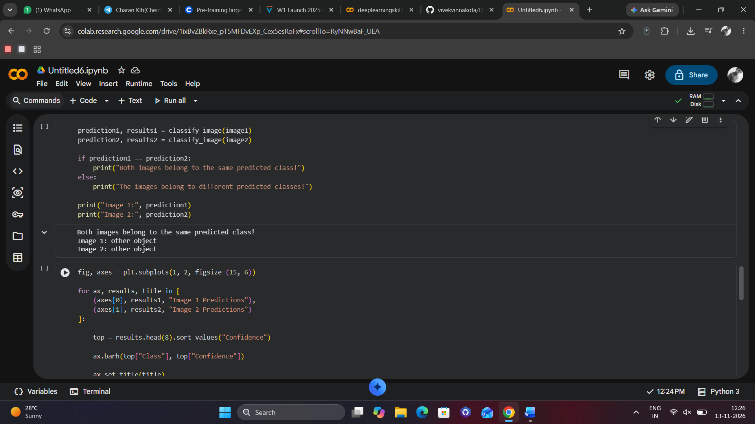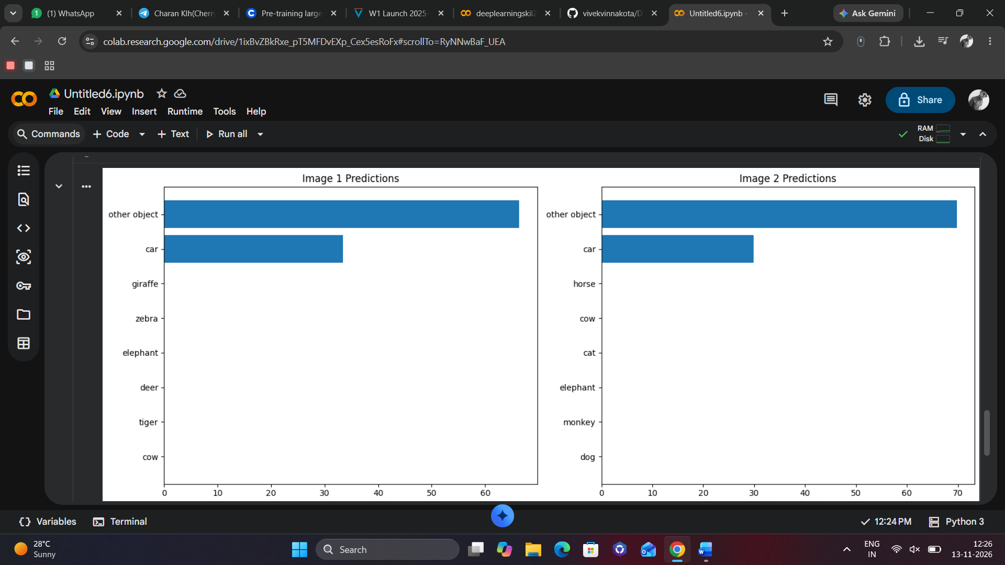
!pip install -q transformers torch torchvision pillow plotly pandas
import torch
import pandas as pd
import plotly.express as px
import matplotlib.pyplot as plt

from PIL import Image
from transformers import CLIPProcessor, CLIPModel
from google.colab import files
from IPython.display import display

device = "cuda" if torch.cuda.is_available() else "cpu"

model_name = "openai/clip-vit-base-patch32"

model = CLIPModel.from_pretrained(model_name)
processor = CLIPProcessor.from_pretrained(model_name)

model.to(device)
model.eval()

print("Model loaded successfully!")
print("Device:", device)
uploaded = files.upload()

image_names = list(uploaded.keys())

image1 = Image.open(image_names[0]).convert("RGB")
image2 = Image.open(image_names[1]).convert("RGB")
animals = [
"dog", "cat", "lion", "tiger",
"elephant", "horse", "cow", "deer",
"zebra", "giraffe", "monkey"
]

labels = [
"car",
*animals,
"other object"
]

descriptions = [
"a photograph of a car",
*[f"a photograph of a {animal}" for animal in animals],
"a photograph of an object that is neither an animal nor a car"
]
def classify_image(image):

inputs = processor(
text=descriptions,
images=image,
return_tensors="pt",
padding=True
).to(device)

with torch.no_grad():

outputs = model(**inputs)

probabilities = outputs.logits_per_image.softmax(dim=1)[0]

scores = probabilities.cpu().numpy()

results = pd.DataFrame({
"Class": labels,
"Confidence": scores * 100
})

results = results.sort_values(
by="Confidence",
ascending=False
)

prediction = results.iloc[0]["Class"]

return prediction, results
prediction1, results1 = classify_image(image1)
prediction2, results2 = classify_image(image2)

if prediction1 == prediction2:
print("Both images belong to the same predicted class!")
else:
print("The images belong to different predicted classes!")

print("Image 1:", prediction1)
print("Image 2:", prediction2)
fig, axes = plt.subplots(1, 2, figsize=(15, 6))

for ax, results, title in [
(axes[0], results1, "Image 1 Predictions"),
(axes[1], results2, "Image 2 Predictions")
]:

top = results.head(8).sort_values("Confidence")

ax.barh(top["Class"], top["Confidence"])

ax.set_title(title)
ax.set_xlabel("Relative score (%)")

plt.tight_layout()
plt.show()

