- 1. Develop a C program that demonstrates how a Linux operating system executes a command entered by a user that 1. Accept a Linux command as input. 2. Create a child process using fork(). 3. Execute the command in the child process using an appropriate exec() system call. 4. Allow the parent process to wait for the child using wait (). 5. Display the Process ID (PID) of both parent and child processes.
OSSP_Practical Result

Using Linux terminal commands (uname, lscpu, lsblk, ps, top), investigate the relationship between hardware resources and operating system services. Prepare a report explaining how the OS abstracts CPU, memory, storage, and I/O devices.

Ans. Input: 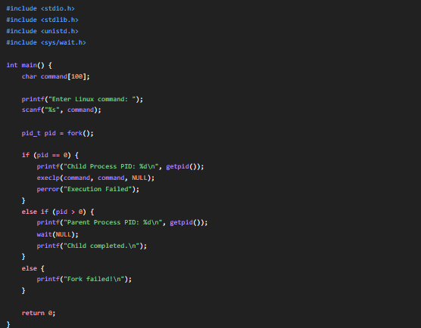
OUPUT:
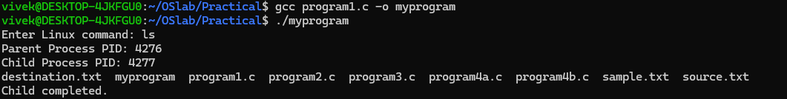

- 2. Develop a C program that uses the system calls open(), read(), write(), and close() to copy the contents of one file to another. Explain how control transitions between user space and kernel space during execution.
Use the strace utility to trace all system calls generated by the command cat sample.txt. Analyze the sequence of system calls and identify the kernel services involved.

Ans. INPUT:
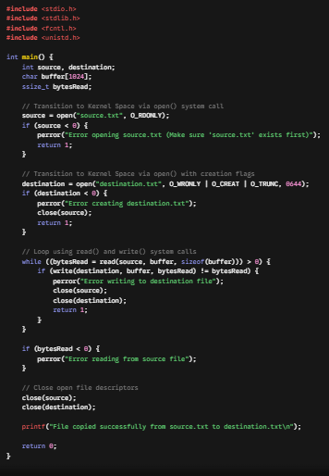
OUTPUT:
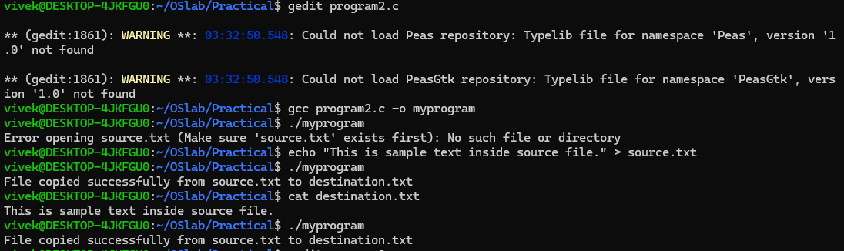
- 3. Develop a C program using fork() that creates a parent and child process. Display the Process ID (PID), Parent Process ID (PPID), and process states at different stages of execution.
Design an experiment to observe process state transitions (Ready, Running, Waiting, Terminated) using Linux monitoring tools such as ps, top, and /proc. Document the observations.
ANS. INPUT
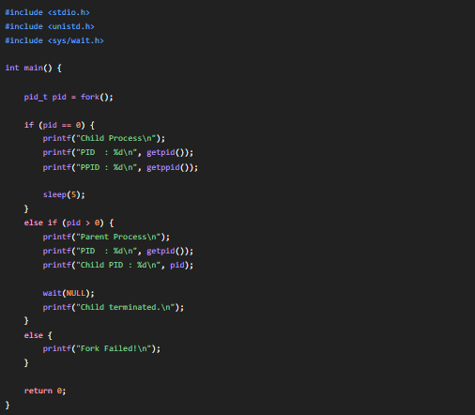
OUTPUT:
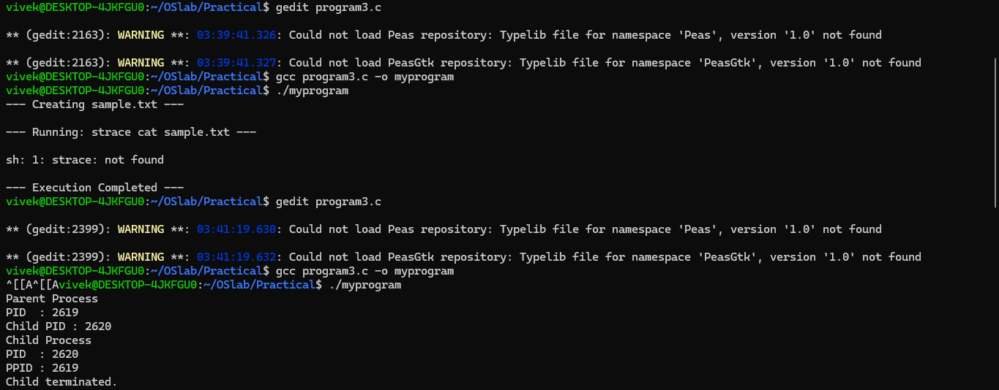
- 4. Write a C program where a parent process creates multiple child processes and synchronizes their completion using wait() and waitpid(). Compare the behavior of both functions.

Create a scenario where a child process becomes a zombie process. Investigate the process table and then modify the program to eliminate zombie processes using proper synchronization techniques.
ANS. INPUT:
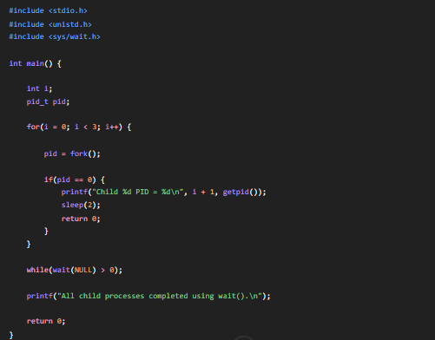
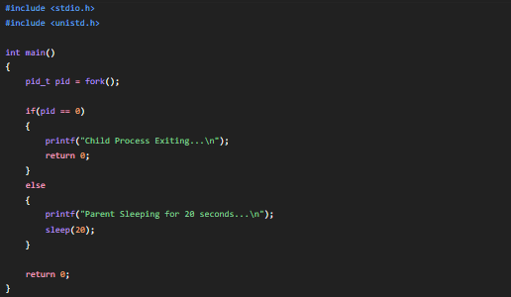
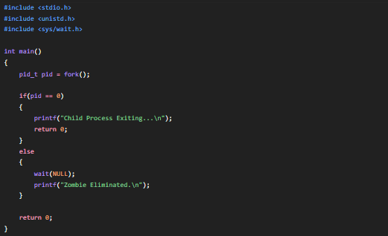
OUTPUT:
