**Challenge: Automated Power Point Slide file creation using python open-source package python-pptx**

Use only open-source library python-pptx to generate PowerPoint Slide files. Details: <https://python-pptx.readthedocs.io/en/latest/>

No other python visualization package should be used for the task. Usage of image file in the Power Point Slide is not allowed. All plots should be native Power Point plots and should be editable.

This case belongs to an e-commerce retailer. Data has been provided to perform analysis. Use Data to Prepare Monthly Operational Review Power Point Slide for week-1 to week-5 in a particular month. Slides would be used for end of month operational review to assess the performance.

Last month (week-1 to week-5) data has been provided for case study. Data for week-5 is limited because month end falls in week-5.

Instead of manually creating visuals for Power Point Slides, requirement is to create power point slides from Python Jupyter notebook using python-pptx package.

**More detail on Case:**

**What is an e-commerce retailer order?**

Order is referred as the “shopping basket” full of items that a buyer has purchased.

Lines: The different products within order, recognized by seller as individual Stock Keeping Unit or Universal Product Code number.

Units: The quantity of each line.

Following is an Order

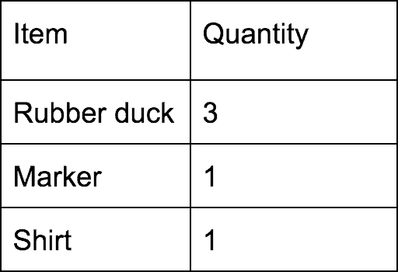

This order can be broken down into:

* 1 order
* 3 lines
* Total 5 units

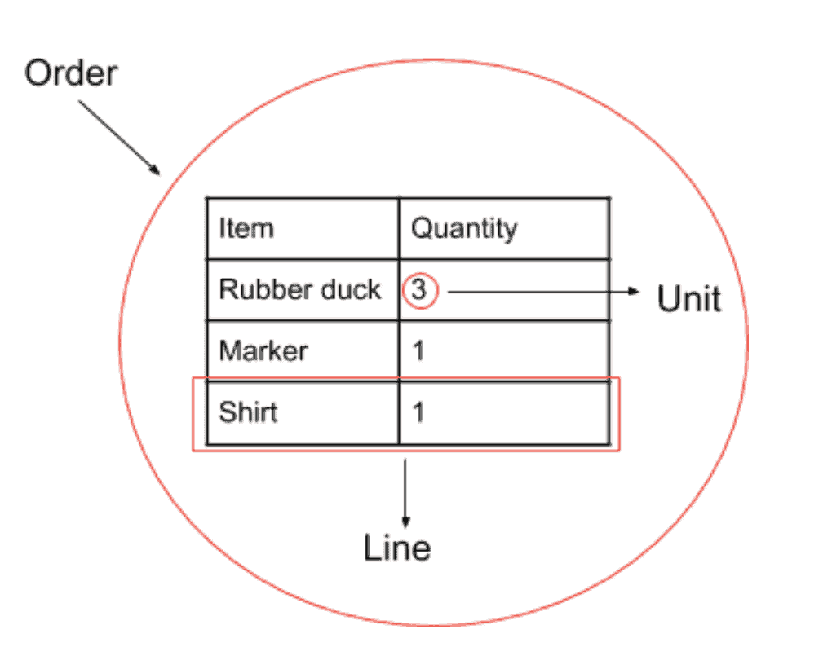

Having more lines adds to more time require to pick items needed to fulfil an order. Therefore, number of lines in an order is significant.

**Data Provided with case:**

Provided data has orders and lines data for the case study

Volume data is given in the file VPD.csv

|  |  |  |  |  |  |  |  |
| --- | --- | --- | --- | --- | --- | --- | --- |
| Date | Week | Day | Orders | Lines | PCS | SKU | CITIES |
| 2017-01-02 | WEEK-1 | MON | 776 | 1367 | 1595.0 | 487 | 174 |
| 2017-01-03 | WEEK-1 | TUE | 902 | 1550 | 1861.0 | 547 | 188 |
| 2017-01-04 | WEEK-1 | WED | 1476 | 2252 | 2856.0 | 513 | 205 |
| 2017-01-05 | WEEK-1 | THU | 909 | 1637 | 1972.0 | 519 | 175 |
| 2017-01-06 | WEEK-1 | FRI | 1023 | 1720 | 1995.0 | 502 | 189 |

Using above data following Power Point Slide plot should be created for daily warehouse workload

Plot for Week-1 slide

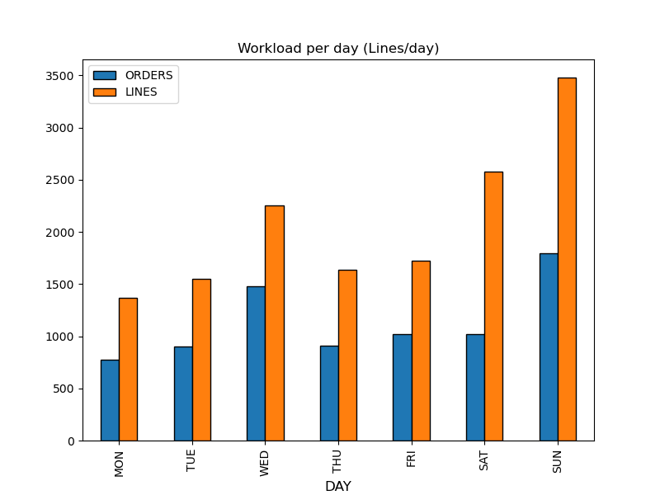

Plot for Week 2 slide

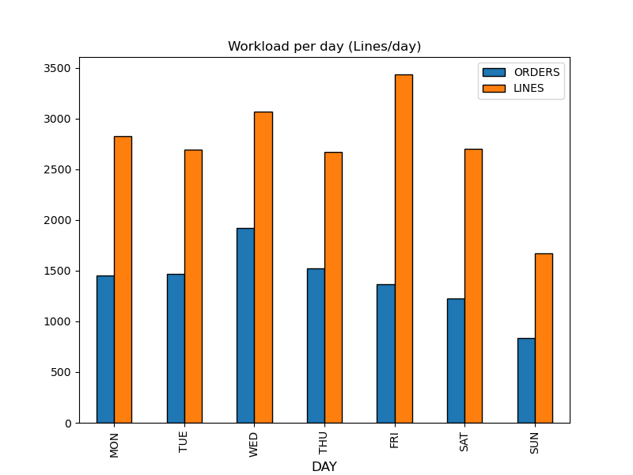

Plot for Week 3 slide

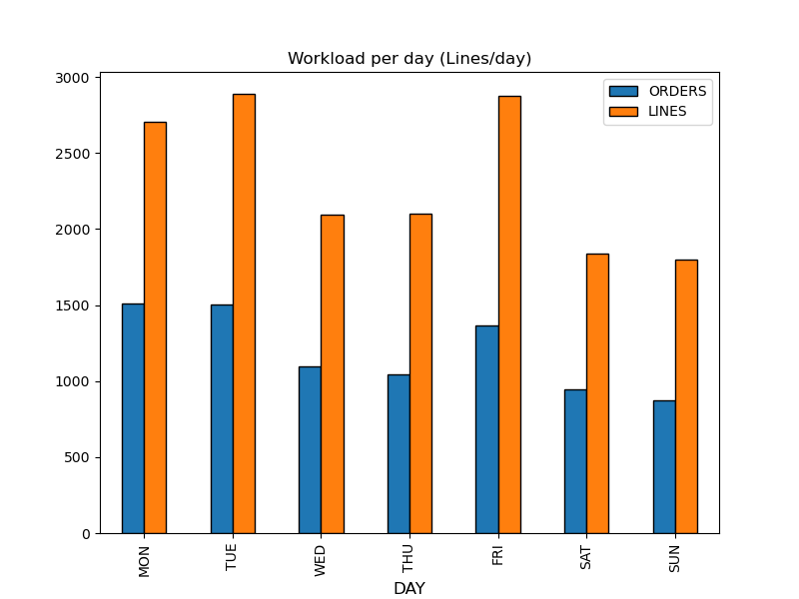

Plot for Week 4 slide

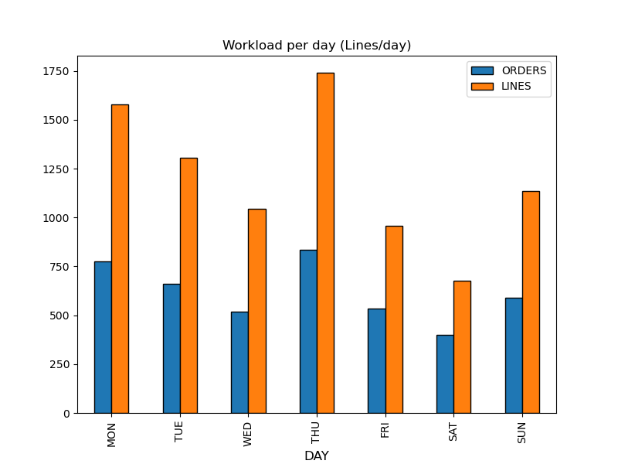

Plot for Week 5 slide (week 5 has only 2 working days in the reporting month)

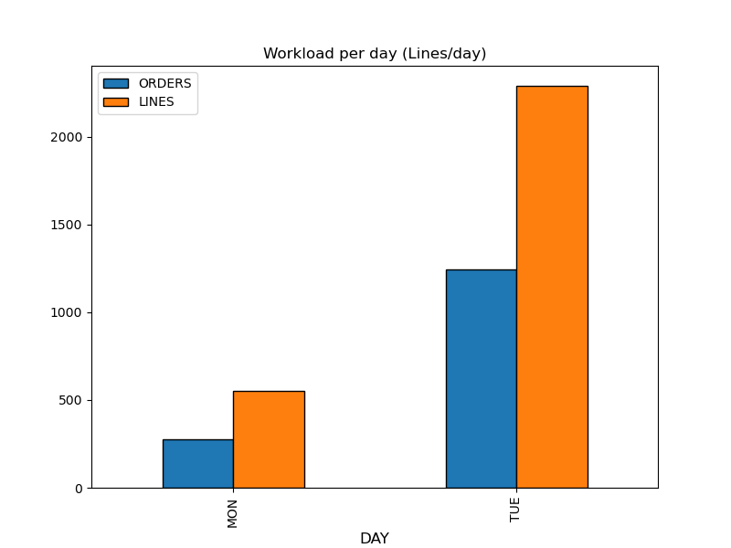

**Order Profile data** – This data set provides split of orders by different category of order. Number of lines per order is the criteria for category.

Categories are:

* Orders with 1 line abbreviated as 1
* Orders with 2 lines abbreviated 2
* Orders with 3 lines abbreviated 3
* Orders with 4 lines abbreviated 4
* Orders with 5 lines abbreviated 5
* Orders with more than 5 lines abbreviated 5+

Data is given in the file LPD.csv

|  |  |  |  |  |  |  |
| --- | --- | --- | --- | --- | --- | --- |
| Week | 1 | 2 | 3 | 4 | 5 | 5+ |
| WEEK-1 | 5178 | 1265 | 501 | 304 | 162 | 494 |
| WEEK-2 | 5930 | 1832 | 756 | 423 | 211 | 640 |
| WEEK-3 | 5047 | 1490 | 717 | 360 | 176 | 550 |
| WEEK-4 | 2681 | 753 | 283 | 190 | 105 | 301 |
| WEEK-5 | 966 | 271 | 95 | 78 | 30 | 85 |

Using above data following Power Point Slide plot for Order Profile analysis should be created

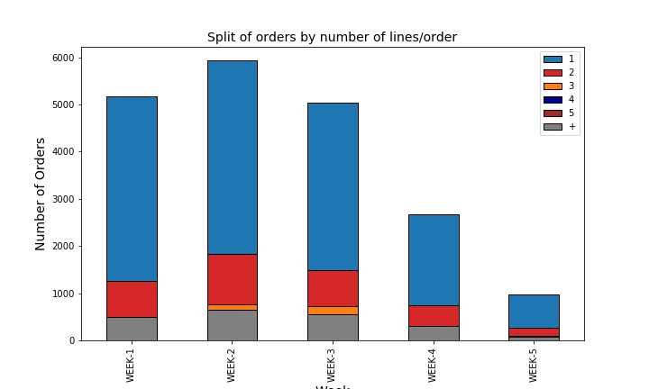

* 5 slides with visuals of the daily warehouse workload
* 1 slide for the order profile analysis

A comment should be added below the plot in each slide to provide insights based on the visual

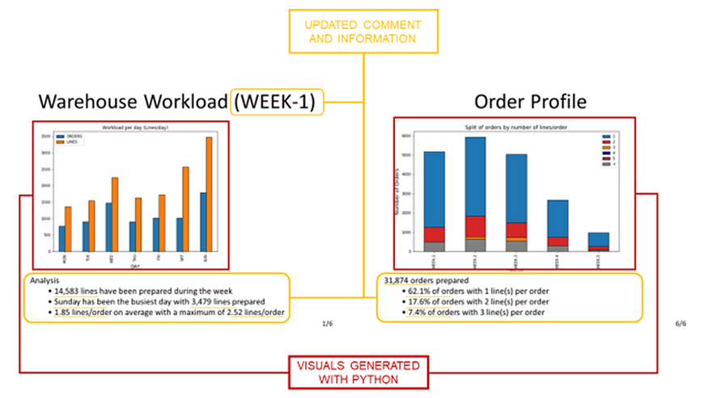

Introduction Slide Start with a special introduction slide at the beginning of the power point slide file



Preview of all Slide putting together

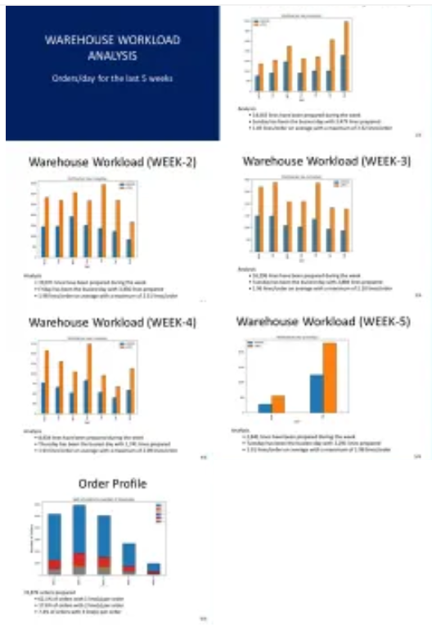

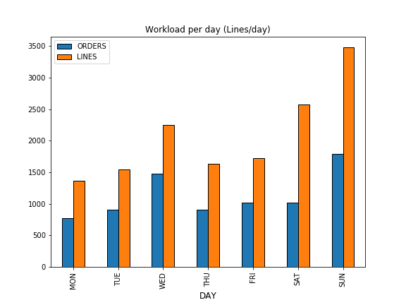

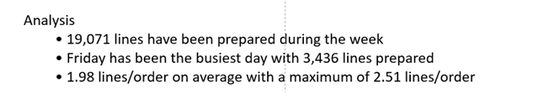

add comments based on the plot to summarize the performance of each week (this should be few bullet points).

Format for Daily Analysis Slide by WEEK

The structure of your slide will be always the same

• A title on top (e.g: Warehouse Workload (WEEK-5))

• A picture at the centre of the slide

• A text box for the comment area

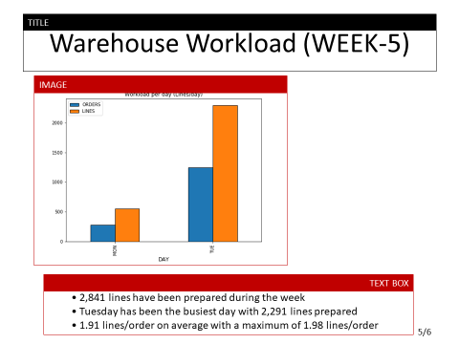

**Slide for Analysis of Order Profile**

use a stacked bar plot chart and add comment based on the full month scope.

