Tab 1
About Journal- International Journal of Agricultural Research and Innovation
The International Journal of Agricultural Research and Innovation (IJARI) is a peer-reviewed, open-access journal dedicated to advancing scientific knowledge and fostering innovation across the diverse fields of agriculture and allied sciences. The journal serves as a global platform for researchers, academicians, scientists, extension professionals, and students to publish original research findings, review articles, case studies, and innovative solutions addressing contemporary challenges in agricultural systems worldwide.
With a strong commitment to scientific rigor and academic excellence, IJARI publishes high-quality manuscripts spanning Agronomy, Horticulture, Plant Breeding and Genetics, Soil Science, Plant Pathology, Entomology, Agricultural Biotechnology, Agricultural Economics, Agricultural Engineering, Agricultural Extension, Food Science and Technology, Animal Husbandry and Dairy Science, Fisheries Science, Forestry, and Environmental Science, among other allied disciplines. By embracing this multidisciplinary scope, the journal reflects the increasingly interconnected nature of modern agricultural research and its critical role in addressing global challenges such as food security, climate resilience, and sustainable resource management.
Every submission undergoes a rigorous double-blind peer-review process conducted by a panel of subject-matter experts, ensuring that only scientifically sound and impactful research reaches publication. IJARI is committed to rapid, transparent, and author-friendly publication practices, enabling researchers to share their innovations with the global scientific community without unnecessary delay. As an open-access journal, IJARI ensures that published research is freely accessible to readers worldwide, maximizing its visibility, citation potential, and real-world impact. Through this commitment to open knowledge-sharing, the journal aims to bridge the gap between agricultural research and practical application — supporting farmers, policymakers, and industry stakeholders in making informed, evidence-based decisions. By continuously showcasing cutting-edge research and emerging innovations, the International Journal of Agricultural Research and Innovation strives to become a leading voice in the global agricultural research community, driving meaningful progress toward a more sustainable, productive, and food-secure future.
Aims & Scope
The International Journal of Agricultural Research and Innovation (IJARI) publish original research and review articles for a global readership across all major fields of agricultural and allied sciences.
Subject areas covered include:
Agronomy · Soil Science · Horticulture · Entomology · Plant Pathology · Plant Science · Crop Physiology · Plant Breeding & Genetics · Genetic Engineering · Biotechnology · Microbial Biotechnology · Agricultural Chemistry · Biochemistry & Molecular Biology · Agroforestry · Animal Science & Nutrition · Veterinary Science · Dairy Science · Fisheries & Aquaculture · Food Science & Technology · Agricultural Engineering · Farm Power & Machinery · Post-Harvest Technology · Agricultural Extension · Agricultural Economics & Agribusiness · Rural Sociology & Development · Sustainable and Organic Agriculture · Environmental Science · Climate Change · Food Security, and related interdisciplinary areas.
IJARI aims to strengthen agricultural research worldwide by upholding rigorous peer review, ensuring equitable access to publishing and reading, promoting cross-disciplinary collaboration, and translating advanced scientific findings into knowledge that benefits researchers, practitioners, and society at large. The journal is committed to a fast, transparent, and author-friendly editorial process, enabling timely dissemination of research for academic, teaching, and reference use. Guided by an international editorial board, IJARI strives to be a trusted and comprehensive publishing platform for the global agricultural research community.
Publication Frequency
International Journal of Agriculture Research and Innovation is published quarterly.
Open Access Policy
All articles published in IJARI are fully open access — freely available to read, download, and share without restriction. The journal upholds the principle that unrestricted access to research accelerates global knowledge exchange and scientific progress.
Peer Review Policy
IJARI follows a rigorous double-blind peer review process to ensure the integrity, originality, and quality of published research:
- All submissions undergo initial screening by the Editorial Office to confirm scope and formatting compliance.
- Manuscripts meeting the criteria proceed to review by at least two independent subject-matter experts.
- Reviewer identities and author identities remain confidential to one another throughout the process.
- Final publication decisions rest with the Editor-in-Chief, informed by reviewer feedback and guidance from the Editorial Board.
- The Editorial Office provides administrative support to maintain review integrity while ensuring a rapid, efficient turnaround.
Publication Ethics & Malpractice Statement
IJARI adheres to internationally recognized standards of publishing ethics, consistent with the Principles of Transparency and Best Practice in Scholarly Publishing set out by COPE, DOAJ, OASPA, and WAME.
Authorship: Only individuals who have made substantial intellectual contributions to the research qualify as authors. Ghost or gift authorship is not permitted, and the corresponding author must confirm that all co-authors have approved the final submission.
Duties of Authors
- Submit original, unpublished work with accurate citation of all sources.
- Report data and findings honestly and transparently.
- Disclose funding sources and any conflicts of interest.
- Obtain and document appropriate ethical approval and informed consent for research involving humans, animals, or sensitive materials.
- Retain raw data for verification purposes and, where feasible, deposit it in a recognized repository.
- Promptly notify editors of significant errors and cooperate in issuing corrections or retractions when necessary.
Duties of Editors
- Base publication decisions on originality, academic merit, and relevance, independent of authors' nationality, gender, religion, or institutional affiliation.
- Maintain strict confidentiality of submitted manuscripts.
- Recuse themselves from handling manuscripts involving personal or institutional conflicts of interest.
Duties of Reviewers
- Provide fair, constructive, and evidence-based evaluations within agreed timeframes.
- Maintain confidentiality throughout the review process.
- Disclose any conflicts of interest and decline reviews where such conflicts exist.
- Flag any concerns regarding originality or overlap with existing literature.
Duties of the Publisher
- Ensure editorial decisions remain independent of commercial interests.
- Provide tools and training (including plagiarism-detection software) to uphold ethical publishing standards.
- Investigate allegations of misconduct in line with COPE procedures and take appropriate corrective action.
- Ensure long-term digital preservation of all published content.
Plagiarism Policy
All submissions are screened using plagiarism-detection software prior to review. While original work with zero similarity is the goal, IJARI permits a maximum similarity threshold of 10%, consistent with common international indexing standards.
Complaints and Appeals
Concerns regarding the editorial process or publication ethics may be submitted to the editorial board at ijariglobal@gmail.com. Appeals against editorial decisions are reviewed by an independent editorial committee, with a final decision communicated to the author along with supporting rationale.
Conflicts of Interest
Authors, reviewers, and editors are required to disclose any financial or non-financial interests that could influence the research or editorial process. A conflict-of-interest declaration must accompany every published article, even where no conflict exists.
Ethical Oversight
Research involving human participants, animal subjects, or sensitive data must include documented approval from an appropriate ethics committee, along with a clear ethics statement and evidence of informed consent where applicable. IJARI reserves the right to reject or retract articles failing to meet these standards.
Publication Fee Policy
IJARI operates on an author-pays, reader-free open-access model to sustain editing, hosting, archiving, and evaluation processes. There are no submission charges — Article Processing Charges (APC) are payable only after a manuscript has been accepted. Authors from low-income countries may be considered for partial or full fee waivers under a transparent waiver policy.
Privacy Statement
Names and email addresses submitted through this journal's platform will be used solely for the stated editorial and publishing purposes of IJARI and will not be shared with any third party.
Tab 2: Editorial Board
Editor in Chief
- Dr. Praveen Kumar
Assistant Professor (Extension Education)
Dr. Rajendra Prasad Central Agricultural University Pusa Samastipur
Email: praveen22@rpcau.ac.in
Executive Members
- Dr. Abhishek Raj
Assistant Professor (Forest Products and Utilization)
Dr. Rajendra Prasad Central Agricultural University Pusa Samastipur
Email:
- Dr. Rajan Kumar
Associate Professor (Agronomy)
Dr. Rajendra Prasad Central Agricultural University Pusa Samastipur
- Dr. Siddhant Padhi
Scientist (Plant Genetic Resource)
National Bureau of Plant Genetic Resource, New Delhi
Advisory Members
- Dr. Hemant Kumar
Associate Professor (Forestry)
Dr. Rajendra Prasad Central Agricultural University, Pusa, Samastipur
Members
- Dr. Theja Anguli
Scientist (Horticulture)
ICAR-RC for NEHR, Umiam

- Dr. Sanjay Kumar
Assistant Professor (Entomology)
Dr. Rajendra Prasad Central Agricultural University, Pusa, Samastipur

- Dr. Krishna D.K.
Assistant Professor (Extension Education)
Bihar Agricultural University, Sabour, Bhagalpur
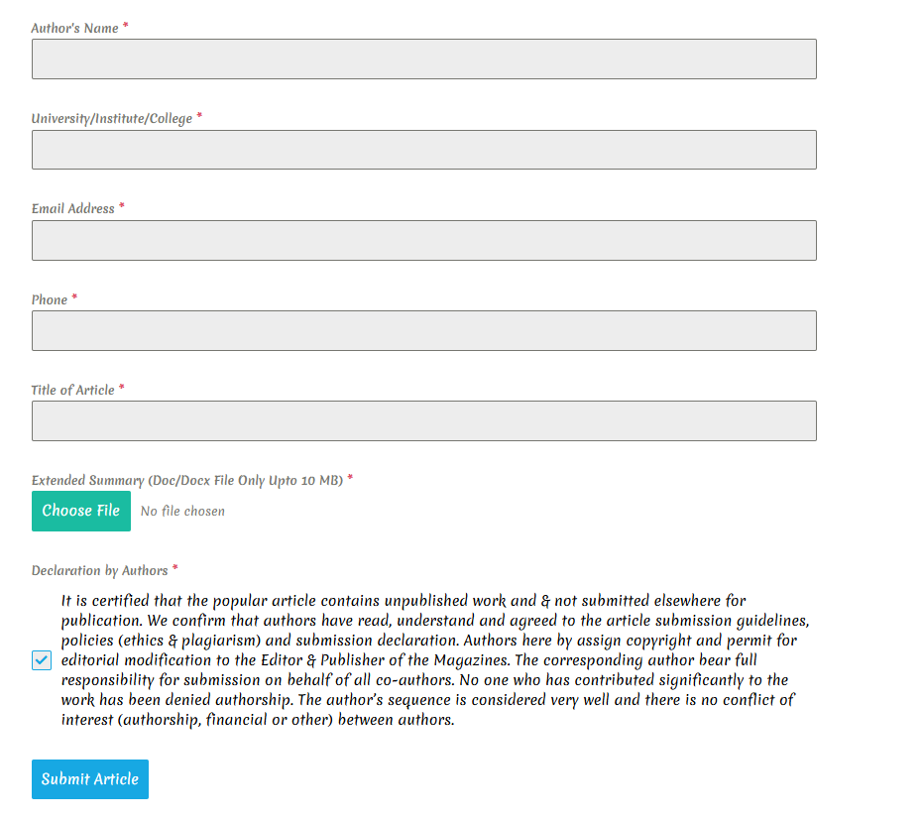
Submission Process:

Publication Fees
An article processing charge of 1000 per manuscript is applicable.

Tab 3. Society
Tab 4. for e-Magazine
About Magazine
Name: Farm Science Today
About e magazine- Farm Science Today is an open access, multidisciplinary, monthly magazine-cum-e Newsletter dedicated to presenting scientific knowledge in a simple, accessible style for progressive farmers, students, researchers, and all those interested in applying science to everyday challenges in Indian agriculture. Alongside research-based articles, the magazine features book reviews, photo features, interviews, farmer success stories, and a dedicated editorial page, making it both a scientific resource and a practical companion for the farming community.
The e magazine also brings out two special issues each year — one in June, and another on a significant occasion relevant to the agricultural calendar. In addition, thematic issues are periodically released, focusing on topical and emerging subjects of interest to the farming and scientific community.
All submitted articles undergo review and evaluation by a panel of subject-matter experts from the relevant field(s). Upon acceptance, articles are published within 7 business days, following the completion of all publication formalities and payment of nominal processing charges.
Themes covered:
Agriculture > Horticulture > Agronomy > Plant Breeding and Genetics > Soil Science > Plant Pathology > Entomology > Agricultural Biotechnology > Agricultural Economics > Agricultural Engineering > Food Science and Technology > Animal Husbandry and Dairy Science > Fisheries Science > Forestry > Environmental Science > Agricultural Extension

E magazine tab will also cover separate tabs for
  - submission process
  - Guidelines for authors- To ensure smooth and timely processing of your submission, authors are requested to carefully follow the guidelines below before submitting their articles to Farm Science Today.
- Manuscript Length & Format:
The complete article should not exceed 1500–2000 words and must be submitted in an editable Microsoft Word (.doc/.docx) format. The manuscript should be typed in Times New Roman, font size 12, with 1.5-line spacing throughout.
- The title should be short, clear, and informative, accurately reflecting the specific content and scope of the article.
  - Authorship: Author names should be written in full, with the first name first (e.g., Rajesh Kumar Sharma, not R. K. Sharma). A maximum of five authors is preferred for popular/technical articles.
  - Author Affiliation & Contact
The complete address (Department, College/Institute, and University) of all authors must be provided below the author names. The email ID of the corresponding author should be mentioned immediately after the address details.
  - Content Structure
The article should be written in clear, simple language, intelligible to a broad readership of farmers, students, and researchers. It must include:
  - A brief summary of the article
  - A short introduction explaining the scope and relevance of the topic
  - A complete account of the methodology and results/discussion
  - A well-articulated conclusion summarizing the key outcomes at the end
  - Visual Content-Authors must include at least one relevant colour figure, photograph, or illustration within the text to enhance reader engagement and clarity.
  - References-All references cited in the text must appear in the reference list at the end of the article, and vice versa. Each reference should include: names of all authors, year of publication, full title of the article, full name of the publisher/journal (in italics), volume(issue), and page numbers.
  - For conference proceedings, the title of the paper, name of the seminar/symposium, place, date, and page numbers should be included along with the names of all authors and the year of the event.
  - Plagiarism Policy-Plagiarism is treated as a serious offense in scientific and popular publishing. Authors must ensure that all submitted content is original and must not reproduce another person's work, data, or ideas as their own.
  - Author Declaration-All authors are required to sign a declaration form confirming their individual contribution to the article and accepting joint responsibility for the content, including any disputes that may arise from authorship or intellectual property claims.
- Archive tab will be there for storing the published manuscripts.
- Submit article tab will be there having the following details
Please read the guidelines before submitting. If your article is rejected for any reason (according to the author’s guidelines), you will be informed. If you do not receive any email, your article will be published in the next upcoming issue according to your submission.”


Publication Fees:
Publication fees for Single article = Rs. 200

Number-9729848196
Email ID- ijariglobal@gmail.com
Office Address: Sasroli, Jhajjar, Haryana 124106
Domain name- ijari.in

To be continued content addition from here
Kindly refer to International Journal of Agricultural Research, Innovation and Technology, website and food and agriculture e newsletter/ RD agriculture/Just Agriculture website for more insight regarding sections and designing

Change front page image changing set up make it more professional type example: Just Agriculture Website.

IJARI SOCIETY Name
IJARI Research Foundation
IJARI Research Foundation (IJARI) was founded in 2026. It is an autonomous research and educational society, which is under process of registration under Societies Registration Act. It is a scientific and educational society, working in agriculture, environment, rural development, allied sciences such as veterinary, home science, biotechnology, engineering as well as natural farming for sustainable development, and provides a unique platform to scientists, academicians, researchers, and policymakers to exchange ideas, encourage research, and disseminate knowledge in the field of agriculture.
IJARI Research Foundation was started with the aim to revitalize agricultural and allied advance scientific research and extension and strengthen community livelihoods by providing members with opportunities for the exchange of knowledge and cooperation among relevant societies. IJARI's primary scope covers Agronomy, Horticulture, Entomology, Plant Pathology, Soil Science, Agricultural Economics, Environmental Science, Home Science, Extension, Agricultural Engineering, Biotechnology as well as humanities and other applied sciences etc.
IJARI Research Foundation is one of India’s emerging networks of agricultural professionals and acts as a bridge between research communities, government bodies, development organizations, and corporate entities and farmers. IJARI achieve this through research and extension publications, field implementation projects, capacity-building programs with integrated deployment of technological and scientific innovation for efficiency and scale.
Vision
To advance scientific research and innovation for sustainable development, empowering communities with basic and applied knowledge in agriculture. We believe that when students and farmers and researchers are enabled with the right knowledge and tools, agriculture can become a place of opportunity and progress for all.
Mission
- To diversify and strengthen organizational competency to develop and implement strategies and programmes that enhance the capacities of students, farmers and researchers through empowerment, participation, and advocacy.
- Our organization has pioneered a participatory approach to the long-term betterment of agricultural sector.
- Enhancing incomes, knowledge access, research output through access to markets, technologies, scientific findings.
- To bridge knowledge gaps and provide technical/scientific innovations that create measurable impact and improved outcomes.
- To ensure that communities and systems remain resilient through the proper application and dissemination of research for sustainable development.

All individuals associated with any scientific community or any other interested citizens can become members of IJARI Research Foundation as per the membership policy and guidelines defined by the advisory board. Professionals engaged and interested in teaching/research/extension in Agriculture and allied sciences shall be admitted as members after they pay the prescribed fee as per the prevailing rate. They shall be entitled to receive the Magazine/Journal of the Foundation free of charge from the year from which subscription is paid, will have rights to vote, and hold an office of the Foundation, provided they have been members for a minimum period of two years prior to the year of election. Members seeking admission to the IJARI research foundation are required to apply in the prescribed format. The format for Joining the Foundation and Fees structure is as follows:
Put this type sign and add a form like, Name, Designation, Affiliation, type of membership (Lifetime, Annual, Students, Institutional) Payment Details and then Submit.
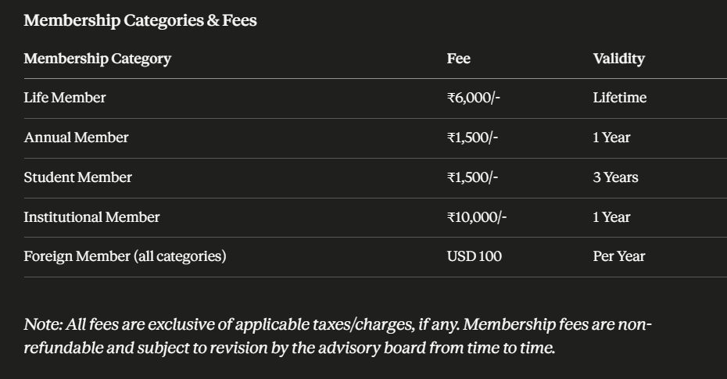

Contact Details of the editorial members to be updated on website
  - Dr. Praveen Kumar
Contact No: 9416410306
  - Abhishek Raj,
Email: abhishekraj20@rpcau.ac.in
Contact: 7004509239
  - Dr. Rajan Kumar
Email: rajan.kumar@rpcau.ac.in
Contact: 9430800862
  - Dr. Siddhant Padhi
Email: siddhant.padhi-icar@nic.in
Contact: 7009580244
Add Executive Members
  - Dr. Abhilash Thapa
Assistant Professor (Fisheries Economics)
Dr. RPCAU Pusa, Samastipur
Email: abhilashcof30@rpcau.ac.in
Phone No- 8016643812

  - Dr Gireesh S
Business manager
Angrau Poshan Incubator, RARS, Tirupati
Email: Bmrabi24@gmail.com
Contact: 9650892731

Add Members
  - Th.D. Grace Chiru
Assistant professor, Sanskriti University, Mathura.
Email: gracechiru61@gmail.com
Contact: 7557823275

- Both cover page must also be reflected on front page in small icons
- On right side of the front web page: a small column will be there for News and Updates

Cover Page for Magazine
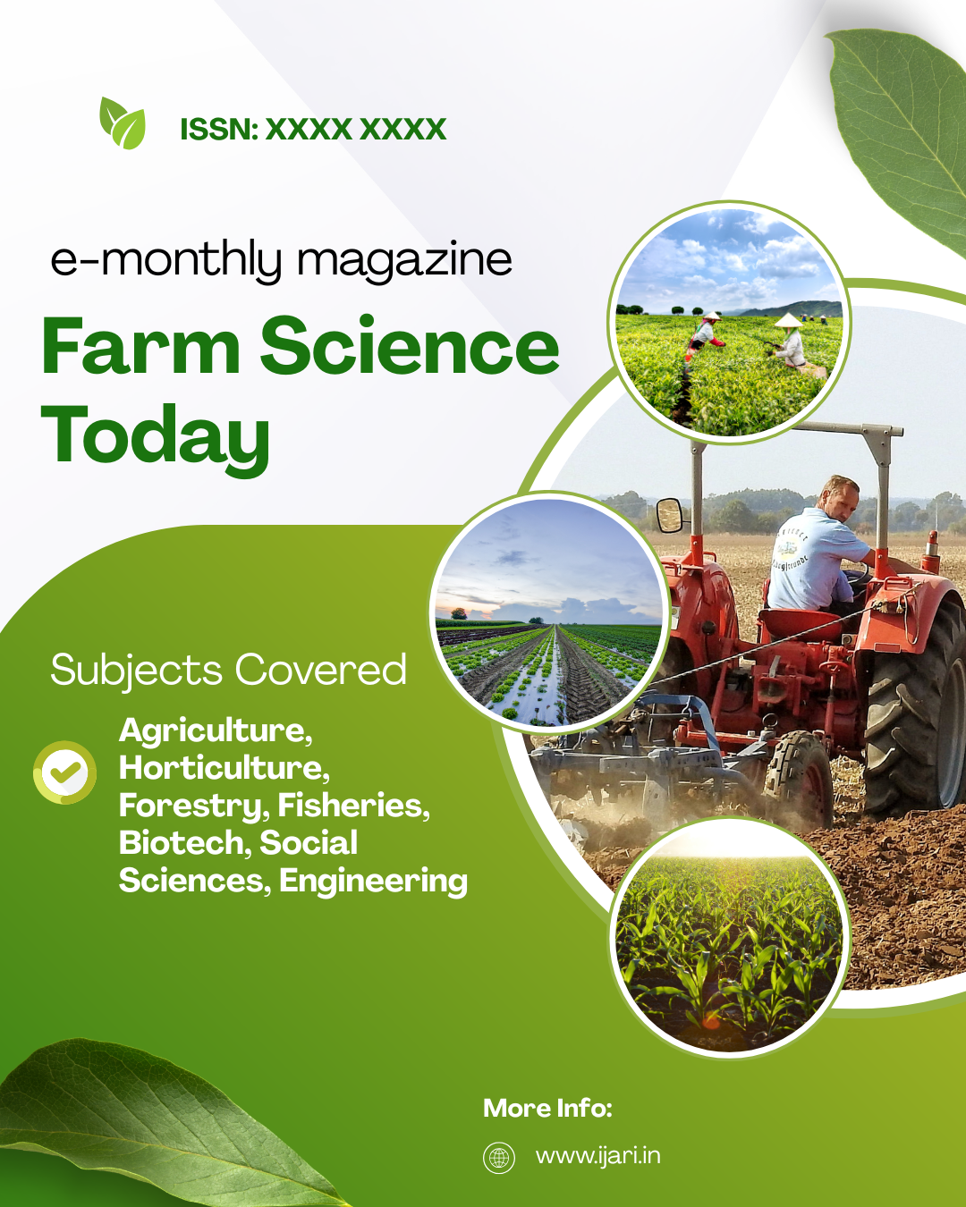

Cover page for Journal
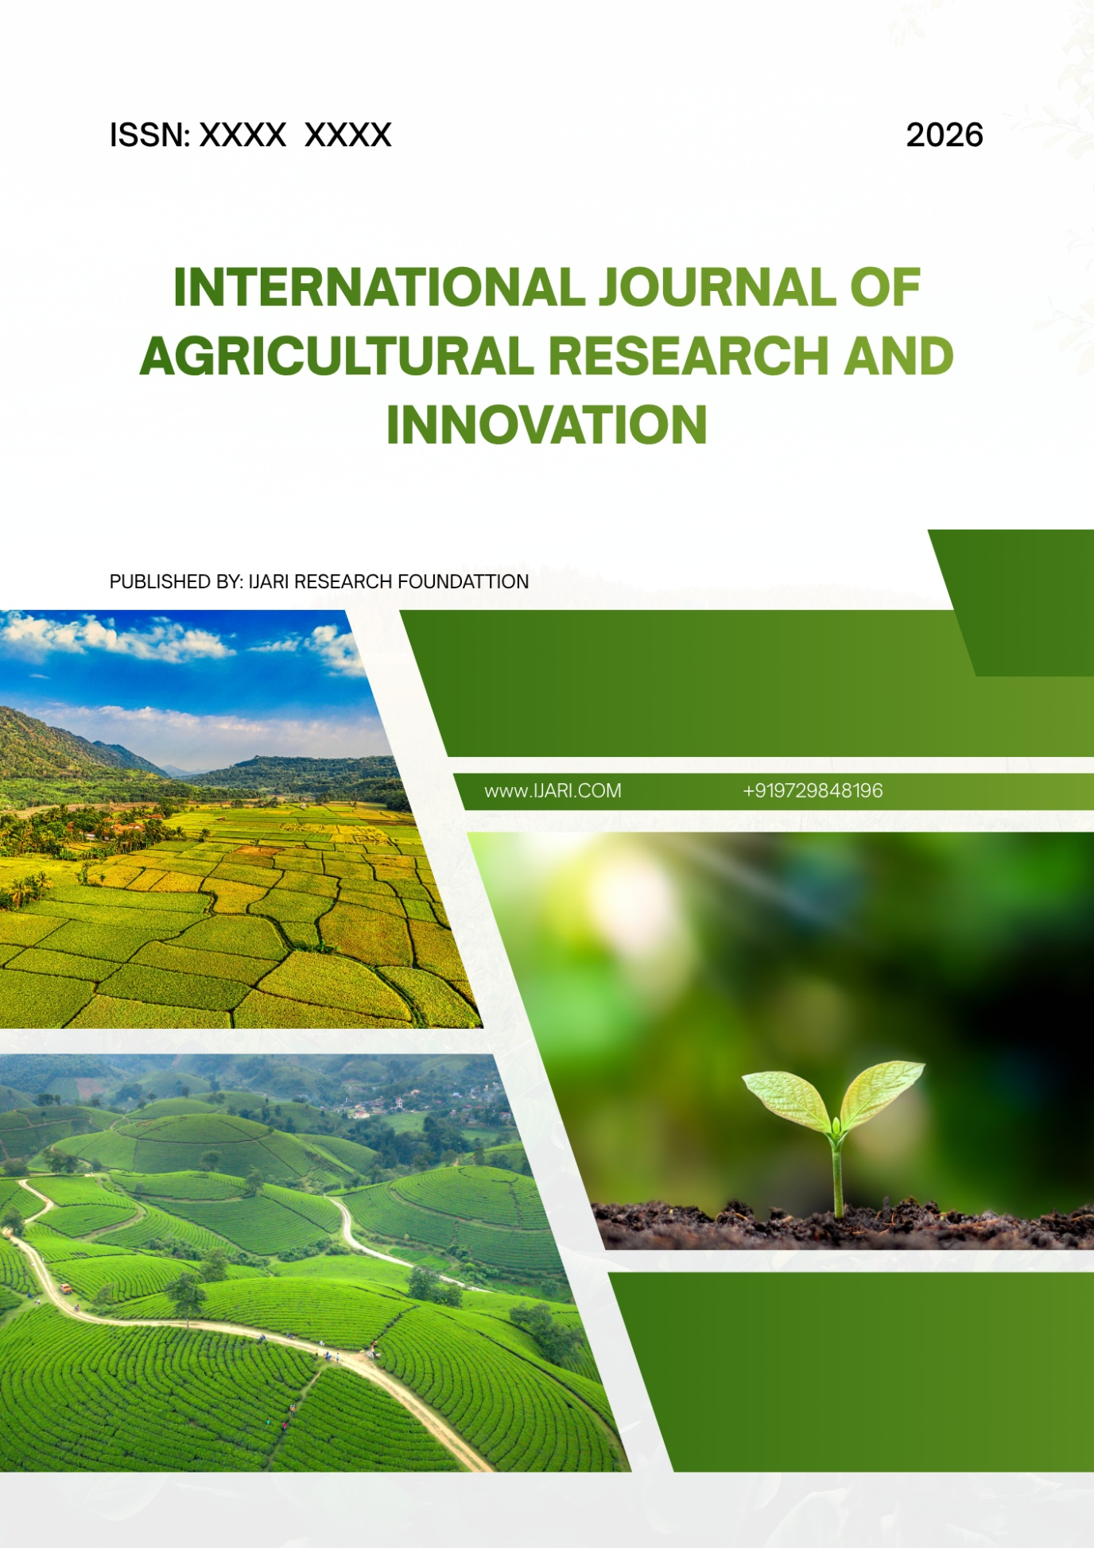

Payment page will also be there which will accept payments for articles publications.
Payment Details
Account Name: Mohit Kumar
Account No: 9729848196
IFSC: AIRP0000001
UPI: 9729848196@pthdfc
UPI QR Code:


