1.Select country from customer2 WHERE country=’USA’;

1. 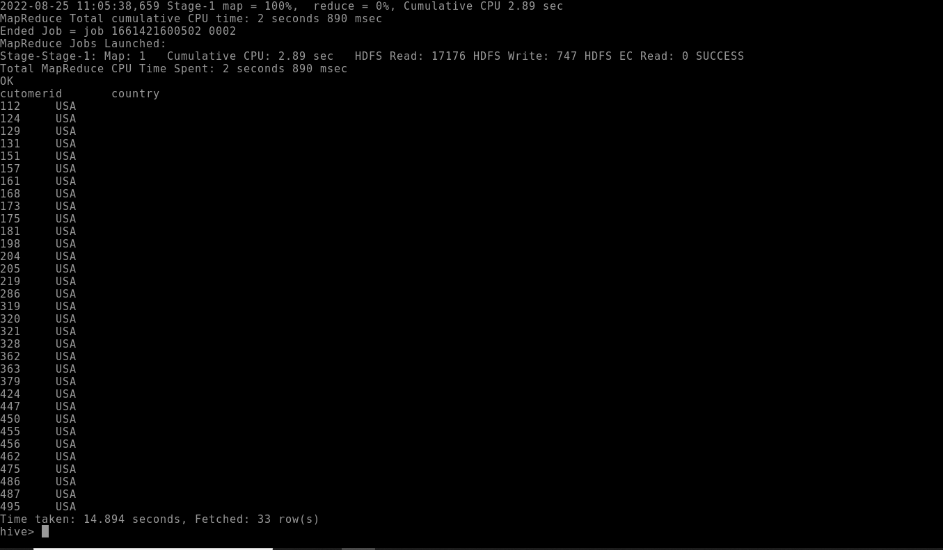

2,. Select country from customer2 WHERE country=’France’;

.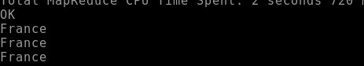

3.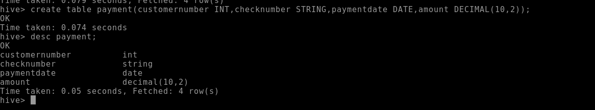

4.SELECT \*from payments

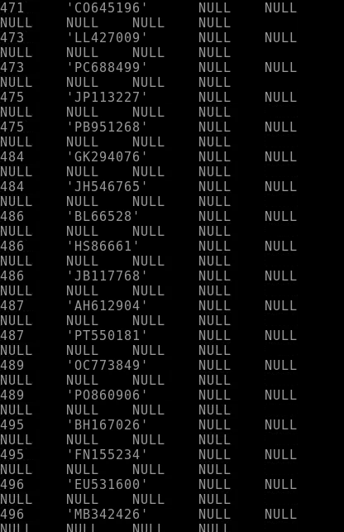

5.6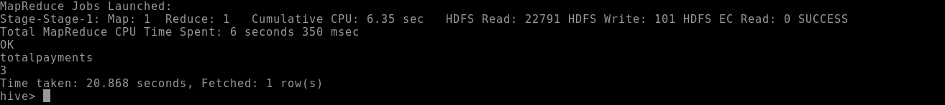

6.select \* from order1 ;

7.select \* from orders1

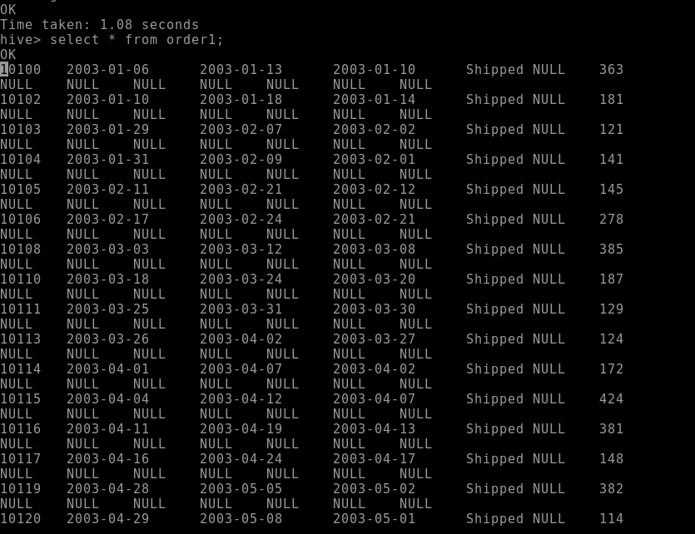

8.select sum(orders) from orders1;

