**Testing**

**Blackbox Testing.**

Test Case name: Test Admin Login

Module name: Admin Login

Created by: Vivek Tamang

Date of Creation: 30/09/2019

|  |  |  |  |  |  |  |
| --- | --- | --- | --- | --- | --- | --- |
| Test case id | Test scenario | Test description | Test data | Expected | Actual | Status |
| Admin_Login_01 | Admin Login | Enter the admin email and password to login to admin panel. | Email: root@session.dev  Password: root | Open dashboard. | As expected | pass |

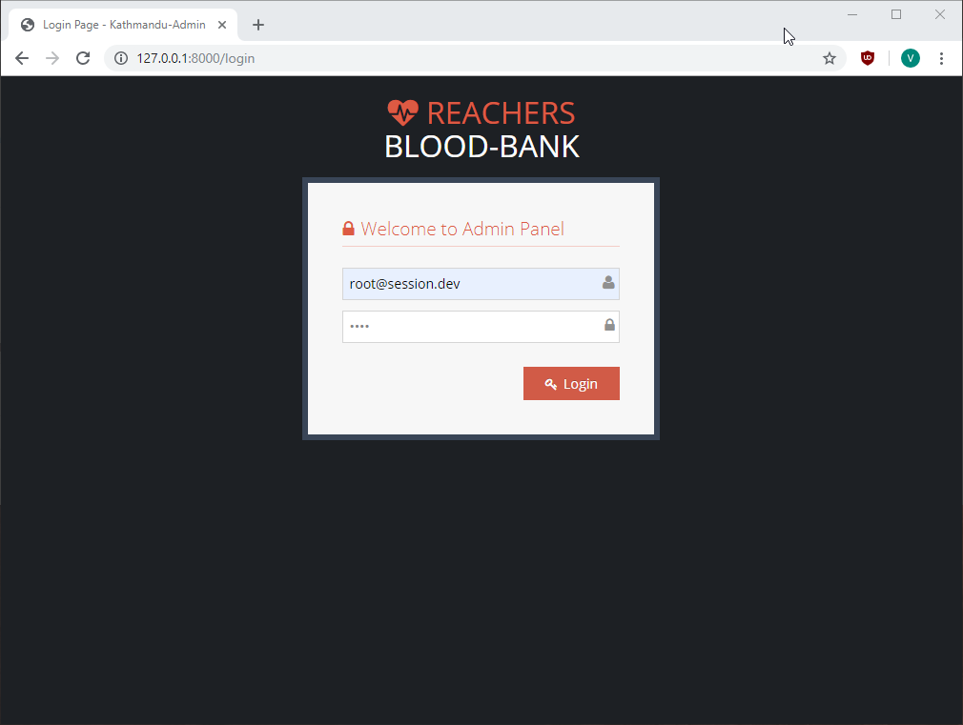

Figure : Login Page

Test Case name: Test User Manger in Admin Pannel

Module name: User Manger

Created by: Vivek Tamang

Date of Creation: 30/09/2019

|  |  |  |  |  |  |  |
| --- | --- | --- | --- | --- | --- | --- |
| Test case id | Test scenario | Test description | Test data | Expected | Actual | Status |
| User_Manager_01 | User Manger in Admin Panel | Click on “List” of user manager to view users (Admins) |  | List of users appear. | As expected | pass |
| User_Manager_02 | User Manger in Admin Panel | Click delete button |  | Delete user | As expected | Pass |
| User_Manager_03 | User  Manger in Admin Panel | Update User information |  | User information updated | As expected | Pass |
| User_Manager_04 | User Manger in Admin Panel | Add user | Username: Chris  Full Name: Chris Tomlin  Contact number: 9845632148  Email: [chris012@hotmail.com](mailto:chris012@hotmail.com)  Password Field: root  Address: Berlin  Gender: Female  Status: Active. | User Added | As expected | Pass |

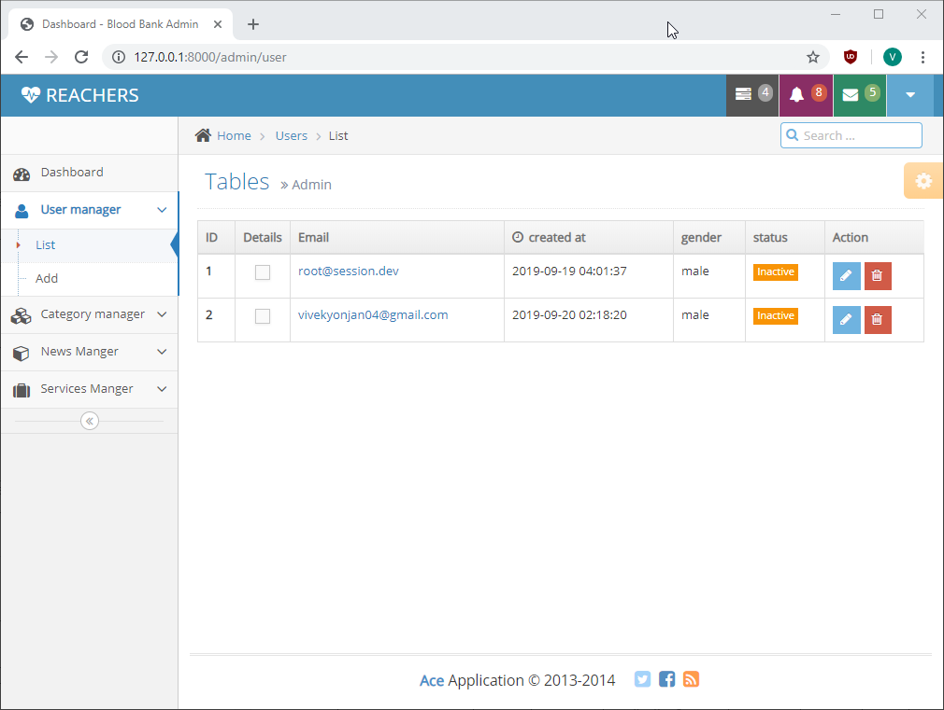

Figure : View user list

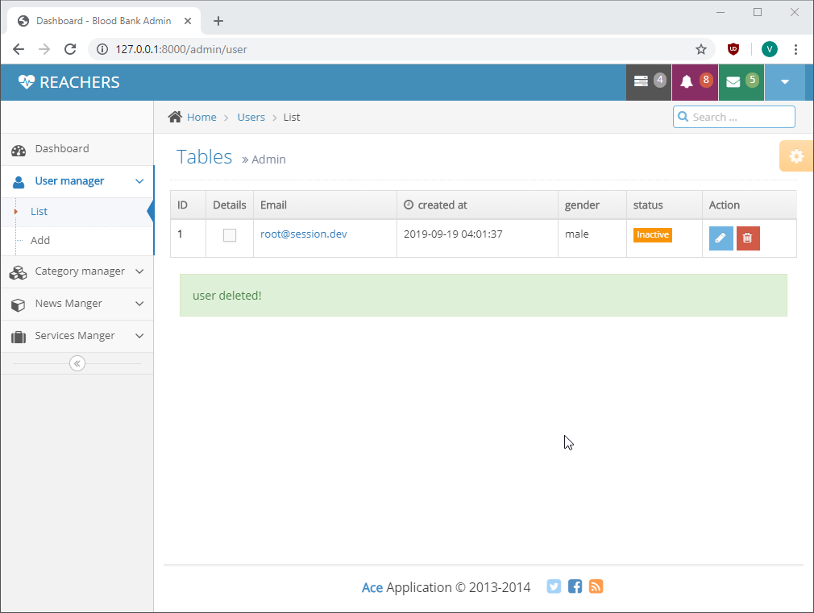

Figure : User deleted

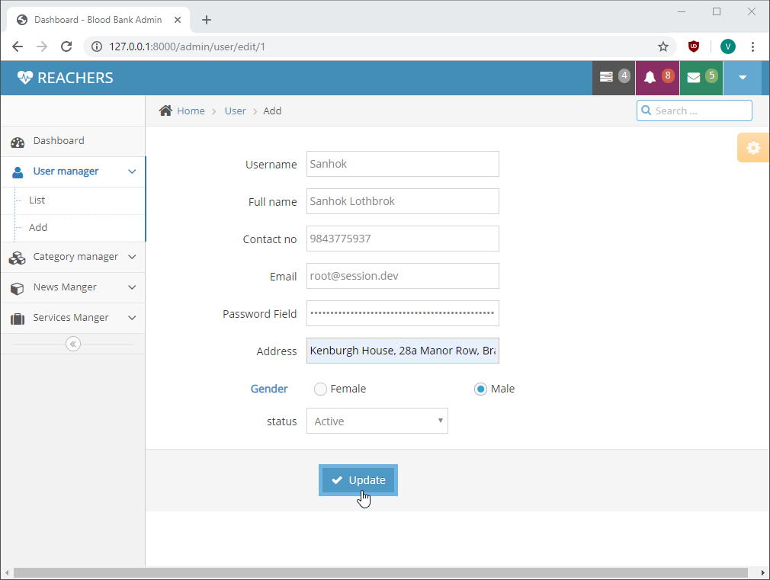

Figure : Update User

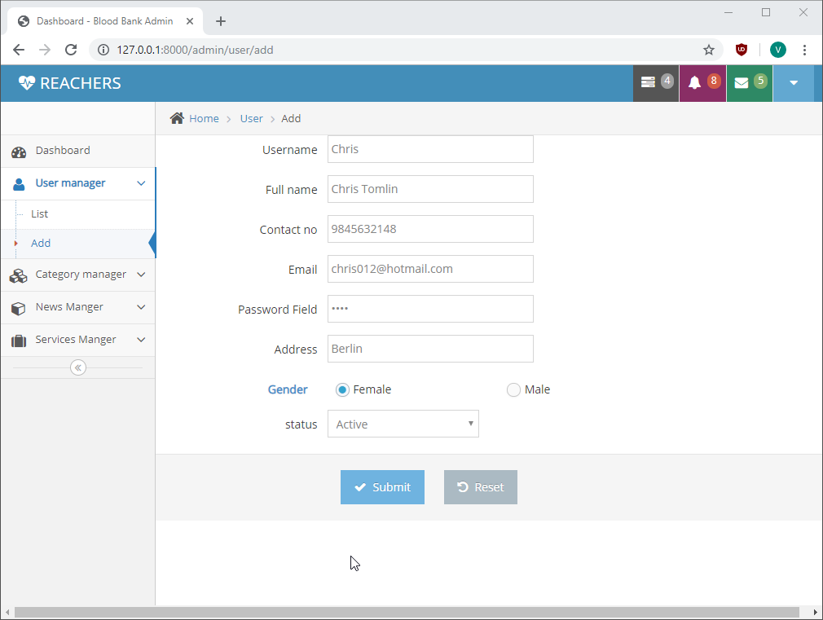

Figure : Add User

Test Case name: Test Service Manager

Module name: Service Manager

Created by: Vivek Tamang

Date of Creation: 30/09/2019

|  |  |  |  |  |  |  |
| --- | --- | --- | --- | --- | --- | --- |
| Test case id | Test scenario | Test description | Test data | Expected | Actual | Status |
| Service_Manager_01 | Service Manager in Admin Panel | Click on “Delete” button of Donor’s Information | First Name: Vivek  Last Name: Tamang  Email: [vivekyonjan04@gmial.com](mailto:vivekyonjan04@gmial.com) | Delete donor information | As expected | pass |
| Service_Manager_02 | Service Manager in Admin Panel | Click on “Delete” button of Event Host | Organization: Socheye  Title: Raktadan-Jivandaan | Delete event | As expected | Pass |

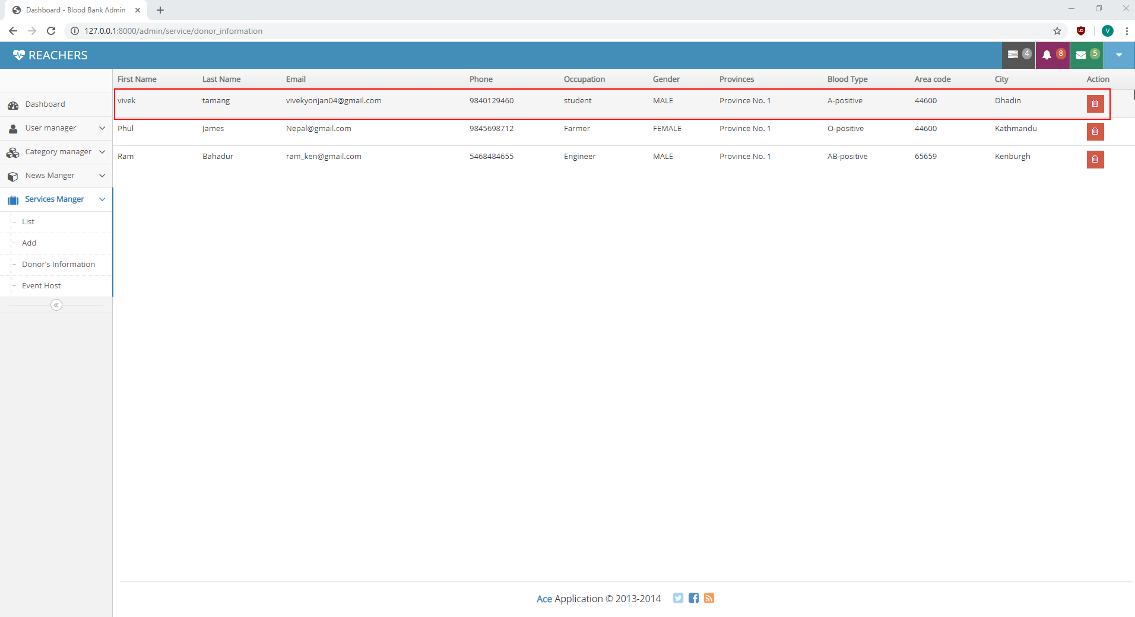

Figure : Before Deleting Information

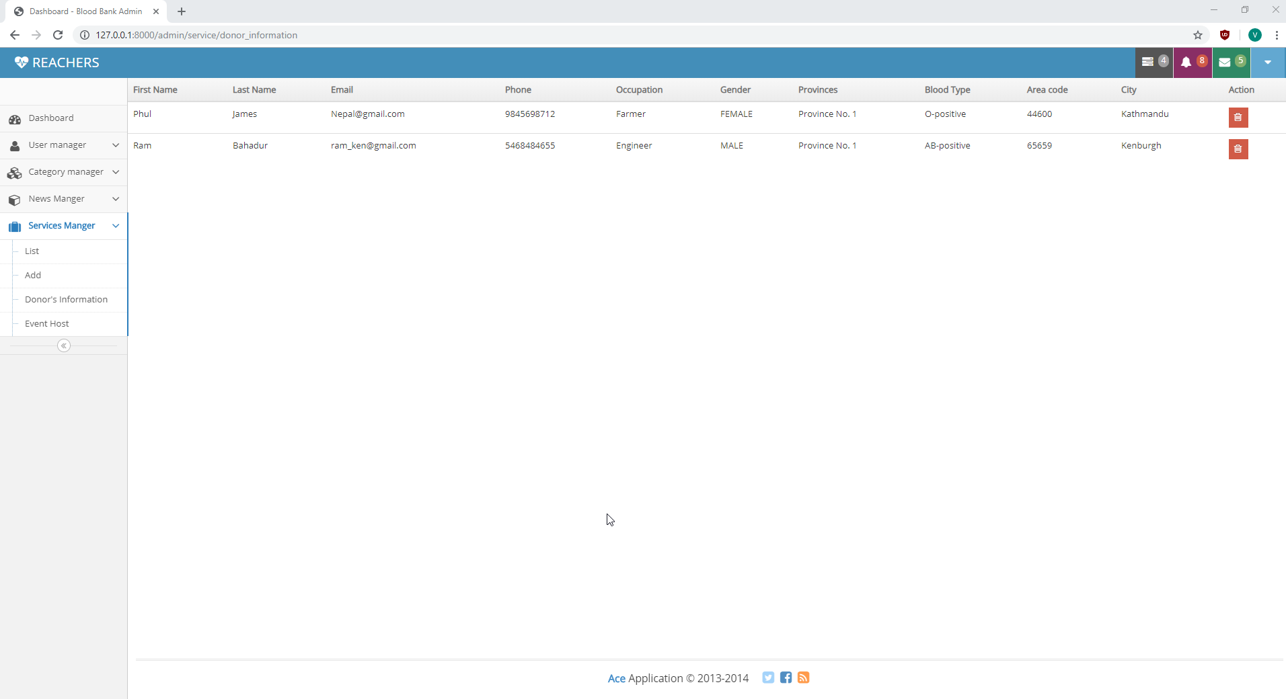

Figure : After Deleting information

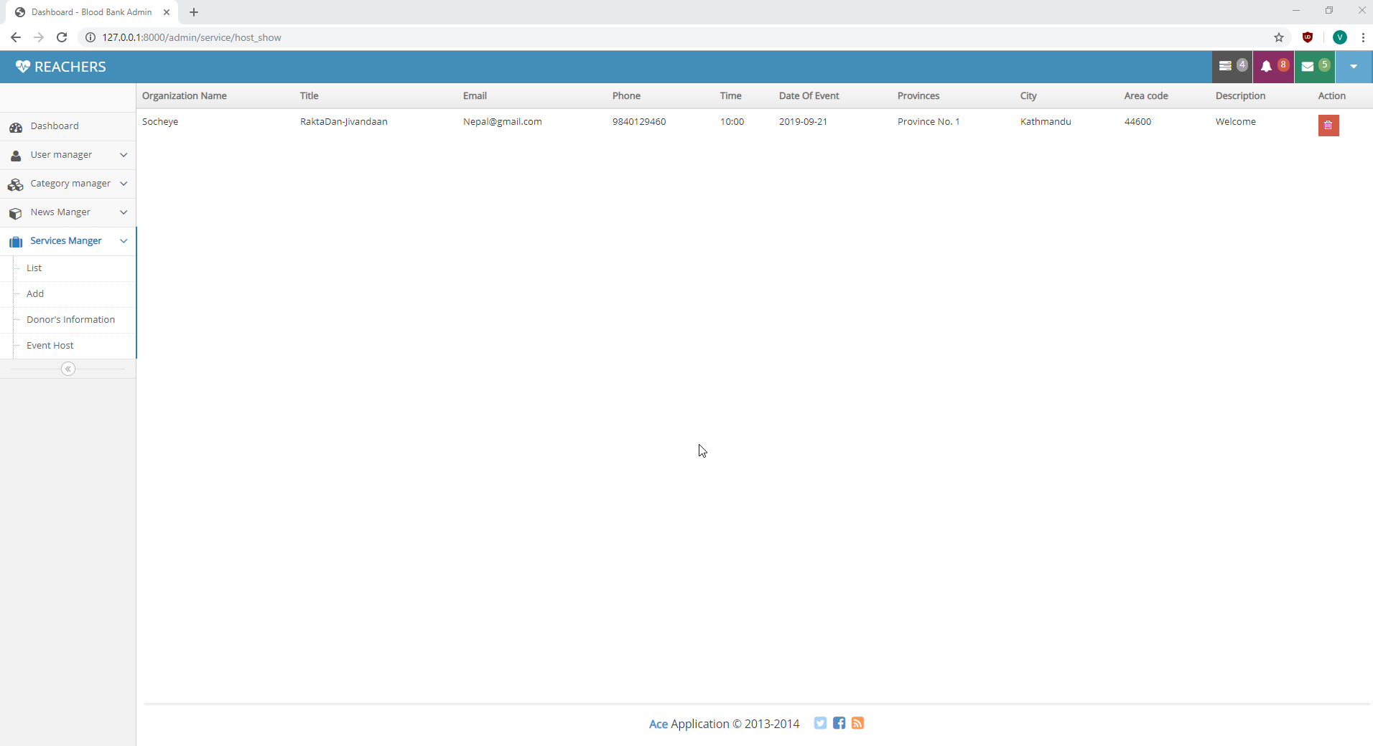

Figure : View list of Event host

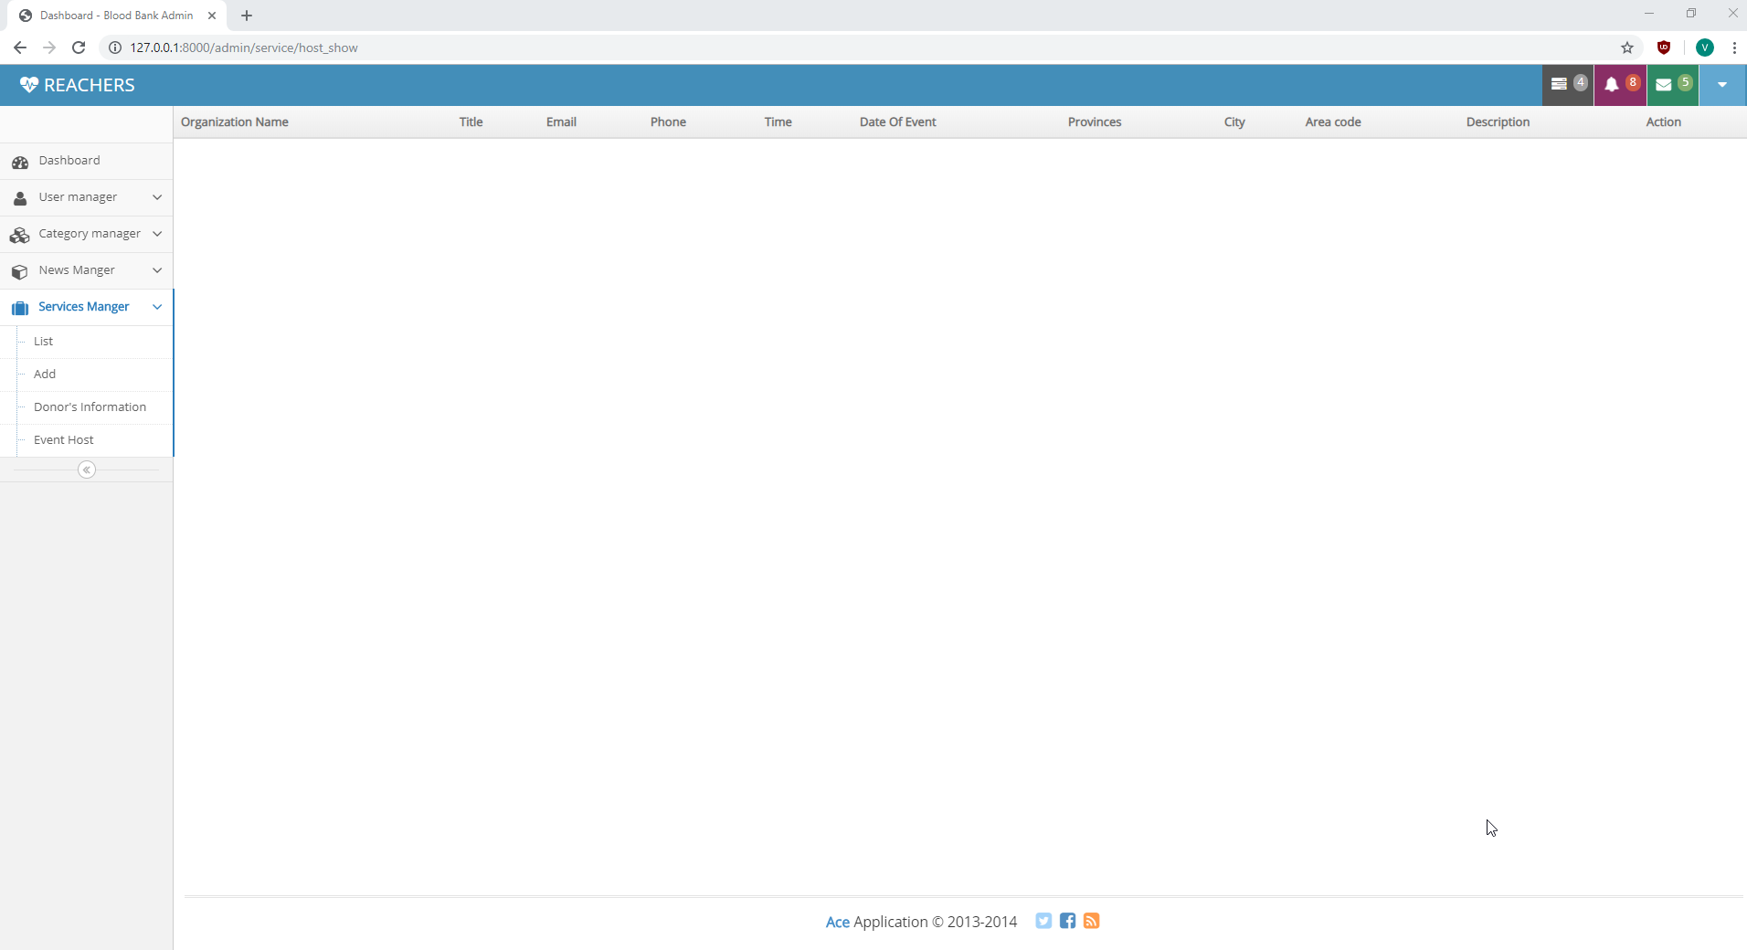

Figure : After deleting event

Test Case name: Test News Manager

Module name: News Manager

Created by: Vivek Tamang

Date of Creation: 30/09/2019

|  |  |  |  |  |  |  |
| --- | --- | --- | --- | --- | --- | --- |
| Test case id | Test scenario | Test description | Test data | Expected | Actual | Status |
| News_Manager_01 | News Manager in Admin Panel | Click on “List” to view News |  | View news | As expected | pass |
| News_Manager_02 | News Manager in Admin Panel | Click on “Add” to add news |  | News form open | As expected | Pass |
| News_Manager_03 | News Manager in Admin Panel | Click on “Delete” button |  | Delete news | As expected | Pass |

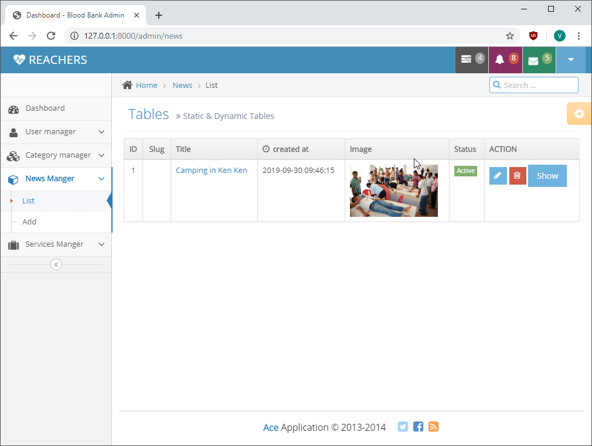

Figure : View News

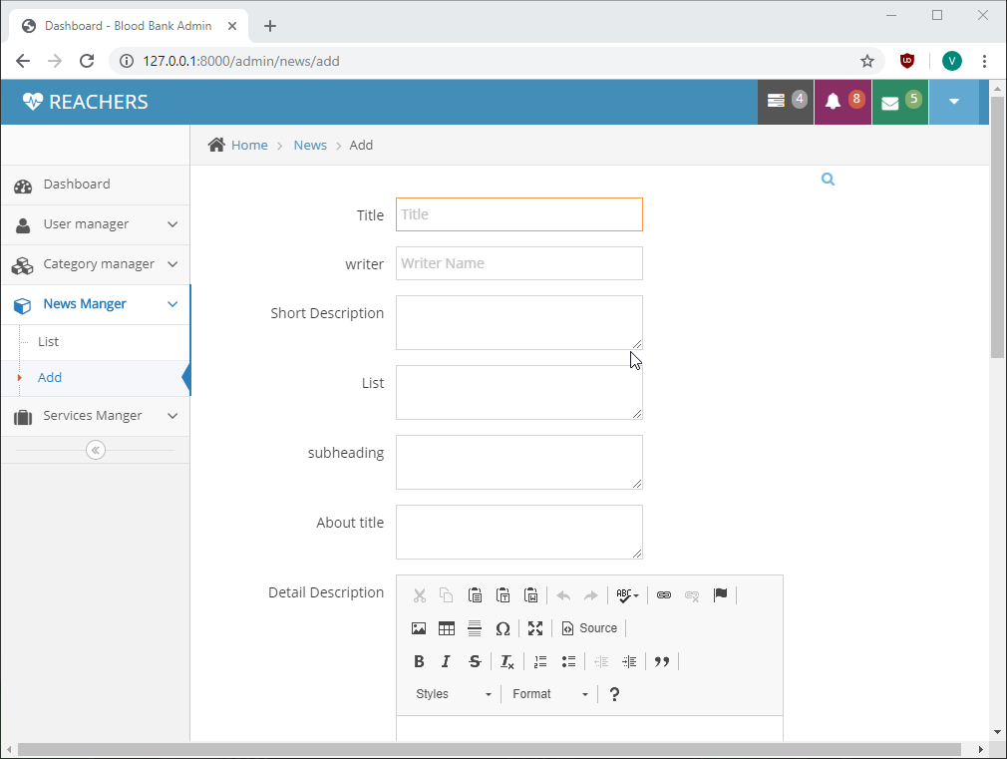

Figure : Add News

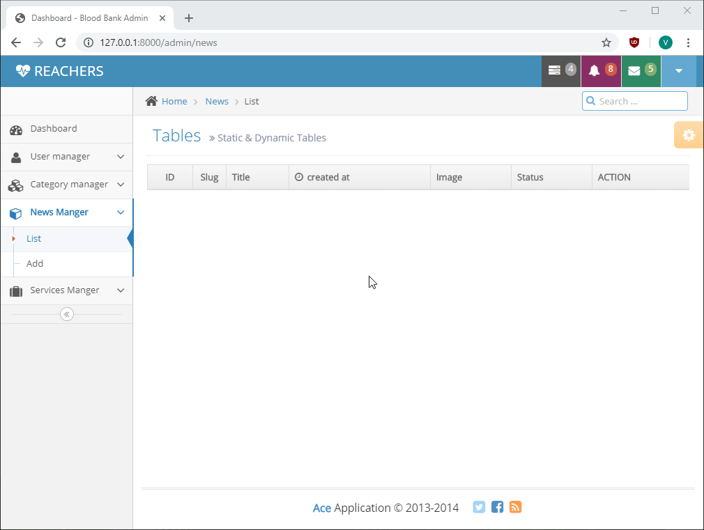

Figure : After news is deleted

Test Case name: Test Donor Registration

Module name: Donor Registration

Created by: Vivek Tamang

Date of Creation: 30/09/2019

|  |  |  |  |  |  |  |
| --- | --- | --- | --- | --- | --- | --- |
| Test case id | Test scenario | Test description | Test data | Expected | Actual | Status |
| Donor_Registration_01 | Register Donor | Add donor information | Donor’s Name: Ram Bahadur  Email: [ram_ken@gmail.com](mailto:ram_ken@gmail.com)  Gender: male  DOB: 08/09/1995  Phone number: 5468484655  Address:  City: Kenburgh  Provience: Provience no 1  Zip code: 65659  Occupation: Engineer  Blood Type: AB positive  Did you ever donate blood before?  Ans: No  Do you suffer of any diseases?  Ans: No  Do you have allergies?  Ans: No  Do you take medication?  Ans: No | Add donor information and show in the find donor page. | As expected | pass |

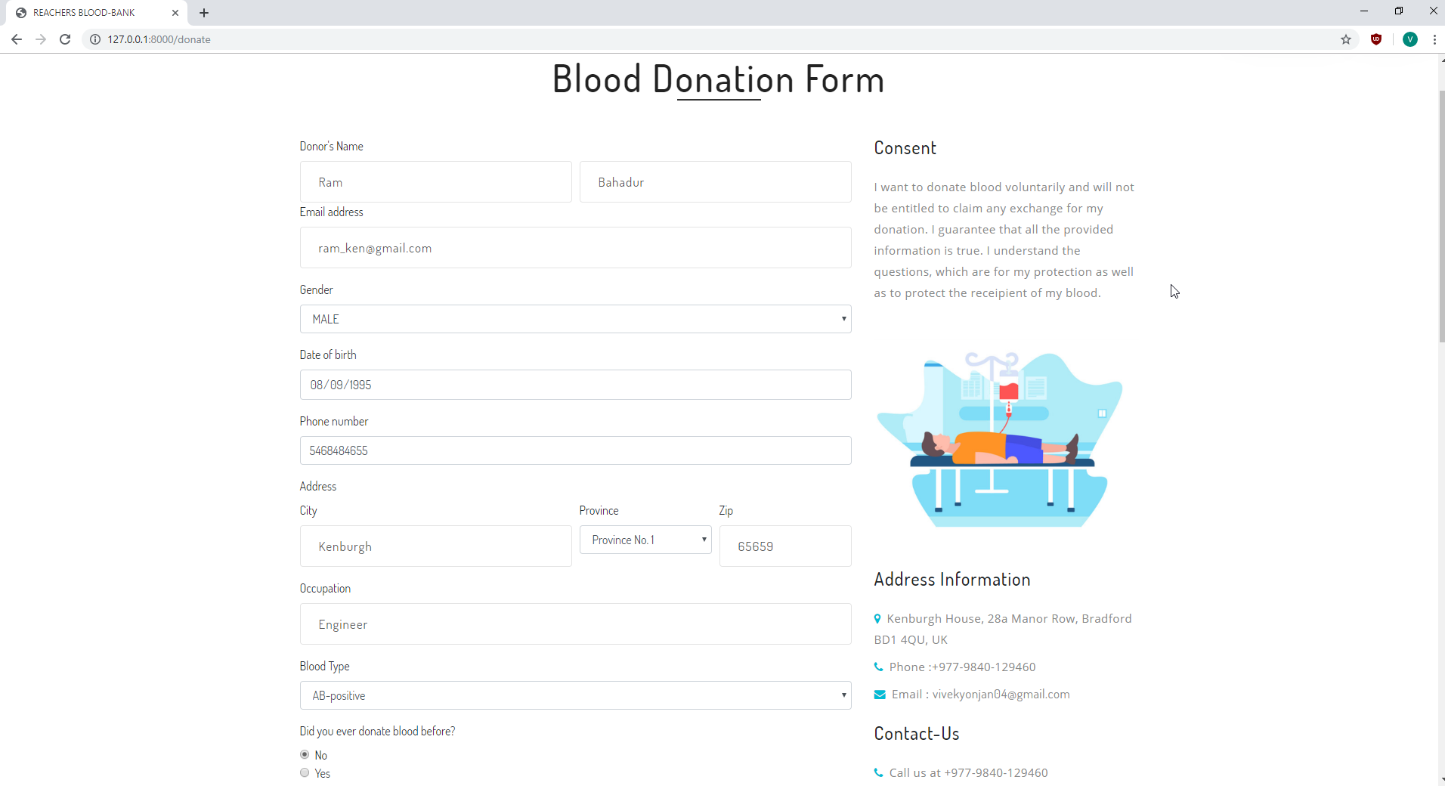

Figure : Donation Form 01

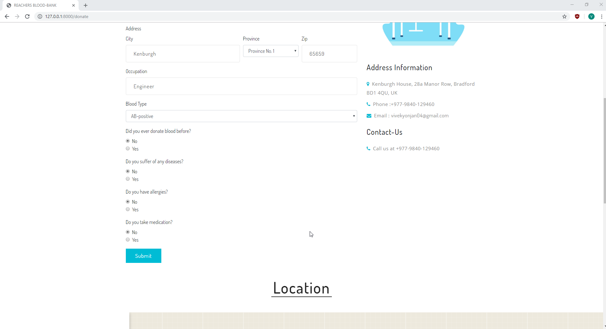

Figure : Donation Form 02

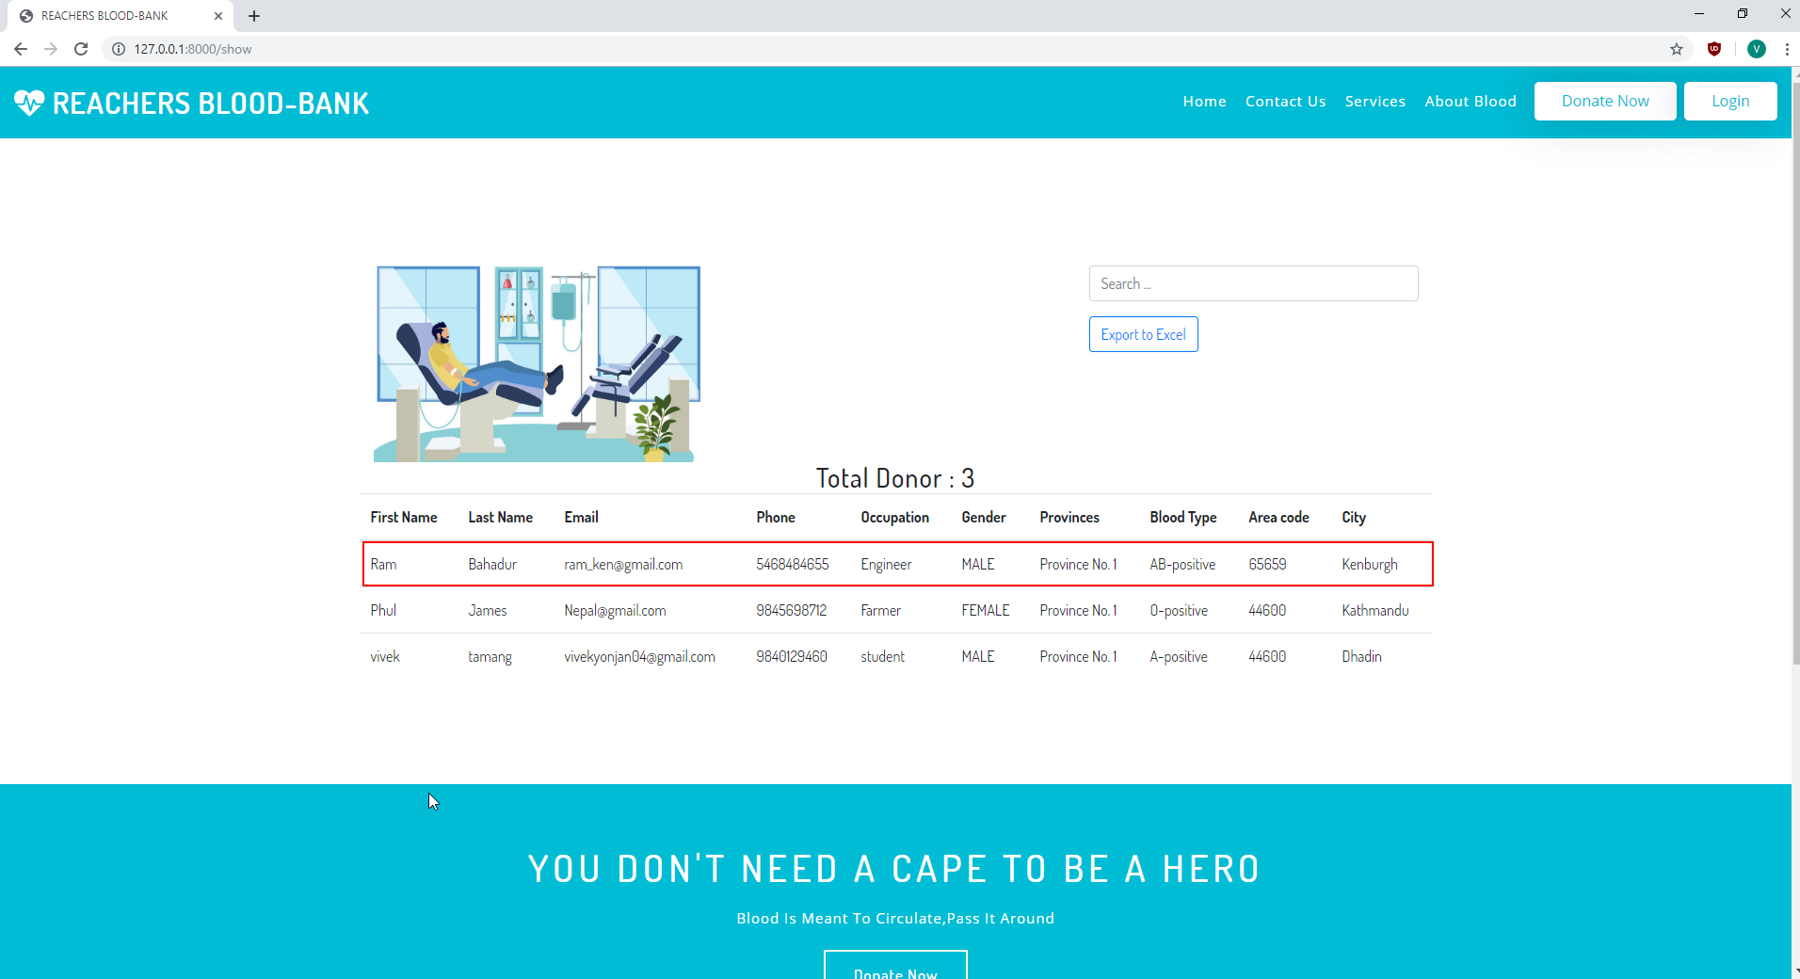

Figure : Door Information List

Test Case name: Test Nav Bar

Module name: Nav Bar

Created by: Vivek Tamang

Date of Creation: 30/09/2019

|  |  |  |  |  |  |  |
| --- | --- | --- | --- | --- | --- | --- |
| Test case id | Test scenario | Test description | Test data | Expected | Actual | Status |
| Nav_Bar_01 | Test Nav Bar | Click all the nav bar item |  | Open the page according to the nav bar item clicked | As expected | pass |

Test Case name: Test Home Page

Module name: Home Page

Created by: Vivek Tamang

Date of Creation: 30/09/2019

|  |  |  |  |  |  |  |
| --- | --- | --- | --- | --- | --- | --- |
| Test case id | Test scenario | Test description | Test data | Expected | Actual | Status |
| Home_page_01 | Test home page | Click on “Donor’s info” button |  | Open donor information table | As expected | Pass |
| Home_page_02 | Test home page | Click on “Donate now “button |  | Open Donor form. | As expected | Pass |

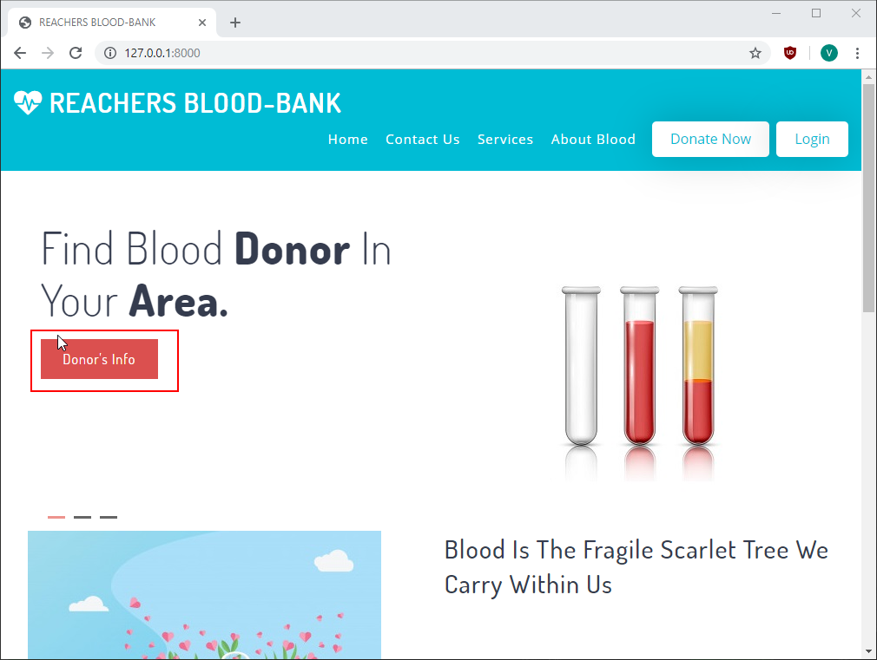

Figure : Donor Information Button

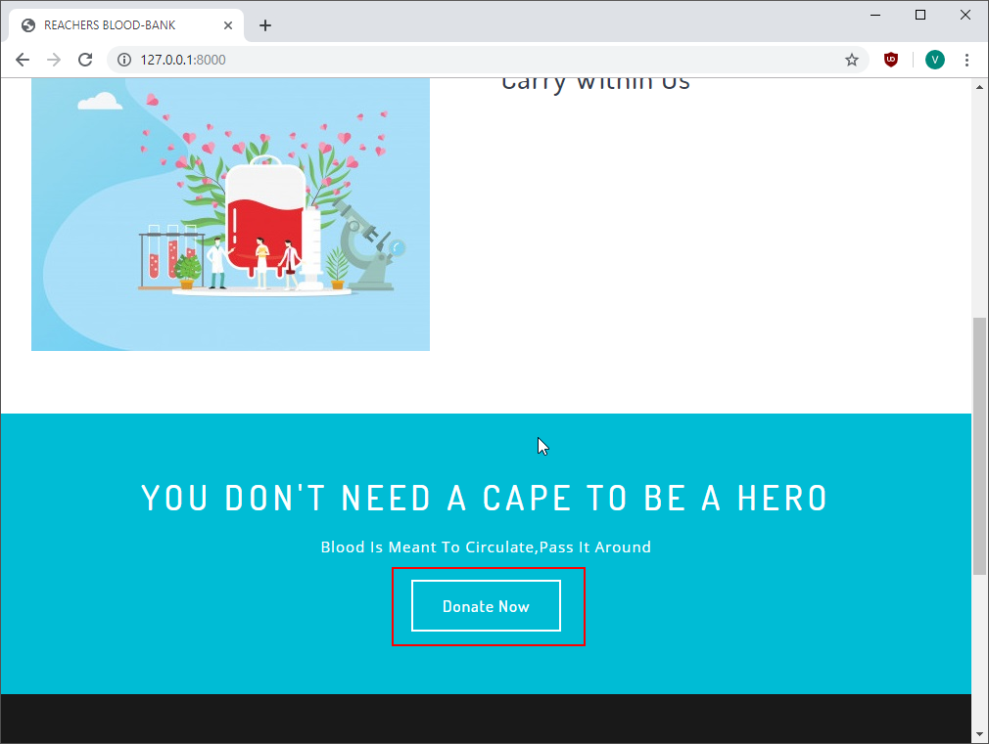

Figure : Donation Form Button

Test Case name: Test Services Page

Module name: Services Page

Created by: Vivek Tamang

Date of Creation: 30/09/2019

|  |  |  |  |  |  |  |
| --- | --- | --- | --- | --- | --- | --- |
| Test case id | Test scenario | Test description | Test data | Expected | Actual | Status |
| Services_page_01 | Test services page | Click on the listed service icon  button |  | Open page according to the service listed such as when click on host an event form of it should open. | As expected | Pass |
| Services_page_02 | Test services page | Enter feedback and click on feedback button |  | Send feedback to the admin. | Feedback not sent. | fail |

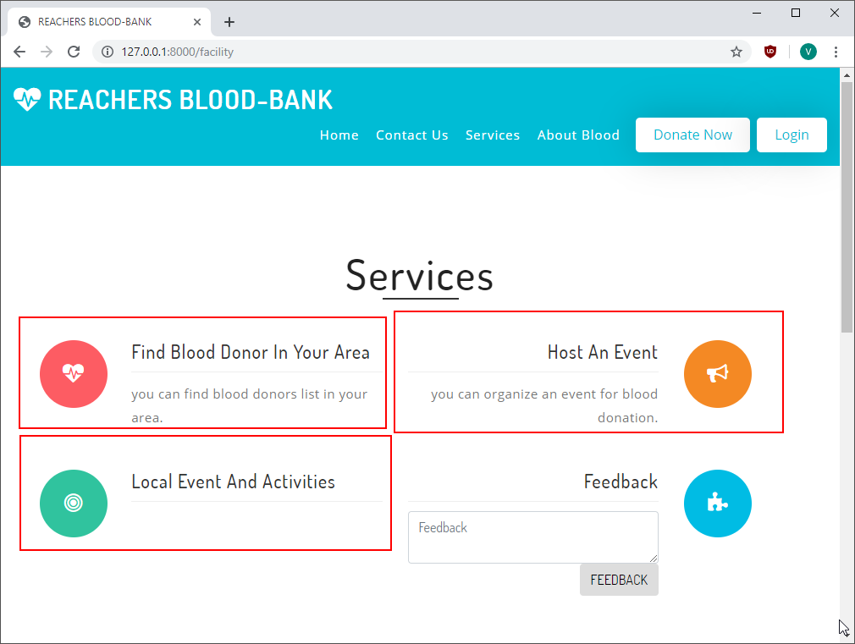

Figure : Services

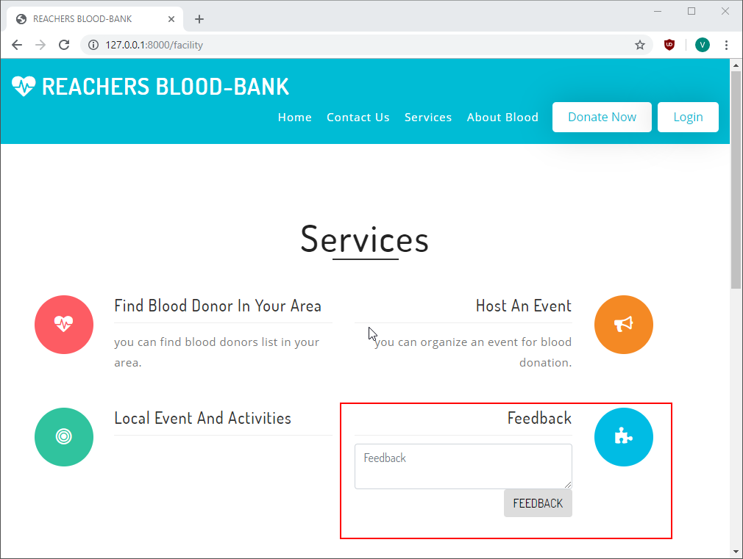

Figure : Feedback

Test Case name: Test About Blood Page

Module name: About Blood Page

Created by: Vivek Tamang

Date of Creation: 30/09/2019

|  |  |  |  |  |  |  |
| --- | --- | --- | --- | --- | --- | --- |
| Test case id | Test scenario | Test description | Test data | Expected | Actual | Status |
| About_Blood_page_01 | Test About Blood Page | Download charts in png, jpeg format |  | Download the charts | As expected | Pass |
| About_Blood_page_02 | Test About Blood Page | View chart in full screen |  | View chart in full screen | As expected | Pass |

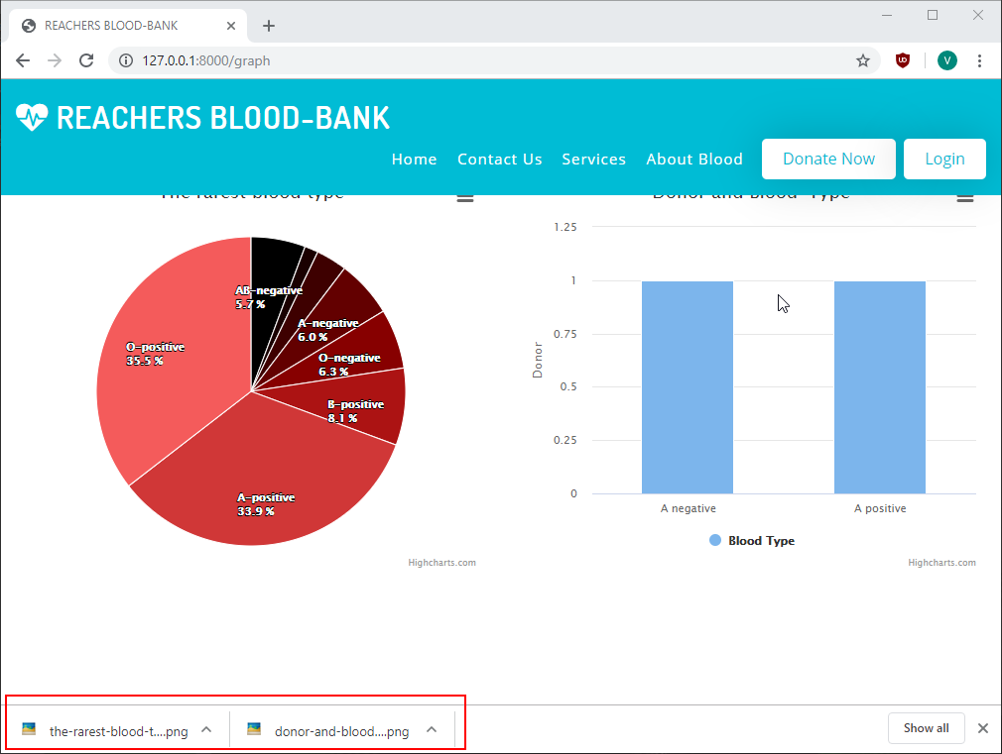

Figure : Download charts

Test Case name: Test Contact Us Page

Module name: Contact Us Page

Created by: Vivek Tamang

Date of Creation: 30/09/2019

|  |  |  |  |  |  |  |
| --- | --- | --- | --- | --- | --- | --- |
| Test case id | Test scenario | Test description | Test data | Expected | Actual | Status |
| Contact_Us_page_01 | Test Contact Us Page | Fill the contact form and submit | Name: Rahul Tamang  Phone number: 9843283563  Email: [rahul_tamang@gmail.com](mailto:rahul_tamang@gmail.com)  Subject: Request  Message: I need 0 negative blood. Please contact me. | Send Message to the admin | Message not sent to the admin | Fail |

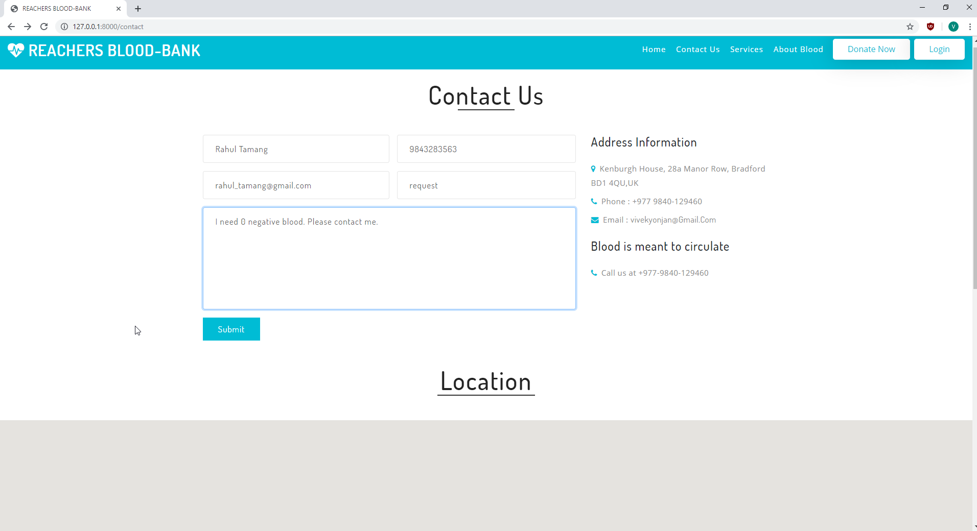

Figure : Contact Us Page

Test Case name: Test Items in footer

Module name: Items in footer

Created by: Vivek Tamang

Date of Creation: 30/09/2019

|  |  |  |  |  |  |  |
| --- | --- | --- | --- | --- | --- | --- |
| Test case id | Test scenario | Test description | Test data | Expected | Actual | Status |
| Items_in_footer_01 | Test the links to the social media and email | Click on the icon of the social media in footer |  | Open the social media pages when the icon of the respective social media is clicked. | Did not open as expected | Fail |