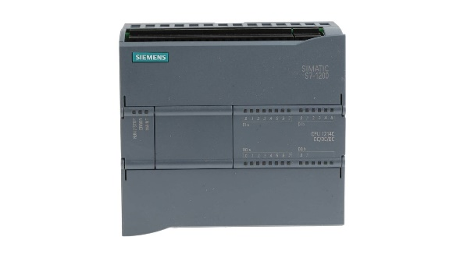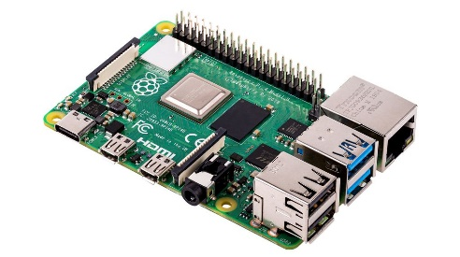

- Dashboard

Netwerk -> node.js

- Dashboard  
 Iot-> Node red

Mqtt-broker 172.16.12.22

Node-red

172.16.12.21

Sensor

PLC

Raspberry PI

Router

Profinet

Ethernet

UFW