VISVESVARAYA TECHNOLOGICAL UNIVERSITY
“JnanaSangama”, Belgaum -590014, Karnataka.

LAB REPORT
on
Database Management Systems (23CS3PCDBM)
Submitted by
Niraj V (1BM24CS192)
in partial fulfillment for the award of the degree of
BACHELOR OF ENGINEERING
in
COMPUTER SCIENCE AND ENGINEERING

B.M.S. COLLEGE OF ENGINEERING
(Autonomous Institution under VTU)
BENGALURU-560019
Sep-2024 to Jan-2025

B.M.S. College of Engineering,
Bull Temple Road, Bangalore 560019
(Affiliated To Visvesvaraya Technological University, Belgaum)
Department of Computer Science and Engineering

CERTIFICATE
This is to certify that the Lab work entitled “Database Management Systems (23CS3PCDBM)” carried out by Niraj V (1BM24CS192), who is bonafide student of B.M.S. College of Engineering. It is in partial fulfillment for the award of Bachelor of Engineering in Computer Science and Engineering of the Visvesvaraya Technological University, Belgaum. The Lab report has been approved as it satisfies the academic requirements in respect of a Database Management Systems (23CS3PCDBM) work prescribed for the said degree.

Mrs Rashmi H  Assistant Professor  Department of CSE, BMSCE | Dr. Joythi S Nayak  Professor & HOD  Department of CSE, BMSCE

Index
Sl.  No. | Date | Experiment Title | Page No.
1 | 4-10-2024 | Insurance Database | 4
2 | 9-10-2024 | More Queries on Insurance Database | 11
3 | 16-10-2024 | Bank Database | 14
4 | 23-10-2024 | More Queries on Bank Database | 21
5 | 30-10-2024 | Employee Database | 25
6 | 13-11-2024 | More Queries on Employee Database | 33
7 | 20-11-2024 | Supplier Database | 36
8 | 27-11-2024 | NO SQL - Student Database | 41
9 | 4-12-2024 | NO SQL - Customer Database | 44
10 | 4-12-2024 | NO SQL – Restaurant Database | 47

Insurance Database
Question
(Week 1)
- PERSON (driver_id: String, name: String, address: String)
- CAR (reg_num: String, model: String, year: int)
- ACCIDENT (report_num: int, accident_date: date, location: String)
- OWNS (driver_id: String, reg_num: String)
- PARTICIPATED (driver_id: String,reg_num: String, report_num: int, damage_amount: int)
- Create the above tables by properly specifying the primary keys and the foreign keys. - Enter at least five tuples for each relation
- Display Accident date and location
- Update the damage amount to 25000 for the car with a specific reg_num (example 'K A053408' ) for which the accident report number was 12.
- Add a new accident to the database.
- To Do
- Display Accident date and location
- Display driver id who did accident with damage amount greater than or equal to Rs.25000

Schema Diagram
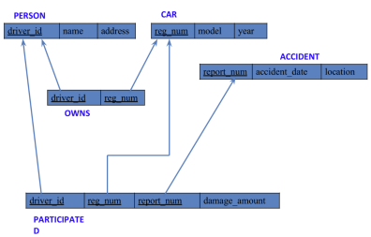
Create database
create database insurance_dhiksha;
use insurance_dhiksha;
Create table
create table insurance_dhiksha.person(
driver_id varchar(20),
name varchar(30),
address varchar(50),
PRIMARY KEY(driver_id)
);
create table insurance_dhiksha.car(
reg_num varchar(15),
model varchar(10),
year int,
PRIMARY KEY(reg_num)
);
create table insurance_dhiksha.owns(
driver_id varchar(20),
reg_num varchar(10),
PRIMARY KEY(driver_id, reg_num),
FOREIGN KEY(driver_id) REFERENCES person(driver_id),
FOREIGN KEY(reg_num) REFERENCES car(reg_num)
);
create table insurance_dhiksha.accident(
report_num int,
accident_date date,
location varchar(50),
PRIMARY KEY(report_num)
);
create table insurance_dhiksha.participated(
driver_id varchar(20),
reg_num varchar(10),
report_num int,
damage_amount int,
PRIMARY KEY(driver_id,reg_num,report_num),
FOREIGN KEY(driver_id) REFERENCES person(driver_id),
FOREIGN KEY(reg_num) REFERENCES car(reg_num),
FOREIGN KEY(report_num) REFERENCES accident(report_num)
);

Structure of the table
desc person;
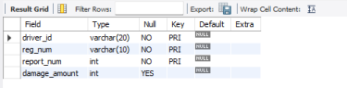desc accident;
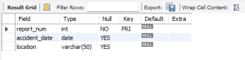
desc participated;
desc car;
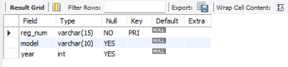
desc owns;

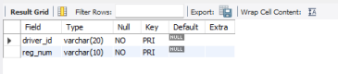
Inserting Values to the table
insert into person values("A01","Richard", "Srinivas nagar");
insert into person values("A02","Pradeep", "Rajaji nagar");
insert into person values("A03","Smith", "Ashok nagar");
insert into person values("A04","Venu", "N R Colony");
insert into person values("A05","John", "Hanumanth nagar");
select * from person;
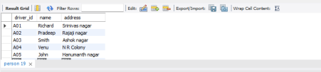insert into car values("KA052250","Indica", "1990");
insert into car values("KA031181","Lancer", "1957");
insert into car values("KA095477","Toyota", "1998");
insert into car values("KA053408","Honda", "2008");
insert into car values("KA041702","Audi", "2005");
select * from car;
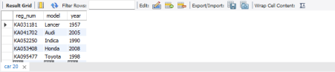
insert into owns values("A01","KA052250");
insert into owns values("A02","KA031181");
insert into owns values("A03","KA095477");
insert into owns values("A04","KA053408");
insert into owns values("A05","KA041702");
select * from owns;
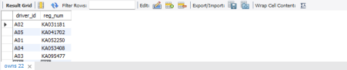insert into accident values(11,'2003-01-01',"Mysore Road");
insert into accident values(12,'2004-02-02',"South end Circle");
insert into accident values(13,'2003-01-21',"Bull temple Road");
insert into accident values(14,'2008-02-17',"Mysore Road");
insert into accident values(15,'2004-03-05',"Kanakpura Road");
select * from accident;
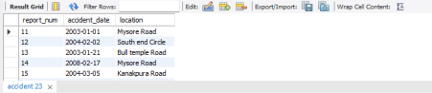insert into participated values("A01","KA052250",11,10000);
insert into participated values("A02","KA053408",12,50000);
insert into participated values("A03","KA095477",13,25000);
insert into participated values("A04","KA031181",14,3000);
insert into participated values("A05","KA041702",15,5000);
select * from participated;

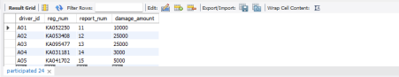

Queries
- Update the damage amount to 25000 for the car with a specific reg-num (example 'KA053408' ) for which the accident report number was 12.
update participated
set damage_amount=25000
where reg_num='KA053408' and report_num=12;
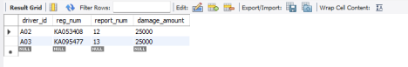
● Find the total number of people who owned cars that were involved in accidents in 2008.
select count(distinct driver_id) CNT
from participated a, accident b
where a.report_num=b.report_num and b.accident_date like '2008%';
● Add a new accident to the database.
insert into accident values(16,'2008-03-08',"Domlur");
select * from accident;
More Queries on Insurance Database
Question
(Week 2)
PERSON (driver_id: String, name: String, address: String)

CAR (reg_num: String, model: String, year: int)

ACCIDENT (report_num: int, accident_date: date, location: String)

OWNS (driver_id: String, reg_num: String)

PARTICIPATED (driver_id: String,reg_num: String, report_num: int, damage_amount: int)

Create the above tables by properly specifying the primary keys and the foreign keys as done in
previous week’s lab and Enter at least five tuples for each relationEnter at least five tuples for each
relation

Enter at least five tuples for each relation

Display the entire CAR relation in the ascending order of manufacturing year.

Find the number of accidents in which cars belonging to a specific model (example 'Lancer') were
involved.

Find the total number of people who owned cars that involved in accidents in 2008.

Schema diagram
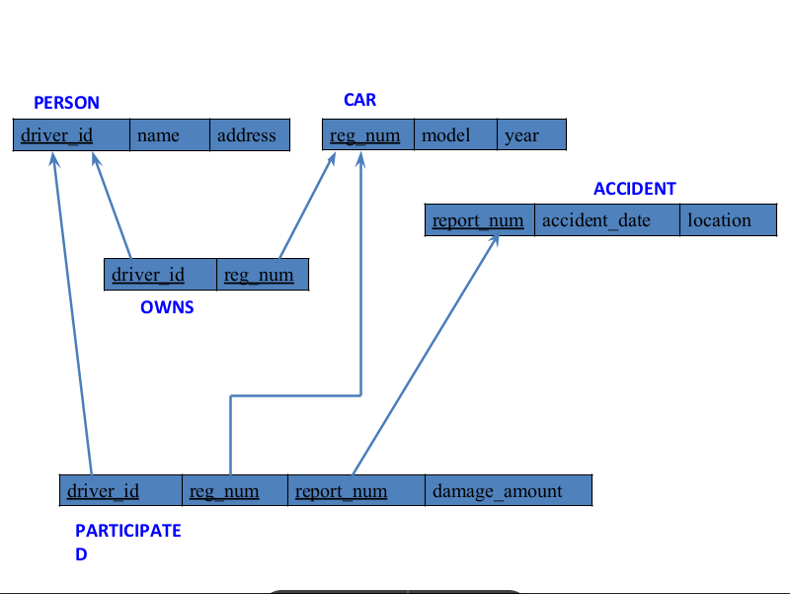

Queries
- Display the entire CAR relation in the ascending order of manufacturing year.
select * from car order by year asc;
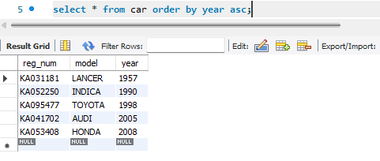

- Find the number of accidents in which cars belonging to a specific model (example 'Lancer') were involved.
select count(report_num)
from car c, participated p
where c.reg_num=p.reg_num and c.model='Lancer';
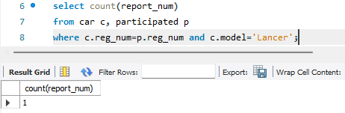
- List the name of the drivers whose damage is greater than the average damage
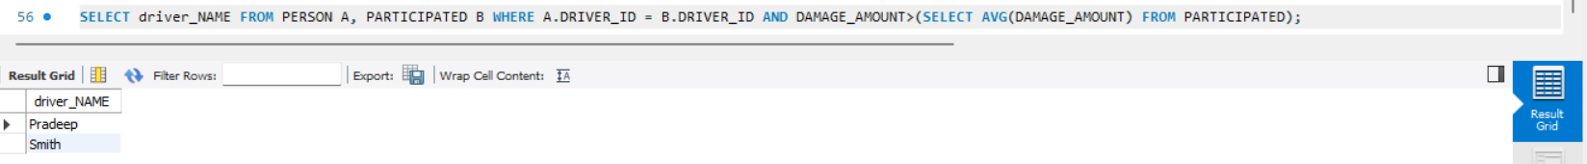
amount

- Find maximum damage amount
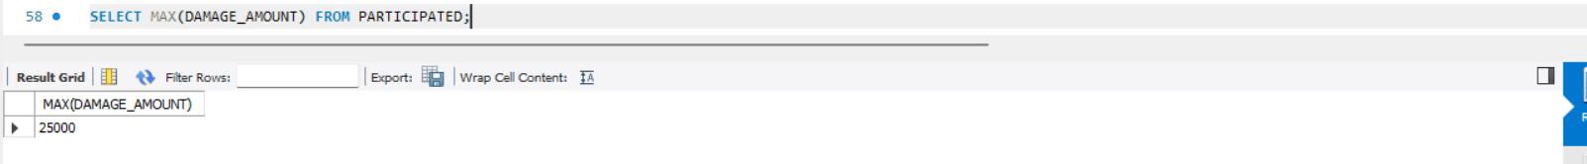
Bank Database
Question
(Week 3)
Branch (branch-name: String, branch-city: String, assets: real)

BankAccount(accno: int, branch-name: String, balance: real)

BankCustomer (customer-name: String, customer-street: String,

customer-city: String)

Depositer(customer-name: String, accno: int)

LOAN (loan-number: int, branch-name: String, amount: real)

Create the above tables by properly specifying the primary keys and the foreign keys.

Enter at least five tuples for each relation.

Display the branch name and assets from all branches in lakhs of rupees and rename
the assets column to 'assets in lakhs'.

Find all the customers who have at least two accounts at the Same branch (ex.
SBI_ResidencyRoad).

CREATE A VIEW WHICH GIVES EACH BRANCH THE SUM OF THE
AMOUNT OF ALL THE LOANS AT THE BRANCH.

Schema Diagram
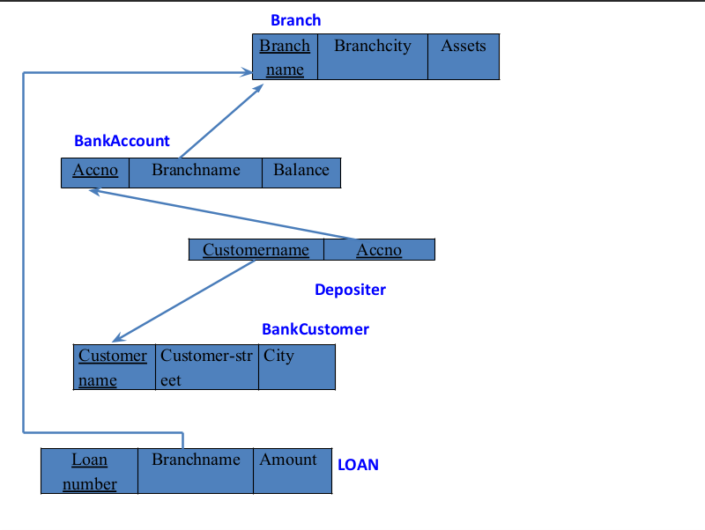
Create database
create database if not exists bank;
use bank;

Create table

create table BRANCH(Branch_name varchar(20), branch_city varchar(20), Assets real, PRIMARY KEY(Branch_name));

create table BANKACCOUNT(accno int, Branch_name varchar(20), balance real, primary key(accno,Branch_name), foreign key(Branch_name) references BRANCH(Branch_name));

create table BANKCUSTOMER(customer_name varchar(20), customer_street varchar(20), customer_city varchar(20),primary key(customer_name));
create table DEPOSITER(customer_name varchar(20), accno int, primary key(customer_name,accno), foreign key(accno) references BANKACCOUNT(accno),foreign key (customer_name) references BANKCUSTOMER(customer_name));

CREATE TABLE LOAN(LOAN_number int, Branch_name varchar(20), ammount real, primary key(Branch_name), foreign key(Branch_name) references BRANCH(Branch_name));

Structure of the table
desc branch;
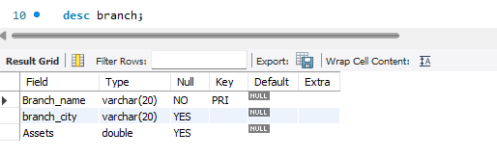

desc bankaccount;
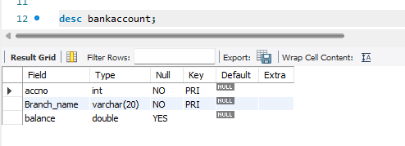

desc bankcustomer;
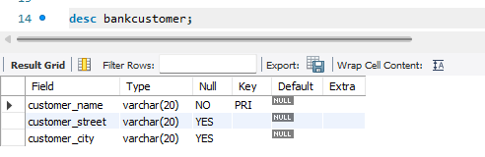

desc depositer;
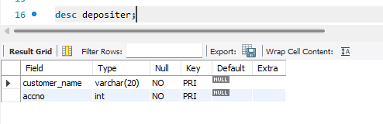

desc loan;
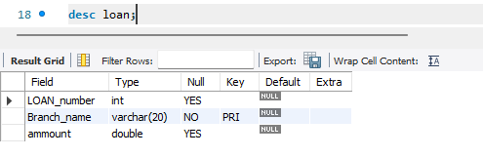

Inserting Values into the table
insert into BRANCH VALUES("SBI_Chamrajpet","Bangalore",50000);
insert into BRANCH VALUES("SBI_ResidencyRoad","Bangalore",10000);
insert into BRANCH VALUES("SBI_ShivajiRoad","Bombay",20000);
insert into BRANCH VALUES("SBI_ParlimentRoad","Delhi",10000);
insert into BRANCH VALUES("SBI_Jantarmantar","Delhi",20000);
select * from BRANCH;
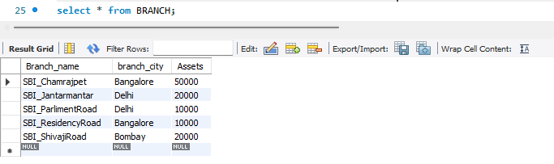

insert into BANKACCOUNT values(1,"SBI_Chamrajpet",2000);
insert into BANKACCOUNT values(2,"SBI_ResidencyRoad",5000);
insert into BANKACCOUNT values(3,"SBI_ShivajiRoad",6000);
insert into BANKACCOUNT values(4,"SBI_ParlimentRoad",9000);
insert into BANKACCOUNT values(5,"SBI_Jantarmantar",8000);
insert into BANKACCOUNT values(6,"SBI_ShivajiRoad",4000);
insert into BANKACCOUNT values(8,"SBI_ResidencyRoad",4000);
insert into BANKACCOUNT values(9,"SBI_ParlimentRoad",3000);
insert into BANKACCOUNT values(10,"SBI_ResidencyRoad",5000);
insert into BANKACCOUNT values(11,"SBI_Jantarmantar",2000);
select * from BANKACCOUNT;
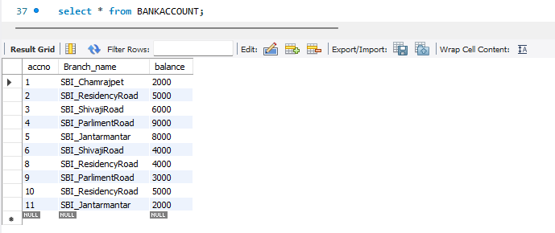

insert into BANKCUSTOMER values("Avinash","Bull_Temple_Road","Bangalore");
insert into BANKCUSTOMER values("Dinesh","Bannergatta_Road","Bangalore");
insert into BANKCUSTOMER values("Mohan","NationalCollege_Road","Bangalore");
insert into BANKCUSTOMER values("Nikil","Akbar_Road","Delhi");
insert into BANKCUSTOMER values("Ravi","Prithviraj_Road","Delhi");
select * from BANKCUSTOMER;
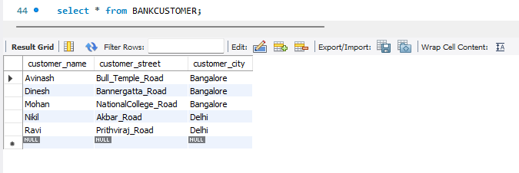
insert into DEPOSITER values("Avinash",1);
insert into DEPOSITER values("Dinesh",2);
insert into DEPOSITER values("Nikil",4);
insert into DEPOSITER values("Ravi",5);
insert into DEPOSITER values("Avinash",8);
insert into DEPOSITER values("Nikil",9);
insert into DEPOSITER values("Dinesh",10);
insert into DEPOSITER values("Nikil",11);
select * from DEPOSITER;
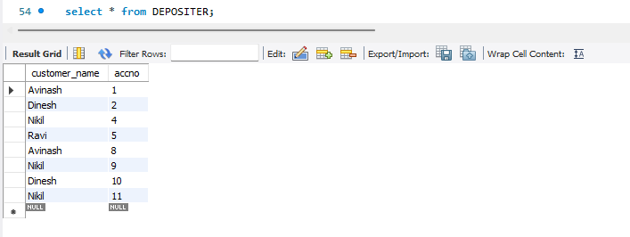

insert into LOAN values(1,"SBI_Chamrajpet",1000);
insert into LOAN values(2,"SBI_ResidencyRoad",2000);
insert into LOAN values(3,"SBI_ShivajiRoad",3000);
insert into LOAN values(4,"SBI_ParlimentRoad",4000);
insert into LOAN values(5,"SBI_Jantarmantar",5000);
select * from LOAN;
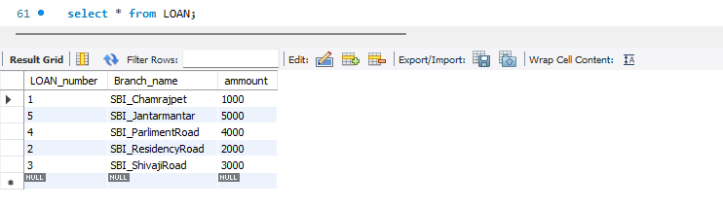

Queries
- Display the branch name and assets from all branches in lakhs of rupees and rename the assets column to 'assets in lakhs'.
select branch_name, CONCAT(assets/100000, 'Lakhs')assets_in_lakhs from branch;
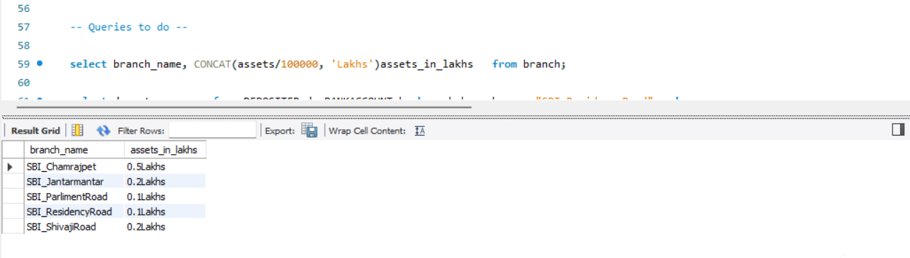

- Find all the customers who have at least two accounts at the Same branch (ex.SBI_ResidencyRoad)
select d.customer_name from DEPOSITER d, BANKACCOUNT b where b.branch_name="SBI_ResidencyRoad" and
d.accno=b.accno group by d.customer_name having count(d.accno)>=2;
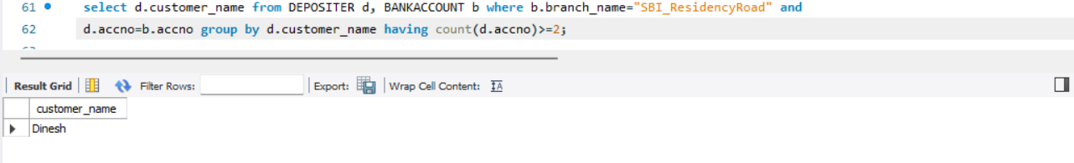

- Create a view which gives each branch the sum of the amount of all the
loans at the branch.
create view sum_of_loan as select Branch_name, SUM(balance) from BANKACCOUNT group by branch_name;
select * from sum_of_loan;
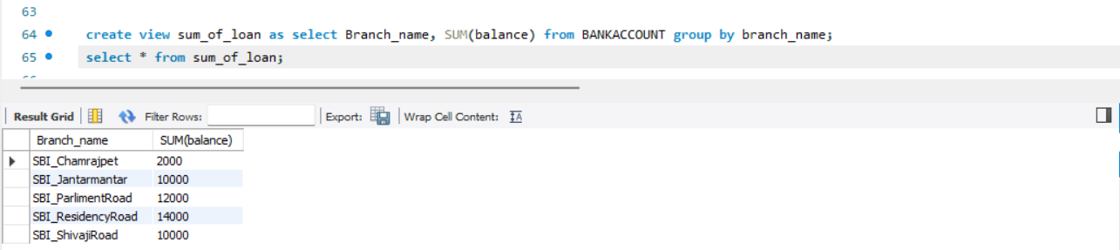

More Queries on Bank Database
Question
(Week 4)
-Branch (branch-name: String, branch-city: String, assets: real)
-BankAccount(accno: int, branch-name: String, balance: real)
-BankCustomer (customer-name: String, customer-street: String, customer-city: String)
-Depositer(customer-name: String, accno: int)
-LOAN (loan-number: int, branch-name: String, amount: real)
-Borrower (customer-name: String, loan-number: int)

-Find all the customers who have an account at all the branches
located in a specific city (Ex. Delhi).

-Find all customers who have a loan at the bank but do not have
an account.

-Find all customers who have both an account and a loan at the
Bangalore branch

-Find the names of all branches that have greater assets than all
branches located in Bangalore.

-Demonstrate how you delete all account tuples at every branch
located in a specific city (Ex. Bombay).

-Update the Balance of all accounts by 5%

Schema Diagram
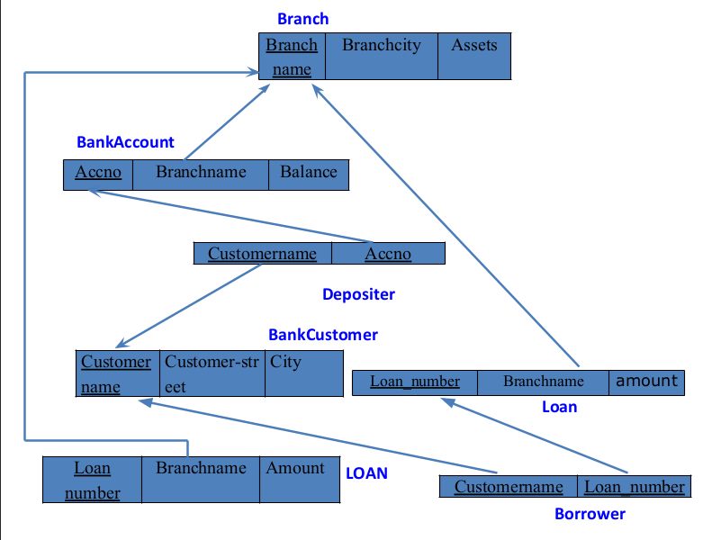

Creating table
create table Borrower (customer_name varchar(20), loan_number int,
foreign key (customer_name) references bankcustomer(customer_name),
foreign key (loan_number) references LOAN(loan_number));

Structure of the table
desc Borrower;
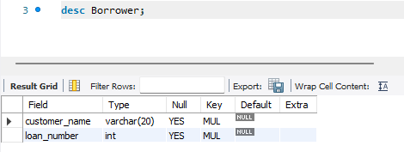
Inserting Values into the table
insert into Borrower values('Avinash',1);
insert into Borrower values('Dinesh',2);
insert into Borrower values('Mohan',3);
insert into Borrower values('Nikil',4);
insert into Borrower values('Ravi',5);
select * from Borrower;
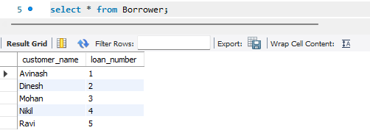

Queries
- Find all the customers who have an account at all the branches
located in a specific city (Ex. Delhi).
SELECT d.customer_name From bankaccount a,branch b, depositer d WHERE b.branch_name=a.branch_name AND
a.accno=d.accno AND b.branch_city='Delhi' GROUP BY d.customer_name
HAVING COUNT(distinct b.branch_name)=(SELECT COUNT(branch_name)FROM branch WHERE branch_city='Delhi');
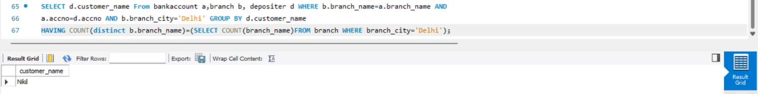
- Find all customers who have a loan at the bank but do not have
an account.
select distinct customer_name from borrower where customer_name not in (select customer_name from depositer);

- Find all customers who have both an account and a loan at the
Bangalore branch
Select customer_name From Borrower ,loan Where borrower.loan_number=loan.loan_number and loan.branch_name in
(select branch_name from depositer, bankaccount where depositer.accno = bankaccount.accno And bankaccount.branch_name in
(Select branch_name from branch WHERE branch.branch_city='Bangalore'));
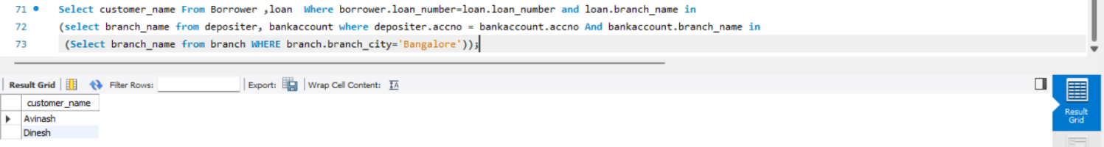
- Find the names of all branches that have greater assets than all
branches located in Bangalore.
Select branch_name From Branch Where assets>(Select Sum(assets) from branch Where branch_city='Bangalore');
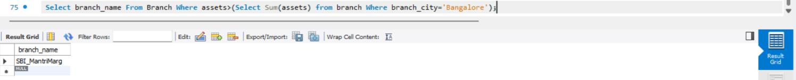
- Demonstrate how you delete all account tuples at every branch
located in a specific city (Ex. Bombay).
DELETE FROM bankaccount WHERE branch_name IN(SELECT branch_name FROM branch WHERE branch_city='Bombay');

delete from depositer where accno in
(select accno from branch, bankaccount where branch_city = 'Bombay' and branch.branch_name = bankaccount.branch_name);
- Update the Balance of all accounts by 5%
update bankaccount
set balance = balance * 1.05

Employee Database
Question
(Week 5)
1. Using Scheme diagram, Create tables by properly specifying the
primary keys and the foreign keys.

2. Enter greater than five tuples for each table.

3. Retrieve the employee numbers of all employees who work on
project located in Bengaluru, Hyderabad, or Mysuru

4. Get Employee ID’s of those employees who didn’t receive incentives

5. Write a SQL query to find the employees name, number, dept,
job_role, department location and project location who are working for
a project location same as his/her department location.

Schema Diagram
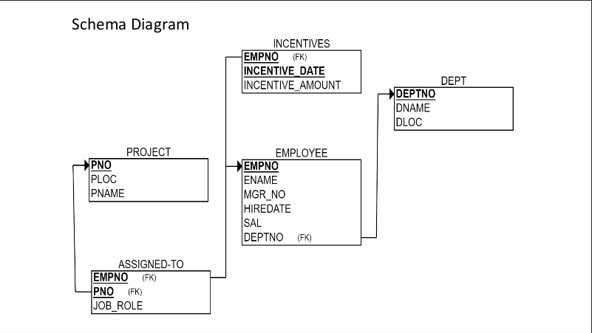

Create database
create database employee;
use employee;

Create table
create table DEPT(DEPTNO int, DNAME varchar(20),DLOC varchar(20),primary key(DEPTNO));

create table EMPLOYEE(EMPNO int,ENAME varchar(20),MGR_NO int, HIREDATE date, SAL int, DEPTNO int, primary key(EMPNO,DEPTNO),foreign key(DEPTNO) references DEPT(DEPTNO));

create table PROJECT(PNO int,PNAME varchar(20),PLOC varchar(20),primary key(PNO));

create table INCENTIVES(EMPNO int,INCENTIVE_DATE date,INCENTIVE_AMOUNT int, primary key(EMPNO),foreign key(EMPNO) references EMPLOYEE(EMPNO));

create table ASSIGNED_TO(EMPNO int,PNO int,JOB_ROLE varchar(20),primary key(EMPNO,PNO),FOREIGN KEY(EMPNO) references EMPLOYEE(EMPNO),FOREIGN KEY(PNO) REFERENCES PROJECT(PNO));

Structure of the table
desc dept;
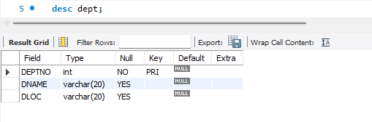

desc employee;
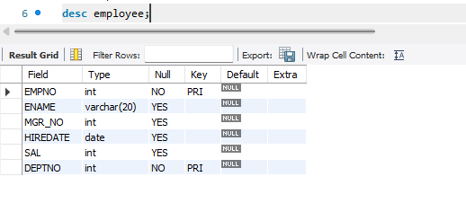

desc project;
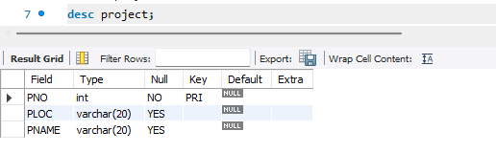
desc incentives;
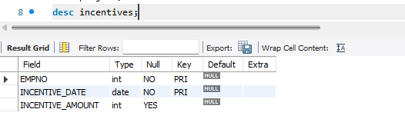
desc assigned_to;
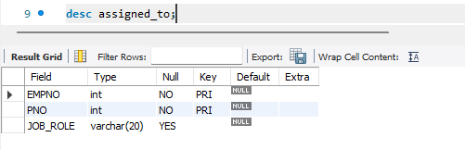

Inserting Values into the table
INSERT INTO DEPT (DEPTNO, DNAME, DLOC) VALUES (10, 'SALES', 'Bengaluru');
INSERT INTO DEPT (DEPTNO, DNAME, DLOC) VALUES (20, 'IT', 'Hyderabad');
INSERT INTO DEPT (DEPTNO, DNAME, DLOC) VALUES (30, 'HR', 'Mysuru');
INSERT INTO DEPT (DEPTNO, DNAME, DLOC) VALUES (40, 'R&D', 'Bengaluru');
INSERT INTO DEPT (DEPTNO, DNAME, DLOC) VALUES (50, 'MARKETING', 'Mumbai');
INSERT INTO DEPT (DEPTNO, DNAME, DLOC) VALUES (60, 'FINANCE', 'Hyderabad');
select * from DEPT;
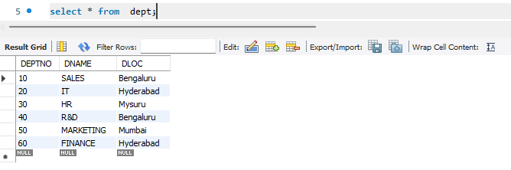

INSERT INTO PROJECT (PNO, PNAME, PLOC) VALUES (100, 'Alpha', 'Bengaluru');
INSERT INTO PROJECT (PNO, PNAME, PLOC) VALUES (200, 'Beta', 'Hyderabad');
INSERT INTO PROJECT (PNO, PNAME, PLOC) VALUES (300, 'Gamma', 'Mysuru');
INSERT INTO PROJECT (PNO, PNAME, PLOC) VALUES (400, 'Delta', 'Mumbai');
INSERT INTO PROJECT (PNO, PNAME, PLOC) VALUES (500, 'Omega', 'Bengaluru');
INSERT INTO PROJECT (PNO, PNAME, PLOC) VALUES (600, 'Zeta', 'Delhi');
SELECT * FROM PROJECT;
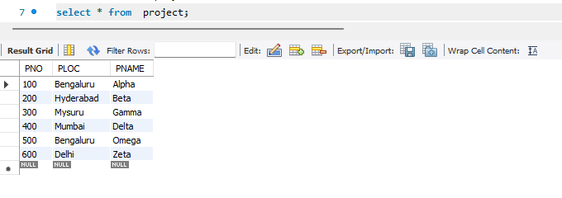

INSERT INTO EMPLOYEE (EMPNO, ENAME, MGR_NO, HIREDATE, SAL, DEPTNO) VALUES (7001, 'Alice', 7004,'2020-01-15', 80000, 10);
INSERT INTO EMPLOYEE (EMPNO, ENAME, MGR_NO, HIREDATE, SAL, DEPTNO) VALUES (7002, 'Bob', 7005,'2019-03-22', 95000, 20);
INSERT INTO EMPLOYEE (EMPNO, ENAME, MGR_NO, HIREDATE, SAL, DEPTNO) VALUES (7003, 'Charlie', 7004,'2021-05-10', 60000, 30);
INSERT INTO EMPLOYEE (EMPNO, ENAME, MGR_NO, HIREDATE, SAL, DEPTNO) VALUES (7004, 'David', NULL, '2018-06-01', 120000, 10);
INSERT INTO EMPLOYEE (EMPNO, ENAME, MGR_NO, HIREDATE, SAL, DEPTNO) VALUES (7005, 'Eve', NULL, '2017-11-30', 110000, 20);
INSERT INTO EMPLOYEE (EMPNO, ENAME, MGR_NO, HIREDATE, SAL, DEPTNO) VALUES (7006, 'Frank', 7005, '2022-02-18', 75000, 50);
SELECT * FROM EMPLOYEE;
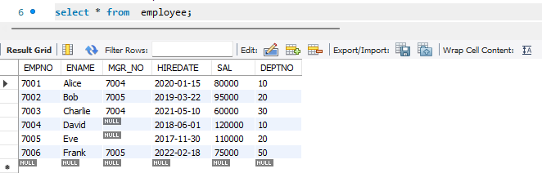

INSERT INTO ASSIGNED_TO (EMPNO, PNO, JOB_ROLE) VALUES (7001, 100, 'Manager');
INSERT INTO ASSIGNED_TO (EMPNO, PNO, JOB_ROLE) VALUES (7002, 200, 'Developer');
INSERT INTO ASSIGNED_TO (EMPNO, PNO, JOB_ROLE) VALUES (7003, 300, 'Recruiter');
INSERT INTO ASSIGNED_TO (EMPNO, PNO, JOB_ROLE) VALUES (7004, 100, 'Sales Lead');
INSERT INTO ASSIGNED_TO (EMPNO, PNO, JOB_ROLE) VALUES (7005, 500, 'Team Lead');
INSERT INTO ASSIGNED_TO (EMPNO, PNO, JOB_ROLE) VALUES (7001, 200, 'Supervisor');
INSERT INTO ASSIGNED_TO (EMPNO, PNO, JOB_ROLE) VALUES (7006, 400, 'Marketer');
SELECT * FROM ASSIGNED_TO;
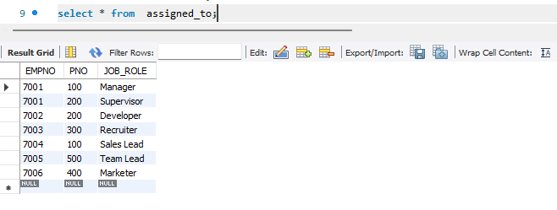

INSERT INTO INCENTIVES (EMPNO, INCENTIVE_DATE, INCENTIVE_AMOUNT) VALUES (7001, '2023-01-01', 5000);
INSERT INTO INCENTIVES (EMPNO, INCENTIVE_DATE, INCENTIVE_AMOUNT) VALUES (7002, '2023-02-01', 3000);
INSERT INTO INCENTIVES (EMPNO, INCENTIVE_DATE, INCENTIVE_AMOUNT) VALUES (7004, '2023-01-15', 5000);
SELECT * FROM INCENTIVES;
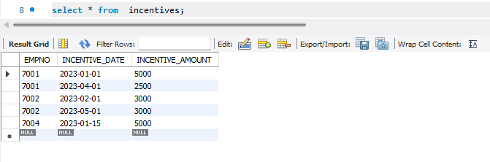

Queries
- Retrieve the employee numbers of all employees who work on
project located in Bengaluru, Hyderabad, or Mysuru
SELECT DISTINCT T1.EMPNO
FROM ASSIGNED_TO T1
JOIN PROJECT T2 ON T1.PNO = T2.PNO
WHERE T2.PLOC IN ('Bengaluru', 'Hyderabad', 'Mysuru');
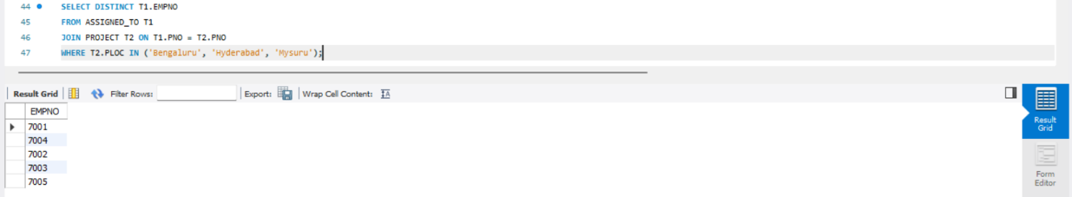

- Get Employee ID’s of those employees who didn’t receive incentives
SELECT E.EMPNO
FROM EMPLOYEE E
WHERE NOT EXISTS (
SELECT 1
FROM INCENTIVES I
WHERE I.EMPNO = E.EMPNO
);
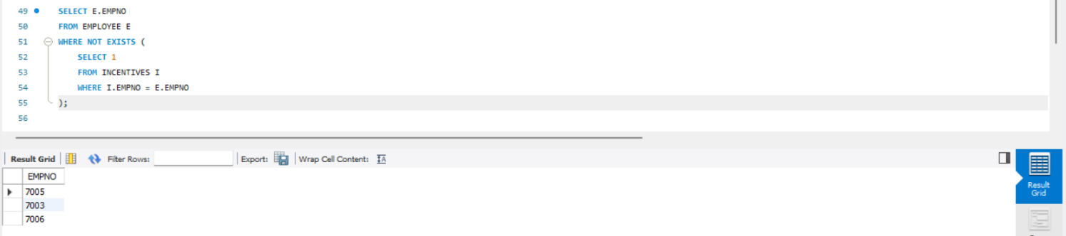

- Write a SQL query to find the employees name, number, dept,
job_role, department location and project location who are working for
a project location same as his/her department location.
SELECT
E.ENAME,
E.EMPNO,
D.DNAME AS DEPARTMENT_NAME,
A.JOB_ROLE,
D.DLOC AS DEPARTMENT_LOCATION,
P.PLOC AS PROJECT_LOCATION
FROM
EMPLOYEE E
JOIN
DEPT D ON E.DEPTNO = D.DEPTNO
JOIN
ASSIGNED_TO A ON E.EMPNO = A.EMPNO
JOIN
PROJECT P ON A.PNO = P.PNO
WHERE
D.DLOC = P.PLOC;
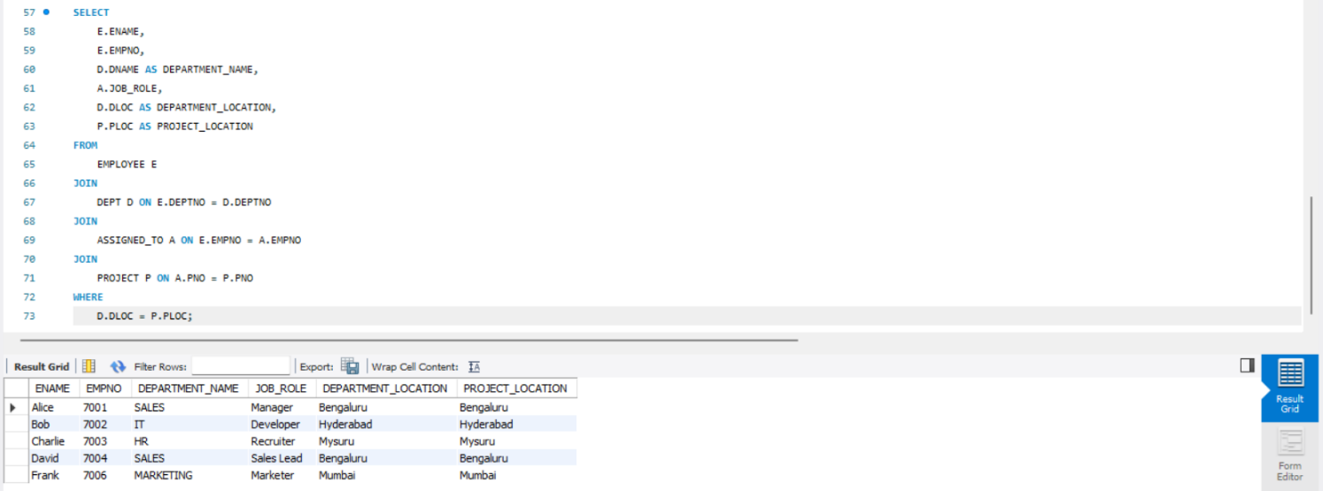

More Queries on Employee Database
Question
(Week 6)

1. Using Scheme diagram, Create tables by properly specifying the primary keys
and the foreign keys.

2. Enter greater than five tuples for each table.

3. List the name of the managers with the maximum employees

4. Display those managers name whose salary is more than average salary of his
employee.

5. Find the name of the second top level managers of each department.

6. Find the employee details who got second maximum incentive in January 2019.

7. Display those employees who are working in the same department where his
manager is working.

Schema Diagram
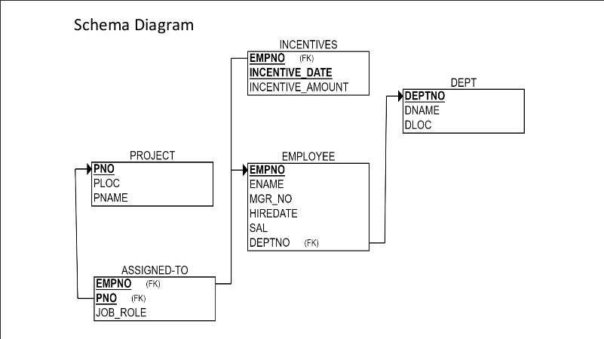
Queries

- List the name of the managers with the maximum employee
SELECT
m.ENAME AS ManagerName,COUNT(*) AS EmployeeCount FROM EMPLOYEE e
JOIN EMPLOYEE m ON e.MGR_NO = m.EMPNO GROUP BY m.ENAME HAVING COUNT(*) = (SELECT MAX(mycount) FROM (SELECT COUNT(*) AS mycount FROM EMPLOYEE WHERE MGR_NO IS NOT NULL GROUP BY MGR_NO)a);
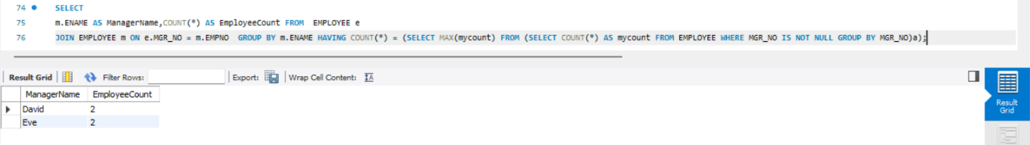

- Display those managers name whose salary is more than average salary of his employee.
SELECT *
FROM employee m
WHERE m.empno IN
(SELECT mgr_no
FROM employee)
AND m.sal >
(SELECT avg(e.sal)
FROM employee e
WHERE e.mgr_no = m.empno );
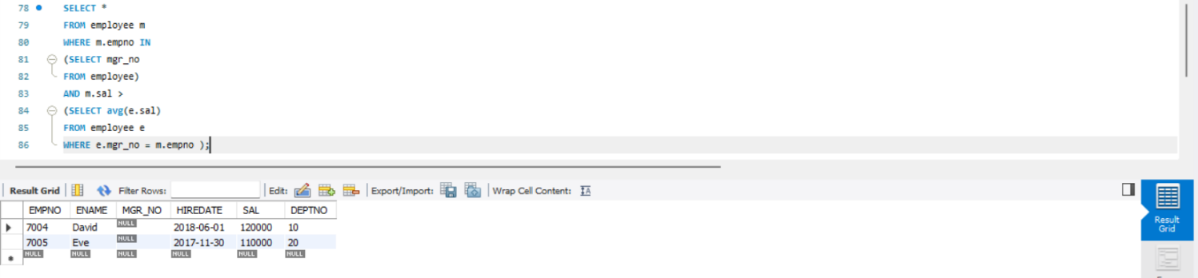

- Find the name of the second top level managers of each department.
select *
from employee e,incentives i
where e.empno=i.empno and 2 = ( select count(*)
from incentives j
where i.incentive_amount <= j.incentive_amount );
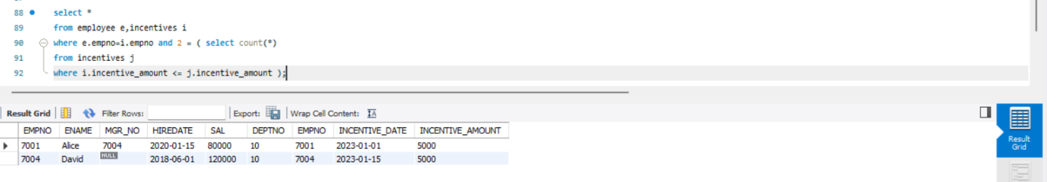
- Find the employee details who got second maximum incentive in January 2019.
SELECT *
FROM EMPLOYEE E
WHERE E.DEPTNO = (SELECT E1.DEPTNO
FROM EMPLOYEE E1
WHERE E1.EMPNO=E.MGR_NO);
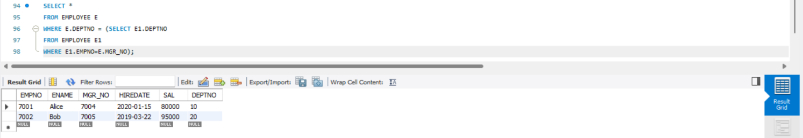

- Display those employees who are working in the same department where his manager is working.
SELECT distinct e.ename
from employee e, incentives i
WHERE (SELECT max(sal+incentive_amount)
FROM employee,incentives) >= ANY
(SELECT sal
FROM employee e1
where e.deptno=e1.deptno);
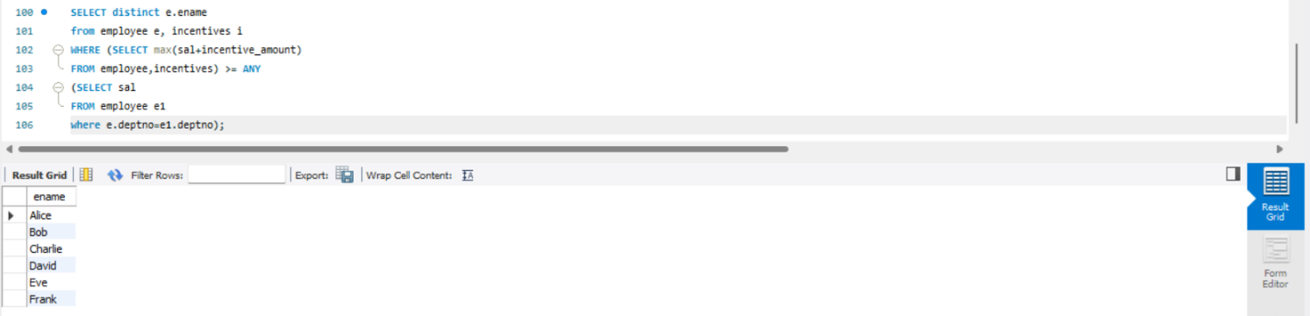
Supplier Database
Question
(Week 7)
1. Using Scheme diagram, Create tables by properly specifying the primary
keys and the foreign keys.

2. Insert appropriate records in each table.

3. Find the pnames of parts for which there is some supplier.

4. Find the snames of suppliers who supply every part.

5. Find the snames of suppliers who supply every red part.

6. Find the pnames of parts supplied by Acme Widget Suppliers and by no
one else.

7. Find the sids of suppliers who charge more for some part than the average
cost of that part (averaged over all the suppliers who supply that part).

8. For each part, find the sname of the supplier who charges the most for
that part.

Schema Diagram
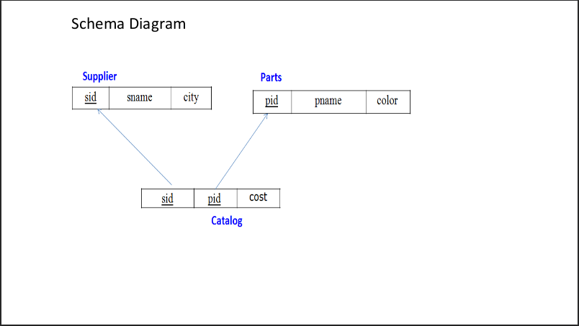
Create database
create database if not exists supplier;
use supplier;

Create table
create table Supplier(SID int,SNAME varchar(20),CITY varchar(20),primary key(SID));

create table Parts(PID int, PNAME varchar(20),color varchar(20),primary key(PID));

create table Catalog(SID int, PID int, cost int, primary key(SID,PID), foreign key(SID) references Supplier(SID), foreign key (PID) references Parts(PID));

Structure of the table
desc Supplier;
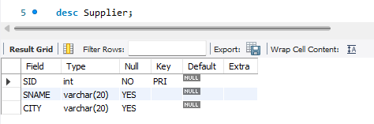

desc Parts;
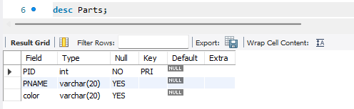

desc Catalog;
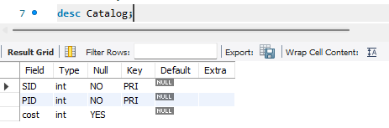
Insert Values into table
insert into Supplier (SID,SNAME,CITY) values
(10001,"Acme Widget","bangalore"),
(10002,"Johns","Kolkata"),
(10003,"Vimal","Mumbai"),
(10004,"Reliance","Delhi");
select * from Supplier;
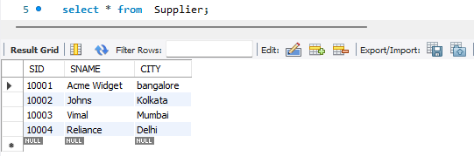

insert into Parts(PID,PNAME,color) values
(20001,"Book","Red"),
(20002,"Pen","Red"),
(20003,"Pencil","Green"),
(20004,"Mobile","Green"),
(20005,"Charger","Black");
select * from Parts;
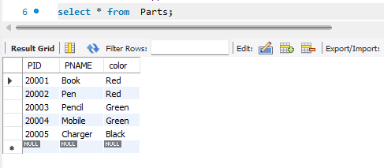

insert into Catalog(SID,PID,cost) values
(10001,20001,10),
(10001,20002,10),
(10001,20003,30),
(10001,20004,10),
(10001,20005,10),
(10002,20001,10),
(10002,20002,20),
(10003,20003,30),
(10004,20003,40);
select * from Catalog;
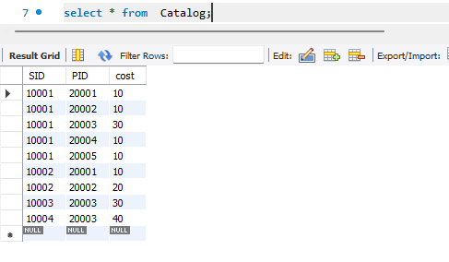

Queries
- Find the pnames of parts for which there is some supplier.
select PNAME from Parts where PID in (select PID from Catalog);
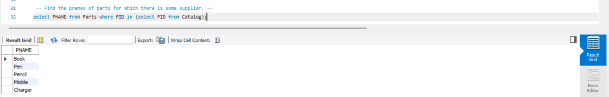

- Find the snames of suppliers who supply every part.
select distinct s.SNAME from Supplier s join catalog c1 on s.SID=c1.SID where (select count(distinct PID) from catalog c2 where c2.SID=c1.SID)= (select count(*) from Parts);
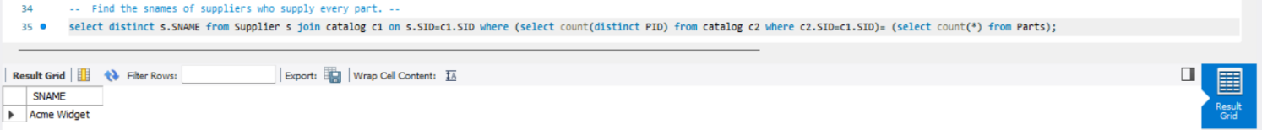

- Find the snames of suppliers who supply every red part.
SELECT s.SNAME
FROM Supplier s
JOIN Catalog c ON s.SID = c.SID
JOIN Parts p ON c.PID = p.PID
WHERE p.color = 'Red'
GROUP BY s.SID, s.SNAME -- Group by both ID and Name
HAVING COUNT(DISTINCT p.PID) = (
-- This subquery gets the TOTAL number of red parts
SELECT COUNT(p2.PID)
FROM Parts p2
WHERE p2.color = 'Red'
);
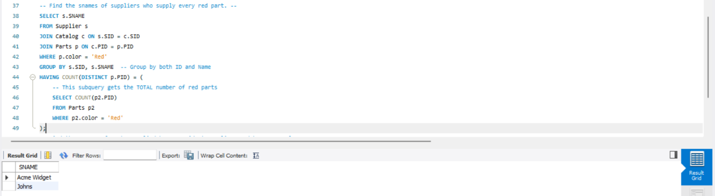

- Find the pnames of parts supplied by Acme Widget Suppliers and by no
one else.
select p.PNAME from parts p where not exists (select * from catalog c join supplier s on s.SID=c.SID where p.PID=c.PID and s.SNAME!="Acme Widget");
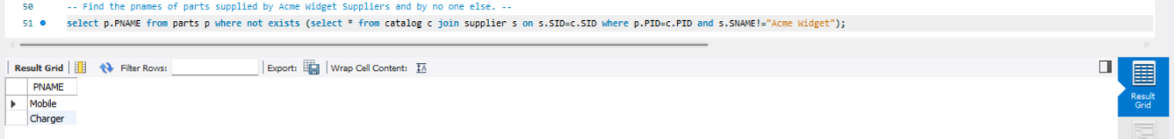

- Find the sids of suppliers who charge more for some part than the average
cost of that part (averaged over all the suppliers who supply that part).
select c.SID from Catalog c where c.cost>(select AVG(cost) from catalog c2 where c.PID=c2.PID);
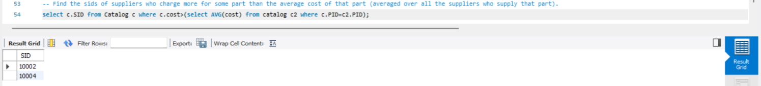

- For each part, find the sname of the supplier who charges the most for
that part.
select c1.pid, s.SNAME from supplier s, catalog c1 where c1.cost=(select MAX(c2.cost) from catalog c2 where c1.PID=c2.PID) and s.SID=c1.SID;
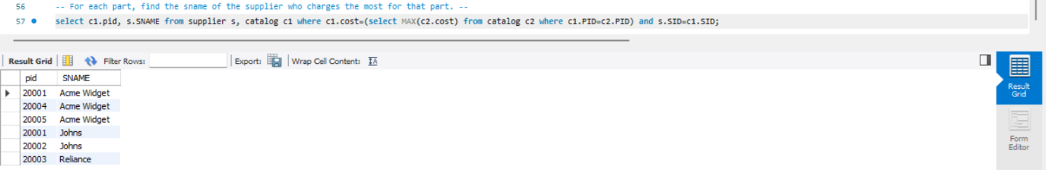

NoSql Lab 1
Question
(Week 8)
Perform the following DB operations using MongoDB.
- Create a database “Student” with the following attributes Rollno, Age, ContactNo, Email-Id.
- Insert appropriate values
- Write query to update Email-Id of a student with rollno 10.
- Replace the student name from “ABC” to “FEM” of rollno 11.
- Export the created table into local file system
- Drop the table
- Import a given csv datasheet from local file system inro collection.

Create database
db.createCollection("Student");

Create table & Inserting Values into the table
db.Student.insert({RollNo:1,Age:21,Cont:9876,email:"antara.de9@gmail.com"}); db.Student.insert({RollNo:2,Age:22,Cont:9976,email:"anushka.de9@gmail.com"}); db.Student.insert({RollNo:3,Age:21,Cont:5576,email:"anubhav.de9@gmail.com"}); db.Student.insert({RollNo:4,Age:20,Cont:4476,email:"pani.de9@gmail.com"});
db.Student.insert({RollNo:10,Age:23,Cont:2276,email:"rekha.de9@gmail.com"});

Structure of the table
db.Student.find();
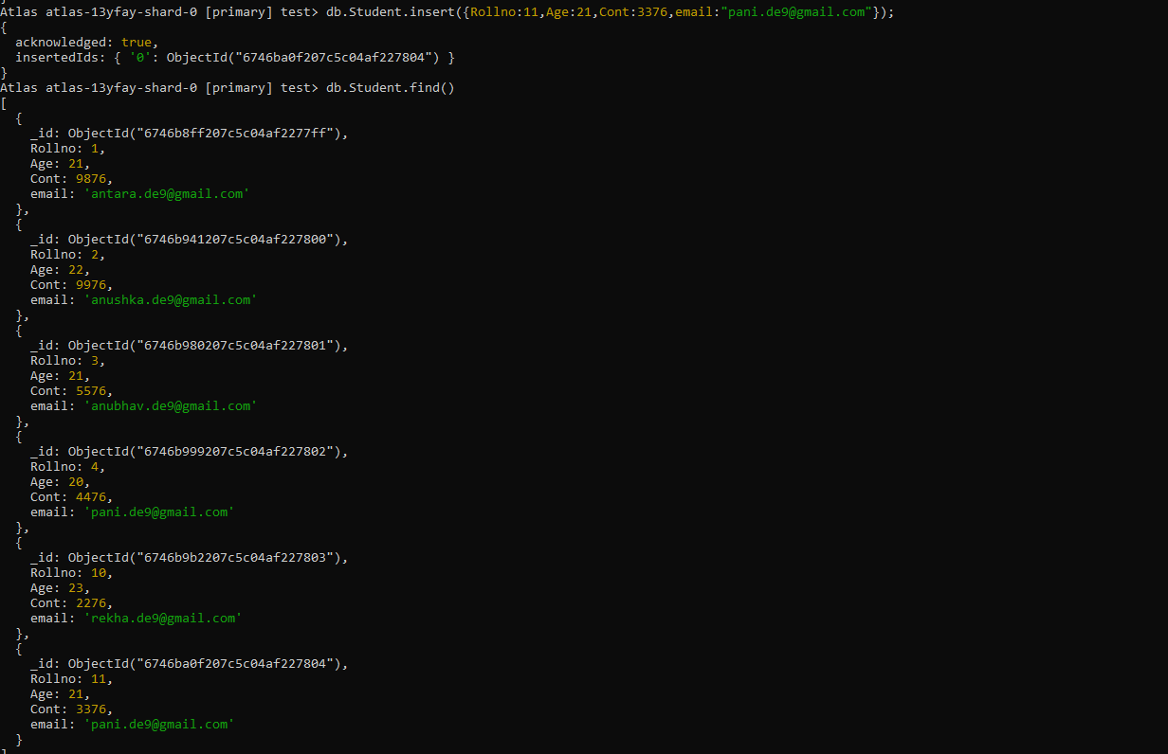

Queries
- Write a query to update the Email-Id of a student with rollno 10.
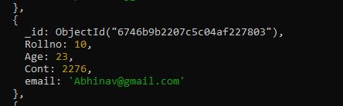
db.Student.update({rollno:5},{$set:{email:"abhinav@gmail.com"}});

- Replace the student name from “ABC” to “FEM” of rollno 11.
db.Student.insert({rollno:11,age:22,name:"ABC",cont:2276,email:"madhura@gmail.com"}); db.Student.update({rollno:11,name:"ABC"},{$set:{name:"FEM"}})

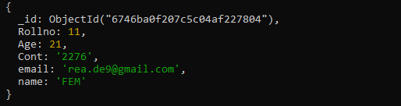

- Export the created table into local file system
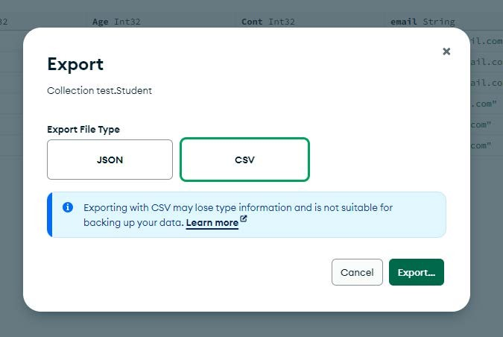
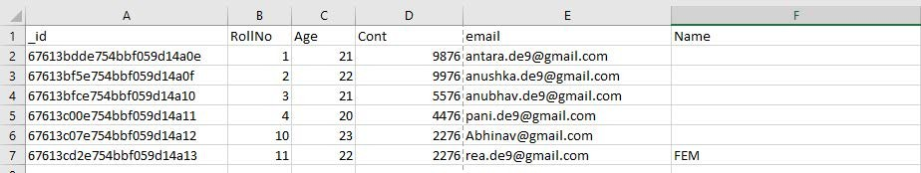
- Drop the table
db.Student.drop()

- Import a given csv datasheet from local file system inro collection.
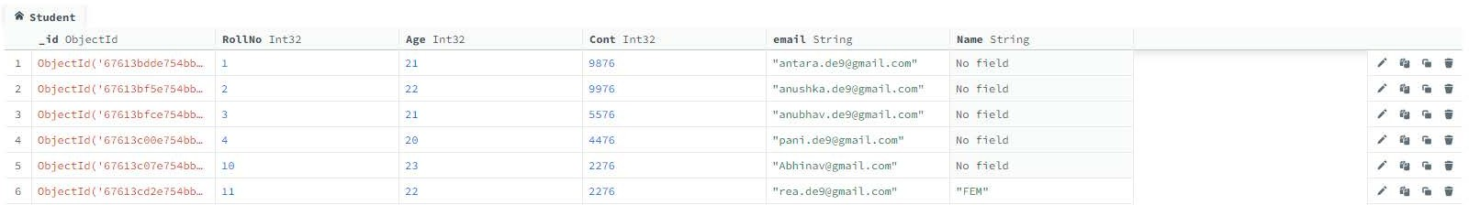
NoSql Lab 2
Question
(Week 9)
Perform the following DB operations using MongoDB
- Create a collection by name Customers with the following attributes. Cust_id, Acc_Bal, Acc_Type
- Insert at least 5 values into the table
- Write a query to display those records whose total account balance is greater than 1200 of account type ‘Checking’ for each customer_id.
- Determine Minimum and Maximum account balance for each customer_id.
- Export the created collection into local file system
- Drop the table
- Import a given csv dataset from local file system into mongodb collection.
Create table
db.createCollection("Customer");
Inserting Values into the table
db.Customer.insertMany([{custid: 1, acc_bal:10000, acc_type: "Saving"}, {custid: 1, acc_bal:20000, acc_type: "Checking"}, {custid: 3, acc_bal:50000, acc_type: "Checking"}, {custid: 4, acc_bal:10000, acc_type: "Saving"}, {custid: 5, acc_bal:2000, acc_type: "Checking"}]);
Structure of table
db.Customer.find()
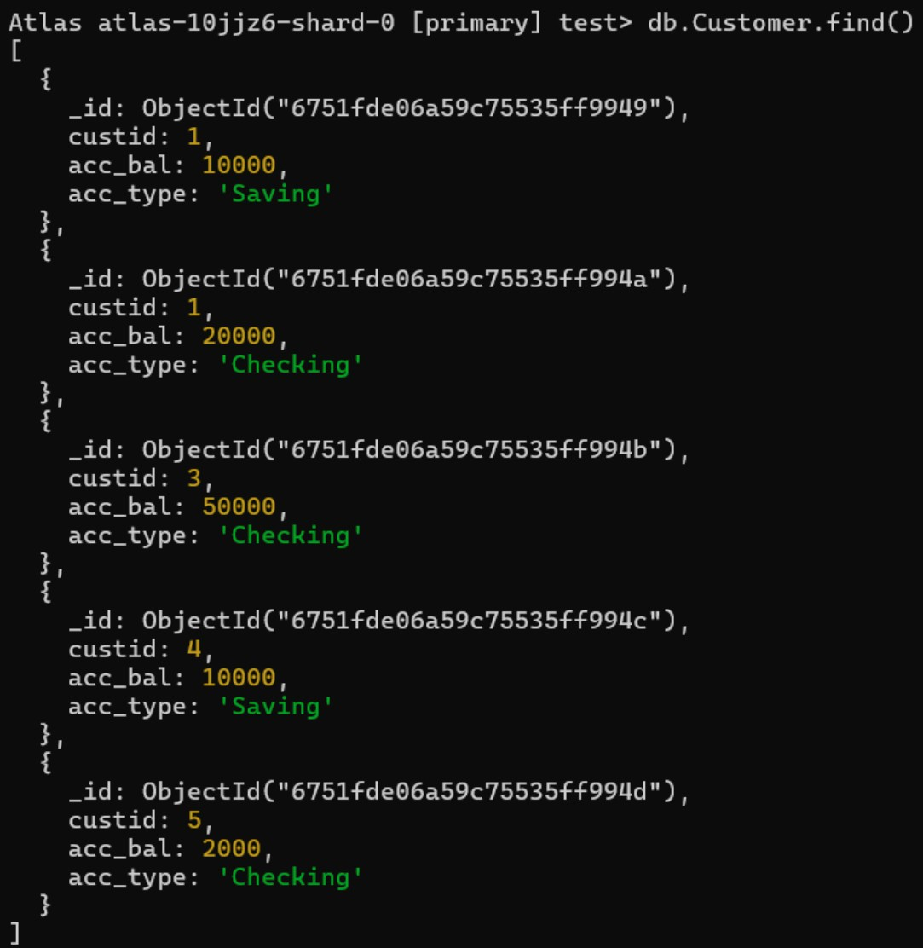
Queries
- Finding all checking accounts with balance greater than 12000
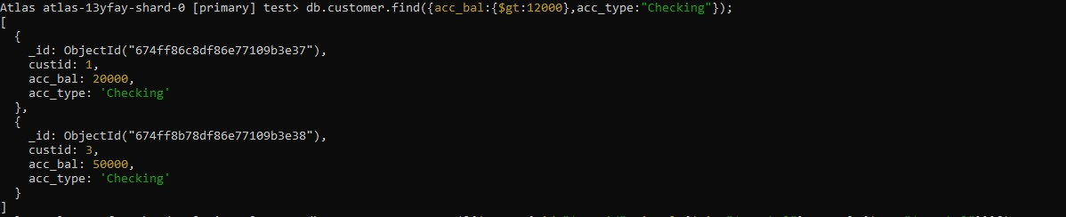
db.Customer.find({acc_bal: {$gt: 12000}, acc_type:"Checking"});

- Finding the maximum and minimum balance of each customer
db.Customer.aggregate([{$group:{_id:"$custid", minBal:{$min:"$acc_bal"}, maxBal: {$max:"$acc_bal"}}}]);
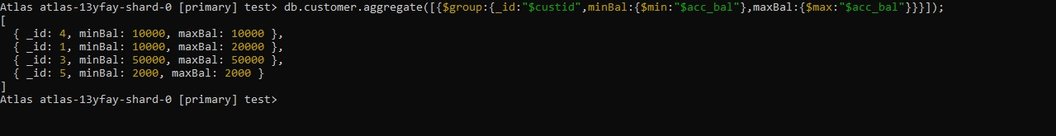

- Exporting the collection to a json file
mongoexport mongodb+srv://Likith:@cluster0.xbmgopf.mongodb.net/test --collection=Customer -- out D:\1BM23CS171\l1.json
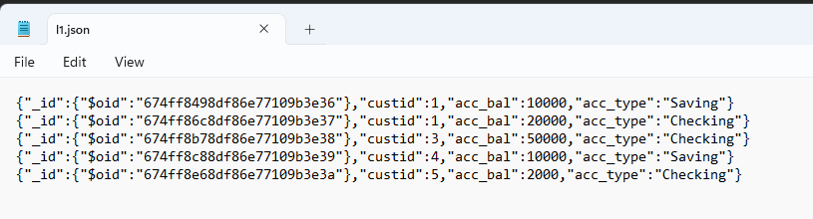

- Dropping collection “Customer”
db.Customer.drop();


- Exporting from a json file to the collection
mongoimport mongodb+srv://Niraj:@cluster0.xbmgopf.mongodb.net/test --collection=Customer --file D:\1BM24CS192\l1.json
db.Customer.find();

NoSql Lab 3
Question
(Week 10)
- Write a MongoDB query to display all the documents in the collection restaurants.
- Write a MongoDB query to arrange the name of the restaurants in descending along with all the columns.
- Write a MongoDB query to find the restaurant Id, name, town and cuisine for those restaurants which achieved a score which is not more than 10.
- Write a MongoDB query to find the average score for each restaurant.
- Write a MongoDB query to find the name and address of the restaurants that have a zipcode that starts with '10'.
Creating table
db.createCollection("restaurants");

Inserting Values into the table
db.restaurants.insertMany([
{ name: "Meghna Foods", town: "Jayanagar", cuisine: "Indian", score: 8, address: { zipcode: "10001", street: "Jayanagar“
} },
{ name: "Empire", town: "MG Road", cuisine: "Indian", score: 7, address: { zipcode: "10100", street: "MG Road" } },
{ name: "Chinese WOK", town: "Indiranagar", cuisine: "Chinese", score: 12, address: { zipcode: "20000", street: "Indiranagar" } },
{ name: "Kyotos", town: "Majestic", cuisine: "Japanese", score: 9, address: { zipcode: "10300", street: "Majestic" } },
{ name: "WOW Momos", town: "Malleshwaram", cuisine: "Indian", score: 5, address: { zipcode: "10400",

street: "Malleshwaram" }
} ])

Structure of the table
db.Restaurant.find()
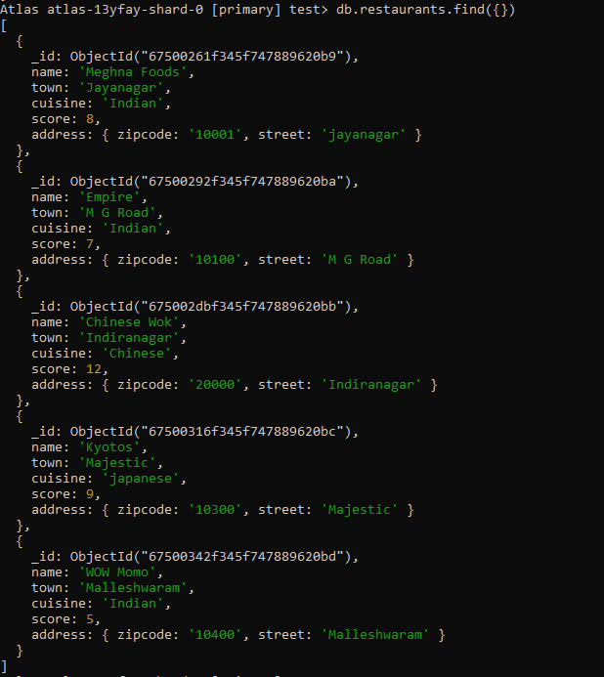
Queries
- Arranging name of restaurants in descending order
db.restaurants.find({}).sort({ name: -1 })
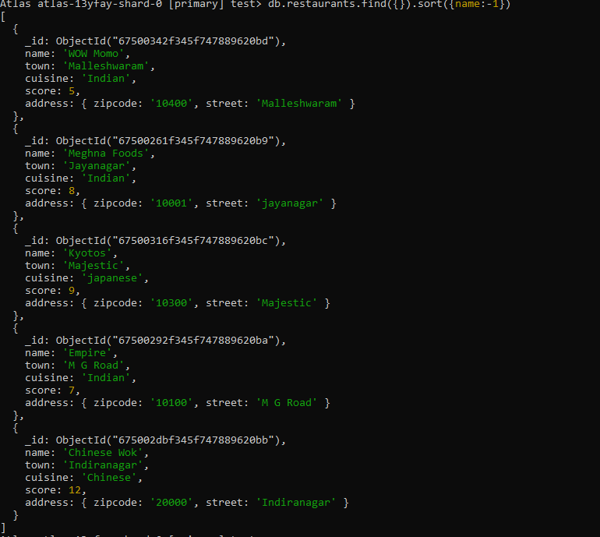
- Finding the restaurant id, name, town and the cuisine for those restaurants which achieved a score that is not more than 10
db.restaurants.find({ "score": { $lte: 10 } }, { _id: 1, name: 1, town: 1, cuisine: 1 })
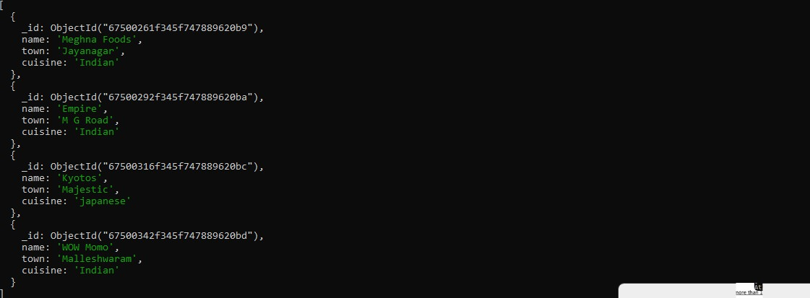

- Finding the average score for each restaurant
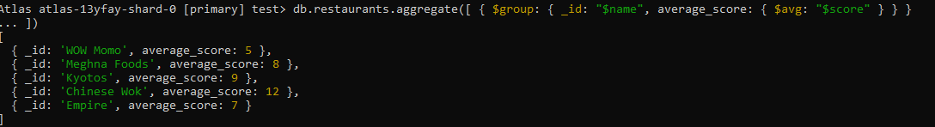
db.restaurants.aggregate([ { $group: { _id: "$name", average_score: { $avg: "$score" } } } ])
- Finding name and address of the restaurants that have a zipcode that starts with 10
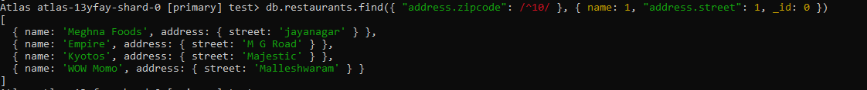
db.restaurants.find({ "address.zipcode": /^10/ }, { name: 1, "address.street": 1, _id: 0 })

