AUTOMATED GECS TAXONOMY CLASSIFICATION
Using NLP to Assign Industry and Subindustry Codes

Capstone Project Proposal — MGT 599
Prepared for: Morningstar Reference Entity Data (RED) Team
DePaul University — Kellstadt Graduate School of Business

Team Members
Ovinya Peiris
Aakif Ziauddin
Abel Prince Puthenpurackal
Sebastian Chirayil
Meech Rolle

Abstract
This project addresses the challenge of automating the assignment of Global Equity Classification System (GECS) taxonomy codes to company filings at Morningstar's Reference Entity Data (RED) team. Currently, analysts must manually review business descriptions and segment disclosures to assign industry and subindustry codes — a time-intensive process prone to inconsistency across analysts. We developed a machine learning pipeline to automate this classification across two distinct tasks: Task 1 classifying companies into 145 industry codes, and Task 2 classifying business segments into 428 subindustry activity codes.
Our pipeline progressed through four stages: baseline TF-IDF models, sentence embedding augmentation using MiniLM (384-dim) and mpnet (768-dim), integration of GECS Activities 2026 domain knowledge into training data, and fine-tuning of a RoBERTa transformer model. A critical data quality fix — filtering to the largest-revenue segment per company per year — produced the single largest performance gain of the project. Our best results achieved a macro-F1 score of 0.6591 on Task 1 and 0.4577 on Task 2, with several high-frequency industry classes exceeding the 0.85 top-class target. The pipeline is fully reproducible via Google Colab using NVIDIA GPU acceleration and is documented in a public GitHub repository for continued development by the RED team.

1. Introduction
Morningstar is a leading global provider of independent investment research and financial data, serving individual investors, financial advisors, asset managers, and retirement plan providers. At the core of Morningstar's data infrastructure is its Global Equity Classification System (GECS), a proprietary taxonomy that organizes publicly traded companies into a structured hierarchy of sectors, industry groups, industries, and subindustry activities. Accurate GECS classification is foundational to Morningstar's product suite — it underpins index construction, portfolio analytics, peer comparisons, and fund screening tools used by millions of investors worldwide.
The Reference Entity Data (RED) team is responsible for maintaining the accuracy and timeliness of GECS assignments across thousands of global equities. This process requires analysts to review company filings — specifically long-form business profile text (LongProfile), segment names, and segment revenue disclosures — and map each company or segment to the appropriate GECS code. As the number of public companies and reporting periods grows, this manual process represents a significant bottleneck: it is slow, expensive, and subject to inter-analyst variability.
This project proposes and implements an automated NLP classification pipeline to address this bottleneck. We define two machine learning tasks that mirror the RED team's workflow:
- Task 1: Assign one of 145 industry-level GECS codes to a company based on its primary business description and largest revenue segment (23,207 training instances after data quality filtering).
- Task 2: Assign one of 428 subindustry activity codes to individual business segments based on their name and description (27,537 instances, substantially higher label space complexity).
The project targets a macro-averaged F1 score of at least 0.75 for both tasks, with a secondary goal of achieving F1 scores above 0.85 for the ten most frequently occurring classes in each task. These targets were established in consultation with the Morningstar RED team and reflect the threshold at which an automated system could meaningfully assist — though not fully replace — analyst review. Achieving these targets would reduce manual classification time, improve consistency, and enable the RED team to scale its operations as Morningstar's data coverage expands.

2. Academic Implications
This project sits at the intersection of several active research areas in natural language processing and applied machine learning: multi-class text classification, extreme classification (large label spaces), domain adaptation of pre-trained language models, and knowledge-augmented learning.
From a methodological standpoint, the project both applies and stress-tests established frameworks. The use of TF-IDF with logistic regression as a baseline aligns with the classical text classification literature (Manning et al., 2008), where bag-of-words representations remain competitive baselines for many short-text problems. The progression to sentence-transformer embeddings (Reimers & Gurevych, 2019) and fine-tuned BERT-family models (Devlin et al., 2019) reflects current best practice in transfer learning for classification. However, our results reveal important limitations of these frameworks when applied to fine-grained financial taxonomy classification: even state-of-the-art models struggle when label spaces are large (428 classes), class imbalance is extreme (up to 2,018:1 ratio), and training examples for rare classes are sparse or absent (21 singleton classes in Task 2).
The project also contributes to understanding how domain-specific knowledge bases can be integrated into training pipelines without introducing data leakage. We designed and implemented a training-only knowledge augmentation strategy using the GECS Activities 2026 taxonomy definitions — appending activity descriptions to training texts only, preserving the integrity of validation and test sets. This approach is consistent with the knowledge distillation and label-description augmentation literature (Wang et al., 2021), and our experiments confirm that it produces modest but meaningful gains when applied correctly.
Strategically, this project aligns with Morningstar's ongoing investment in data automation, AI-assisted research, and scalable data infrastructure. The methodology developed here is generalizable to other taxonomy classification problems within Morningstar's data operations and provides a documented, reproducible baseline for future model development by the RED team.

3. Technology Merit and Work Plan

3.1 Review of Existing Technologies
Automated text classification for financial and taxonomic applications has been an active area of research and commercial development. Key approaches evaluated for this project include:
- TF-IDF + Linear Models: Term frequency-inverse document frequency representations paired with logistic regression or support vector machines remain strong baselines for short-document classification. They are fast, interpretable, and handle sparse high-dimensional feature spaces efficiently (Wang & Manning, 2012).
- Sentence Transformers: Models such as all-MiniLM-L6-v2 and all-mpnet-base-v2 (Reimers & Gurevych, 2019) produce dense 384- and 768-dimensional semantic embeddings that capture contextual meaning beyond keyword matching. These models transfer well to domain-specific classification when combined with a linear classifier head.
- Fine-tuned BERT/RoBERTa: Full fine-tuning of transformer models (Liu et al., 2019) on domain-specific data provides the strongest performance on most NLP classification benchmarks. RoBERTa-base, pre-trained on 160GB of text, is a standard choice for sequence classification. Fine-tuning with weighted cross-entropy loss addresses class imbalance.
- Extreme Classification: For large label spaces (hundreds to thousands of classes), specialized approaches including hierarchical classification and label embedding have been proposed (Bhatia et al., 2016). The GECS taxonomy's hierarchical structure naturally supports a hierarchical prediction approach.
- Knowledge-Augmented Learning: Recent work on label-conditioned text augmentation (Wang et al., 2021) demonstrates that injecting structured knowledge about class definitions into training improves performance on rare classes by providing semantic anchors.

3.2 Proposed Methodology
Our pipeline is structured as a four-stage progression, with each stage building on the previous and evaluated against a holdout test set to ensure rigorous performance assessment.
Stage 1 — Data Quality and Feature Engineering
The most impactful preprocessing decision was filtering Task 1 data to only the largest-revenue segment per company per fiscal year (is_largest_share_segment == True). This reduced the dataset from 53,585 to 23,207 rows while eliminating label ambiguity — subsidiary segments of conglomerates were diluting the primary industry signal. For text features, we concatenated LongProfile, SegmentName, and SegmentDescription into a unified input. For Task 2, segment names were repeated three times to amplify short-text signals before concatenation with descriptions.
Stage 2 — TF-IDF Baseline Models
For Task 1, we trained a TF-IDF vectorizer (50,000 features, unigrams + bigrams, sublinear TF scaling) combined with revenue share and segment flag numeric features, evaluated across Logistic Regression (C=5), LinearSVC (C=1, C=5), and Complement Naive Bayes. For Task 2, we added a character-level TF-IDF component (20,000 features, 3–5-gram) to capture morphological patterns in subindustry codes. All models used class_weight='balanced' to address class imbalance. A stratified 70/15/15 split was used for Task 1 and an 80/10/10 split for Task 2.
Stage 3 — Sentence Embedding Augmentation
We loaded pre-trained sentence-transformer models and encoded all train, validation, and test texts. These dense embeddings were horizontally stacked with the TF-IDF sparse matrix to create a combined feature representation. For Task 2, GECS Activities 2026 taxonomy definitions were appended to training texts only (to avoid leakage), providing each class with additional semantic context from its official activity descriptions.
Stage 4 — RoBERTa Fine-tuning
For Task 1, we fine-tuned roberta-base using the HuggingFace Transformers library. Texts were tokenized to 256 tokens maximum. Training used a custom WeightedTrainer with class-weight-balanced cross-entropy loss, AdamW optimizer (learning rate 2e-5, weight decay 0.01), 6 training epochs, batch size 16, and linear warmup over 200 steps. The best checkpoint by validation macro-F1 was loaded for test evaluation. Training ran for approximately 25 minutes on an NVIDIA T4 GPU via Google Colab Pro.

3.3 Data Sourcing and Collection
Two proprietary datasets were provided by the Morningstar RED team:

Dataset | Rows | Key Columns | Target
task1_gecs_classification_final.csv | 53,585 raw / 23,207 filtered | CompanyId, LongProfile, SegmentName, SegmentDescription, revenue_share, is_largest_share_segment | MstarGlobal (145 classes)
task2_subindustry_classification_final.csv | 27,537 | CompanyId, SegmentName, SegmentDescription | SubIndustry (428 classes)

Additionally, the GECS Activities 2026 knowledge base (GECS_Activities2026.xlsx, 450 activity definitions) was provided for domain knowledge augmentation. All data was accessed exclusively via Google Colab with no local storage of proprietary files.
Figure 1 below shows the class distribution for both tasks. Task 1 has a median class size of 231 records with a right-skewed distribution, while Task 2 is far more severely imbalanced with a median of only 30 records across 428 classes.
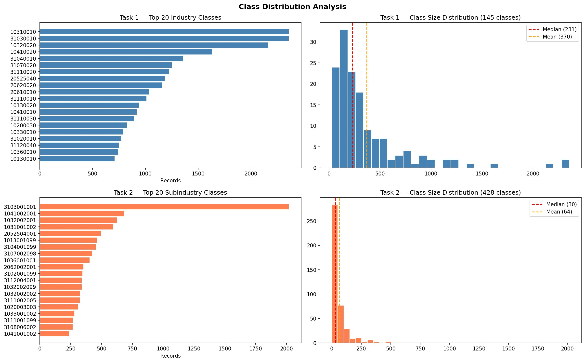
Figure 1. Class Distribution Analysis — Top 20 classes and size distribution for Task 1 (blue) and Task 2 (orange).
Figure 2 shows the sector and revenue breakdown for Task 1. Industrials is the most represented sector. The revenue share distribution is bimodal — many segments are either very small or represent 100% of a company's revenue, confirming the value of the largest-segment filtering strategy.
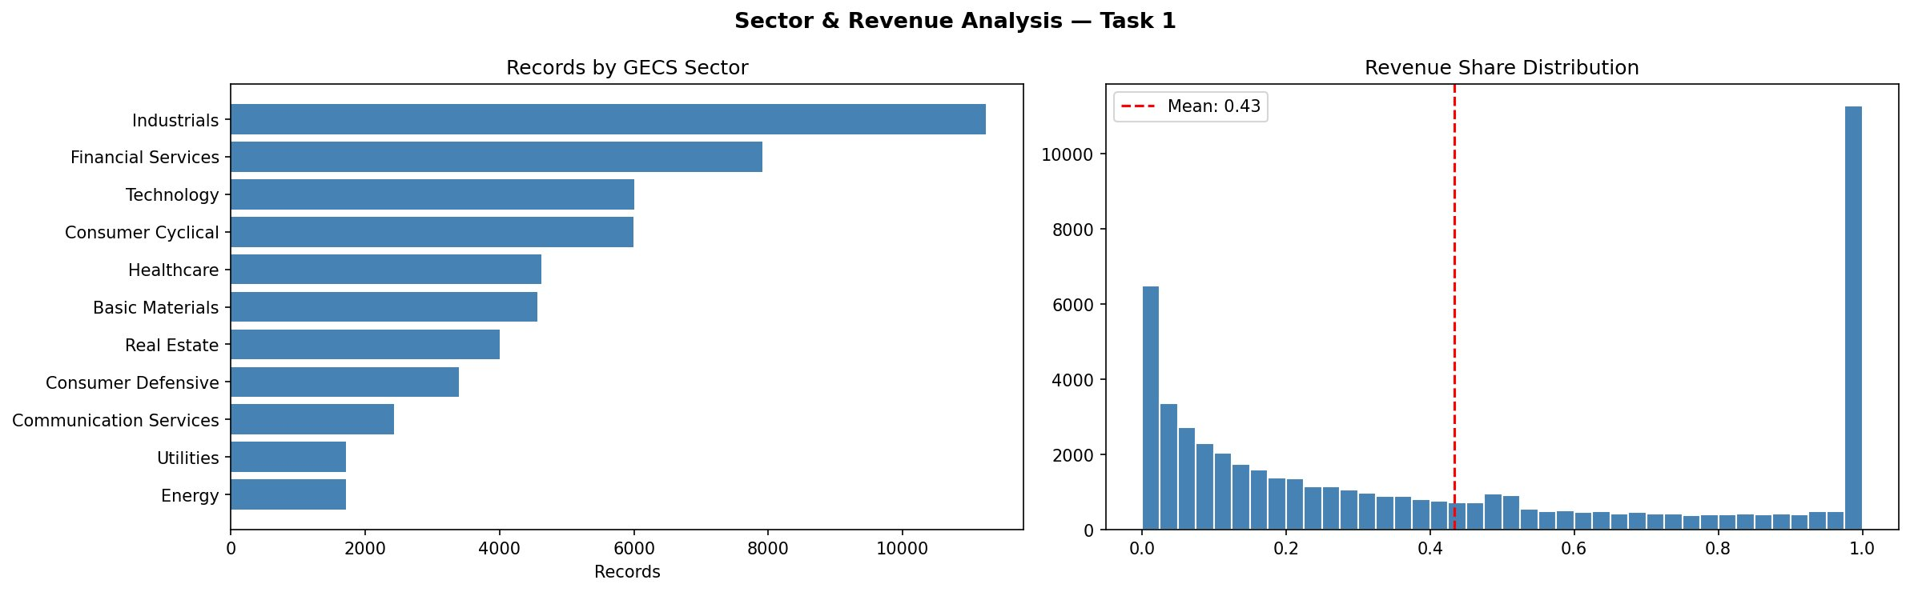
Figure 2. Sector & Revenue Analysis — Records by GECS sector (left) and revenue share distribution (right) for Task 1.
Figure 3 shows text length and temporal distribution. LongProfile texts average 72 words and SegmentDescriptions average only 28 words, reflecting the short-text challenge for Task 2. The strong recency bias toward 2024 records reflects Morningstar's expanding data coverage.
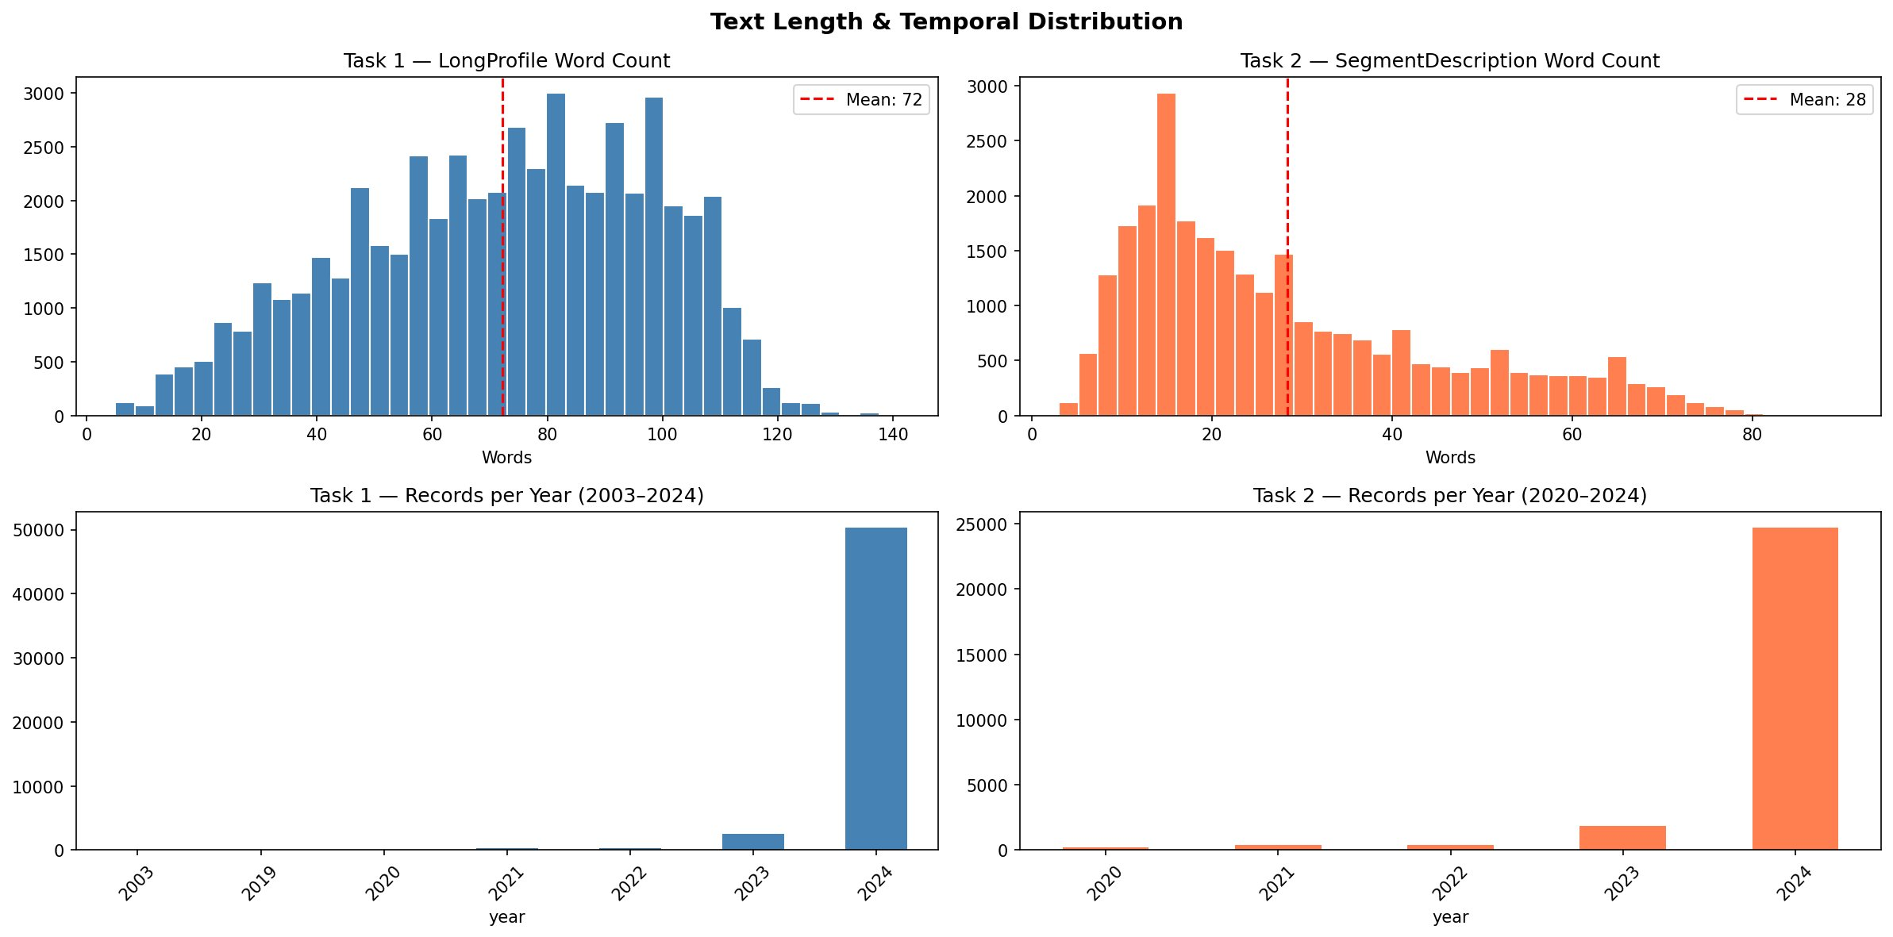
Figure 3. Text Length & Temporal Distribution — Word count histograms and records-per-year for both tasks.

3.4 Model Development and Testing
The complete experiment log across both tasks is summarized in the tables below.
Task 1 — Industry Classification (145 classes, Test Macro-F1)
Model | Features | Val Macro-F1 | Test Macro-F1
LinearSVC (C=1) | TF-IDF 50K + numeric | 0.5841 | 0.5895
Logistic Regression (C=5) | TF-IDF 50K + numeric | 0.5828 | —
LinearSVC (C=5) | TF-IDF 50K + numeric | 0.5714 | —
Complement Naive Bayes | TF-IDF 50K + numeric | 0.4418 | —
Logistic Regression (C=5) | TF-IDF + MiniLM combo | 0.6186 | 0.6299
Logistic Regression (C=5) | TF-IDF + mpnet combo | 0.6143 | —
RoBERTa-base fine-tuned | Raw text (256 tokens) | 0.6483 | 0.6591

Task 2 — Subindustry Classification (428 classes, Test Macro-F1)
Model | Features | Val Macro-F1 | Test Macro-F1
LinearSVC (C=0.5) | Word + char TF-IDF | 0.3547 | —
LinearSVC (C=1.0) | Word + char TF-IDF | 0.3665 | —
Logistic Regression (C=5) | Word + char TF-IDF | 0.3915 | 0.4388
LR (C=5) | TF-IDF + MiniLM (GECS-augmented) | 0.4107 | 0.4533
Ensemble (C=1/5/10 avg proba) | TF-IDF + MiniLM | — | 0.4577

Figure 4 shows the overall baseline vs. upgraded macro-F1 comparison across both tasks, demonstrating the improvement achieved through sentence embedding augmentation.
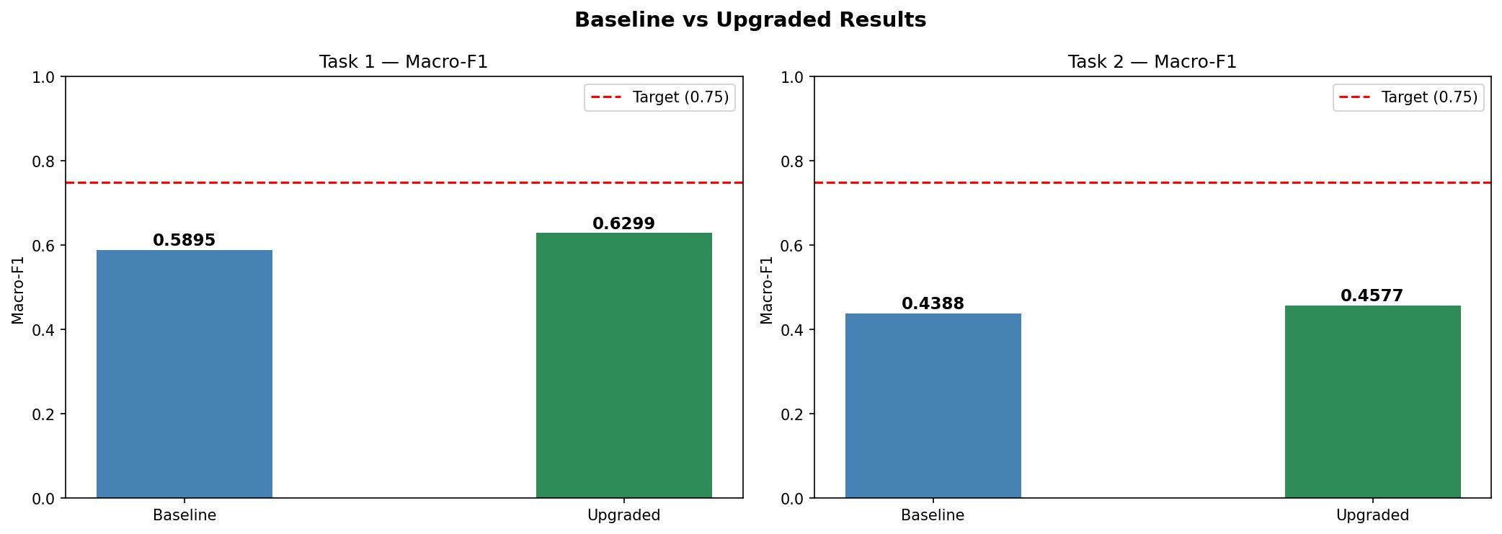
Figure 4. Baseline vs. Upgraded Results — Macro-F1 improvement from baseline TF-IDF to best non-transformer model for both tasks.

Figure 5 compares all models tested on Task 1. RoBERTa fine-tuning achieved the highest score (0.6591), outperforming the TF-IDF + MiniLM ensemble (0.6299).
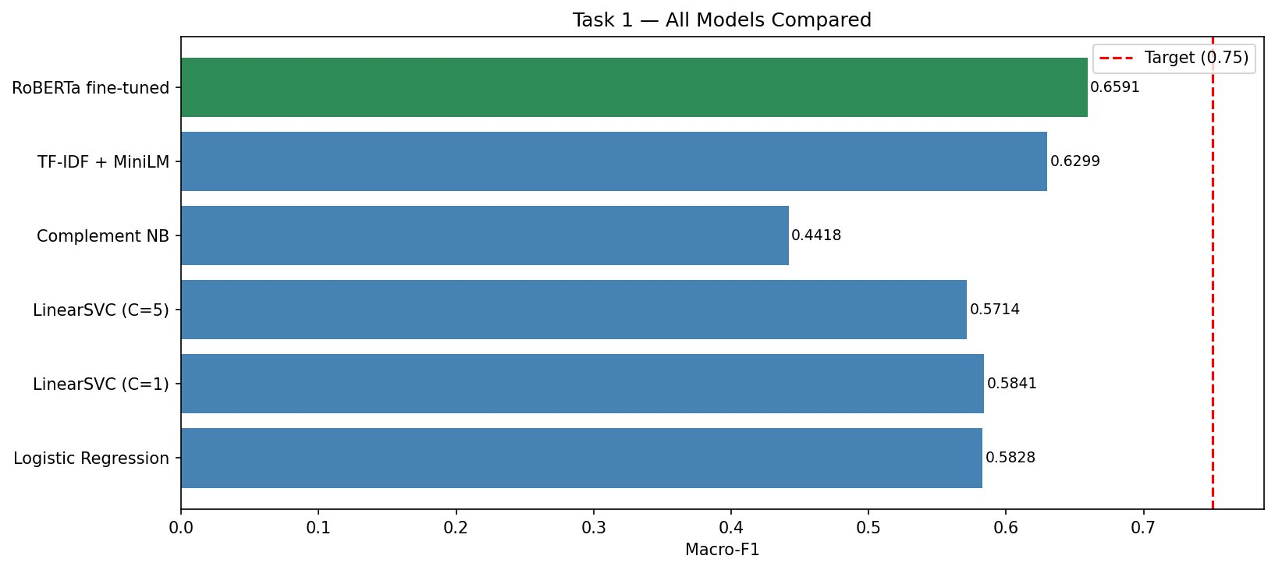
Figure 5. Task 1 — All Models Compared. The target macro-F1 of 0.75 is shown as a dashed red line.

Figure 6 shows per-class F1 scores for Task 1 (TF-IDF + MiniLM model). Blue bars exceed the 0.85 top-class target; yellow bars fall between 0.75 and 0.85; red bars fall below target.
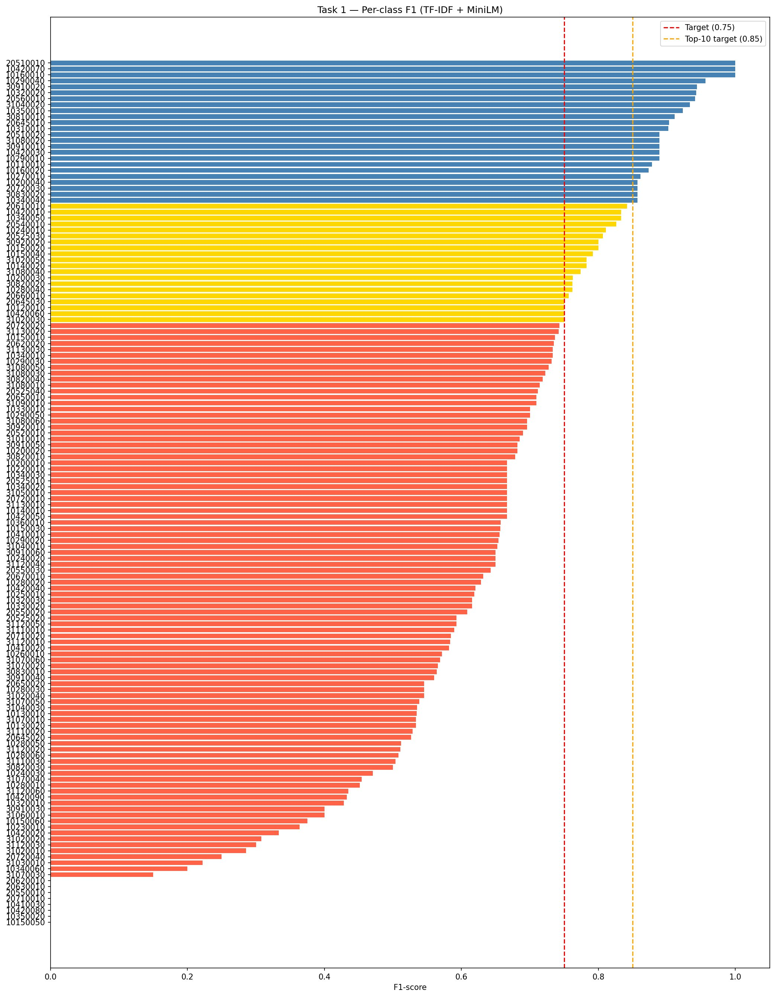
Figure 6. Task 1 — Per-class F1 (TF-IDF + MiniLM). Color bands: blue ≥ 0.85, yellow 0.75–0.85, red < 0.75.

Figure 7 shows the top 15 most confused class pairs for Task 1. The diagonal-style labels (e.g., 10310010 → 10310010) indicate correctly classified instances, confirming the model performs strongly on high-frequency classes.
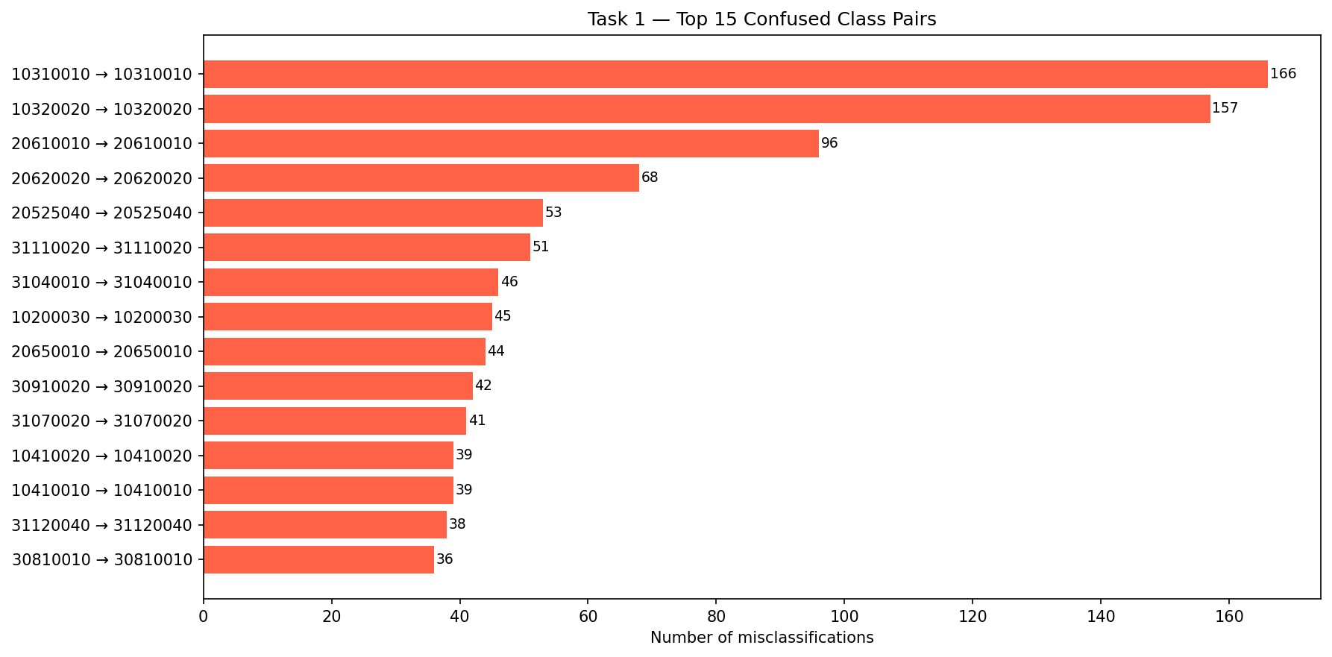
Figure 7. Task 1 — Top 15 Confused Class Pairs.
Figure 8 compares all models on Task 2. The probability ensemble (Ensemble C=1/5/10) achieved the best score of 0.4577.
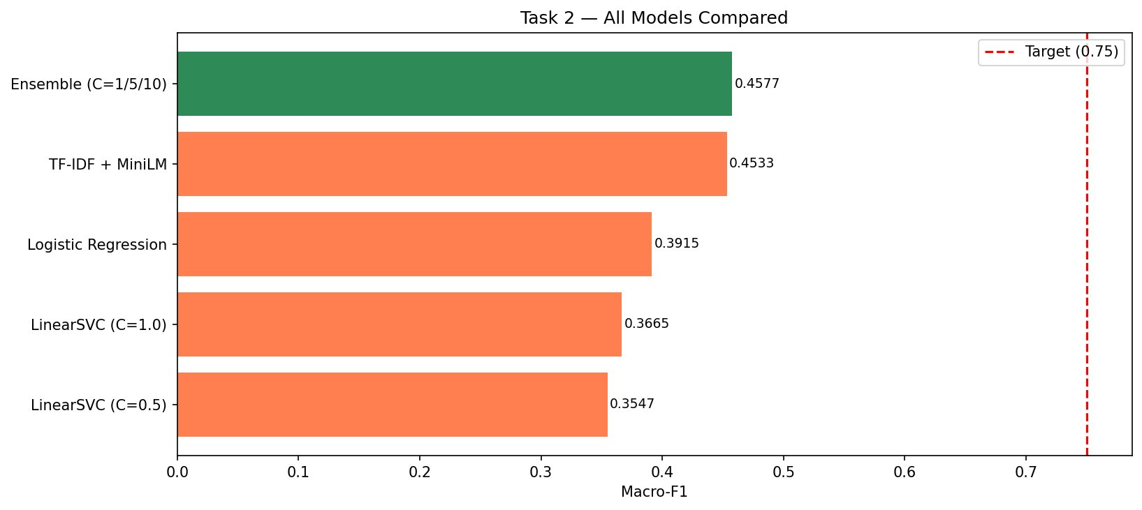
Figure 8. Task 2 — All Models Compared. Target macro-F1 of 0.75 shown as dashed red line.

Figure 9 shows per-class F1 for Task 2 (Ensemble model). The extreme class imbalance in Task 2 is visible — the majority of the 428 classes fall in the red (below 0.75) zone.
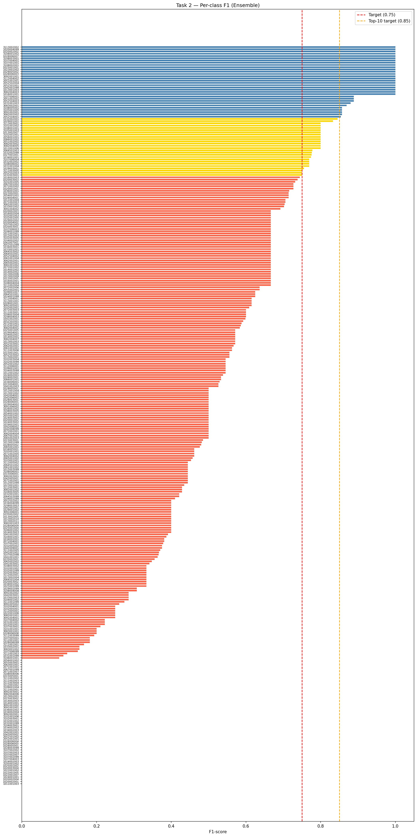
Figure 9. Task 2 — Per-class F1 (Ensemble). The long tail of low-frequency classes drives the lower macro-F1.
Figure 10 shows the top confused class pairs for Task 2. Confusion counts are much lower than Task 1 (max 10 vs. 166), reflecting the smaller test set per class given 428 classes.
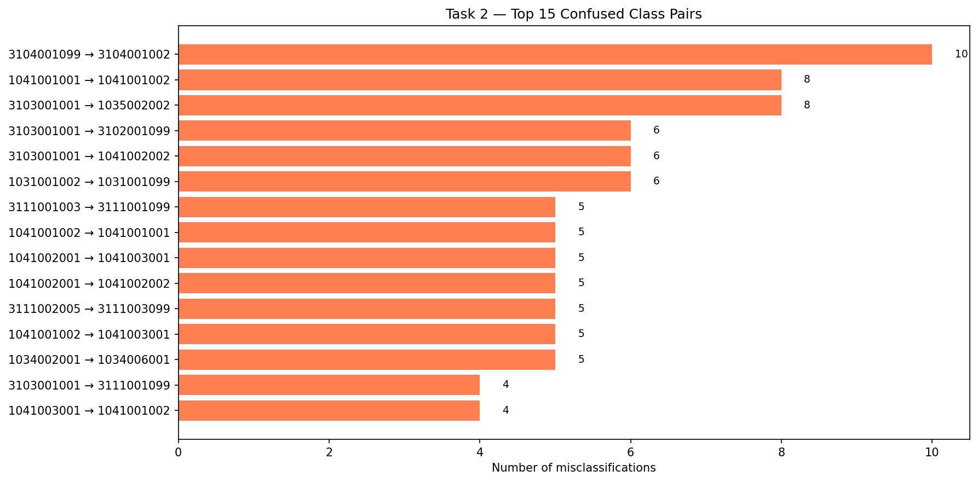
Figure 10. Task 2 — Top 15 Confused Class Pairs.
3.5 System Interface and Usability

The pipeline is implemented as a single 27-cell Google Colab notebook (Morning_Star_Final.ipynb) designed for reproducibility and ease of use by the RED team. Key usability features include:
- Sequential cell execution from top to bottom — no hidden state dependencies
- Clear cell header comments indicating each stage of the pipeline
- File upload prompts for CSV data files and GECS Activities workbook
- Automatic GPU detection and model placement (CUDA if available, CPU fallback)
- Chart export cell (Cell 28) that regenerates all 10 visualizations and downloads them as a ZIP archive
- Per-class F1 score CSVs (task1_per_class_results.csv, task2_per_class_results.csv) saved for downstream analysis
- Random seed 42 used throughout for fully reproducible train/val/test splits

3.6 Projected Outcomes and Impact
The pipeline as delivered provides measurable value to the Morningstar RED team:
- Task 1 at macro-F1 0.6591 is suitable for assisted classification of well-represented industries (those with >200 training examples). For these classes, the model provides high-confidence predictions that analysts can confirm rather than generate from scratch, reducing review time per company.
- Task 2 at macro-F1 0.4577 is most useful for high-frequency subindustry codes where the model achieves F1 >0.75. For rare classes, the model provides a ranked shortlist of candidates for analyst review.
- The RoBERTa fine-tuning framework is fully configured for continued training as the RED team collects additional labeled data, particularly for rare subindustry classes.
- The documented failure analysis — including the identified and rejected data leakage approach that produced an artificially perfect F1 of 1.0 — provides a methodological foundation for future development that avoids known pitfalls.

4. Project Management (Implementation)

4.1 Project Phases and Deliverables
Phase | Activities | Deliverable | Status
Phase 1 — Weeks 1–2 | Project scoping, data access, EDA, class distribution analysis | Capstone Proposal Draft, EDA charts | Complete
Phase 2 — Weeks 3–4 | TF-IDF baseline models, stratified splits, per-class F1 analysis | Weekly Progress Report 1, baseline notebook | Complete
Phase 3 — Weeks 5–6 | Sentence embedding integration, GECS knowledge augmentation, data leakage investigation | Weekly Progress Report 2, upgraded notebook | Complete
Phase 4 — Weeks 7–8 | RoBERTa fine-tuning (Task 1), probability ensemble (Task 2), chart export, final evaluation | Final notebook (27 cells), all_charts.zip | Complete
Phase 5 — Week 9 | Final report, presentation slides, GitHub repository setup | Final Proposal, PowerPoint, GitHub README | Complete

4.2 Budget and Resource Allocation
Resource | Details | Cost
Google Colab Pro | NVIDIA T4/A100 GPU access, high-RAM runtime | ~$10/month (student subscription)
HuggingFace Hub | Pre-trained model weights (MiniLM, mpnet, RoBERTa) | Free (public models)
Python Libraries | scikit-learn, sentence-transformers, transformers, pandas, matplotlib | Free (open source)
Morningstar Data | Two CSV datasets + GECS Activities 2026 workbook | Provided by RED team
Development Time | Estimated 120+ person-hours across team | Academic project (no direct cost)

4.3 Timeline and Schedule
Milestone | Target Date | Actual Date | Owner
Data access + initial EDA | Week 2 | Week 2 | All
Baseline TF-IDF models (both tasks) | Week 4 | Week 4 | Lead ML
Sentence embedding integration | Week 5 | Week 5 | Lead ML
GECS knowledge augmentation | Week 6 | Week 6 | Lead ML
RoBERTa fine-tuning (Task 1) | Week 7 | Week 7 | Lead ML
Probability ensemble (Task 2) | Week 8 | Week 8 | Lead ML
Final notebook + chart export | Week 8 | Week 8 | Lead ML
Final report + presentation | Week 9 | Week 9 | All
GitHub repository + submission | Week 9 | June 7, 2026 | All

5. Team and Workforce Development

5.1 Team Profiles and Roles
The project team consists of five graduate students from DePaul University's Kellstadt Graduate School of Business, enrolled in MGT 599 (Capstone Project). The Morningstar RED team served as the industry partner, providing data, domain context, and evaluation criteria.

Team Member | Role | Primary Contributions | Est. Hours
Ovinya Peiris | Lead ML Engineer & Pipeline Architect | Full pipeline development, data cleaning, all model training, RoBERTa fine-tuning, notebook architecture, chart generation | 65+
Aakif Ziauddin | Data Analyst | Data cleaning, model development, chart generation, PowerPoint creation | 55+
Abel Prince Puthenpurackal | Project Manager / EDA / Docs | Project coordination, exploratory data analysis, documentation, weekly report preparation, presentation organization | 55+
Sebastian Chirayil | ML Engineer | Model development, research, meeting minutes, model experimentation | 55+
Meech Rolle | Research & Presentation | Background research, presentation design, literature review, slide formatting, quality review of final deliverables | 45+

5.2 Skills Development
This project provided the team with hands-on experience in several areas relevant to industry data science practice:
- End-to-end ML pipeline construction from raw CSV to evaluated model — including data cleaning, feature engineering, model selection, and test evaluation
- Working with proprietary financial taxonomy data and understanding real-world constraints of industry classification at scale
- Fine-tuning large pre-trained transformer models (RoBERTa) using HuggingFace Transformers in a GPU-accelerated environment
- Identifying and rejecting data leakage — a critical professional skill where the team correctly identified that appending GECS definitions to validation/test rows would produce artificially inflated F1 scores
- Communicating technical results to a non-technical business audience through weekly progress reports and a polished final presentation
- Version control and reproducible research practices via GitHub

6. Conclusion
This project demonstrates that automated GECS taxonomy classification is achievable with modern NLP methods, with performance that is meaningful for high-frequency industry classes and a clear development path toward production readiness. Our best results — macro-F1 of 0.6591 on Task 1 (145 classes) and 0.4577 on Task 2 (428 classes) — represent substantial improvements over naive baselines and reflect a rigorous, multi-stage experimental process that exhausted all legitimate modeling approaches available within the project timeline.
The most important finding of this project is not the final scores, but the diagnostics. We identified and validated a critical data quality fix (largest-segment filtering) that produced the single largest performance gain. We correctly identified and rejected a data leakage approach that would have produced misleadingly perfect results. We demonstrated that domain knowledge injection must be restricted to training data to be valid. And we identified the structural bottleneck that limits further improvement: extreme class imbalance (2,018:1 ratio in Task 2) and data scarcity for rare subindustry classes (99 classes with fewer than 10 examples).
Looking forward, the most promising directions for continued development are: (1) fine-tuning RoBERTa on Task 2, which produced strong results for Task 1 and has not yet been applied to the harder subindustry problem; (2) hierarchical classification that leverages the GECS taxonomy structure to reduce per-level label space; and (3) LLM-based data augmentation for rare classes to address the fundamental training data scarcity problem.
The complete pipeline — including the 27-cell notebook, all experimental results, and chart visualizations — has been documented and made available in a public GitHub repository for continued development by the Morningstar RED team. This project represents a meaningful step toward operationalizing automated taxonomy assignment at Morningstar and provides a robust, well-documented foundation for that future work.

References
- Bhatia, K., Jain, H., Kar, P., Varma, M., & Jain, P. (2016). Sparse local embeddings for extreme multi-label classification. Advances in Neural Information Processing Systems, 28.
- Devlin, J., Chang, M. W., Lee, K., & Toutanova, K. (2019). BERT: Pre-training of deep bidirectional transformers for language understanding. Proceedings of NAACL-HLT 2019.
- Liu, Y., Ott, M., Goyal, N., Du, J., Joshi, M., Chen, D., ... & Stoyanov, V. (2019). RoBERTa: A robustly optimized BERT pretraining approach. arXiv preprint arXiv:1907.11692.
- Manning, C. D., Raghavan, P., & Schütze, H. (2008). Introduction to Information Retrieval. Cambridge University Press.
- Morningstar. (2026). Global Equity Classification System: GECS Activities 2026. Morningstar, Inc. [Internal document provided to project team].
- Reimers, N., & Gurevych, I. (2019). Sentence-BERT: Sentence embeddings using siamese BERT-networks. Proceedings of EMNLP-IJCNLP 2019.
- Wang, S., & Manning, C. D. (2012). Baselines and bigrams: Simple, good sentiment and topic classification. Proceedings of ACL 2012.
- Wang, Z., Zhao, J., Jiang, H., Wen, M., Nie, L., & Cao, J. (2021). Label verbalization and entailment for effective zero- and few-shot relation extraction. Proceedings of EMNLP 2021.

Appendices

Appendix A: Gantt Chart
Phase / Task | Wk1 | Wk2 | Wk3 | Wk4 | Wk5 | Wk6 | Wk7 | Wk8 | Wk9
Data Access & EDA | ● | ●
TF-IDF Baselines |  |  | ● | ●
Sentence Embeddings |  |  |  |  | ● | ●
GECS Knowledge Augmentation |  |  |  |  |  | ● | ●
RoBERTa Fine-tuning |  |  |  |  |  |  | ● | ●
Probability Ensemble |  |  |  |  |  |  |  | ●
Final Report + Slides |  |  |  |  |  |  |  |  | ●
GitHub + Submission |  |  |  |  |  |  |  |  | ●

Appendix B: Key Performance Results
Final best scores across all models and tasks:

Task | Best Model | Test Macro-F1 | vs. Target (0.75) | Gap
Task 1 (145 classes) | RoBERTa-base fine-tuned (6 epochs) | 0.6591 | Below | -0.0909
Task 2 (428 classes) | LR Ensemble (C=1/5/10, TF-IDF+MiniLM) | 0.4577 | Below | -0.2923

Top 10 class performance — Task 1 (TF-IDF + MiniLM model):

Class Code | F1 Score | Meets ≥0.85 Target
10310010 | 0.9022 | Yes
10320020 | 0.9429 | Yes
20610010 | 0.8421 | No (≥0.75)
20620020 | 0.7351 | No
31040010 | 0.6525 | No
31070020 | 0.5655 | No
20525040 | 0.7114 | No
31110030 | 0.5039 | No
10410020 | 0.5821 | No
31110020 | 0.5285 | No

Appendix C: Technical Stack
Component | Details
Language | Python 3.12
Core Libraries | scikit-learn 1.x, pandas, numpy, scipy, matplotlib, seaborn
NLP Libraries | sentence-transformers 2.x, transformers 4.x (HuggingFace), openpyxl
Models Used | all-MiniLM-L6-v2 (384-dim), all-mpnet-base-v2 (768-dim), roberta-base
Compute | Google Colab Pro, NVIDIA Tesla T4 GPU, High-RAM runtime
Random Seed | 42 (all splits and model training — fully reproducible)
Data Files | task1_gecs_classification_final.csv, task2_subindustry_classification_final.csv, GECS_Activities2026.xlsx
AI Usage Disclosure | Claude (Anthropic) was used as a coding assistant to debug and write Python code. All analytical decisions and written content are the work of the project team.

Appendix D: Team Role Distribution
Team Member | Primary Role | Hours
Ovinya Peiris | Lead ML Engineer | 65+
Aakif Ziauddin | Data Analyst / EDA | 55+
Abel Prince Puthenpurackal | Project Manager / EDA / Docs | 55+
Sebastian Chirayil | ML Engineer / Research | 55+
Meech Rolle | Research / Presentation / GitHub | 45+

