**ULTIMATE AWS CERTIFIED CLOUD PRACTITIONER - 2021**

**Teacher: Stephane Mareek**

**Course Udemy**

**1 - Intro**

Qual serviço AWS simplifica a migração da base de dados para AWS?

AWS Storage Gateway (aprenderemos neste curso)

AWS Database Migration Service (correct answer)

Amazon EC2 (aprenderemos)

Amazon AppStream 2.0 (distractor, 200 services in AWS, we will not learn in this course) - aparece no teste como resposta errada.

**2 - Link para download**

<https://courses.datacumulus.com/downloads/certified-cloud-practitioner-zb2/>

**3 - What is Cloud Computing?**

Client - Network - Server

IP Adress (clients and servers have de IP to comunicate)

**Server**

* CPU, do calculations and find results
* RAM/Memory, store info and retrieve quickly.

CPU + RAM : Brain

* Storage: Data (files, database). Store data in a structured way.
* Network: routers, switch, DNS server.

**IT Terminology**

Network: cables, routers and servers connected with each other.

Router: networking device that forwards data packets between computer network. They know where to send your packets on the internet.

Switch: takes a packet and send it to the correct server/client on your network.

**Cloud Computing**

* On-demand delivery of compute power, database storage, applications and other IT resources.
* Pay-as-you-go pricing.
* Provision exactly the right type and size of computing resources you need.
* Simple way to access servers, storage, databases and a set of application services.

Deployment Models of the Cloud ☁

* Private Cloud (used by single organization, not exposed to the public, complete control, security for sensitive applications, meet specific business needs)
* Public Cloud (Azure, Google Cloud, AWS. Cloud resources owned and operated by a third-party cloud service provider delivered over the internet, six advantages we will learn in this course).
* Hybrid Cloud (keep some servers on premises and extend some capabilities to the Cloud; control over sensitive assets in your private infrastructure; flexibility and cost-effectiveness of the public cloud).

**The Five Characteristics**

1. On-demand self service;
2. Broad (larga) network access;

Resources available over the network and can be accessed by diverse client plataforms.

1. Multi-tenancy and resource pooling;
2. Multi customers can share the same infrasctructure and applications with security and privacy / multiple customers are serviced from the same physical resources.
3. Rapid elasticity and scalability;

Automatically and quickly acquire and dispose resources when needed / quickly and easily scale based on demand.

1. Measured service.

Pay exactly what we use.

**Six Advantages of Cloud Computing**

1. Trade capital expense (CAPEX) for operational expense (OPEX)

Don't own hardware / Reduced Total Cost of Ownership & Operational Expense (OPEX)

1. Benefit from massice economies of scale

Prices are reduced as AWS is more efficient due to large scale

1. Stop guessing capacity

Scale based on actual measured usage

1. Increase speed and agility
2. Stop spending money running and maintaing data centers
3. Go global in minutes: levarage (aproveitar) the AWS global infrastructure

**Problems solved by the Cloud**

1. Flexibility
2. Cost-Effectiveness
3. Scalability
4. Elasticity
5. High availability and fault tolerance
6. Agility

**03/04**

**Types of Cloud Computing**

* Infrastructure as a Service (IaaS)

Provide building blocks for cloud IT

Provides networking, computers, data storage space

Highest level of Flexibility

Easy parallel with traditional on-premises IT

Services: Amazon EC2 (on AWS). GCP, Azure, Rackspace, Digital Ocean, Linode

* Platform as a Service (PaaS)

Focus on the deployment and management of your applications

Services: Elastic Beanstalk (on AWS). Heroku, Google App Engine (GCP), Windows Azure (Microsoft)

* Software as a Service (SaaS)

Completed product that is run and managed by the service provider

Services: Many AWS services (ex: Rekognition for Machine Learning). Google Apps, Dropbox, Zoom.

X 
On-Premises 
Applications 
Data 
Runtime 
Middleware 
Virtualization 
Servers 
Storage 
Networking 
Infrastructure 
as a Service 
Applications 
Data 
Runtime 
Middleware 
Virtualization 
Servers 
Storage 
Networking 
Platform 
as a Service 
Applications 
Data 
Runtime 
Middleware 
Virtualization 
Servers 
Storage 
Networking 
Software 
as a Service 
Applications 
Data 
Runtime 
Middleware 
Virtualization 
Servers 
Storage 
Networking 
795 x 591 
You Manage 
Other Manages 

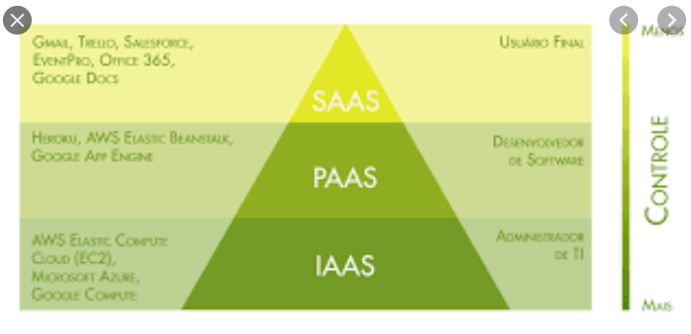

**Pricing of the Cloud** - 3 pricing fundamentals, following the pay-as-you-go pricing model

1. Compute (pay for compute time)
2. Storage (pay for data stored in the Cloud, the exact amount of data storage in the cloud)
3. Data transfer OUT of the Cloud (data transfer IN is free, only pay when the data leaves the cloud)

*solves the expensive issue of traditional IT*

**AWS CLOUD HISTORY**

2002: launched in 2002 internally at amazon.com

2004: launched publicly with SQS

2006: SQS, S3, EC2

2007: launched in Europe

Today: many applications running in AWS: Dropbox, Netflix, AirBNB, Nasa.

**AWS Cloud Use Cases**

* Enables you to build sophisticated, scalable applications
* Applicable to a diverse set of industries
* Use cases include: enterprise IT, backup and storage, bid data analytics // website hosting, mobile and social apps // gaming

**AWS Global Infrastructure**

* AWS has regions all around the world
* Names can be US-EAST-1, etc...
* A region is a cluster of data centers
* Most AWS services are region-scope

**How to choose na AWS Region?**

* Compliance: with data governance and legal requirements (data never leaves a region without your explicit permission)
* Proximity to customers: reduced latency
* Available services within a Region
* Pricing

**AWS Avaialability Zones**

* Each region has many availability zones (AZ) (normalmente 3, mínimo 2, máximo 6)
* Cada AZ tem 1 ou mais datacenters com poder, conectividade e networking.
* São separados, assim estão isolados de desastres.

Availability Zone 
REGION 
Availability Zone 
Center 
Data 
Center 
Data 
Center 
Low latency 
resilient fiber 
connectivity 
Data 
Center 
Data 
Center 
Data 
Center 
Data 
Center 
Availability Zone 

**AWS Points of Presence (Edge Locations)**

Amazon has 216 points of presence (205 edge locations & 11 regional caches) - 84 cities across 42 countries

Content is delivered to end users with lower latency

**Tour of the AWS Console**

* AWS has Global Services (IAM, DNS service, Content Delivery Network, Web Application Firewall)
* Most AWS services are Region-scoped (Amazon EC2, Elastic Beanstalk, Lambda, Rekognition

Important obs: not every service is offered in every region!

**Shared Responsability Model & AWS Acceptable Policy**

**Shared Responsability Model**

CUSTOMER 
RESPONSIBILITY FOR 
THE aouo 
AWS 
RESPONSIBILITY FOR 
SECURITY •or THE CLOUD 
CUSTOMER DATA 
PLATFORM. IDENTITY & ACCESS MANAGEMENT 
OPERATING SYSTEM. NETWORK & FIREWALL CONFIGURATION 
CLIENT-SIDE DATA 
ENCRYPTION DATA INTEGRITY 
AUTHENTICATION 
COMPUTE 
SERVER-SIDE ENCRYPTION 
AND/OR DATA) 
SOFTWARE 
STORAGE 
NETWORKING TRAFFIC 
PROTECTION IENCRYPTION, 
INTEGRITY. IDENTITY) 
NETWORKING 
HARDWARE/AWS GLOBAL INFRASTRUCTURE 
REGIONS 
AVAILABILITY ZONES 
EDGE LOCATIONS 

**Quiz - Observations**

* AWS Regions are composed of: two or more Availability Zones
* IAM is a global service (encompasses all regions)
* Using a Hybrid Cloud deployment model allows you to benefit from the flexibility, scalability and on-demand storage access while keeping security and performance of your own infrastructure.

You can run analytics on AWS, but you cannot run analytics on fraudulent content. Refer to the AWS Acceptable Use Policy to see what is not authorized to do on AWS.

[NEW] Ultimate AWS Certified Cloud Pract... 
Otimo trabalho! Vocé esté pronto para avangar pr6xima aula. 
Vocé teve 13 de 13 acertos na primeira tentativa. 
u que voce saoe u 
You ONLY want to manage Applications and Data. Which type of Cloud Computing model should you . 
What is the pricing model of Cloud Computing? 
Q 
Udemy 
Visäo geral 
O 
Seu progresso v 
Conteüdo do curso 
Compartilhar 
x 
Tentar novamente o teste 
Continuar 
Perguntas e respostas 
Observaqöes 
Anüncios 
Sobre este curso 
Pass the Amazon Web Services Certified Cloud Practitioner CLF-COI exam, Practice 
Exams included with explanations! 
Teste 1: What is Cloud Computing Quiz 
Seqäo 4: IAM - Identity and Access 
Management 
0/ 19 | 48m 
Seqäo 5: EC2 - Elastic Compute Cloud 
0/181 lh 16m 
Seqäo 6: EC2 Instance Storage 
0/14 | 47m 
seqäo 7: ELB & ASG - Elastic Load 
Balancing & Auto Scaling Groups 
O/ 9134m 
seqäo 8: S3 
0/21 17m 
Seqäo 9: Databases & Analytics 
0/ 19 | 43m 
Seqäo 10: Other Compute Services: ECS, 
Lambda, Batch, Lightsail 
0/11 | 35m 

OBS: tem anotações no PC do trabalho até a aula 17, section 4.

**4. Identity and Access Managment (IAM)**

**IAM Section**

Global service

Root account created by default, shouldn't be used or shared

User are people within your organization and can be grouped

Groups only contain users, not other groups.

User dont have to belong to a group, and user can belong to multiple groups.

IAM : Permissions

Users or groups can be assign Json documents called policies.

IAM User: stephane

Account: stephane-ccp

* No at sign (@) : means that I'm using the root user
* The at sign : I am using the IAM user

Policies hands on

Left hand side (console) there are Policies

Can see policies that can be either managed by AWS, linked to job function or create own policy.

Its possible to see the JSON document/form (created in the first place) -> simple JSON statments

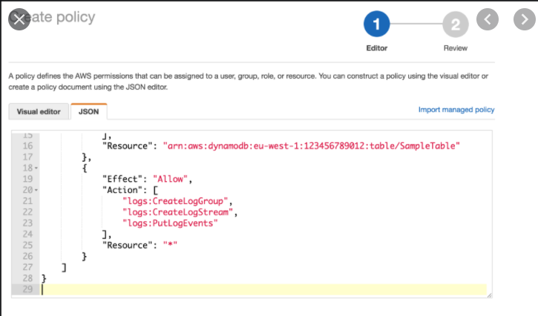

**IAM MFA Overview**

Two defense mechanisms

1. Password policy

Strong password, security for our accounts

Minimin password length

Require specific character types

Allow all IAM users to change their own passwords

Require users to change their password after some time (password expiration)

Prevent password re-use

2. Multi Factor Authentication - MFA

Users have access to your account and can possibly change configurations or delete resources in your AWS account.

Protect our Root Accounts and IAM users.

MFA = password you know + security device you own

Alice : has a password and a MFA generating token ==> sucessful login

MFA devices options in AWS

1. Virtual MFA Device

·         Google Authenticathor : phone only

·         Authy (Amazon) : multi-device

Multiple tokens on a single device.

2. Universal 2nd Factor (U2F) Security Key

·         YubiKey by Uybico (3rd party)

Support for a multiple root and IAM users using a single security key.

Physical device.

3. Hardware key Fob MFA Device

* Provided by Gemalto (3rd party)

4. Hardware Key Fob MFA Device for AWS Gov Cloud (USA)

* Users from US, it special Key Fob
* 3rd party

IAM MFA Hands On

**19. AWS CLI (Command Line Interface)**

To access AWS we have three options:

1. AWS Management Console (protected by password + MFA)
2. AWS Command Line interface (CLI): protected by access keys
3. AWS Software Developer Kit (SDK): when we are coding, protected by access keys.

Access keys are generated through the AWS Console (we don't share these access keys!!)

Users manage their own access keys

Access Key ID ~= username

Secret Access Key ~= password

**AWS CLI**

The AWS Command Line Interface (AWS CLI) is an open source tool that enables you to interact with AWS services using commands in your command-line shell. With minimal configuration, the AWS CLI enables you to start running commands that implement functionality equivalent to that provided by the browser-based AWS Management Console from the command prompt in your terminal program:

* **Linux shells** – Use common shell programs such as [bash](https://www.gnu.org/software/bash/), [zsh](http://www.zsh.org/), and [tcsh](https://www.tcsh.org/) to run commands in Linux or macOS.
* **Windows command line** – On Windows, run commands at the Windows command prompt or in PowerShell.
* **Remotely** – Run commands on Amazon Elastic Compute Cloud (Amazon EC2) instances through a remote terminal program such as PuTTY or SSH, or with AWS Systems Manager.

Hands on

No terminal:

* aws configure

AWS Access Key ID: pegar no site

AWS Secret Access Key: pegar no site

Default region name: eu-west-1 (example) -- tem a info em um dropdown no site

Default output format: press enter (vazio mesmo)

* aws iam list-users (isso irá mostrar a lista dos usuários)