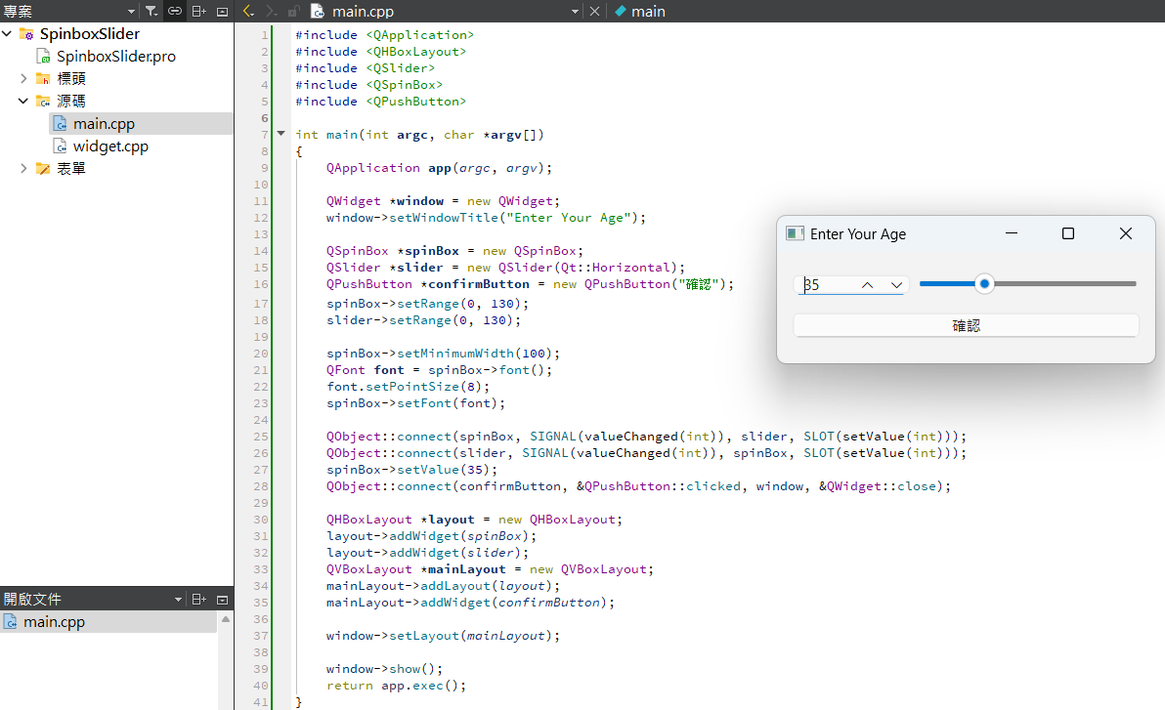#include <QApplication>

#include <QHBoxLayout>

#include <QSlider>

#include <QSpinBox>

#include <QPushButton>

int main(int argc, char \*argv[])

{

QApplication app(argc, argv);

QWidget \*window = new QWidget;

window->setWindowTitle("Enter Your Age");

QSpinBox \*spinBox = new QSpinBox;

QSlider \*slider = new QSlider(Qt::Horizontal);

QPushButton \*confirmButton = new QPushButton("確認");

spinBox->setRange(0, 130);

slider->setRange(0, 130);

spinBox->setMinimumWidth(100);

QFont font = spinBox->font();

font.setPointSize(8);

spinBox->setFont(font);

QObject::connect(spinBox, SIGNAL(valueChanged(int)), slider, SLOT(setValue(int)));

QObject::connect(slider, SIGNAL(valueChanged(int)), spinBox, SLOT(setValue(int)));

spinBox->setValue(35);

QObject::connect(confirmButton, &QPushButton::clicked, window, &QWidget::close);

QHBoxLayout \*layout = new QHBoxLayout;

layout->addWidget(spinBox);

layout->addWidget(slider);

QVBoxLayout \*mainLayout = new QVBoxLayout;

mainLayout->addLayout(layout);

mainLayout->addWidget(confirmButton);

window->setLayout(mainLayout);

window->show();

return app.exec();

}