**SELECT** column_name(s) FROM table_name WHERE condition **AND|OR** condition

ALTER TABLE table_name **ADD** column_name datatype **REFERENCES** Filming(id)

ALTER TABLE Movie ALTER COLUMN test TYPE int USING test::integer;

ALTER TABLE Movie RENAME COLUMN test TO test2;

ALTER TABLE Movie DROP COLUMN test;

ALTER TABLE Movie **RENAME** TO Movie2;

**DROP** COLUMN column_name

SELECT column_name **AS** column_alias FROM table_name; SELECT column_name FROM table_name AS table_alias

SELECT column_name(s) FROM table_name WHERE column_name **BETWEEN** value1 AND value2(包括前后)

**CREATE** **DATABASE** database_name

CREATE **TABLE** table_name(column_name1 data_type, (id SERIAL PRIMARY KEY, title VARCHAR, tstart DATE CHECK (tstart > '1895-01-01'), tend DATE, CHECK (tstart < tend));

CREATE **INDEX** index_name ON table_name (column_name) (Duplicate values are allowed)

CREATE **INDEX** movie_tags ON movies **USING** gin (tags);

CREATE **UNIQUE INDEX** index_name ON table_name (column_name) (Duplicate values are not allowed)

CREATE **VIEW** view_name AS SELECT column_name(s) FROM table_name WHERE condition

**DELETE** FROM table_name WHERE some_column=some_value

DELETE FROM table_name (Note: Deletes the entire table!!); DELETE * FROM table_name (Note: Deletes the entire table!!)

**DROP DATABASE** database_name

**DROP INDEX** table_name.index_name (SQL Server); DROP INDEX index_name ON table_name (MS Access); DROP INDEX index_name (DB2/Oracle) ; ALTER TABLE table_name DROP INDEX index_name (MySQL)

**DROP TABLE** table_name

IF **EXISTS** (SELECT * FROM table_name WHERE id = ?) BEGIN --do what needs to be done if exists END ELSE BEGIN --do what needs to be done if not END

SELECT column_name, aggregate_function(column_name) FROM table_name WHERE column_name operator value **GROUP BY** column_name **HAVING** aggregate_function(column_name) operator value(常与COUNT(), MAX(), MIN(), SUM(), AVG()一起用)

SELECT column_name(s) FROM table_name WHERE column_name **IN** (value1,value2,..)

**INSERT INTO** table_name VALUES (v1, v2, v3,....); INSERT INTO table_name (column1, column2, column3,...) VALUES (v1, v2, v3,....)

SELECT column_name(s) FROM table_name1 **INNER JOIN** table_name2 ON table_name1.column_name = table_name2.column_name

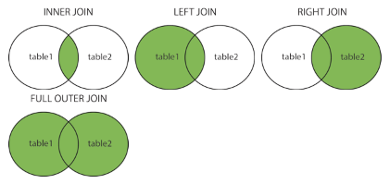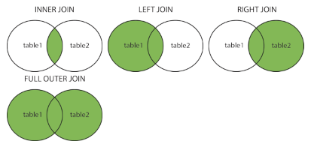SELECT column_name(s) FROM table_name1 **LEFT JOIN** table_name2 ON …

SELECT column_name(s) FROM table_name1 **RIGHT JOIN** table_name2 ON …

SELECT column_name(s) FROM table_name1 **FULL JOIN** table_name2 ON …

SELECT column_name(s) FROM table_name WHERE column_name **LIKE** pattern **%** :zero, one, or multiple characters, **(_)** one single character

SELECT column_name(s) FROM table_name **ORDER BY** column_name **[ASC|DESC] LIMIT 5**

**SELECT** **DISTINCT** column_name(s) FROM table_name (return only distinct (different) values)

**SELECT * INTO** new_table_name [IN externaldatabase] FROM old_table_name (copies data from one table into a new table)

SELECT column_name(s) INTO new_table_name [IN externaldatabase] FROM old_table_name

SELECT **TOP** number|percent column_name(s) FROM table_name

**TRUNCATE** TABLE table_name

SELECT column_name(s) FROM table_name1 **UNION** SELECT column_name(s) FROM table_name2

SELECT column_name(s) FROM table_name1 **UNION ALL** SELECT column_name(s) FROM table_name2 (allow duplicate values)

**UPDATE** table_name SET column1=value, column2=value,... WHERE some_column=some_value

Comments, with -- or /* ... */

**\l** to list databases **\c database** change database \**dt** list tables **\d table** show details about a table

PostgreSQL types : **BOOLEAN** , **INT** for integers (4-byte) **SERIAL** for an auto-incrementing identifier (4-byte), or AUTO INCREMENT with MySQL **REAL** for floating-point numbers (4-byte) **NUMERIC** for high-precision numbers (1000 digits) • **TEXT or VARCHAR**: text • VARCHAR(42): text of length at most 42 • **BYTEA** or **BLOB** for binary strings • **TIMESTAMP** for date and time (can be WITH TIME ZONE), DATE, etc