Connor Young (cdy3xv)

SYS 3048-Early Prototype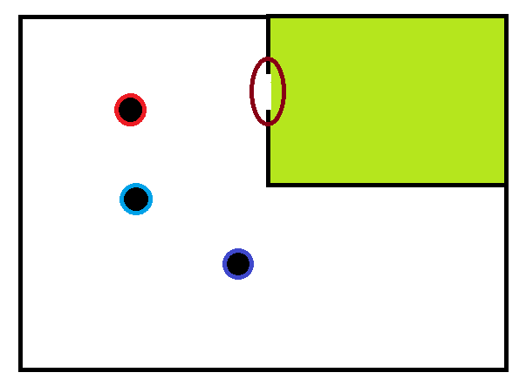

Here we see a potential setup. The green room is the room that we are monitoring (in practice, this can be scaled to include multiple rooms, even all the rooms in a home, but for the purposes of this illustration we will examine the one room case). The encircled brown area is the sensor area. The sensor has to both identify that somebody has transitioned rooms and who that person is. Multiple transition areas can be combined into one transition area for the purposes of contextualizing the data. This would be done through some trivial logic that intakes sensor data from multiple transition areas and outputs data for the virtual combined transition area. The colored black circles are people, colors marking different identities. The goal of the system is to determine who leaves a room last. This can then be combined with data on electrical uptime of certain fixtures (lights, appliances, etc.) to identify personal energy waste. People could be identified by characteristics such as weight, height, appearance, RFID chip located on their person, or other wearable technology like a smart watch. The above list is not exhaustive. If a person is identified, direction can be inferred by what the system knows about who is in the room already.

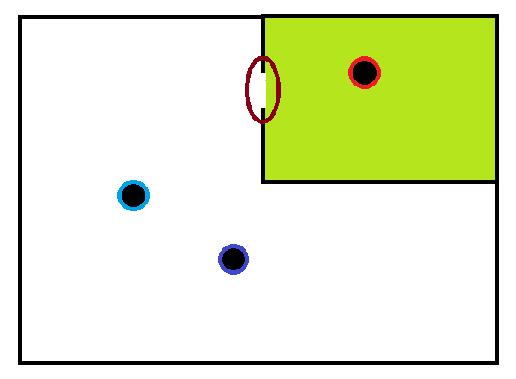

Here, Red has entered the room. The brown area should log this event as an entry for Red. As far as the system knows, Red is the only one in the room (Assuming the system thinks the room is empty at the beginning of this simulation). We will assume that during or near this transition, Red has turned on the lights.

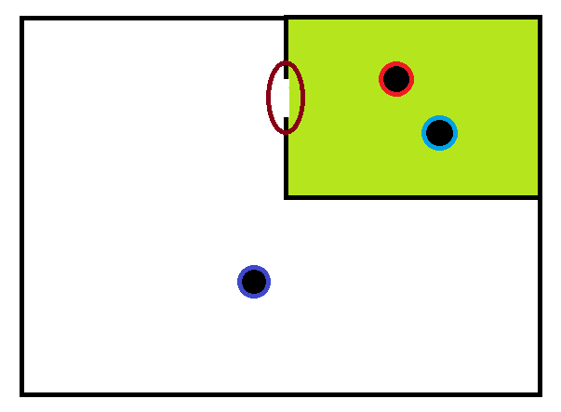

Here, Blue has entered the room with Red. Blue turns on the TV.

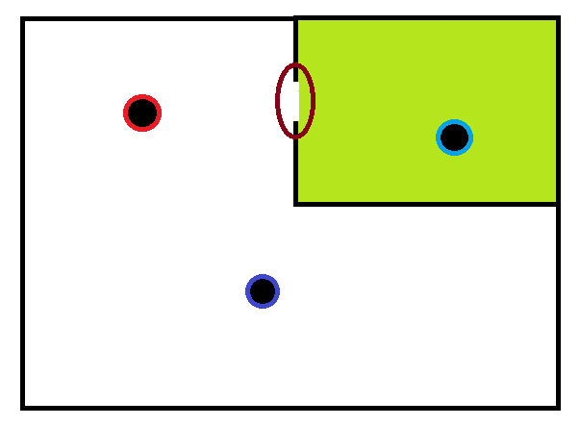

Red leaves the room. Red turns nothing off as he leaves the room, but Blue remains in the room, so it isn’t waste.

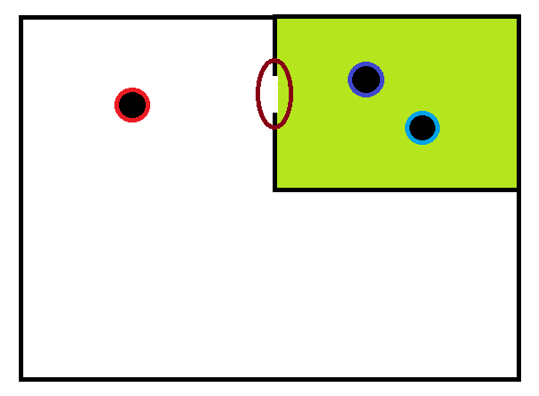

Purple has entered the room, but is not using the TV. The TV and lights remain on.

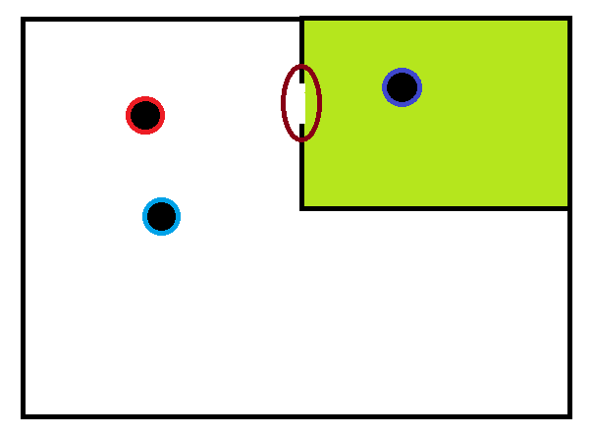

Blue leaves the room, but does not turn the TV off. Here, one of the system’s weaknesses becomes apparent. The TV is currently wasting energy (nobody is using it), but because there is still someone in the room, the system does not record this as waste. As such, the system works best for things that will be used by everybody in the room like lighting. A TV may still actually work with this system, as it is unlikely that Purple does not realize the TV is on. As such, it will be at least partially Purple’s fault when he leaves the room without turning the TV off. That being said, it is not an ideal system, because no responsibility is placed on Blue, who left it on in the first place. The system still does work to promote people to be aware of devices that are left on when they are the last to leave the room, but makes no allowance for people leaving things on in an occupied room. If we reduce the size of the monitored zones” to be more local (e.g: the couch facing the tv), we get better results. However, we lose the advantage of doors as a transition zones, as it is much easier to track who has gone through the door than it is to track who has gotten on and off the couch.

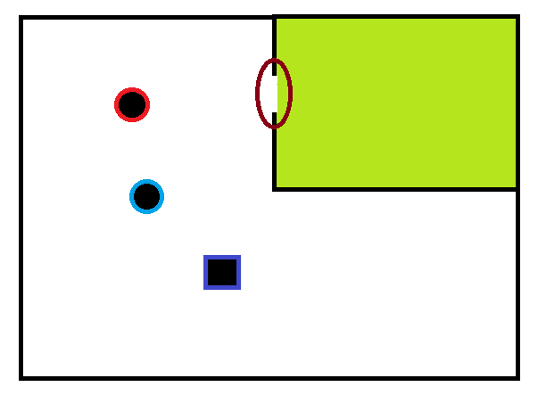

Finally, Purple leaves the room with both the lights and the TV left on. The system identifies Purple as a square for wasting energy. The system may then track how much energy is wasted in the room before it becomes occupied again and assigns that waste to Purple in a database. Actions such as dessert rationing may be taken based on this database.