**BIA 472: Visual Analytics and Visualization**

**Instructor**: Dr. Cindy Corritore **Email Address**: [cindy@creighton.edu](mailto:cindy@creighton.edu)

**Office Number**: COBA 4th floor west hall **Phone**: 402-612-1260 cell (include your name in SMS)

**Textbooks**

# Storytelling with Data: A Data Visualization Guide for Business Professionals (1st Edition) by Cole Nussbaumer Knaflic; ISBN 978-1119002253

# Practical Tableau (1st Edition) by Ryan Sleeper (Tableau Zen Master); ISBN 978-1491977316

###### Course Information Site

We will use Blueline for all our course materials and class communication.

1. I will post class announcements on the Announcements Discussion Board.
2. You will post all class questions and problems on Class Questions board to be answers by myself or others in class. I will respond within 24 hrs.
3. Email me at [cindy@creighton.edu](mailto:cindy@creighton.edu) for any personal questions or problems. I will respond within 24 hrs.

### Philosophy

**Information Visualization or Visual Analysis** is an active, hot area in business and in BIA in particular. I can’t think of a job in which you will never interact with data visualization. The presence of big data in business today, along with the need for fast, accurate, and timely decisions based on information make visualization critical. However, this is a new field for business. It is in its infancy in business but luckily not in other fields. Therefore a strong body of theory and best practices exist outside of business upon which we can build.

**Official Course Learning Objectives**When done with this course, you will

1. understand and apply principles of visual analytics and data visualization.
2. be able to identify standard visuals and the features of each that provide an optimal interpretation.
3. be able to design and implement standard visualization techniques using modern visual analysis tools.
4. Be able to quantitatively and qualitatively evaluate existing visualizations using principles of user design and user experience.
5. be able to tell a story with data using visualizations.

**Weekly Course Structure**This is what each week will generally look like for you.

1. You will prepare for each class day: complete readings, watch videos, and install new software tools.
2. You will practice the new material by applying it in class through creation of new visuals.
3. After each class, complete the Three Questions form in Blueline.
4. After last class of the week, complete the Engagement Checklist in Blueline.
5. Every two weeks: you will individually complete an assignment focusing on the previous two weeks content and practices.
6. In the last few weeks of the course, you will work with your team on a signficiant visual analytics and data visualization project.

### Course Grading Model

|  |  |
| --- | --- |
| **Item** | **Percent Worth** |
| Assignments (3) | 40% |
| Exams and Quizes | 45% |
| Course Engagement | 15% |

**Course Grading Criteria**

### Here are my grading criteria for all work in this course. These will be applied to the specific requirements of each assignment/activity. Grades will be returned within at least one week of the due date.

|  |  |  |  |
| --- | --- | --- | --- |
|  | **A** | **B** | **C** |
| Content elements (95%) | Contains all elements/functionality required by assignment. Works correctly and completely. Applies previously learned concepts as well as the new ones. | Missing less than 10% of elements or functionality required by assignment. Little or no initiative displayed. Applies current concepts appropriately but few if any previous concepts. | Missing more than 10% of elements or functionality of assignment. Does not consistently apply current or previous concepts taught in course. |
| Quality (5%) | Assignment well done, organized, shows extra work above and beyond what assignment required, professional, creative. | Assignment fulfills requirements with little to no extra work. | Assignment elements and functionality in place but work is messy, shoddy, thrown together and shows little effort, unprofessional. |

**Heider College of Business Grade Scale**

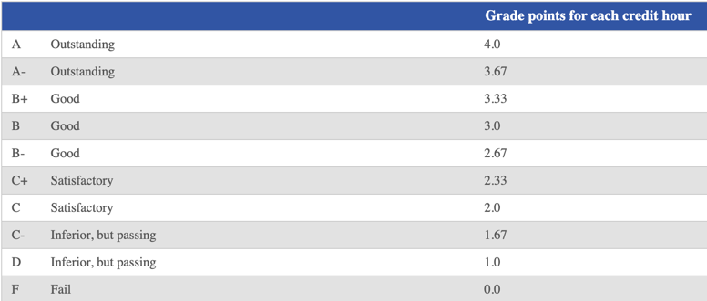

### Handing in work

Work is to be submitted to Blueline unless otherwise specified.

### Late Assignments

### Assignments may be assessed up to 10% off for each day they are late. After 5 days, they will not be accepted.

**Descriptions of Course Activities**

1. **Practice (each class day)**. This course is very applied. That means the majority of class will be spent working problems, creating and evaluating visualizations, practicing with tools. Come to class prepared to use the concepts and skills from the preparation readings and videos. This is practice, and so will not be graded unless there is a problem with participation or preparation.
2. **Assignments.** These are assignments that require application of concepts and skills from the previous two weeks of material. They are based on the fact that you have practiced the content in class, and are ready to apply it to more complex problems. They are graded on a 100 point scale. They must be done individually.
3. **Exams and Quizzes**
   * **Midterm Exam.** The Midterm will be an in-class exam, open book, with questions and application exercises.
   * **Final Exam.** The Final Exam is the same as the Midterm in style, with questions and application exercises. However, it is comprehensive over the entire course.
   * **Quizzes**. Unscheduled quizzes will be given as needed based on class preparation. If none are given, the points in this section will all go to the Midterm and Final exams.
4. **Course Engagement.** Course engagement is vital; that means your ‘attendance’ and active participation in the course, Blueline Discussion boards (for questions), etc is critical. I will use my judgment on the items below to determine the points you earn.   
   **Note**: You will evaluate this each week to see your own progress and make any necessary adjustments.

|  |
| --- |
| 1. attends class regularly. |
| 1. is consistently prepared for in-class practices. |
| 1. pays attention in class (ie. not on phone or surfing Internet). |
| 1. actively participates in in-class activities and team projects. |
| 1. asks questions and contributes verbally in class in productive ways. |
| 1. contributes to question board on the Blueline Discussion in high quality and meaningful ways: quality questions, comments, clarification, answering questions of peers, etc. |
| 1. completes assignments on time. |
| 1. submits complete work that reflects good effort. |
| 1. demonstrates growth on the course learning objectives (in syllabus). |
| 1. completes at least 90% of the ‘Three Questions’ forms (after each class) and weekly ‘Engagement Checklist’ forms. |