

Documentation – Project Capstone
FinacialApps

- Goals:
The project proposes the development of an analytical solution for small businesses, initially focused on the real estate sector. The tool aims to support cash flow forecasting, and the identification of financial risks based on historical income and expense data. The goals of this project is to design and implement a financial forecasting system tailored to micro and small businesses, aiming to improve cash flow visibility and strategic decision-making. The solution integrates the following components Automated Data Ingestion: Allow manual entry or import of income and expense data via Excel

2. Database:
A dataset comprising six months of financial records was collected for the purpose of analysis and transformation. Given the unstructured nature of the original data, it was necessary to engineer additional features to enhance analytical capacity. Four new columns were introduced: Type, Category, Payment Method, and Seasonality. Following this step, the data was normalized to ensure consistency and reliability for further modeling and analysis.
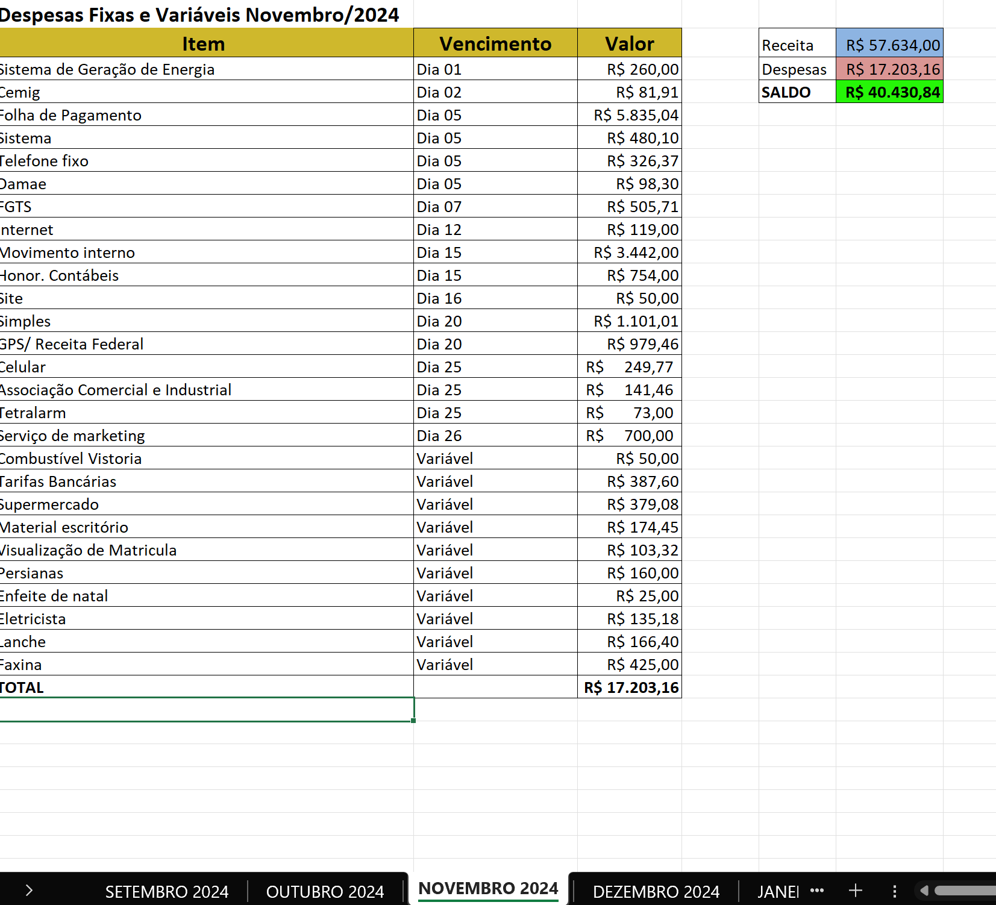

- After incorporating the new columns, we had additional parameters to support the analysis and improve the accuracy of the prediction..
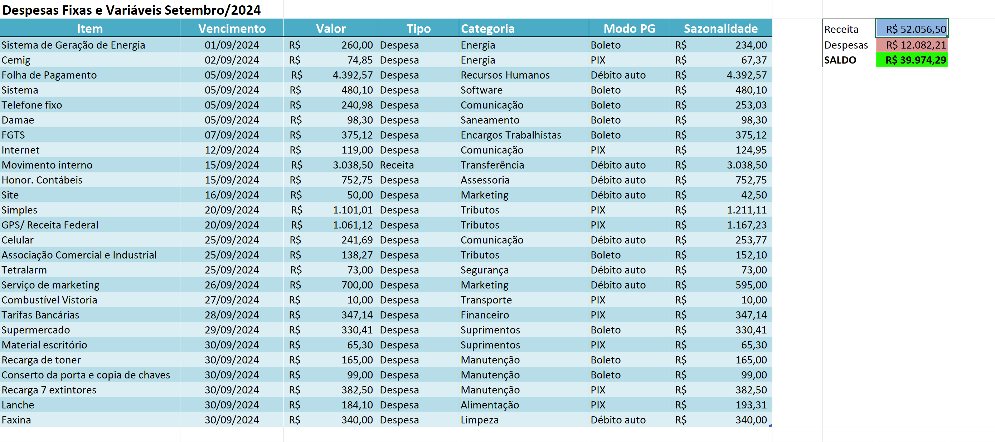

- An environment was established to facilitate version control of the project using GitHub. Additionally, a Data Dictionary was developed to ensure clarity and consistency in the interpretation of variables throughout the project.
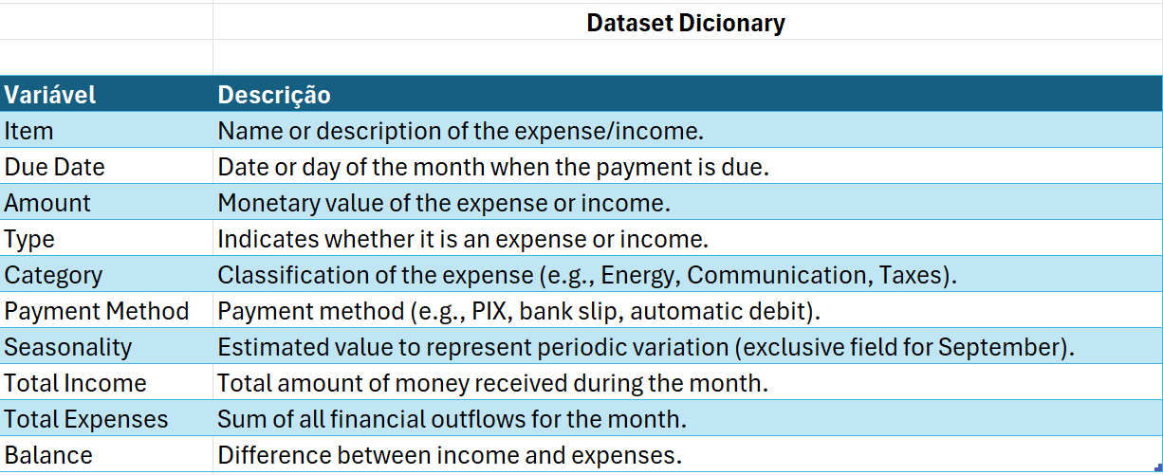

Link do Github: https://github.com/vivianecristino2/Project_Capstone

- A project architecture was designed to guide the overall structure and define the data flow, ensuring clarity and coherence in each development stage.:

- Within the GitHub environment, a Kanban-based project management method was implemented to organize and monitor task delivery, ensuring a structured and agile workflow throughout the development process.
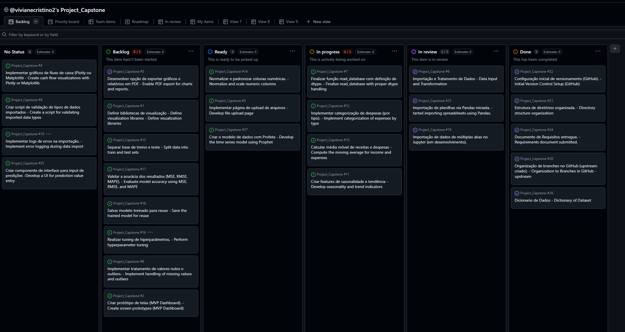

- The database was imported into VSCode; however, since the tables were separated across different sheets by month, it was necessary to develop a function to consolidate all the data into a single file. This step was essential to enable further processing and ensure we worked with a unified and normalized dataset.

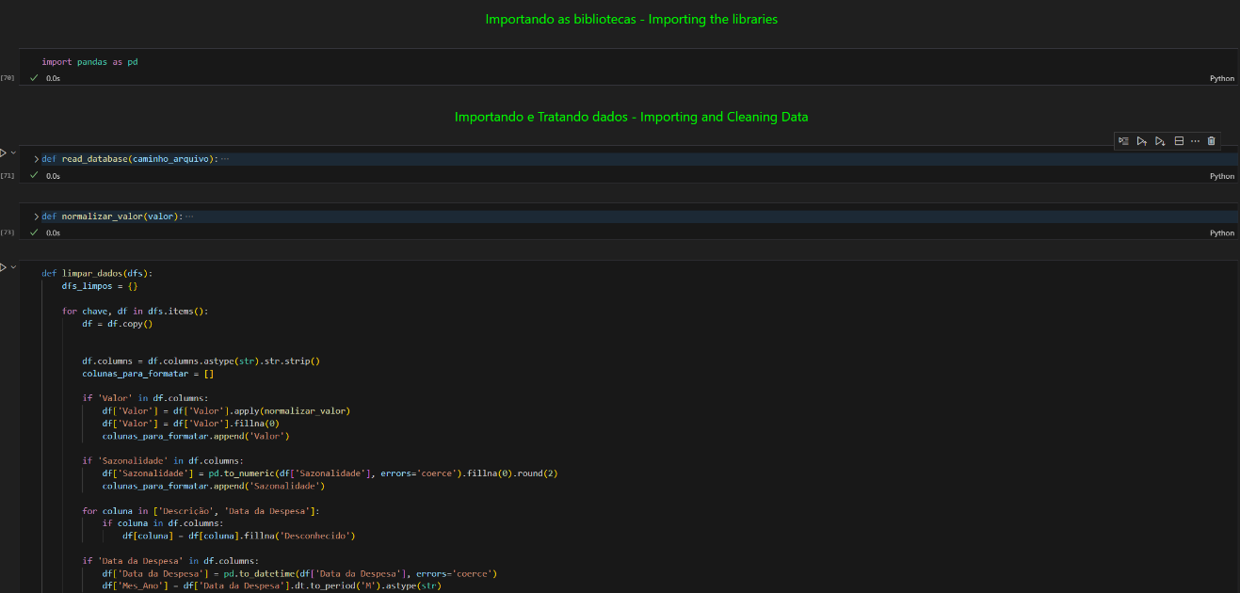

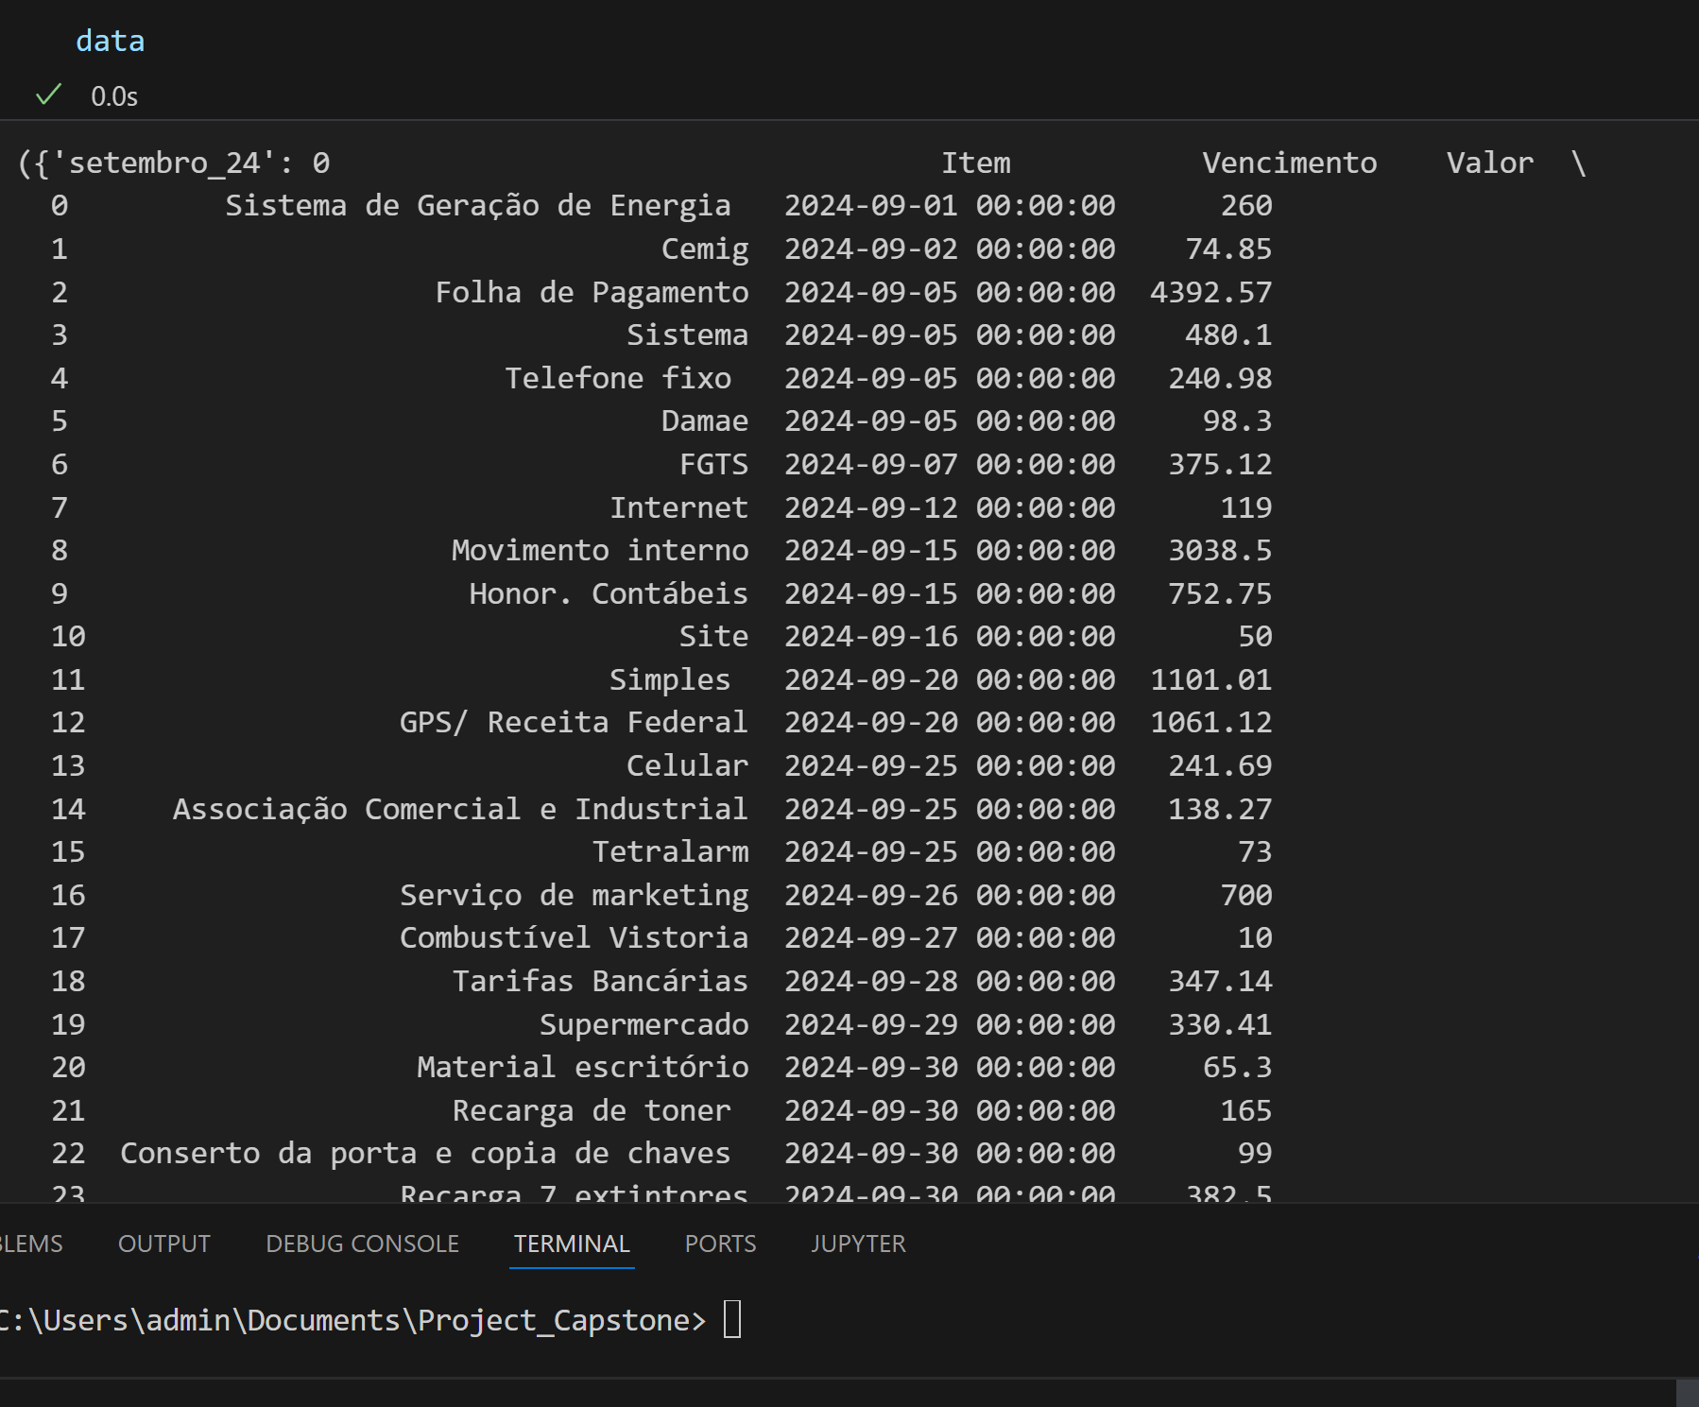

- Data normalization will be applied to the spreadsheet values, as it plays a key role in ensuring consistency and improving model performance.

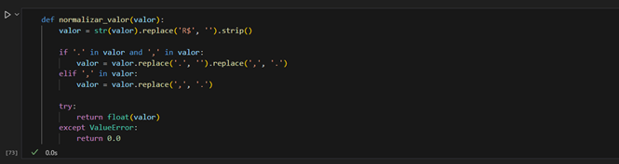
- Clean data entries with empty spaces that could interfere with the performance of the predictive Machine Learning model.

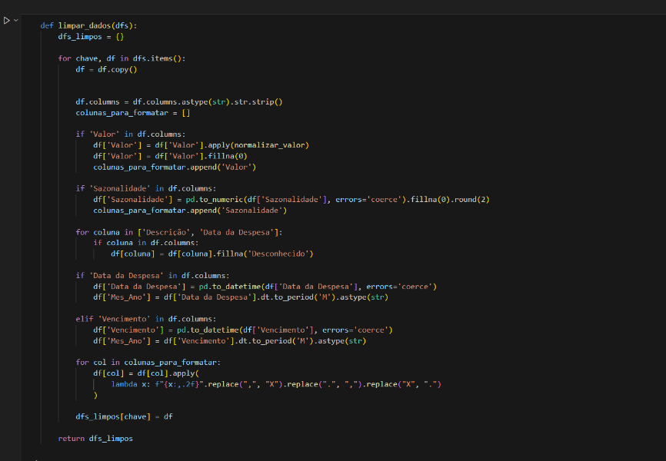
Dataset clean:


- As part of the cash flow consolidation process, new variables were engineered to enable comprehensive financial insights. These include monthly variation, cumulative expenses, cumulative profit, and profit margin, derived from the "amount", "type", and "month-year" fields. Data preprocessing steps ensured that empty values were excluded from calculations and expense figures were consistently cast to float data type to maintain analytical integrity.

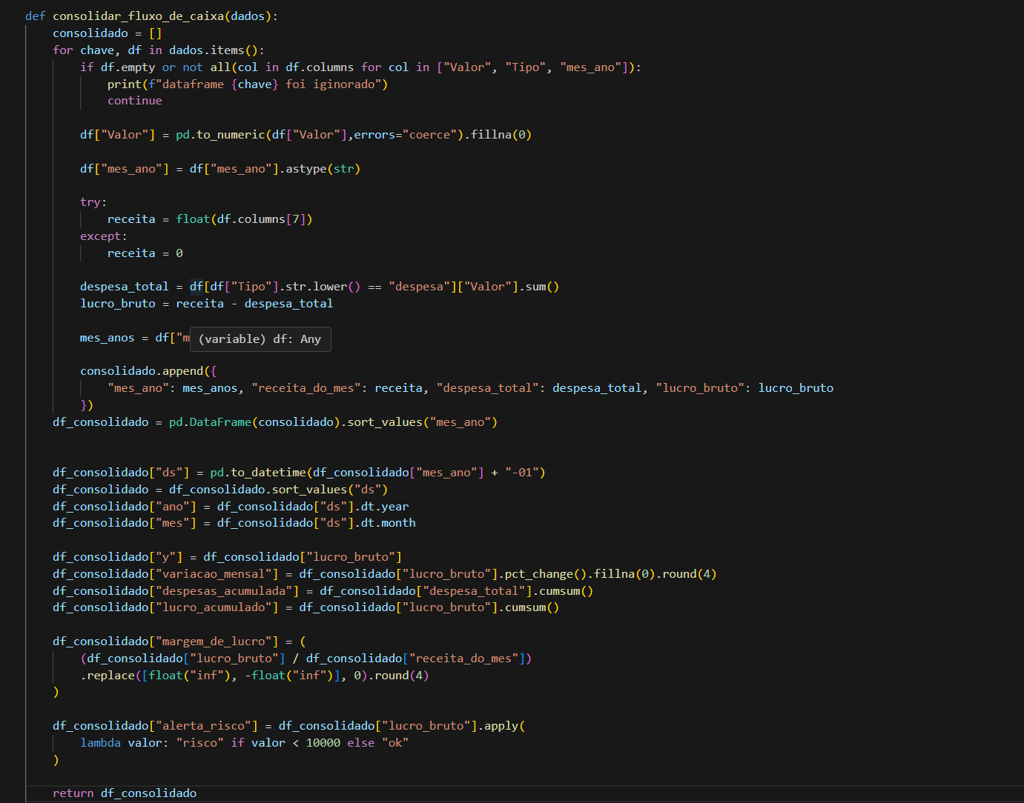

- A structured visualization of the financial data was created based on an Excel spreadsheet, after applying essential preprocessing steps. These included data cleaning to ensure consistency and accuracy, followed by the consolidation of cash flow metrics, enabling a comprehensive and insightful analysis of financial trends.

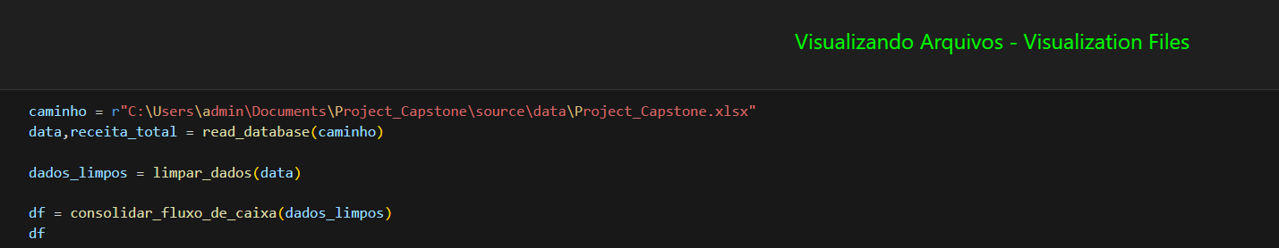

- The dataset was exported in two formats: Excel(.XLSX) and CSV, ensuring flexibility for subsequent processing stages. With the data preparation completed, the project can now advance to the predictive modeling phase.

