

Financial Forecasting System for Small Rental Business
Project Capstone

Ali Wahdat
Viviane Cristino
ADVISOR: Prof. Humera Noor Minhas

Table of Contents

- Introduction & Problem Motivation
- Problem Statement
- Background & Literature Review
- Project Structure Overview
- Data
- Model and Analysis
- Results and Recommendations
- Conclusions
- Acknowledgements
- References

Introduction & Problem Motivation

Líder Real Estate, founded in 1974, has evolved from a single-agent operation to a recognized player in the regional real estate market. Over the years, it expanded its services, implemented automation, and professionalized its departments to adapt to increasing competition. Recent changes such as the digitization of payment systems and the strengthening of its sales and marketing operations highlight the company’s ongoing commitment to modernization. This project was initiated to support Líder Real Estate in transitioning toward proactive financial planning through machine learning and business intelligence.
Micro and small enterprises (MSEs) operate under severe resource constraints so financial planning and risk management is critical and tough. Real estate businesses in this segment have recurring issues with irregular cash flows, delayed payments and operational blind spots that hinder long term growth. Traditional tools like spreadsheets have limited forecasting capabilities and are prone to human error, commercial solutions are too expensive or too complex for small businesses.
This project proposes the development of a financial forecasting and risk analysis system for small businesses first for a real estate agency, Líder Real Estate. Founded in 1974 Líder has grown consistently and has undergone digital transformation in recent years. However, the company still uses semi-manual processes for financial analysis which creates inefficiencies and hinders proactive decision making.
The primary goal of this capstone is to design and implement a practical data-driven solution capable of importing, processing, and analyzing historical financial data. The system aims to offer insights into cash flow behavior, predict profitability trends, and identify financial risk zones. By incorporating machine learning models, structured data processing, and interactive dashboards, the solution empowers small business stakeholders to make timely and informed decisions.
Ultimately, this work seeks to bridge the digital divide for MSEs by combining affordability with advanced analytics, delivering a scalable and replicable solution for other businesses with similar constraints and data environments.

2. Problem Statement

Small Rental in Brazil like Líder Real Estate often lack sophisticated tools to monitor, forecast, and manage their financial performance effectively. The absence of automated systems results in time-consuming manual processes, limited visibility into future financial states, and reactive decision-making. While spreadsheets may serve basic record-keeping purposes, they fail to support complex forecasting or risk analysis, especially in environments with high variability in cash inflow and outflow.
For Líder Real Estate, a company with decades of history and a growing client base, understanding its financial trajectory has become crucial. As the firm expands its operations in both rental and sales domains, financial planning must evolve beyond traditional bookkeeping. The company needs a solution that not only consolidates historical financial data but also interprets trends, identifies risks, and projects future performance.
The core problem addressed in this project is the absence of a practical, affordable, and data-driven system to analyze financial operations and predict future cash flow and profitability patterns for a small enterprise. The project tackles challenges such as inconsistent data formats, incomplete information, and the need for feature engineering to transform raw financial data into actionable insights.
The proposed system must be simple enough for non-technical users to operate, yet robust enough to deliver reliable forecasts and risk indicators. It must also support regular updates through manual or semi-automated data entry, providing flexibility without compromising analytical depth.
The analysis begins with data collection and cleaning of six months of historical financial records, followed by normalization and feature engineering to derive new metrics such as cumulative expenses, monthly variation, and profit margins. Predictive models are trained to forecast future cash flows and detect patterns indicative of financial risks. The system architecture integrates Python-based scripts for data processing, Excel spreadsheets for structured storage, and Power BI for dashboard visualization. The analysis is confined to financial variables—revenues, expenses, payment methods, and seasonal trends—without incorporating non-financial data such as customer demographics or market trends. The final solution is designed to be scalable, allowing adaptation for other micro-enterprises with similar operational structures.

3. Background & Literature Review

Financial forecasting has long been a critical element of business planning, yet micro and small enterprises (MSEs) often struggle to access tools that support reliable projections and risk mitigation. Traditional solutions are typically tailored to large corporations and require integration with complex Enterprise Resource Planning (ERP) system resources that smaller firms lack both the budget and technical capacity to implement. As a result, many MSEs rely on spreadsheets and manual processes, which are prone to error and offer limited predictive insight.
Recent advancements in data science and business intelligence offer a promising alternative. Literature in the field emphasizes the importance of data preprocessing, normalization, and feature engineering to enable effective predictive modeling (Zhou et al., 2021; Han et al., 2016). Predictive models such as linear regression, time series forecasting, and machine learning algorithms like Random Forest or XGBoost have shown strong results in financial analysis, particularly when paired with clean, structured datasets.
Prophet, developed by Meta, is a time-series forecasting tool optimized for business data. It accommodates seasonal effects, missing data, and holiday influences. Literature has shown that Prophet performs well with daily, weekly, and monthly financial datasets, making it ideal for small business use cases.
Studies also highlight the role of data visualization in enhancing decision-making for non-technical users. Dashboards powered by tools like Power BI or Tableau allow businesses to interact with data in real time, simplifying the interpretation of trends and forecasts (Few, 2012). According to studies from the U.S. Small Business Administration (SBA), poor financial planning is a leading cause of small business failure. Forecasting models such as ARIMA and exponential smoothing have traditionally dominated financial analytics, but recent advances favor more flexible tools like Facebook Prophet.
In the context of small businesses, case studies have shown that low-cost, tailored analytical solutions can improve cash flow management, help anticipate periods of financial strain, and support more strategic allocation of resources (Kearns & Sabherwal, 2007). However, few documented solutions integrate both predictive analytics and interactive dashboards in a lightweight framework specifically designed for MSEs.
This project contributes to that gap by developing a financial analysis system customized to the operational realities of Líder Real Estate. It builds on existing research by applying core data science techniques within a practical, real-world business context and aims to deliver a replicable model that can support other small enterprises facing similar challenges.
4. Project Structure Overview
To ensure clarity, traceability, and efficiency throughout the project development, a well-defined architecture and task management methodology were implemented, combining technical structure and agile workflow principles.
4.1. Project Architecture
The system architecture was designed to manage financial data flow and enable predictive modeling for risk analysis. The pipeline begins with the upload of financial datasets by the user in formats such as .xlsx, .csv, or, in future versions, directly from SQL databases. Once uploaded, the data undergo cleaning, normalization, and consolidation using Python libraries such as Pandas and NumPy.
The cleaned data is stored in a consolidated Excel file, which serves as the main input for the forecasting model built with Prophet. This model predicts cash flow, trend patterns, and risk alerts based on historical data. The results are then exported in .xlsx format and visualized through interactive dashboards in Power BI.
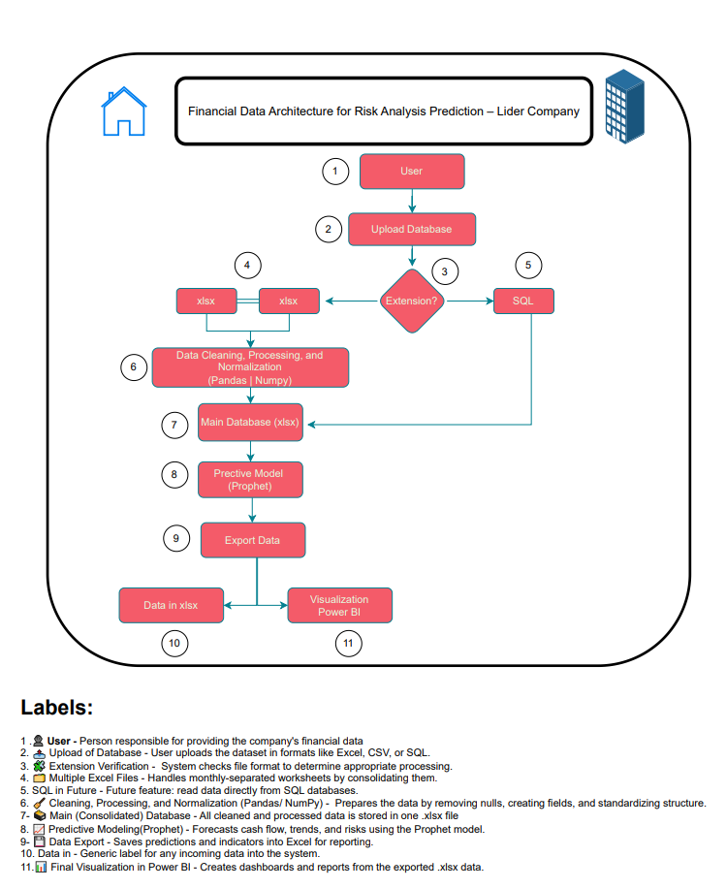

4.2. Data Dictionary
A comprehensive data dictionary was created, covering both the financial input table and the forecast output table. Each column was documented with detailed descriptions to ensure transparency, proper data interpretation, and trust in the automated analytics pipeline.
4.3. Task Management Methodology
Project management was conducted using GitHub Projects, following a Kanban methodology. Tasks were organized into workflow stages including No Status, Backlog, Ready, In Progress, In Review, and Done. Each task was clearly defined with objectives, estimations, and delivery criteria.
This method enabled incremental and continuous delivery, while version control was maintained through structured Git commits and branch management, allowing for full traceability and efficient collaboration.
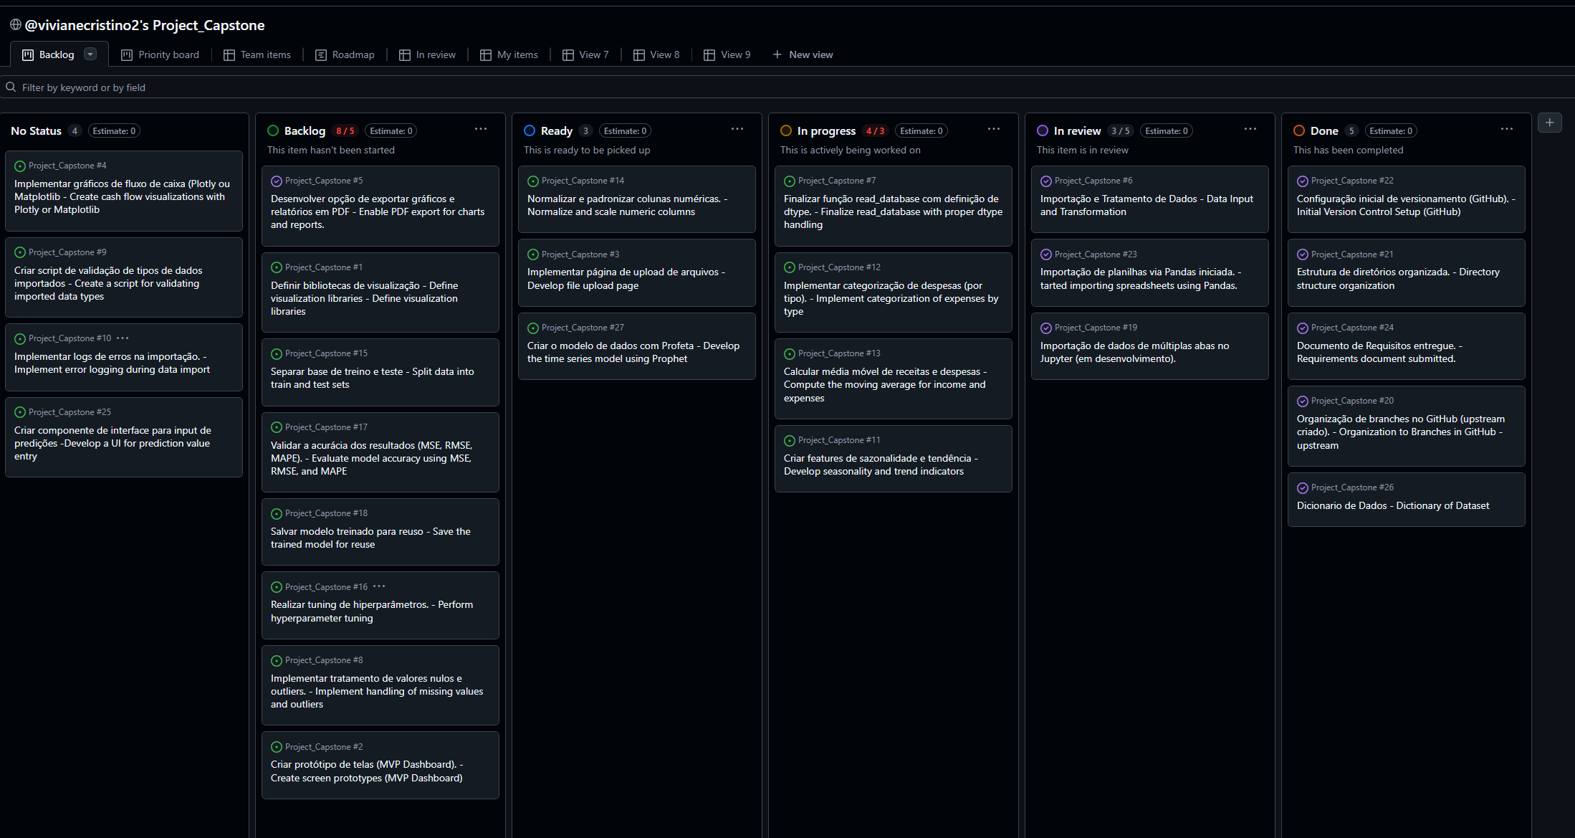
4.4. Documentation and Repository
All project assets — including the data dictionaries, flowcharts, Jupyter notebooks, and visualization outputs — were consolidated in the GitHub repository:
🔗 GitHub – Project Capstone
This integrated approach supported reproducibility of results and provided a clear end-to-end view of the system — from data acquisition and preparation to insight generation and dashboard delivery.

4. Data

The dataset used in this project was derived from six months of historical financial records provided by Líder Real Estate. The raw data was stored in Excel spreadsheets, with each sheet corresponding to a different month. The data contained unstructured entries for income and expenses, with inconsistent formats, missing values, and mixed data types.
To prepare the data for analysis, a multi-step preprocessing pipeline was implemented using Python in Jupyter Notebooks. First, all monthly sheets were consolidated into a single dataset to allow unified analysis. Following this, the data underwent normalization to standardize date formats, numerical precision, and categorical labeling. New columns were engineered to increase the analytical value of the dataset. These included:
- Type (e.g., income or expense)
- Category (e.g., rent, utilities, commissions)
- Payment Method (e.g., cash, transfer)
- Seasonality (month-year indicator)
Additional financial metrics were calculated, such as:
- Monthly variation
- Cumulative expenses
- Cumulative profit
- Profit margin
Empty or null values were handled by exclusion or imputation based on business logic. All expense entries were cast to float type to ensure consistency in downstream calculations. The cleaned and enriched dataset was exported in both .xlsx and .csv formats for flexibility in further processing and dashboard integration.
A data dictionary was also created to define each variable and ensure consistency across all project stages. This resource supported model interpretability and helped non-technical stakeholders understand the inputs and outputs of the system.
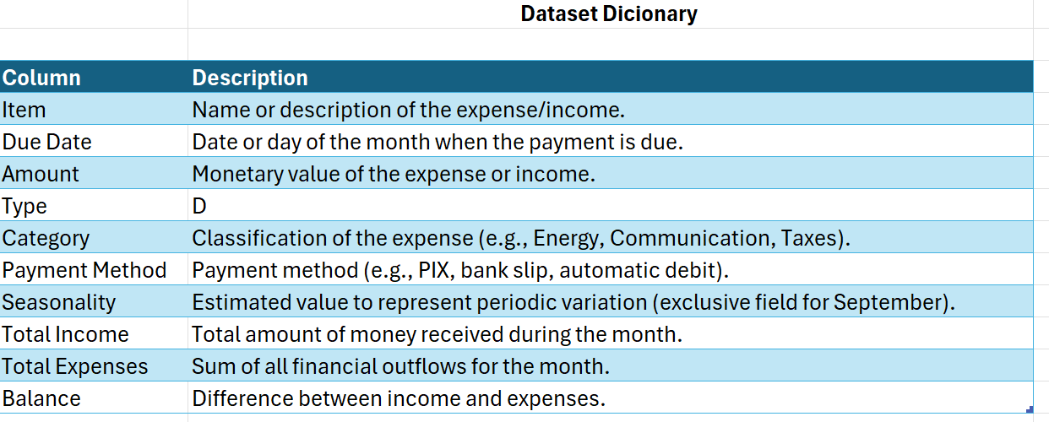
Raw_data

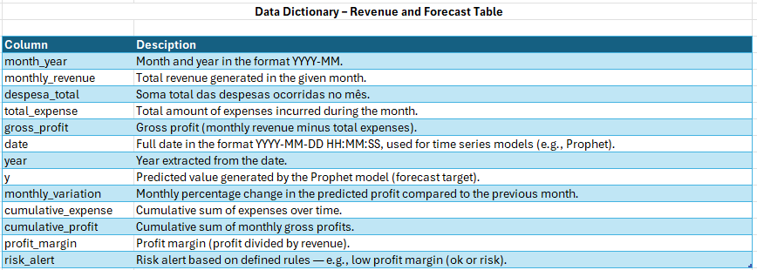

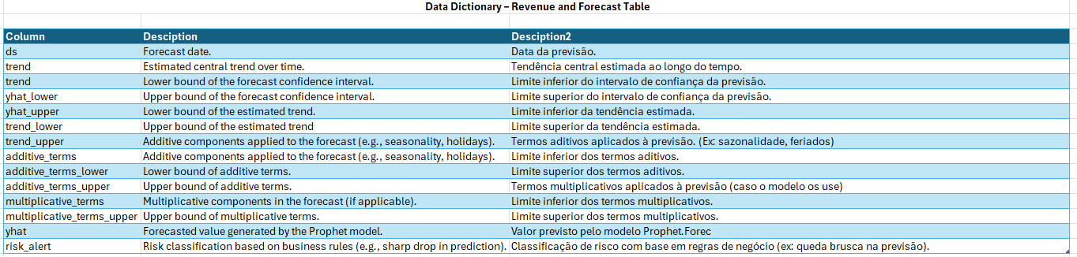

5. Model and Analysis
To forecast financial outcomes and assess potential risks, the project utilized a machine learning pipeline developed in Python using Jupyter Notebook. The analysis focused on predicting cumulative profit trends and identifying expense patterns that could signal financial vulnerability. It consists of two main stages: (1) financial data preparation and cleaning, and (2) time-series forecasting for cumulative profit and expense trends using Prophet.

5.1 Data Preprocessing
In the first stage, the process.ipynb notebook handled the importation and transformation of monthly financial records stored in Excel. A custom function parsed multiple sheets and consolidated them into a single structured dataset. Key preprocessing steps included:
- Column Standardization: Removal of unused columns and harmonization of headers.
- Value Normalization: Custom logic (normalizar_valor) converts string-based currency values (e.g., “R$ 1.234,56”) into consistent float format.
- Data Structuring: Each sheet was labeled and stored in a dictionary format to preserve the month reference and support further aggregation.
These steps ensured the creation of a clean and numerically stable dataset, ready for analysis.
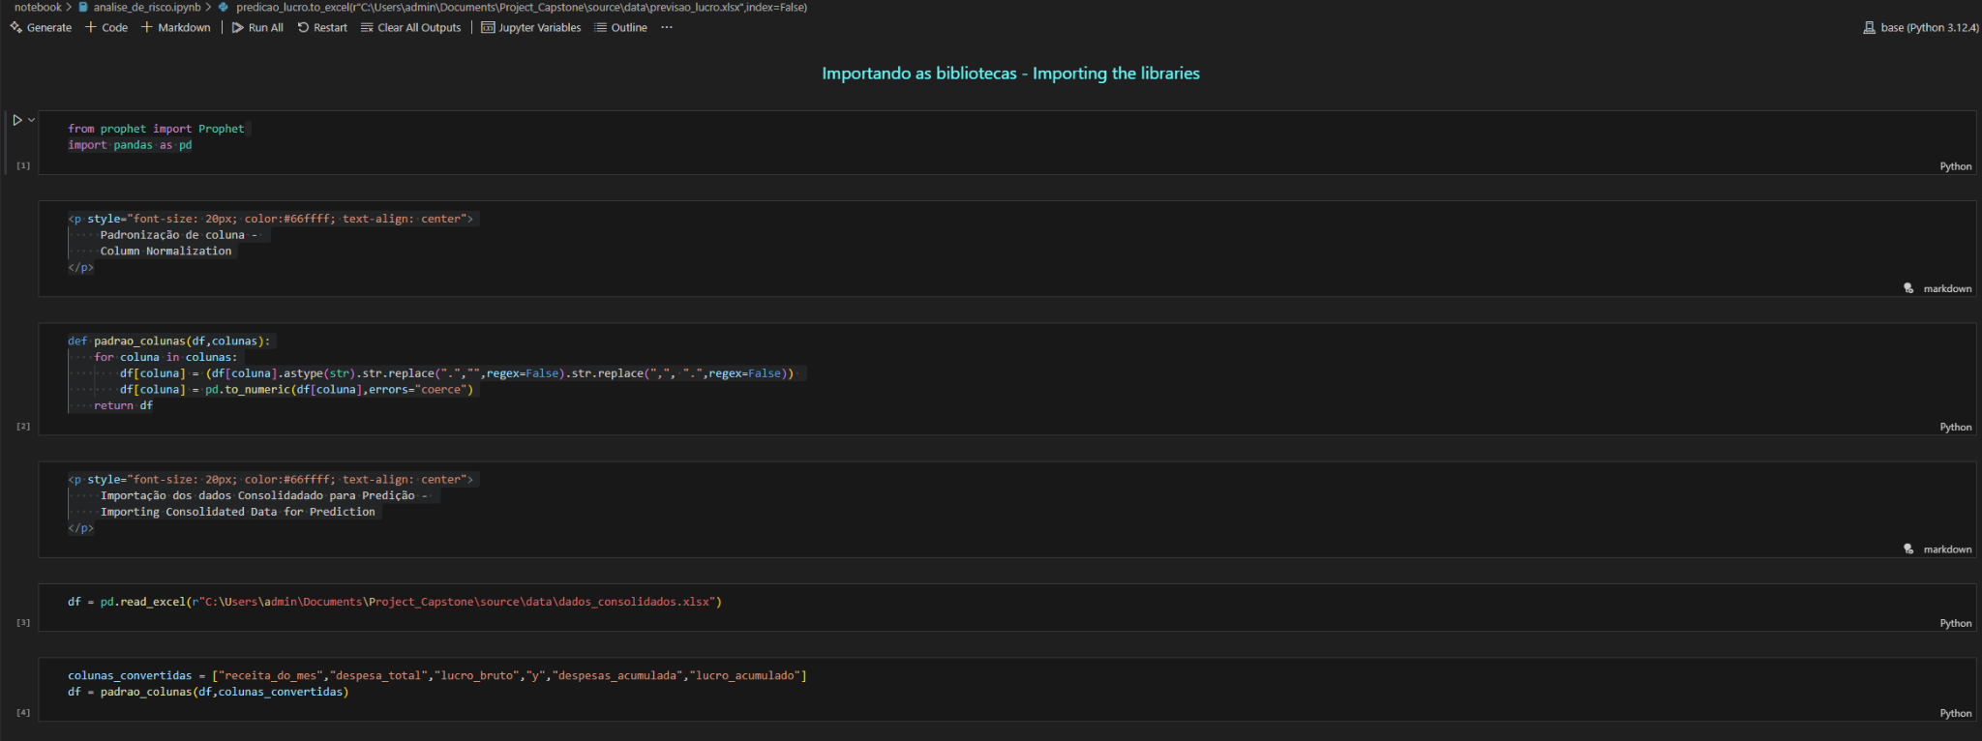
Figure X: Data Loading and Column Formatting Setup
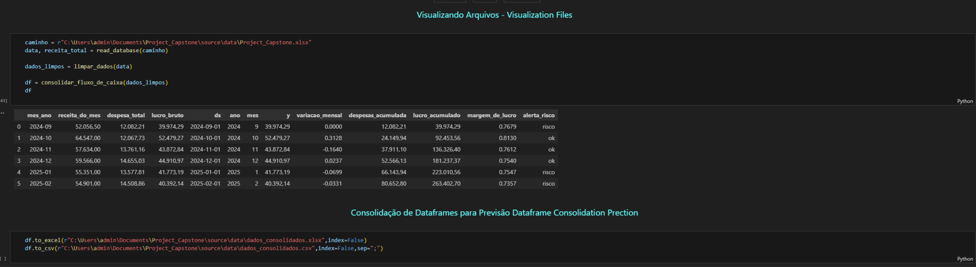
Figure X: Final Structured Dataset for Prediction and ExportFinal processed data, including engineered features and risk indicators, prepared and exported for visualization.

5.2 Forecasting with Prophet
In the second stage, implemented in analise_de_risco.ipynb, the cleaned data was used to build a time-series forecasting model using Facebook Prophet. Prophet was selected due to its ability to:
- Automatically detect seasonality
- Handle missing values
- Deliver interpretable trend forecasts, even on small datasets
The data was structured to fit Prophet’s expected format (ds for date and y for value), focusing on cumulative expense and profit columns. A function was also applied to ensure that numeric fields were converted from European formats (e.g., “1.234,56”) to decimal format recognized by the model. The model was trained on six months of financial data and then extended into future periods to forecast upcoming trends. The goal was to predict:
- Profit accumulation trends (to identify downturns early)
- Unusual growth in expenses (as a financial risk indicator)
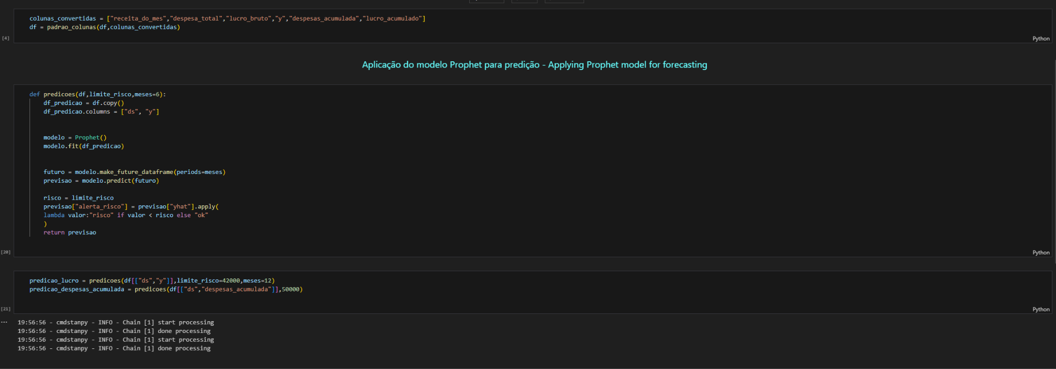
Figure X: Time Series Forecasting with Prophet, Custom function created to apply Prophet for forecasting financial variables, capturing future trends and preparing data for risk evaluation.

5.3 Risk Interpretation
Although Prophet does not directly classify "risk," the forecast outputs were cross-checked using thresholds defined from business rules. For example:
- If predicted monthly expenses exceeded historical highs by 30%, a risk flag was raised.
- If the forecasted profit margin approached zero or became negative, the system flagged potential financial stress.
This enabled a hybrid approach — using time-series forecasting to drive forward-looking insights, and business logic to interpret model outputs into actionable risk categories.
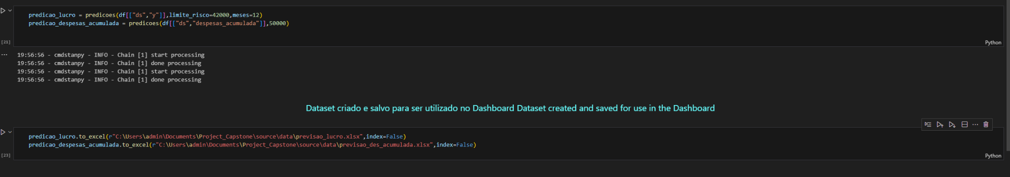
Figure X: Risk Threshold Classification and Data Export, Predictions are evaluated against defined thresholds, and results are saved for dashboard integration and risk visualization.

5.4 Dashboard Integration and Data Modeling
To visualize forecasts and risk metrics interactively, a Power BI dashboard was created based on the outputs of the Prophet model. The architecture behind the dashboard was reverse-engineered to align with the Prophet schema and business logic.

Forecast results were organized into two main tables: TB_PrevisaoDeLucro (profit predictions) and TB_PrevisaoDesAcumulada (cumulative expense predictions). Each included fields such as ds (date), trend, additive_terms, and alerta_risco, a custom-calculated field indicating whether a given period exceeded the defined risk threshold.
These forecast tables were linked to a shared Calendario table using the ds field, enabling dynamic time-based filtering across the dashboard (e.g., by quarter or month). Additional DAX measures were implemented in the _Medida table to calculate metrics such as Cont_Risco_ac (risk count) and MediaIncerteza_Dinamico (mean forecast uncertainty). Tables like _tab_sel and Risco served as slicers and flags for user interaction.
This structured data model allowed the Power BI dashboard to provide a responsive, multi-perspective interface for analyzing profit and expense trends, risk exposure, and confidence intervals supporting real-time financial planning.

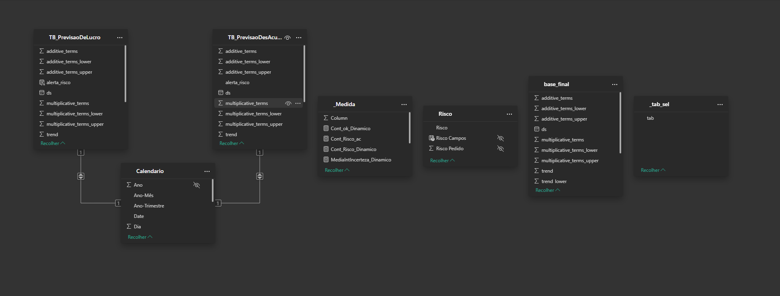
Figure X: Power BI Data Model for Forecast and Risk Analysis

6. Results and Recommendations
The forecasting model developed using Facebook Prophet successfully predicted future trends for both cumulative profit and expenses over the analyzed six-month period. The model revealed a generally increasing trend in monthly expenses, with noticeable spikes projected during specific months likely due to seasonal patterns in operational costs. Conversely, the cumulative profit forecasts showed a slower growth rate, suggesting potential stress on cash flow if current patterns persist. The forecasting system generated 12-month projections for profit and expenses. Two scenarios were analyzed: one focused on monthly profit, and the other on accumulated expenses.

6.1 Profit Forecasting Results
The model predicted profit trends with a threshold of R$42,000 to identify potential financial risks. Out of six predictions, one month was flagged as falling below the risk limit — representing 17% of the projected months. The forecast showed a gradual downward trend, and confidence intervals revealed moderate variability, with a mean uncertainty of R$10.08K. The lowest projected values approached the threshold zone near Q1 2025, which the dashboard visually marked in red.
Forecast Value (Yhat): R$263.39K Confidence Interval: R$232.91K to R$293.39K

6.2 Cumulative Expense Forecasting Results
Using a threshold of R$70,000, the forecast for accumulated expenses showed that three out of six months exceeded the risk level, corresponding to 50% of the prediction horizon. The rising expense trend was flagged as a significant concern. The model's variability was higher in this scenario, with a mean forecast error band of R$418.89, showing less stability than the profit model.
Forecast Value (Yhat): R$263.39K Confidence Interval: R$232.91K to R$293.39K
Visualization of the forecast results in Power BI allowed for clearer stakeholder interpretation. The dashboard included line charts for profit and expense forecasts, risk indicators based on defined thresholds (e.g., 30% expense growth or profit margin below 5%), and filterable views by category and payment method. These features enabled the management team to simulate different financial scenarios and make informed decisions more proactively.
A key finding from the risk analysis was the identification of periods where the forecasted expenses outpaced expected income growth. These risk windows, if unaddressed, could lead to negative profit margins or depleted reserves. Additionally, inconsistent categorization of certain expense types in earlier months affected the model's confidence and should be improved through more structured data entry.
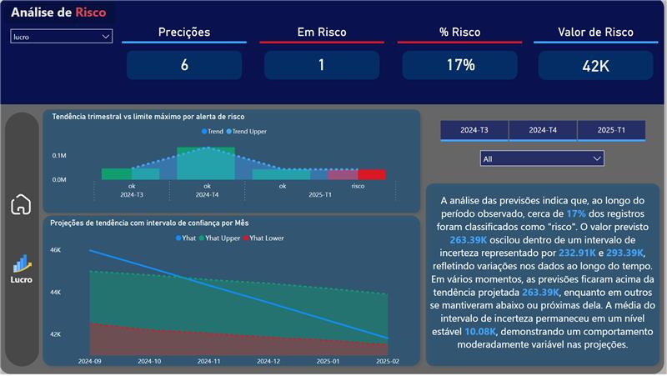
Figure X: Profit Forecast and Risk Zones. Power BI visualization indicating one month (17%) forecasted to fall below the R$42,000 threshold. The dashboard highlights trend behavior and predictive uncertainty across the forecast horizon.
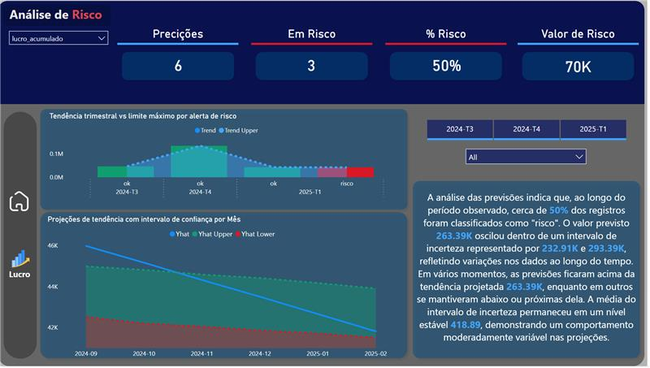
Figure X: Forecasting and Risk Assessment of Cumulative Profit. Power BI dashboard showing that 50% of projected months exceed the R$70,000 threshold, triggering financial risk alerts. The forecast includes uncertainty intervals and a breakdown of quarterly trends.

6.3 Recommendations:
- Implement Structured Financial Recording:
Use the developed Excel template and data entry guidelines to ensure consistent recording of income and expenses going forward.
- Adopt the Dashboard for Monthly Reviews:
Leverage the Power BI dashboard to track real-time trends and detect early warning signs, rather than relying on post-event analysis.
- Refine Category Granularity:
Add subcategories under key expense types (e.g., “Marketing” → “Digital Ads,” “Print Media”) to improve model precision.
- Extend Forecasting Horizon:
Continue logging data monthly and retrain the Prophet model quarterly to improve long-term prediction accuracy.
- Apply Risk Threshold Alerts:
Automate risk flagging logic to trigger when specific financial thresholds are exceeded — improving oversight and response time.

Conclusions

This project sets out to address a critical need faced by micro and small businesses: the ability to predict and manage financial outcomes with minimal resources and technical complexity. By partnering with Líder Real Estate as a case study, the work aimed to develop a scalable, low-cost forecasting solution that supports proactive financial decision-making.
The solution integrates structured data collection, preprocessing via Python, predictive modeling using Facebook Prophet, and interactive dashboards built in Power BI. The system was applied to six months of real-world financial data and successfully generated 12-month forecasts for profit and cumulative expenses.
The results revealed actionable insights, including risk zones in upcoming quarters where profit is projected to fall below R$42,000 and cumulative expenses exceed R$70,000. These indicators were visualized in an intuitive dashboard environment, empowering non-technical stakeholders to assess risk and performance trends with ease.
The project demonstrates how advanced analytical techniques when tailored to the operational realities of small businesses can significantly improve financial transparency and planning accuracy. By enabling a shift from reactive to data-driven financial management, this solution lays the foundation for scalable adoption across similar organizations.
Future enhancements include expanding the system to support scenario simulation, automating data entry through APIs, and incorporating external variables such as market conditions or inflation trends to improve forecast robustness.
This project successfully delivered an automated forecasting system for small businesses using Python, Pandas, and Prophet. The system consolidates raw data, cleans it, forecasts financial performance, and identifies potential risks. It is scalable and adaptable for broader industry use.

8. Acknowledgements
This project was developed collaboratively by Viviane and Ali as part of the EBTM 881 Capstone course. We would like to thank our advisor, Prof. Humera, for her clear guidance and constructive feedback throughout the process.
We also acknowledge the support of Líder Real Estate, whose real-world data allowed us to build and test a solution grounded in practical needs. Business Impact The dashboards were developed in Portuguese, as the client company is based in Brazil and the visualizations will be used directly by internal stakeholders for strategic decision-making. This localization ensures that managers and collaborators can fully interpret the insights generated.
Given the value generated by this forecasting solution, the company has expressed interest in continuing to invest in the project. The future includes the implementation of a centralized database and the development of a web platform that will connect to this data pipeline. This integration aims to deliver near real-time insights to managers and collaborators, enhancing operational responsiveness and decision-making agility.

9. References
Taylor, S. J., & Letham, B. (2018). Forecasting at Scale. The American Statistician, 72(1), 37-45.
GitHub Repository: https://github.com/vivianecristino2/Project_Capstone
U.S. SBA: Financial Management Tips and Resources
Few, S. (2012). Show Me the Numbers: Designing Tables and Graphs to Enlighten (2nd ed.). Analytics Press.
Han, J., Pei, J., & Kamber, M. (2011). Data Mining: Concepts and Techniques (3rd ed.). Morgan Kaufmann.
Prophet Team. (n.d.). Forecasting at scale with Prophet. Facebook Open Source. Retrieved from https://facebook.github.io/prophet/
Microsoft. (n.d.). Power BI Documentation. Retrieved from https://learn.microsoft.com/en-us/power-bi/
Project GitHub Repository. (n.d.). Project_Capstone by Viviane. Retrieved from https://github.com/vivianecristino2/Project_Capstone

