DATA LINK INSTITUTE OF BUSINESS AND TECHNOLOGY

SCHOOL OF COMPUTER SCIENCES

A WEB-BASED PROJECT DEFENSE PLANNING AND TRACKING SYSTEM

APRIL, 2024

DATA LINK INSTITUTE OF BUSINESS AND TECHNOLOGY
SCHOOL OF COMPUTER SCIENCES

A WEB-BASED PROJECT DEFENSE PLANNING AND TRACKING SYSTEM

VIVIAN EYRAM ADJORLOLO
(CS20200015)

A PROJECT SUBMITTED TO THE SCHOOL OF COMPUTER SCIENCES, DATA LINK INSTITUTE OF BUSINESS AND TECHNOLOGY IN PARTIAL FULFILMENT OF THE REQUIREMENTS FOR THE AWARD OF BACHELOR OF SCIENCE DEGREE IN COMPUTER SCIENCE AND INFORMATION SYSTEMS

APRIL, 2024

TABLE OF CONTENTS
CHAPTER ONE .................................................................................................................. 5
1.1 INTRODUCTION .......................................................................................................... 5
1.2 Background to the Study .................................................................................................. 5
1.3 Problem Statement ........................................................................................................... 5
1.4 Research Objectives ......................................................................................................... 6
1.4.1 General Objective .......................................................................................................... 6
1.4.2 Specific Objectives ........................................................................................................ 6
1.5 Significance of the Study .................................................................................................. 6
1.6 Scope of the Study ............................................................................................................ 6
1.7 Proposed Methodology .................................................................................................... 7
1.8 Organization of the Study ................................................................................................. 8

CHAPTER TWO ................................................................................................................... 9
LITERATURE REVIEW .................................................................................................... 9
2.0 Introduction ....................................................................................................................... 9
2.1 Terminologies within the context of web-based project defense....................................... 10
2.2 Potential Gaps in Existing Web-Based Project Defense.................................................... 10
  - Review of existing systems............................................................................................... 12
2.4 The use of technology in academic assessment and evaluation.......................................... 13
2.5 Challenges of online project defense platforms.................................................................. 14
2.6 Traditional processes of reviewing project materials.......................................................... 15
2.7 Importance of the newly improved system.......................................................................... 15

CHAPTER THREE ............................................................................................................. 16
ANALYSIS AND DESIGN OF THE SYSTEM ................................................................ 16
3.1 Methodology ..................................................................................................................... 16

3.1.2 Phases of Agile Model.................................................................................................... 17

3.1.3 Agile Testing Method used.............................................................................................. 18
3.2 Objectives of the project..................................................................................................... 19
3.3 Analysis and design of the System.................................................................................... 19
3.3.1 System Requirements .................................................................................................... 19
3.3.2 Functional Requirements ............................................................................................... 20
3.3.3 Non-Functional Requirements ....................................................................................... 20
3.3.4 Hardware Requirement ................................................................................................... 21
3.3.5 Software Requirement ……………................................................................................ 21
3.4 Tools Used……………..................................................................................................... 21
3.5 System Design.................................................................................................................... 22
3.5.1 Use Case Scenario............................................................................................................ 22
3.5.2 Use Case Diagram............................................................................................................. 23
3.5.3 Entity Relational Diagram................................................................................................. 24
3.5.4 Data Flow Diagram............................................................................................................ 25
3.5.5 System Architecture Diagram............................................................................................. 27

TABLE OF FIGURE
Fig. 2.3 Overview of the FYP procedures………………………………………………………. 12
Fig. 3.1.1 Overview Agile Methodology……………………………………………………….. 18

Fig. 3.1.2 Detailed Overview of Methodology used……………………………………………. 18
Figure 3.5: Student and Supervisor Use Case Diagram………………………………………… 23
Table 3.1: Use Case Table………………………………….……………………….………….. 24
Fig 3.5 Entity Relational Diagram……………………………………………………………… 25
Fig 3.5.4 Data Flow Diagram…………………………………………………………………… 26
Fig 3.5.4 Data Flow Diagram…………………………………………………………………… 27
Fig 3.5.5 System Architecture Diagram ……………………………………………………….. 28

CHAPTER ONE
1.1 INTRODUCTION
1.2 Background of the study
In today’s academic landscape, project defense plays a pivotal role in evaluating students’ understanding, knowledge, and application of their coursework. The Traditional manual process of planning, coordinating, and conducting project sessions often involves administrative challenges, time constraints, and potential communication gaps. As universities and educational institutions increasingly adopt digital solutions to enhance efficiency and accessibility, there arises a need for a comprehensive web-based system that streamlines and elevates the project defense experience [4].
The “DefensePro” project is conceived to address these challenges by leveraging modern web technologies to create a centralized platform for project defense planning, execution, and tracking| 1 |. By seamlessly integrating student engagement, supervisor reviews, and automated notifications. This system aims to transform the project defense process into a more organized, transparent, and collaborative endeavor. The background research highlights the shortcomings of the current manual approach and underscores the benefits of an innovative web-based solution in fostering effective project defense management.

1.3 Problem statement
Within academic institutions, the existing process of project defense planning and tracking lacks an efficient and streamlined approach, leading to administrative complexities, communication gaps, and delays. Other challenges include:
- Communication Gaps: Lack of a centralized communication platform results in communication gaps between students, faculty advisors, and supervisors.
- Administrative Complexities: The manual process involves administrative burdens, such as paper-based submissions and manual review tracking.
- Limited Progress Tracking: Inadequate tools for tracking project defense progress hinder students’ ability to monitor their milestones.
- Feedback Delay: Students often experience delays in receiving timely feedback from supervisors, affecting project improvements.

1.4 Research objectives
1.4.1 General Objective
This system will improve coordination, transparency, and collaboration among students, advisors, and supervisors. By providing automated notifications, progress tracking, and timely feedback, the goal is to enhance the efficiency and quality of project defense sessions.

1.4.2 Specific objectives
To enhance Communication by creating a virtual communication platform for students and supervisors [2].

- To ensure a Streamlined Administration by developing a file upload system that allows students to submit and supervisors to review project defense materials [3].
- To create a centralized platform where project materials are accessed remotely
- To enhance Feedback by designing a visual dashboard that allows students to monitor their project milestones and overall progress.
- To ensure Data Security by implementing a robust login system with secure authentication and role-based access control for students and supervisors.

1.5 Significance of the study
The proposed system aims to enhance efficiency by simplifying project defense processes, ultimately saving time for students, faculty advisors, and supervisors. It promotes transparent collaboration, enabling clear communication among stakeholders and leading to more effective feedback and improved project outcomes. Additionally, the system facilitates timely and detailed feedback from supervisors, contributing to a better understanding and higher quality of projects. Through Automated notifications, it keeps all parties informed with reminders, reducing the likelihood of missed deadlines and encouraging prompt actions. Moreover, the user-friendly interface ensures an intuitive and responsive experience across various devices and screen sizes.
1.6 Scope of the study
1.6.1 User Registration and Enrollment:
- Implement a system for students and supervisors to register and enroll in the platform.
- Collect necessary information and assign roles based on user type.
1.6.2 Login Functionality:
- Develop a secure login system for registered users (students and supervisors).
- Enable access to personalized features and data upon successful login.
1.6.3 Preset Project Defense Sections:
- Create predefined sections for project defense based on selected courses.
- Ensure uniformity and consistency in the presentation of project content.
1.6.4 File Uploads and Management:
- Allow individual file uploads for project defense presentations.
- Implement a file management system for organizing and storing uploaded files.
1.7 Proposed methodology
The proposed methodology for the “DefensePro” project will involve a structured approach to develop a web-based system for project defense planning and tracking. It includes steps such as:
Requirement Analysis:
- Microsoft Excel or Google Sheets (for data collection)
System Design:
- Sketch or Figma (for UI/UX design)
- UML diagrams
Development:
- Integrated Development Environments (IDEs) (Visual Studio Code)
- Version control system (GitHub)
- Programming languages (Python)
- Front-end frameworks (HTML, CSS, JavaScript)
- Back-end frameworks (Django, Python)
- Databases (MySQL)
Testing:
- Postman or Insomnia (for APl testing)
Feedback:
Google Forms or SurveyMonkey (for collecting user feedback)
Data Security Measures:
Hashicorp Vault or AWS Key Management Service (KMS) for encryption and key management
Deployment:
Amazon Web Services (AWS), Microsoft Azure, or Google Cloud Platform (GCP) for cloud hosting
Data Backup:
- Google Cloud Storage for data storage and backup
This methodology will ensure the system’s security, usability, and compliance with regulations, with a focus on meeting the needs of students, faculty advisors, and supervisors. Continuous documentation and user involvement are essential throughout the process.

1.7 Organization of the study
The study is broadly organized in five chapters:
Chapter one: Chapter one (General Introduction) introduces you to the topic and begins with the background to the study, problem statement, research objectives, significance of the study, limitations and the structure of the study.
Chapter Two: The second chapter (Literature Review), also entails review of related literature, it gives a summary of the idea’s opinions and contribution of other researchers and authors which are related to the project.
Chapter Three: The third chapter (Analysis and Design of the system) deals with the methodology used for the study.
Chapter Four: The fourth chapter (System testing, Implementation and Documentation) looked at the data analysis and interpretation of results and findings.
Chapter Five: The last chapter (Summary of findings, Conclusion and Recommendation) of the study covers the summary, conclusion, recommendations and suggestions.

CHAPTER TWO

LITERATURE REVIEW
2.0 Introduction
In recent years, advancements in technology have revolutionized various aspects of education, including assessment and evaluation processes. One significant development in this domain is the emergence of web-based project defense and monitoring systems. These systems leverage the power of the internet to facilitate efficient and effective project assessment, providing a platform for students to defend their work remotely while enabling instructors to monitor progress and provide feedback in real-time.
The transition from traditional face-to-face project defense sessions to web-based platforms has sparked considerable interest among educators and researchers alike. This shift is driven by the potential benefits of online assessment tools, such as increased accessibility, flexibility, and scalability. Moreover, the integration of technology into project defense processes promises to streamline administrative tasks, enhance collaboration, and accommodate diverse learning needs.
However, the adoption of web-based project defense and monitoring systems is not without its challenges. Concerns regarding security, reliability, and the equitable evaluation of student work in an online environment necessitate a thorough examination of existing literature to identify best practices and address potential pitfalls. Additionally, understanding the factors influencing user acceptance and satisfaction with these platforms is crucial for successful implementation and widespread adoption.
This literature review aims to provide a comprehensive overview of research findings, theoretical frameworks, and practical insights related to web-based project defense and monitoring systems. By synthesizing existing knowledge in this field, we seek to identify gaps in current understanding, highlight areas for future research, and inform the design and implementation of effective online assessment strategies in educational settings. The purpose of the review is to examine existing literature on web-based project defense and monitoring systems in education. It aims to:
1. Provide a comprehensive overview of research findings, theoretical frameworks, and practical insights related to these systems.
2. Identify potential benefits, challenges, and best practices associated with their implementation.
3. Highlight areas for future research and address gaps in current understanding.
4. Inform the design and implementation of effective online assessment strategies in educational settings.

2.1 Terminologies within the context of web-based project defense and monitoring systems:
- Project Defense: The process in which students present and defend their projects or research findings before a panel of evaluators, typically including faculty members or industry experts.

- Monitoring System: A platform or tool used to track and oversee the progress of projects, including milestones, deadlines, and tasks. In the context of project defense, it may also involve monitoring student activity during presentations or interactions within the system.

- Web-Based: Refers to applications, tools, or systems that are accessed and operated through a web browser over the internet, without the need for locally installed software.

- Assessment: The process of evaluating student performance or work based on predefined criteria or learning objectives. In the context of project defense, assessment may involve evaluating the quality of project deliverables, presentation skills, and understanding of the subject matter.

- Feedback: Information provided to students by instructors or evaluators regarding their performance, strengths, weaknesses, and areas for improvement. In a web-based project defense system, feedback may be provided asynchronously through written comments or recorded video/audio feedback.

- User Authentication: The process of verifying the identity of users accessing a web-based system, typically through login credentials such as usernames and passwords. User authentication is essential for ensuring data security and controlling access to sensitive information within the system.

- Scalability: The ability of a web-based system to accommodate an increasing number of users, projects, or data without compromising performance or functionality. Scalability is important for ensuring that the system can support growth and meet the needs of a larger user base over time.

2.2 Potential Gaps in Existing Web-Based Project Defense and monitoring systems:

- Limited User Interaction: Some existing systems may lack robust features for interactive communication between students and evaluators during project defense sessions, potentially hindering effective feedback exchange and dialogue.

- Inadequate Feedback Mechanisms: Current systems may offer limited options for providing detailed and constructive feedback on student projects, leading to a lack of clarity or specificity in evaluation criteria and recommendations for improvement.

- Accessibility Challenges: Accessibility features in existing systems may be insufficient or overlooked, resulting in barriers for users with disabilities and impairments, thus compromising inclusivity and equitable access to the platform.

- Security Vulnerabilities: Despite implementing basic security measures, some systems may still be vulnerable to cyber threats such as data breaches, unauthorized access, or malicious attacks, posing risks to the integrity and confidentiality of assessment data.

- Scalability Issues: Certain systems may struggle to accommodate growing user populations or handle large volumes of project submissions and data, leading to performance bottlenecks, delays, or system failures during peak periods.

- Integration Complexity: Integration with existing educational technologies and infrastructure may be challenging for some systems, resulting in compatibility issues, data synchronization problems, or limited interoperability with other platforms and tools.

- Limited Customization Options: Users may encounter restrictions in customizing system settings, workflows, or assessment criteria to align with specific institutional requirements or pedagogical approaches, limiting flexibility and adaptability.

- Inadequate Support Resources: Users may face difficulties in accessing timely technical support, training resources, or documentation to troubleshoot issues, learn how to use the system effectively, or address implementation challenges.

    - Review of existing systems
Case Study of Caritas Institute of Higher Education - The Hong Kong Polytechnic University
Our FYP management system is similar to a typical course management system (CMS), or a project management system. The comprehensive comparisons of CMS had been made by various parties like Unal (2011) and Bremer (2005), especially the two commonly employed systems: Moodle (Dougiamas, 2003) and Blackboard (Blackboard Inc, 2013). ClockingIT (Clocking.com 2008) is a general project management system with licensing free of charge. It provides basic management function like task management with priority assignment to tasks, so that project manager can better arrange manpower and plan the schedule of project. Moreover, it has chat function and forum for ease of communication, while at the same time, it provides share folders for user to access documents and source code simultaneously. This system also included some advanced functions like Gantt chart generator which is a standard tool for project scheduling.
Clement and Bounds (2013) shared similar goal as our system in facilitating the management of FYP. While, their focus was to better connect students with potential supervisors before the project allocation starts. Their system also included tools for assessment submission and collection which are normal functions in a CMS. Bakar et. al. (2011) had reported their experience in developing and using an FYP management system at Universiti Kebangsaan Malaysia. Their system consists of three major modules including user profile, project monitoring and appointment setting modules. Our system also contains similar functional modules as Barkar’s, while we have additional modules like project allocation, file repository and online communication. The HKU CS Project Management System (2014) is a project management system that developed in the University of Hong Kong, Department of Computer Science. The system can show project information, news, schedules and project allocation. In the main page of this system, it includes functions like blogs, calendar and forms downloading. Also, there is a list of projects and related information, as well as some advanced function like providing a virtual machine for students as servers for their FYP.

2.3.2 Existing System Overview
Our system is divided into five modules based on their functionalities; they are project allocation module, communication module, project management module, file sharing & repository, and submission & grading module. These modules are useful for different parties involved in the FYP, they are the Programme Organizers (PO) or Administrator, Supervisor/Marker and Students.
Before the beginning of a year, PO will use the project allocation module to create all users’ accounts and make it ready for supervisors to input their proposed project themes. Later, students can form groups and select project topic through the project allocation module. Before the start of the first semester, PO will allocate projects to each group of students by the automatic allocation function provided, and students will be informed via the system.
When the semester starts, students and supervisors are supported by the system with functions like task management, file sharing, and instant chat and discussion. Finally, students have to submit deliverables like proposals or reports by uploading to the submission and grading module. Marker and supervisors will be notified and insert their score to each project after review.
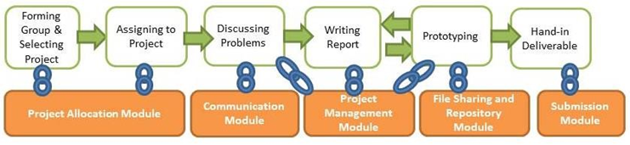Fig. 2.3 Overview of the FYP procedures and related system functionalities from the point of view of students.

2.4 The use of technology in academic assessment and evaluation and how it has transformed traditional methods:
1. Enhanced Efficiency: Technology streamlines assessment processes, from test creation to grading. Automated grading systems, online quizzes, and digital submission platforms save time for educators and provide prompt feedback to students.
2. Diverse Assessment Methods: Technology enables the implementation of diverse assessment methods beyond traditional exams, including multimedia projects, simulations, peer evaluations, and online discussions. This allows educators to assess students’ skills, creativity, and critical thinking in more authentic contexts.
3. Personalized Learning: Adaptive learning technologies tailor assessments to individual student needs, providing personalized feedback and adaptive pathways based on students’ strengths and weaknesses. This approach promotes student engagement and mastery of learning objectives.
4. Data-Driven Insights: Technology generates vast amounts of data on student performance, which can be analyzed to identify trends, patterns, and areas for improvement. Educators can use data analytics to inform instructional decisions, adjust teaching strategies, and provide targeted interventions.
5. Accessibility and Inclusivity: Technology offers accessibility features such as screen readers, captioning, and alternative formats, making assessments more accessible to students with disabilities. Digital assessments also accommodate diverse learning styles and preferences, promoting inclusivity.
6. Remote and Flexible Assessment: Online assessment platforms enable remote and flexible assessment options, allowing students to complete assessments anytime, anywhere. This flexibility accommodates diverse schedules and enhances accessibility for distance learners.
7. Security and Integrity: Ensuring the security and integrity of online assessments is a critical consideration. Technology provides tools for plagiarism detection, secure exam proctoring, and identity verification to maintain academic integrity and deter cheating.
8. Professional Development: Integrating technology into assessment practices requires ongoing professional development for educators. Training programs and resources help educators develop digital literacy skills, explore new assessment tools, and implement best practices in online assessment and evaluation.

2.5 Challenges of online project defense platforms:
- Technical Issues: Connectivity problems, platform crashes, or compatibility issues with different devices and browsers can disrupt the smooth conduct of project defense sessions, leading to frustration and delays for both presenters and evaluators.

- Security Concerns: Ensuring the integrity and confidentiality of project materials and assessment proceedings is paramount. Online platforms may be susceptible to hacking, data breaches, or unauthorized access, raising concerns about the protection of sensitive information and academic integrity.

- Quality of Interaction: Online project defense platforms may lack the spontaneity and interpersonal dynamics of face-to-face interactions. Presenters may struggle to convey their ideas effectively, and evaluators may find it challenging to gauge non-verbal cues or engage in meaningful dialogue, potentially impacting the quality of feedback and assessment outcomes.

- Accessibility Barriers: Students with disabilities or limited access to technology may face barriers in participating fully in online project defense sessions. Ensuring that platforms are accessible and inclusive for all users is essential to promote equitable access and participation.

- Technical Skill Requirements: Students and faculty may require training and support to navigate and use online project defense platforms effectively. Technical proficiency and familiarity with the platform’s features are essential for ensuring a smooth and successful defense experience

- Internet Connectivity: In regions with unreliable internet connectivity or limited access to high-speed internet, conducting online project defense sessions may pose challenges. Poor internet connectivity can lead to disruptions, audio/video lag, or dropped connections, affecting the overall experience and outcomes of the defense.

- Digital Divide: Socioeconomic disparities in access to technology and internet connectivity can exacerbate inequalities in online project defense. Students from disadvantaged backgrounds may lack the necessary resources or infrastructure to participate fully in online assessments, widening the digital divide.

- Evaluation Validity: Ensuring the validity and reliability of assessment outcomes in an online environment is essential. Evaluators must be confident that the assessment accurately reflects students’ knowledge, skills, and abilities and that the integrity of the assessment process is maintained despite the virtual format.

2.6 Traditional processes of reviewing project materials (Data Link):
- Work on project materials
- Reach out to Supervisor
- Schedule a physical meeting
- Meet supervisor

  - Importance of the newly improved system:

- To ensure a Streamlined Administration by developing a file upload system that allows students to submit and supervisors to review project defense materials [3].
- To create a centralized platform where project materials are accessed remotely
- To enhance Feedback by designing a visual dashboard that allows students to monitor their project milestones and overall progress.
- To ensure Data Security by implementing a robust login system with secure authentication and role-based access control for students and supervisors.

CHAPTER THREE

ANALYSIS AND DESIGN OF THE SYSTEM

3.1.1 Methodology

It is important to fulfil the planning for the implementation phase. This can be done if proper methodology is selected. Methodology is important to make sure all project life cycle activities are being carried out without any shortcuts. Methodology helps the system developers to take one step at a time towards accomplishing the full system. After numerous researches, I selected the Agile Life Cycle Development System.

In the traditional SDLC, software is created on a well-planned pattern. There will be planning, consultation, creation, testing, documentation and launching. This pattern is seen in most software developments. Since it is planned right from the start, it should be efficient as planned. When the plan is properly executed, everything will work as it is written.

To answer that need, a unique model for developing software is created called the Agile methodology. The meaning of Agile is swift or versatile. " Agile process model" refers to a software development approach based on iterative development. Agile methods break tasks into smaller iterations, or parts do not directly involve long term planning. The project scope and requirements are laid down at the beginning of the development process. Plans regarding the number of iterations, the duration and the scope of each iteration are clearly defined in advance

Each iteration is considered as a short time "frame" in the Agile process model, which typically lasts from one to four weeks. The division of the entire project into smaller parts helps to minimize the project risk and to reduce the overall project delivery time requirements. Each iteration involves a team working through a full software development life cycle including planning, requirements analysis, design, coding, and testing before a working product is demonstrated.

3.1.2 Phases of Agile Model:
- Requirements gathering
- Design the requirements
- Construction/ iteration
- Testing/ Quality assurance
- Deployment
- Feedback

1. Requirements gathering: In this phase, you must define the requirements. You should explain business opportunities and plan the time and effort needed to build the project. Based on this information, you can evaluate technical and economic feasibility.

2. Design the requirements: When you have identified the project, work with stakeholders to define requirements. You can use the user flow diagram or the high-level UML diagram to show the work of new features and show how it will apply to your existing system.

3. Construction/ iteration: When the team defines the requirements, the work begins. Designers and developers start working on their project, which aims to deploy a working product. The product will undergo various stages of improvement, so it includes simple, minimal functionality.

4. Testing: In this phase, the Quality Assurance team examines the product's performance and looks for the bug.

5. Deployment: In this phase, the team issues a product for the user's work environment.

6. Feedback: After releasing the product, the last step is feedback. In this, the team receives feedback about the product and works through the feedback.

3.1.3 Agile Testing Method used:
- Scrum framework is an agile development process focused primarily on ways to manage tasks in team-based development conditions.

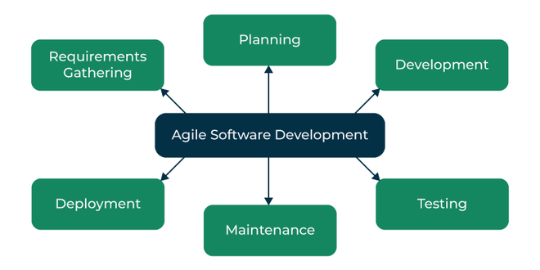

Fig 3.1.1 Overview of Agile Methodology

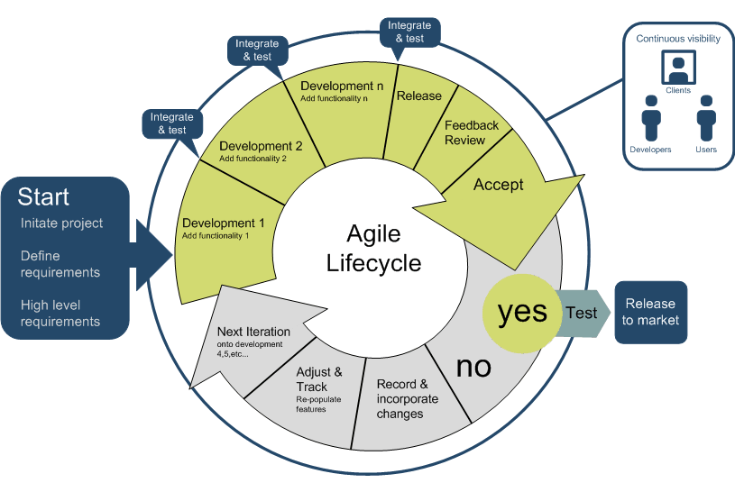

Fig. 3.1.2 Detailed Overview of Methodology used

3.2 Objectives of the project:

The project will among other things achieve the following:

1. Efficient Planning of project plans

2. Progress Tracking of project against the established plan

3. Enhancing Communication and Collaboration by providing a centralized platform

4. Documentation: The system serves as a repository for the project

3.3 Analysis and design of the System
The following are the various requirements of the system;
- System requirements
- Functional requirements
- Non-Functional requirements
- Hardware requirements
- Software requirements

3.3.1 System Requirements
In every system, there are sets of requirements which are often categorized into functional and non-functional requirements. These requirements determine the functions and characteristics of the system to be designed.

3.3.2 Functional Requirements

The functional requirements of a system define the internal workings of the system: that is the calculations, technical details, data manipulation and processing and other specific functionality or services that the system is expected to provide. Below are some functional requirements of the system.
- The system should be able to authenticate authorized users.
- The system should be able to store user’s details.
- The system should enable authorized users to have access to the system and perform various actions based on their privileges, provided they have the right username and password.

3.3.3 Non-Functional Requirements

The Non-functional requirements are not really functions of the system but are also needed to aid the system to run safely. The non-functional does not really have an impact on the software but rather needs its services. Those requirements are appearance, intuition, platform dependency, Database consistency, multi user and Security.
- Appearance: The graphic design of the system has to do the same in the whole application.
- Intuition: The user may be able to use all the systems functionality in an intuitive way.
- Platform dependency: The application should work correctly in the main browsers.
- Database consistency: The new creation, changes or deleting operations should be recorded on the database at the moment.
- Multi user: The system should allow interaction of two or more users at the same time.
- Security: The system prevents unauthorized users to access the system. Authorized users are provided with user id and passwords. In order to achieve high level of security, the password is encrypted. Data confidentiality is also provided through the same means.

3.3.4 Hardware Requirements

Hardware requirement are the physical component of the system that helps a system to perform a given task.
- Laptop or Desktop with at least 80GB hard disk
- Keyboard and Mouse
- Internet Connectivity

3.3.5 Software Requirement
Software Requirement are the programs that communicates with the hardware component in order to achieve a task.
- Operating systems e.g. Windows 10
- HTML, CSS, JavaScript
- MySQL
- Python
- Django

  - Tools Used
3.4.1 PYTHON
This is the main programming language used in the design and implementation of the web application. Version 3.6 has been used because, at the time of designing this system, python 3.6 is the most stable supported version for Geospatial Data Abstraction Library which is very central to GIS technologies used in the system.

    - DJANGO (A python framework)
Django is an open-source framework for backend web applications based on Python — one of the top web development languages. Its main goals are simplicity, flexibility, reliability, and scalability.
Django has its own naming system for all functions and components. It also has an admin panel, which is deemed easier to work with than in other frameworks. Other technical features include its simple syntax, a self-contained web server, a Middleware support; and a powerful templating language for interactive front-end design. The following dependencies work perfectly with Django to render the geospatial capabilities of this web system.
  - PROJ4
  - GDAL
  - GEOS
    - HTML, CSS, JavaScript (Static Files)
These are the main front-end technologies used in the design of this web application.
    - MySQL: for Database Management

3.5 System Design
The system design depicts the structures and framework of the system. It draws a conceptual image of the development of the system. It also defines the database schema and other procedures needed to meet the project requirements.

3.5.1 Use Case Scenario
A use case diagram is a graphical representation that describes the interaction between a user and a system. It displays the relationship among actors and use cases. The actor represents a user or another system that interacts with the system under development and the use case is an external view of the system that represent some actions the user of the system might perform to complete a particular task.

3.5.2 Use Case Diagram
The actors in this instance, the user and the administrator both have access to the system and its resources. However, the administrator of the system has all privileges to the system whereas; the normal user of the system is restricted to specific functions.
Thus, the use cases column of the table below states the allowable actions that can be taken either by both the administrator and the user.
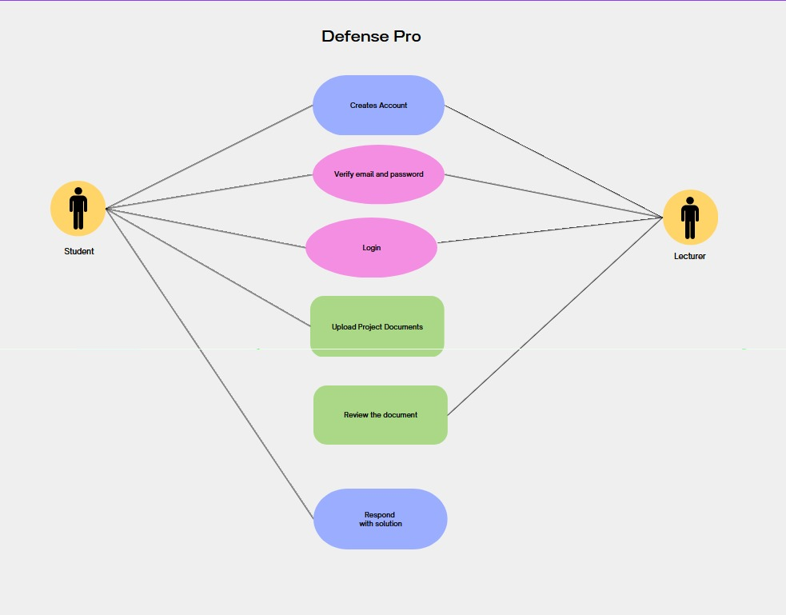
Figure 3.5: Student and Supervisor Use Case Diagram.
The table below gives more insight and a better explanation of the use case diagram above.
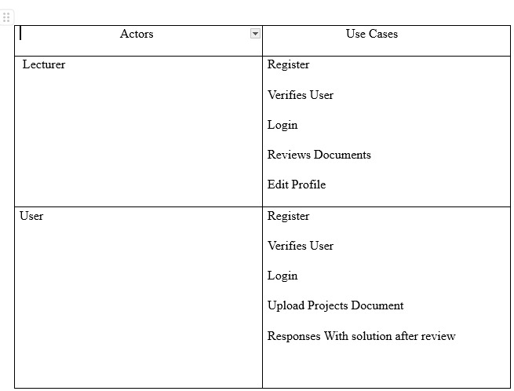
Table 3.1: Use Case Table

3.5.3: Entity Relational Diagram
Entity Relational-modeling is a data modeling technique used in software engineering to produce a conceptual data model of an information system. Diagrams created using this Entity Relational-modeling technique are called Entity-Relational Diagrams.
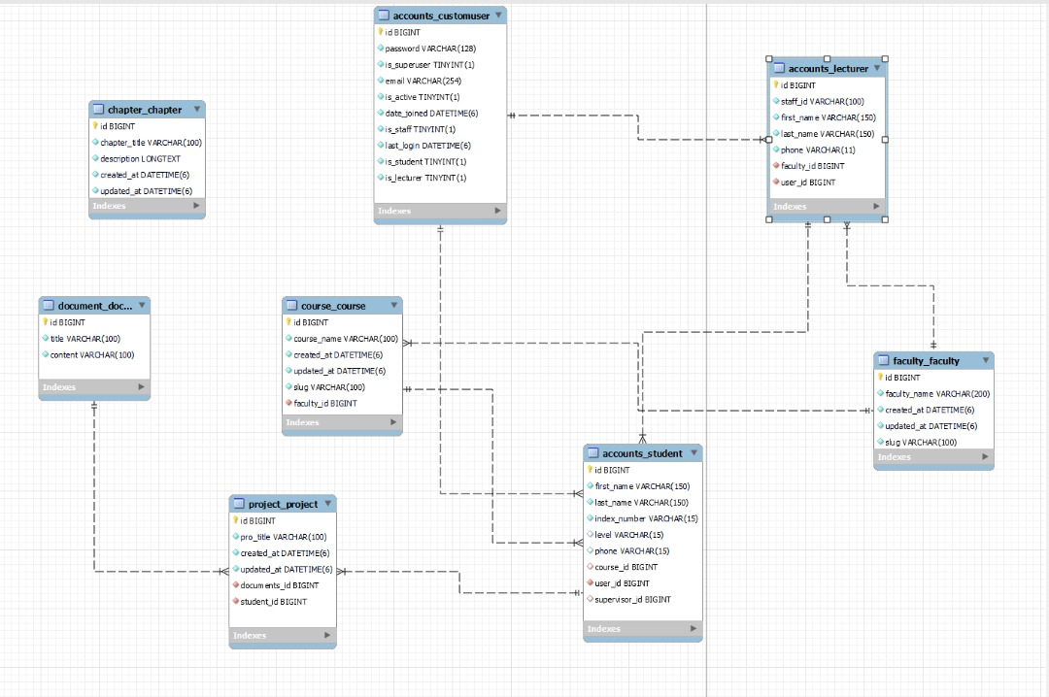
Fig 3.5 Entity Relational Diagram
3.5.4 Data Flow Diagram.
A data flow diagram is a graphical representation of the “flow” of data through an information system, modeling its process aspects. A DFD is often used as a preliminary step to create an overview of the system, which can later be elaborated. DFDs can also be used for the visualization of data processing (structure design). A DFD shows what kind of information will be input to and output from the system, where the data will come from and go to, and where the data will be stored. It does not show information about the timing of process or information about whether processes will operate in sequence or in parallel (which is shown on a flowchart). Below is the dataflow diagram of the system.

Fig 3.5.4 Data Flow Diagram

Fig 3.5.4 Data Flow Diagram

3.5.5 System Architecture Diagram
A system architecture is the conceptual model that defines the structure, behavior and more views of a system. An architecture description is a formal description and representation of a system organized in a way that supports reasoning about the structures and behaviors of the system. System architecture can comprise system components, the externally visible properties of those components, the relationships (e.g. the behavior) between them. It can provide a plan from which products can be procured and systems developed, that will work together to implement the overall system. There have been efforts to formalize languages to describe system architecture, collectively these are called architecture description languages (ADLs).
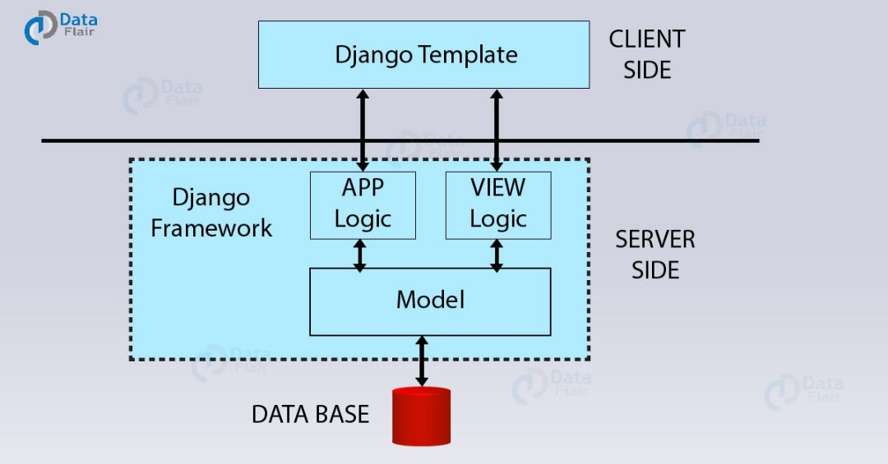
Fig 3.5.5 System Architecture Diagram

REFERENCES
[1]ruAlexander. B., & Dale, E. (2019). The Role of Technology in the Assessment of
Student Learning. EDUCAUSE Review.(https://er.educause.edu/)
[2]1Alves, G. R., & Corchuelo, R. (2019). An Environment for Collaborative Project
Defense in Virtual Learning Environments. *IEEE Transactions on Learning
Technologies*, 13(3), 504-513.
[3]1 Garba, S. M.. & brahim, A. O. (2017). A Web-Based System for Efiicient
Monitoring of Project Supervision and Defence. *International Journal of Computer
Applications*, 160(), 22-28.
[4] Hasan, N. (2018). E-Learning and Its Effects on Teaching and Learning in a
Global Age. *International Journal of Education and Research*, 6(6), 13-22.
[5] Caritas Institute of Higher Education - The Hong Kong Polytechnic University
https://www.researchgate.net/publication/283757588_The_Development_of_a_Final_Year_Project_Management_System_for_Information_Technology_Programmes
[6] Agile Methodology for Software Development
https://www.javatpoint.com/software-engineering-agile-model

