**Number of HIV Diagnosis in New York City**, Vivian Garcia, 15 April 2019

**Motivation and Background**

Over a million people in the United States are living with HIV. While health outcomes are improving, and new treatments are becoming available for viral suppression, 1 in 7 people are unaware of their status. Increasing awareness is important in leading people to get tested and find treatment. I am currently working at the Southern HIV and Alcohol Research Consortium (SHARC) as a data assistant. SHARC has a cohort of people living with HIV in Florida and aims to improve health outcomes and reduce HIV transmission. Becoming curious about the number of HIV diagnoses in other states, I have decided to analyze publicly available data from the City of New York.

The purpose of this paper is to compare the trends in the total number of HIV diagnosis for different ethnicities in New York City over the years 2010-2013. Among people living with HIV, “Blacks/African Americans account for a higher proportion of new HIV diagnosis” (Centers for Disease Control and Prevention, 2019). I am interested in seeing how this difference compares to other ethnicities. I also aim to compare the proportion of each race/ethnicity among people living with HIV in New York City with the proportion of each race in the city in total in the year 2010. If one race/ethnicity was not more significantly affected by HIV than the others, the proportions should be similar to the population proportions.

In addition to race/ethnicity, the change in the number of HIV diagnoses over time can also provide insight. Over time, awareness of HIV increases simply by exposure to the topic. Greater awareness may lead to education that results in reduced transmission and thus less new HIV diagnosis. However, it is also possible that increased awareness may lead to more people getting tested, resulting in new diagnosis. It would therefore also be valuable to know the number of people who were tested, not just the number of positive tests.

**Aims:**

1. Compare the total number of HIV diagnoses in New York City over the years 2010 to 2013.
2. Compare change over time in total number of HIV diagnosis for different race/ethnicities.
3. Compare the proportions of different race/ethnicities among people living with HIV and among the total population of New York City in the year 2010.

**Data Sources:**

The City of New York has a publicly available data set that can be found at data.gov. This includes data on new reported HIV and AIDS diagnoses for the years 2010-2013. The reported cases are stratified by neighborhood, age, and ethnicity, resulting in a data set with 8604 observations. After cleaning the data to my variables of interest, I was able to reduce the data set to 32 observational units that summarize HIV diagnoses by rates and year.

In order to clean the data, I first had to remove observations with an unknown number of reported HIV diagnoses, which was 113 observations. It’s important to note that these observations may have provided a significant difference to the outcome of this report.

Next, I decided to ignore the age categories and save only the observations for all ages, reducing the total number of observations to 1375. I then took the sum of all the total number of HIV diagnoses for each race and year, thereby ignoring the neighborhoods and resulting in my final data set of 32 observations with the following variables:

* RACE.ETHNICITY (8 values, including “all” and “unknown”)
* YEAR (2010-2013)
* TOTAL.NUMBER.OF.HIV.DIAGNOSES

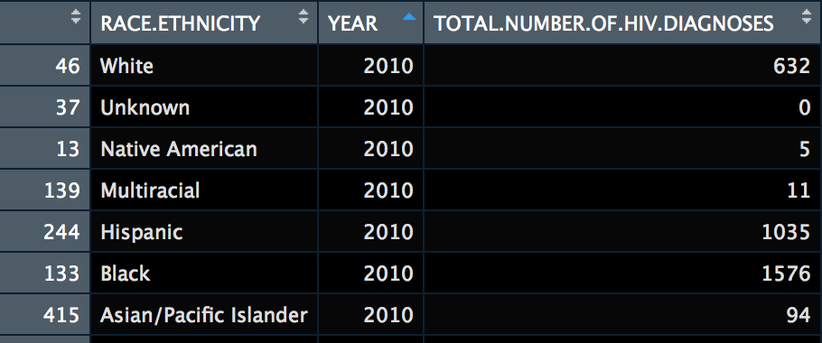

**Aim 1:**

The following plot shows the trend in total number of HIV diagnoses over the years 2010-2013:



The number of HIV diagnoses is decreasing over the years. It is important to note that these are total numbers and does not consider the number of people who were tested or the change in the population. However, the total NYC population increased 5.5% from year 2010 to 2017 (United States Census Bureau, n.d.). Future analysis should consider the trends in administered HIV tests in order to asses if the rate of HIV positive tests is increasing relative to the number of HIV negative tests. It could be that while the total number of HIV diagnoses is decreasing, the total number of people getting tested is also decreasing. However, this is unlikely simply because awareness increases over time, so more people should be getting tested as they become aware of HIV.

**Aim 2:**

There is missing Data for Native Americans for five different neighborhoods. Considering that Native Americans only make up 0.4% of New York City’s population, this amount of missing data may be significant. Thus, I will remove this ethnicity from my analysis due to lack of sufficient data.

The following plot shows the trend in total number of HIV diagnoses over the years 2010-2013 stratified by Race/Ethnicity.



The trends in these lines is similar to our results from Aim 1. The total number of HIV diagnoses is decreasing over time and is still decreasing when stratifying by race/ethnicity. Additionally, it is important to note that the magnitude of differences between races/ethnicities is decreasing over time. That is, the number of people affected by HIV are more similar between the races/ethnicities in 2013 than they were in 2010. We can see from the graph that people who are Black or Hispanic are more affected by HIV than the other races. However, these are raw numbers and do not consider the numbers of each race in NYC as a whole. This leads me to my next aim.

**Aim 3:**

In order to understand the significance of how the different races are affected by HIV, I will compare how the distribution of the races differ between the population of people living with HIV in NYC and the total population of NYC.

To accomplish this, I will be looking only at the year 2010. Taking the total number of HIV diagnoses for each race in my data set I computed the proportion of each race by dividing by the total number of diagnoses in 2010 (n = 3,353). Next, I gathered data from the United States Census for the year of 2010 (n = 8,175,133) in NYC in order to calculate the proportion of each race in the whole city.



New HIV diagnoses in NYC

If HIV diagnoses were independent of race/ethnicity, we would estimate the proportion of each race/ethnicity to be equal between the two populations. From this graph, it is clear that the number of people living with HIV who are black is disproportionate compared to the population of the city. In other words, the black community is largely more affected by HIV than expected. This finding is significant in order to emphasize resources, education, and awareness in these communities. Additionally, the opposite is true for white people. Even though New York is populated more by white people than black people, white people are less affected by HIV. Further research should be conducted in order to analyze how differently these two populations may be receiving resources, whether that be educationally or access to health care.

# Bibliography

Centers for Disease Control and Prevention. (2019, March 19). *HIV and African Americans*. Retrieved from Centers for Disease Control and Prevention: https://www.cdc.gov/hiv/group/racialethnic/africanamericans/index.html

Data.gov. (2019, March 19). *HIV/AIDS Diagnoses by Neighborhood, Age Group, and Race/Ethnicity*. Retrieved from Data.gov: https://catalog.data.gov/dataset/hiv-aids-diagnoses-by-neighborhood-age-group-and-race-ethnicity

United States Census Bureau. (n.d.). *Quick Facts New York city, New York*. Retrieved April 2019, from United States Census Bureau: https://www.census.gov/quickfacts/fact/table/newyorkcitynewyork/PST045217