**What does SEX look like?**

*Visualizing Sexual Health in the United States*

Project Proposal, March 13, 2014

By: Lucas Freitas, Vivian Leung, and Charles Lovett

**1. BACKGROUND & MOTIVATION**

In this project, we seek to develop a clearer, holistic picture of the sexual health landscape in the United States. Sexual health is an important and dynamic aspect of individual and public health which is complexed and influenced by cultural perceptions, sexual preference, varying forms of engagement in sex-related activities, use of contraceptives and protection, sexual health education, media and pornography, and socioeconomic and demographic diversity. We hope to collect data from these dimensions, and by intersecting them visually, uncover new trends and correlations among different social, economic, cultural, and sexual practice factors with disease outcomes among youth and individuals under 30.

As we have yet to collect all the data and parse it, our current visualization is large in scope. Furthermore, some of the data we would love to use relies on outside sources getting back in touch with us (e.g. MindGeek). Recognizing this, a more concrete and centralized project will be outlined once we have pooled all our resources, and we look forward to meeting with our final project advisor and finalizing our product resultantly.

**2. PROJECT OBJECTIVES**

Primary Questions:

* How have sexual practices changed over time, including contraceptive and condom use, sexual activity (and frequency), types of sexual activity, nature of sexual relationships, and engagement in porn and erotic entertainment?
* How do these factors vary among different demographic (i.e. age, sex, sexual preference, religious identification, location of residence) and socioeconomic (i.e. urban/rural, household income, level of education, type of sexual health education) cohorts?
* What is the frequency of STIs and other health outcomes among these cohorts, and, possibly, what are the long-term results?
* Are there correlations between consumption of various categories of pornography, religious affiliation and prevalence per state, sexual health educational practices in primary and secondary schools …

We hope to learn more about the factors that are most important to determining sexual health outcomes among youth and individuals under 30, in order to understand where we as a country are lagging, and how best to improve sexual health education and promote safe sex practices.

**3. DATA**

Sources:

* UN, including WHO, UNAIDS, UNDP (http://data.un.org/)
* CDC
* Gallup.com
* National Survey on Sexual Health and Behavior (Indiana University) (2010) [all findings currently unreleased. Aspects of it available in papers published from data]
* Planned Parenthood
* National Health and Social Life Survey (NHSLS) (1990) <http://popcenter.uchicago.edu/data/nhsls.shtml>

**4. DATA PROCESSING**

We expect to do some data cleanup and consolidation from various sources into a common usable format (CSV files, etc.). To address correlations among factors, we expect to perform some statistical analyses. We plan to get the quantitative data mostly dynamically using various APIs provided by sources, web scraping with Python and JavaScript, and from static CSV files. We are currently reaching out to data sources to acquire sets, and are thus in the process of narrowing down our specific factors.

**5. VISUALIZATION**

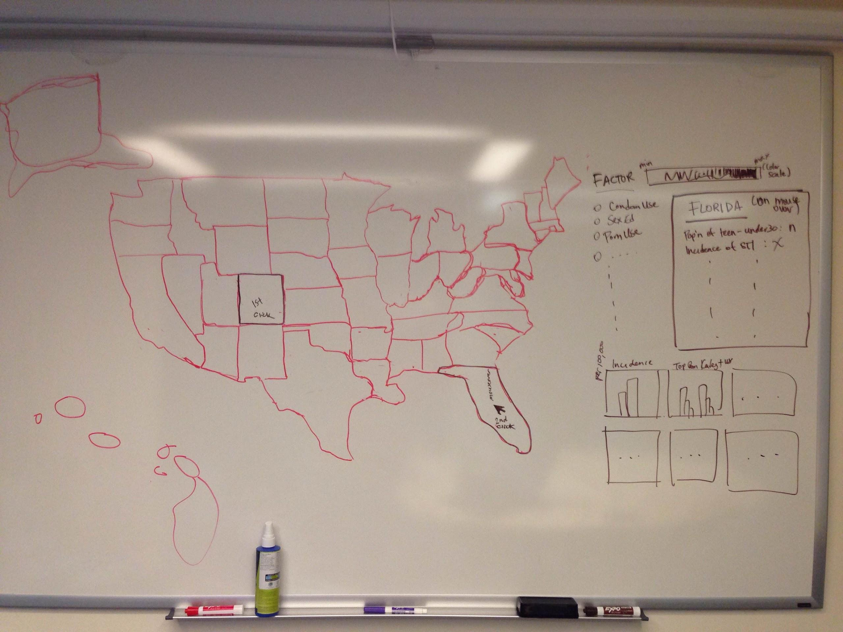

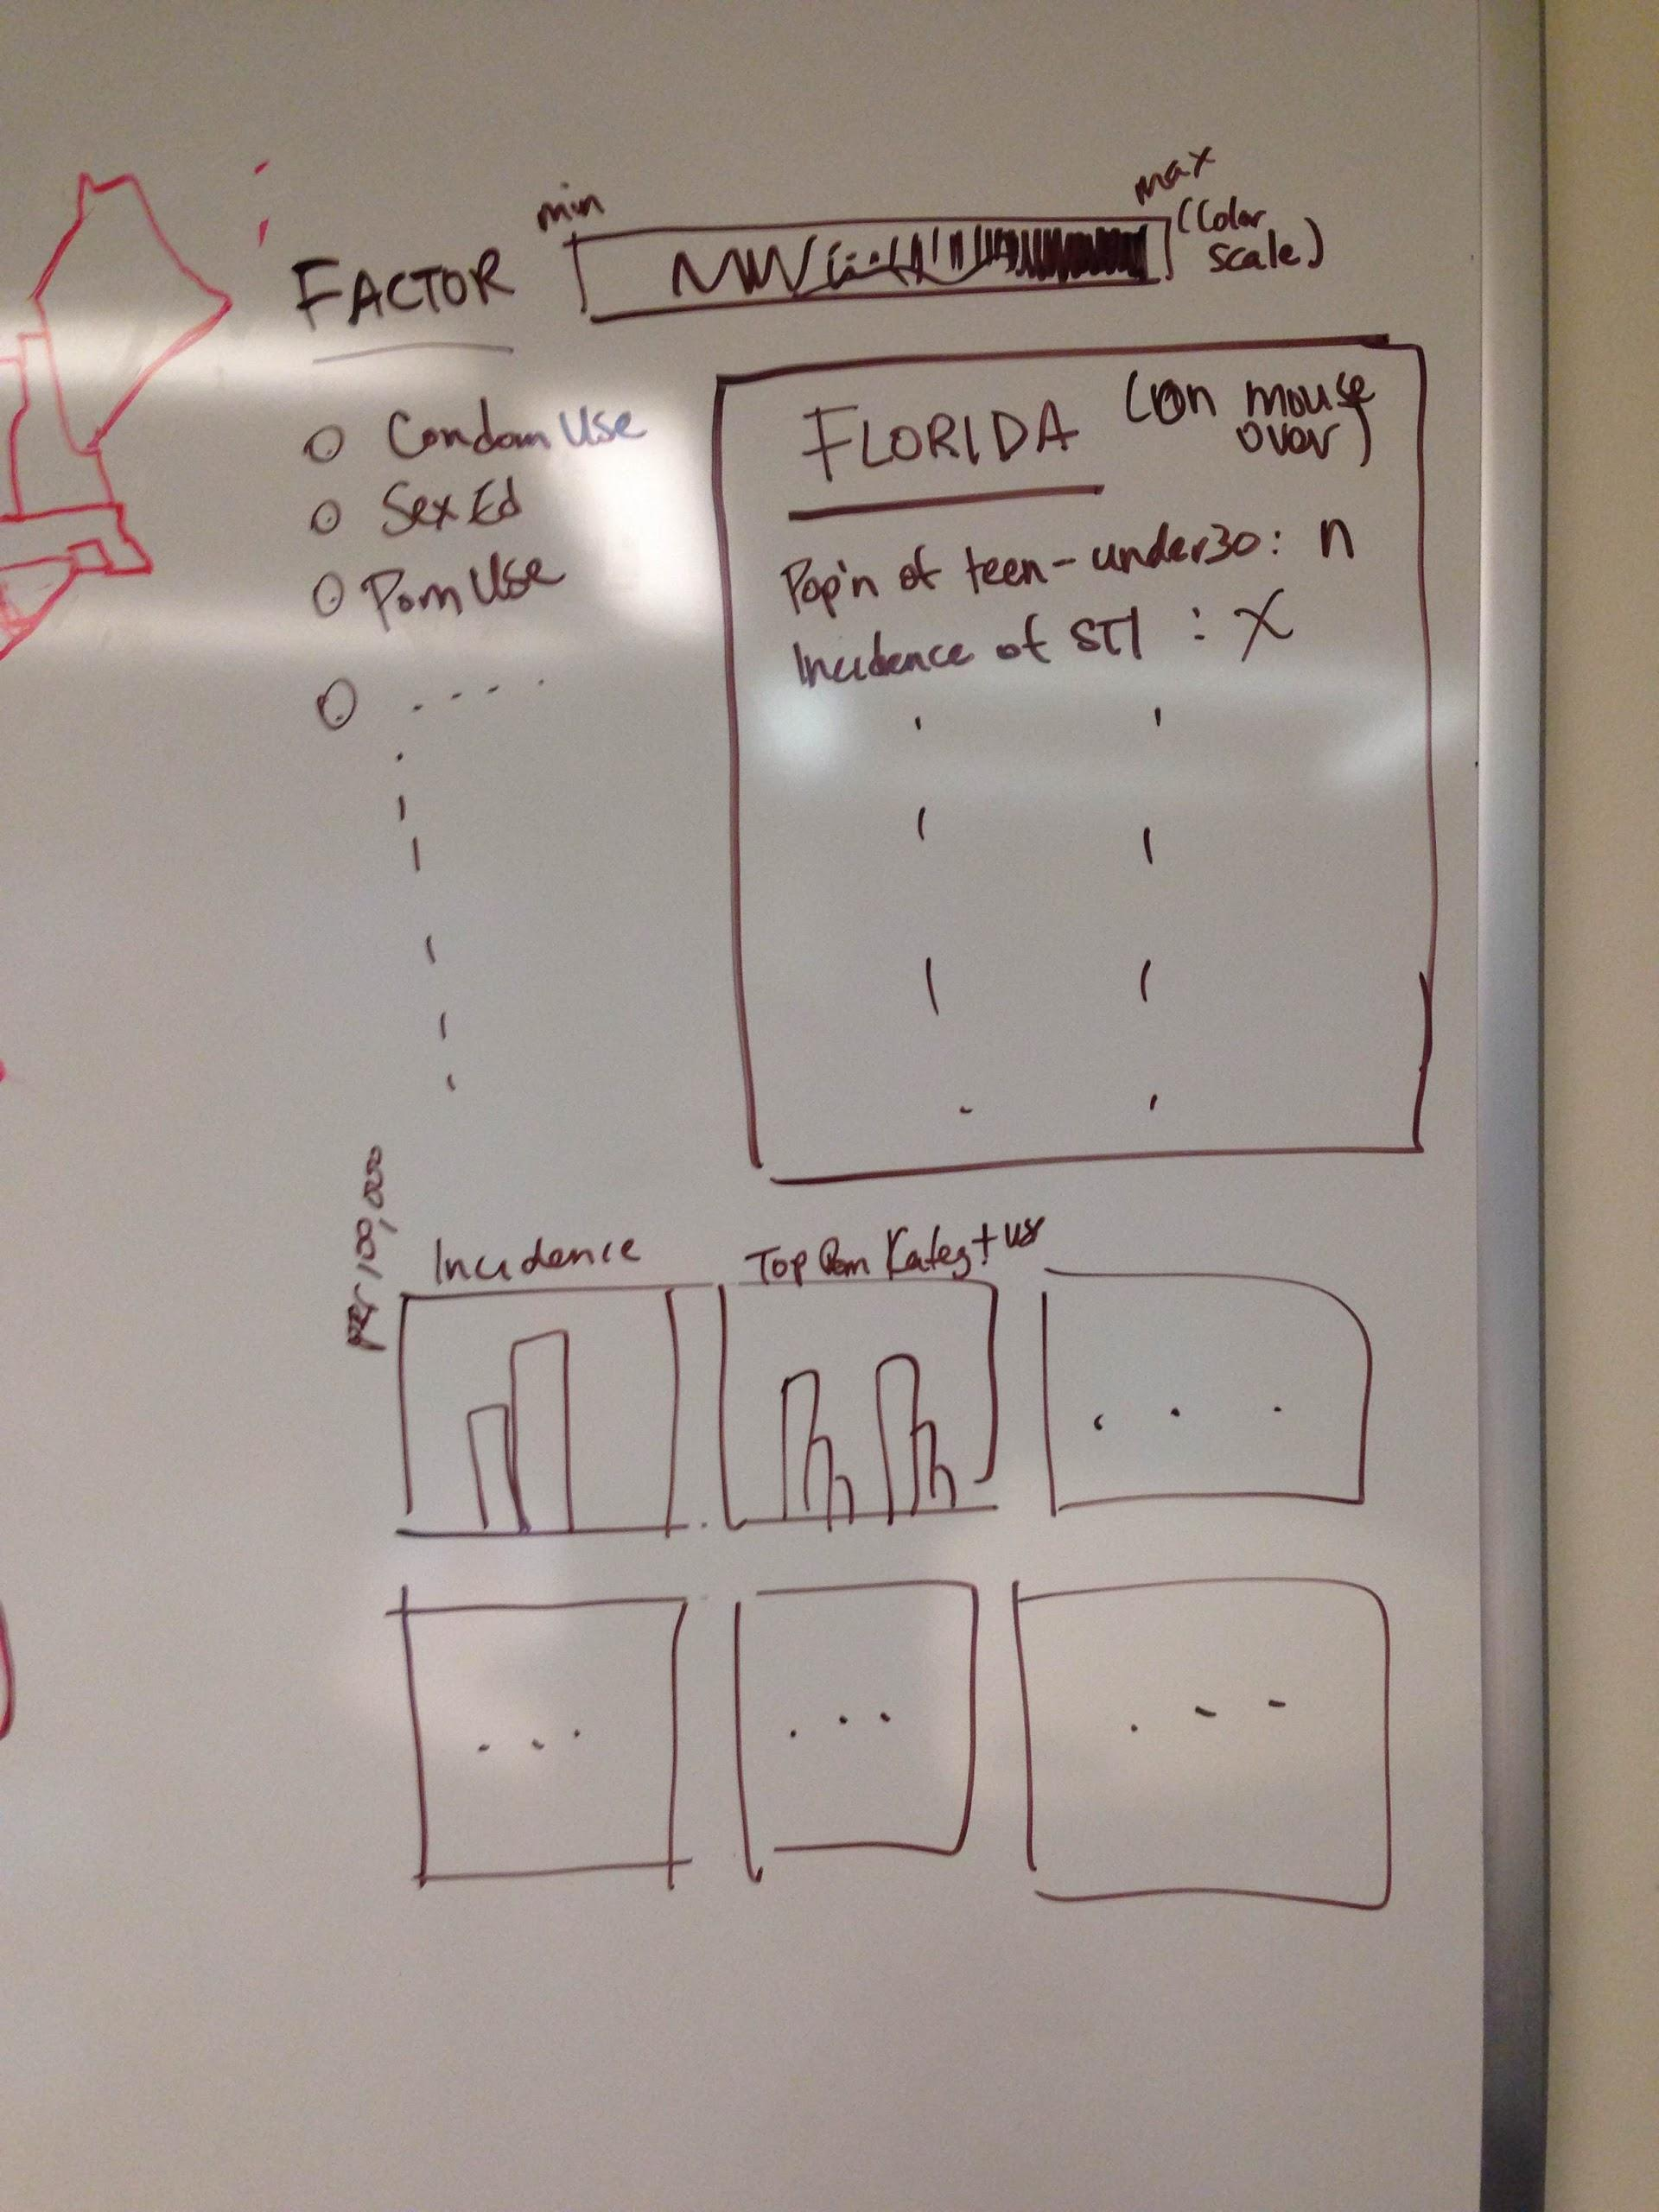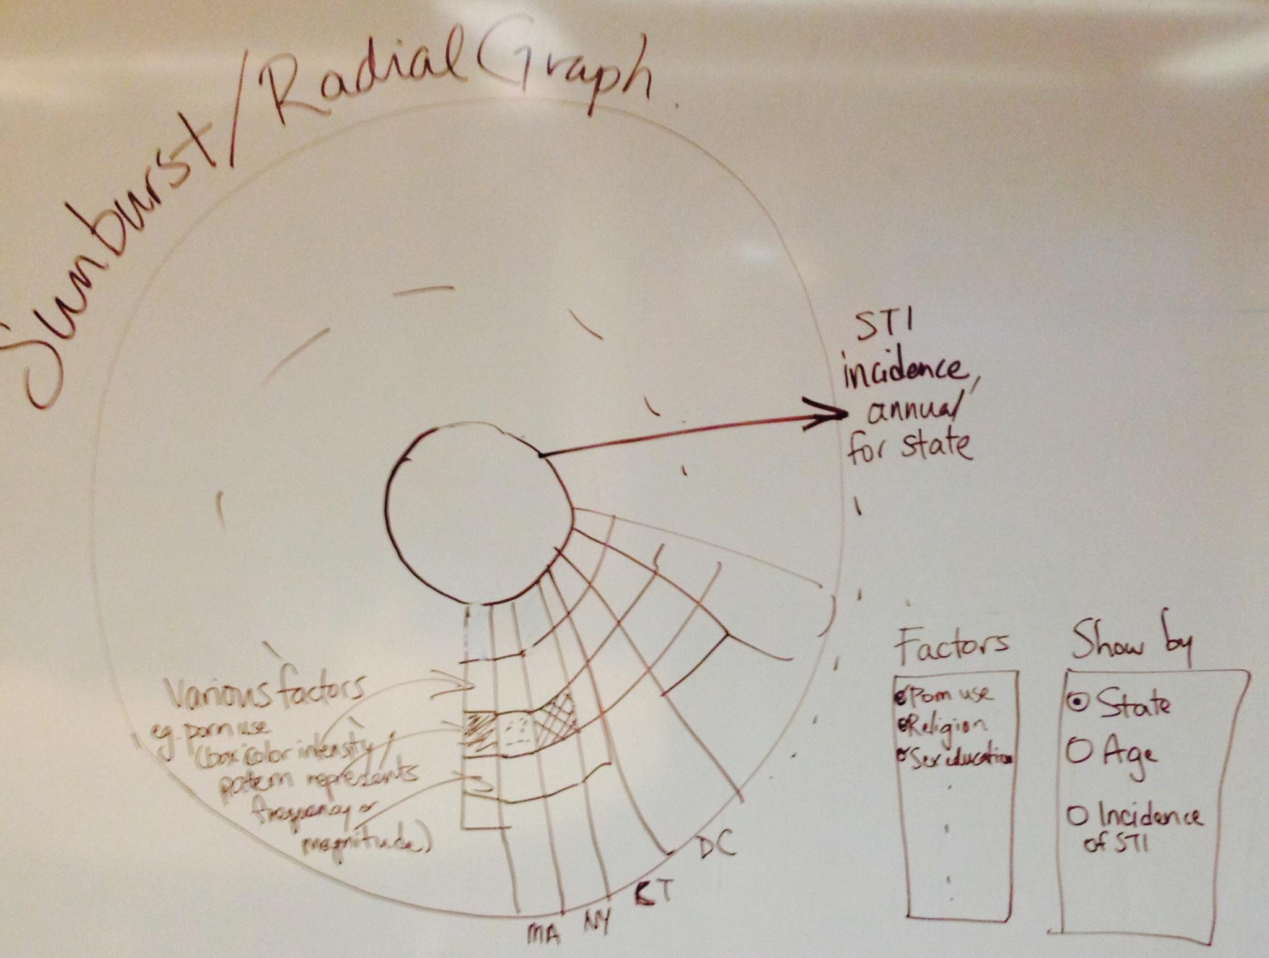

**6. MUST-HAVE FEATURES**

* D3 map of US for states -- toggle factors and show using a color intensity scale of frequency / magnitude of outcomes for states by:
  + Porn consumption by state
    - By total consumption
    - By average duration
    - By preferred category
  + Condom use (ideally including options for FC2 and dental dam use, or other barrier, hormonal, and behavioral birth control methods. However, only condoms, FC2s, and dental dams can prevent the spread of sexually transmitted infections)
  + Religiousness

Users should have the ability to click on a specific state on the D3 map that will resultantly highlight that states specific data in any of the following visualizations:

* Sunburst: each column/ray is a state, and the height of the ray represents incidence or prevalence of STIs in the state. rays are sectioned by different factors (e.g. porn use ) and the color intensity / pattern of the section is determined by the value of the factor for that state.

**7. OPTIONAL FEATURES**

* For the Sunburst, we may have the option to toggle different factors to focus on specific areas, and to toggle different geographic regions. It would also be interesting to include a time scale into the sunburst, and transition through time to see changes in frequency and patterns of sexual behaviors.

**8. PROJECT SCHEDULE**

After spring break, we have three weeks until the functional project prototype is due on April 10th. Semi-weekly meetings until this deadline will be necessary to ensure our project’s must-have features are in operational.

**WEEK MARCH 24th (HW 4 also due)**

* Goal: Get data, finalize variables and implement scraping
  + LUCAS AND CHARLIE WORK HARDER THIS WEEK. Vivian has thesis due on Tuesday.

**WEEK MARCH 30th**

* Goal: Finish any scraping, sketch out and implement preliminary visualizations
  + Buy domain and hosting for website.
* Sketch out website page layout

**WEEK APRIL 6**

* **Deliverable: THURSDAY APRIL 10 -- Functional project prototype due**
* Goal: Looking at results from preliminary visualization, modify/add to visualizations. May be lacking in website design, but visualizations should be functional by the Deliverable.

**WEEK APRIL 13**

* Deliverable: Project review with TFs
* Goal: Implement more complex features for visualizations

**WEEK APRIL 20**

* Goal: Continue implementing visualizations
* If time, potentially start working on bonus/optional/additional features
* Ensure webpage layout is easily navigable.

**WEEK APRIL 27TH,**

* **DUE THIS THURSDAY, MAY 1**
* Goal: fine tune visualizations, add instructions, textual information, refs, etc.