**Meeting Summary 2/24**

1. **Discussion Agenda**
2. Revision of As-Is Business Process Diagram
3. Revision of As-Is Architecture System Diagram
4. Q&A – Budget
5. Q&A – Root Cause Analysis
6. Understand Joe’s specific requirements (functions, designs)
7. **What We Need**
8. **Help us Sign-off the Charter Deliverables**

* Kindly help us sign off the “Ready for Review” items on the Trello Board – Charter Deliverables
* How: Click on each card under the “Ready for Review” column, check “I Approve…”

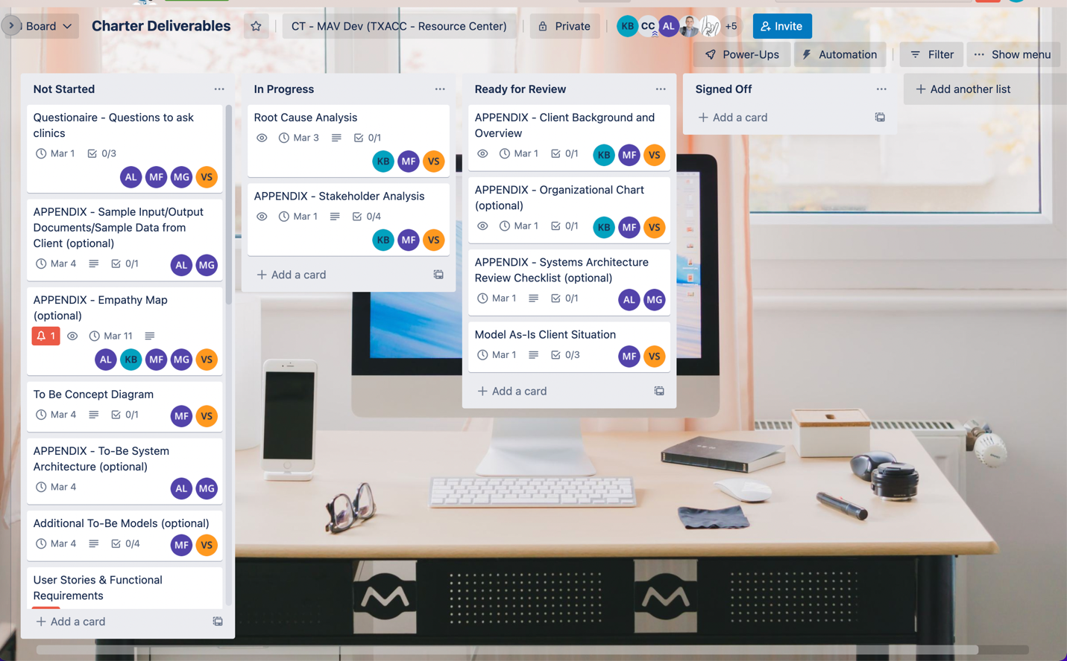

1. **Clinics interview**

* The list includes 3-5 clinics for interview
* The best time for us to reach out to each of them!

1. **Project Tracking**

* Project Tracking (For Meetings and Development)

<https://trello.com/b/r8DXAHG0>

* For Charter Deliverables

<https://trello.com/b/sucG4Wpv>

1. **Next Meeting**

* Time: Tuesday, 3/1 @9:30AM
* Location: Zoom
* Meeting Agenda and Zoom Invitation will be sent out on Saturday (2/26)