**Meeting Summary 5/3**

1. **Discussion Agenda**
2. Landing Page
3. Update Progress
4. **Schedule**

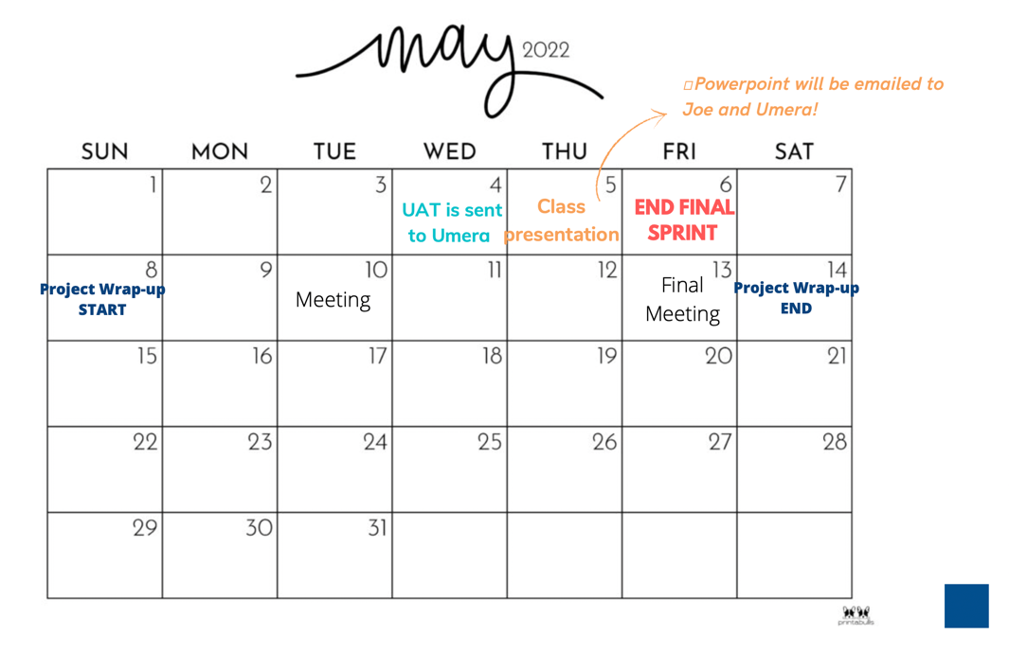

1. **Trello Board**

* Project Tracking (For Development)

<https://trello.com/b/r8DXAHG0>

* Meetings

<https://trello.com/b/x66wisSh>

1. **Next Meeting**

* Time: Friday, 5/6 @1:30 PM
* Location: Zoom