"""

列表推导式
练习:exercise01.py
"""
# 将list01中所有元素,增加１以后存入list02中.
list01 = [5, 56, 6, 7, 7, 8, 19]
# list02 = []
# for item in list01:
# list02.append(item + 1)
list02 = [item + 1 for item in list01]
print(list02)
# 将list01中大于１０元素,增加１以后存入list02中.
# list02 = []
# for item in list01:
# if item >10:
# list02.append(item + 1)
list02 = [item + 1 for item in list01 if item > 10]

"""

元组
基础操作
练习:exercise02.py
exercise03.py
"""
# 1. 创建元组
# 空
tuple01 = ()
# 具有默认值
tuple01 = (1, 2, 3)
# 列表 --> 元组
tuple01 = tuple(["a", "b"])
print(tuple01)
# 元组 --> 列表
list01 = list(tuple01)
print(list01)
# 如果元组只有一个元素
# tuple02 = (100)
# print(type(tuple02))# int
tuple02 = (100,)
print(type(tuple02)) # int
# 不能变化
# tuple02[0] = 10
# 2. 获取元素（索引 切片）
tuple03 = ("a", "b", "c", "d")
e01 = tuple03[1]
print(type(e01)) # str
e02 = tuple03[-2:]
print(type(e02)) # tuple
# 可以直接将元组赋值给多个变量
tuper04 = (100, 200)
a, b = tuper04
print(a)
print(b)
# 3. 遍历元素
# 正向
for item in tuper04:
print(item)
# 反向
# 1 0
for i in range(len(tuper04) - 1, -1, -1):
print(tuper04[i])

"""

字典
15:35 上课
练习:exercise04.py
"""
# 1. 创建
# 空
dict01 = {}
dict01 = dict()
# 默认值
dict01 = {"wj":100,"zm":80,"zr":90}
dict01 = dict([("a","b"),("c","d")])
print(dict01)
# 2. 查找元素(根据ｋｅｙ查找ｖａｌｕｅ)
print(dict01["a"])
# 如果ｋｅｙ不存在，查找时会错误.
if "qtx" in dict01:# 如果存在key
print(dict01["qtx"])
# 3. 修改元素(之前存在ｋｅｙ)
dict01["a"] = "BB"
# 4. 添加(之前不存在ｋｅｙ)
dict01["e"] = "f"
# 5. 删除
del dict01["a"]
print(dict01)
# 6. 遍历（获取字典中所有元素）
# 遍历字典，获取key
for key in dict01:
print(key)
print(dict01[key])
# 遍历字典，获取value
for value in dict01.values():
print(value)
# 遍历字典，获取键值对key value(元组).
# for item in dict01.items():
# print(item[0])
# print(item[1])
for k,v in dict01.items():
print(k)
print(v)

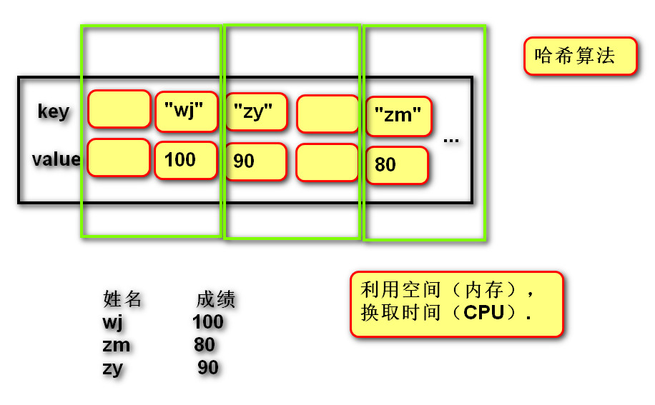
字典内存图

求最小值内存图:

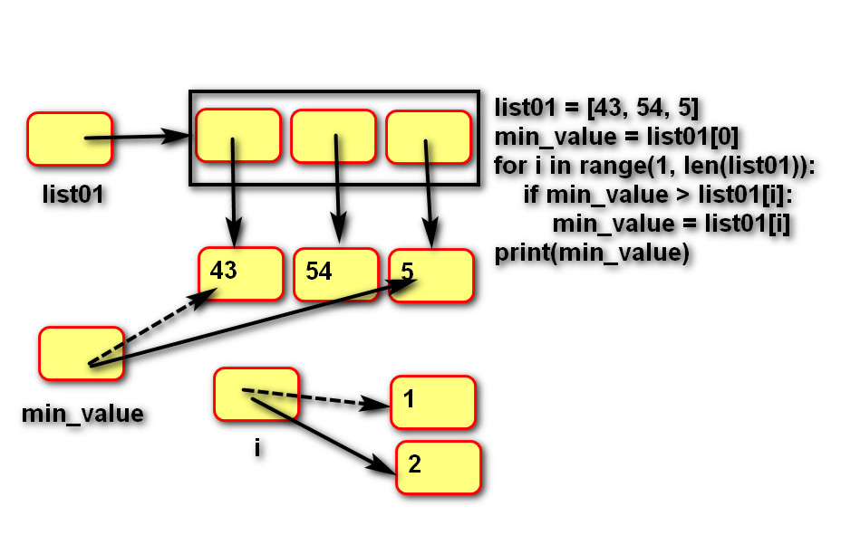

列表与元组

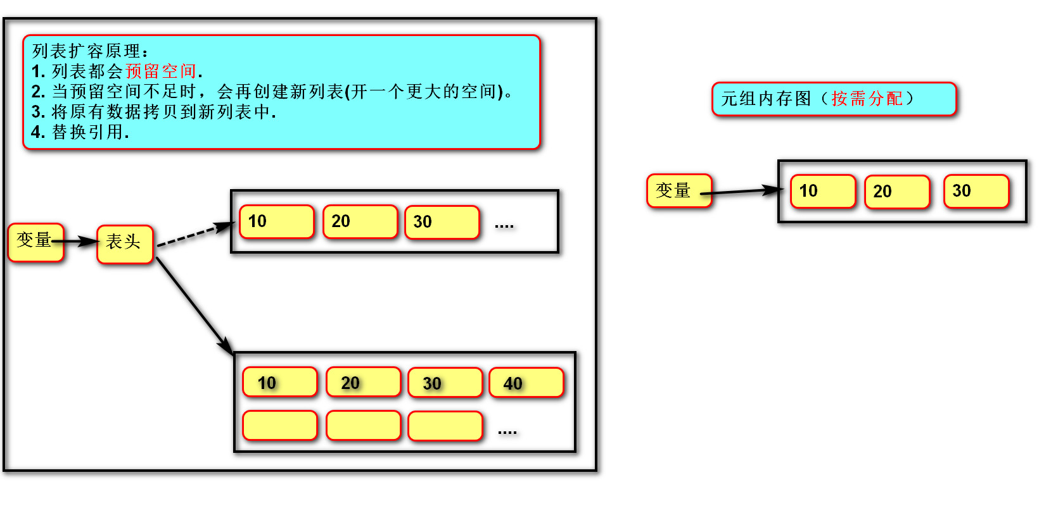
程序扩容

·程序扩容原理,可变意味着预留空间
·切片所得会生成一个新容器(同事耗费一些内存)

