Made by: Bhavmanyu Singh Sisodia |  | ALLOTTED SCHOOL UID: SBVPH-05 | STREAM: PHYSICS
SANJIVANI | संजीवनी | Design and Development of a Sensor-Triggered Hybrid PCM–Peltier Cooling System |  |  |  | STUDENT INVESTIGATORS: | EVENT PARTICIPATION:
HYBRID PCM–PELTIER MEDICAL COLD-CHAIN SYSTEM |  | for Extended Medical Cold-Chain Storage |  |  |  | STUDENT INVESTIGATORS:
 |  |  |  |  |  | • Vaishnavi Shrivastava (Class XI) | SCHOOL UID: SBVPH-05
Preserving Temperature. Protecting Life. |  | COMPETITION: Dr. B. K. Passi Memorial Senior Bal Vigyan 2026–2027 |  |  |  | • Gaurav Choudhary (Class XI) | Senior Bal Vigyan 2026-27 (PHYSICS)
 |  |  |  |  |  | • Prathamesh Rao (Class XII) | Date: 17 November 2026 (Tuesday)
CATEGORY: PHYSICS / THERMAL ENGINEERING / HEALTHCARE TECHNOLOGY |  | NATIONAL FRAMEWORK: STEM for Viksit and Atmanirbhar Bharat • SUB-THEME: Health and Hygiene |  |  |  | • Bhavmanyu Singh (Class XII) | Mentor: Mr. Gopal Kumar Roy
 |  |  |  | HERO ENGINEERING CUTAWAY
  1. THE COLD-CHAIN PROBLEM WHO LAST-MILE CRISIS
  • The Vaccine Wastage Crisis: The World Health Organization (WHO) estimates that up to 50% of temperature-sensitive vaccines (e.g. HPV, Rotavirus, mRNA, Hepatitis B) are compromised globally due to cold-chain breaches during off-grid transit in developing regions.
  • Thermal Trap of Passive PCM: Conventional insulated boxes rely strictly on phase change materials (PCMs) absorbing latent heat (Q = m·L). While isothermal and reliable, PCMs possess a finite thermal energy capacity. As ambient heat inexorably penetrates the insulated shell, the latent reserve depletes monotonically (Qlatent → 0), culminating in rapid thermal runaway.
  • Baseline Constraint: Standard WHO Category A/E vaccine carriers offer approximately 72 hours of thermal hold under 43°C ambient stress—a planning baseline that provides zero contingency margin during logistical delays, monsoon transit hurdles, or severe rural heat pulses.
  4. SANJIVANI SYSTEM ARCHITECTURE & INTEGRATION
  6. QUANTITATIVE SIMULATION & BALANCE | THERMAL KPIS
  • Planning Baseline: 72.0 h (VIP Passive)• Extended Target: 110.0 h (Design Target)• Modelled Hold: 109.4 h (+52.6% autonomy)• Active Run Time: 8.75 h (8.0% duty cycle) | • Active Power: 30.0 W (Dual TEC, 7.5V·4A)• Auxiliaries: 4.2 W (Fans + Micro-Pump)  • Total Mission Energy: 301.2 Wh (Mission total)• Battery Sizing: 12.8V 30Ah (78.4% DOD)
  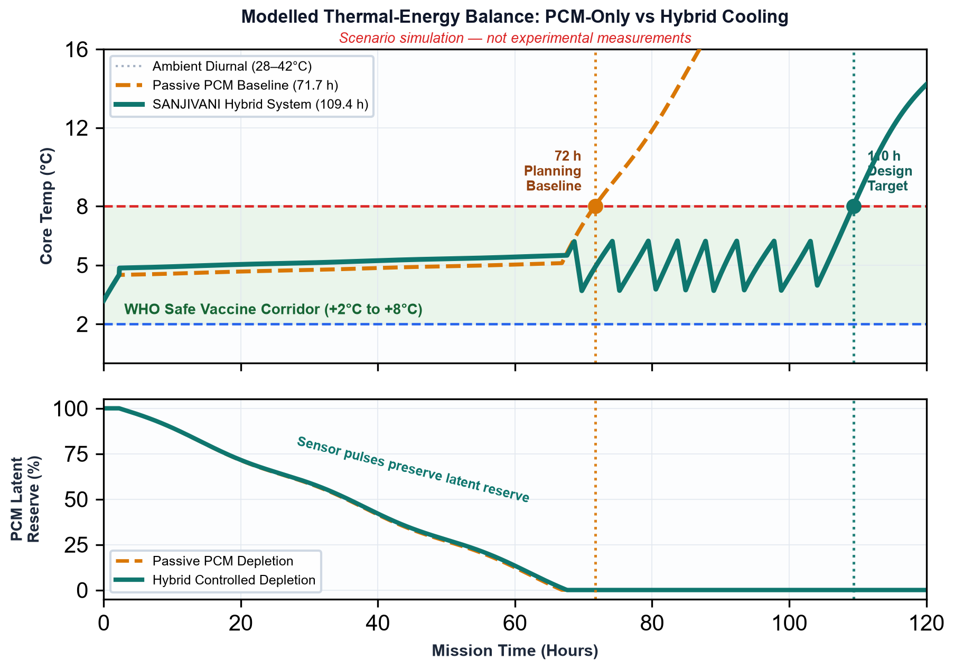
 |  |  | 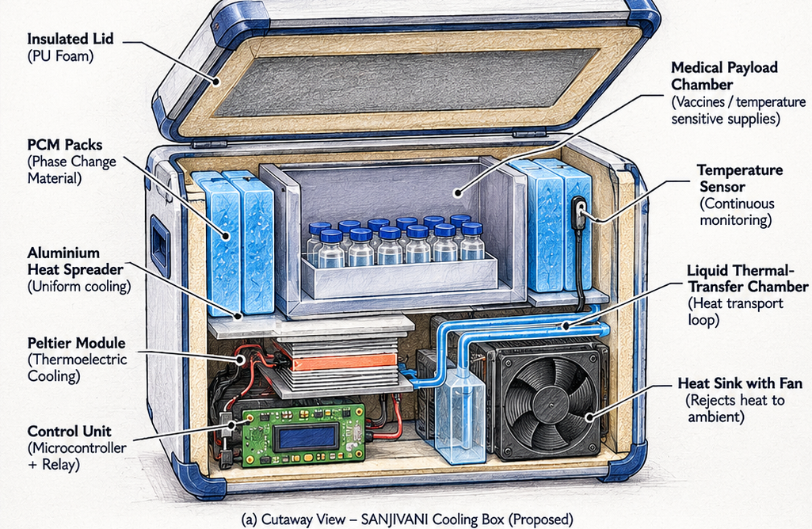
  2. RESEARCH QUESTION & HYPOTHESIS
  CORE THESIS
CENTRAL RESEARCH QUESTION:

“Can sensor-triggered thermoelectric cooling extend the useful temperature-holding duration of a
PCM-based medical cold-chain container beyond 100 hours while controlling electrical energy
consumption?”
• Engineering Hypothesis: Selectively activating solid-state thermoelectric (Peltier) heat pumping only
during peak ambient thermal stress pulses suppresses sensible temperature rise and retards core PCM
phase-change degradation, substantially extending holding autonomy without requiring continuous active
refrigeration.
• Strategic Objective: Augment the 72 h planning baseline to achieve a 110 h extended design target
(+52.8% holding duration) under severe diurnal tropical stress (28°C to 42°C cycling). |  |  | Proposed Cutaway Architecture: Insulated PU Foam Lid • CrodaTherm 5 Bio-PCM Packs • 6061-T6 Al Heat Spreader
  7. BILL OF MATERIALS & ECONOMICS VERIFIED INR PRICES
  • Prototype Cost Tiers (Actual Verified Indian Sourcing):
  1. Minimum Viable Prototype (MVP): ₹ 6,480 (External 12V DC input, air-cooled) 2. Fully Autonomous Field Unit: ₹ 11,850 (LiFePO4 battery, smart BMS, telemetry)• Top 3 Engineering Cost Drivers:
  1. 12.8V 30Ah LiFePO4 Battery & Smart BMS: ₹ 3,450 (29.1%)
  2. Medical VIP + High-Density PUF Composite Shell: ₹ 2,850 (24.1%)
  3. Dual TEC1-12706 + Skived Fin Sink + Dual Fan: ₹ 1,780 (15.0%)
  • Operational Cost: ₹ 0.24 / operating hour (₹ 8.80 grid recharge per 110 h mission).
 |  |  | Solid-State Peltier Module • Liquid Thermal-Transfer Loop • Low-Rth Ambient Heat Sink & Fan • Microcontroller Relay Unit
  3. THERMODYNAMIC GOVERNING EQUATIONS PHYSICS PRINCIPLES
  1. Latent Heat Storage (Bio-PCM Phase Transition):
  Qlatent = mpcm · Δhfus = 4.8 kg × 218 kJ/kg = 1,046.4 kJ (290.7 Wh) 2. Thermoelectric First Law Energy Balance:
  Qhot = Qcold + Pelec = 18.5 W + 30.0 W = 48.5 W (Heat Rejection) 3. Thermoelectric Coefficient of Performance (COP):
  COP = Qcold / Pelec = (α·Tc·I − ½I2R − K·ΔT) / (V·I) ≈ 0.61
  4. Enclosure Fourier Heat Penetration:
  Qin = (U·A) · (Tamb(t) − Tcore(t)) = 0.147 W/K × 30 K = 4.41 W
  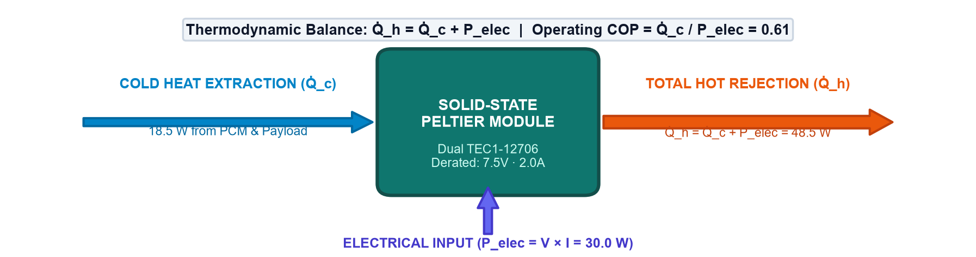
  CRITICAL THERMAL ENGINEERING PRINCIPLE:
 |  |  | “The Peltier module does not destroy heat. It transfers heat from its cold side to its hot side, where
 |  |  | the heat must be rejected.”
 |  |  | Without adequate forced-air dissipation, hot-side accumulation (Qhot = Qcold + Pelec = 48.5 W) rapidly conducts backward across
 |  |  | the bismuth telluride junctions, accelerating payload degradation.
5. INTELLIGENT SENSOR-TRIGGERED CONTROL LOGIC CLOSED-LOOP HYSTERESIS
Closed-Loop Hysteresis Cycle:
• Sampling: Continuous 1-Wire DS18B20 digital probes (±0.1°C).
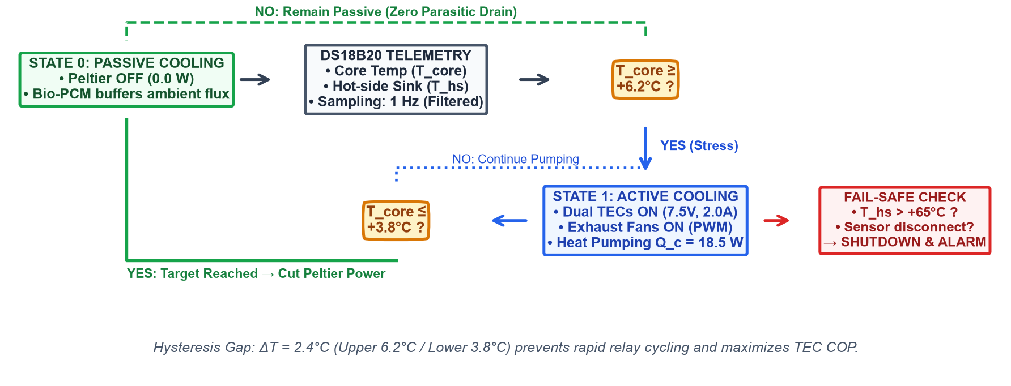 | • T ≥ Tupper (+6.2°C): Controller activates Peltier & liquid pump for active cooling.  • T ≤ Tlower (+3.8°C): Controller cuts active power; system relies on passive Bio-PCM buffering.  • Hysteresis Band (ΔT = 2.4°C): Prevents relay chattering, suppresses thermal fatigue, and reserves battery energy.

8. EXPERIMENTAL VALIDATION PROTOCOL | EMPIRICAL BENCHMARK

EXPERIMENTAL VALIDATION PENDING: Simulated values represent numerical model benchmarks. Controlled physical

bench validation is scheduled under the following protocol.
• Comparative Configurations:
Configuration A: Passive VIP/PUF Box + 4.8 kg Bio-PCM (Benchmark Control).
Configuration B: SANJIVANI Hybrid System (PCM + Sensor-Triggered Peltier).
• Environmental Conditions: 40.0°C isothermal environmental chamber.
• Primary Metrics: Time within +2°C to +8°C corridor, internal gradient (ΔT < 0.6°C), cumulative energy
drain (Wh), and hot-side heat sink stability.
 |  | FUTURE DEVELOPMENT & FIELD ROADMAP |  |  | KEY SCIENTIFIC REFERENCES
  TECHNICAL CHALLENGES & THERMAL TRADEOFFS
• Low Thermoelectric COP (≈0.61) dictates restricted duty cycle (≤10%). |  | • Phase 2: Direct-contact microchannel vapor chamber integration. |  |  | [1] WHO, PQS Performance Specification: Vaccine Cold Boxes, WHO/PQS/E004/CB01.3.
• Hot-side heat dissipation boundary layer requires aggressive forced airflow. |  | • Phase 3: MPPT 40W flexible monocrystalline solar PV lid harvesting. |  |  | [2] Riffat, S. B. & Ma, X., Thermoelectrics: A review of materials, applications, Appl. Therm. Eng., 2003.
• Parasitic reverse heat conduction during OFF state decoupled via pump cutoff. |  | • Phase 4: Cold-chain compliance certification under WHO PQS E004/CB01. |  |  | [3] Oró, E. et al., Phase change materials, cold thermal energy storage, Appl. Energy, 2012.
• Thermal contact resistance minimized via Arctic MX-4 (Rc < 0.04 K·cm²/W). |  | • Phase 5: Cellular IoT & GPS cloud temperature tracking telemetry. |  |  | [4] Goldsmid, H. J., Introduction to Thermoelectricity, Springer Series in Materials Science, 2016. |  |  | Made by: Bhavmanyu Singh Sisodia

