Regression HDC를 이용한 DAB 컨버터의 최적 TPS 변조
ICROS 2026 2026년7월 1일~3일, 대구 EXCO

Optimal Triple Phase Shift Modulation for DAB Converters Using Regression Hyperdimensional Computing
○주 휘 재¹, 송 승 호^{2*}, 정 문 호³, 최 주 엽⁴
¹⁾ 광운대학교 수학과(TEL: 02-940-5220; E-mail: vividori55790@gmail.com)
²⁾ 광운대학교 전기공학과(TEL: 02-940-5140; E-mail: ssh@kw.ac.kr)
³⁾ 광운대학교 로봇학부(TEL: 02-940-8430; E-mail: mhjeong@kw.ac.kr)
⁴⁾ 광운대학교 전기공학과(TEL: 02-940-5140; E-mail: juyeop@kw.ac.kr)

Abstract
Conventional Triple Phase Shift (TPS) modulation for Dual Active Bridge (DAB) converters suffers from complex calculations and latency issues, limiting its real-time applicability. To resolve this, this paper proposes a lightweight and highly efficient machine learning controller utilizing Regression Hyperdimensional Computing (RegHDC), which eliminates the need for complex matrix multiplications. Compared to the conventional SPS modulation, the proposed method achieved a maximum peak current reduction of 3.392 A and an overall reduction of 1.064 A in TPS applied region.

Keywords
Hyperdimensional Computing, Regression, Machine Learning Controller, Dual Active Bridge Converter

- Background

Contemporary methods for Triple Phase Shift (TPS) modulation involve calculating complex equations on Dual Active Bridge (DAB) converters to find optimal inner and outer phases. However, these methods are time-consuming and often inaccurate, while controllers using calculated look-up tables to compensate for latency suffer from degraded performance between the data points [1].
While conventional deep learning models require heavy computational resources and memory, Regression HDC operates on highly compressed hypervectors. This enables extreme lightweightness and eliminates the need for complex matrix multiplications, making it exceptionally suitable for real-time power electronics control on embedded microcontrollers (MCUs) with limited hardware resources.
Unlike the original HDC, which was primarily utilized for classification tasks requiring relatively lower output precision, research on Regression HDC incorporates two major structural changes [2]. First, Regression HDC utilizes an integer model rather than bipolar (-1, +1) or binary (0, 1) bits, ensuring a more accurate representation of the learned dataset. Second, it employs clustering techniques to maintain high performance and robustness when processing complex training datasets.
To demonstrate this, this paper constructs a virtual physical model to generate an optimal TPS dataset, which is subsequently utilized to train and evaluate the proposed RegHDC controller.

- Virtual Physical Model

The DAB Converter parameters for the Simulink model are set as follows: V₁ = 380 V, V₂ = 84-109.2 V, f_{sw} = 80 kHz, L = 90 uH, and n = 4. To collect the dataset, 20 points of two inner phases and low side voltage (D₁, D₂, V₂) are evenly distributed across its domain, while 39 points of outer phase D₀ are distributed evenly from -90 to 90 degrees based on its power transfer equation under SPS modulation as expressed in (1), 312,000 points in total. As illustrated in Fig 1, the optimal points of the outer phase D₀ for maximum power transfer in both forward and reverse directions are plotted across varying inner phases (D₁, D₂). These center points, averaged over the V₂ range, are mathematically derived from the quadratic curve fitting of the power transfer with respect to the outer phase.

$P=\frac{nV_{1}V_{2}}{2f_{sw}L}\left(D_{0}\right)\left(1-D_{0}\right)$ (1)

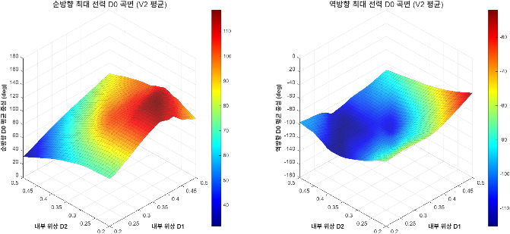
Fig 1. Estimated Maximum Power Transfer Point

Using this dataset with an 80:20 train-validation split, we trained Best-in-Class models to accurately predict peak inductor current I_{pk}, P₁, and P₂ from the input variables (D₀, D₁, D₂, V₂). As summarized in Table 1, these models demonstrated highly robust performance, achieving R² > 0.99 across all key parameters.

Table 1. Best-in-Class Model Performance
 | P₁ | P₂ | I_{pk}
R² | 0.9995 | 0.9995 | 0.9959
RMSE | 25.24 W | 25.16 W | 0.25 A
Used model | MLP | MLP | XGBoost

- Controller

To generate the optimal TPS dataset, we utilized the Sequential Quadratic Programming (SQP) algorithm with various optimization techniques on the Best-in-Class virtual physical model. This approach allowed us to find the global optimal inner phases (D₁, D₂) that minimize I_{pk} under given conditions (P, V₂). Subsequently, we approximated the optimal phases to those of SPS modulation in the high-power region. This post-processing and the resulting surface are visualized in Fig 2.

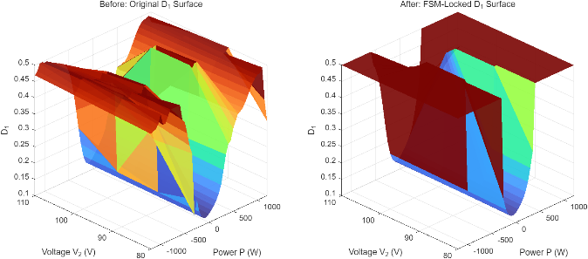
Fig 2. D₁ Surface (Left: Raw, Right: Post-processed)

The dataset is separated into two groups: 80% to train, 20% to validate. Various agents were evaluated with different hyperparameters (D, K, Q, gamma) based on their fitness score [2]. The comprehensive performance of the trained Regression HDC controller is detailed in Table 2, which highlights a remarkably small model size of 5.1kB. Furthermore, Fig 3 visualizes the predicted optimal control surfaces for D₁ and D₂.

Table 2. HDC Controller Performance
 | Performance
SPS/TPS Classification (Accuracy) | 97.44%
SPS/TPS Classification (F1-score) | 0.9825
TPS RMSE | 0.0220
Size (D = 32, K = 8, Q = 32, gamma = 8) | 5.1kB

※ Following are results of a study on the “Convergence and Open Sharing System” Project, supported by the Ministry of Education and National Research Foundation of Korea.
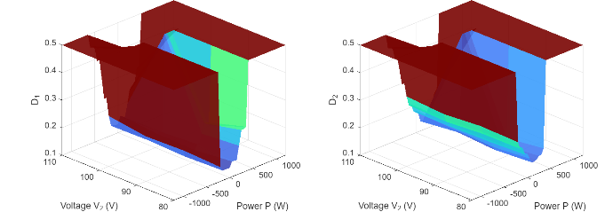
Fig 3. HDC Output (Left: D₁, Right: D₂)

Based on the dataset we have trained, current peak has reduced by 0.337A overall, 1.222A in TPS controlled area. Maximum reduction on single point was 3.392A compared to SPS modulation. On random point evaluation, it reduced to 0.272A, 1.064A on whole, TPS controlled area, respectively. The model implemented into STM32G474RET6 and showed performance of under 0.01 MSE for D₁ and D₂ on the dataset we trained, around 60 ㎲ of latency.

- Conclusion

This paper successfully implemented an optimal TPS modulation controller for DAB converters utilizing Regression HDC. The proposed controller demonstrated significant efficiency, reducing the overall current peak by 1.064 A in the TPS controller area, with a maximum reduction of 3.392 A at a single point compared to conventional SPS modulation. The hardware implementation on an STM32G474RET6 MCU verified its feasibility for real-time applications, yielding an MSE under 0.01 with a computational latency of approximately 60 ㎲ and a compact model size of 5.1kB.

References

[1] X. Li, X. Zhang, F. Lin, C. Sun, and K. Mao, “Artificial-Intelligence-Based Triple Phase Shift Modulation for Dual Active Bridge Converter With Minimized Current Stress,” IEEE J. Emerg. Sel. Top. Power Electron., vol. 11, no. 4, pp. 4430–4441, Aug. 2023, doi: 10.1109/JESTPE.2021.3105522.
[2] A. Hernandez-Cano, C. Zhuo, X. Yin, and M. Imani, “RegHD: Robust and Efficient Regression in Hyper-Dimensional Learning System,” in 2021 58th ACM/IEEE Design Automation Conference (DAC), San Francisco, CA, USA: IEEE, Dec. 2021, pp. 7–12. doi: 10.1109/DAC18074.2021.9586284.

